
B(Eng) Ordnance Munitions and Explosives

ACDA5022 Work-Based Group Project
Lecturers: Dave Holley and Jenni Steen

Group Project Portfolio

Anna Katherine Victoria Williams 2023597
15th July 2024

Table of Contents
ACDA5022 Work-Based Group Project 1
Table of Figures 3
1. Introduction 4
2. Introduction to the Problem 4
a. Brief 4
b. Team thoughts 5
3. Solutions 6
a. Options 6
b. Our design 7
4. Manufacturing contributions 9
a. Manufacturing method 9
b. Underlying Chemistry affecting Manufacture 9
c. How this feeds into the team 10
d. Recommendations to the team 11
5. Design Reviews and Presentation 11
a. Team working process 11
b. Design Review 12
c. Presentation 12
i. Process 12
ii. Feedback 13
iii. Lessons Learnt 14
6. Reflection 15
a. The actual solution 15
b. Working as a team 15
7. Conclusion 16
8. Bibliography 17

Table of Figures

Figure 1: Requirements set for the Rapid Cratering Kit.....................................Page 5

Figure 2: Functionality of requirements for the Rapid Cratering Kit...................Page 5

Figure 3: Initial sketch showing Shaped-charge design for bore hole generation..........................................................................................................Page 7

Figure 4: Initial sketch showing bag charge design, for crater generation.........Page 8

Figure 5: Overall marking matrix for group presentation..................................Page 13

Figure 6: Individual feedback on technical section of presentation..................Page 13

Figure 7: Individual and group feedback on style of presentation....................Page 14

Introduction
Over the course of a few months, a small project team were given the task of redesigning the current Rapid Cratering Kit (RCK) used by NATO military to make the munition an insensitive munition (IM) [1]. The rapid cratering kit consists of 2 explosive components, which are used to ultimately achieve the end goal of creating a crater in the soil to be used for cover or further warfare [2]. This kit should also be designed to be used on a variety of soil types and terrains, with a focus on a hot desert climate. The project started with a brief given by the customer, followed by some initial details of a new IM composition called TAW-EX.
The team and I then went away and had some initial brainstorming sessions, with each of us then researching different options for the design. Once this was completed, we agreed on a design as a team and then went about researching in our individual roles the different aspects of the project. This process of undertaking different roles within one overarching team meant there was a lot of team working as many of us relied on results and data from other roles to inform our decisions for our own processes.
Finally, we then presented this design to the customer, with feedback from the customer detailed in this report. This report will aim to reflect on this feedback, whilst also evaluating the effectiveness of the design solution, and evaluating the process of undertaking the project, with a focus on looking at how the team worked with each other to ultimately achieve our design.

2. Introduction to the Problem

Brief
At the first meeting with the customer, the brief was given to redesign the current in-service Charge Demolition Rapid Cratering Kit Mk2. The current process for making these kits involves using ‘run off’ or waste explosive from shell fillings, usually a RDX/TNT mix at a 60/40 blend [3]. The customer was requiring a change so that the munition is now IM compliant and suggested using a new RAM mixed explosive called ‘TAW-EX-2022’. The focus for this should be that it can be operable in any condition, but mainly it should be particularly effective in a hot desert climate. The customer also required the system to be transportable in all types of current aircraft, which includes fixed wing and rotary wing systems, and should be possible to be transported in tracked or wheeled road vehicles as well. The brief also detailed the main requirements they expected from us, including comparing the performance of the new formulation to the existing kit, obtaining safety data, proposing a new design for the kit, recommending a production route, describing the Manufacture to Disposal Sequence (MTDS), proposing packaging, and proposing a series of trials to prove the device meets these needs. We were then asked to present all of our findings to the customer at a later date.

Team thoughts
Currently, the Rapid Cratering Kit’s main issue is that it is not IM compliant, and therefore causes lots of issues in regard to transportation, storage, and handling. The first priority therefore for the team was to ensure our design incorporated insensitive munition compliant main fills into the shaped charge element, as well as the bag charge. We decided collectively straight away to keep the original design of having the two components of the shaped charge and bag charge, as this was currently effective and soldiers are well trained on how to operate them, and so it was simpler to continue with the same design. The rest of the requirements we believed the customer required were then put into some systems engineering tools, namely looking at a cohesive list of requirements, and then looking at the functionality of these requirements. The requirements are listed below in Figure 1.
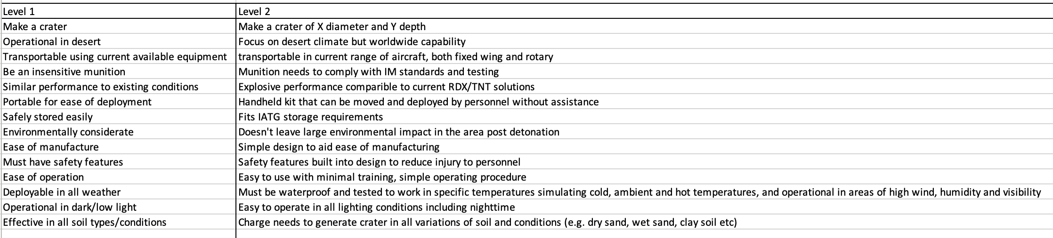
Figure 1: Requirements set for the Rapid Cratering Kit.
After going through this process in a team meeting, it was clear that there were objectives that the kit had to achieve in order to fulfil all of the needs of the customer to be effective. We then shifted our focus to looking at how these requirements could be achieved, and what functions were needed to achieve the effectiveness the customer was looking for. This functionality is detailed below in Figure 2.
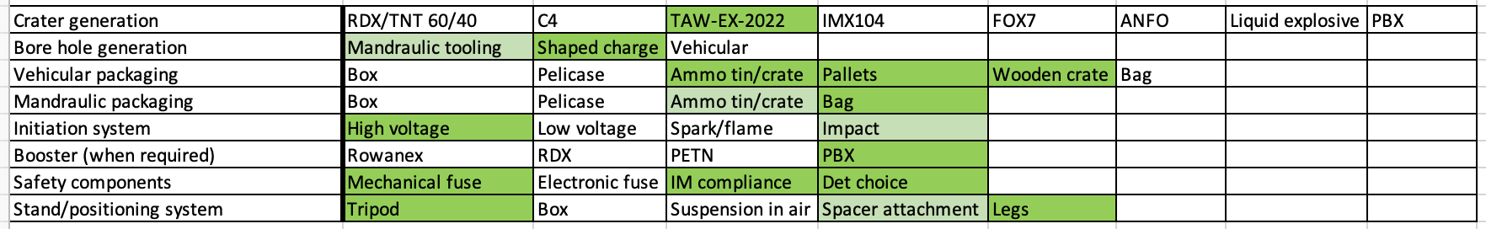
Figure 2: Functionality of requirements for the Rapid Cratering Kit.
Firstly, the team broke down the initial requirements into simple functions that needed to be achieved to complete the requirements, which is on the left side of Figure 2. The team then had a brainstorming session of all the likely methods that could be used to achieve the function, before deciding which was the best option for each function. The chosen or most desired option is highlighted in dark green, with good second choices highlighted in pale green. This was all decided as a team by going through each option and ensuring everyone agreed on each option. The next step was then to go away and each research the solution from their role’s perspective, so for example my role was manufacturing. The other roles in the team were as follows:
- Josh Ede- Disposal and large-scale testing
- Josh Evans- Transportation and storage
- Sam Parker- Small scale hazard testing and lab testing
- Stan Collins- IM compliance

These roles were decided on based on our own areas of expertise and what we felt comfortable with, and whether we felt we understood the subject area adequately in order to help inform others on issues that may arise from our areas. This again was decided in an open forum amongst the team, ensuring everyone was happy with their role before continuing the project.

3. Solutions

a. Options
After discussing all of the above, the team came to a natural point where it would then be appropriate for us to start doing individual research into different options. The different options were:
- RDX/TNT filling in new casing
- New fill in current casing
- New fill and new casing
- Mixed-In-Case shaped charge
- TAW-EX in current casing

My area of research was to look at TAW-EX in the current casing. As TAW-EX is a new novel substance for the purpose of this project, I mainly looked at the data that was provided by the customer and compared this to existing compositions, such as the traditionally used TNT/RDX mix. Initially, the new TAW-EX component looked to perform well under the initial testing that had already taken place, which was initial small-scale hazard testing (SSHT). The only testing indicator which caused some concern was the Figure of Insensitiveness (Rotor) which was 60, which means it is more sensitive than RDX which has an FoI of 80 [4]. I brought this to the attention of the group, and we collectively decided that TAW-EX could still be classed as an insensitive munition as we did not know it’s critical diameter or other factors that could determine it to be such, and so we worked on the assumption that we could still class TAW-EX as an insensitive munition. TAW-EX also outperformed RDX in several other tests, including Figure of Friction, and also had a higher Temperature of Ignition than RDX, with 220°C compared to 213°C respectively [5]. Because of this, and the fact that the current casing for the kit is working as intended and would require less cost to keep on than to change the casing, it was decided by the team that our design to go forward would include TAW-EX in the current casing.

Our design
After our initial research, the team again convened to design our proposal to give to the customer. In this meeting, we spoke about how the design might look to achieve its functions, and what components it needed to include to ensure the requirement were met by the design. Below in Figures 3 and 4 are our initial sketches of our design, which were designed together as a whole team.
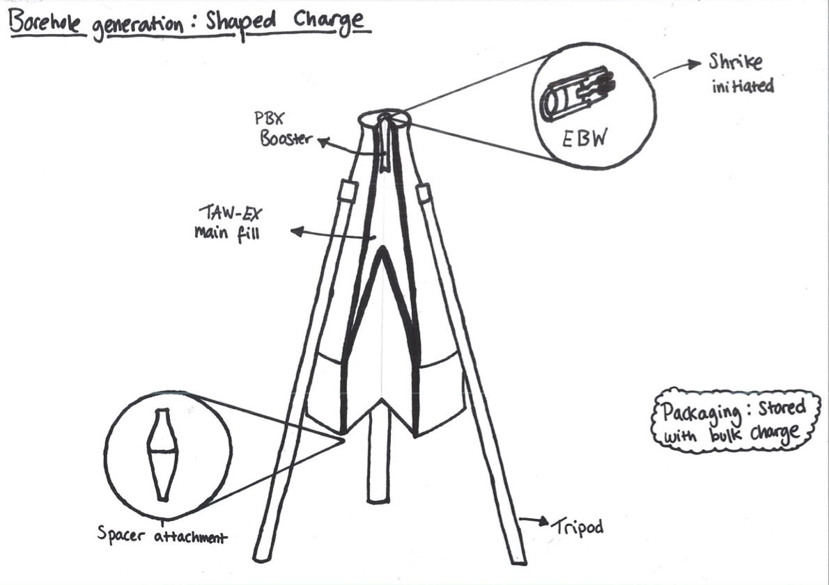
Figure 3: Initial sketch showing Shaped-charge design for bore hole generation.
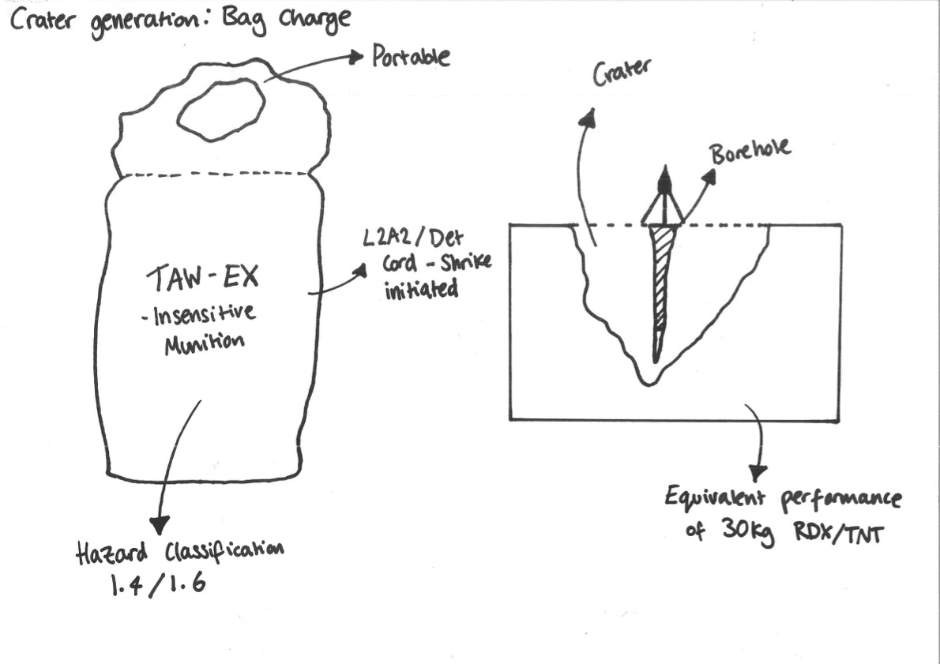
Figure 4: Initial sketch showing bag charge design, for crater generation.
The design features a two-stage process which is also currently used by the current design, which is to first crate a bore hole to get deep into the layer of earth, and then to deploy a bag charge into the hole to then blast the crater out wide, so that the crater is not only wide but also deep. To achieve the bore hole, the team selected to use a shaped charge, filled with TAW-EX. A shaped charge is what is currently used in the rapid cratering kit, and so to keep things simple and to minimise having to retrain soldiers, this design feature was kept in [6]. The initiation for this system was to be a PBX booster initiated by shrike detonator, which would all be kept separate from the shaped charge until use to ensure the munition could not be armed accidentally. The shaped charge also features adjustable legs and a spacer attachment; the purpose of these features is to ensure the correct standoff from the ground is used at all times, to make sure the bore hole generated is always at the same depth that it has been designed for. The legs are also adjustable so that the kit can be used in any terrain, even if the surface is unstable or uneven.
The second part of the design is creating the actual crater, and this is achieved by placing a bag charge filled with TAW-EX pellets into the ground and initiating them through an L2A2/Det cord- shrike initiation which will again be stored separately from the main bag charge. This will create a wider crater that can be used for tactical cover in any terrain. The design also features a handle so that the bag is easily portable and will be at 1.4 or 1.6 Hazard classification depending on further testing [3].

4. Manufacturing contributions

a. Manufacturing method
In the details provided by the manufacturer, TAW-EX is said to be melt-castable, and so when the team presented to the customer we proposed that TAW-EX would be manufactured using a melt-casting method, However, upon speaking with the customer it was realised that this was a miscommunication and in fact the method for manufacturing TAW-EX would preferably be cure-casting, as TAW-EX needs to be cured with a catalyst and an isocyanate based curing agent in order to then be manufactured into the rapid cratering kit. Despite this discrepancy, the remainder of the method is still valid in that the TAW-EX would be melt casted directly into the shaped charge casing to prevent cracking from occurring. For the bag charge, the cure-casted TAW-EX would then be poured into pellet moulds to then be set as pellets, which can then be used to fill the bag [7].
In terms of working with TAW-EX, the material is known to be susceptible to having cavities when melt casted due to clumping of the mixture, so to prevent this the extra step of passing the material through a molecular sieve would also be introduced. The TAW-EX would then be directly casted into the shaped charge casing. ​The reproducibility of TAW-EX means it can be produced in 25kg batches at one time. This means that to fulfil the current Rapid Cratering Kit design of having 2 x 15kg bags there would only need to be 2 batches of TAW-EX made, depending on performance testing data. If mass-produced, the data shows that TAW-EX has a pot life of around 2 hours, so potentially more batches could be made to avoid wasting the extra 10kg that making one RCK would produce.​
Another aspect of manufacturing that I have taken on is function testing. This is testing the kit without any explosives present to ensure it functions as intended. Whilst it will not be possible to test if the crater is actually created during a function testing due to the lack of energetics, other details of how the kit functions may be drawn from this series of testing. One of these details could be simply checking that the legs of the tripod can hold the weight of the shaped charge casing above it. To achieve this, the shaped charge would need to be filled with a substance of the same weight as the main fill, but not include energetics as this defeats the purpose of function testing. The legs could then be tested at all adjustable heights and on all terrain types to ensure the kit is stable.

b. Underlying Chemistry affecting Manufacture
Before manufacturing can begin, certain tests need to be undertaken by Sam, who is leading on SSHT and lab testing. Firstly, it would be crucial to understand the results from the thermal testing, as this could impact how TAW-EX is manufactured as it will involve thermal stress being applied to the substances. It would also be highly useful to understand the results from the mechanical testing, particularly the DMTA testing. This will depict mechanical properties such as storage modulus (elastic strain), loss modulus (energy dissipated during a deformation) and tan delta (ratio of the loss and storage modulus) [8]. Glass transition temperatures are also typically found using this method. Depending on the results from this, the method for how manufacture is completed may have to change and so it is important to understand these values before manufacturing begins.
Another crucial part of Sam’s testing is to understand the various compatibilities of the binders, catalysts, and isocyanate-based curing agents as we need to ensure that TAW-EX is not reactive with any of these agents and does not produce any undesired affects. Because of this, prior to manufacturing beginning I would liaise with Sam to ensure the results of his testing were compatible with the method that I am proposing for manufacture, and that he had no concerns over the compounds I would be using.

How this feeds into the team
The manufacturing aspects of the project feed in quite closely with the other members of the team, as they will depend on knowing how TAW-EX and the kits are manufactured to then inform their decisions. For example, Sam will need to know what chemical components make up TAW-EX in order for him to properly assess the initial chemistry of the substance.
In terms of testing, Josh Ede will need to understand how the kit has been manufactured so that he can test the munition correctly, but he will more importantly need to understand any results from function testing that may have occurred. This will give him a greater understanding of how the kit operates and how It functions. I would also be able to let Josh know if there were any concerns with the legs after performing the function testing, i.e. they may be wobbly or they may be very sturdy and substantial. I could also inform Josh of any queries he had concerning disposal, including details of how the kits are produced and with what additives so that he knows how to dispose of the various elements correctly and responsibly. I would also work with Josh if the desired outcomes were not achieved in his testing series- this is a common occurrence when developing a system, as if there is something amiss during testing, we can take it back to the manufacturing stage and try to alter some things to get the desired effect.
When considering transportation needs, Josh Evans will need to know what components make up the rapid cratering kit in order to determine how they can be transported. I will likely need to sign off to say they are safe for a certain classification of travel, and to also agree with Josh what hazard division the kits would be a part of. I could also liaise with Josh to ensure the storage of the kits had no impact on their properties when they were manufactured, for example by recommending they are stored out of direct sunlight to prevent the mixture cracking inside the shaped charge. I could also advise him how many kits can be stored together, as well as their compatibility on what can be stored and transported with them.
Finally, when working with Stan on IM compliance, I would help him to understand the properties of the kit before he started IM testing. This would be especially important to know what materials the kit is made from when he is doing testing such as the bonfire testing, as that involves melting the kit on a bonfire and so we would need to ensure the kits are safe to do this before the testing is completed. I would also be able to advise on how the design and manufacture of the kit could aid the munition to be IM compliant- Stan has stated that changing the charge dimensions could make the munition more insensitive, and so I could liaise with Stan in order to determine if this is possible. I can also let Stan know the details of the manufacturing process as the various stages in this may have affected the sensitivity of the components, and so he would need to take this into account before conducting IM testing on the kits.

Recommendations to the team
In terms of the manufacturing technique and function testing impacting the team, it is clear to see that our work very much interlinks with each other, and so it is key to make some recommendations to the team based on our own areas of expertise.
My first recommendation would mainly be to Josh Ede, and that would be that we do not perform function testing. As the function testing would not be able to replicate what size craters would be expected from the kit, it would be beneficial to instead run this through a modelling system to gain a better understanding of the craters that will form. Whilst we are already doing modelling, it would be fair to say that it would be sensible to also model the legs holding the weight of the shaped charge at the same time, as this would be more cost effective and would save the time of having to perform function testing at all.
Another recommendation I would make would be to never store the initiation systems with the main charges, and to keep them separate until it is absolutely necessary to have them together. This is to reduce the risk of unintended initiation within the system, but to also ensure the system is IM compliant for as long as it can be when being transported and stored.
Finally, I would also advise Stan that changing the charge dimensions to make the system more IM compliant would mean detrimentally altering the performance of the cratering kits, and so it may not be possible to change anything in the geometry to make it more IM compliant. This is due to the fact that we would need the kit to be in the same geometry as the current design for it to produce the desired effect. Stan has also advised me that creating internal voids within the shaped charge would help mitigate shockwaves from the munition if it were to unintentionally detonate, however this would significantly decrease the impact of the kit for creating the crater and so again I would advise Stan against doing this in the manufacturing stage.

5. Design Reviews and Presentation

a. Team working process
From the start of the project the team decided that the best way to carry out work was to have freedom within our roles, but to also have regular check ins as a team to ensure everyone was happy with how things were progressing. Upon reflection, this strategy really worked well for our team because it allowed us the autonomy we needed to go away and research our individual roles, whilst also having sight of what others in the team were doing. We also had regular check ins one-on-one, so for example I had multiple safety reviews with Josh Evans throughout the project to ensure that my processes were safe and within the guidelines he had researched. I also liaised regularly with Sam to ensure my understanding of the underpinning chemistry was correct, and that my methods for manufacturing were still sound in logic and safety. After the manufacturing process had been designed, I spoke with Josh Ede and Stan to advise them on the process, so they had a better understanding of the manufacturing process. These check ins were also covered at our whole team meetings, where we each summarised any conversations we had had in the meantime.

Design Review
As well as the regular check ins with the team, we also had a design review with the customer at the mid-point of the project. In this design review, the team presented our initial findings through showing the customer the systems engineering work we had done- this was the requirements setting and functionality, as well as a brief QFD 1 and 2 that was created by Stan. We also presented an initial template and division of work which was what we thought was correct based on the brief, however it became apparent that there was a miscommunication and we had not understood properly what was required of us from the customer. In hind’s sight, this may have been prevented by questioning the customer earlier on to find out exactly what they required; however, it was still useful to get clarification from the customer at the design review. After the design review, the team had an immediate meeting together to discuss the changes the customer had set forward. We then agreed upon a method of work moving forward, which was to each individually research our independent areas and have regular check ins as was previously mentioned.

Presentation

Process
After the mid-point design review, the team set about doing autonomous work in their own areas. At this point, we also started drawing together slides for our own areas of work. Some weeks later, the team had a check in and we realised that we each individually had enough content to start making a shared PowerPoint for the presentation. I created a live PowerPoint in OneDrive so that we could all adjust the slides in real time, and we then collectively added to the slides when we had time. Upon returning to university in person, we then had several practice sessions all together so that we could ensure we were cohesive and presenting the team’s ideas correctly. We continued to rehearse and give feedback to each other leading up to the presentation, so that we all felt thoroughly comfortable with how we were presenting to the customer.

ii. Feedback
After presenting on the group solution to the customer, the customer gave us individual feedback as well as overall group feedback. This feedback is shown below:
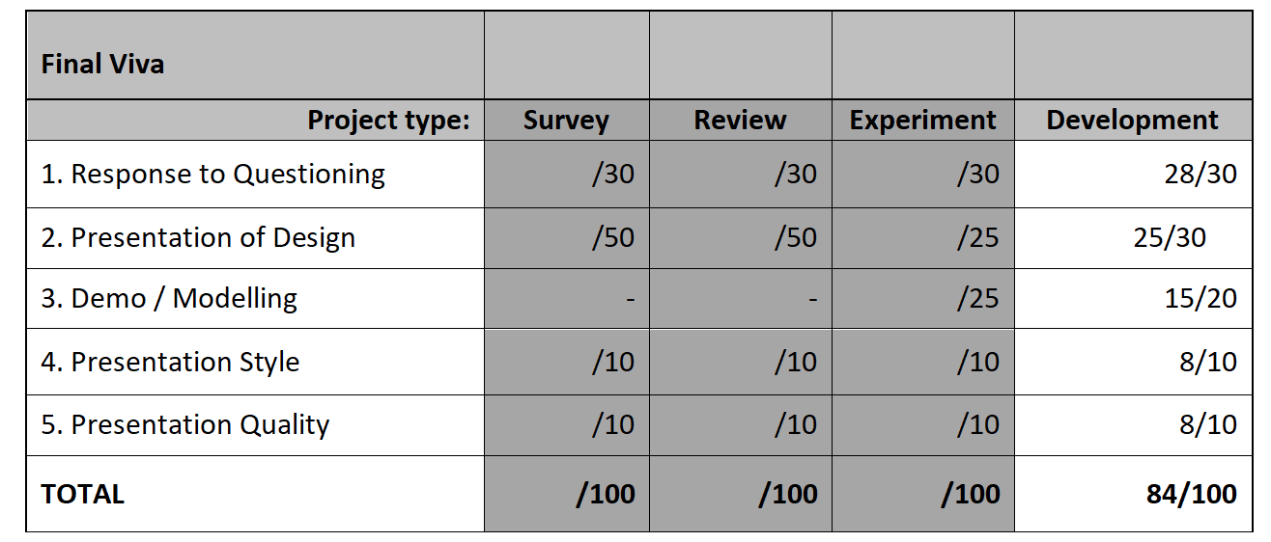
Figure 5: Overall marking matrix for group presentation
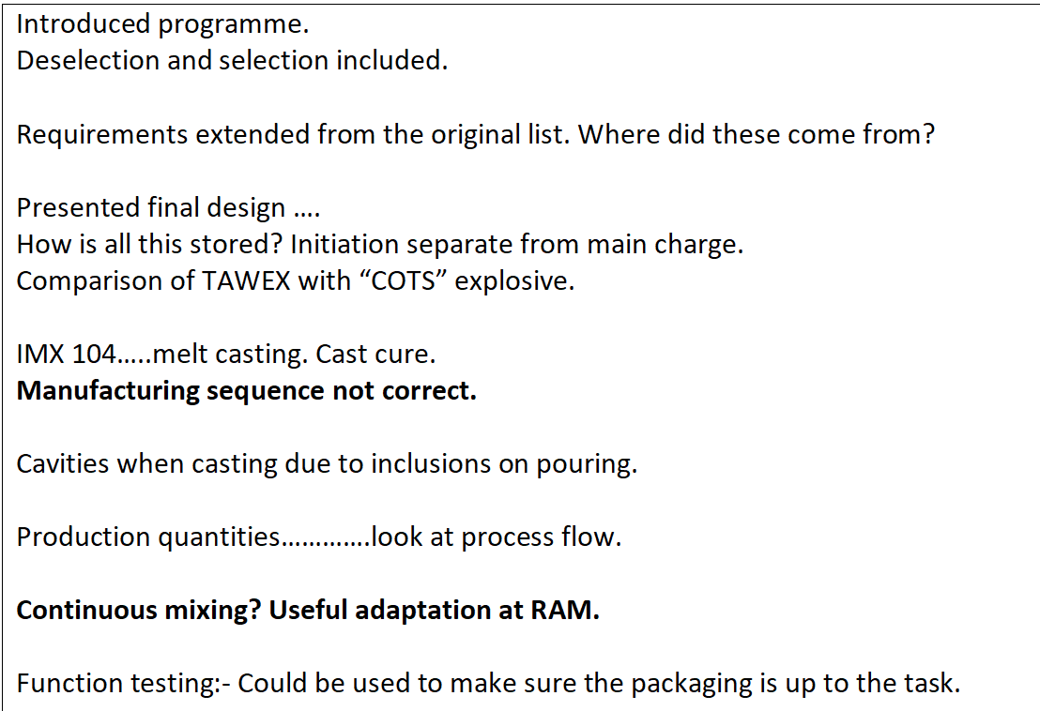
Figure 6: Individual feedback on technical section of presentation.
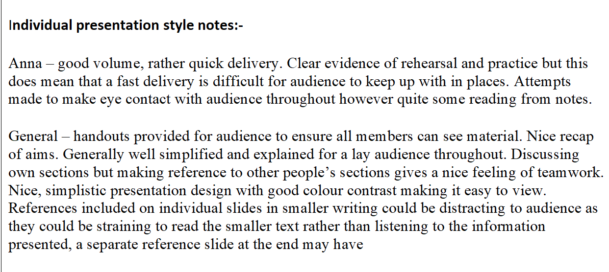
Figure 7: Individual and group feedback on style of presentation.
Reflection on this feedback will be covered in the next section.

iii. Lessons Learnt
When looking back at the feedback provided by the customer, I am happy we managed to cover a lot of key points that they were looking for. Despite this, it is also important to address the less positive comments so that the team and I can improve for next time.
Firstly, the manufacturing method of melt casting was presented, and this was incorrect. This was a miscommunication between us and the customer, as we understood the only method possible was melt casting. Upon reflection, I should have clarified with the customer what their preferred method was for manufacturing TAW-EX, and asked the question of whether it could be melt casted or cure casted. This is an important error as it changes the way Taw-EX is manufactured and therefore might change the advice I pass on to the rest of the team, so this mistake will be learned from and will not happen in future.
Secondly, and more generally, it is good to note that my presentation style seemed rushed and made too much use of notes. In general, this is not normally the case, however for quite a long presentation I felt it necessary to do so. This will definitely be worked upon for future presentations and I will make an effort to have less reliance on notes in the future.
Finally, another lesson learnt is to have a references slide at the end of the presentation, rather than having individual references on the slide. This was done based on the advice from previous presentations, so to have conflicting advice can be difficult. Instead, a better approach from the team could have been to clarify at the start of the project on things like presentation styles with the customer and what works for them- this is particularly apparent when presenting to customers that we do not know as well, as they may have some reasonable adjustments that they need for accessibility and readability purposes, and so this is good to clarify before starting.

6. Reflection

a. The actual solution
When looking back at the actual solution, it is clear to see there are a few flaws that we failed to pick up on until the feedback was returned from the customer. Firstly, the mistake in selecting the wrong manufacturing process for TAW-EX. This was an issue with communication rather than knowledge, and so could have been easily avoided. In future, every effort will be taken to understand the customer with complete transparency, rather than making assumptions and leading to incorrect decisions.
Secondly, when looking at the actual design of the kit, the system is actually a strong option and is well designed. One main feature of the design is that externally it is identical to the current kit, and so will make it a lot easier to deploy as no extra training will be needed for soldiers using it in theatre. This will also reduce the overall cost of the project, as there will be no need to run extra training on the use of the kits.
Thirdly, further options could be explored when looking at transportation and disposal, as this was highlighted by the customer as potentially wanting to explore other options. In this case, this again could have been achieved by better communication between the team and the customer to truly understand what the customer’s requirements were.
Overall, I think the kit is well designed and using TAW-EX to make it an insensitive munition is a good option. In hind’s sight, further exploration is needed into various options post manufacture, and as a team we could sit down and go through these with the knowledge of everyone contributing.

Working as a team
When reflecting on how we worked as a team, the general feelings are that we worked well as a team and we chose a method that worked well for all of us individually, which gave us that extra level of autonomy. I felt very supported by the other team members in terms of knowledge but also in terms of softer skills- we regularly checked in with each other on a more informal basis to see if we were all okay and managing the workload okay, which I liked. I also felt well listened to within the team and was pleased that there was not one overarching voice with some people not being heard in the team, but rather we all had an equal share of input and opinion and I think this was key to having a successful group project.
In terms of looking to improve our teamwork, the key point here would be to have more face-to-face meetings as a team to discuss the project. This was difficult to organise due to work scheduling and location, and unfortunately it was not really possible to organise a formal meeting for everyone to gather at one time. I think this may have helped form a more cohesive team approach, however I do not feel this is something we particularly lacked due to our good communication online to each other in the meantime.

7. Conclusion
Upon reflection, the team delivered a good solution to the problem raised by the customer, with swift action and great collaborative work. The team had a solid approach from the beginning of the project, with key discussions being held early on so that work could commence at the earliest opportunity. When looking back at our communication to the customer, this could definitely have been improved and resulted in having some major errors made, including selecting an incorrect manufacturing method. To prevent this in the future, the team has learned to communicate more frequently and in in depth with the customer to ensure any miscommunications are not carried through to end. If this project were to be done again, I would also suggest that the team tries to have more in-person meetings in order to have a clearer level of communication within the team; I did not feel this hindered our performance, however, as we still communicated effectively online and presented in a cohesive manner.

8. Bibliography

[1] | CBRNergetics, “Shaped Charges — Rapid Crater Kits,” Army Technology, [Online]. Available: https://www.army-technology.com/contractors/mines/cbrnergetics/pressreleases/medical-trauma-kits-prevent-injury/. [Accessed 12 July 2024].
[2] | STV Group, “Demolition Charge Rapid Crater Kit,” STV Group, [Online]. Available: https://www.stvgroup.cz/en/product/demolition-charge-rapid-crater-kit. [Accessed 12 July 2024].
[3] | A. Chau, “IM Explosive Replacement for Cratering Charge,” US Army, Picatinny Arsenal, New Jersey, 2024.
[4] | W. P. Luigi T. DeLuca, Nano and Micro-Scale Energetic Materials, Weinheim, Germany: Wiley-VCH GmbH, 2023.
[5] | J. Akhavan, The Chemistry of Explosives, London: Royal Society of Chemistry, 2007.
[6] | United States. Department of the Army, Operator's and Organizational Maintenance Manual (including Repair Parts and Special Tools List), Washington, D.C: United States. Department of the Army, 1988.
[7] | BAE Systems, “DEVELOPMENT AND MANUFACTURE OF AN INSENSITIVE COMPOSITION B REPLACEMENT EXPLOSIVE IMX-104 FOR MORTAR APPLICATIONS,” BAE Sytems, Kingsport, TN, 2010.
[8] | W. Shi, “Thermal Mechanical Analysis,” Adhesives in Marine Engineering, 2012.

