

Module name: Digital skills for personal and professional growth
Module code: (BMSW4008)
Assignment name: Evidence of Learning (E-portfolio)
Student name: Ionut Humulescu
Student number: (2332006)
Lecturer: Gareth Hughes
Deadline: Monday 16th of March 2026 at 9am
Word count: 1890 (1139 + 751)

List of contents
Task 1: Market research and Website development project............................... 4
Business remit .......................................................................................................... 4
Questionnaire responses........................................................................................... 5
Question 1. How the customers first hear about the coffee shop? ......................... 5
Question 2. How likely are customers to continue visiting the cafe? ...................... 5
Question 3. How likely are customers to recommend the coffee shop? ................. 5
Question 4. Does the cafe cater for the customers’ dietary preferences?............... 6
Insights and key patterns that influenced website design and marketing materials.................................................................................................................... 7
1. The importance of positive customer experiences ............................................. 7
2. The importance of customer loyalty .................................................................... 7
3. The relationship between customer satisfaction and customer recommendations...................................................................................................... 9
4. Transparency is essential when communicating dietary options ...................... 10
Audience segmentation........................................................................................... 11
SEO strategy........................................................................................................... 12
Conclusion............................................................................................................... 13

Task 2: The importance of Excel in the digital era ............................................. 14

References ............................................................................................................. 17

List of figures
Figure 1. Testimonials ............................................................................................... 7
Figure 2. Website screenshot featuring new menu items ......................................... 8
Figure 3. Promotional poster created in Canva ........................................................ 8
Figure 4. Loyalty card created in Canva ................................................................... 9
Figure 5. Website screenshot: Facebook link ......................................................... 10
Figure 6. Website screenshot highlighting the use of dietary symbols ................... 11
Figure 7. Website screenshot highlighting the use of SEO techniques .................. 12
Figure 8. Website screenshot highlighting the use of SEO techniques .................. 12

Appendixes ........................................................................................................... 18

List of attachments & links .................................................................................. 20

TASK1: Market research and Website development project

Business remit
The remit of this project is to develop and promote The cuppa & cake fix, an inclusive coffee shop located on Mumbles Road in Swansea. The cafe aims to provide a welcoming environment offering coffee, desserts and healthy options suitable for customers with food allergies, dietary requirements and wellness-focused lifestyles.
The cafe’s USP is ‘’Wellness by the waves – safe, healthy, delicious’’, reflecting the seaside location and focus on inclusive, health-aware food choices.
To ensure the business meets customer needs, a questionnaire was conducted to explore customer preferences, behaviours and expectations when visiting the coffee shop. A total of 34 responses were collected, providing insights into customer awareness, loyalty and menu expectations.
The findings informed the business strategy, website design and marketing materilas developed for the project.

Questionnaire responses
Question 1. How did customers first hear about the coffee shop?
The questionnaire revealed that 76% of respondents discovered the café through friends or family recommendations, while smaller proportions reported hearing about it through social media or general word of mouth (see Appendix 1). This demonstrated the significant influence of personal recommendations when customers choose cafés.
Word-of-mouth marketing is particularly influential in hospitality businesses because customers often rely on trusted opinions when selecting places to eat or drink (Kotler et al., 2020). Positive experiences encourage customers to recommend the business to others, creating steady growth and increasing brand awareness without significant advertising costs.

Question 2: How likely are customers to continue visiting the café?
The results were extremely positive, with 62% reporting they were very likely to return and 38% stating they were extremely likely to return (see Appendix 2). This indicates strong customer satisfaction and suggests that the coffee shop successfully meets customer expectations.
Customer loyalty is particularly valuable in the café industry because repeat customers generate consistent revenue and often become advocates for the brand (Jobber and Ellis-Chadwick, 2020). The results indicate that customers already perceive the café as a place they would regularly visit.

Question 3: How likely are customers to recommend the coffee shop?
The results were extremely strong, with 59% rating their likelihood of recommending the café as 10 out of 10, while many others rated it between 8 and 9 (see Appendix 3). This indicates a very high level of customer satisfaction and suggests that customers perceive the café positively.
High recommendation scores are associated with Net Promoter Scores (NPS), which indicate that customers are willing to promote the brand voluntarily. Businesses with high NPS scores often experience higher growth, because satisfied customers act as brand ambassadors (Reichheld, 2003).
Questions 4: Does the café cater for customers’ dietary preferences?
The results showed that 71% of respondents believed the café did cater to their dietary needs, while 24% were unsure and 6% said no (see Appendix 4).
These findings are particularly significant because the café is designed to provide inclusive menu options for people with allergies, dietary restrictions and health-conscious lifestyles. Most respondents recognising that the café caters to their needs supports the viability of the business.

Insights and key patterns that influenced website design and marketing materials

- The importance of positive customer experiences
The responses received for Q1. highlight the importance of creating memorable customer experiences that encourage people to share recommendations. The inclusive menu concept, welcoming atmosphere and unique seaside location can all contribute to positive customer experiences that generate word-of-mouth promotion.
This finding influenced the marketing strategy for the café. The website design includes customer testimonials, which can replicate word-of-mouth recommendations in a digital formal.
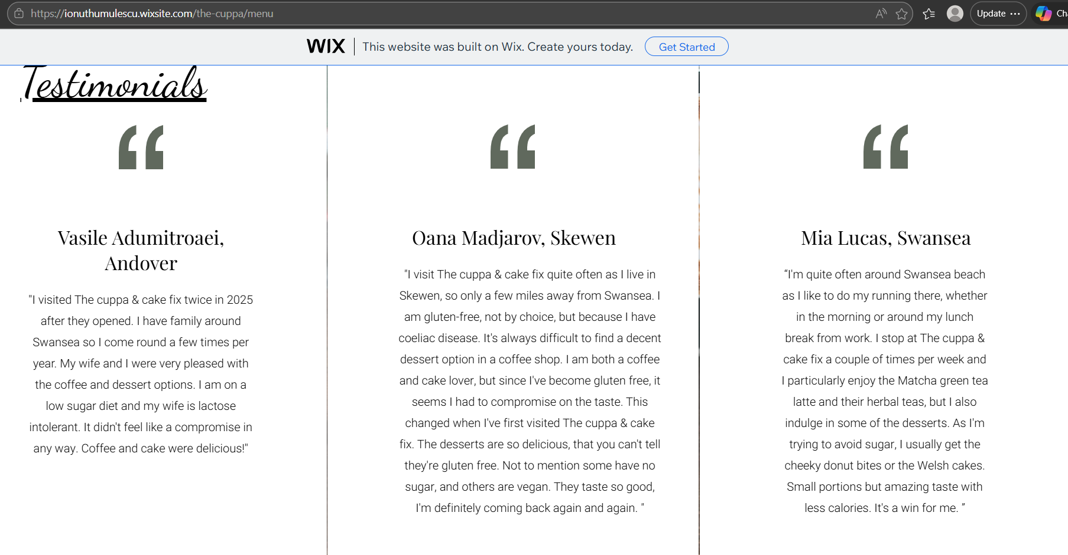
Figure 1. Testimonials
Online reviews are an important factor in influencing consumer decisions, particularly for local businesses (Chaffey and Ellis-Chadwick, 2019).

- The importance of customer loyalty
Responses to Q2. revealed a strong customer satisfaction. This finding supports the long-term potential of the business concept. By offering inclusive menu options and a relaxing beachside atmosphere, The cuppa & cake fix can position itself as a destination customers return to frequently.
This insight influenced both the website design and creation of marketing materials.
- The website has been designed to encourage repeat visits by highlighting new menu items:
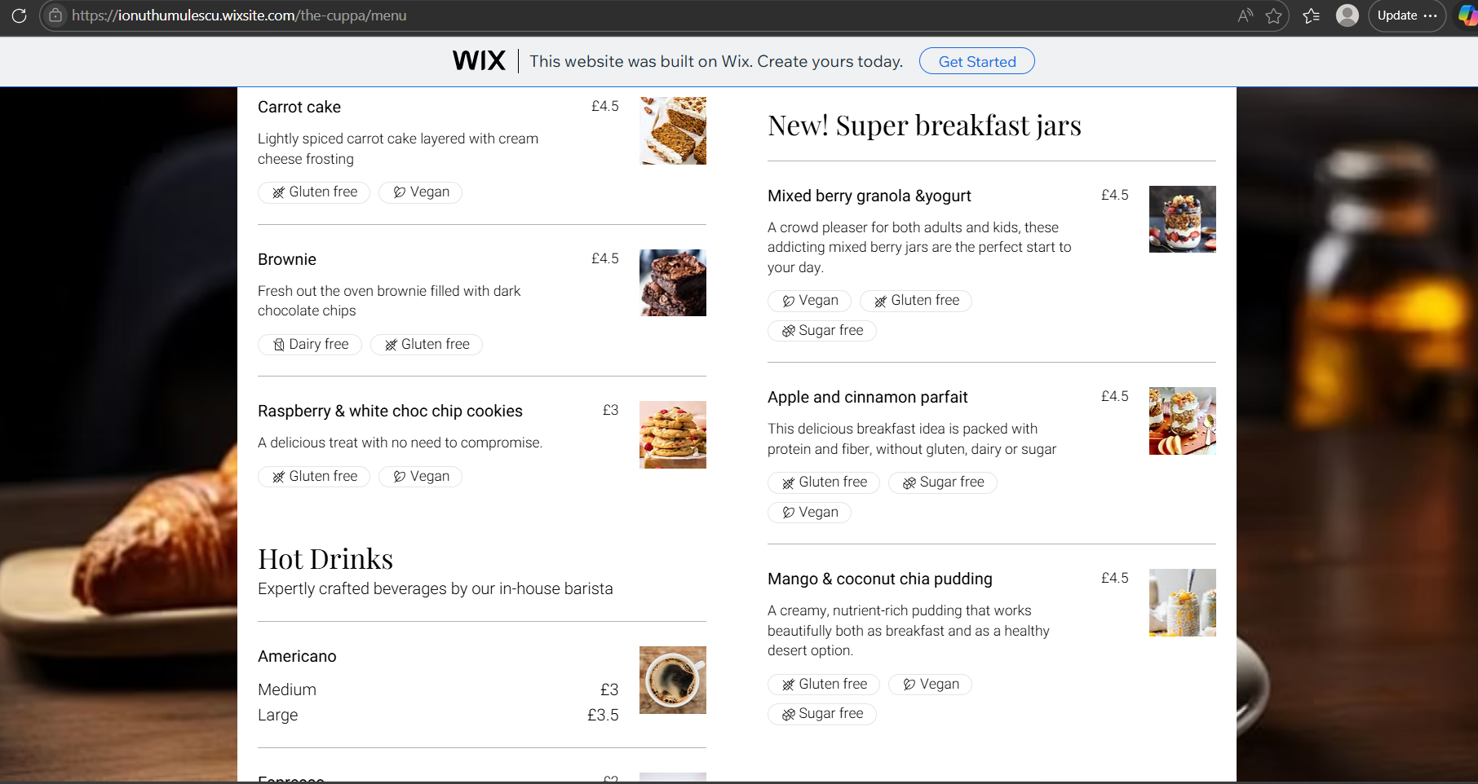
Figure 2. Website screenshot featuring new menu items

- To support customer loyalty, marketing materials created in Canva have been designed:
- posters with promotional bundles posted in store and outside the store, on our outdoor roller banner;

Figure 3. Promotional poster created in Canva

- cake loyalty cards.
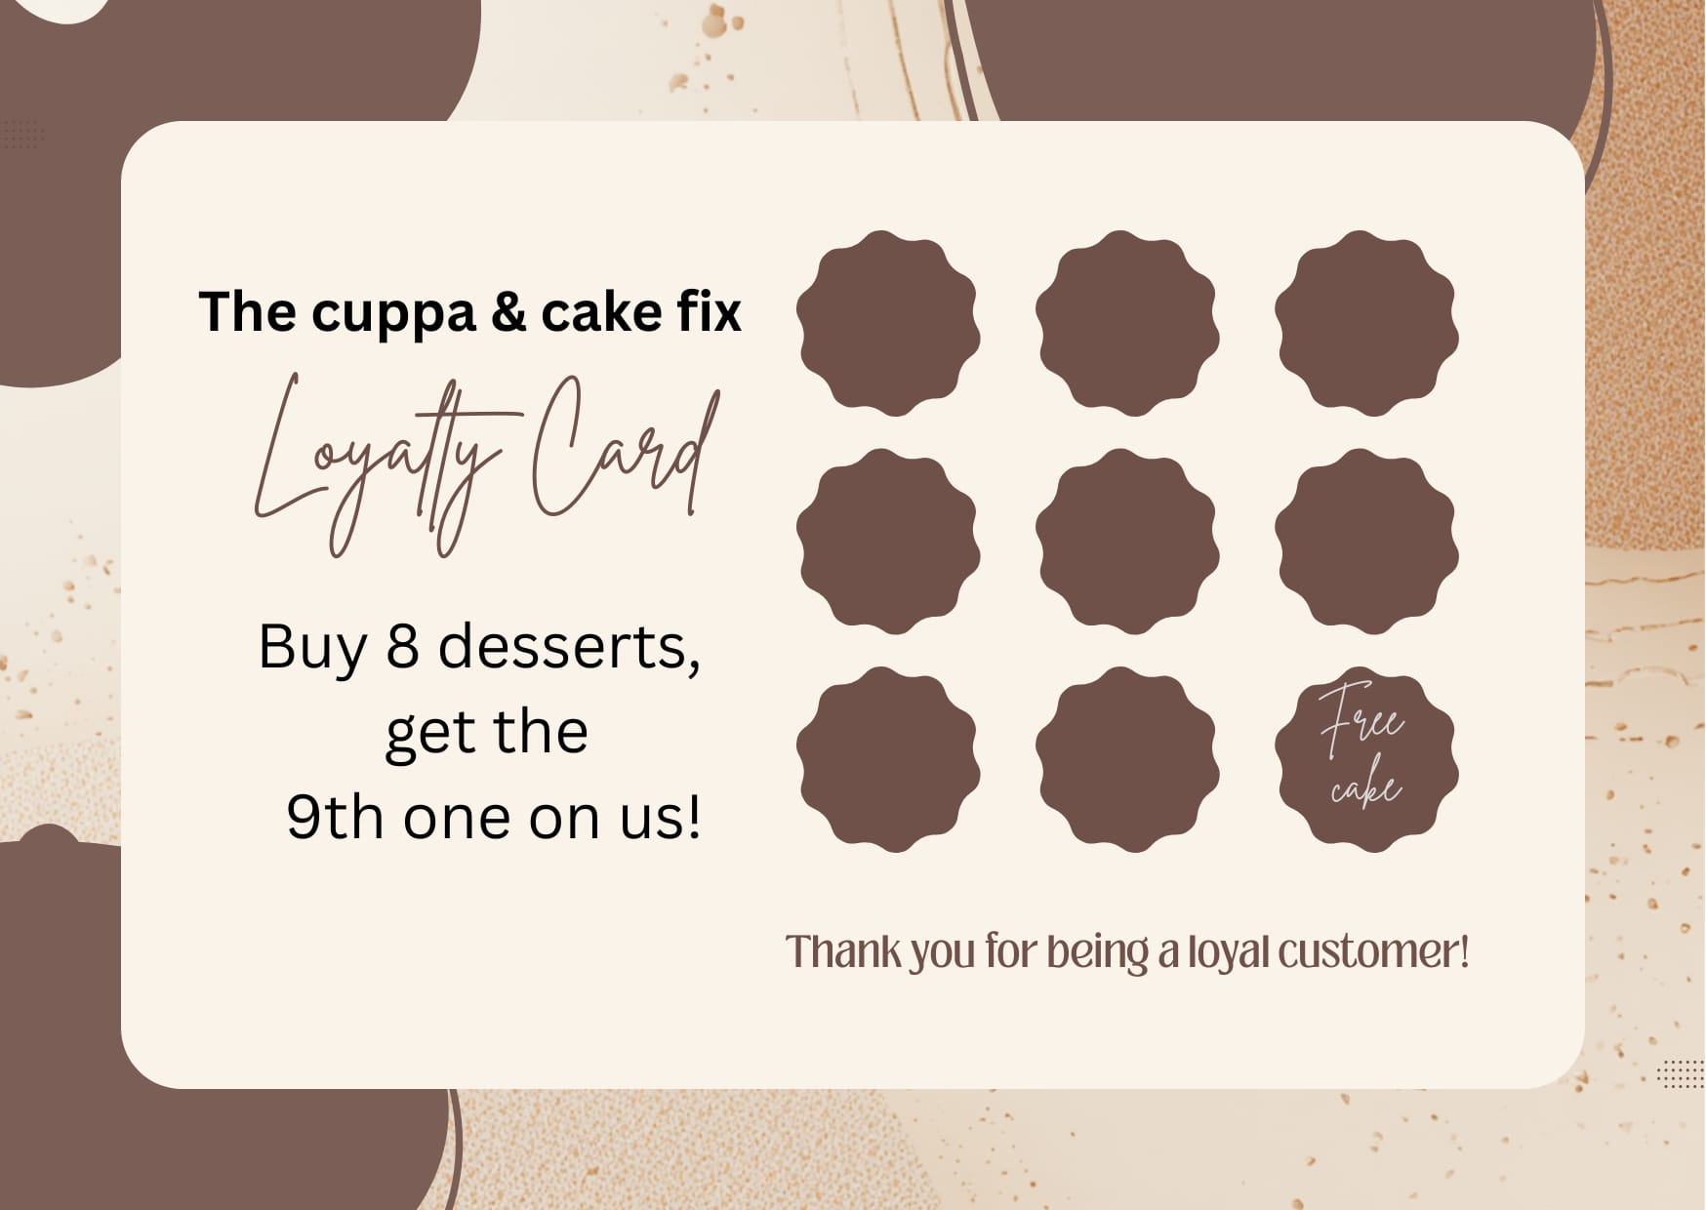
Figure 4. Loyalty card created in Canva

Maintaining strong relationships with existing customers can be more effective than constantly acquiring new customers (Ryan, 2017).

- The relationship between customer satisfaction and customer recommendations
The responses to collected for Q3. suggest that customers appreciate the café experience and would be willing to share it with others. The inclusive menu concept contributes to this positive experience, as customers who struggle to find suitable dietary options will value a café that caters to their needs.
To maximise this opportunity, the café’s marketing strategy should encourage social media engagement. Platforms such as Instagram and Facebook are particularly effective for cafés, because customers often share images of food and drinks online (Tutem and Solomon, 2018).
The café’s website has been updated to integrate social media links and encourage customers to share their experiences online. This approach can increase visibility and attract both local customers and tourists visiting Swansea’s seafront.
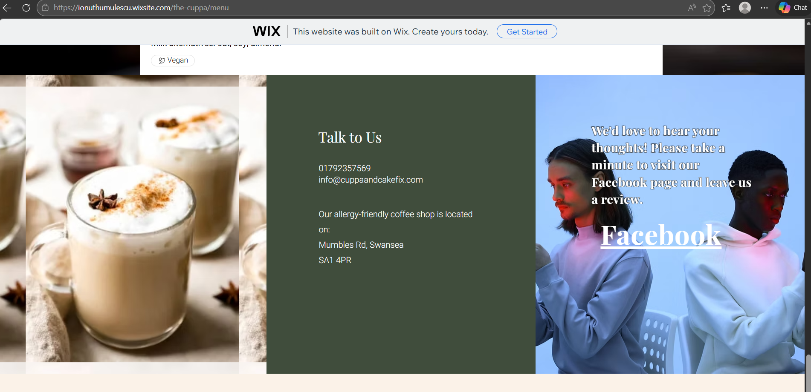Figure 5. Website screenshot: Facebook link

- Transparency is essential when communicating dietary options
The responses to Q4. reveal a percentage of respondents (24%) who were unsure the menu caters for their dietary requirements. This suggests that dietary options may not be communicated clearly enough. According to Mintel (2023), customers with allergies or dietary preferences often require clear information about ingredients and preparation methods before choosing where to eat.
This insight influenced the website design, particularly the structure of the menu page. The website now clearly labels dietary-friendly items using symbols such as:
- GF (gluten-free)
- VG (Vegan)
- DF (dairy-free)
- Sugar free
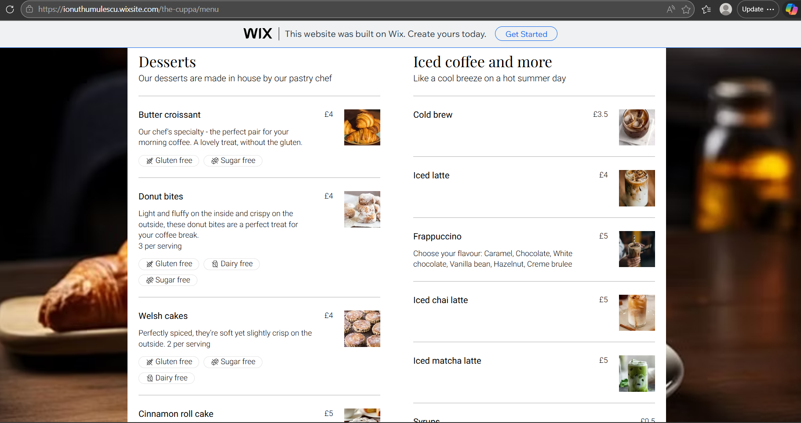Figure 6. Website screenshot highlighting the use of dietary symbols

Providing clear labels helps customers quickly identify suitable options and improves trust in the brand.

Audience segmentation
The questionnaire also revealed that most respondents were aged between 26 and 45 (see Appendix 5), representing the primary target audience for the café.
This demographic often values quality coffee, comfortable environments and socially engaging café spaces.
Three key audience segments can be identified:
- Health-conscious professionals
- Customers with dietary restrictions
- Social café visitors.
The audience segmentation helps inform marketing and website designs by highlighting the need for clear menu categories, visible dietary information and inviting images that reflect an inclusive café environment (Kotler and Keller, 2016).

SEO Strategy
Search engine Optimisation (SEO) plays an important role in helping customers discover the café online.
The cuppa & cake fix’s website content includes relevant keywords: ‘’Gluten free’’, ‘’Dairy free’’, ‘’Sugar free’’, ‘’Inclusive coffee shop Swansea beach’’, ‘’Allergy-friendly coffee shop Swansea’’,
These keywords help improve the website’s ranking in search engine results, making it easier for potential customers to find the business online (Kingsnorth, 2019).
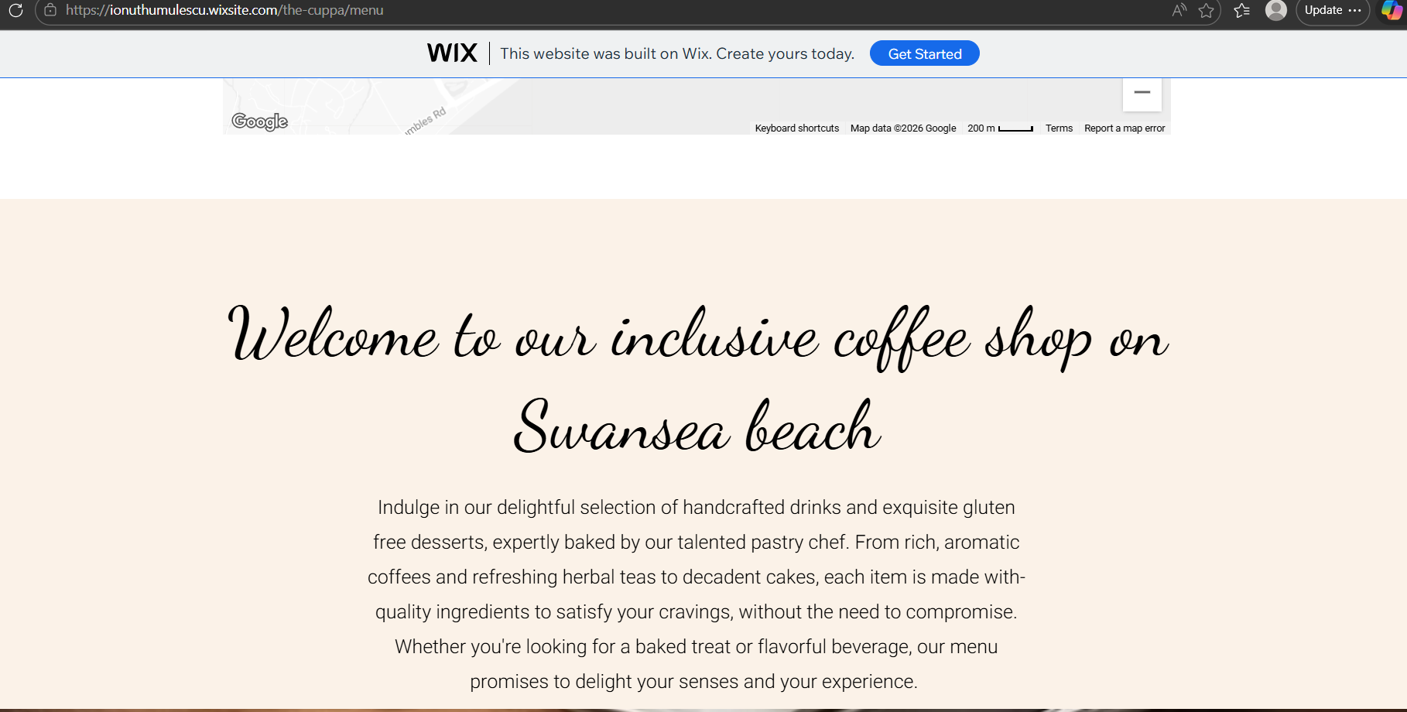
Figure 7. Website screenshot highlighting the use of SEO techniques

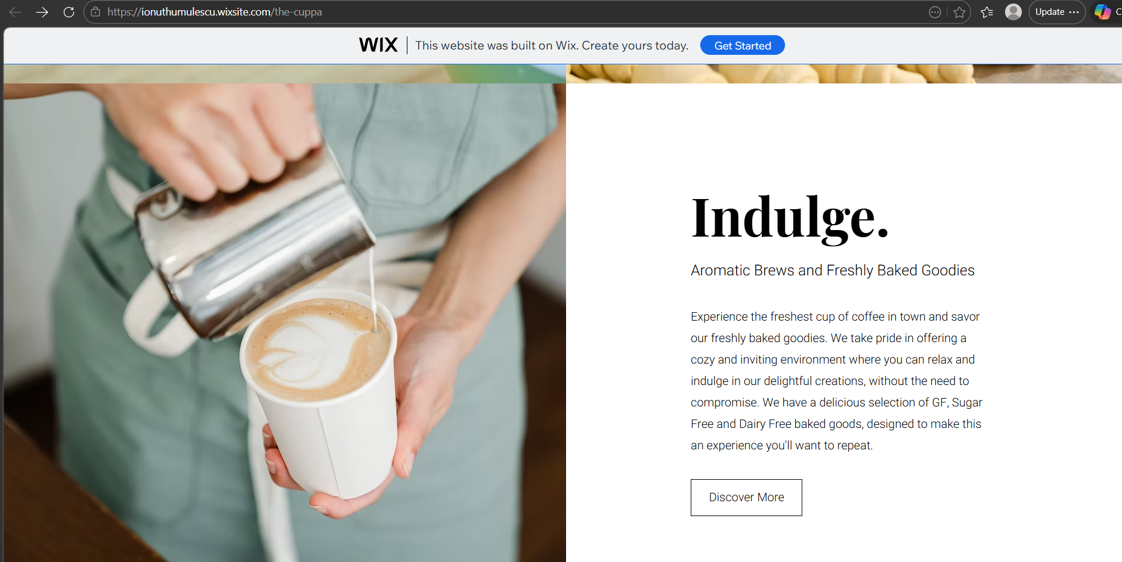
Figure 8. Website screenshot highlighting the use of SEO techniques
Conclusion
The questionnaire analysis provided valuable insights into customer awareness, satisfaction and menu expectations. Word-of-mouth recommendations were identified as the primary way customers discover the café, emphasising the importance of positive customer experiences. High levels of loyalty and recommendation scores demonstrate strong satisfaction with the coffee shop experience.
The analysis also highlighted the importance of inclusive menu options for customers with dietary restrictions and health-conscious lifestyles. Expanding and clearly communicating these options will strengthen the café’s USP.
Overall, the research demonstrates how customer insights can inform The cuppa & cake fix’s business strategy, website design and marketing materials including video advert (see YouTube link), ensuring the café effectively meets the needs of its target audience.

TASK 2: The importance of excel in the digital era
In the digital era, businesses rely on technology to manage information, analyse data and support decision-making. One of the most widely used digital tools in business is Microsoft Excel. Excel is a spreadsheet software that allows users to organise data, perform calculations and analyse financial information efficiently.
One of the key advantages of Excel is its ability to organise large amounts of data clearly. Businesses often collect a large amount of information: sales figures, expenses and customer data. Excel allows users to store this information in tables and spreadsheets so that it can be easily managed and accessed. Spreadsheets provide a structured way to organise and analyse data, making it easier to understand business performance and identify patterns or trends (Microsoft, 2023). According to Laudon and Lauden (2022), digital tools such as spreadsheets help organisations manage large amounts of information and support everyday business operations.
Another important benefit of Excel is its ability to perform calculations quickly and accurately. Excel contains a wide range of formulas and functions that allow businesses to calculate totals, averages, profits and other financial values automatically. These automated calculations help reduce the risk of human error and improve efficiency.
For example, in a cash flow forecast spreadsheet, Excel can automatically calculate monthly profit or loss by subtracting expenses from income (see Attachment). According to Almabetter (2023), Excel enables users to perform complex calculations and analyse financial data within a single platform, which makes it a valuable tool for businesses.
Excel also plays an important role in financial planning and forecasting. Businesses need to predict future income and expenses to plan for growth and manage risks. Forecasting helps business owners prepare for potential challenges and make strategic decisions. Research shows that spreadsheets are widely used in organisations to support financial decision-making and organisational planning (Rebman, 2023). This demonstrates the importance of Excel as a digital tool that helps businesses manage financial information effectively.
Chaffey and Ellis-Chadwick (2019) highlight that digital technologies allow businesses to collect and analyse data more effectively, leading to more informed strategic decisions. Excel provides tools such as sorting, filtering and pivot tables that allow users to analyse large datasets and identify trends. By analysing data, business owners can understand customer behaviours, monitor sales performance and identify areas for improvement. For example, analysing monthly income and expenses can help a business determine whether it is profitable and where costs can be reduced. Excel also allows users to generate insights from data, which supports better strategic planning (Kaplan, 2024). Data-driven decision-making is an important part of modern digital business management.
Excel also allows businesses to present information visually using charts and graphs. Visual data presentation helps users understand complex information more easily. Charts can show trends in sales, profit or expenses over time, making it easier to communicate financial information to stakeholders such as investors, partners or managers. Microsoft (2023) explains that excel can generate visual summaries of data through tables and charts, helping users identify patterns and trends more easily.
Another reason why Excel is important in the digital era is its accessibility and flexibility. Excel is widely used across many industries because it is easy to learn and adaptable to different business needs. It can be used for many purposes including budgeting, project management, inventory tracking and financial analysis. Excel's user-friendly interface makes it accessible even for users with limited technical skills (AceProject, 2024). This makes it particularly useful for entrepreneurs and small business owners who need cost-effective digital tools.
Furthermore, Excel supports collaboration and digital sharing. In modern business environments, Excel files can be stored on cloud platforms such as Microsoft OneDrive or SharePoint. This allows multiple users to access and edit spreadsheets at the same time, improving teamwork and communication. Digital collaboration tools allow businesses to share financial data and reports quickly and efficiently. Excel’s ability to integrate with other digital systems also makes it a valuable tool for business operations (GeeksforGeeks, 2025).
In conclusion, Excel is an essential digital tool that helps businesses organise data, perform calculations and make informed decisions. Its ability to manage financial information, analyse data and present information visually makes it extremely valuable for businesses of all sizes. For small businesses, such as a coffee shops, Excel can be used to create cash flow forecasts, track expenses and monitor profitability. In the digital era, tools like Excel allow businesses to operate more efficiently, reduce errors and improve decision-making. As businesses continue to rely on data, Excel will remain an important tool for digital business management.

References
- AceProject, 2024. 10 advantages of managing projects with Excel. Available at https://www.aceproject.com (Accessed: 12 March 2026)
- Almabetter, 2023. Advantages and disadvantages of MS Excel. Available at: https://www.almabetter.com (Accessed: 10 March 2026)
- Chaffey, D. and Ellis-Chadwick, F., 2019. Digital marketing. 7th edn. Harlow: Pearson.
- GeeksforGeeks, 2025. Why Microsoft Excel is essential for professionals. Available at: https://www.geeksforgeeks.com (Accessed: 12 March 2026)
- Jobber, D. and Ellis-Chadwick, F., 2020. Principles and practice of marketing. 9th edn. London: McGraw-Hill.
- Kaplan, 2024. Is Microsoft Excel still relevant? Available at: https://www.kaplan.co.uk (Accessed: 11 March 2026)
- Kingsnorth, S., 2019. Digital marketing strategy. London: Kogan Page.
- Kotler, P. and Keller, K., 2016. Marketing Management. 15th edn. Harlow: Pearson.
- Kotler, P., Keller, K. and Chernev, A., 2020. Marketing management. 16th edn. Harlow: Pearson.
- Laudon, K.C. and Laudon J.P., 2022. Management information systems: managing the digital firm. 17th edn. Harlow: Pearson.
- Microsoft, 2023. Spreadsheets on Microsoft Excel. Available at: https://www.microsoft.com (Accessed: 10 March 2026)
- Mintel, 2023. UK Free-from food market report. London: Mintel.
- Rebman, C., 2023. An industry survey of analytics spreadsheet tools adoption. Available at: https://files.eric.ed.gov (Accessed 10 March 2026)
- Reichheld, F., 2003. ‘’The one number you need to grow’’, Harvard Business Review. 81(12), pp. 46-54.
- Ryan, D., 2017. Understanding Digital Marketing. London: Kogan Page.
- Tutem, T. and Solomon, M., 2018. Social media marketing. London: Sage.
- WeCreateProblems, 2025. Importance and uses of Excel in business. Available at: https://www.wecreateproblems.com (Accessed: 11 March 2026)

Appendixes
Appendix 1
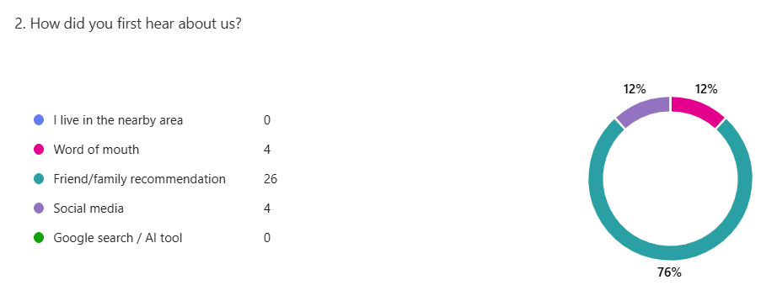Appendix 2
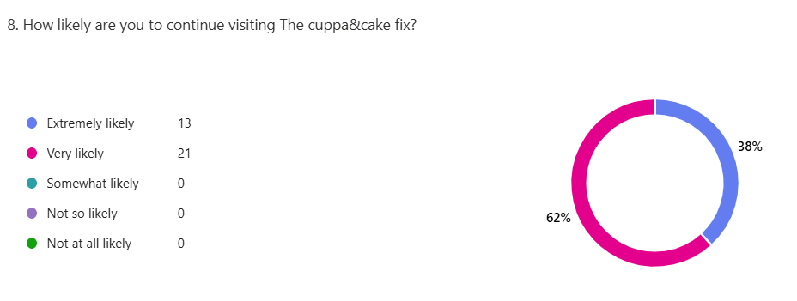Appendix 3
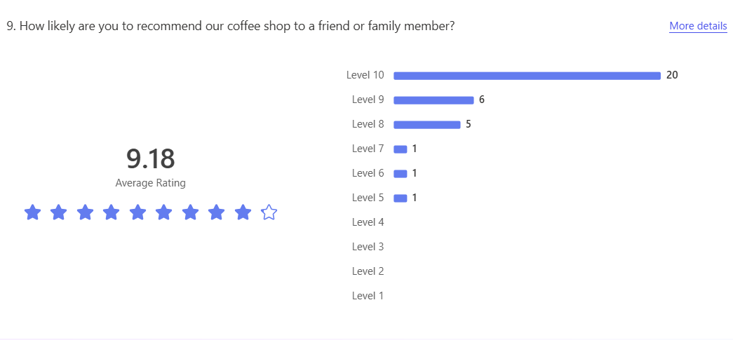
Appendix 4 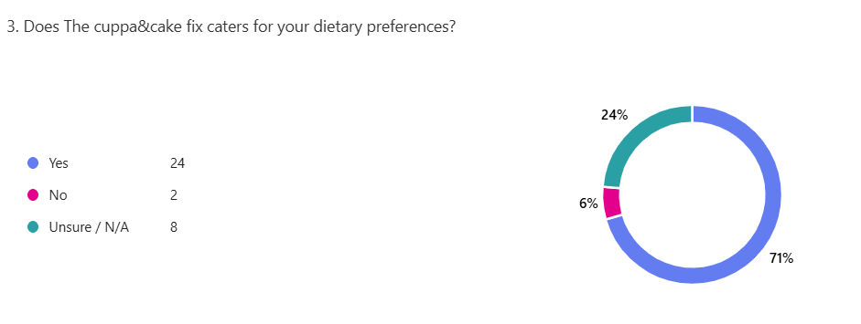Appendix 5
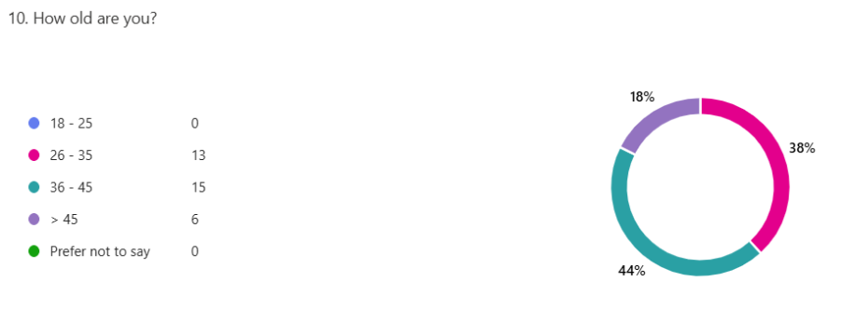

List of attachments & links
- YouTube link for video advert: https://youtu.be/EIRrLUf7TNk
- Attachment: Excel spreadsheet – 12-months cash-flow forecast for The cuppa & cake fix

