Problem
Analysis and Solution
Development

Module Name: Analysing and Solving Problems
Module Code: ACCA 4019
Student Name: Richard Valentine Mamuto
Student ID: 2442383
Group: 1

Lecturer’s Name: Fahad Ahmed

Table of Contents
Table of Contents 1
1. Introduction 2
2. Deconstruct the Problem 2
2.1 MoSCoW Technique Requirement 2
2.2 Variables Identification 3
3. Proposed Solution 4
3.1 Flowchart 4
3.2 Flowchart Explanation 4
4. Reflection and Justification 6
4.1 Abstract thinking 6
4.2 Sub-dividing 6
4.3 Justification of the solution 6
4.4 Limitation 7
4.5 Assumption 7
5. Conclusion 7
References 8

Introduction
My names are Richard Valentine Mamuto, as part of my assesment on problem analysis and solution development and would like to start with how, Colleges must learn to manage classroom resources to maintain educational quality and operational efficiency. Issues such as overcrowded rooms, idle spaces, time schedule clashes and excessive intervals between classes have to be addressed by the local college in this situation. This report breaks down the problem using the MoSCoW prioritisation method, finds the most important variables, suggests a structured flowchart-based solution based on constraint-based scheduling principles, and considers the computational thinking methods used in the analysis.

Deconstruct the Problem

MoSCoW Technique Requirement
The MoSCoW method is a common technique to rank requirements originating in the Dynamic Systems Development Method (DSDM). It shows requirements into four categories: Must-have, Should-have, Could-have and Won't-have. This assists the stakeholders and analysts in distinguishing between significant deliverables and those that are nice to have and not necessary enhancements [1]. This is done using the method in the classroom allocation problem as follows:
Must Have
There should be one classroom per class, with not more than the maximum rated capacity of the room. This will ensure that the standards of health and safety are addressed and also that there is no overcrowding.
No conflicts in schedules can be observed in the schedule; no two classes can be held in the same room simultaneously.
Before any allocation decision is made, the system should be able to access and store all room information, including unique identifiers, maximum capacities, and availability status.
Should-have
Room assignments should cut down on the time it takes to move by putting classes that happen one after the other in rooms in the same building or on the same floor whenever possible.
The system must be in a position to detect and highlight any scheduling conflict that arises in the process of allocation automatically.
Could have
To ensure that people are even happier, the preferences of both the lecturer and the student towards a particular type of room or time could be considered in further versions of the solution.
The college's information system could send out automatic messages to people who need to know about changes to rooms or updates on room assignments.
Won't have
This variant of the solution will not be based on the integration with external systems, such as smart building management sensors or student enrollment systems.
This structured use of MoSCoW ensures that the available resources and the analysis effort are put into must-have features first. In this manner, a conflict-free baseline is achieved prior to optional features being considered. Kravchenko et al. [1] affirm that well-ranked requirements are required to provide timely and effective solutions.

Variables Identification
These are the following variables are required to be present as data points in order to make the process of classroom allocation a reality. As Bandyopadhyay [2] notes, successful scheduling of classes needs to consider numerous factors simultaneously, including the capacity of the room, availability of time, and allocation of instructors. These factors need to be well spelt out to come up with a sound solution.

Variable | Description
Room ID | A unique number is assigned to each classroom in the college.
Room Capacity | The maximum number of students that can be accommodated in a room.
Class Size | The total number of students who are taking a certain class or module.
Time Slot | The period of time which has been allocated to a lesson to begin and end.
Course ID | An identification number with which the subject or module is being instructed.
Lecturer ID | A teacher ID of the teacher who is to teach the class.
Building Location | The block or the floor on which the room is placed reduces the travelling time.
Allocation Status | Informs you whether there is a room available or it's booked at a specific time.
Conflict Flag | A Boolean (True/False) that informs you whether you have found a scheduling conflict.

Proposed Solution

Flowchart
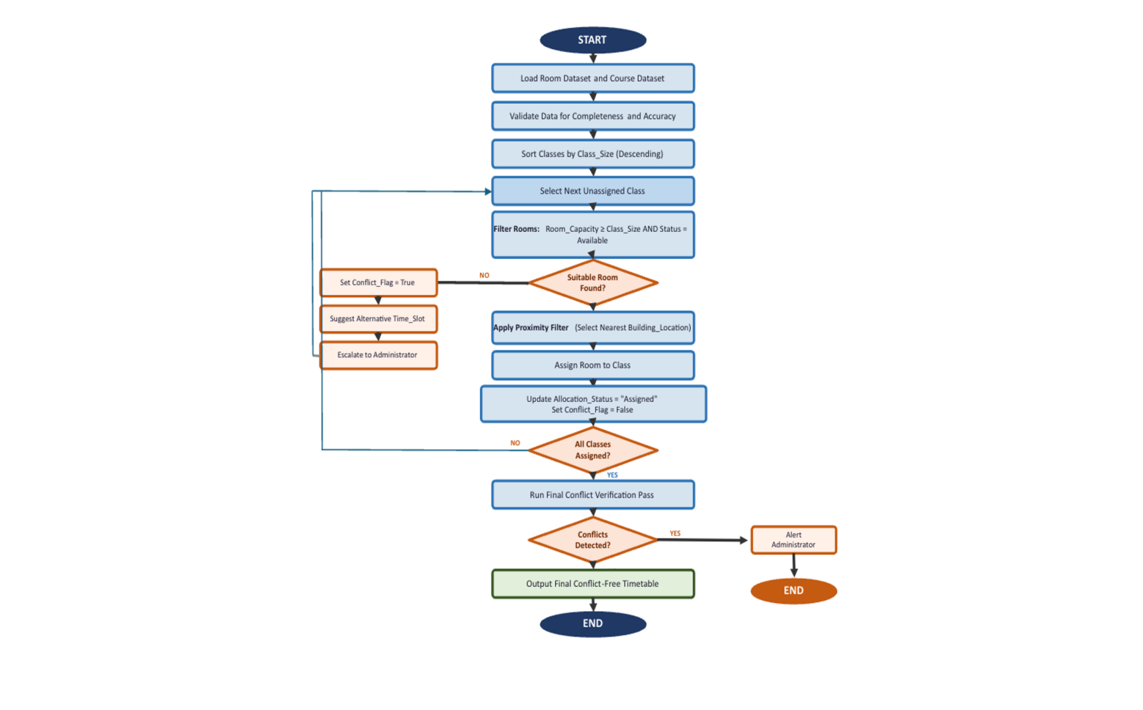

Flowchart Explanation
The proposed algorithm maximises classroom allocation with a capacity matching, conflict elimination, and mobility minimisation rule-based and constraint-based algorithm. Resource allocation in education is based on constraint-based scheduling, which captures rules and generates conflict-free and provable solutions [3]. The following are each flowchart stage.
Data Collection and Preparation.
Once two primary datasets have been loaded, the process starts. The room dataset contains Room ID, Room Capacity, Building Location and the current Allocation_Status of each college classroom. The course dataset will be comprised of Course ID, Class Size, Lecturer ID, and the lesson time Time Slot. Both datasets are verified at the pre-processing stage to make sure that all data is complete and correct. Chen et al. [3] argue that the quality of input data influences the optimality of a schedule, and therefore, data validation should be implemented before the execution of allocation logic.
Sorting and Prioritising
Classes are ordered by Class Size (in descending order) before assignment. A "largest-first" heuristic is used in many constraint satisfaction problems, whereby the least flexible assignments are assigned initially, followed by more flexible ones [2]. When larger classes are given first, the assignment cycle will be less likely to end with big, unaccommodated courses. Capacity restrictions restrict the compatibility of rooms. Smaller classes, which can fit more rooms, are processed in later rounds with more possibilities.
Room Assignment, Proximity Filtering.
It tries to find rooms whose AllocationStatus = "Available" at the desired Time Slot and narrows down to the ones whose Room capacity = Class size at that Time Slot. In case there are two or more potential rooms that fit the two criteria, a proximity filter is used to choose the room closest to the last or next assignment of the lecturer or student cohort. As Çaylı and Yilmaz [6] note, a reduction in the time of movement is usually not given much consideration in classroom scheduling. The proximity as a decision factor increases the feasibility of this plan. After the assignment, Allocation Status is set to Assigned and Conflict Flag is set to False.
Dealing with Conflict
Conflict Flag = True in case there is no room complying with the capacity and availability requirements. The system will then see whether there is another Time Slot with an appropriate room to attend the same class. In case one of the alternatives works, the class will be rescheduled temporarily, and processing will proceed. Where there is no alternative, then a conflict is resolved manually by an administrator. This mechanism of escalation signals all conflicts that cannot be resolved, instead of simply going around them, keeping the end deadline.
Last Checks and Schedule.
After all classes have been processed, a final assignment check is done. Pairs of room-time slots are verified to make sure that no two classes are in the same room or the room capacity is not surpassed. This two-step technique of assigning and then globally verifying is consistent with the multi-constraint validation technique used by Bandyopadhyay [2] and guarding against errors in assignments. The last peace-building schedule is then shared with employees and students. The method is reusable: each academic term, the same logical structure can be used with updated datasets without changing the algorithm.

Reflection and Justification

Abstract thinking
The fundamental structure of the allocation challenge and irrelevant complexity were separated using abstract thinking. Wu et al. state that abstraction is the process of elimination of irrelevant information to retain only the information that influences the results [4]. The generalised model that can be used in several scheduling cycles was developed by eliminating room aesthetics and student preferences and keeping measurable variables such as capacity, time slot, and location of the building.

Sub-dividing
The issue was broken down to three manageable sub-problems, which included capacity matching, conflict avoidance and movement minimisation. This is in line with the computational thinking principle of breaking down a complex problem into small, manageable components [4]. A flowchart element tackled each sub-problem and was then combined into one algorithm. Ezeamuzie and Leung [5] discovered that structured decomposition always provides more convenient and verifiable scheduling solutions.

Justification of the solution
Rule-based, constraint-driven was selected since it is transparent, repeatable, and does not need any special infrastructure. In contrast to machine learning, it works with well-defined logical predicates, which can be audited by unexpert administrators [2]. The MoSCoW process placed more importance on conflict resolution and capacity compliance than preference integration.

Limitation
The solution is based on fixed input data and fails to automatically revise class sizes and room capacities once allocated. The proximity constraint is at the building level, which can be inadequate on large campuses, and disruptions such as room closures are not taken into account in real-time.

Assumption
The room capacity and enrolment data have all been assumed to be correct at entry; each period requires a standard room, and there are no limitations on any specialist equipment. In the case of standard colleges, these assumptions are valid; however, the lab-intensive or specialist facilities would have to be revised.

Conclusion
A local college's classroom allocation problem was analysed and solved in this report. MoSCoW prioritisation listed capacity compliance and conflict elimination as the main design objectives. An algorithm based on constraint-based flowchart and largest-first sorting, availability checking, proximity filtering, and a last verification pass was used to produce a conflict-free timetable. The solution is based on computational thinking, abstraction, and decomposition and academic literature. Although the proposed approach encounters the limitation of data dependency and proximity granularity, it is transparent, repeatable and scalable, to enhance efficiency and learning experience in college timetabling.

References
[1] T. Kravchenko, T. Bogdanova, and T. Shevgunov, "Ranking requirements using MoSCoW methodology in practice," in Cybernetics Perspectives in Systems, CSOC 2022, Lecture Notes in Networks and Systems, vol. 503, Cham: Springer, 2022, pp. 188–199, doi: 10.1007/978-3-031-09073-8_18.
[2] P. Bandyopadhyay, "Optimization of class scheduling problem: A multi-constraint approach for effective resource allocation and space utilization," Int. J. Comput. Trends Technol., vol. 72, no. 10, pp. 36–42, Oct. 2024, doi: 10.14445/22312803/IJCTT-V72I10P107.
[3] Y. Chen, M. Bayanati, M. Ebrahimi, and S. Khalijian, "A novel optimization approach for educational class scheduling with considering the students and teachers' preferences," Discrete Dynamics Nat. Soc., vol. 2022, Art. no. 5505631, 2022, doi: 10.1155/2022/5505631.
[4] T.-T. Wu, A. Asmara, Y.-M. Huang, and I. P. Hapsari, "Identification of problem-solving techniques in computational thinking studies: Systematic literature review," SAGE Open, vol. 14, no. 2, 2024, doi: 10.1177/21582440241249897.
[5] N. O. Ezeamuzie and J. S. C. Leung, "Discovering computational thinking in everyday problem solving: A multiple case study of route planning," J. Comput. Assist. Learn., vol. 38, no. 6, pp. 1779–1796, Dec. 2022, doi: 10.1111/jcal.12720.
[6] O. Çaylı and A. Yılmaz, "Smart classroom scheduling and resource optimization for educational institutions: Integrating AI and multi-objective decision support," Eur. J. Res. Dev., vol. 5, no. 1, pp. 95–112, 2025.

