Development of a manufacturing system simulation

Student: Adam McGowan

Lecture: Jaymie Phillips

Contents
Table of Figures 3
What is UML? 4
What is class diagram in UML? 4
What is use case diagram in UML? 5
What is Sequence Class in UML? 6
What is Activity Diagram in UML? 7
Section 1: What is the project all about? 8
Project Definition 8
Objectives 8
Scope 8
Deliverables 8
Constraints 8
Assumption 9
Section 2: Business Case 9
Benefits 9
Options 9
Cost 9
Risks and Analysis 9
Risk Prevention 9
Risk Management 10
Risk Monitoring 10
Quality Control 10
Conclusion 10
References 11
Appendix 12

Table of Figures
Figure 1- Class Diagram 4
Figure 2 - Use Case 5
Figure 3 - Sequence Diagram 6
Figure 4 - Activity Diagram 7
Figure 5 - Company Webpage 12
Figure 6 - User Login 13
Figure 7 - System Checker 14
Figure 8 - System 15
Figure 9 - Update System Status 15
Figure 10 - Catalog 16
Figure 11 - Company 17
Figure 12 - Order 18

What is UML?
UML sands for (Unified Modeling Language), it a software that is a family of diagrams in classes. There is also another name called “a family of graphical notations, backed by single meta-model, that help in describing and designing software systems, built using the object-oriented” [1].
Unified Modeling Language is used to engineer diagrams from class, objects, state machine, activity and Sequences, and so on… These diagrams which has different structures and different behaviours, they all do different jobs when it comes to programming but they all have the same effect.

What is class diagram in UML?
A class diagram is software that is used in UML (Unified Modeling Language), it a system that shows a diagram of how the classes are developed used to design a similar understanding as a C++ class program. As class is like a building block it takes a shape in explaining what the author/dev wants to create in the diagram that could help with the project. The reason of class is used because: “Class diagrams are one of the most useful types of diagrams in UML as they clearly map out the structure of particular system” [2].
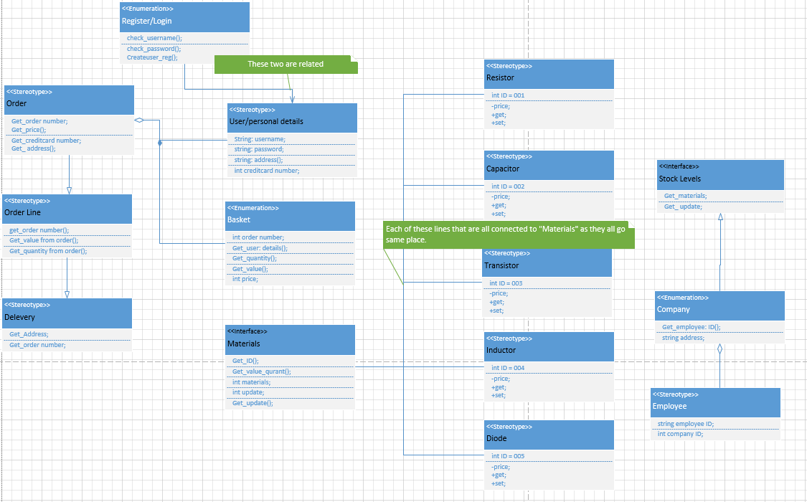
Figure 1- Class Diagram
Here is a class diagram that explains how an order is made and each class does a different job. It also shows how things are going from start to end, as this explains how and what is does when simulate into a program.

What is use case diagram in UML?
Use case is a behaviour diagram, this type of diagram is used to identify and organize. This software is usually used in planning and catalogues etc… It is like a flowchart but not connected in a way as it can be placed on pages after pages. “use cases in a product sales environment would include item ordering, catalog updating, payment processing, and customer relations” [3].
The use case is also capturing function that are requirements of a system. “Use case work by describing the typical interactions between the user of a system and the system itself, providing a narrative of how a system is used” [4].

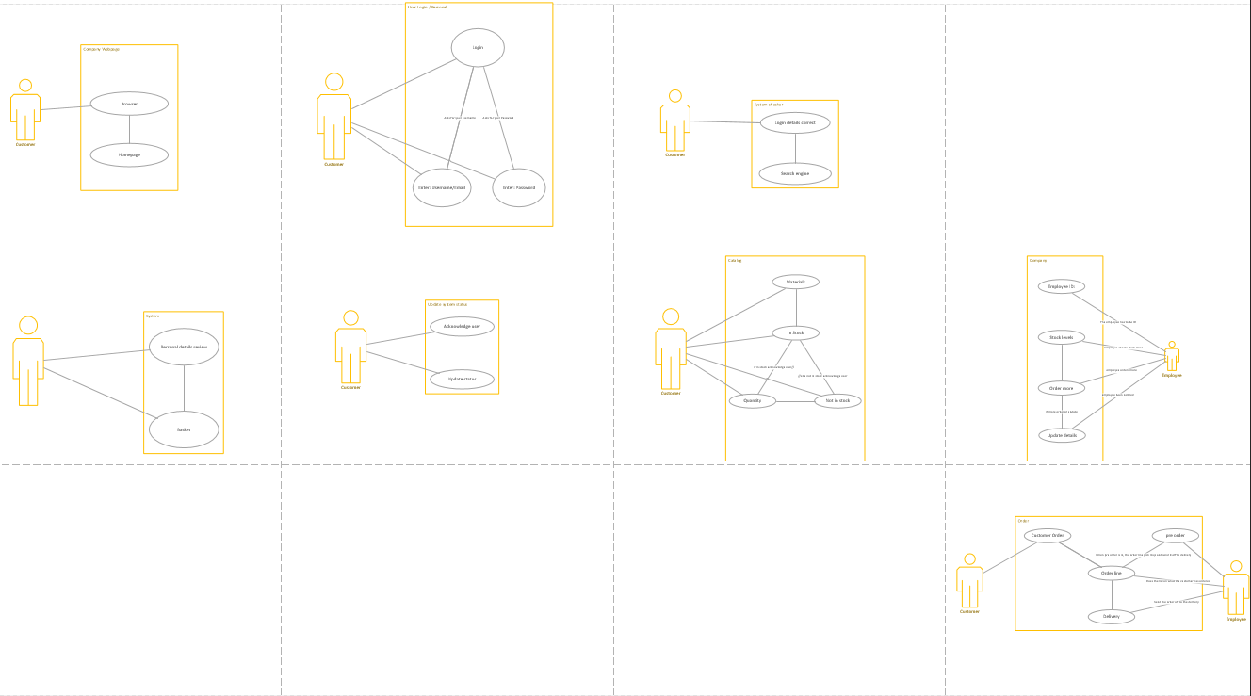
Figure 2 - Use Case
This diagram shows what a Use Case is as it all on separate pages doing different jobs. Each of the diagrams are giving an instruction of what it would do in order.

What is Sequence Class in UML?
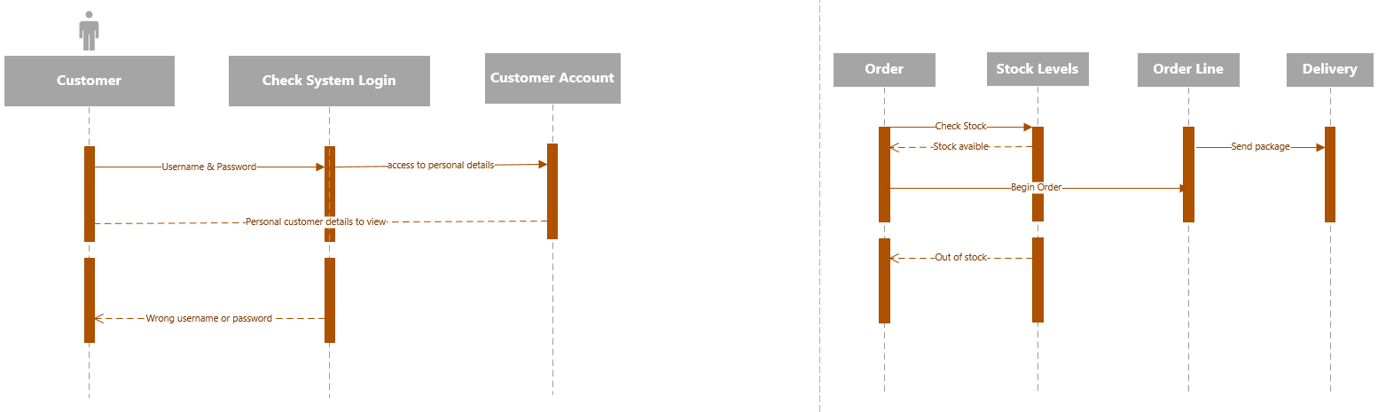
Sequence diagram is a dynamic model in UML, as it acts in lines to lines. An ATM for an example would use Sequence as it an easy diagram to explain the basic way of how it does its job, the way it works as simultaneously and message that being exchanged between them. Sequence diagram is described “how groups of objects collaborate in some behaviour. The UML defines several forms of interaction diagram” [5].
Figure 3 - Sequence Diagram

Here is the Sequence diagram that has two different jobs, one it the customer login and the other is the Order. This is showing how the communication between customer and ordering product works. Which shows how the top set of activation in the sequence diagram is how everything should happen in order, as for the bottom activation only happens if there a problem like for an example – “out of stock”.

What is Activity Diagram in UML?
An activity diagram is very familiar to a flow chart. The activity uses the same commands such as: square for comments, diamond shape for decisions round shape as nodes and lines/arrows to join it up. The only difference is that it can be more than one on the same page that are not connected as this can be different classes. The “purposes of a activity diagrams is similar to other four diagrams. It captures the dynamic behaviour of the system” [6].
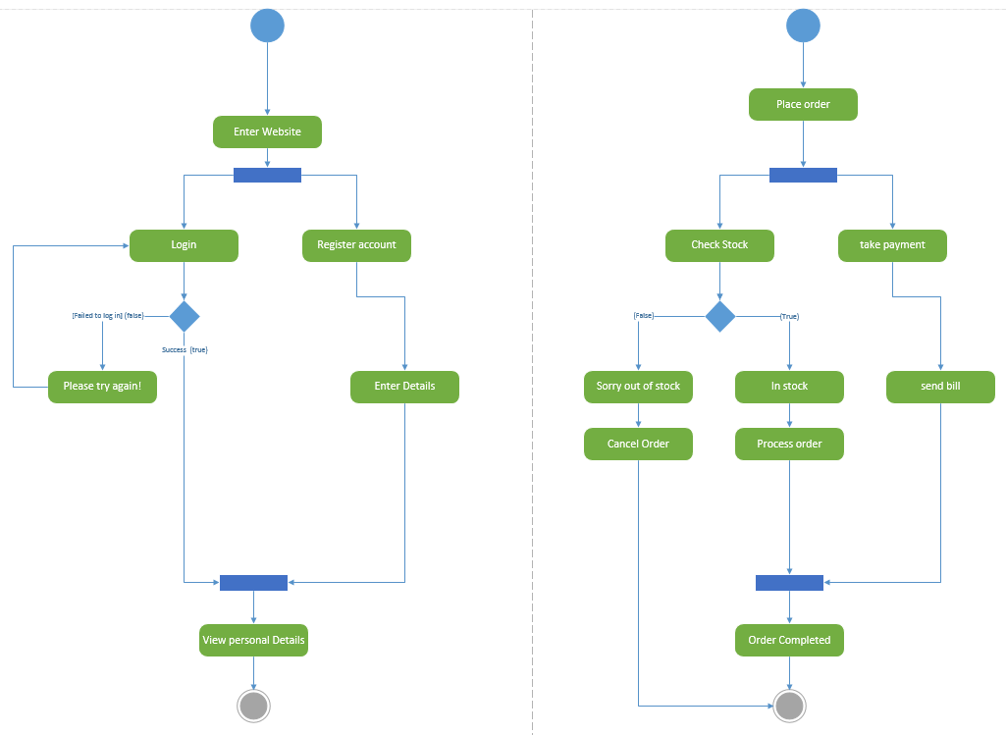
Figure 4 - Activity Diagram
On the first page it shows the “login and register section”, this shows how the actions take place in the system in order to complete task. In the other page that shows a different activity diagram working with more variables, the action in this three paths which does three different jobs. As the “take payment” does one part of the job and then stops at the “join node” to wait for the order to be completed, if the order isn’t completed the payment doesn’t go through as this shows on the diagram how the “in stock and out of stock” communicates.

Section 1: What is the project all about?

Project Definition
The purpose of the programming is developing a simulation manufacturing system to help customers with login/register and ordering the product, and the employees with the stock management and order line. There are some positive sides of the project that helps both parties, this makes it easier to work around and operate. But there are also negative sides about this project, the project could operate for people who have a good understanding of this project but there are others who might need some training to operate this project. This could become expensive to train people.

Objectives
- This project is about creating a simulation of manufacturing system to help customers order and to help employees how to manage stock.
- Allow customers create an account and login to place an order from the catalogue or the customer can view the catalogue without ordering anything.
- The employee that able to monitor the stock management and keep track of what is being ordered by the customer.
- If a payment is made the employee can start off with the order line to deliver the customers product.

Scope

The project of this simulation is about designing a software in programming to create classes in c++, this would make a stock exchange and orders to create for customers. This will make an employee’s job easier to monitor and to do business for the company. The program will not do payments as this isn’t feasible with the time.

Deliverables
The add-ons for this project are:

- Documentation
- Guide/manual – how to work the system
- The system itself
- Training

Constraints
- Lack of programming experience
- Slow experience time consuming
- Unfinished
- Possible delays
- Finance

Assumption
- Lab access
- Library access
- Lecture available
- Software available

Section 2: Business Case

Benefits
- Help stock management
- Employee free time
- Quick for customer
- Integrated system

Options
- Payment system
- Repeat order system
- Delivery scheduling

Cost
- £400 - £600 computer desktop system [7].

Risks and Analysis
- Data loss
- Illness
- Natural disaster
- Personal absent
- Company closing down
- Lack of currency
- Software failure

Risk Prevention
- Back data up
- Working on a laptop instead of desktop in case power cut etc…
- Save work on different drives e.g. – pen drive
- Working at home instead of university

Risk Management
- Software failure on server
- No internet

Risk Monitoring
- Check backups work
- Update saved work on pen drive
- Check if the computer is still in stock

Quality Control
- Make accounts
- Delete accounts
- Check if stock management works
- Check if stock management sold out
- Check if basket works
- Check if add and remove item from basket works
- Check if order works by buying

Conclusion
In the writing report that contains a document on a project in programming a simulation for manufacturing system. This talks about the different diagrams and what their purpose are and do, there is also a details project specification about the proposed system from what this document is letting the user know what this project is about and the risks are and how to deal with the risks, there is also a limit to resources which explains through a guide/manual for the user.

References

[1] | M. Fowler, “UML Distilled Third Edition,” in What is UML?, Boston, MA 02116, 2007, p. 1.
[2] | “UML Class Diagram Tutorial,” Lucidchart, 2018. [Online]. Available: https://www.lucidchart.com/pages/uml-class-diagram. [Accessed 28 March 2018].
[3] | M. Rouse, “use case diagram (UML use case diagram),” WhatIs.com, Janurary 2015. [Online]. Available: http://whatis.techtarget.com/definition/use-case-diagram. [Accessed 28 March 2018].
[4] | M. Fowler, “UML Distilled Third Edition,” in Use Case, Boston, MA 02116, 2007, p. 99.
[5] | M. Folwer, “UML Distilled Third Edition,” in Sequence Disgrams, Boston, MA 02116, 2007, p. 53.
[6] | “UML - Activity Diagrams,” tutorialspoint, [Online]. Available: https://www.tutorialspoint.com/uml/uml_activity_diagram.htm. [Accessed 4 April 2018].
[7] | “DELL Inspiron 3268 Desktop PC,” Currys adn PC World, [Online]. Available: https://www.currys.co.uk/gbuk/computing/desktop-pcs/desktop-pcs/dell-inspiron-3268-desktop-pc-10164878-pdt.html. [Accessed 4 April 2018].

Appendix
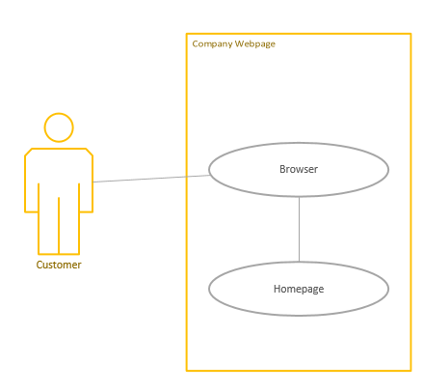
Figure 5 - Company Webpage
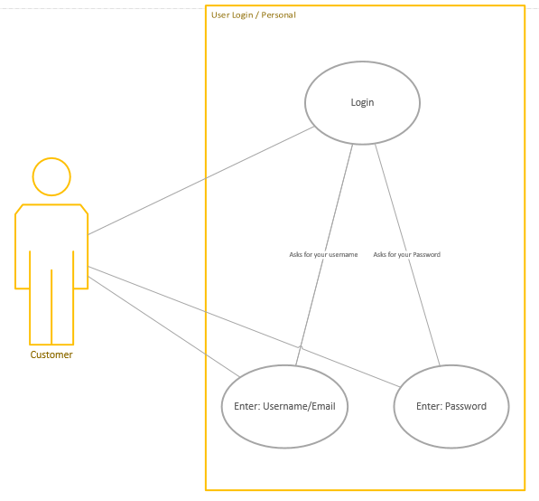
Figure 6 - User Login

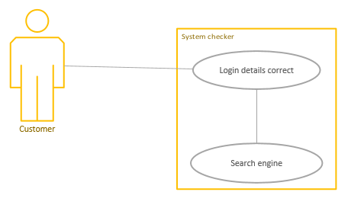
Figure 7 - System Checker

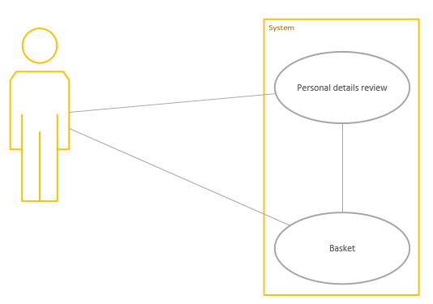
Figure 8 - System
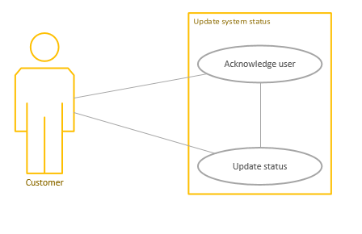
Figure 9 - Update System Status
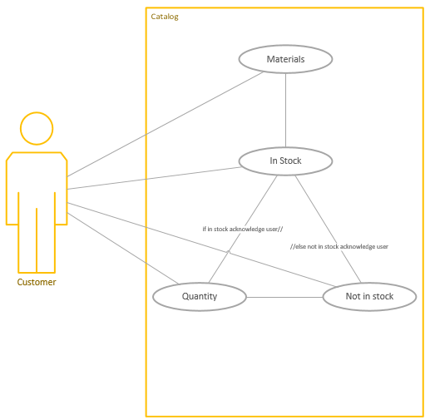
Figure 10 - Catalog

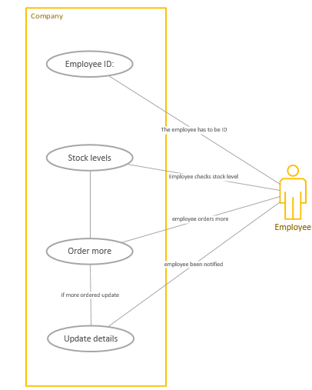
Figure 11 - Company

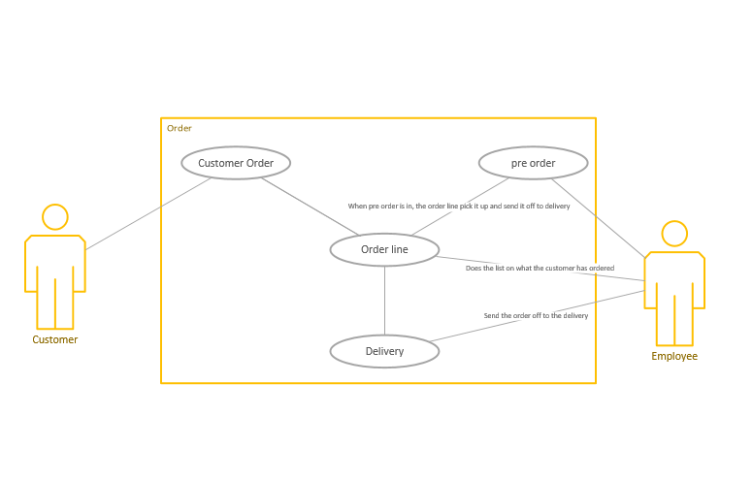
Figure 12 - Order

Code

Main source.cpp
#include <stdio.h>
#include <iostream>
#include <fstream>
#include <stdlib.h>

#include "Transistor.h"
#include "Capacitor.h"
#include "Component.h"
#include "Customer.h"
#include "Diode.h"
#include "Resistor.h"
#include "Register.h"
#include "Materials.h"
#include "Inductor.h"
#include "Quantity.h"
#include "Stocklevels.h"
#include "User.h"

using namespace std;
using std::cout;
using std::cin;
using std::endl;

int main() //
{
Register *registername = new Register();
registername->registerUser();

Capacitor *capacitorname = new Capacitor();
capacitorname->orderCapacitor();

Resistor *resistorname = new Resistor();
resistorname->orderResistor();

Transistor *transistorname = new Transistor();
transistorname->orderTransistor();

Diode *diodename = new Diode();
diodename->orderDiode();

Inductor *inductorname = new Inductor();
inductorname->orderInductor();

/*Quantity quantityname;
quantityname.printOrder(); //the problem lies here with the new program on "Quanitiy/h"//*/

cout << "\nYour Capacitor order:\n" << capacitorname->number;

cout << "\nYour Resistor order:\n" << resistorname->number;

cout << "\nYour Transistororder:\n" << transistorname->number;

cout << "\nYour Diode order:\n" << diodename->number;

cout << "\nYour Inductor order:\n" << inductorname->number <<"\n";

system("pause");
return 0;
}

Register.h

#include <iostream>
#include <string>

using namespace std;

class Register {
public:
void registerUser() {

string username = "";
string password = "";
bool loginsuccess = false;

cout << "\tWelcome! Please login. \n\n";

do {

cout << "Enter Username: ";
cin >> username;
cout << "Enter Password: ";
cin >> password;

if (username == "Name" && password == "123456") {

cout << "\nWelcome!\n\n";
loginsuccess = true;
}
else {

cout << "Access Denied \n";
cout << "\tPlease try again!\n\n";
}

} while (!loginsuccess);

}

Capacitor.cpp
#include "Capacitor.h"

Capacitor::Capacitor()
{
number = 0;
}

void Capacitor::orderCapacitor() {

number = 0;
int inventory = 1000;

bool Units = false;

do {

cout << "\namount of capacitor: ";
cin >> number;

if (number <= inventory) {

cout << "Ok\n\n";
Units = true;
inventory = inventory - number;

}
else {

cout << "Not enough in stock \n";
cout << "\tThis amount:\t" << inventory;
}

} while (!Units);

}

Capacitor.h
#pragma once

#include <iostream>

using namespace std;

class Capacitor
{
public:

int number;

Capacitor();

void orderCapacitor();

};

Resistor.cpp
#include "Resistor.h"

Resistor::Resistor()
{
number = 0;
}

void Resistor::orderResistor() {

number = 0;
int inventory = 1500;

bool Units = false;

do {

cout << "\namount of resistor: ";
cin >> number;

if (number <= inventory) {

cout << "Ok\n\n";
Units = true;
inventory = inventory - number;

}
else {

cout << "Not enough in stock \n";
cout << "\tThis amount:\t" << inventory;
}

} while (!Units);

}

Resistor.h
#pragma once

#include <iostream>

using namespace std;

class Resistor
{
public:

int number;

Resistor();

void orderResistor();

};

Transistor.cpp
#include "Transistor.h"

Transistor::Transistor()
{
number = 0;
}

void Transistor::orderTransistor() {

number = 0;
int inventory = 2250;

bool Units = false;

do {

cout << "\namount of transistor: ";
cin >> number;

if (number <= inventory) {

cout << "Ok\n\n";
Units = true;
inventory = inventory - number;

}
else {

cout << "Not enough in stock \n";
cout << "\tThis amount:\t" << inventory;
}

} while (!Units);

}

Transistor.h
#pragma once

#include <iostream>

using namespace std;

class Transistor
{
public:

int number;

Transistor();

void orderTransistor();

};

Diode.cpp
#include "Diode.h"

Diode::Diode()
{
number = 0;
}

void Diode::orderDiode() {

number = 0;
int inventory = 500;

bool Units = false;

do {

cout << "\namount of diode: ";
cin >> number;

if (number <= inventory) {

cout << "Ok\n\n";
Units = true;
inventory = inventory - number;

}
else {

cout << "Not enough in stock \n";
cout << "\tThis amount:\t" << inventory;
}

} while (!Units);

}

Diode.h
#pragma once

#include <iostream>

using namespace std;

class Diode
{
public:

int number;

Diode();

void orderDiode();

};

Inductor.cpp
#include "Inductor.h"

Inductor::Inductor()
{
number = 0;
}

void Inductor::orderInductor() {

number = 0;
int inventory = 3050;

bool Units = false;

do {

cout << "\namount of inductor: ";
cin >> number;

if (number <= inventory) {

cout << "Ok\n\n";
Units = true;
inventory = inventory - number;

}
else {

cout << "Not enough in stock \n";
cout << "\tThis amount:\t" << inventory;
}

} while (!Units);

}

Inductor.h
#pragma once

#include <iostream>

using namespace std;

class Inductor
{
public:

int number;

Inductor();

void orderInductor();

};

