

MSc Data Science

Data Mining & Visualisation

Student Number: 2006796

Student Name: Hao Ke

May,2021

Contents
1. Introduction 2
2. Dataset 3
3. Data Pre-Processing 5
3.1 Removal of inappropriate attributes 5
3.2 Replacing the attribute content 5
3.3 Change the content of the data without changing the meaning 8
3.4 Creating new attributes column 9
3.5 Creating the ARFF file for Weka 11
4. Data Visualisation in Weka 13
5. Data Analysis 14
5.1 The classification and prediction in train set 15
5.1.1 Question 1- Can data mining be used to find out what is the relationship between various attributes and house prices? 17
5.1.2 Question 2- Can data mining be used to find out what is the relationship between various property attributes and house area? 19
5.2 The classification and prediction in test set 21
6. Reflection 23
7. Reference List 24

1. Introduction
The purpose of this report is to analyse the dataset of house prices in India and to perform categorization and forecasting. The dataset needs to be pre-processed before being imported into Weka. After the import is successful, the data set can be previewed, and various classification methods can be used to create the model and get the classification results. The present questions related to the content of the dataset attempt to be answered using a different model. Any significant findings will then be discussed and reported, and finally a conclusion will be drawn on the whole process.

2. Dataset
The dataset used in this project is "Housing Price Forecasting Challenge" which is published by Devrup Banerjee on Kaggle in 2020. This dataset has been collected across various property aggregators across India [1]. Those who provided data included owners, dealers and builders.
The dataset is divided into test set and train set. The train set contains 29,451 pieces of data and 12 attributes, while the test set contains 68,720 pieces of data and 11 attributes [2]. All attributes will be used for analysis. The train set has one more housing price attribute (PRICE_IN_LACS) than the test set. The identity of the data provider (POSTED_BY) is also an attribute and other common attributes of the test set. The detailed description of the attributes is shown in the following Table 1.
Table 1 Attribute Description
Attribute | Description
POSTED_BY | Category marking who has listed the property
UNDER_CONSTRUCTION | Under Construction or Not
RERA | Rera approved or Not
BHK_NO | Number of Rooms
BHKORRK | Type of property
SQUARE_FT | Total area of the house in square feet
READYTOMOVE | Category marking Ready to move or Not
RESALE | Category marking Resale or not
ADDRESS | Address of the property
LONGITUDE | Longitude of the property
LATITUDE | Latitude of the property
PRICE_IN_LACS | House prices in India (Need to be predicted)
According to Kaggle, the purpose of this dataset is to predict house prices in India as accurately as possible. There may have other factors besides the size of a house that determine the price of a house/property, so it is necessary to find out the correlation between the various attributes.
The file names of the experiments are ‘train.csv ‘and ‘test.csv’. The size of the dataset and the number of attributes is appropriate for data analysis, and the dataset used for modelling does not include mismatches and missing values. Because it is impossible to accurately predict the accurate housing price and the test set does not contain the price attribute, it is necessary to classify the price attribute and the housing area attribute in advance, so that the prediction analysis can be carried out according to the attribute types of different documents. In summary, the data set needs to be pre-processed so that it can be loaded into Weka to facilitate experiments.
The original train dataset and test dataset are shown in Figure 1 and Figure 2.
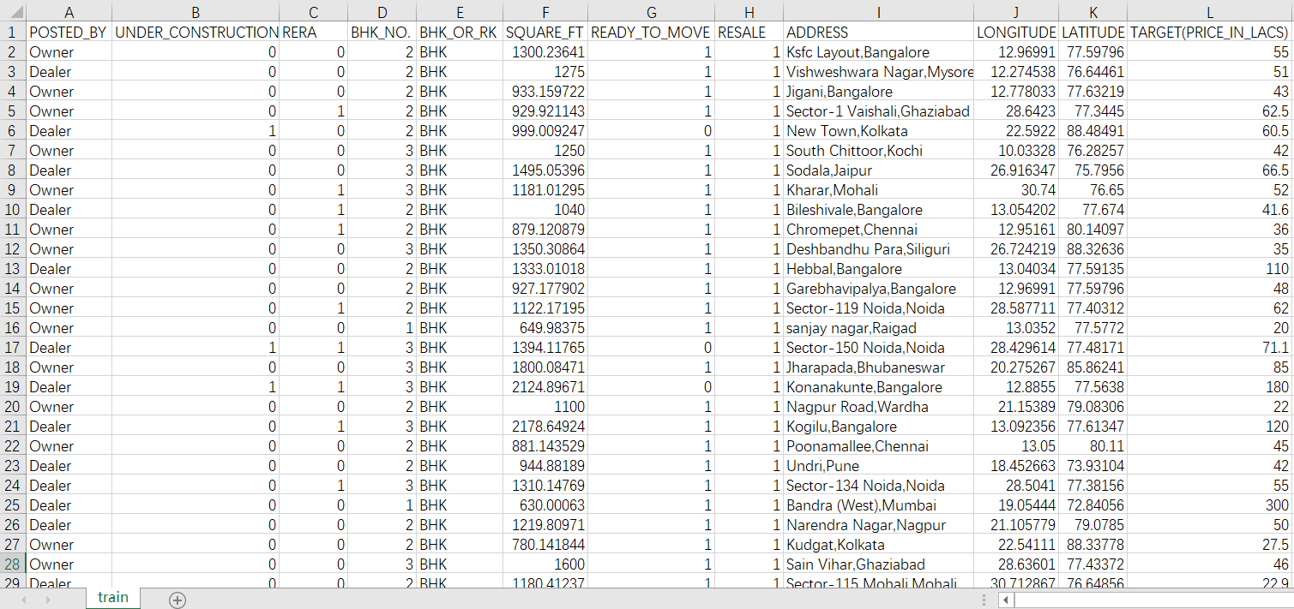
Figure 1 The ‘train’ CSV file
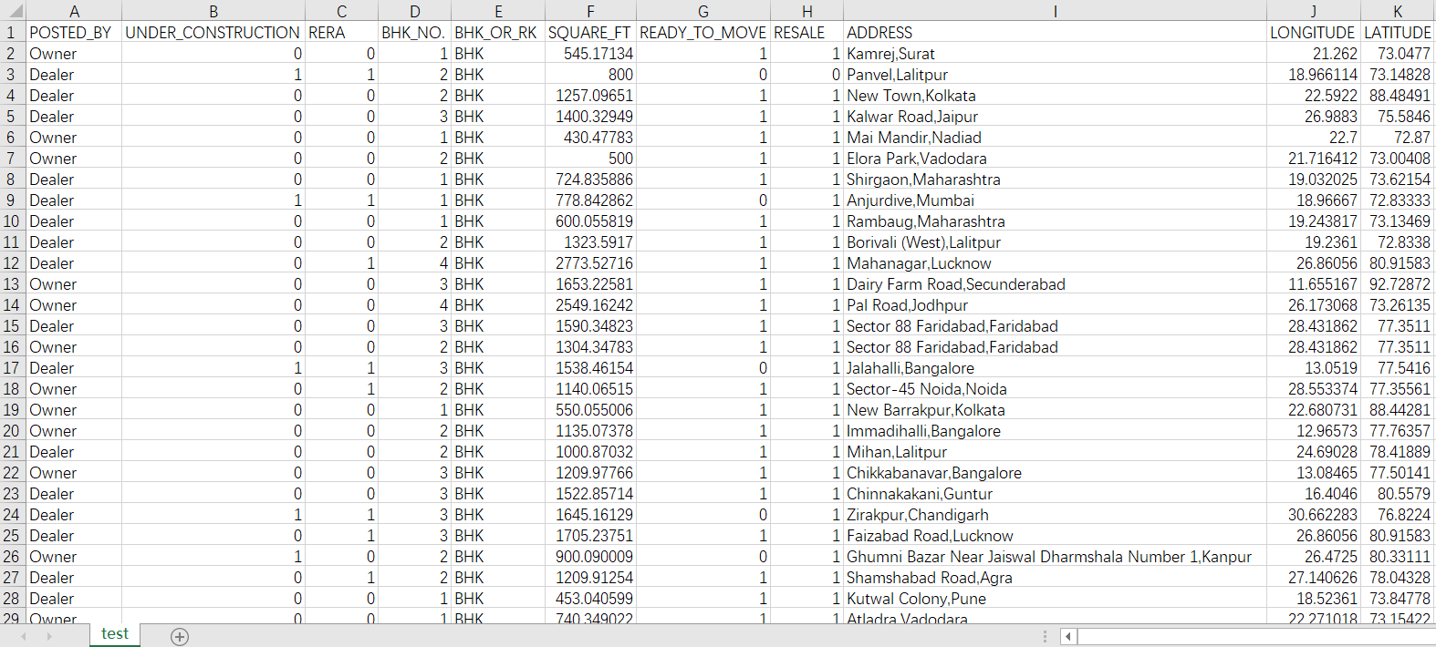
Figure 2 The ‘test’ CSV file

3. Data Pre-Processing

3.1 Removal of inappropriate attributes
After observation, there are many wrong data of longitude and latitude in the data set, and some data indicate that the location is not in India. Compared with other attributes, latitude and longitude are not important, because if experimentation needs location information, keeping the address attribute is enough. The examples and reasons for deleting attributes are shown in Table 2.
Table 2 The deleted attributes
Attribute | Example Data | Reason
LONGITUDE | -38.391261 | A lot of non-compliant data, for example, longitude cannot be negative
LATITUDE | -118.3541 | A lot of non-compliant data, for example, longitude cannot be negative
The dataset after removing the inappropriate attributes in Excel is shown in the figure 3.
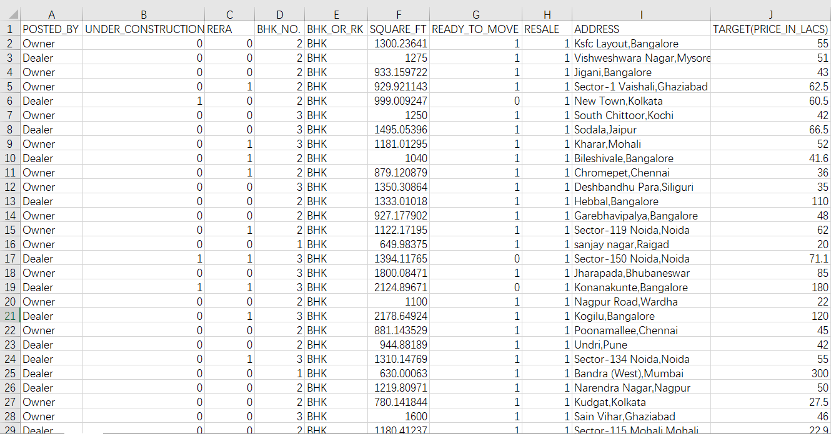
Figure 3 The dataset with inappropriate attributes removed

3.2 Replacing the attribute content
When I imported the data into Weka, I found that the Address attribute value could not be displayed (Details shown in Figure 4). After browsing the original data, I found that the Address attribute included street, building name, block number and city at the end, for example, Electronics City Phase 1, Bangalore. I think the city is relatively the most important information, and keeping it alone is more helpful for experimental analysis, so I used the tool of Excel to divide the data and finally only retained the city information.
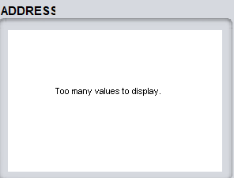
Figure 4 The display of Address (1)
First replace ",," with ", "with "," using the Find and Replace tool, otherwise the import into Weka will fail because the data cannot begin with a comma. Specific operation is shown in the figure 5. Then I need to use the Convert Text to Columns tool to split the Address data. The operation process is shown in Figure 6. The dataset after removing the columns that are not needed after the split is shown in the figure 7. I use city data replace the address data, After I replace the address data with the city data, Weka displays the address data.
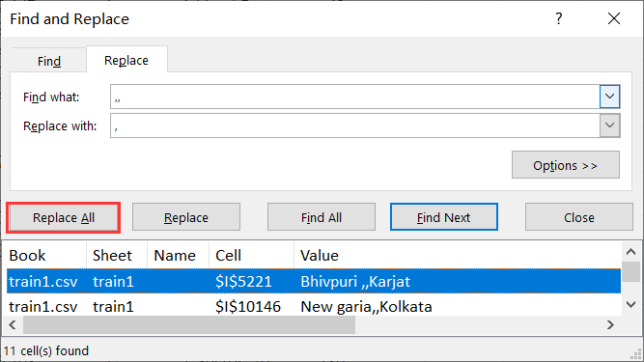
Figure 5 Find and Replace
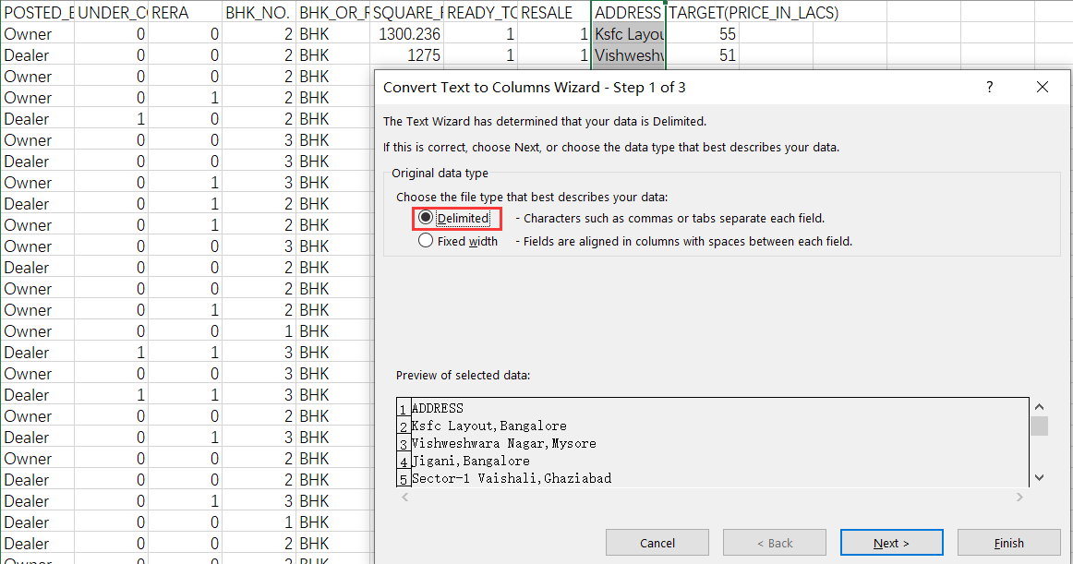
Convert Text to Columns (a)
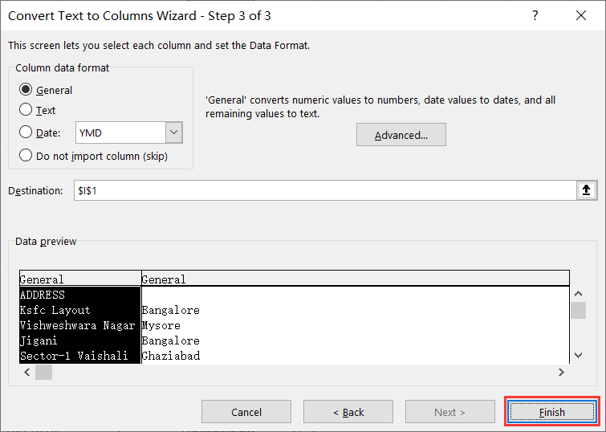
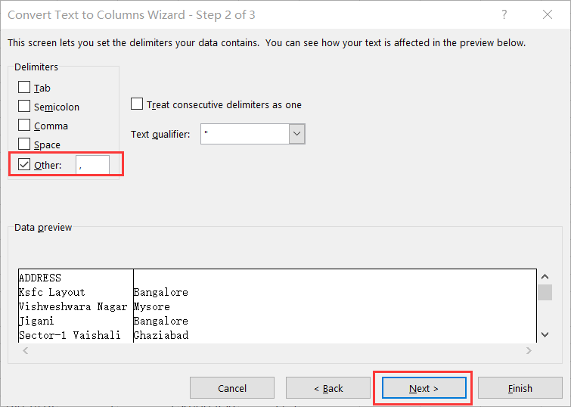
Convert Text to Columns (b) Convert Text to Columns (c)
Figure 6 Convert Text to Columns
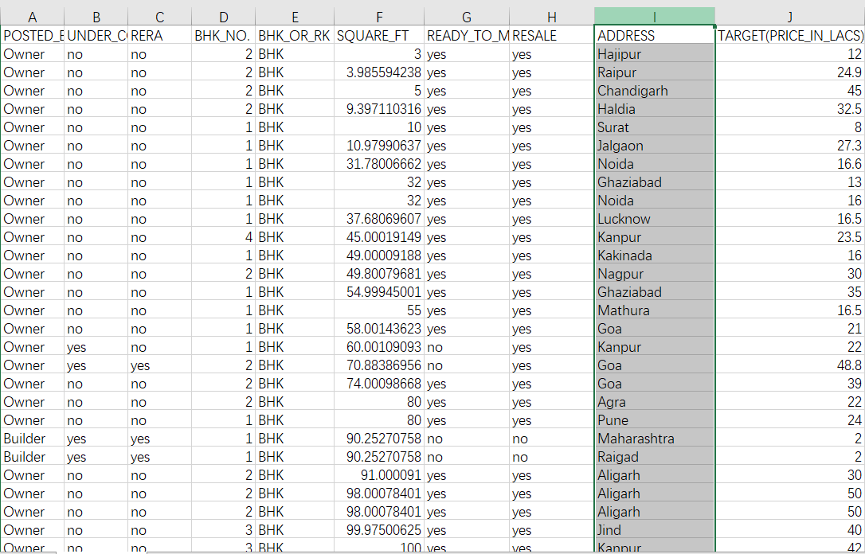
Figure 7 Preserving the address attributes of the city data
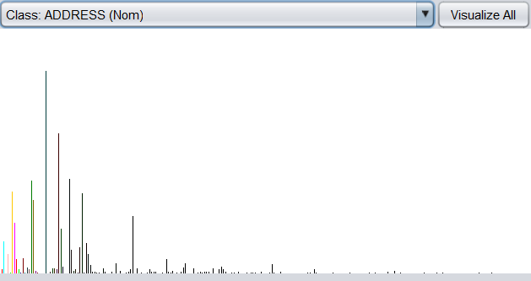
Figure 8 The display of Address (2)

3.3 Change the content of the data without changing the meaning
When importing the Weka preview data, I found that it was easy for Weka to automatically recognize the data as numeric if the data content was 0 or 1, but I wanted a data type that I could classify. Therefore, I want replace 0 with no and replace 1 with yes and such replacement do not change the meaning of the data. The contents of the "UNDER_CONSTRUCTION", "RERA", "READY_TO_MOVE" and "RESALE" columns in the dataset are all 0 or 1. I use the Find and Replace tool in Excel to replace the content. Take the replacement of 0 with no as an example, the specific operation is shown in the figure 9 and the dataset is shown in figure 10.
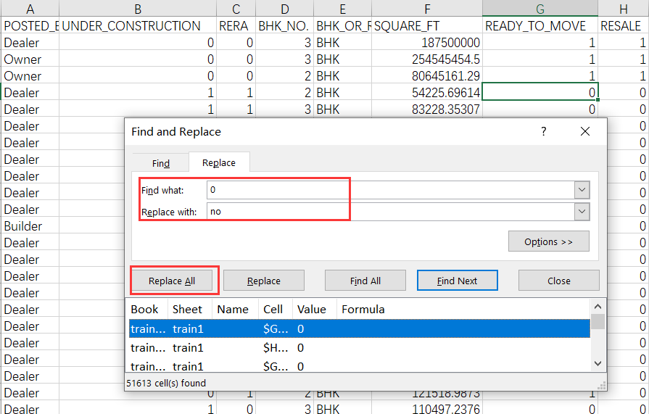
Figure 9 Replacing 0 with no
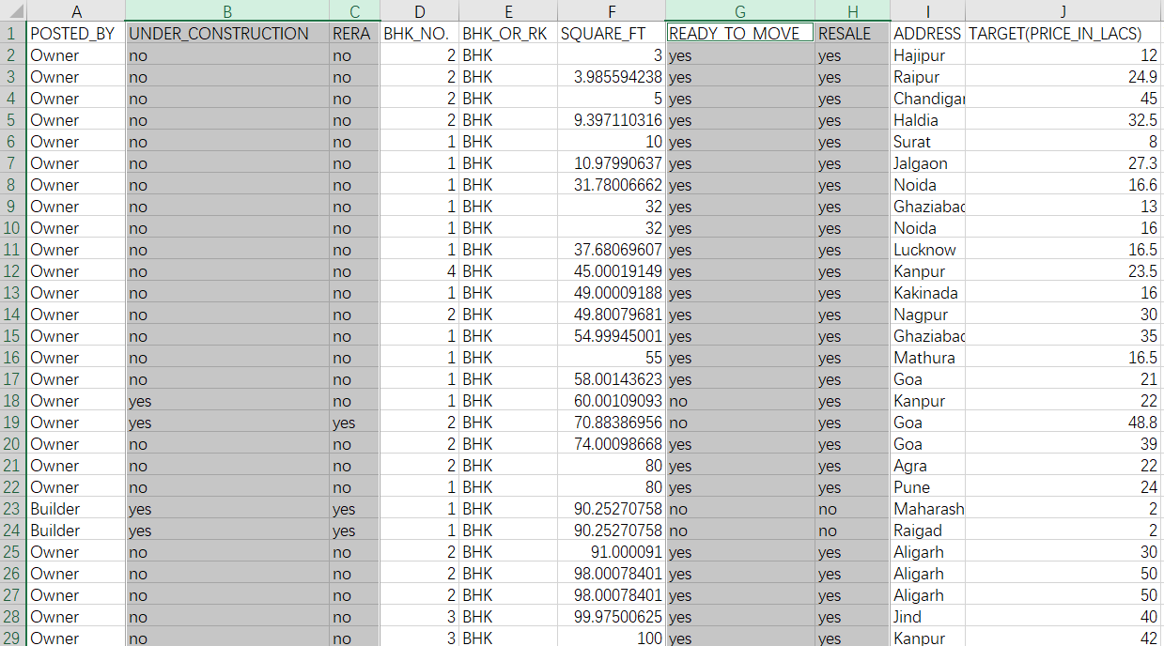
Figure 10 The dataset with four column data contents changed

3.4 Creating new attributes column
Because it is difficult to accurately predict the house price, I want to divide the house price into five classes: very low, low, middle, high, very high and create a new attribute named “THE LEVEL OF PRICE” for this.
By sorting the house prices (The sorting used in Excel is shown in the figure 11, I first tried to count the house prices according to the number of digits in the data and the price is preliminarily divided into five classes: one-digit, double-digit, three-digit, four-digit and five-digit. Then I use the COUNTIF function to count the total number of digits at different price and the number of each class is shown in Figure 12.
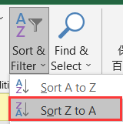
Figure 11 Sort house price
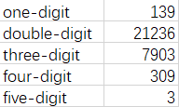
Figure 12 Preliminary price classification of the train set
Obviously, the two-digit data accounted for the largest proportion, so I considered using the median or average of the two-digit data to divide the two-digit data into two part. First, I use Median function and average function in Excel to calculate median and average and the result is 49.7 and 69.05056 respectively. When using the average value to divide the interval (COUNTIF function is also used to count the number of categories.), the data is divided into 14,591 and 6,645 pieces. The median divides the data equally into 10,681 numbers per segment. I think it's more scientific to use the median to divide the data because the data is more evenly distributed, so I use the median to divide the interval. The results of data division are shown in Table 3.
Table 3 The count of price label
Label | Count
very low | 139
low | 10618
middle | 10618
high | 7764
very high | 312
Then use the IF function in Excel and according the basis of division to fill the data of “THE LEVEL OF PRICE”. The dataset with the new attribute, THE LEVEL OF PRICE, has been added as shown in the figure 13.
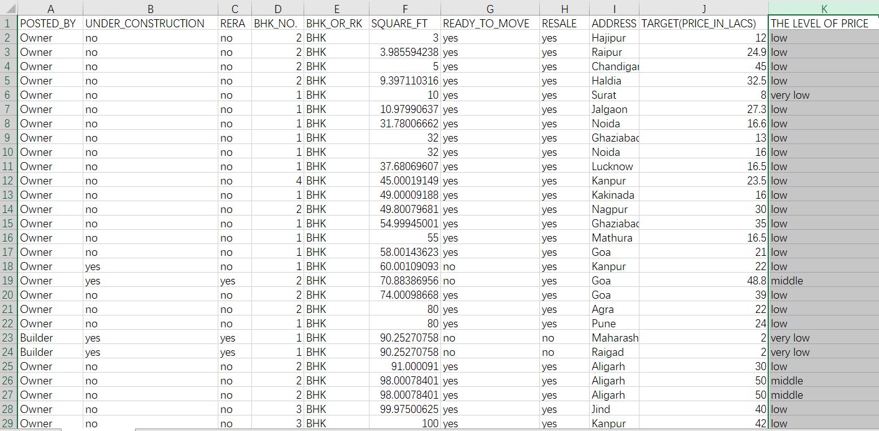
Figure 13 The dataset with “THE LEVEL OF PRICE”
Considering that the test set data does not have accurate housing price data, I would like to use house size (SQUARE_FT) as a classification basis as well. I try to divide the house size data with the method of dividing the price category data and create a new attribute named “THE LEVEL OF SQUARE” which has five class: very small, small, middle, big, very big. First, divide the data into categories according to the number of data, then calculate the median and average, and use them to divide the largest part. The intermediate process of the method is shown in Figure 14. Finally, I merge some types of data and finally get five types of data and the final partition result according to the median number and average number are shown in table 4 and table 5 respectively. Because the amount of data divided by the two methods is relatively balanced, the results are retained named “THE LEVEL OF SQUARE1” and “THE LEVEL OF SQUARE2” respectively. Then the better classification method of “SQUARE_FT” was selected through experiments in Weka.
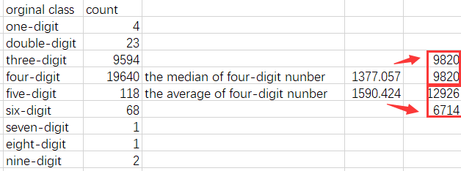
Figure 14 The intermediate process of the method
Table 4 The count of “THE LEVEL OF SQUARE1”
Label | Count
very small | 27
small | 9594
middle | 9820
big | 9820
very big | 190
Table 5 The count of “THE LEVEL OF SQUARE2”
Label | Count
very small | 27
small | 9594
middle | 12926
big | 6714
very big | 190
After using the IF function in Excel, the data of “THE LEVEL OF SQUARE1” and “THE LEVEL OF SQUARE2” are both filled. The dataset with “THE LEVEL OF SQUARE1” and “THE LEVEL OF SQUARE2” are shown in figure 15.
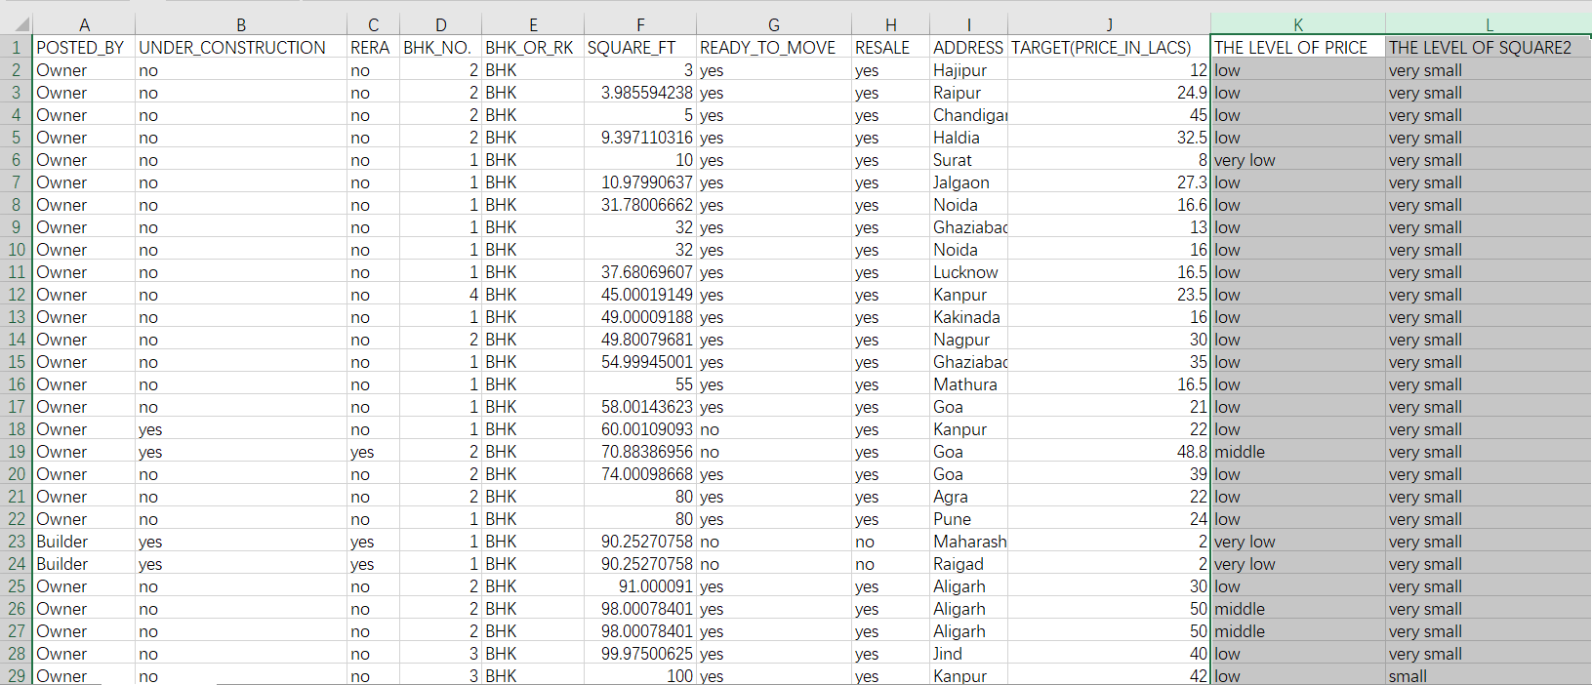
Figure 15 The dataset with “THE LEVEL OF SQUARE1” and “THE LEVEL OF SQUARE2”

3.5 Creating the ARFF file for Weka
After data pre-processing is completed, use Weka to open the CSV file and save the file as an ARFF format file. I can see the header section for the file in Editplus:
@relation homework
@attribute POSTED_BY {Owner,Dealer,Builder}
@attribute UNDER_CONSTRUCTION {no,yes}
@attribute RERA {no,yes}
@attribute BHK_NO. {1,2,3,4,5,6,7,8,9,10,11,12,13,15,17,20}
@attribute BHK_OR_RK {BHK,RK}
@attribute SQUARE_FT numeric
@attribute READY_TO_MOVE {yes,no}
@attribute RESALE {yes,no}
@attribute ADDRESS {Bhubaneswar,Coimbatore,Bangalore,Hosur,Vadodara,Aurangabad,Maharashtra,Raigad,Rajkot …}(The city has a total of 432, omitted here)
@attribute LONGITUDE numeric
@attribute LATITUDE numeric
@attribute TARGET(PRICE_IN_LACS) numeric
@attribute 'THE LEVEL OF PRICE' {'very low',low,middle,high,'very high'}
@attribute 'THE LEVEL OF SQUARE1' {big,'very big',middle,small,'very small'}

4. Data Visualisation in Weka
The overview diagram after importing the data into Weka is shown in Figure 16. The city has too many classes and cannot be displayed in the overview diagram, but it can still be displayed separately in Weka as shown in Figure 17.
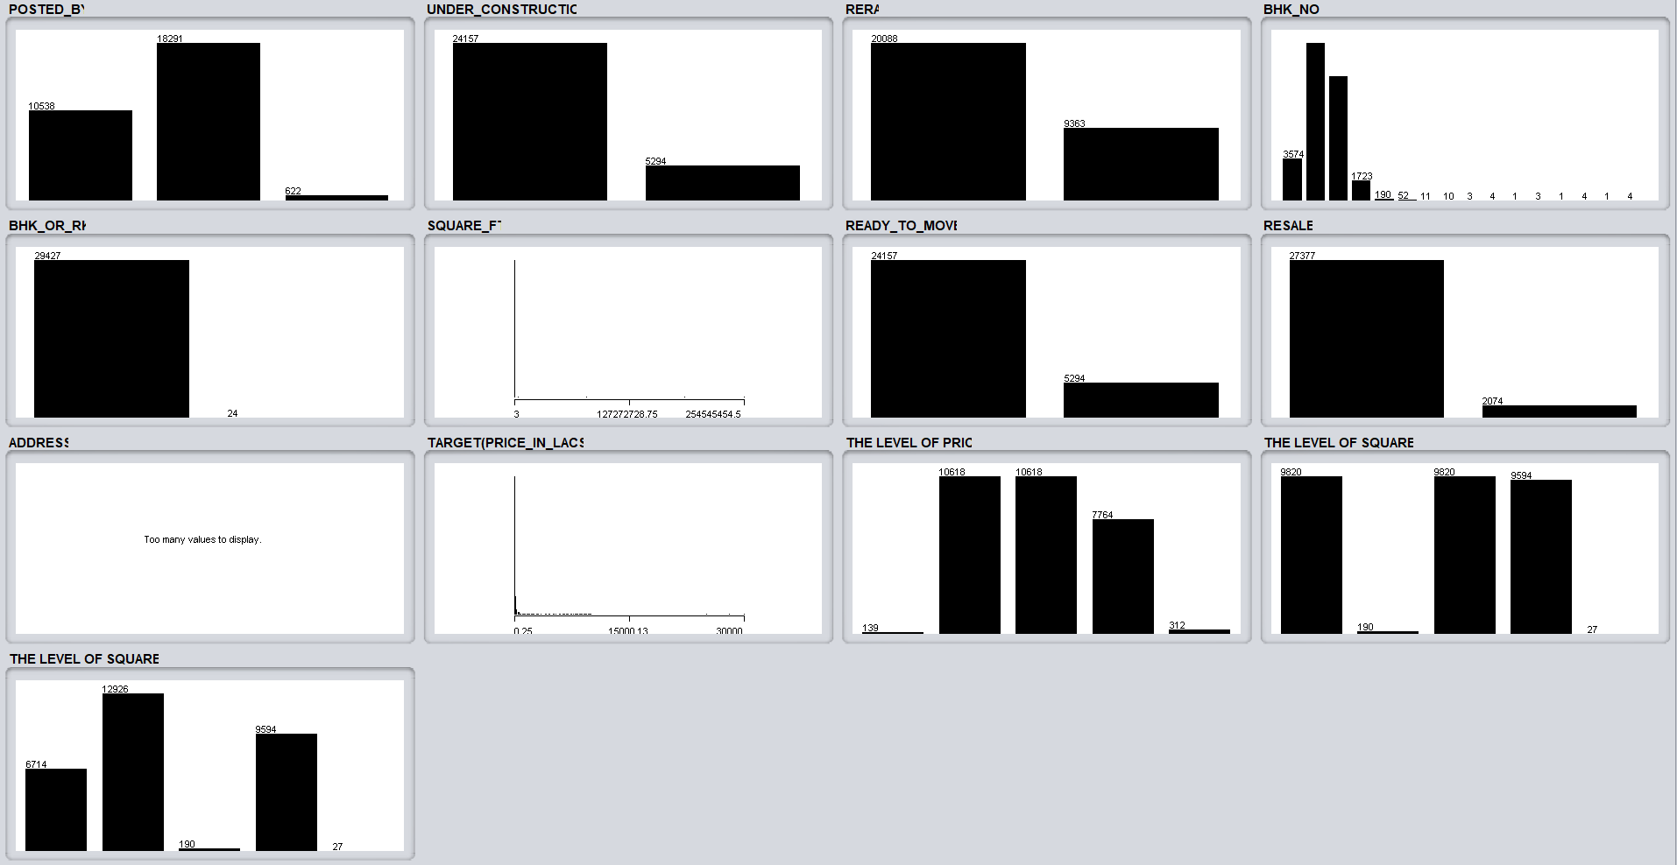
Figure 16 The visualisation of dataset in Weka (train set)
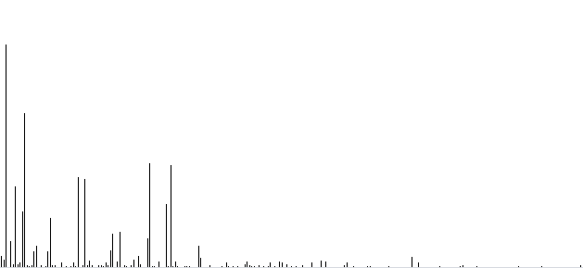
Figure 17 The display of Address (train set)
Roughly speaking, dealers provide the most data. Most houses have been built and have real estate certificates. Most houses have 2 rooms, and most houses are second-hand houses. These attributes all affect the final housing price. These conclusions are only superficial, if further analysis is needed, other tools or methods of classification and prediction in Weka may be needed.

5. Data Analysis
At first, I tried to use the model of the training set to predict the price of the test set, but I failed. If I choose “supplied set” in the test options block in Weka, there will remind me that the attributes of the train set are different from those of the test set, as shown in figure 18. Then I search the Internet for a solution, and the Internet said the same attribute should be added to the test set, with the value set to the missing value. I followed the solution and the modified test set is shown in figure 19. Then, I try to use RandomForest to do simple classification and prediction, but it doesn't work, as shown in figure 20. Therefore, it is more reasonable to use THE LEVEL OF SQUARE to classify the test set in this project and use both THE LEVEL OF PRICE and THE LEVEL OF SQUARE to classify the train set.
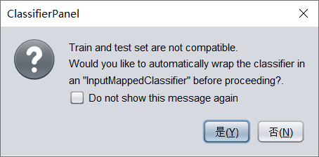
Figure 18 the prompt of Weka
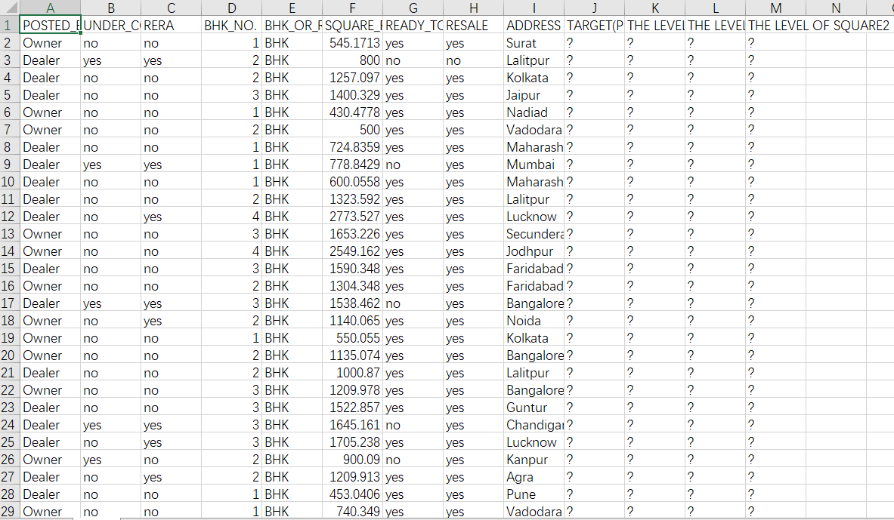
Figure 19 the test set filled with the same attributes as the train set
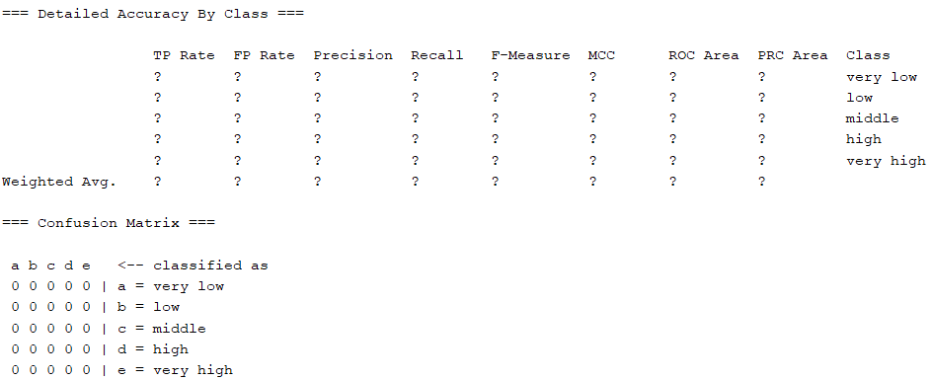
Figure 20 the result of using RandomForest

5.1 The classification and prediction in train set
When I first classified the data, the accuracy of either the J48 method or the RandomForest method was very high as shown in figure 20 and figure 21. But after looking at the Tree view as shown in figure 22, I found that because I did not delete the numeric attributes SQUARE_FT and TARGET(PRICE_IN_LACS). Because the content of THE LEVEL OF SQUARE and THE LEVEL OF PRICE based on the numeric attributes, so the classification algorithm can easily classify only based on them and other attributes had no effect on the classification results. In summary, I delete the attributes SQUARE_FT and TARGET(PRICE_IN_LACS) in train set and delete the SQUARE_FT in test set.
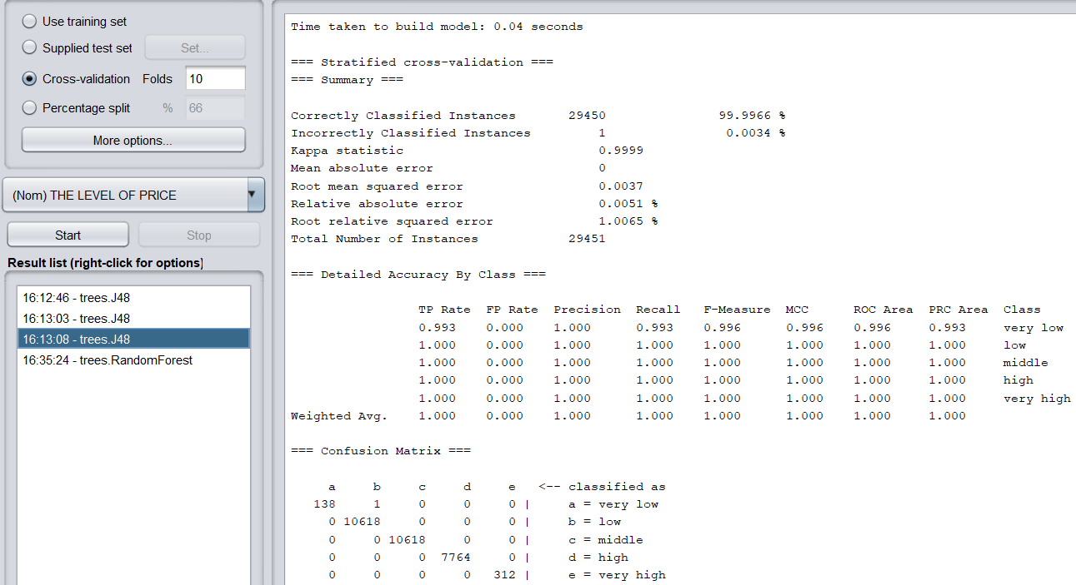
Figure 20 The result of J48
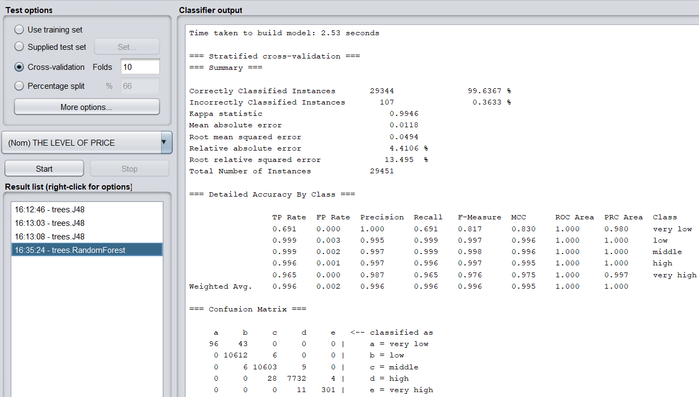
Figure 21 The result of RandomForest

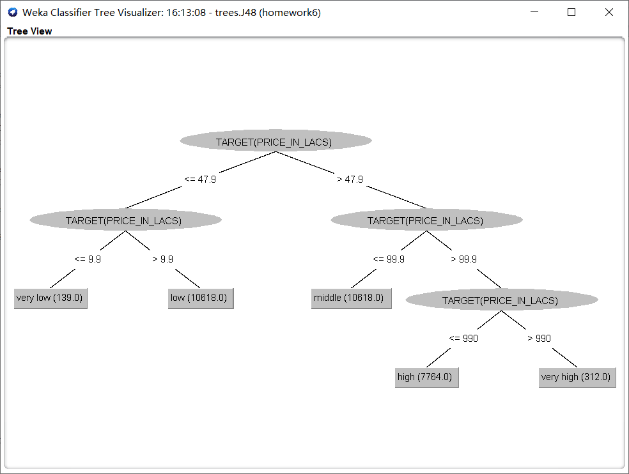
Figure 22 The Tree View of classification
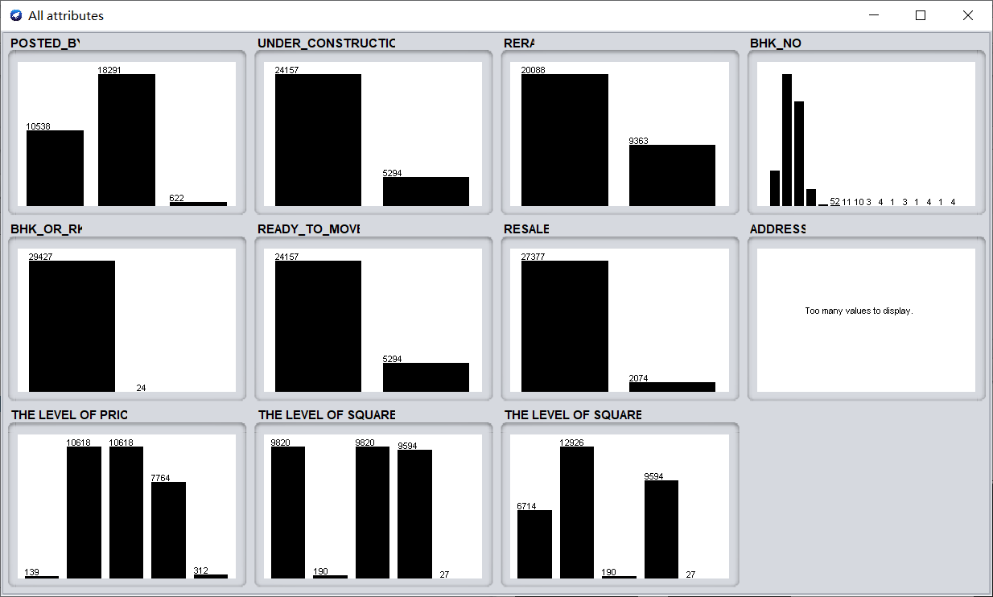
Figure 23 All attributes in train set
There are 2 questions to investigate the train set:
Table 6 questions in train set
Question | Tool
1. Can data mining be used to find out what is the relationship between various attributes and house prices in train set? | - RandomForest algorithm  - J48 algorithm
1. Can data mining be used to find out what is the relationship between various attributes and house area in train set? | - RandomForest algorithm  - J48 algorithm

5.1.1 Question 1- Can data mining be used to find out what is the relationship between various attributes and house prices?
I can use classification techniques to analyse the relationships between individual data in a data set. The core of this question is whether it is possible to use attributes other than THE LEVEL OF PRICE to classify the data set and then use the classification results and THE LEVEL OF PRICE to calculate the classification accuracy.
Since the training set contains 29541 pieces of data, percentage split can be used to split the data set.
(1) RandomForest algorithm
RandomForest [3] should be considered as a very simple but effective algorithm. Its core idea is to form a forest by training and combining different decision trees, and the final classification results are decided by voting among these trees.
The classification results of RandomForest algorithm with different percentage split is shown in table 7.
Table 7 The classification results of RandomForest algorithm (train set)
Percentage split | Correctly Classified Instances | Incorrectly Classified Instances
90% | 73.3107 % | 26.6893 %
75% | 73.095 % | 26.905 %
66% | 73.0001 % | 26.9999 %

(2)J48 algorithm
J48 is a decision tree algorithm based on C4.5 [4] and it uses divide and conquer methods.
I use the different percentage split and the classification results of J48 algorithm are shown in the table 7.
Table 8 The classification results of J48 algorithm (train set)
Percentage split | Correctly Classified Instances | Incorrectly Classified Instances
90% | 73.2428 % | 26.7572 %
75% | 72.9186 % | 27.0814 %
66% | 73.2548 % | 26.7452 %
In general, the result of J48 algorithm is better than randomForest algorithm. Therefore, I choose J48 algorithm to obtain better results by improving parameter values.
I want to improve the accuracy by changing the number of random seeds, but the effect after changing is not as good as when the seed is 1. The table 8 below shows the accuracy rates of different seed numbers when percentage split is 66%.
Table 9 The accuracy rates of different seed numbers (train set)
Seed | Correctly Classified Instances | Incorrectly Classified Instances
3 | 72.9452 % | 27.0548 %
2 | 73.1449 % | 26.8551 %
1 | 73.2548 % | 26.7452 %
There was little difference in the results under different parameters. The highest classification accuracy is the result of using the J48 algorithm when the percentage split is 90% and the random number seed is 1.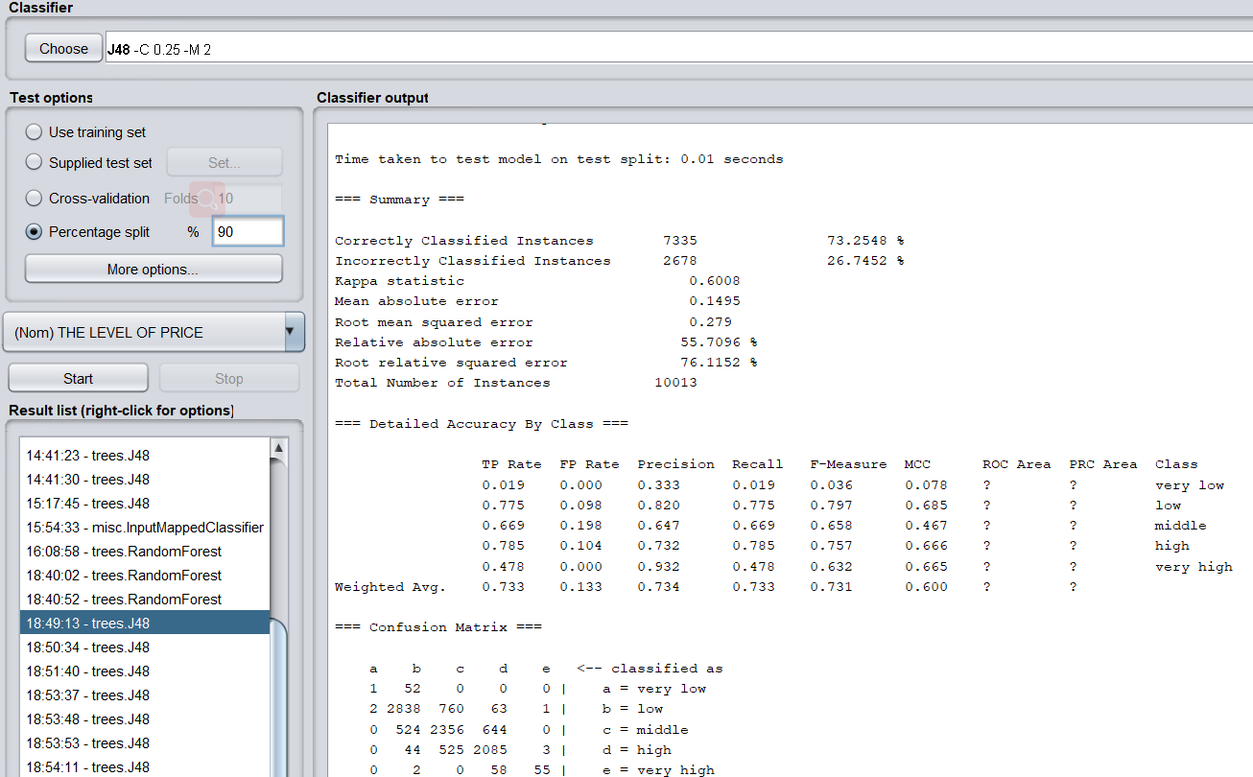
Figure 24 The result of using the J48 algorithm (percentage split is 90% and seed is 1)
As shown in Figure 24, the following conclusions can be drawn after analysing the confusion matrix:
- The highest classification accuracy rate is group b (2838), followed by group c (2356) and group d (2085). This shows that the model is better for classifying data that accounts for a relatively large data set.
- It is more difficult to classify data of a small number of “very low” and “very big” types. Data on extreme house prices are hard to predict.
According to the Tree Visualizer as shown in figure 25, the most relevant properties for price are THE LEVEL OF SQUARE, REAR, and UNDER_CONSTRUCTION.
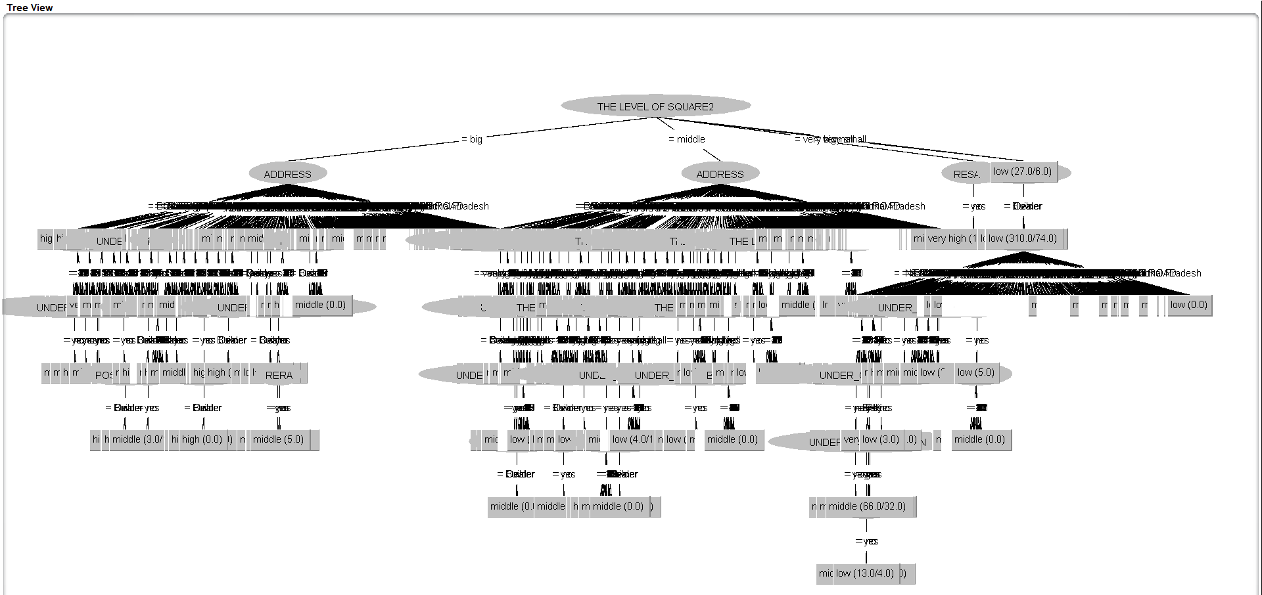
Figure 25 The Tree Visualizer of THE LEVEL OF PRICR

5.1.2 Question 2- Can data mining be used to find out what is the relationship between various property attributes and house area?
The house size category was based on the median and the average divided into two categories namely, THE LEVEL OF SQUARE1 and THE LEVEL OF SQUARE2.
(1) THE LEVEL OF SQUARE1
First, I use the RandomForest algorithm to calculate the classification result. I delete the attribute named THE LEVEL OF SQUARE2 to ensure the reliability of the classification result. I used RandomForest algorithm and J48 algorithm for classification respectively.
- RandomForest algorithm
The classification results of RandomForest algorithm with different percentage split is shown in table 10.
Table 10 The classification results of RandomForest algorithm (train set)
Percentage split | Correctly Classified Instances | Incorrectly Classified Instances
90% | 75.8234 % | 24.1766 %
75% | 75.472 % | 24.528 %
66% | 75.9912 % | 24.0088 %
In this case, the best percentage split with RandomForest algorithm is 66%, with an accuracy of 75.9912%.
- J48 algorithm
The classification results of J48 algorithm with different percentage split is shown in table 11.
Table 11 The classification results of J48 algorithm (train set)
Percentage split | Correctly Classified Instances | Incorrectly Classified Instances
90% | 75.5178 % | 24.4822 %
75% | 75.5942 % | 24.4058 %
66% | 75.7415 % | 24.2585 %
In this case, the best percentage split with J48 algorithm is same as RandomForest algorithm, but the Correctly Classified Instances is lower than RandomForest algorithm.
In summary, I choose RandomForest algorithm to analysis. The highest classification accuracy is the result of using the RandomForest algorithm when the percentage split is 66%. As shown in Figure 26, the following conclusions can be drawn after analysing the confusion matrix:
1) The highest classification accuracy rate is group a (2909), followed by group d (2451) and group d (2199). This is because the number of the three classes accounted largest and model training is more sufficient.
2) It is more difficult to classify data of a small number of “very small” and “very big” types, but this part of the classification accuracy can reach more than 50%.
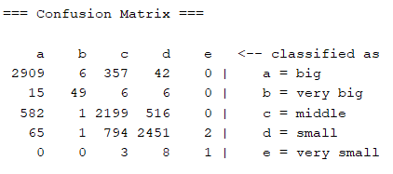
Figure 26 The confusion matrix of RandomForest algorithm (percentage split is 66%)
(2) THE LEVEL OF SQUARE2
For the same reason, I delete the attribute named THE LEVEL OF SQUARE1 and I used 1) RandomForest algorithm and J48 algorithm for classification respectively.
- RandomForest algorithm
The classification results of RandomForest algorithm with different percentage split is shown in table 10.
Table 12 The classification results of RandomForest algorithm (train set)
Percentage split | Correctly Classified Instances | Incorrectly Classified Instances
90% | 74.8048 % | 25.1952 %
75% | 74.725 % | 25.275 %
66% | 74.583 % | 25.417 %
In this case, the best percentage split with RandomForest algorithm is 90%, with an accuracy of 74.8048%
- J48 algorithm
The classification results of J48 algorithm with different percentage split is shown in table 11.
Table 13 The classification results of J48 algorithm (train set)
Percentage split | Correctly Classified Instances | Incorrectly Classified Instances
90% | 75.0424 % | 24.9576 %
75% | 74.9966 % | 25.0034 %
66% | 75.0225 % | 24.9775 %
When the classification attribute is THE LEVEL OF SQUARE1, the suitable algorithm is RandomForest algorithm, but the best percentage split is 90%. Becaue the result is worse than the first one, I didn't analyse the situation.
In summary, when the algorithm is RandomForest algorithm and the attribute is THE LEVEL OF SQUARE1 (The data is better divided by the median), I can get relatively best result.

5.2 The classification and prediction in test set
There are 1 question to investigate the test set: Can data mining find out the relationship between each attribute in the test set and the house area based on the classification basis of the train set?
I use the median and average values calculated by the train set to classify the housing sizes in the test set and the test is shown in Figure 27.
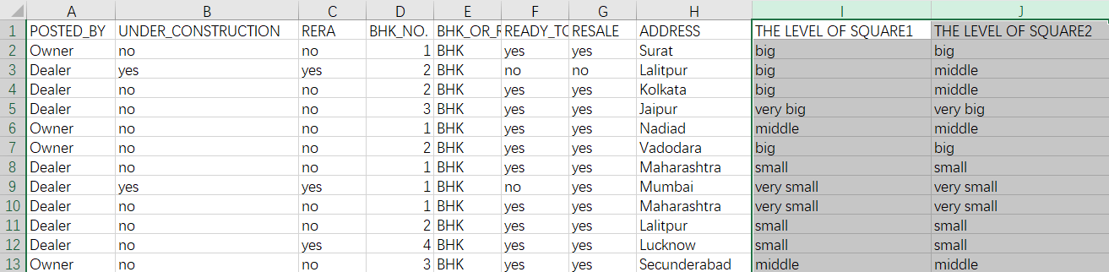
Figure 27 The part of test set
The core of this question is similar to the core of the training set question, whether it is possible to use attributes other than The LEVEL of SQUARE to classify the data set, but this question is based on the training set. Therefore, I use the similar experiment method and setup to classify the test set. I choose THE LEVEL OF SQUARE1 because it turns out to be more reasonable in the train set.
- RandomForest algorithm
The classification results of RandomForest algorithm with different percentage split is shown in table 14.
Table 14 The classification results of J48 algorithm (test set)
Percentage split | Correctly Classified Instances | Incorrectly Classified Instances
90% | 33.378 % | 66.622 %
75% | 34.0022 % | 65.9978 %
66% | 33.5884 % | 66.4116 %
- J48 algorithm
The classification results of J48 algorithm with different percentage split is shown in table 15.
Table 15 The classification results of RandomForest algorithm (test set)
Percentage split | Correctly Classified Instances | Incorrectly Classified Instances
90% | 34.1145 % | 65.8855 %
75% | 34.1368 % | 65.8632 %
66% | 33.1511 % | 66.8489 %
As shown in the above two tables, the classified accuracy is very low. The classification method using the training set is not successful and there may be a lot of reasons.
Relatively speaking, the better percentage split is 75% and the better algorithm is J48 algorithm. By analysing the confusion matrix (Figure 28), it can be seen that the Big, Middle and Small categories are still the most accurate predictions and small amounts of data are hard to predict.
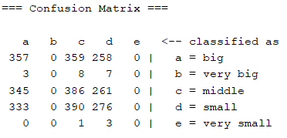
Figure 28 The confusion matrix of J48 algorithm (percentage split is 75%)
According to the Tree Visualizer(Figure 29), the most relevant properties for THE LEVE OF SQUARE are ADDRESS, REAR, and THE LEVEL OF PRICE.
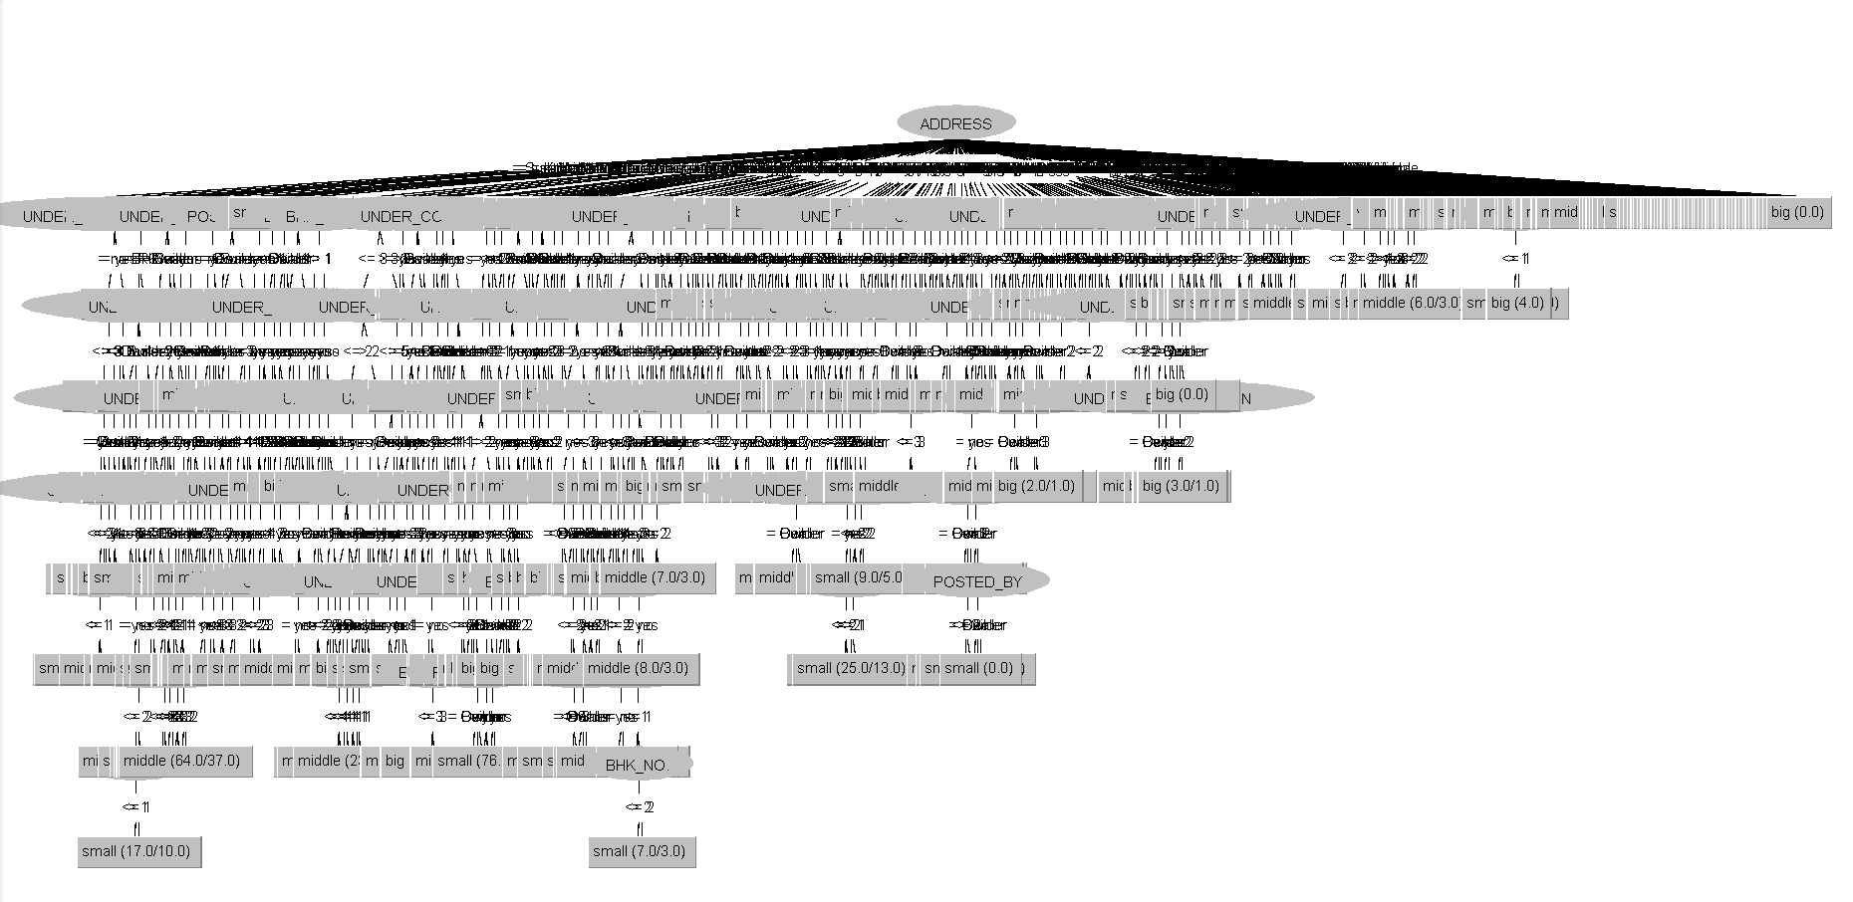
Figure 29 the Tree Visualizer of THE LEVE OF SQUARE

6. Reflection
After this experiment, I understand the importance of understanding the use method of Weka and the importance of classification method and basis.
- Importing the dataset into Weka for analysis and prediction requires the following considerations:
- Data need to be pre-processed, because most data analysis requires the data to be made in the nominal type, because numerical data cannot be classified by using the classification algorithm and cannot be accurately predicted. Therefore, I need to use replace tool in excel to replace the content without changing the meaning of data or I need to classify the numeric type data to a number of classes (In this experiment, it is divided into 5 categories) and create new attribute to put the sorted data in.
- Delete numeric types that have already been classified during classification, because this data can cause an error in classification accuracy.
- If the data is too long to display in Weka, keep only the most important parts of the data. In this experiment, all address information is replaced with city information.
- Notes on data classification:
- No matter what classification algorithm is used, in order to achieve the best classification prediction effect, a large number of experiments are required to adjust parameters and variables. The best results were obtained through comparative experiments
- For the classification of housing area in the test set and the training set, it is necessary to comprehensively consider all the data, otherwise, the classification results will only be good in the train set. In this experiment, the best percentage split is 75% and the best algorithm is J48 algorithm in test set, but the result of correctly classification is 34.1368 %.
In sum, the classification tool used in this project were successful. In order to make the classification more accurate, the data were classified in advance in this experiment, and the accuracy of price classification can reach 73.3% on the training set, and the accuracy of housing area classification can reach 75%.
Since the test set does not provide house price data, Weka cannot be used for prediction analysis temporarily, and other software such as Python can be used for prediction and classification of housing prices in the test set in the future.

7. Reference List
[1] Kaggle, House Price Prediction Challenge--Predict the house prices in India, Metadata, Online source: https://www.kaggle.com/anmolkumar/house-price-prediction-challenge(accessed 10/02/2020)
[2] Kaggle, House Price Prediction Challenge--Predict the house prices in India, overview, Online source: https://www.kaggle.com/anmolkumar/house-price-prediction-challenge/metadata (accessed 10/02/2020)
[3] Breiman L . Random forest[J]. Machine Learning, 2001, 45:5-32. [2] I. H. Witten, F. Eibe and M. A. Hall, Data Mining: Practical Machine Learning Tools and Techniques, Amsterdam, 2011.
[4] I. H. Witten, F. Eibe and M. A. Hall, Data Mining: Practical Machine Learning Tools and
Techniques, Amsterdam, 2011.

