

Student Name: Rowan Francis-Jones
Student ID: 2516294
Course Name: Construction Materials
Date Handed In: 26/03/2026

Contents
Q1 Tower 2
Strength, Durability, and Climate Resistance 4
Time, Labour Programme, and Cost Compared to Steel Framing 5
Ease of Assembly and Adaptability 5
Integration of Services Provision 6
End-of-Life Demolition Challenges 7
The Effects Processes Have On Environment and Society 8
Reference list 9
Aggregates Table and Graph 10

Q1 Tower
The Q1 Tower, also known as Queensland Number One, is a prominent landmark in Surfers Paradise on Australia’s Gold Coast. Completed in November 2005, the 322.5 metre supertall residential skyscraper rises approximately 78 storeys above ground and 2 sublevels. It was the world’s tallest residential building at the time of its completion. Developed and built by the Sunland Group at a cost of around $255 million, Q1 exemplifies early 21st-century high-rise residential design. It combines symbolic architectural expression with advanced reinforced concrete engineering to meet the demanding conditions of a coastal environment, including strong winds, salt air, and potential cyclones. 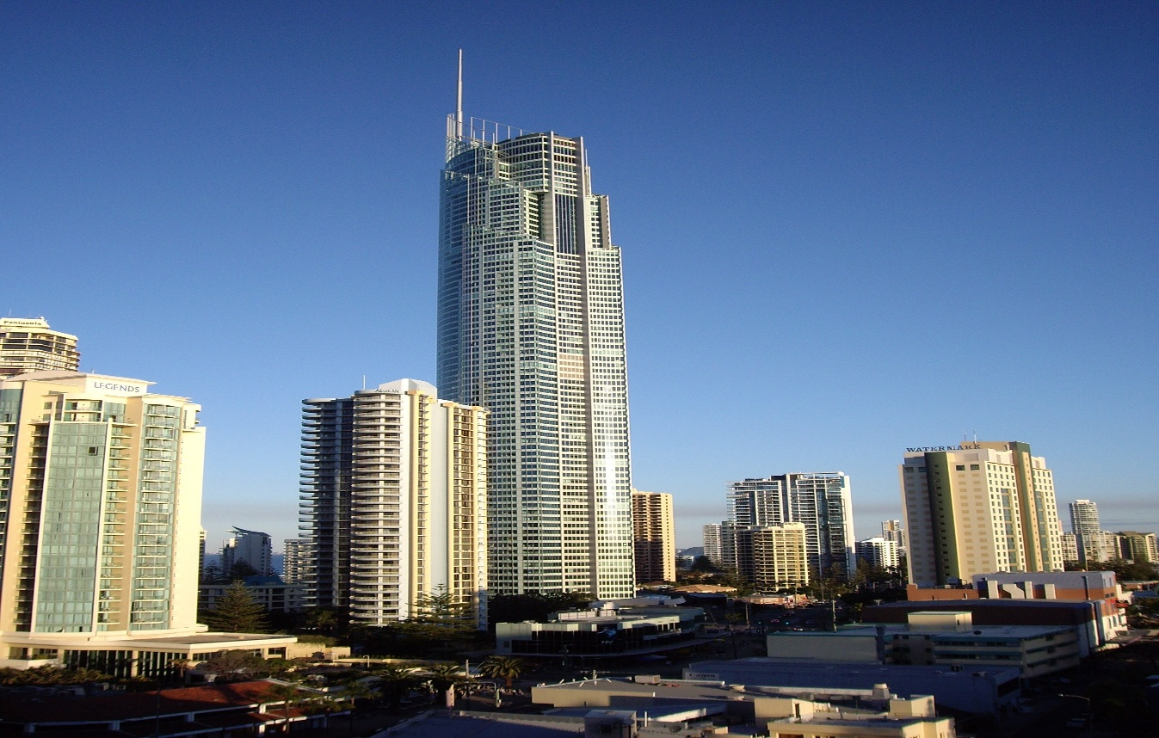
At street level, a podium base provides open public spaces and retail areas, sheltered by curved roof structures that echo the tower’s fluid lines. Above this, the slender tower shaft is clad in a reflective glass curtain wall system. This maximises natural light for residents and offers spectacular views of the coastline and hinterland. The combination of sculptural form and structural clarity gives Q1 its distinctive presence on the Gold Coast skyline.
From an engineering perspective, Q1 relies primarily on reinforced concrete for its main structural frame, a practical choice for a supertall building in a coastal setting. The foundation system addresses the challenges of sandy coastal soils by using 26, 2-metre diameter bored piles. These extend approximately 40 metres deep, penetrating through weaker surface layers to reach competent rock strata. This deep piling transfers the tower’s substantial vertical loads safely into stable ground, helping to prevent settlement and resist uplift forces in a high-wind environment.
Above the foundation, the structure is organised around a robust central reinforced concrete core. This core accommodates lifts, stairwells, and service shafts while providing the primary resistance to both loads and lateral forces such as wind. In a building of this height and exposure, wind loading is a critical design factor. To increase overall stiffness and minimise sway, the core connects to perimeter columns through a system of concrete outriggers and shear walls. This arrangement distributes horizontal forces more evenly, enhancing stability and improving occupant comfort by reducing perceptible movement.
High-strength concrete played a central role in Q1's success. Different grades were specified according to varying load demands: higher-strength mixes were used in the heavily loaded lower columns and core. In contrast, lighter, lower-strength concrete was used higher up to reduce self-weight without compromising performance. This graduated approach demonstrates an efficient, performance-based use of materials.
Pumping concrete to extreme heights posed one of the most significant construction challenges. Concrete had to be delivered hundreds of metres upward while maintaining workability and preventing segregation. Specialised high-pressure pumping equipment, combined with carefully designed mixes and chemical admixtures, ensured the concrete remained fluid enough to flow through the system yet strong enough once placed.
The repetitive floor plate and central core layout enabled the use of efficient formwork systems, including slipforming or jump forms for the core. These techniques supported continuous vertical progress and helped maintain quality and schedule.

Strength, Durability, and Climate Resistance
Reinforced concrete was chosen as the primary structural framing material for the Q1 Tower primarily due to the demanding coastal environment of Surfers Paradise on Australia’s Gold Coast. Situated close to the ocean, the building is exposed to high wind loads, salt-laden air, high humidity, and the potential impact of tropical cyclones. These conditions favour reinforced concrete because of its excellent compressive strength and inherent durability when properly detailed.
In a supertall residential tower like Q1, the heaviest vertical loads are concentrated at the lower levels. To handle these forces effectively, higher-strength concrete mixes were used in the lower columns and the central core. This ensures adequate resistance to compression while minimising deformation. Beyond its load-bearing capacity, the concrete structure's significant mass also provides natural damping against wind-induced vibrations. This mass helps reduce perceptible sway, contributing to greater occupant comfort, a vital factor in a high-rise apartment building where residents live there full-time rather than visiting briefly.
Durability is a major advantage in this marine setting. Chloride ions from sea spray can penetrate concrete over time and corrode the embedded steel reinforcement, leading to cracking and spalling if not properly managed. For Q1, designers addressed this risk through high-quality concrete mixes with low permeability, appropriate water-cement ratios, and sufficient concrete cover to protect the reinforcement. Good curing practices further enhance resistance to environmental attack. Compared with exposed structural steel, which typically requires regular protective coatings or galvanising to combat corrosion, well-designed reinforced concrete generally offers a longer service life with lower ongoing maintenance requirements. This makes it particularly suitable for coastal high-rises where access for maintenance can be difficult and expensive.

Time, Labour Programme, and Cost Compared to Steel Framing
The decision to use reinforced concrete for Q1 involved clear trade-offs in construction time, on-site labour, and overall cost when benchmarked against a steel-framed alternative.
Concrete construction is largely sequential and site-based. It requires erecting formwork, fixing reinforcement, pouring concrete, and allowing sufficient curing time before proceeding to the next level. This approach is typically slower than steel construction, where off-site prefabricated components can be delivered and rapidly bolted or welded together on site.
In the case of Q1, however, the highly repetitive floor plate and strong central core enabled an efficient construction cycle. Techniques such as slip forming or jump forming for the core support more continuous vertical progress, reducing some of the delays common with traditional formwork methods. Once the rhythm was established, the project achieved steady floor-by-floor advancement.
Labour requirements for concrete tend to be higher on site, involving teams for formwork carpentry, steel fixing, concreting, and finishing. Steel framing, by contrast, relies more heavily on off-site fabrication and specialised erection crews. In Australia, reinforced concrete is often cost-effective because raw materials like cement and aggregates are locally sourced, reducing transportation costs compared to importing structural steel. Concrete also removes the need for extensive passive fire protection systems, which are usually mandatory for steel members. Although the initial construction programme may be longer with concrete, potential savings in fireproofing and long-term maintenance can make it a financially attractive option over the building’s lifecycle.

Ease of Assembly and Adaptability
Assembly of the reinforced concrete frame for Q1 followed a systematic, repetitive vertical progression. Modular formwork systems supported consistent quality and helped the construction team maintain predictable cycle times once the process was underway. While not as rapid as erecting a prefabricated steel frame, this method aligned well with the tower’s repetitive residential layout.
Adaptability during the building’s life is moderate with reinforced concrete. The combination of a central core and perimeter columns created open floor plates, enabling flexible apartment layouts and internal fitouts. However, concrete’s monolithic character makes it less adaptable than steel for significant structural modifications. Cutting or altering concrete elements is difficult, costly, and requires careful engineering to avoid compromising the building’s overall integrity.
Q1’s original residential-focused design, with its repetitive floor plans, supports internal reconfigurations but limits the potential for radical changes in use, for example, converting large sections to commercial space. Steel framing, with its bolted connections and lighter members, generally provides greater long-term flexibility for retrofitting or repurposing. Despite this, the robustness of Q1’s concrete structure ensures the primary frame remains stable and serviceable for many decades, even if major internal changes are constrained.

Integration of Services Provision
Integrating mechanical, electrical, and plumbing services into a reinforced concrete structure demands more detailed upfront planning than in a steel frame. Steel beams often include web openings that allow services to pass through easily, whereas concrete elements require service routes and penetrations to be cast in during construction.
In Q1, vertical services such as lifts, stairwells, and major service ducts are concentrated within the central core for efficiency. Horizontal services are typically routed through pre-formed sleeves and openings in the floor slabs or within suspended ceilings. This arrangement required close collaboration between structural engineers and services consultants from the design stage to ensure all penetrations were accurately located and did not compromise structural performance.
The primary limitation appears when future modifications are needed. Drilling or cutting into hardened reinforced concrete is labour-intensive and expensive, and uncontrolled modifications can weaken structural elements. Detailed planning is therefore essential to integrate services effectively from the beginning and reduce the risk of costly retrofits later.
End-of-Life Demolition Challenges
Demolishing a reinforced concrete high-rise, such as Q1, at the end of its service life presents substantial technical and logistical challenges compared to demolishing a steel-framed building. Concrete structures are massive and monolithic, and the embedded steel reinforcement adds further complexity, requiring heavy specialised equipment to break apart and separate materials.
Located in the dense urban beachfront setting of Surfers Paradise, any future demolition would need to be carefully controlled to ensure safety and to manage noise, dust, and vibration, protecting neighbouring buildings, residents, and the public. Mechanical dismantling, either top-down or selective, is more likely than implosion, which is often impractical due to proximity to other structures and the need for extensive risk management.
Sustainability is another important consideration. Recycling concrete is more difficult than steel; while the material can be crushed and reused as aggregate, separating the reinforcement increases both cost and effort. Advances in demolition technology and recycling methods are helping to improve outcomes, but end-of-life management for large concrete towers remains a significant challenge for the industry.

The Effects Processes Have On Environment and Society
One of the most pressing global concerns is the high carbon footprint associated with cement manufacturing. The production process involves heating limestone to extremely high temperatures in kilns, which releases substantial amounts of carbon dioxide from both the combustion of fuels and the chemical calcination of limestone. As a result, the cement and concrete industry is responsible for approximately 7–8% of global CO₂ emissions. This makes it one of the largest single contributors to global greenhouse gas emissions, playing a notable role in accelerating climate change.
Beyond carbon emissions, the extraction of raw materials for concrete, including limestone, sand, and gravel, often leads to considerable environmental degradation. Quarrying activities can destroy natural habitats, reduce local biodiversity, cause soil erosion, and permanently alter landscapes. River sand mining disrupts aquatic ecosystems, changes water flow patterns, and can increase the risk of flooding in vulnerable areas. These impacts are not abstract; they affect ecosystems and natural resources on a large scale to meet the massive global demand for aggregates.
Concrete production is also resource-intensive in other ways. It consumes large volumes of water and energy, which can strain local water and energy supplies, especially in regions already experiencing water scarcity. Furthermore, the manufacturing and transportation processes generate dust and particulate matter that contribute to air pollution. This can lead to respiratory and other health issues for communities living near cement plants or quarries.
From a social perspective, the effects on nearby populations are often significant. Residents near extraction sites or production facilities frequently experience ongoing noise pollution, increased heavy-vehicle traffic, and a general decline in quality of life. These disturbances can reduce property values and make areas less attractive for living or other economic activities. In some cases, the environmental degradation linked to quarrying and mining may also affect local agriculture, fisheries, or traditional livelihoods, creating broader community challenges.
That said, the industry is actively exploring pathways toward greater sustainability. Innovations such as the increased use of supplementary cementitious materials such as fly ash, slag, or calcined clay, carbon capture and storage technologies, alternative low-carbon binders, and greater incorporation of recycled aggregates are showing promise in reducing emissions, sometimes by 30–50% or more in optimised mixes.

Reference list
Archify. (2019). Q1 Residential Tower. [online] Available at: https://www.archify.com/au/product/holcim-australia/updates/detail/q1-residential-tower? [Accessed 03 Mar. 2026].
Skene, K. (2014). Q1 is pinnacle of safety Q1 is pinnacle of safety. [online] Gold Coast Bulletin. Available at: https://www.goldcoastbulletin.com.au/news/behind-the-scenes-of-australias-tallest-residential-building-gold-coasts-q1-in-surfers-paradise/news-story/f309e8cc44945b38fb7d56ea8d363b10? [Accessed 03 Mar. 2026].
Wu, S., Shao, Z., Andrew, R.M., Bing, L., Wang, J., Niu, L., Liu, Z., and Xi, F. (2024). Global CO2 uptake by cement materials accounts 1930–2023. Scientific Data, 11(1). doi:https://doi.org/10.1038/s41597-024-04234-8. [Accessed 05 Mar. 2026].
Giatec Scientific Inc. (2026). Concrete Basics 101: Foundational Knowledge for Modern Leaders. [online] Available at: https://www.giatecscientific.com/concrete-fundamentals/. [Accessed 05 Mar. 2026].
Galli, L. and Suraneni, P. (2025). Durability and damage resistance of sustainable Portland limestone cement-based (ultra) high-performance concrete in seawater. Materials and Structures, [online] 58(9). doi:https://doi.org/10.1617/s11527-025-02824-5. [Accessed 05 Mar. 2026].

Aggregates Table and Graph
Sieve Size (mm) | Mass (g) | % On Sieve | % Passing
125 | 0 | 0 | 100
75 | 0 | 0 | 100
63 | 0 | 0 | 100
37.5 | 120 | 9.6 | 90.4
20 | 137 | 10.96 | 79.44
10 | 143 | 11.44 | 68
6.3 | 105 | 8.4 | 59.6
3.35 | 45 | 3.6 | 56
2 | 130 | 10.4 | 45.6
1.18 | 63 | 5.04 | 40.56
0.6 | 105 | 8.4 | 32.16
0.3 | 102 | 8.16 | 24
0.212 | 109 | 8.72 | 15.28
0.15 | 98 | 7.84 | 7.44
0.063 | 55 | 4.4 | 3.04

b)
Coarse Aggregate= 120+137+143+105=505
(505/1250) x 100=40.4%
Fine Aggregate=45+130+63+105+102+109+98+55=707
(707/1250) x 100=56.56%

c)
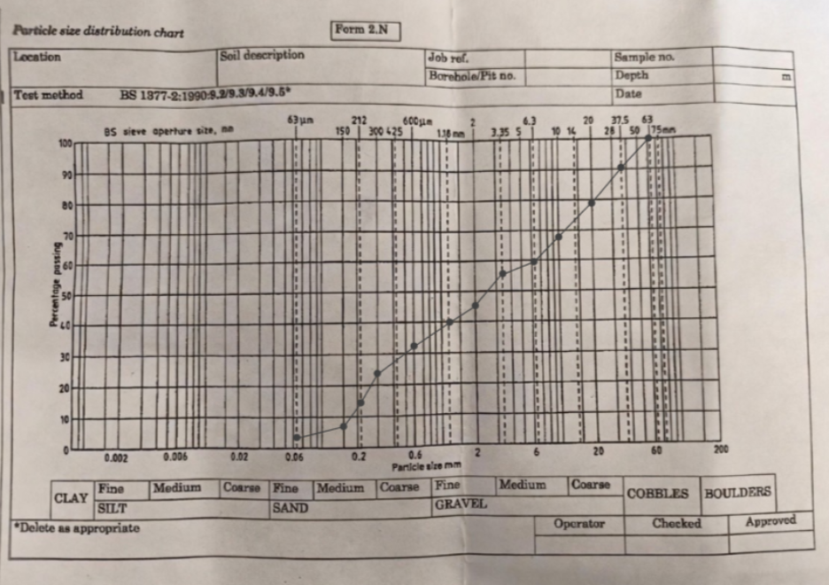
d) The sample exhibits a well‑graded mixture of sand and gravel. This grading is highly favourable for direct use as an aggregate. Sustainability performance is strong due to minimal processing needs, high reusability

