CRITICAL ANALYSIS OF ROLE OF MARKETING IN CREATING CUSTOMER VALUE AND IMPACT OF STAKEHOLDER ENGAGEMENT ON MARKETING ACTIVITIES: A CASE OF CHANNEL
Student: Mirela L Andrei 1914800
Marketing Fundamentals
Tushara Balendran

Table of Contents
Introduction 3
Overview of Company 3
Role of Marketing in Creating Value for Customers 4
Definition of Marketing and its Practices in Chanel 4
Advantages of Marketing to Chanel Customers 5
Branding 6
Concept and Advantages 6
Chanel Branding and Creating Value for Customers 7
Application of ANSOFF Model 7
Relationship Marketing of Chanel 9
Stakeholders Engagement and its Impact on Marketing Activities 10
Defining Stakeholder 10
Internal and External Stakeholder of Chanel 10
Chanel Stakeholder Communication Strategy 10
Stakeholder Influence on Marketing Activities of Chanel 11
Conclusion and Recommendation 11
References 13

Introduction
The present essay is composed to critically evaluate and present the marketing management practices of Chanel along with the role of stakeholders. Accordingly, the presented information has been extracted from relevant resources to indicate the conceptual and theoretical aspect of marketing and marketing management. Later on, information is aligned and critically analysed based on future consequences concerning the current practices of Chanel. The study is significant as it has outlined the theoretical models as well as their practical implication in the luxury market.

Overview of the Company
Chanel is a fashion house rooted in France; it is operating for 111 years. The company was founded in the year 1909 and Coco Chanel was the founder after whose name the brand has been dedicating (Chanel, 2020). In association with this, the company has drastically expanded itself over more than 310 regions across the globe (Marketing, 2020). Under these localities, the company operates with four basic types of market offering namely; haute couture, ready-to-wear fashion apparels, accessories and perfumes (Forbes, 2020). Additionally, the company is active in its marketing management as it targets its customers through intensive relationship management. Accordingly, the company has an active approach towards all the strategic actions of their marketing management. For example, the practice of segmentation and targeting is prudently catered by the firm so that the market offering and communication tactics can be designed based on the nature of the targeted audience (Companies Histories, 2020). Simultaneously, the company is proactive in the positioning of the brand in correspondence with the quality of production and type of market offering. A most important element of the marketing management practice of Chanel is its connectivity with its consumers. Practically, online sales, public relations, billboards and active fashions shows are the core means of market communication and consumer connectivity as practised by the enterprise.

Role of Marketing in Creating Value for Customers
According to Kotler (2016), the action of promoting and selling a particular product or service in association with specific market research and advertisement tactic is termed as marketing. Traditionally, the concept of marketing is overlooked as a simple exchange of goods and services among the buyers and the sellers for mutual benefits. However, the modern concept of marketing has upgraded the spectrum of simply buying and selling products or services. In simple words, contemporary the buyers and sellers exchange values for benefitting them rather than just meeting a need. The modern customer prefers buying products that bring a certain value to them. Simultaneously, the sellers pay attention to those consumers that are of higher value in the context of the customer life cycle (Fenn and Hobbs, 2017). In association with this, the concept of marketing has been reviewed to be modified from a simple exchange of needs and money to exchange values. Accordingly, the contemporary marketers are employing the new concept of marketing to communicate and stay connected with their potential consumers and the process is termed market management. In correspondence, Kotler (2017) defined marketing management as a set of planning, controlling and implementing specified programs, policies and tactics to satisfy demand obtained from the market.

Definition of Marketing and its Practices in Chanel
As defined above, marketing is composed of strategic actions to plan, design and offer value to the customer and receive the same from them, reputable companies prudently practice this aspect. Concerning the marketing tactics of Chanel, the set of practices are composed of segmentation, positioning, development of competitive marketing, distribution strategy, market communication and customer relationship. In detail, the defined STP model exhibits the practices that are employed by Chanel for discovering its target audience and positioning itself in the market accordingly (Chanel, 2020 b). From the defined STP model it has been explicitly outlined that the company employees emotional spectrum to articulate the brand towards the targeted audience.
Segmentation | Target | Positioning
Chanel screens the mix of demographics as well as psychographic segmentation tactics to bifurcate potential audience from the general public | The company uses selective targeting tactic to pan-specific groups out of the selected segments and design market offering as per the extracted targets | Chanel has always kept a keen focus on its placement and positioning in the market. Accordingly, the company positions itself as an emotional quotient that revolves around products that are more than just luxury.
Table 1
Source: (Kotler et al., 2018; Chanel, 2020)
In addition to the stated market practice, the company is also active towards the sustainability of its competitive advantage. In correspondence, three factors earn competence to the brand name; reputation, recognition and strong brand portfolio (Kotler et al., 2018). Based on this, the company has also kept an attentive eye over its distribution sector to maintain the value for the customers. For example, the company distributes its products through various channels such as multi-brand stores, direct stores, electronic stores, high-end supermarkets and private boutiques (Vault, 2020). Due to massive distribution, the company is serving over 310 different locations all over the world (Armstrong et al., 2018). Eventually, the company makes a critical review of its analysis techniques as well. As the company is under constant influence from several internal as well as external forces, the marketing management practices are always behind the consequences of these forces. For this, intense customer analysis is performed by the enterprise through effectual customer relationship and stakeholder preference.

Advantages of Marketing to Chanel Customers
Along with the understanding of the stated marketing tactics as practised by Chanel, another step is to determine the positive and negative outcome of the defined practices. At first, it is outlined that the company has selected a mix of demographic and psychological segmentation to bifurcate the target audience from the general public. In contrast to this, if the company relies on mixed segmentation of the demographics of the general public it paves away from its core mission to target a specific niche. In response, the company must be actively operating with intensely selected segmenting practices to precisely target a niche out of the market (The Guardian, 2020). However, the implied mixed segmentation strategy is beneficial to explore wider markets and demands that assist in the development of specified products and it increases the involvement of a wider audience.
Another marketing practice carried out by the enterprise is towards its distribution and communication. Alongside, the company has efficiently practised diversity by employing several distribution channels. The most comprehensive advantage of multiple distribution channels is it allows the brand to reach a wider audience (Ojadonor, 2017). However, the association of multiple distribution channels often lays-off the quality and service standard due to lack of control. Similarly, the present communication channel is mostly concentrated over direct fashion shows, billboard advertisement and electronic promotions (Wongsunnopparat, 2018). These communication tactics are limited in number as well as they do not align with the selected marketing practice for segmentation and targeting. As the company is using mixed segmentation, the firm must induce wider yet smart ways of communication to stay connected with its consumers.

Branding

Concept and Advantages
Marketing is a composition of several measures such as entities, processes, development, targeting, distribution, communication and exchange of values (Lim et al., 2018). Under this set of elements of marketing, the most efficient factor is positioning and placement that has been drastically upgraded in the last couples of years (Kotler, 2016). Consequently, the concept of branding has been established that creates a sense of distinction among the competitive line of similar product offering. Branding is not only a practice to promote products or service distinctively, it is also an effective tool to associate the name of a brand to the potential consumers (Jones and Grandjean, 2018). In doing so, the branding assists the companies to design value in the form of the customised market offering an empathetic association among the personality of the target audience and the brand. Therefore, the role of branding is essential in planning, designing, developing and implementing values for consumers.

Chanel Branding and Creating Value for Customers
However, there is a certain critical aspect of branding that has been outlined by a set of studies indicating that branding is not always a beneficial decision. For example, Kusumastuti and Setyabudi (2018) denoted in a study that heavy costing is required to set a brand. Similarly, Sugimoto and Nagasawa (2017) outlined that branding is a nonflexible attribute that turns the marketing process towards rigidity and inefficiency. Eventually, Fenn and Hobbs (2017) indicated that brands are stubborn marks that require critical and intense efforts to be sustained on a positive paradigm. On these accounts, it has been determined that the role of branding is indeed effectual for delving higher value for customers and the organization as well, yet it is a complex measure. Hence, the induction of branding is backed up by critical evaluation, determination and constant urge to improvement.

Application of the ANSOFF Model
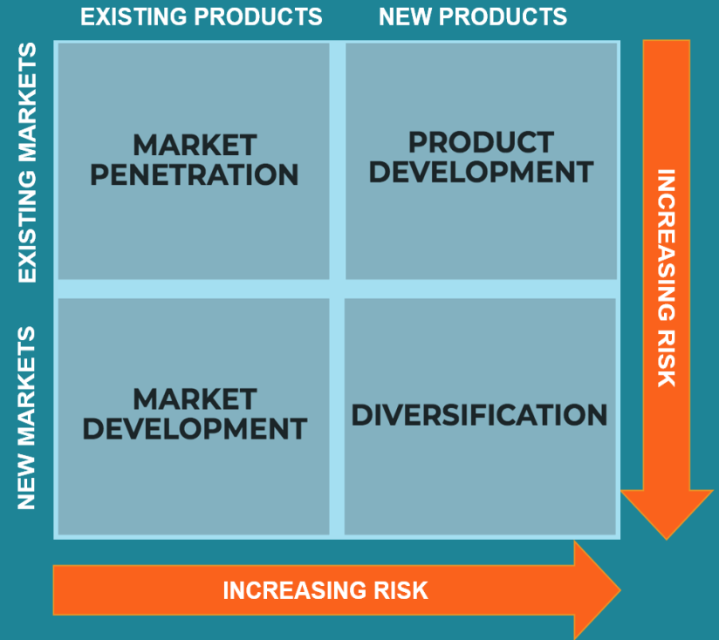
A Russian-American mathematician designed the ANSOFF matrix that is named after his last name; Igor Ansoff (Septian and Leksono, 2018). The model is composed of four-quadrant each divided based on the type of market and product. The model acts as a tool to assist in designing strategic decisions and actions among the managing spectrum of recent businesses. More precisely, the product-market association is placed in a manner that each quadrant exhibit the most comprehensive market driving strategy for the growth of the business. Additionally, each quadrant presents a different level of risk as to the steering element as defined in the Fig below;
Chanel
Christian Dior
Prada
LVMH
L’Oreal
Gucci

Fig 1
Source: (Kotler et al., 2019; Chanel, 2020)

Depending on the illustrated Ansoff’s model, it has been indicated that Chanel is in the middle of product development and diversity as the core growth strategic measure. In simple words, the company is facing critical issues in dealing with the existing market as a result of which it is planning to expand with product development and diversification. For example, the company has recently launched a collection of fashion apparel based on vintage attributes of arts (Kocian-Dirr, 2019). This action of Chanel indicates that the company is indeed employing product development as it has always centred the most modern and recent design whilst currently it is promoting the vintage fashion that is out of the spectrum of Chanel’s traditional positioning. However, the intense competitive pressure from the global market has imposed Chanel to revisit its positioning and product development tactics that are observed in its recent moves.

Relationship Marketing of Chanel
The company has emphasized on the maintenance of the relationship with the customers. According to this, Nuraminudin, Utami, and Al Fatta (2018) explored the tools that are employed by the company to practice customer relationship management. In this regard, the author figured out that the company actively involve direction meeting and communication with the customers to maintain their relationship. Moreover, the association of personal image and brand image as practised by the enterprise is also outlined as an essential tool that assists Chanel in managing its relationship. However, in doing so, the company is liable to maintain relevant relationship not only with the customers but with the suppliers, competitors and rivals as well. For this, the following porter’s five forces are drawn to indicate the sort of relationship that is to be practised by Chanel for sustaining its growth;
Bargaining Power of Buyers | The bargaining power of the buyer is low as they regulated based on one-way communication on prices. In this regard, the company must imply a bi-dimensional communication to obtain the responses.
Bargaining Power of Supplier | The bargaining power of supplier is higher due to the increased number of competition. Under this, the company practice fair-trade and long-term oriented relationship with its suppliers.
Rivalry | The completive rivalry is relatively higher as per the increasing market share and awareness about the related brands. The company maintain its relationship with rivalry through a proactive approach
Threat of Substitute | The threat of substitutes is also higher due to intense competitive rivalry. However, the company address this issue through differentiation as the core mode of relation
The threat of New Entrants | The fashion industry has a slender boundary for limiting new entrants. Therefore, the company maintain its relations with competitors and supplier to keep the stated boundary sufficient enough for the new entrants in the market.
Table 2
Source: (Jermsittiparsert, Sutduean, and Sriyakul, 2018; Chanel, 2020)

Stakeholders Engagement and its Impact on Marketing Activities

Defining Stakeholder
According to Jones and Grandjean (2018), the stakeholder is referred to as the entity that is directly or indirectly associated with any business. In association with this, there are two sets of stakeholders namely; the internal stakeholder and the external ones. The internal stakeholders are the one that is the direction associated with the organization or entities that exist within a particular business. On the other hand, the external stakeholders are the one that is directly influenced by the business as are not placed within the spectrum of business.

Internal and External Stakeholder of Chanel
Practically, the internal stakeholders are composed of employees, management, shareholders and board of directors whilst consumer, legal regulators, investors, suppliers are claimed as the external stakeholders. As the nature and interest of both the set of stakeholders are different, the communication tactic for each segment is also different. For example, Nuraminudin, Utami, and Al Fatta (2018) proposed a theoretical framework for stakeholder engagement.

Chanel Stakeholder Communication Strategy
Under the theory, it is denoted that all the stakeholders are categorized based on two factors namely; interest and power on the organization. In this regard, four quadrants are derived indicating the strategy to communicate with the stakeholder that is at the highest priority as indicated in the following Fig;
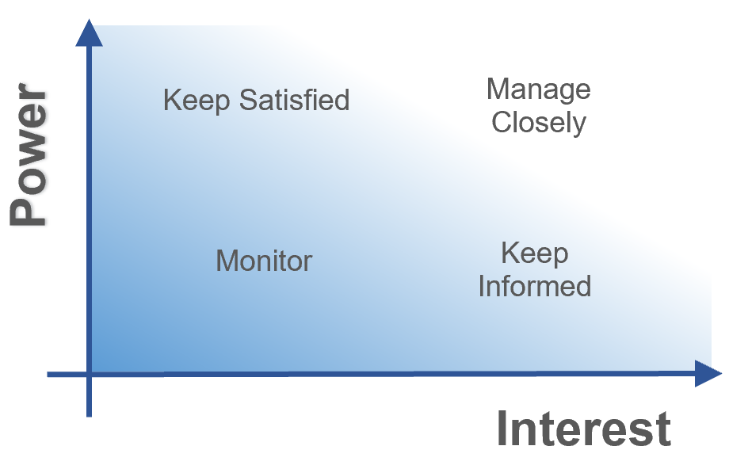
Fig 2
Source: (Kotler, 2016; Kusumastuti and Setyabudi, 2018; Chanel, 2020)

Depending on this, the stakeholders are the most priority are communicated through direction channels whist the one that indicated an association with less influential power are communicated through promotional tactics. Practically, the company uses expensive magazines, billboard promotion and e-advertisement. Similarly, the least associated and influential stakeholders are communicated through wider fashion shows and digital platform so that they can be informed.

Stakeholder Influence on Marketing Activities of Chanel
Contrastingly, the company lacks feedback from the customers’ perspective due to the one-way communication channel. Therefore, this problem must be addressed by the firm to sustain quality and value offering for their potential consumers.

Conclusion and Recommendation
Based on listed review and analysis the study revealed several crucial findings of the Chanel organization in the context of market and marketing management. At the beginning of the essay, it has been indicated that Chanel is active in its marketing tactics in terms of segmentation, targeting, positioning, distribution, and communication. In association with this, the study also revealed the present measures that are employed by the organization to practice their marketing tactics. For example, the company is backed up on mixed segmentation strategy to extract target audience and entertain them. Similarly, the writing also revealed that Chanel is composed of the wider distribution chain and effective relationship management to stay connected with all the stakeholders and maintain communication.
However, certain critical outcomes are also highlighted for which the study suggests certain recommending measures. For instance, the current segmenting practice is too vague for an organization that regulates on niche marketing. Hence, it is recommended to Chanel to narrow down its segmenting approach and extract the core sector and entertain them. Secondly, the distribution channel is not allowing the firm to exercise its quality standards. Responsively, it is recommended to the company to focus on direct distribution. Eventually, it is also recommended to pay key attention to a bi-directional communication channel so that more accurate consumers’ preferences can be entertained.

References
Armstrong, G.M., Kotler, P., Harker, M. and Brennan, R., 2018. Marketing: an introduction. Pearson UK.
Chanel, 2020 b. Chanel About the Company. [Online] Available at: https://www.chanel.com/us/
Chanel, 2020. Company History. [Online] Available at: https://www.businessoffashion.com/organisations/chanel
Companies Histories, 2020. CHANEL history, profile and history video. [Online] Available at: https://www.companieshistory.com/chanel/
Fenn, T. and Hobbs, J., 2017, January. Conceiving and Applying Relationship Models for Design Strategy. In International Conference on Research into Design (pp. 517-528). Springer, Singapore.
Forbes, 2020. Chanel Company Review. [Online] Available at: https://www.forbes.com/companies/chanel/#776a53ae1ca2
Jermsittiparsert, K., Sutduean, J. and Sriyakul, T., 2018. Social Customer Relationship Management Capabilities and Customer Relationship Performance: Moderating Role of Social Media (Face-book) Usage among Indonesian Firms. Opcion, 34(86), pp.1257-1273.
Jones, G. and Grandjean, E., 2018. Coco Chanel: From Fashion Icon to Nazi Agent.
Kocian-Dirr, C., 2019. Corporate management and controlling. Quickly recorded in business administration (pp. 143-199). Springer Gabler, Berlin, Heidelberg.
Kotler, P., 2016. A framework for marketing management. Pearson Education Limited.
Kotler, P., 2017. Philip Kotler: some of my adventures in marketing. Journal of Historical Research in Marketing.
Kotler, P., Keller, K.L., Ang, S.H., Tan, C.T. and Leong, S.M., 2018. Marketing management: an Asian perspective. Pearson.
Kusumastuti, A.R. and Setyabudi, D., 2018. Hubungan Brand Image, Brand Prestige, Lifestyle, dan Social Influence dengan Keputusan Pembelian Produk Tiruan Merek Chanel. Interaksi Online, 23(3), pp.84-95.
Lim, H., Childs, M., Cuevas, L. and Lyu, J., 2018, July. CHANEL INVITES YOU BACKSTAGE! PHOTO NARRATIVE AND VIP EMOTIONS IN LUXURY BRANDS’SOCIAL MEDIA COMMUNICATION. In 2018 Global Marketing Conference at Tokyo (pp. 454-454).
Marketing, 2020. Marketing Mix of Chanel. [Online] Available at: https://www.marketing91.com/marketing-mix-chanel/
Nuraminudin, N., Utami, E. and Al Fatta, H., 2018. Perancangan E-Customer Relationship Management Berbasis Cross Platform Memanfaatkan Web Service Pada Perusahaan Software House. Informasi Interaktif, 3(2), pp.128-137.
Ojadonor, J.U., 2017. Marketing: An Effective Tool for Managing Secondary Schools in Nigeria. ATBU Journal of Science, Technology and Education, 5(4), pp.50-55.
Septian, MD and Leksono, AB, 2018. Dasar Manajemen Desain . Universitas Brawijaya Press.
Sugimoto, K. and Nagasawa, S.Y., 2017. Luxury branding: the case of Chanel. International Journal of Quality and Service Sciences.
The Guardian, 2020. Chanel's Lagerfeld-inspired Haute Couture Shows How Luxury can Thrive Online. [Online] Available at: https://www.theguardian.com/fashion/chanel
Vault, 2020. Chanel Incorporation. [Online] Available at: https://www.vault.com/company-profiles/personal-care/chanel-inc
Wongsunnopparat, S., 2018. The Study of Factors that affact Consumer Purchase of Luxury Brand Choice Progressing on Hermes, Chanel, Louis Vuitton in Bangkok.

