FESTO Cyber Physical Production System
Manufacturing Design & Technology
ACMA5002
University of Wales Trinity Saint David
Engineering Management

JOSHUA THOMAS
STUDENT NO: 2113454

Executive Summary
This report follows the design process used to create an end effector to be utilised in a manufacturing process, at the request of a client, Festo.
The report begins with a short introduction to the problem, followed by the creation of a design brief and additional constraints that have been deduced from interrogating three-dimensional models supplied by the client. Technical drawings of the models have been created to support the additional constraints found.
Following the design brief, the report provides observations on research of end effectors that are already marketed for similar operations to the clients needs. Care was taken to ensure the end effectors researched met similar criteria as the end effector requested by the client, but thought was also given to alternative solutions.
Prior to creating the initial design, two forms of root cause analysis are performed in attempt to mitigate potential problems in the design stage. A five whys cause and effect analysis is performed which identifies three potential root causes. A common root cause was found for two failures, and as such an Ishikawa analysis was performed to outline further variables that may be overlooked but have an impact on the performance of the final product. A short “quality function design” (QFD) analysis was created to highlight qualities that have most importance to the client and map those qualities to the design characteristics.
With the root cause and QFD analyses completed a three-dimension prototype model was created. This model was created respecting the outcomes of the analyses, utilising two grippers within the end effector and collecting the finished goods horizontally.
Design for manufacturing and reliability were then discussed before a final proposal for a suitable end effector was created.
Table of Contents

Executive Summary 2
Introduction 4
Product Design 5
Design Brief 5
Further Constraints 5
Competitor Research 9
Observations 9
Root Cause Analysis 11
Five Whys 11
Ishikawa Cause and Effect Analysis 13
Quality Function Design 15
Initial Design 16
Design for Manufacturing 18
Design for Reliability 18
Conclusion 19
Final Proposal 19
19
References 20

Introduction

Industrial control and automation manufacturers, Festo, have requested that an end effector compatible with their cobot be designed for use in transporting finished goods from an output station to an automated guided vehicle. Screenshots of CAD models provided by Festo can be seen in figure 1, in which the output station, cobot and finished goods can be seen.

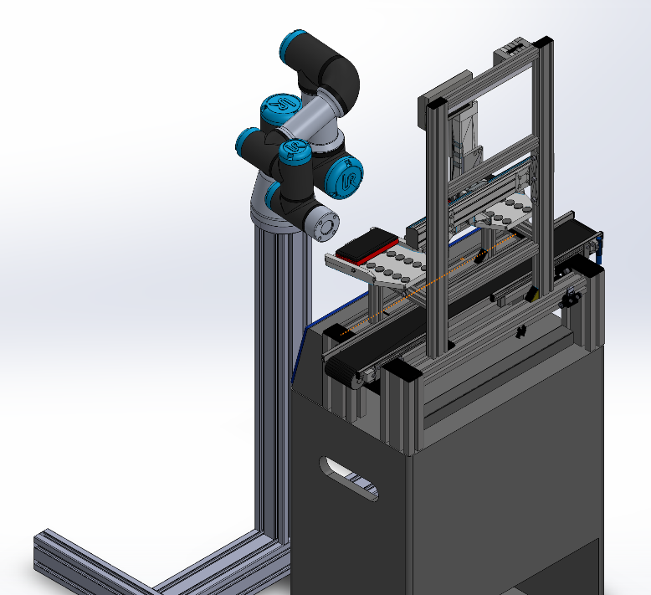
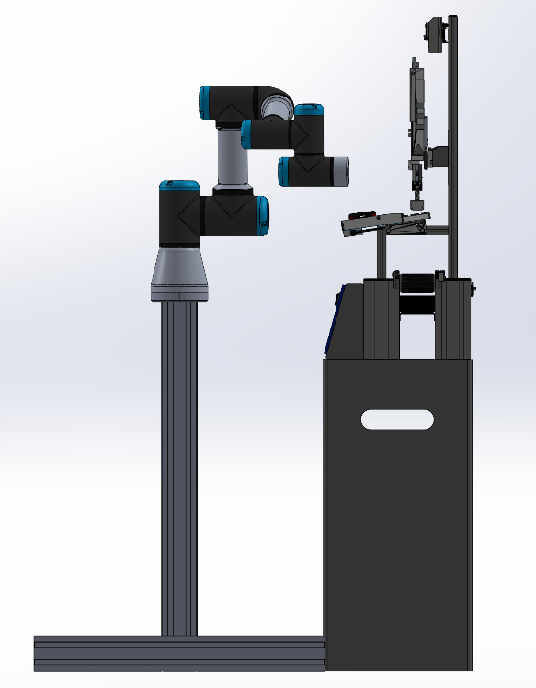
Figure one – Output station, cobot and finished goods

Throughout the design process, principles of lean product development will be followed, such as those described by Ward and Sobek (2014). There are a range of tools that have been created to aid the design process and ensure quality and value is better provided to clients. Marodin et al (2018) believe that ensuring the customers’ needs are fully understood, and that the design is optimised in the initial design phases, the amount of rework in the final model should be limited.

Product Design

Design Brief
Before the design process can begin, the request of the customer must first be properly defined to better allow for a suitable product to be generated. Creating a design brief can be described as defining value. This is the first of five principles described by Womack and Jones (1997) as part of the now popular “Lean” continuous improvement philosophy. Cross (2021) adds weight to this theory by describing the design brief as an important step in the design process, summarising constraints and allowing creativity to begin. Furthermore, Cross (2021) argues that despite the benefits of a design brief, the information contained within will not be sufficient to create an optimal solution.
Client | Festo
Designer | Joshua Thomas
Problem Statement | An end effector is required to allow for the automated transference of finished goods (mobile phone) from a dispatch station, located in the CP lab, onto an automated guided vehicle (AGV).
Design Statement | Design and model an end effector capable of transferring finished goods as part of an automated manufacturing system.
Constraints | - Final design should be appropriate for high volume manufacturing  - The gripper should be mechanically actuated  - The design should be sufficiently robust to withstand sustained use within a production environment
Deliverables | - Initial sketches  - Five why’s root cause analysis  - Ishikawa cause and effect analysis  - Three-dimensional CAD models/assemblies  - Final Proposal

Further Constraints
The design brief above was created directly from the request submitted by the customer. Model files of the mobile phone, cobot and output station were supplied with the client request, and upon interrogation (figures two, three and four), several additional constraints can be defined. These additional constraints are:
- The end effector should be able to securely hold a cuboid object that is 114mm x 60mm x 20mm in size.
- The end effector should have a cylindrical interface able to attach/detach to the cobot.
- The interface between end effector and cobot should be no more than the 32.5mm radius of the cobot face the end effector will attach to.
- The method of attaching the end effector to the cobot should make use of the 16mm radius hollowed cylinder centred in the cobot face along with the four 4.25mm radius equally spaced cylinders 26mm from the arm centre.
- There is 3mm clearance between the face of the tray and the mobile phone.

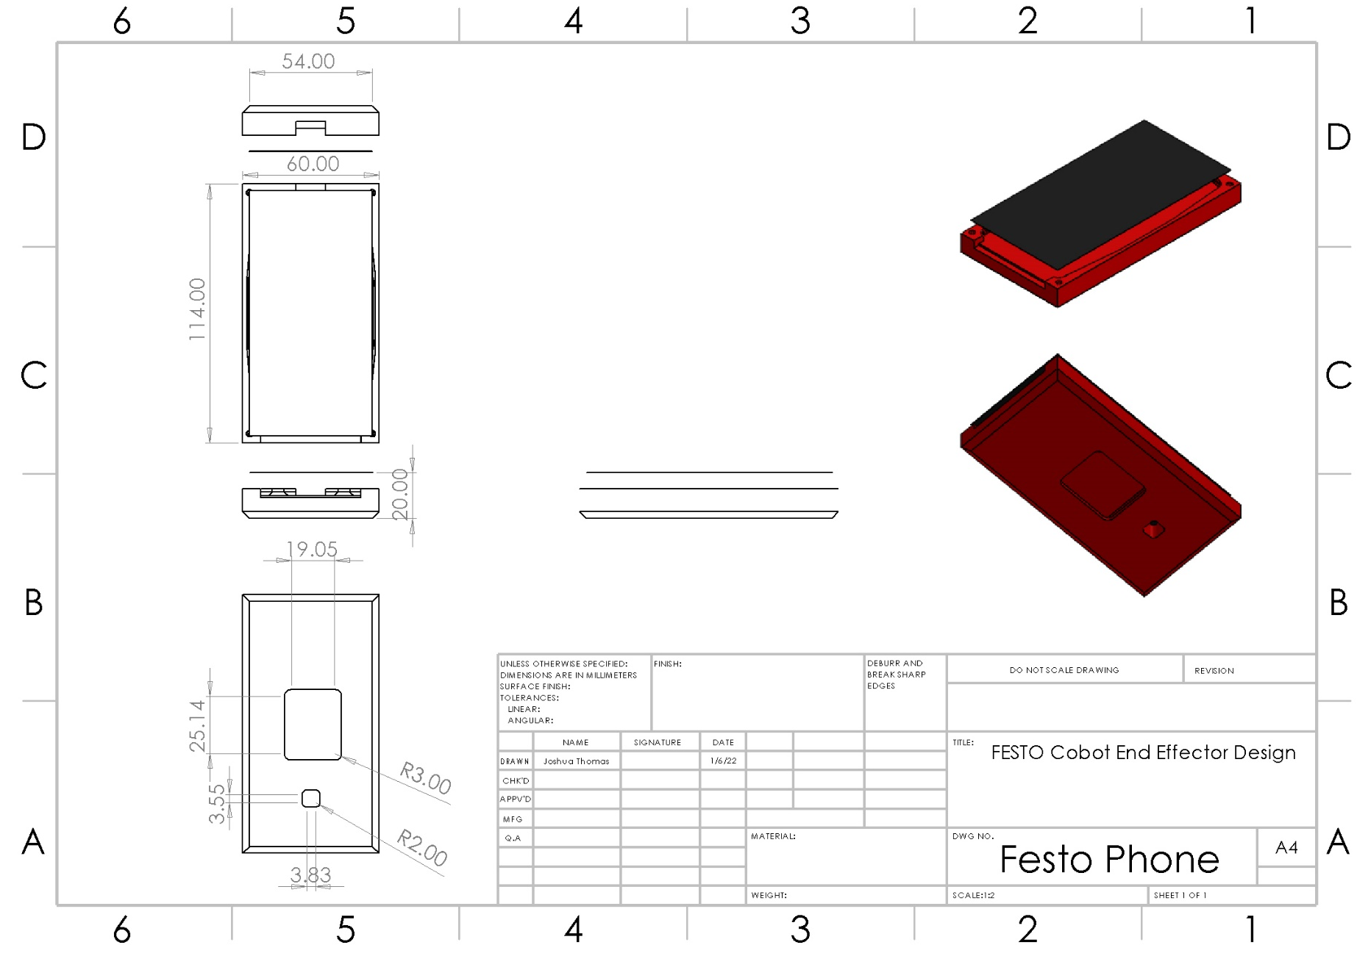
Figure two – Mobile phone to be transported

Figure three – Interface between end effector and cobot
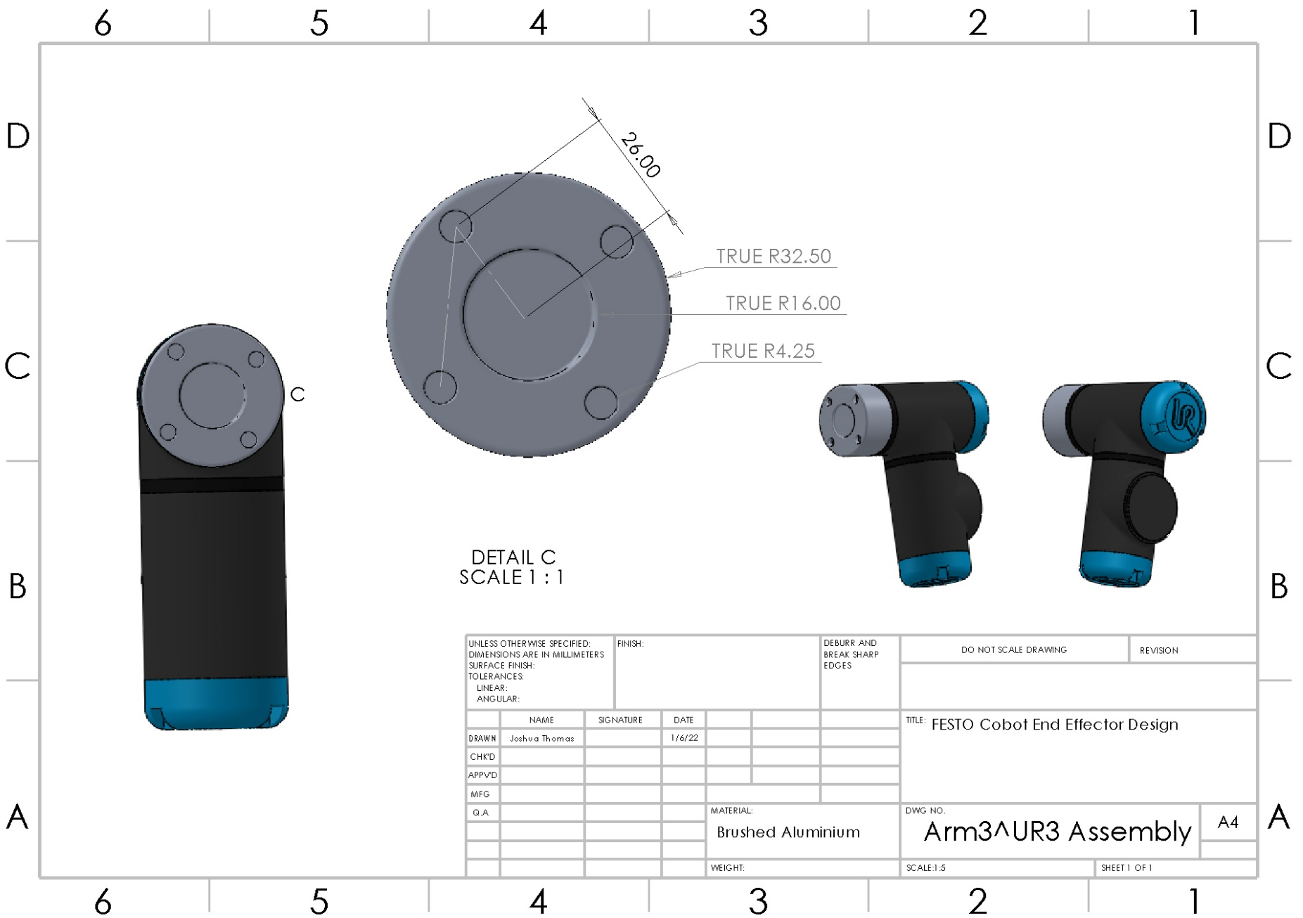

Figure four - Dispatch tray of the output station

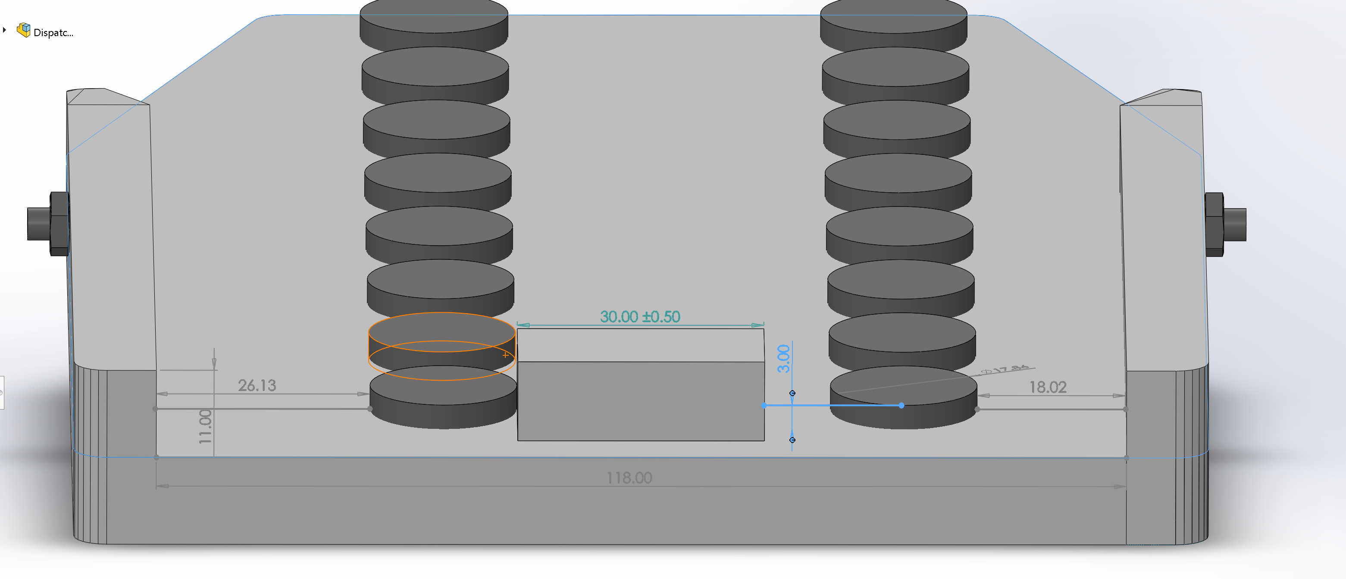

Competitor Research
As part of the design process, it is useful to perform research as to products that are already in use to meet similar needs as the design brief created. It is important that the market research performed is used to inspire possible solutions to the problem statement, without being a direct copy incurring copyright infringement. Garrett and Wrigley (2019) place importance on performing adequate research to ensure customers needs are met but also to speed up the design process. The research performed should be relevant, but at times “thinking outside of the box” is what leads to inspired product design, according to Dam and Siang (2018).
In figure five are a sample of cobot end effectors that are currently on the market, that have been utilised for design inspiration. Care was taken to ensure that each of the mechanical end effectors researched would be able to comply with the design constraints.

Observations
From the market research it was observed that a large proportion of end effectors were pneumatically actuated two finger grippers. Both the SMC and St Robotics pneumatic grippers would be capable of opening to hold the 20mm height of the finished goods. Both pneumatic grippers utilised fingers that were of suitable size to manoeuvre within the clearance of the output station tray and the finished goods, although there would not be a great margin for error. The St Robotics end effector made use of a cuboid body mounted to a circular face, like the circular face constraint of the cobot interface.
The Niryo two finger electric gripper can open wide enough to grip the 54mm width of the finished goods, although this method of transport would require alterations to the output station and current method of dispatch. Due to the dimensions of the Niryo gripper, it would not be able to manoeuvre within the clearance of the finished goods and the output station.
Thought was given to other methods that the end effector might utilise although it was acknowledged that this would likely mean returning to the client to alter the design brief. The alternative methods included the use of an electromagnet or a vacuum unit to grip the finished goods from above. Very quickly it could be seen that the electromagnet would not be a viable alternative in this instance as it would require a metal component to be included within the finished goods cover. The vacuum suction cup would seem a viable alternative on initial examination, with the Niryo vacuum end effector able to lift a load of 300g. Bouchard (2016) describes several issues that vacuum end effectors can experience, such as leaving marks on the gripped object that would need another process to remove. Another issue Bouchard (2016) describes is the compliant nature of the vacuum cup, reducing its effectiveness after experiencing sustained use.
With the following observations made, it is believed that an end effector inspired by the two-finger pneumatic options, will most successfully meet the design brief.

Figure five – Design inspiration from market research
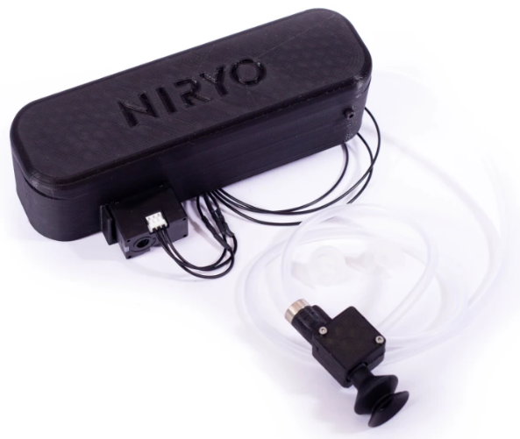
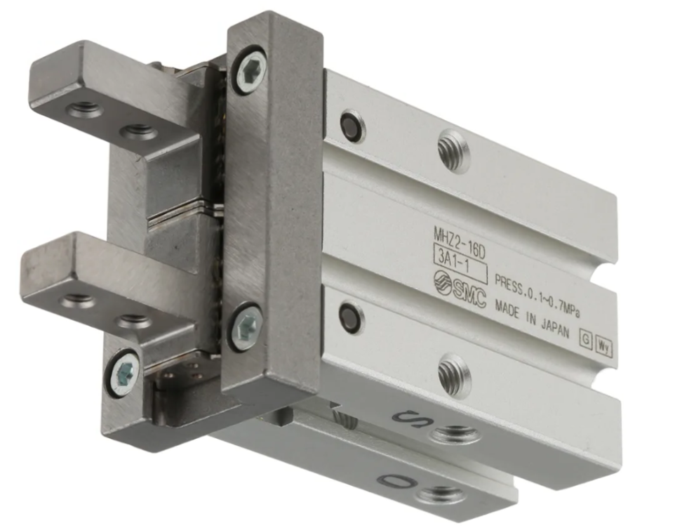
Niryo - Vacuum suction cup and vacuum pump

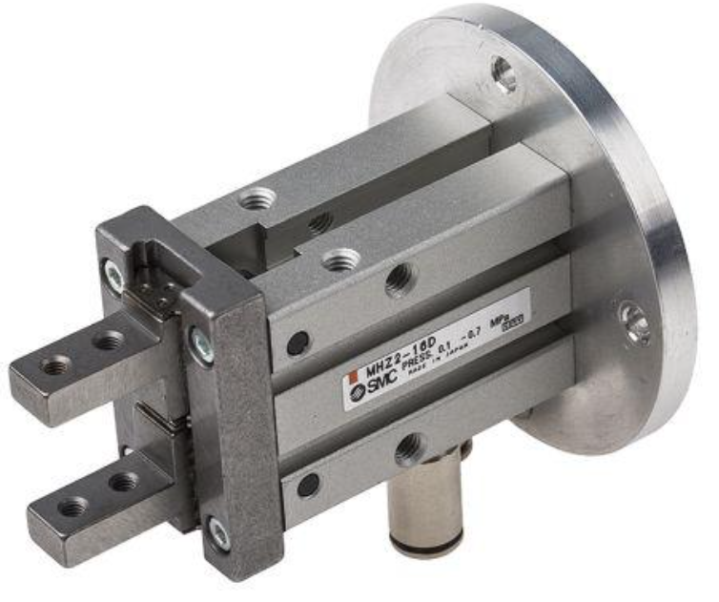
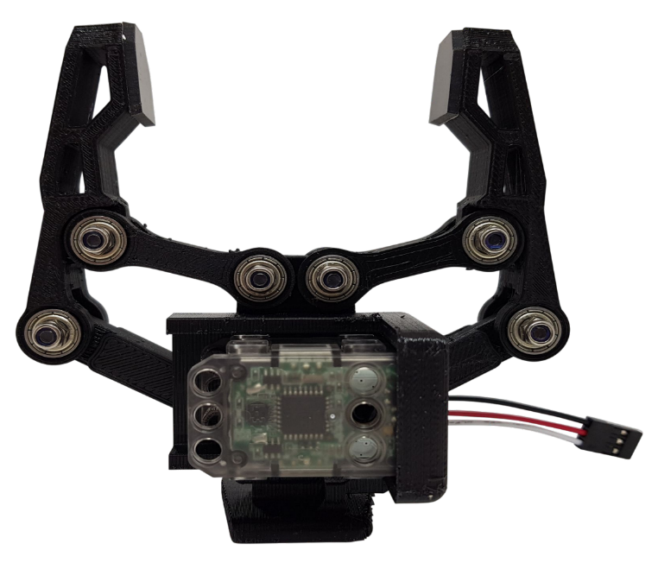
St Robotics - PG17 ST Robotics Pneumatic Parallel Pneumatic Gripper

Niryo - Large two finger electric gripper

SMC - Parallel two finger double action pneumatic gripper

Root Cause Analysis

Five Whys
Root cause analysis is an important process that allows engineers to identify the initial cause that lead to an event or problem, allowing the initial cause to be rectified thus reducing the likelihood of the undesirable event occurring. Okes (2019) describes five methodologies for approaching route cause analysis, of which events and causal factor analysis, and barrier analysis, are of particular interest. Events and causal factor analysis is typically backward looking and is performed following a major event. Okes (2019) does however suggest it can be performed in a forward-looking manner, allowing barriers to be engineered to prevent a failure or event from occurring.
A widely used tool used for route cause analysis is the “five whys” process, explained by Ohno and Bodek (2019) as a scientific method to problem solving. By continually asking why, typically five times, seemingly invisible issues are likely to become apparent. With the root cause identified, further work can be undertaken to understand and eliminate the cause. Card (2019) describes the strengths of five whys as a root cause analysis tool but argues that their outcomes rely heavily on the experience of the team performing the analysis and suggests that the simplicity of the tool limits its effectiveness in understanding complex problems.

Outcomes
A five whys analysis follows in figure six, centred upon causes for unsuccessful delivery of finished goods to the AGV, in relation to the performance of the end effector. Four failures were analysed producing three root causes that are required to be addressed.
The first root cause found suggests that additional information is required from the client. Womack and Jones (1997) suggest that it’s critical to fully understand the clients need as value is defined by customer, and not by the designer. In this instance it is suggested that further information be sought from the client to understand the weight of the finished goods to be transported.
The second root cause found indicates that the data from the three-dimensional model suggests the feeding tray of the output station is asymmetrical. This asymmetry creates a variation in distance that the mobile phone sits in the feeding tray, which could lead to inconsistent positioning in the end effector. It is suggested that a discussion with the client as to possibly altering the feeding tray, to reduce the variation of starting position of the finished goods. Removing the cause of the problem is an example of “Poka-Yoke” or mistake-proofing, as described by Dillon (2021).
For the final two failures, the same root cause was found to be an oversight during the design process. As the common root cause has been found, further analysis is necessary to identify additional problems that could be caused by incorrect design.

Figure six – Five whys analysis asking, “Why are finished goods unsuccessfully loaded onto the AGV?”

Ishikawa Cause and Effect Analysis
Ishikawa and Lotus (1990) created another analysis technique known as an Ishikawa or “fishbone” diagram, to identify and the cause of an undesirable effect and bring attention to factors effecting quality. Allen (2019) emphasises the ability of an Ishikawa diagram to highlight many issues that might otherwise be overlooked. Allen (2019) also adds that the tool is most effective as a collaborative tool, as members of the analysis team initiate thought processes amongst each other that can be visually interpretated.
The Ishikawa analysis that follows in figure seven breaks the problem of “unsuccessful loading of finished goods onto the AGV” down into six categories. The factors identified are:
Environment: the environment of the CP lab needs to be considered as this could have an impact on the performance of the end effector. Particular attention to dust would need to be taken should a vacuum system be used, but for a pneumatically actuated end effector it should have little effect. Greater thought needs to be given to humidity, as humidity can cause accelerated corrosion, in particularly if dissimilar metals are used.
Material: The material of the end effector needs to be robust enough to withstand sustained use at high volumes, in the environments described above. Care needs to be at the interface of the cobot, which is made of brushed aluminium. Dissimilar metals create the potential for galvanic corrosion, although the likelihood is reduced in a manufacturing environment. The density of the material needs to be considered as this will impact the weight, which could be a root cause of a failure as demonstrated in the five whys analysis. Similarly cost needs to be managed to ensure a suitable end effector is created that is also reasonably priced for the client.
Machine: The clearance between the goods and tray is small (3mm) and this needs to be considered to ensure the finished goods are collected correctly. Considerations need to be given to wear that may occur during the end effectors operation, which may be cause through friction between parts. The end effector should be able to be replaced, either to replace in instances of damage, or to repurpose the cobot. Providing this interchangeability may cause opportunity for wear, which should be minimised. The use of one two finger gripper may cause issues with balance, thought should be given to utilising a system of two, two finger grippers.
Measure: Incorrect tolerances can cause poor fits and incorrect function of the cobot. A measure of throughput should be obtained so that performance can be analysed, and a history collected for future failure analysis.
Method: As well as deciding how many grippers are utilised in the end effector, a decision on the orientation of gripper is required. There is a greater potential for the finished good from slipping when gripped on the sides, than while being gripped from below and above. It also must be recognised that the loading of the finished good onto the AGV is as important as the collection of the finished goods from the output tray.

Figure seven – Ishikawa fishbone diagram to determine factors requiring attention during product design st
Throughput
Density
Weight
Dissimilar Metals
High volume manufacturing - robust
AGV to be located consistently?
Friction
Interchangeability
Clearance between goods/tray
Monitoring
Orientation gripper applied
Troubleshooting
Mobile Phones
unsuccessfully loaded
onto the AGV
Cost
Cobot to be positioned consistently?
Dust
Hold time
Tolerances
Using one gripper or two?
Humidity
Temperature
Wear
Human
Measure
Material
Method
Machine
Environment

Quality Function Design
Quality function design (QFD), is a methodology that was created to place emphasis on customer satisfaction with a product being measured as “quality” (What is Quality Function Deployment (QFD)? | ASQ, 2022). It is suggested by Hauser and Clausing (1988), that QFD is a conceptual map that can be used in a wide range of scenarios to identify design priorities that are of upmost importance to the customer.

Figure 8 – Quality function design of end effector
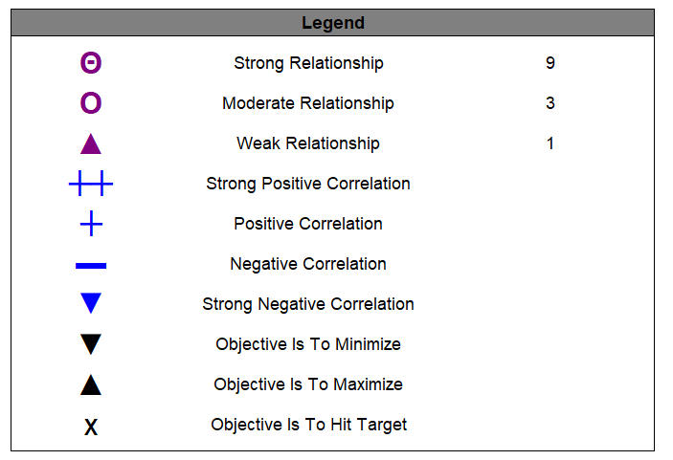

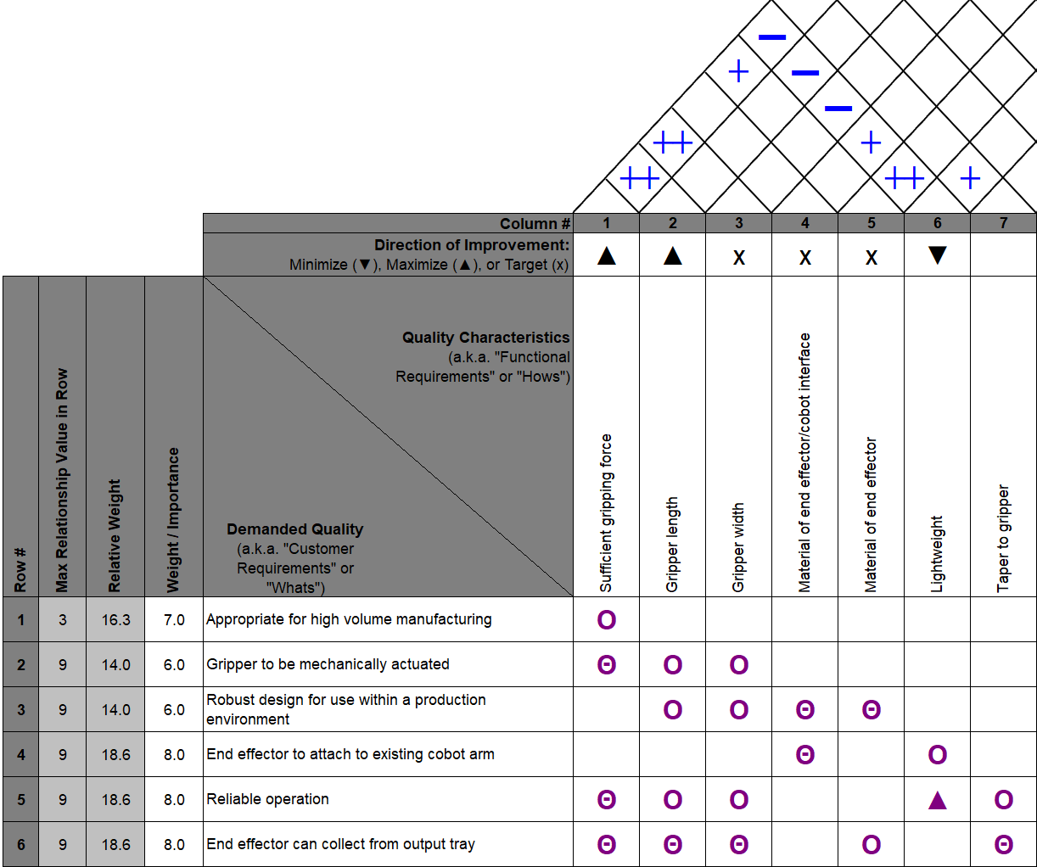

From the QFD it can be concluded that the most important customer requirements are for a compatible end effector that can reliably collect finished goods from the output station for delivery. Of the quality characteristics, the gripping force of the end effector was most important and highly correlated with other quality characteristics.

Initial Design
The end effector prototype was created with the findings of the root cause analyses and quality for design analyses in mind. It was decided that two gripping pneumatic gripping mechanisms would be utilised, to ensure sufficient gripping force was provided to transport the finished goods, but also that the goods would be correctly balanced during transition.
The grippers move in a channel to provide the gripping pressure necessary to hold the finished goods securely. Thought was given to make the gripping pins symmetrical in design to allow for more cost-effective manufacture and assembly. The length of the gripping pins is slightly greater than those identified during market research, but this is due to the importance placed upon “sufficient gripping force” and “gripping length” in the quality function design analysis.
The end effector has been designed in brushed aluminium, like the cobot interface. This removes the issue of dissimilar metals but also ensures that the end effector is kept light but robust.

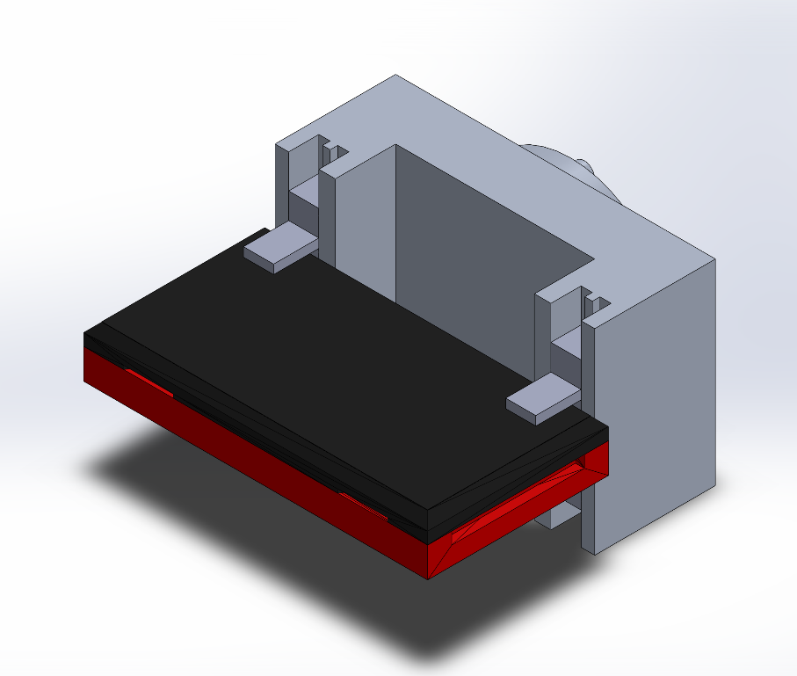
Figure nine – Initial prototype of end effector with finished goods secured

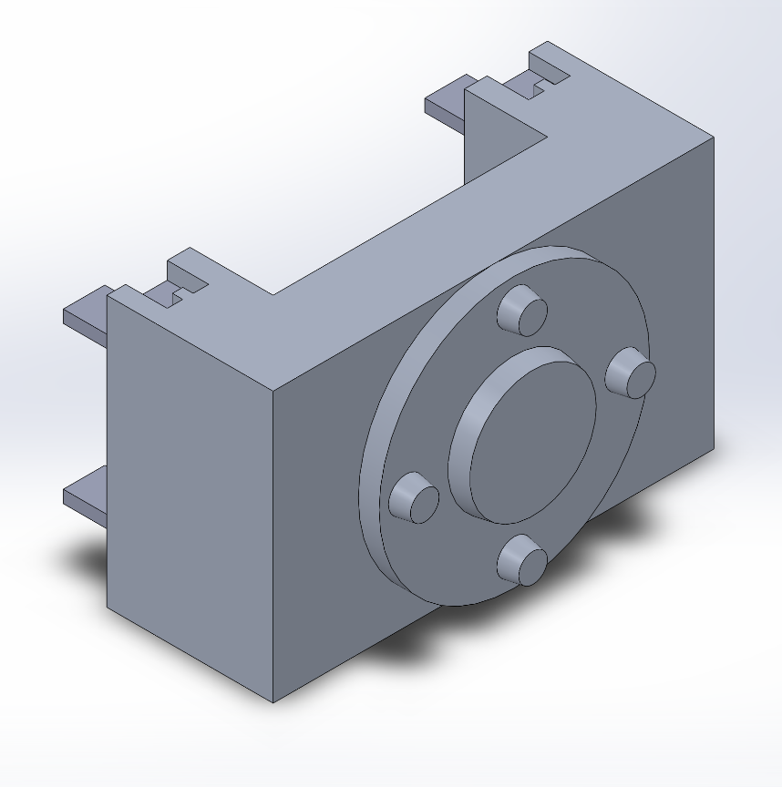
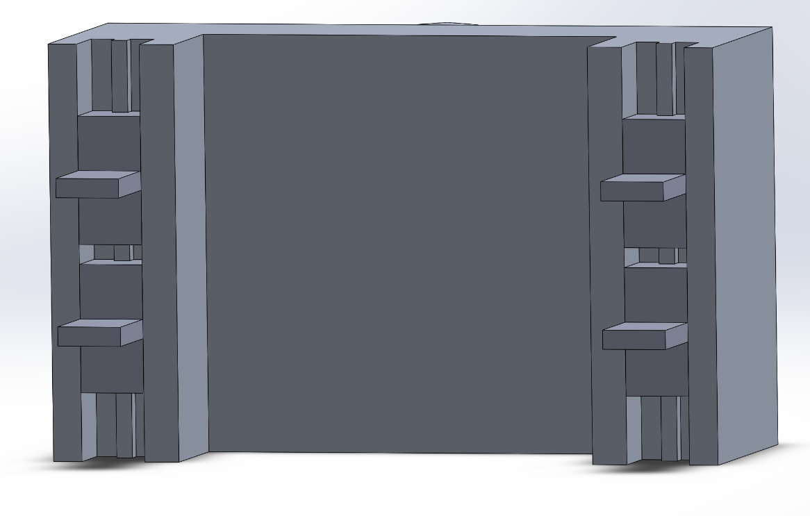
Figure ten – Prototype end effector front and rear view without finished goods.
From the rear the interface between end effector and cobot can be seen. It is envisaged that the four equidistant pins will have a mechanism allowing the effector to clip into the cobot.
From the front of the end effector, the pins can be seen, symmetrical in design.

Design for Manufacturing
Design for manufacturing is the principle of ensuring that product design allows for an easy manufacturing process. El Wakil (2019) places emphasis on ensuring product design uses standard process that are common within industry. The use of common fastening methods is one example of ensuring ease of manufacture is considered.
During the initial design stage, it was decided that the pins for the end effector would be created symmetrically, so that the one pin design could be repeatedly produced four times to create the final end effector. A suitable fastening mechanism should be sought to connect the end effector to the cobot, using a standard mechanism such as a push fit connection would work towards DFM principles.

Conclusion

Final Proposal
Figure eleven shows the final end-effector proposed to the client. The main body of the end effector has been streamlined to further reduce weight in the component. The gripping pins have been chamfered symmetrically, to reduce the likelihood of incorrect loading due to the tight tolerance between the output station and the finished goods.

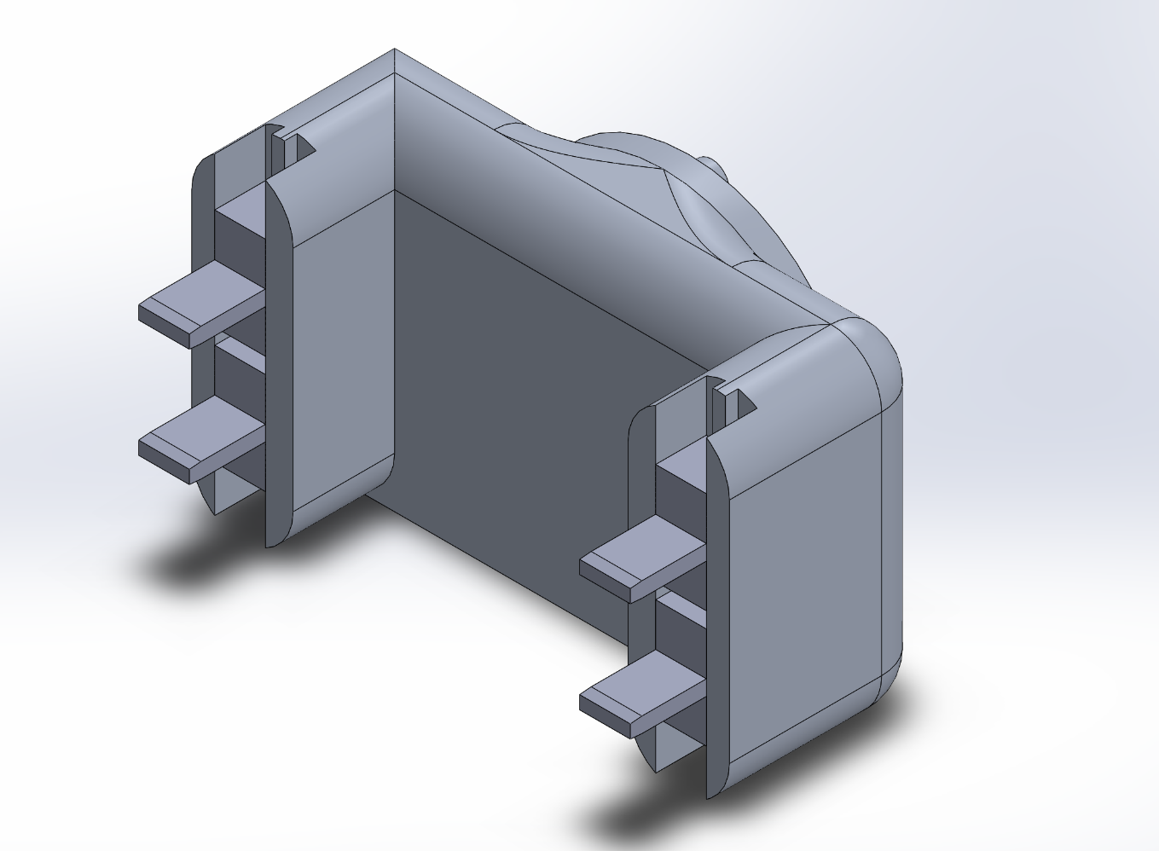
Figure eleven – End proposal
In conclusion, the design process is comprehensive but could still go further. Market research, root cause analysis and quality function design analysis are all useful tools in ensuring a suitable design is created. The next steps of the proposal above would be to utilise analytical tools such as stress analysis modelling software, to ensure that the end effector can suitably transport the finished goods.
From the process of design, the importance of strong client communications is apparent. Several design issues and suggestions should be communicated to ensure the most effective solution is created.

References

Allen, T. (2019). Introduction to Engineering Statistics and Lean Six Sigma. Springer London.

Asq.org. (2022). What is Quality Function Deployment (QFD)? | ASQ. [online] Available at: <https://asq.org/quality-resources/qfd-quality-function-deployment> [Accessed 7 June 2022].

Bouchard, S. (2016). Robot Vacuum Cup Grippers: Top 5 Problems. [online] Blog.robotiq.com. Available at: <https://blog.robotiq.com/bid/53128/Vacuum-cups-robot-gripper-Top-5-problems> [Accessed 12 June 2022].

Card, A. (2017). The problem with ‘5 whys.’ [online] Available at: <https://qualitysafety.bmj.com/content/26/8/671> [Accessed 9 June 2022].

Cross, N. (2021). Engineering design methods: strategies for product design. 5th ed. Chichester: John Wiley and Sons.

Dam, R. and Siang, T. (2018). What is design thinking and why is it so popular? Interaction Design Foundation, pp.1-6.

Dillon, A.P. (2021). Zero Quality Control: Source Inspection and the Poka-yoke System. Routledge.

El Wakil, S.D. (2019). Processes and Design for Manufacturing. CRC Press.

Garrett, A. and Wrigley, C. (2019), "Navigating market opportunity: traditional market research and deep customer insight methods", Qualitative Market Research, Vol. 22 No.3, pp. 456-471.

Ifm.eng.cam.ac.uk. (2022). Quality Function Deployment. [online] Available at: <https://www.ifm.eng.cam.ac.uk/research/dstools/quality-function-deployment/> [Accessed 7 June 2022].

Ishikawa, K., and Loftus, J.H. (1990). Introduction to quality control. Vol. 98. Tokyo: 3A Corporation.

Hauser, J. and Clausing, D. (1988). The House of Quality. [online] Harvard Business Review. Available at: <https://hbr.org/1988/05/the-house-of-quality> [Accessed 8 June 2022].

Marodin, G., Frank, A., Tortorella, G. and Netland, T. (2018). Lean product development and lean manufacturing: Testing moderation effects. International Journal of Production Economics, 203, pp.301-310.

Okes, D. (2019). Root cause analysis: The core of problem solving and corrective action. Quality Press.

Ohno, T. and Bodek, N. (2019). Toyota production system: beyond large-scale production. Productivity press.

Ward, A.C. and Sobek II, D.K. (2014). Lean product and process development. Lean Enterprise Institute.

Womack, J.P. and Jones, D.T. (1997). Lean thinking—banish waste and create wealth in your corporation. Journal of the Operational Research Society.

