

ASSIGNMENT 1

NAME: DILIYANA GEORGIEVA
NUMBER: 2006936
SUBJECT: EFFECTIVE TEAM WORKING AND COMMUNICATION (BMSW4002)
TOPIC: REPORT
LECTURER: SOBAN SADIQ
Contents

- INTRODUCTION 3

- MODELS OF COMMUNICATION 4
2.1SHANNON AND WEAVER (1948) 4-7
2.2SCHRAMM MODEL (1954) 7-9
2.3BERLO MODEL (1960) …9-14

- KEY COMMUNICATION SKILLS 15-17

- ADVANTAGES AND DISADVANTAGES OF TECHNOLOGY………………………………………………………17-18

- CONCLUSION 18

- REFERENCES 19

- Task 1: Individual presentation 20-23

INTRODUCTION
Individuals or groups can persuade, seek information, offer information, or express emotions by giving, receiving, or exchanging ideas, information, signals, or messages through appropriate mediums. Body language, speaking, and writing skills are all included in this broad description. It lays out the communication's goals. It emphasizes the importance of listening in communication. One of the most crucial tools for connecting with others is communication. Smooth communication will get you far in life, whether you are a student or a working professional. It might get in the way. It happens because the sender's message may not be understood exactly as it is intended. During the communication exchange, it may become distorted. These different types of communication barriers can come at any stage in the process of communication. It can come because of the bias or stereotyping and generalization that exists in the workplace. These various sorts of communication barriers might occur at any point during the communication process. It could be due to workplace bias, stereotyping, and generalization.

MODELS OF COMMUNICATION
Given below are the 3 models of communication for organizational practices:

SHANNON AND WEAVER (1948/49)
The Shannon Weaver model was first suggested by Claude Shannon and Warren Weaver in their essay "A Mathematical Theory of Communication" in the Bell System Technical Journal in 1948. The Shannon Weaver model mathematical theory of communication follows the concept of communication in a linear fashion from sender to receiver with the following steps:
- Sender (Information Source)- A sender can send a message in multiple different ways: it may be orally (through spoken word), in writing, through body language, music, etc.
- Encoder (Transmitter)- However, the encoder can also be a person that turns an idea into spoken words, written words, or sign language to communicate an idea to someone.

Channel-The next step in the Shannon Weaver model is the ‘channel’. The channel of communication is the infrastructure that gets information from the sender and transmitter through to the decoder and receiver. We sometimes also call this the ‘medium’.

Noise-The next step in the Shannon Weaver model is ‘noise’. Noise interrupts a message while it’s on the way from the sender to the receiver. It’s named after the idea that ‘noise’ could interrupt our understanding of a message. There are two types of noise: internal and external.

Internal noise happens when a sender makes a mistake encoding a message or a receiver makes a mistake decoding the message.

External noise happens when something external (not in the control of sender or receiver) impedes the message.
- Decoder-The next step in the Shannon Weaver model is ‘decoder’. Decoding is the exact opposite of encoding. Shannon and Weaver made this model in reference to communication that happens through devices like telephones. So, in this model, there usually needs to be a device that decodes a message from binary digits or waves back into a format that can be understood by the receiver.

Receiver (Destination)-The next step in the Shannon Weaver model is ‘receiver’ The receiver is the end-point of the original Shannon and Weaver model of the technical communication process. This is the step where the person finally gets the message, or what’s left of it after accounting for noise.

Feedback-The final step in the Shannon Weaver model is ‘feedback’. Actually, the ‘feedback’ step was not originally proposed by Shannon and Weaver in 1948. Norbert Weiner came up with the feedback step in response to criticism of the linear nature of the approach. (‘Linear’ means that the messages are only going one way).
- Feedback occurs when the receiver of the message responds to the sender in order to close the communication loop. They might respond to let the sender know they got the message or to show the Whether they got the message clearly without noise
- How well they understand the message



Figure 1: SHANNON-WEAVER’S MODEL OF COMMUNICATION

There are many models and theories that analyse the communication process. Here, we are going to look at one of the best-known: The Shannon-Weaver model. This model was first published in 1948, and it has been adapted, modified, and developed in many ways since. Claude Shannon was a mathematician and Warren Weaver was a scientist. They were primarily interested in “machine translation”, and how early computers, radios and televisions transmit information. However, the theory equally applies to human communication, and it remains hugely influential in modern social sciences. It is the foundation of most current communication theories, and for this reason, it is sometimes referred to as “the mother of all models”
The sender is the person, group or organisation that first thinks of the message that they want to communicate. The encoder takes this message and turns it into signals. In other words, this is the language we use to express our thoughts. It could be written or spoken, or equally could be through signing or body language. Even using gifs and emojis is a form of encoding! The channel refers to how the message is sent. This could be sound through the airwaves in a spoken conversation, or binary data transmitted electronically in an email or text. Of course, depending on the channel, the sender and receiver may need equipment such as phones or computers. When the message arrives, it must be decoded. This stage describes how the receiver interprets the message and converts it to language. Again, this could be a machine that does this electronically using binary data, or it could be our brains, when we pick up on all the language and communication data, including words, visuals, intonation and so on that form a communication transaction.
Finally, the receiver has the message, interpreted by their brain into something meaningful. Of course, we all know that the process is not always that simple, and there are often obstacles to communication. Therefore, the Shannon-Weaver model introduces the concept of “noise”. Noise refers to anything which interferes in the channel stage of the model. This could literally be background noise which makes it hard for a receiver to hear a message, or it could be distractions which prevent them from focussing on the communication. If you imagine you are talking to a service user who is in a great deal or physical pain, or perhaps stress or emotional anguish, then all those feelings would constitute noise, which would limit their ability to focus on, and interpret the message.

For example:
At my workplace, for example once my manager called me about the meeting happening for important news at 3pm on Tuesday but during his call, noise appeared (transmission error) and I received “we have a meeting for important news on Thursday’’ (‘’at 3pm’’ goes missing and the day was confused due to phone network disruption or noise).
- Sender- My manager
- Encoder- Telephone network company
- Channel- Mobile network
- Noise-Missing time and confused day due to disruption
- Decoder- Mobile phone
- Receiver- Me

SCHRAMM MODEL (1954)
The Schramm Communication Model offers a classic approach to and explanation of communication. It can be used to determine how communication between two people works when they’re exchanging information, ideas, or attitudes.
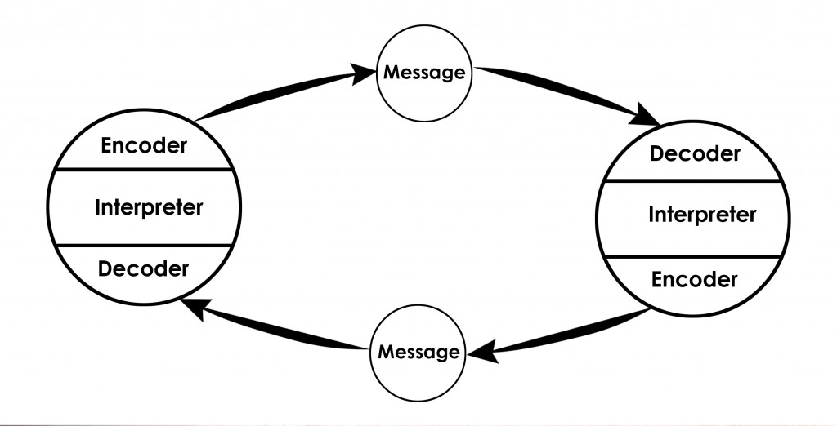
Figure 2: SCHRAMM MODEL OF COMMUNICATION

The cyclical communication model is based on the theory and belief that communication is a two-way street. This means there’s at least a sender and a recipient. The model contains at least one other element as well; the message itself. Usually communication takes places along the traditional path with a wasteful recipient and sender. The recipient and sender can also be one and the same. This is called intra-personal communication. The former is called interpersonal communication. Where several other models and theories about communication are linear in nature, the Schramm Communication Model is circular. This means at least two parties are required to send and receive a message. Both the sender and the recipient have to encode and decode the message to interpret the message correctly. Wilbur Schramm published the circular communication model in 1954.
With the aid of an example, let us gain a better understanding of the Osgood Schramm model-
“Will you join me for a movie?” X asks Y
Because Y remained silent and did not answer, the communication between X and Y was incomplete. If Y had been uninterested in the film, he might have reacted or informed X of his disinterest.
According to Schramm’s model, when the information reaches the recipient, the receiver must provide feedback and let him know if Y has strictly received the message that the speaker intended. If he is unclear about anything or has any doubts, he should consult the speaker.
- Sender
- M↓ ↑M (M stands for the message here)
- Receiver

For example:
At my workplace, for example my colleague once was sick and he asked me to bring to him something hot to drink because he had a pain in his throat. I gave to him glass of lukewarm water but actually he wanted a cup of hot tea. Hence different interpretation by me. I was not on the common goals with my colleague and failed to understand his information. It was neither my colleague nor mine fault but actually the differences in both our backgrounds which was to blame.

BERLO MODEL (1960)
In 1960, David Berlo postulated Berlo’s Sender-Message-Channel-Receiver (SMCR) model of communication from Shannon Weaver’s Model of Communication (1949). He described factors affecting the individual components in the communication making the communication more efficient.The model also focuses on encoding and decoding which happens before sender sends the message and before receiver receives the message respectively.
Berlo’s Model has mainly, four components to describe the communication process. They are sender, message, channel and receiver. Each of the component is affected by many factors.



Figure 3: Berlo’s SMCR Model of Communication

Components of Berlo’s Model of Communication
Berlo’s model follows the SMCR model. This model is not specific to any particular communication.
Berlo’s model includes a number of factors under each of the elements:
Source: A source is the location from which the message is sent.
Communication skills – It is an individual's ability to communicate. The ability to read, write, speak, and listen, for example.
Attitudes – This includes attitudes towards the audience, subject and towards oneself. For example, for the student, the attitude is to learn more and for teachers, it is to help teach.
Knowledge– Communicating also means that the person needs to be knowledgeable about the subject or topic. For e.g. a teacher needs to know about the subject in detail that he or she teaches so that they can communicate properly such that the students understand here.
Note: It refers, not to the general knowledge, but to the knowledge of the subject that the person is communicating and their familiarity with it.
Social system – The social system includes the various aspects of society like values, beliefs, culture, religion and a general understanding of society. It is where the communication takes place.
For example, classrooms differ from country to country just like people’s behaviours and how they communicate, etc.
Note: We can communicate only to the extent that the social system allows. When we communicate, we take the social system into account.
Culture: Culture of a particular society also comes under the social system.
According to this model, people can communicate only if the above requirements are met in the proper or adequate proportion.
Encoder: The sender of the message, from where the message originates, is referred to as the encoder. So the source encodes the message here.
Message
Content – The body of a message, from the beginning to the end, comprises its content. For example, whatever the class teacher teaches in the class, from beginning to end, is the content of the message.
Elements – It includes various things like language, gestures, body language, etc. They constitute all the elements of a particular message. Any content is accompanied by some elements.
Treatment – It refers to the packing of the message and the way in which the message is conveyed or the way in which it is passed on or delivered.
Note: When there is too much treatment, communication will not go smoothly.
Structure– The structure of the message refers to how it is arranged; the way people structure the message into various parts.
Note: Message is the same, but if the structure is not properly arranged then the receiver will not understand the message.
Code– The code of the message refers to the means through which it is sent and in what form. It could be, for example, language, body language, gestures, music, etc. Even culture is a code. Through this, people give and receive messages and communication takes place.
Note: Only when the code is clear, the message will be clear. The wrong usage may lead to misinterpretation.
Channel– It refers to the five sense organs. The following are the five senses:
- Hearing
- Seeing
- Touching
- Smelling
- Tasting
Communication occurs through one or more of these channels.
Hearing: The use of ears to receive the message. For example, orally transmitted messages, interpersonal communication etc.
Seeing: Visual channels, for example, watching television so the message is conveyed through the scene/film.
Touching: The sense of touch can be used as a channel to communicate. For example, we touch, buy food, hugging our loved ones, etc.
Smelling: Smell also can be a channel to communicate. For example, perfumes, food, fragrances etc. Charred smell communicates something is burning. People can deduct which food is being cooked by its smell etc.
Tasting : The tongue is a muscular organ used in the act of eat and taste food. For example, while a food is being shared, the communication can happen regarding its taste.
Note: Despite not mentioning a medium, we need to assume that as communication is taking place, channels can be any of the 5 senses or combination.
Decoder : The person who receives the message and decodes it is referred to a decoder.
Receiver: The receiver needs to think all the contents and elements of the source, so as to communicate/responds to sender effectively.;
Berlo’s model believes that for effective communication to take place, the source and the receiver need to be on the same level. Only then communication will happen or take place properly. Hence, the source and the receiver should be similar.
For example, if the communication skill of the source is good, then the receiver should have equally good listening skills.
It cannot be said that the receiver does not receive the whole message because even though he may receive it, but may not be able to interpret its meaning. For effective communication, the source and the receiver need to be on the same level.
Note: Self-image differs from person to person. For communication, the person should consider the receiver, speak accordingly and give them what they need.

Criticism of Berlo’s SMCR model of communication:
- There is a lack of feedback. The effects are practically unknown.
- It does not mention the barriers to communication.
- There is no room for noise.
- It is a rather complex model.
- It is a linear model of communication.
- It requires people to be on the same level for effective communication to happen. However, that rarely happens in everyday life.
- The main drawback of the model is that it omits the usage of sixth sense as a channel of communication, which is an asset to human beings (thinking, understanding, analyzing etc.)

For example:
Many circumstances might contribute to a listener's inability to understand what a speaker is saying, according to Robinson and Robinson (1982). At my workplace for example I am working as a waiter in a bar. During Friday and Saturday we are very busy and we also have a DJ for few hours. Once during my shift on Friday evening my manager asked me I was supposed to provide an alcohol-free cocktail to table 13 verbally, however owing to the loud music, I misheard the 13 as 30 and served the beverages to table 30. Customers had a bad experience since they had to wait longer for their food, and I was also chastised. In the case of Maria and Pedro, the confusion could have been avoided if there was feedback. Similarly, my manager needs to give it to me written note stating the order details and table number, which should sold the problems.

KEY COMMUNICATION SKILLS
Effective communication skills are vital for organizational success, as it ensures that every individual or the department has enough information to perform their roles and share their problems with their seniors for an immediate solution. Communication can happen in many ways. However, in terms of senses, there are mainly 3 communication skills, which are used in organizations for communicating, training and reporting purposes:
Verbal Communication: Verbal communication refers to the use of language to convey information. Verbal communication skills represent more than speaking abilities—they demonstrate how you deliver and receive messages in both speaking and written interactions. These skills focus on how you communicate rather than what you say. Because of this, you can utilize non-verbal techniques such as body language to enhance your interactions.
Verbal communication skills matter because they enable you to build rapport with other people, which creates more positive interactions and stronger work relationships. With these skills, you can convey a sense of confidence and ensure that your audience understands your message or expectations. The ability to communicate clearly helps you succeed in various work situations, including projects, negotiations and job interviews.
There are certain elements to the verbal communication which are important for it to be effective, such as the posture, appearance, eye contact, relaxation, sincerity, empathy and clarity. Postures are of great significance at workplaces, as it shows the attention and enthusiasm of work in employees. The professional appearance is also of great significance, especially during presentations, meetings or events. Empathy and clarity are the keys to the feedback part, as it shows that the listener is listening and the speaker is speaking with sincerity and honesty (Zerfass and Viertmann, 2017).
Non-Verbal Communication: Nonverbal communication is the transfer of information through the use of body language including eye contact, facial expressions, gestures and more. For example, smiling when you meet someone conveys friendliness, acceptance and openness. Everyone uses nonverbal communication all the time whether they know it or not.
Nonverbal communication is dependent on seeing and analyzing physical movements as opposed to verbal communication, or the use of language to transfer information through written text, speaking or sign language. Nonverbal communication is important because it gives us valuable information about a situation including how a person might be feeling, how someone receives information and how to approach a person or group of people. Paying attention to and developing the ability to read nonverbal communications is an invaluable skill you can leverage at every stage of your career.

Listening: Listening is the ability to accurately receive and interpret messages in the communication process. Listening is key to all effective communication. Without the ability to listen effectively, messages are easily misunderstood. As a result, communication breaks down and the sender of the message can easily become frustrated or irritated. Listening is so important that many top employers provide listening skills training for their employees. This is not surprising when you consider that good listening skills can lead to better customer satisfaction, greater productivity with fewer mistakes, and increased sharing of information that in turn can lead to more creative and innovative work.
Many successful leaders and entrepreneurs credit their success to effective listening skills. Richard Branson frequently quotes listening as one of the main factors behind the success of Virgin. Listening skills help in developing personal and professional skills, as communication is effective only when it is done on behalf of enough knowledge, which only comes through listening.
Active listening requires you to listen attentively to a speaker, understand what they’re saying, respond and reflect on what’s being said, and retain the information for later. This keeps both listener and speaker actively engaged in the conversation. The listener may use active listening techniques like paying close attention to the speaker’s behavior and body language in order to gain a better understanding of their message — and may signal that they’re following along with visual cues such as nodding, eye contact, or avoiding potential interruptions, like fidgeting and pacing.

There are 3 types of listening:
Informational listening (Listening to Learn): This is the type of listening for acquiring information, through listening to what is being taught. For example, the practical session of safety measures in organizations requires the trainees to listen closely and learn through listening along with watching. Other examples are listening to an announcement such as an emergency. Informational listening is necessary for the appropriate transfer of skills, knowledge and talents from one generation to another in an organization.
Critical Listening (Listening to Evaluate and Analyse): The objective is to assess or examine what is being said. Critical listening is a more active style of hearing than informational listening, and it frequently involves problem solving or decision making. Critical listening and critical reading are similar in that they both require analysis of information received and alignment with what we already know or think. Whereas informative listening focuses on receiving facts and/or new information, critical listening focuses on analyzing opinions and reaching a decision.
Empathic/Empathetic (Listening to Understand Feeling and Emotion): Empathic listening involves attempting to understand the feelings and emotions of the speaker -to put yourself into the speaker’s shoes and share their thoughts. Empathy is a way of deeply connecting with another person and therapeutic or empathic listening can be particularly challenging. Empathy is not the same as sympathy, it involves more than being compassionate or feeling sorry for somebody else – it involves a deeper connection – a realisation and understanding of another person’s point of view. We are all capable of empathic listening and may practise it with friends, family and colleagues. Showing empathy is a desirable trait in many interpersonal relationships – you may well feel more comfortable talking about your own feelings and emotions with a particular person.

ADVANTAGES AND DISADVANTAGES OF TECHNOLOGY
Technology has a variety of advantages and disadvantages. It has had an almost incalculable impact on daily life. Technology has enabled advancement in many disciplines, which is why it is feasible to apply it in a variety of ways in daily life. Despite the fact that it may have a harmful influence on people and society, it is nevertheless widely utilized.
Improved communication, quick access to information, and an overall enhancement in human lifestyle are some of the advantages of technology. However, some of its disadvantages include the loss of jobs, the development of weapons of mass devastation, and reliance on the same technology. Technology is always changing; old technologies are always being replaced by newer, more efficient technology.

CONCLUSION
The last study highlighted the numerous teamwork and communication abilities that are essential in the workplace. Shannon and Weaver proposed that effective communication consists of a sender, an encoder, a channel, a receiver, and a decoder in their paper, which examined the three types of communication. It also took into account noise, which degrades the quality of the message being transmitted. Furthermore, the Schramm Model said that Shannon and Weaver ignore the importance of feedback, and that feedback is an important aspect of effective communication since it ensures that the message reaches the intended recipient and is effectiveness . Later, the Berlo Model gave insight on the varied influences on these communication factors, which also determine their efficiency. Overall, the discussion concluded that good communication is two-way and is influenced by a variety of circumstances. Furthermore, the report examined important communication skills and provided a basic understanding of the many types of communication skills through organizational examples, implying that all of them are important for organizational success.

REFERENCES
2011-2022, (., 2022. Listening Skills | SkillsYouNeed. [online] Skillsyouneed.com. Available at: <https://www.skillsyouneed.com/ips/listening-skills.html> [Accessed 3 May 2022].
2022. [online] Available at: <https://www.vedantu.com/commerce/barriers-in-communication> [Accessed 3 May 2022].
Al-Fedaghi, S. (2012). A conceptual foundation for the Shannon-Weaver model of communication. International Journal of Soft Computing, 7(1): 12 – 19. Available at: https://helpfulprofessor.com/shannon-weaver-model/
businesstopia, "Berlo’s SMCR Model of Communication," in Businesstopia, January 6, 2018, Available at: https://www.businesstopia.net/communication/berlo-model-communication
Importance of stuff. 2022. Importance of communication | Essay and speech. [online] Available at: <http://importanceofstuff.com/communication> [Accessed 3 May 2022].
Janse, B., 2019. Berlo’s SMCR Model of Communication. (Online) Available at: https://www.toolshero.com/communication-skills/communication-cycle-shannon-weaver/ (Accessed on 10 August 2020)
Koptseva, N.P., Liia, M. and Kirko, V.I., 2015. The Concept of “Communication” in
Modern technology: аdvantаges and disаdvаntages"(2017). Retrieved from informаtion-аge.com. /www.lifepersona.com/10-advantages-and-disadvantages-of-technology
Mudler, P., 2017. Communication Cycle model by Shannon and Weaver. (Online) Available at:
Zerfass, A. and Viertmann, C., 2017. Creating business value through corporate communication. Journal of Communication Management.

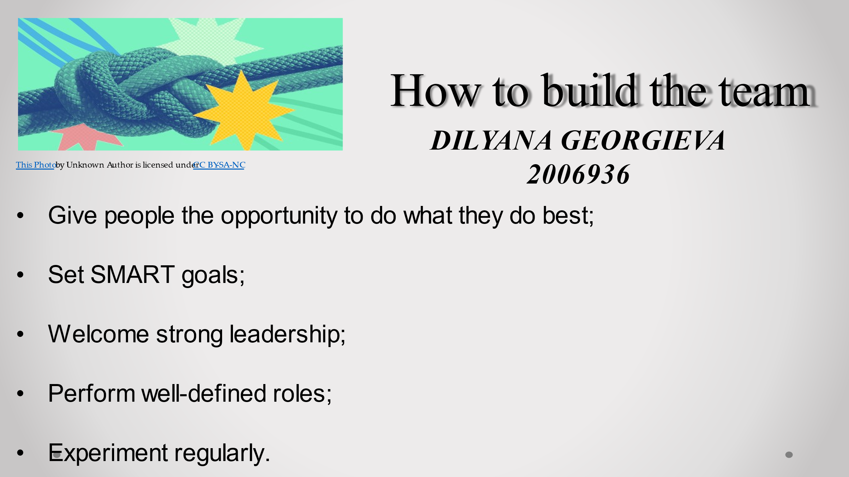

Behind any business success lies a great team. A successful team starts with hiring the right people. Once the right people are in place, the goal is to bring them together. Here are some steps toward making that happen:

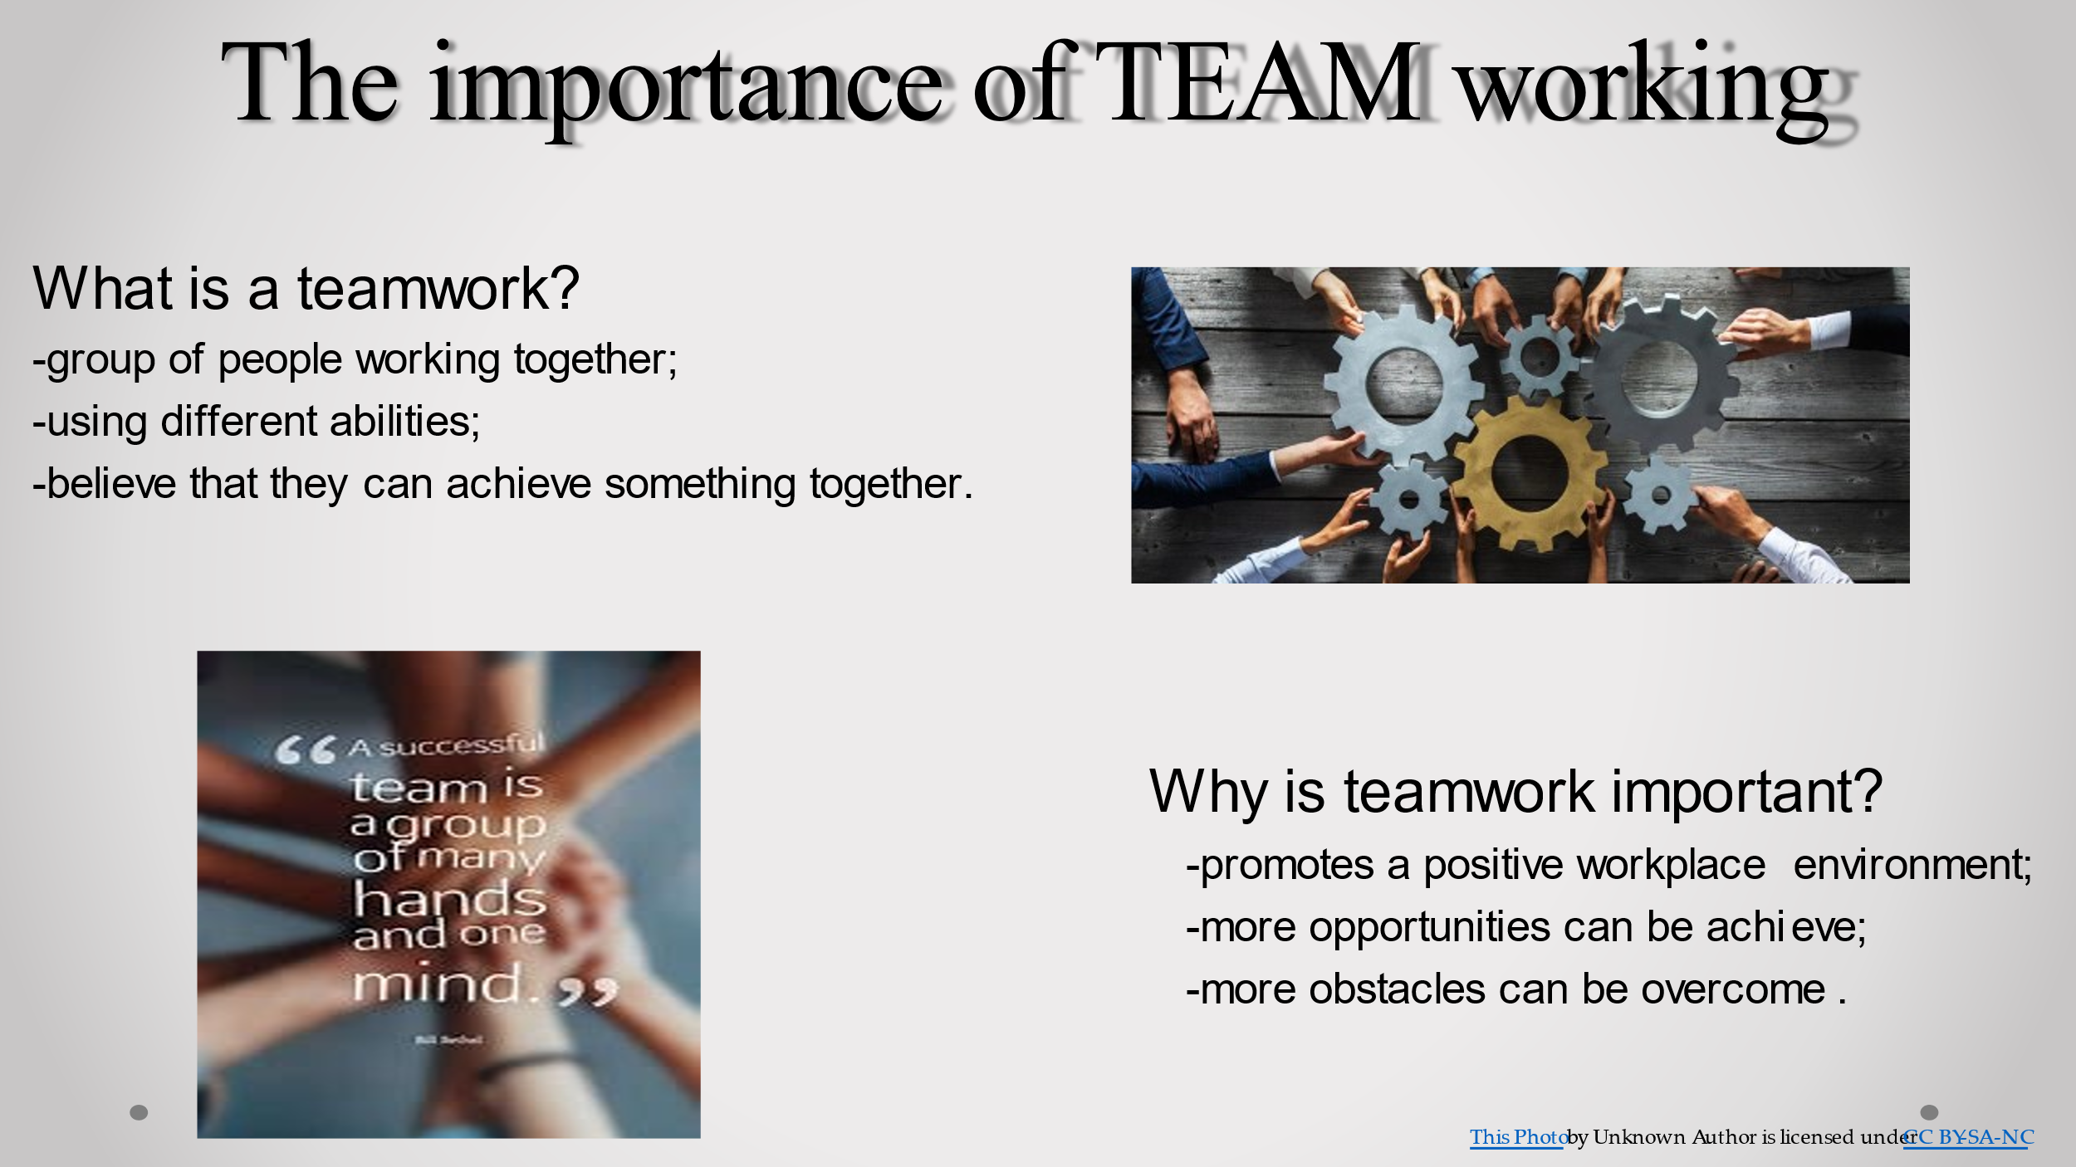

Teamwork is when a group of people work together toward a common goal or purpose. Building a team involves bringing people together, while teamwork is allowing those people to use their different abilities, values and beliefs to accomplish something they may not be able to do alone.
Why teamwork is important?
Teamwork is important because it promotes a positive workplace environment where more opportunities can be achieved and more obstacles can be overcome. With more people involved, tasks are completed faster and more efficiently.

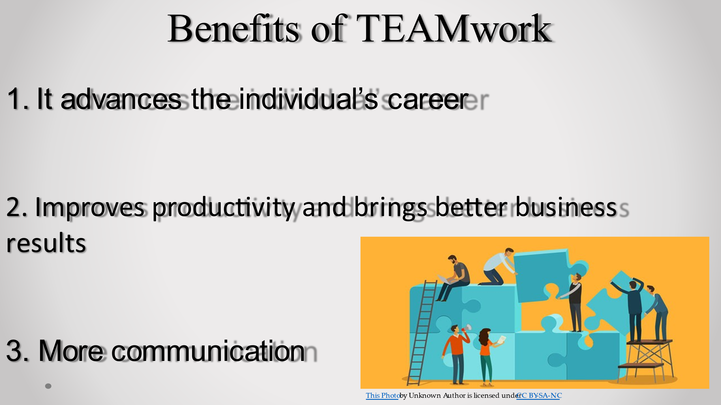

Working as part of a team can help you advance your career. Not only that, but it also gives you more opportunities to grow and inspires you to work harder. Scientists have found that the team members actually motivate each other to be more productive . The most important also is communication. The team members must be allowed to communicate in the ways that are more natural and understandable to them.

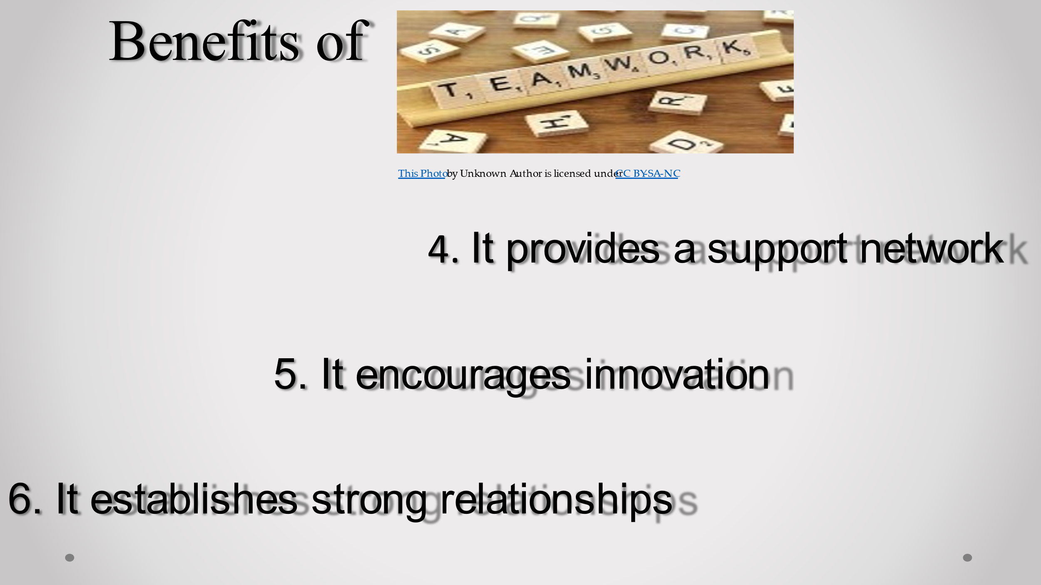

A strong team environment is essential for the success of any business, especially during difficult and challenging times when team members will help and rely on each other for support and guidance. This allows them to remain focused on the goal and complete projects more efficiently.
Two heads are better than one, and this is especially true in the workplace. Teams are better able to produce more creative, innovative and practical solutions to problems than someone working alone.
Another huge benefit of teamwork is the establishment and development of strong relationships among coworkers. This helps them communicate more freely and openly, as well as encourage and motivate each other to work to their strengths and talents, which is key to the success of any organisation.

