Lidl LTD – Profile of the organization

Lidl is a German retailer with a global footprint and a nearly 50-year history. The company's evolution has been marked by rapid expansion throughout Europe in recent decades, and since 2017 in the United States. It is one of the top ten food traders in the world, with operations in 29 countries and over 215,000 employees. Lidl is one of Europe's largest chain shops, with over 100 logistics facilities supplying around 12,000 outlets. (Lidl.co.uk, 2021) The company is part of the Schwarz Group, which also includes the hypermarket chain Kaufland. Schwarz Group had a revenue of € 125.3 billion in the fiscal year 2020/2021. For the same fiscal year, Lidl reportedly achieved a sales increase of 9.9 percent to 96.3 billion euros. (Manager-magazin.de, 2021)
The fruit trader Südfrüchte Grosshandel Lidl & Co caught the attention of Joseph Schwarz, making the latter become a business partner in 1930. It was the birth moment of what will later become The Schwarz Group. Being a visionary of his times, he proceeded to expand the business into a general food wholesaler. World War II brought the end of Schwarz company but, unwilling to give up, a ten-year reconstruction period began soon after. It joined Heilbronn based retailer chain, A&O. In 1973, the first Lidl discount store opened its door, adopting a concept which was very similar to the one of competitor Aldi. Following Josef’s Schwarz death in March 1977 , his legacy has been taken over by his son, Dieter. Under new management, Lidl &Schwarz switched their attention to cash and carry wholesale markets, cheap marketplaces and larger supermarkets. (Scribd.com, 2021)The Lidl chain had a number of 30 discount stores in 1977. Due to a legal battle with co-owner A. Lidl, Dieter had to purchase the right to use the Lidl name from retired teacher Ludwig Lidl for 1,000 German marks. The group's prosperity was built on the success of the Lidl bargain markets. Initially, Schwarz focused his attention on replicating Aldi’s concept. Lidl proceeded to establish itself as a new, strong brand, having a wider selection and bigger stores compared to its competitors. The German discounter market was no longer a dream, but a reality and Lidl was now competing against other names such as Aldi, Plus, etc. Lidl’s expansion began north from its southern German base, and then it made it into other European countries, a successful project. The chain of 179 Handelshof and Kaufland supermarkets which Schwarz opened in the new German states within a few years of the Berlin Wall's fall have also proved to be important for the Group’s overall expansion. As a result, the company rose to the top of the supermarket industry.
According to their German website, Lidl, as a sustainable freshness discounter, stands for the highest quality at the best price, as well as a quick, easy, and dependable shopping experience. They strive to be the first choice for their customers, staff, and partners at all times and rely on fairness and eye-level communication. “We run our firm on a straightforward and uncomplicated system, and as a result, we provide one of the finest value for money. As a hybrid brand, we are connected to our customers: our large food and non-food variety compliments our stationary business approach.” (Germany, 2021)
The company works intentionally in the interests of people and nature, and they are constantly striving to improve in the areas of environmental and climatic protection, employees, social commitment, and product range. Lidl owns the “Silvercrest” brand, which manufactures household gadgets such as satellite receivers and Freeview receivers.
As an international corporation, they are conscious of their size and public visibility. Respects and values the diversity of cultures and their values and traditions. Their work is guided by the following company and leadership principles:
• “Our activity is oriented towards customer satisfaction”
• “The superior ratio between quality and price is what defines our position on the market”
• “We respect the legislation in force and the internal regulations”
• “In our daily work, we assume economic, social and environmental responsibilities”
• “Correctness towards each employee is an imperative”
• “We respect and support each other”
• “We fulfil our commitments in a climate of mutual trust”
• “Appreciation, recognition and criticism must characterize our daily work climate”
• “We have well-trained employees, filling a position is ensured in each department”
• “Being a chain of stores, we work in a systematic set”
• “Quick decisions and simple working procedures ensure our success” (Scribd.com, 2021)
Lidl's mission in the UK is to offer their customers on a daily basis, in areas in their immediate vicinity, quality products at the best price, directly from manufacturers, in a wide variety of assortments.
Lidl is a company that operates sustainably in all areas of activity. This is the company's way of fulfilling its promise of quality and at the same time securing the future for Lidl and society. The company is actively involved in solving the needs of the communities it belongs to, within the 5 central pillars: product range, environment, society, employees, and business partners.
Lidl, like any other commercial firm of this type, seeks to expand into new markets by offering high-quality products at competitive costs. Furthermore, the products delivered by Lidl must be stored and given to the recipients in the best possible condition. In addition to the core goal, the company has several distribution goals, as well as the creation of excellent shopping environments in Lidl stores. These goals are the following :
- High flexibility to travel from one point to another as rapidly as needed;
- Total distribution control;
- Adoption of transport strategies by own means;
- Products arranged neatly and in a variety of colours;
- Storage spaces as large as possible to always secure the products' existence.

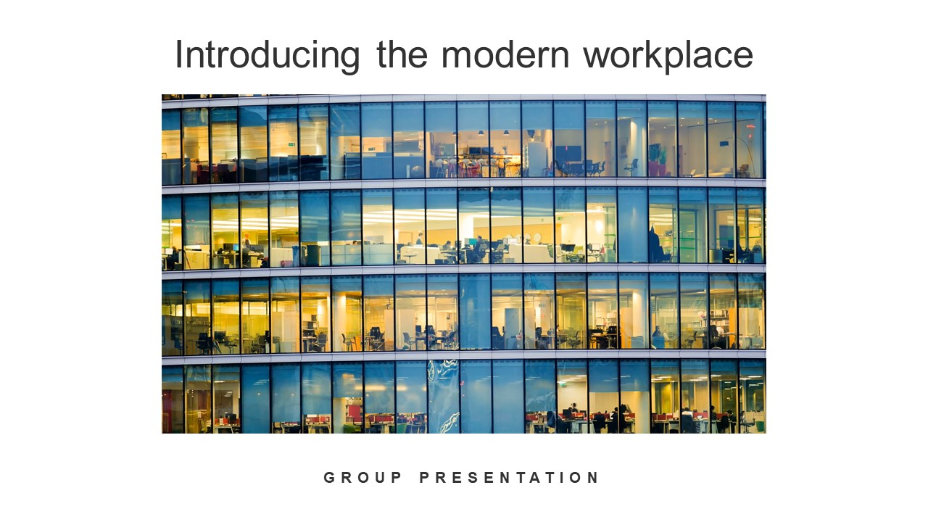

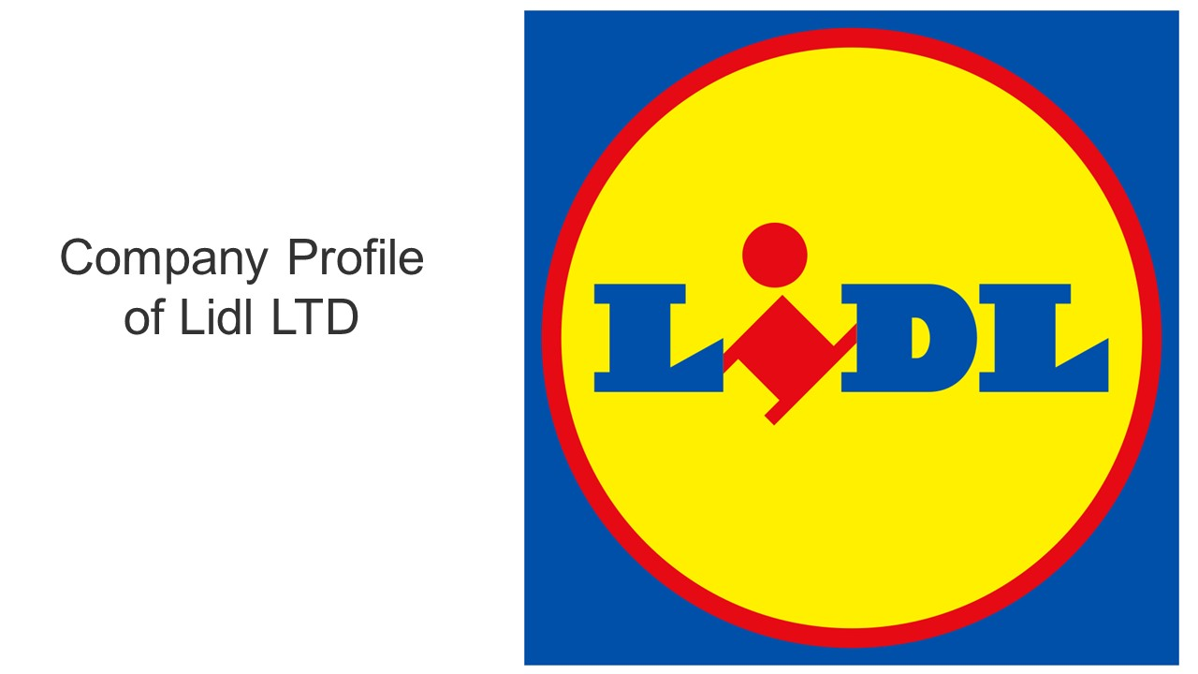

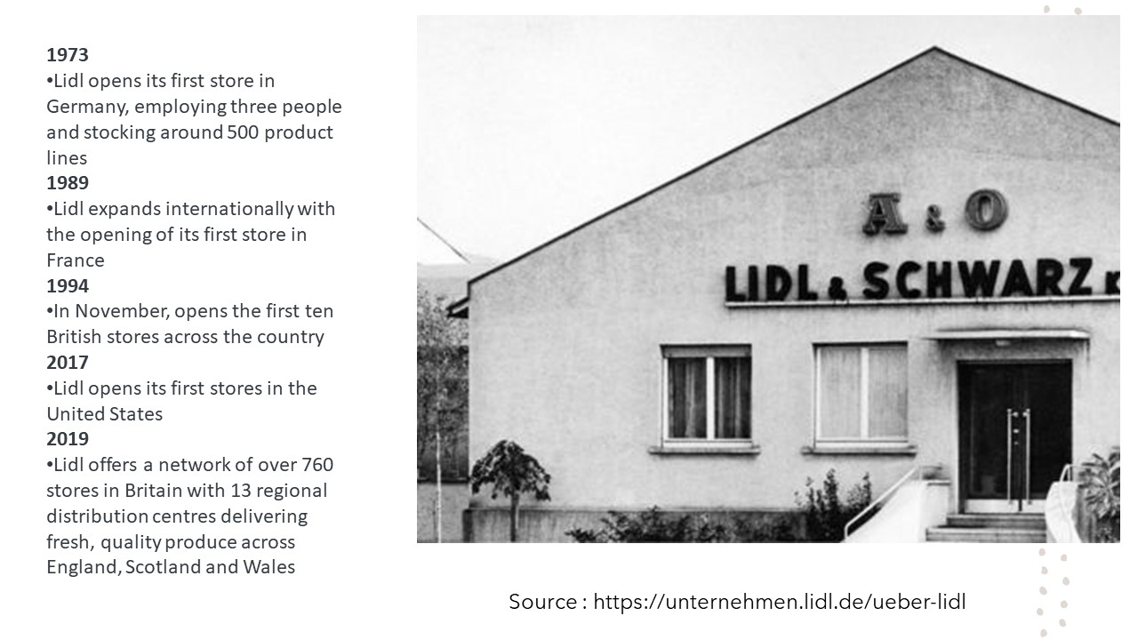
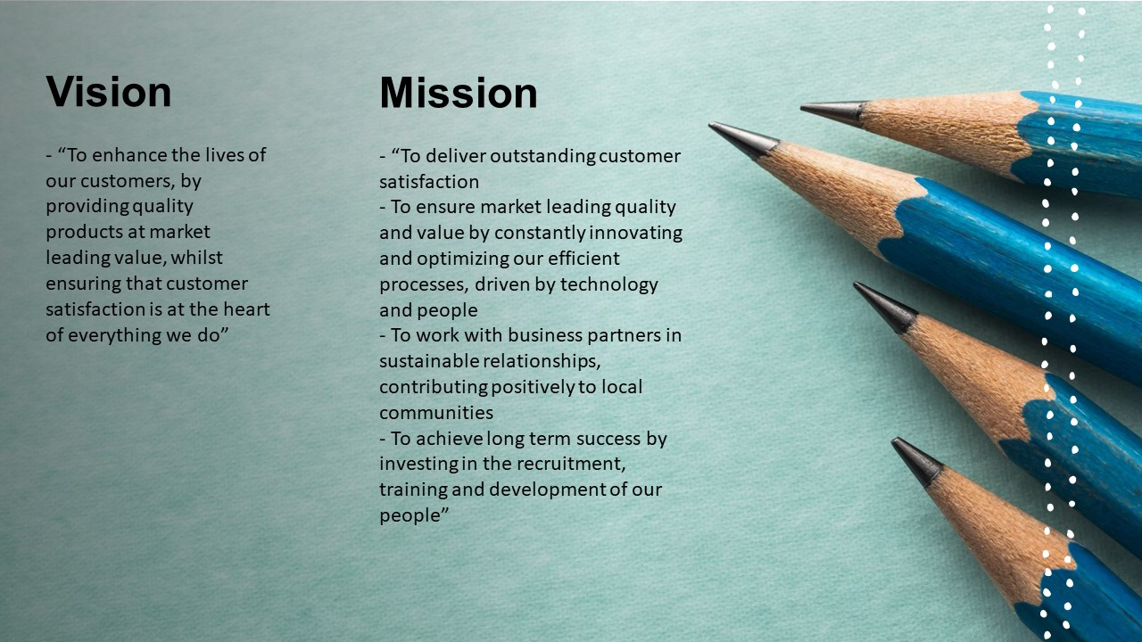

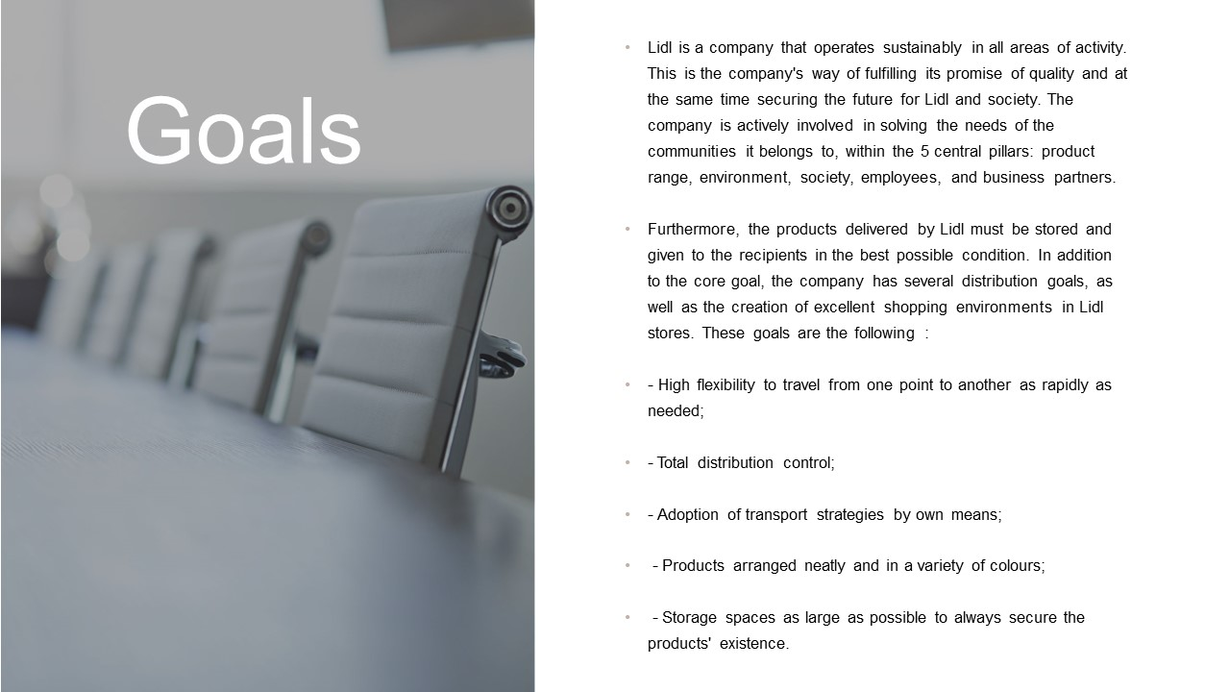

References :

Lidl Campaign 2021. [online] Available at: <https://www.attac.de/archive/lidl/www.attac.de/lidl-kampagne/content/background/Lidl_UNI_Commerce_background_paper.pdf?cv=1> [Accessed 9 August 2021].
Lidl Corporate 2021. [online] Available at: <https://corporate.lidl.co.uk/?_ga=2.197727787.523480869.1628503986-1696841688.1628503986> [Accessed 9 August 2021].
LIDL Germany 2021. [online] Available at: <https://unternehmen.lidl.de/> [Accessed 9 August 2021].
Lidl Website 2021. [online] Available at: <https://www.lidl.co.uk/about-us> [Accessed 9 August 2021].
Magazin, m., 2021. Schwarz-Gruppe: Lidl und Kaufland steigern Umsatz auf 122 Mrd. Euro im Gesamtjahr. [online] Manager-magazin.de. Available at: <https://www.manager-magazin.de/unternehmen/handel/schwarz-gruppe-lidl-und-kaufland-steigern-umsatz-auf-122-mrd-euro-im-gesamtjahr-a-d977f1e7-b69e-43f1-b32d-127f01f70abe> [Accessed 9 August 2021].
Scribd.com. 2021. [online] Available at: <https://www.scribd.com/document/338032507/lidl-proiect?fbclid=IwAR3Sgypxm3Gn4pMrOGmg6ACHDmOqIHwYQH_ZIBIbHyYHdUTuVkHlDn1I-Ms> [Accessed 9 August 2021].
Scribd.com. 2021. [online] Available at: <https://www.scribd.com/document/211333065/Tr-0708-CaracterizacaodeAldieLidl> [Accessed 9 August 2021].

