Certificate of Higher Education in Skills for the Workplace
Employability and Career Development (LCLM4005)

Component 1 - Mock Interview Assessment

Job Applied For: Assistant Manager – Pieminister Birmingham

Student name: Xenia- Giorgiana Anghel
Student ID: 2438527

Contents
Job Advertisement 3
CV 6
COVER LETTER 8

Job Advertisement

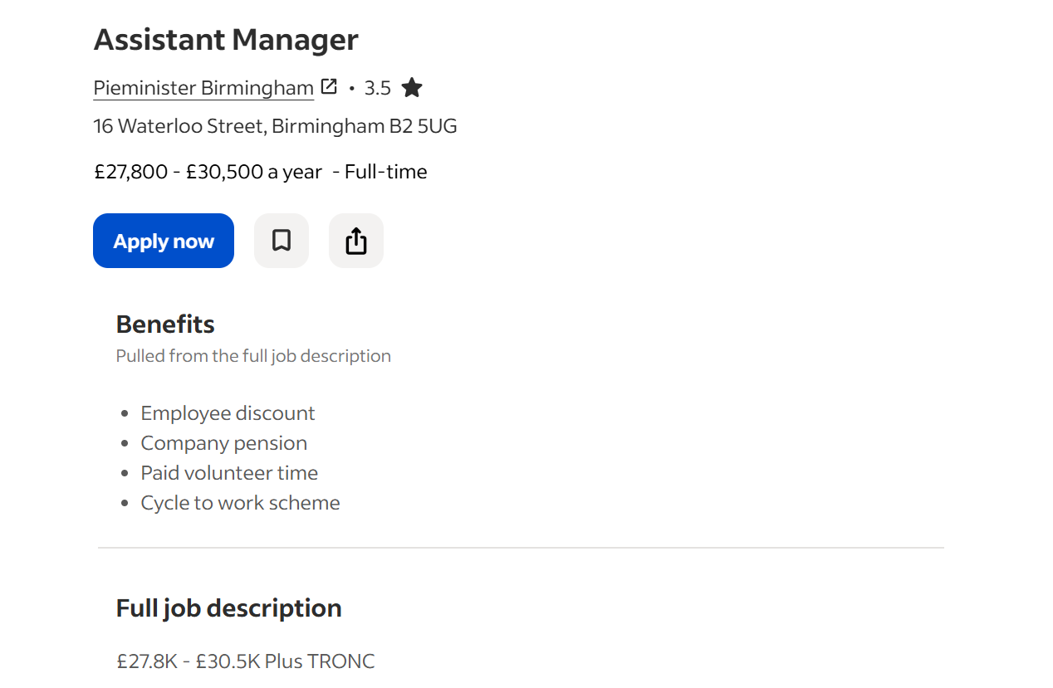

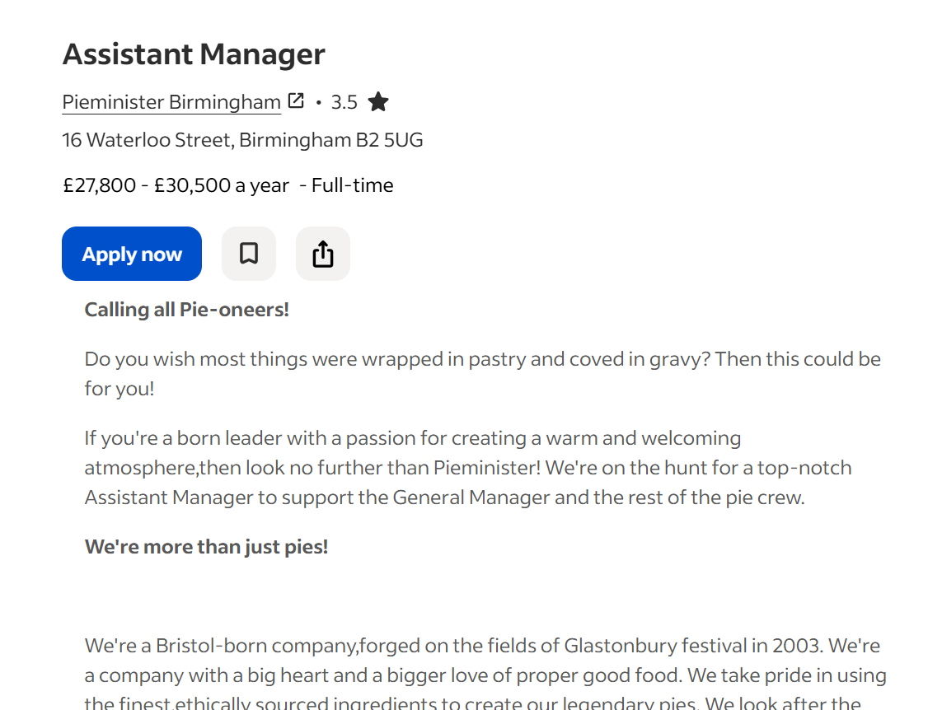

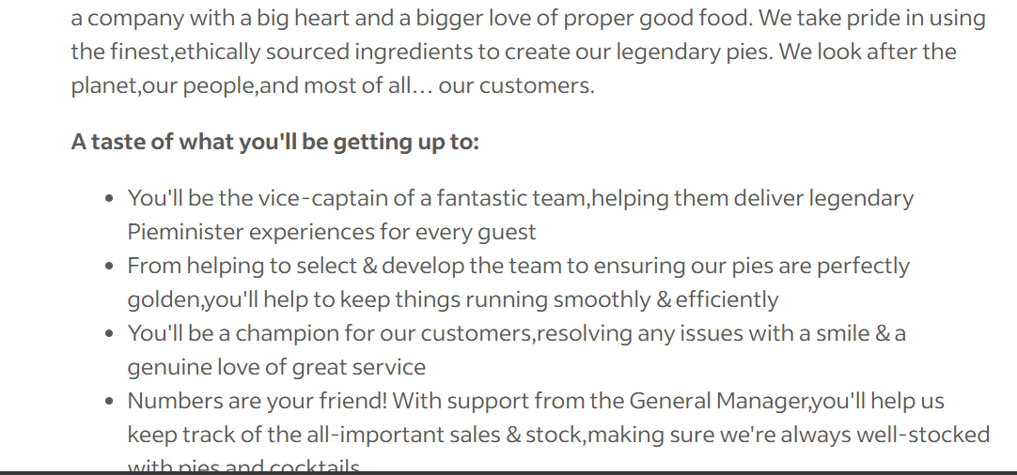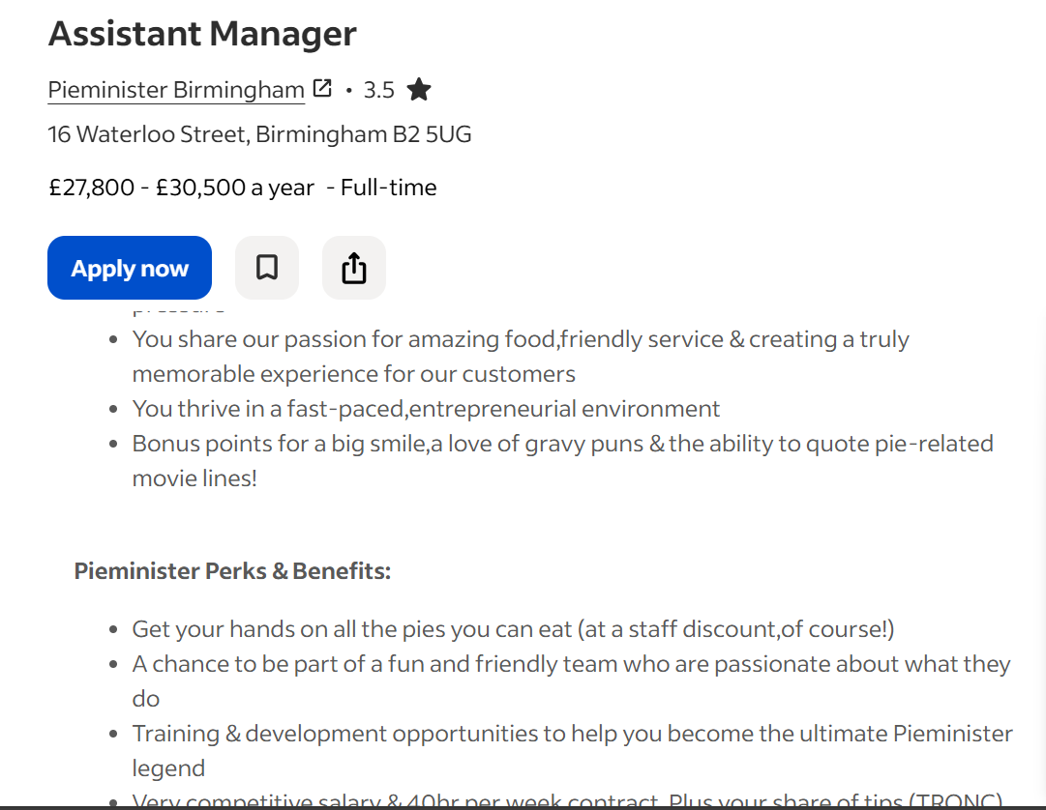
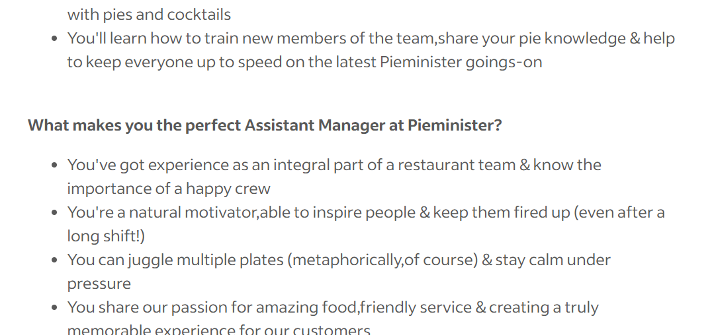
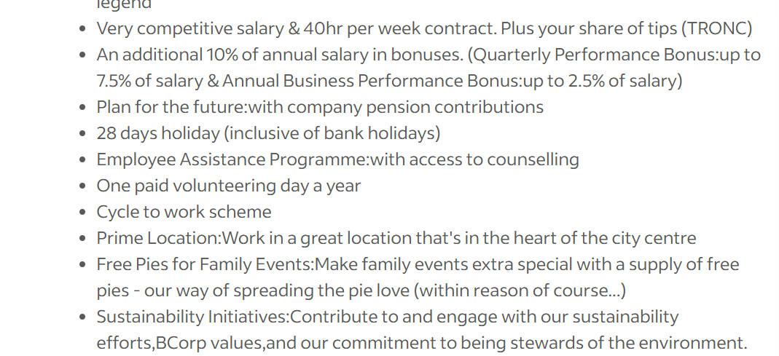

CV
Xenia- Giorgiana Anghel
Birmingham, UK
Phone: +44 7436 530130
Email: 2438527@student.uwtsd.ac.uk
Career Profile
Business Management candidate with an emphasis in hospitality leadership and restaurant operations. I dedicate myself to delivering exceptional customer service while supporting my team members to reach their objectives during their active work activities. I have acquired knowledge about operations management, financial planning and team coordination because I want to establish a successful hospitality company in the future. Self-started, flexible and willing to expand in a fast-paced restaurant environment.

Key Skills
- Teamwork and collaboration
- Leadership potential and team motivation
- Customer service awareness
- Ability to work under pressure
- Strong organisational skills
- Basic sales and stock awareness
- Communication and presentation skills
- Problem-solving mindset
- Time management

Education
Business Management
University of Wales Trinity Saint David Birmingham
Present
Acquired knowledge on team leading, customer value generation, cost management and company analysis.
Academic Experience
Group Business Project & Presentation
Participated in a team approach towards the creation of a business idea, including market research and financial analysis. Played a major role in this process of planning, organization and presentation. Strong communication, teamwork and ability to perform without stage fear.
Volunteering Experience
Volunteer Support – Local Independent Restaurant
Supported front-of-house duties, preserving pleasant environment for customer visits. Assisted with stockroom organization and monitored day to day activities. Developed a real-life view of service etiquette, the value of collaborating with others and what it’s like to work in fast-paced hospitality.
Additional Information
- Strong interest in hospitality and restaurant management
- Flexible and adaptable to shift work
- Willingness to undertake further training and development
- Long-term ambition to build a career in hospitality management

COVER LETTER
Xenia- Giorgiana Anghel
Birmingham
2438527@student.uwtsd.ac.uk
+44 7436 530130
[17th February 2026]
Hiring Manager
Pieminister
16 Waterloo Street
Birmingham B2 5UG

Re: Assistant Manager Position - Pieminister Birmingham
Dear Hiring Manager,
I am writing to show my interest in becoming the Assistant Manager at Pieminister Birmingham. Being business management student with special interests in hospitality leadership, I am excited to play a role on your team while gaining management experience in a fast-paced and customer-oriented setting.
My academic work has taught me about operations management and business finance and organisational behaviour which helped me understand how leadership effectiveness and cost management and team coordination systems impact business success. Your advert shows that you need to build teams which will run the business and track both sales performance and inventory levels. The subject areas align with my academic education and my career objectives.
I have gained experience through my academic work, and I have also volunteered at a local independent restaurant to learn about front-of-house operations and how to provide top-notch service in a busy restaurant setting. I have worked on group business projects which required me to present ideas while helping with team organization to build my leadership required communication and teamwork abilities.
I will contribute my high level of motivation to my flexible nature and my goal to progress in hospitality. I want to build my career in restaurant management, so I believe the Assistant Manager role at Pieminister provides me with the ideal environment to develop my leadership skills by supporting your team to success.
Thank you for considering my application. I want to discuss how my skills and commitment will support Pieminister Birmingham to reach its upcoming targets.
Yours sincerely,
Xenia-Giorgiana Anghel

