

Module: Challenges of Sustainability

Assessment 1

Is it Possible to Achieve Net Zero through Circular Economy in the Automotive Industry

  - By Qahtan Al-Mahrooqi
  - Student No: 2206054

In September 2015, 192 countries around the world pledged to meet the targets of the Sustainable Development Goals (SDG) by the year 2030 (Refer to figure 1). The SDGs are split into 17 goals and 169 targets made to cover various sustainability aspects such as preserving the earth and protecting it from the environmental issues, improving human wellbeing and implementing equality, decarbonizing business, and making them green. One of the major global sustainability issues is Climate Change which is caused by human activities. Businesses are facing difficulties in becoming more sustainable. Take the transportation sector for example, which is responsible for 24% of CO₂ emissions from energy by itself as per Our World in Data (Refer to figure 2). Our World in Data also mentioned that the entire transport sector accounts for 21% emissions. As per Figure 2 below, road travel is responsible for 74.5% of the emissions caused by transport. Many of the vehicle manufacturers have promised to meet the SDG targets by 2030. However, the transportation industry still lacks serious action to make it sustainable and net zero. Luckily, research and development have illustrated methods such as circular economy to mitigate the negative environmental effect caused by the transportation sector in providing sustainable solutions, which will ultimately create the ideal future we are hoping to see.
Figure 1: SDG
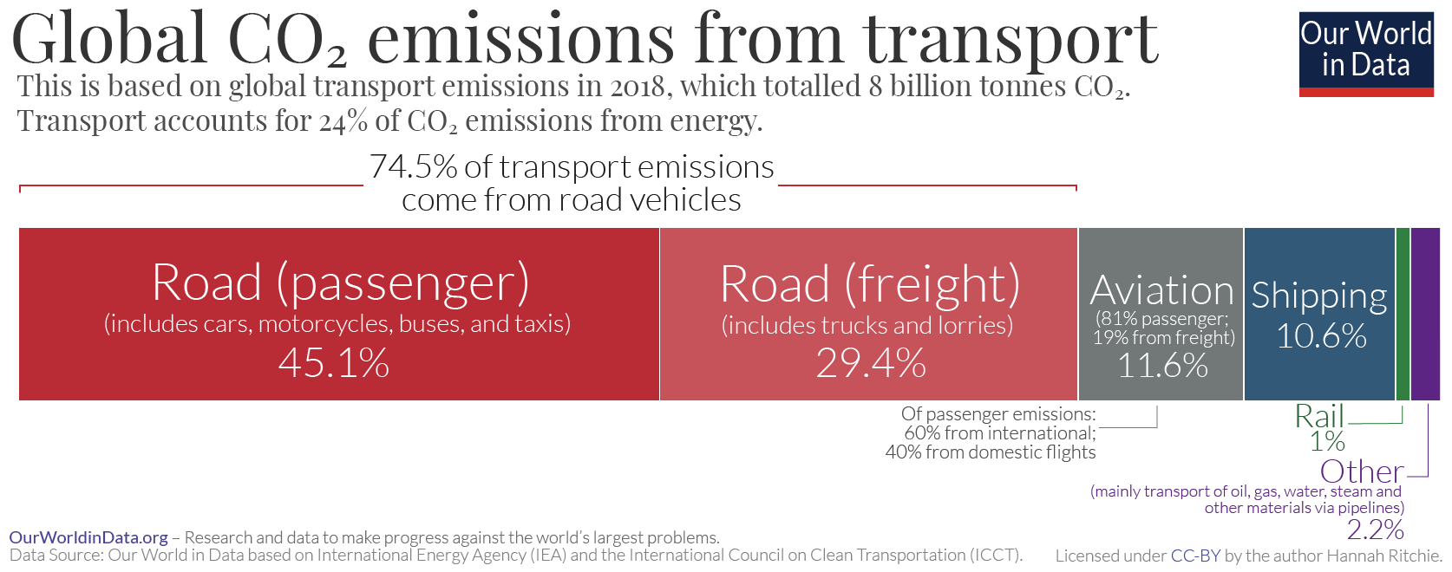
Figure 2

Before we talk about the transportation industry and how its business can achieve net zero through circular economy, we first must understand why the industry is not sustainable in its current stage. As mentioned earlier that in transportation, 74.5% of the carbon emissions comes from road vehicles. Several countries and vehicle manufacturers have pledged to meet the SDG targets by 2030. This is going to be achieved by replacing Combustion Engine Vehicles with Electrical Vehicles. As per We Mean Business Coalition article, Tesla for example have calculated that 550,000 of their sold EVs have been driven 10 billion miles which resulted in savings of 4 million metric tonnes of carbon emissions. It also mentioned that Global automakers plan to invest $300B USD in developing Electrical Vehicles technology.
For the world to transition from Combustion Engine Vehicles to Battery Electrical Vehicles we need to compare both manufacturing processes. According to the discussion between Thomas, Jenz and Claus related to the Circular Car Initiative, that the life cycle of a Combustion Engine Vehicle total emissions is split into 80% emissions while using the vehicle and burning fossil fuels for the long run, 20% emissions are linked to the materials. Where on the other hand, only 40% of the emissions of Battery Electrical Vehicles relate to the use phase and if we live in an ideal world where green renewable energy is used that BEVs can reach close to zero emissions. The main problem is the production phase of BEVs where Green House Gas emissions caused by the manufacturing of batteries will increase by the factor of 1.5 to 2 times the norm. This is because battery production is a very energy intensive process.
If we also look at scope 3 of carbon emissions, which indirect emissions in the production of vehicles, we can reduce the manufacturing process carbon emissions by following a circular economy method and create a cycle where materials are used to make a product and then it is used, finally it is recycled and goes back to the production line (Refer to Figure 3). Unlike a Linear Economy method that disposes resources at the end of its cycle which cannot be replenished.
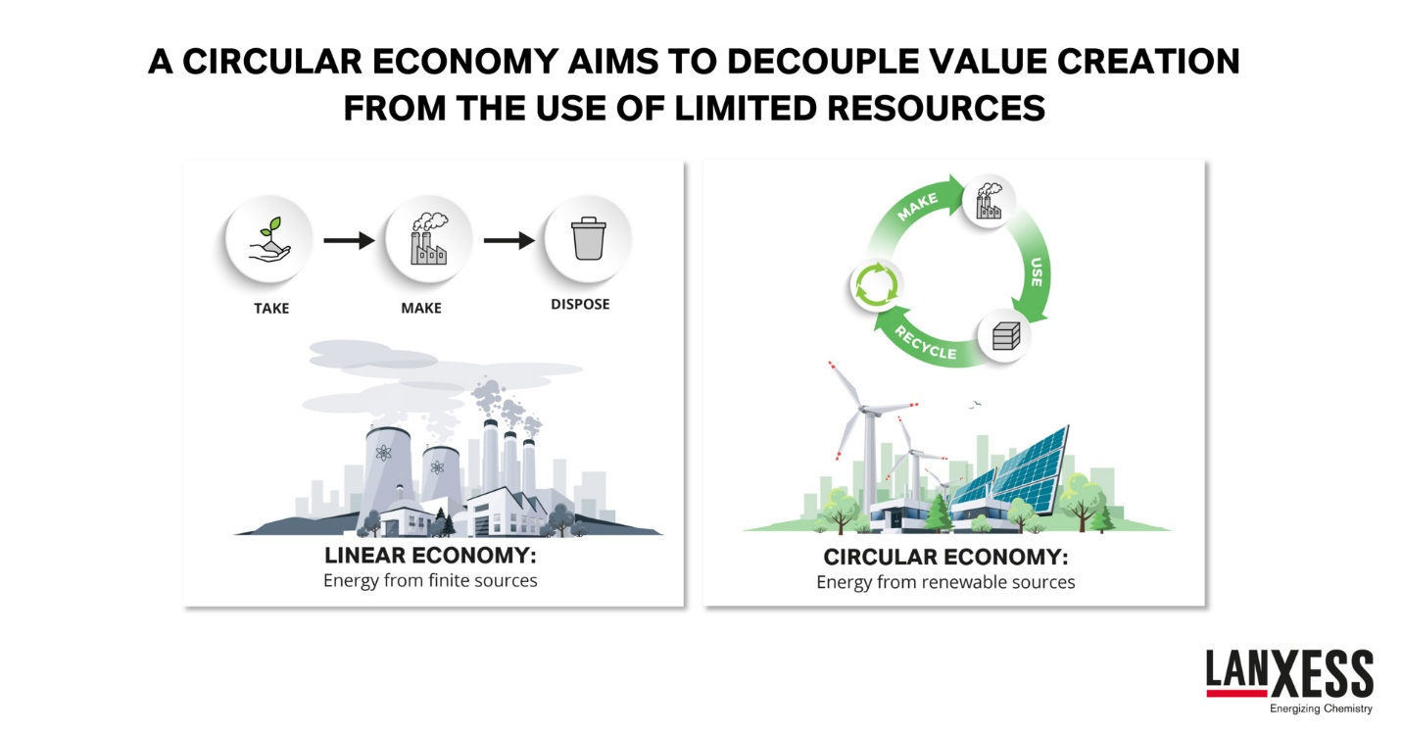
Figure 3

Figure 4 Below illustrates how LANXESS Engineering uses different approaches to achieve Circular Economy. First, we have the Reuse or Repair Method where products are reused if they are in a good shape after the user phase and repaired if necessary. The second method is Mechanical Recycling which is basically separating the materials using mechanical means and then reuse them in product production. The third and final method is Chemical Recycling which is breaking down materials which are chemically bound into chemical building blocks to make them valuable for the chemical industry again.
Figure 4
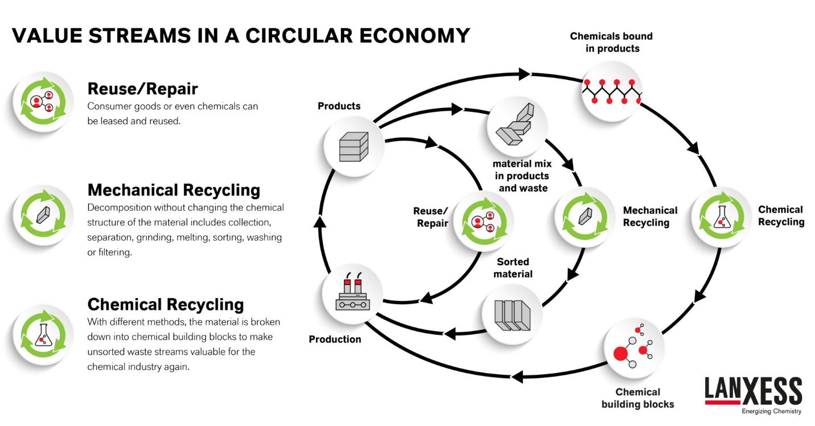

Circularity help reduce manufacturing related emissions of a car manufacturer. If the above-mentioned method of Circular Economy is used carefully it may be able to reduce carbon emissions by extending the life cycle of materials. This can only be achieved if the manufacturing plants use green renewable energy.
67% of Battery Electric Vehicles (BEVs) are currently charged with non-renewable energy. If BEVs are to be sustainable for the long run, a huge renewable energy infrastructure is required which is currently unavailable. The promising solution to replace BEVs are Fuel Cell Electric Vehicles (FCEV). FCEVs produce electrical power by fuel cell technology which is a chemical reaction of Hydrogen and oxygen. FCEVs are considered is the Zero-Emissions vehicles since the only thing that comes out of the exhaust pipe is pure water. Unfortunately, Hydrogen is expensive to produce since it requires electricity or fossil fuels. If Hydrogen were to be produced using renewable energy such as solar, hydro or wind power, it would have made FCEVs the best choice when Hydrogen is more affordable to produce. The idea is amazing, but it is not a good for the present period since there is no infrastructure for green Hydrogen as a fossil fuel. Instead, researchers have advised that Hybrid Electric Vehicles are much better for the time being since they have small Lithium batteries unlike the fully BEVs which use larger batteries and cause a lot of emissions during the manufacturing process as mentioned above. Hybrid Electric Vehicles can be utilised until an infrastructure for FCEVs is ready. Toyota for example have made two strategies for net zero. The first is a mid-term target by 2030 aligning with the SDGs. Where they have six targets. The first being new Vehicle Zero Carbon Emissions by selling 5.5 million Electrical vehicles annually, including one million zero emission vehicles FCEVs. While the second was focused on a strategy of the Life Cycle Zero Carbon Emissions which is a goal to reduce carbon emissions by 25% for its vehicles life cycles compared to their record in 2013. The third strategy goal was related to their manufacturing Plants Zero Carbon Emissions where they intend to reduce their plant carbon emissions by 35% by 2030. Minimizing and Optimizing Water Usage in four plants. Establishing a Recycling Based Society, where Toyota have claimed that by 2030, they will complete the establishment of battery collection and recycling systems globally, and also establishing 30 model facilities that match local facilities for end-of-life vehicles to receive appropriate treatment and recycling. Lastly, the final challenge is Establishing a Future Society in Harmony with Nature, which will be achieved by collaborating with local communities and firms, also by Toyota mentioned that they will continue to contribute to biodiversity conservation activities in collaboration with NGOs, and that they will expand initiatives to encourage environmentalists to take responsibility for the future of the planet.
Hydrogen fossil fuel is the renewable green energy of the future, and many countries are investing in it. The future is bright and there are already Hydrogen plants in China to meet the demand of the FCEVs. Also, the largest Green Hydrogen plant is going to be built in Duqm Port, Oman. It will produce 330,000 tonnes of green ammonia by 2027 to meet the global demands. Global commitments are being actioned to reach the Sustainable Development Goals by 2030.

To conclude, there is a possibility for automotive manufacturers to reach net zero by using circular economy. However, it is not going to happen in the current period unless the automakers manufacturing plants follow a circular economy method. FCEVs using green renewable Hydrogen are the future for the automobile industry to achieve net zero. But the goal is far from reach because of the infrastructure required. Achieving net zero in all human activities must be looked at seriously. Toyota’s initiative of the sustainable challenges and the goals it has set as a company to reach net zero is very encouraging and promising. Our planet has suffered a lot from the human activities and especially during our generation. We wish that more companies like Toyota will investigate sustainability in such a way and keep an excellent legacy for the future generations. Yes, the strategies will take time and it will not be most of these businesses will not be fully sustainable by 2030. But we could only hope that they are at least trying to do good for the next generations and provide a better environment for them to live in.

References

United Nations website. Link: https://www.un.org/sustainabledevelopment/blog/2015/12/sustainable-development-goals-kick-off-with-start-of-new-year/
Our World in Data Website. Link: https://ourworldindata.org/transport#:~:text=It%20emits%20just%20under%20one,similar%20amount%2C%20at%2010.6%25.
We Mean Business Coalition. Link: https://www.wemeanbusinesscoalition.org/blog/six-companies-helping-to-create-the-zero-carbon-transport-future/
Autovista24. Discussion between Thomas Deloison Director Mobility of World Business Council for Sustainable Development, Jenz-Christian Bald from LANXESS and Claus Zemke from LANKESS website Link: https://autovista24.autovistagroup.com/news/circular-economy-and-the-automotive-industry-zero-carbon-car/
Types of Electric vehicles. Website link: https://e-amrit.niti.gov.in/types-of-electric-vehicles
Oman Duqm Hydrogen Plant: Link: https://timesofoman.com/article/117990-ministry-outlines-plans-to-make-oman-a-global-green-hydrogen-hub

