Leading and implementing workplace change
BA (Hons) Leadership and Management Skills for the Workplace

Contents
Introduction 2
Question 1. Critical evaluation of organization power and politics & how these manifested in the case 2
Question 2: Using two relevant stakeholder analysis models, critically identify the stakeholders and explain how your chosen model is interrelated in the evaluation of critical stakeholders. 4
Question 3: Reflecting on Thomas Kilmann’s Conflict Resolution model, critically evaluate the different resolution approaches and suggest the appropriate approach for resolving the conflict. 8
Conclusion 11
Recommendation 12
References 13

Introduction
The topic which will be discussed in the following sections has a great relevance in today’s world. The news nowadays is mostly full of strikes and disturbances. It is about such a strike which is called by the members of Communication Workers Union of United Kingdom for a demand of due payments which is currently freeze for the year 2021-22 and a pay rise of 2% for the following year (Shelton, 2021). The strike will go on for 24 hours in the 114 Crown Post offices which will, in turn disrupt the services of other 11,500 sub-post offices around the country. There will be no collection of payments and also no cash deliveries. The Post Office authority said that a great majority of the post offices throughout the country will not be disturbed by the strike and the daily works of these offices will go on as usual. They also directed the customers, in case of any problem for the protest, to go the nearest alternative branch, location of which is shared by posters on one can even find them online (Speak, 2021). In the following sections, a thorough evaluation of the above topic will be done by using some related theories.

Question 1: Critical evaluation of organization power and politics & how these manifested in the case
What is power? : In an organizational overview power can be defined as a combination of authority and influence in different events which occurs in the organization and related to the organization. People who have power have a lot of authority to decide or to speak on which as an effect can change the state of an organization. Due to their authority in the organizational behaviour they also tend to have and in most of the cases they do have influence on other members in the organization whether they are down stream in the organizational hierarchy or in the same level (Stephen, et al. 2019). A person who possess with power in an organization sometimes also have influences on other organizations which either serving that organization as a vendor or a service provider in some areas or beneficiary of that organization. Influence and authority can cause organizational change because with power, a powerful person gets control over several parts in the organization. In the given case of having strike in one hundred forty four branches of post office which effected eleven thousand five hundred sub branches of Post office which over the issue of freeze pay due on 2021-2022 financial year and a 2 per cent increment on the next year. With influence of a particular powerful body in the organization of Post office the strike might have constructed an executed.
What are politics? : Politics have many aspects. Politics can be at state or country level. Politics can also be institutional or in organization level. The politics which is confined in an organization or an institution then it is called workplace politics or office politics. Politics is simply systematic and planned utilization of power for achieving a short term or long term goal. That goal can be for the betterment of the organization or can be to benefit and individual or a group of individuals in the organization (Nazir, et al. 2019). Politics can follow different ideologies to achieve the same objective or goal. Politics in simple words is a way which consist of some ideas a protocols. When office politics or work place politics takes place to make some change towards a better present and smoother future of the organization, no matter which ideology it follows it is good for any working environment. But when the same politics is applied to benefit an individual or a group of individuals in the organization depriving others from its positive impact and organizational benefit is ignored then no matter how good or morally rich the ideology is, it is harmful in a greater sense. Office Politics or organizational politics can be an extended political ideology of state politics or can be led by individuals separated from the governmental ideology.
Debate about power and politics in organization: There are several opinions about those power and politics in an organization. Social Power and politics is often ignored by the commons but organizational power and office politics affects the like of a common man working in that firm or organization directly. There are some pros and cons that can occur in an organization with effective and un effective power and politics in a institution or organization. A powerful person can become good leader who can influence his subordinate positively and make the organization grow better. But in the other hand a powerful boss often become a bully boss to his or her subordinates (Fish, 2018). A powerful leader or person in any organization can become a pioneer for those who are under his or her influence. But at the same time a miss leading and manipulation can also take place. Politics is a real important subject is any organization or society or institution. Politics is more like a game that can include exercising power to amend any decision taken by the organization in a advantageous manner. Constructive politics helps the organization to grow and become advanced. Some people argue against the organizational politics that politics in work places should not be allowed or tolerated as it deprives persons who are not politically advanced. But the other half pledge in for politics that every one should have his or her freedom to choose and think about the future and they should be free to exercise their power to achieve that keeping in mind that others should not be affected by the same (Buchanan, et al. 2020).
Argument on how power or politics manifested in the case: In the given case where the employees of one hundred and forty four post offices has gone on a strike. There financial grievances about the freeze in the last years pay and that promised 2 per cent increment in the next year is strong enough for their anger. Now come the roles of power and politics. Though the workers had their own anger since last year it was not well directed to result into a strike before this. There is probably a strong powerful individual or group of individuals who have provided fire in the pool of gasoline to cause this strike (Ogbar, 2019). There can be political interests behind this event. It is clear that when 114 post offices shopped there operations there would not be any regular operation in the 11500 sub branches across the state. It shall effect in the service area to its customers especially in the emergency services. Though the Post office authority has given a statement that there would be smooth and regular operation in 11000 sub branches out of 11500 sub brunches and in the closed brunches the approaching customers shall be notifies about the next or nearest post office. The political players are probably has a vision that acute inconvenience would force the Post office authority to call up on an increment and clear the freeze payment. So it eventually clear that Power and politics is manifested in the given case of strike Post offices.

Question 2: Using two relevant stakeholder analysis models, critically identify the stakeholders and explain how your chosen model is interrelated in the evaluation of critical stakeholders.
The positions of stakeholders are very important for any organisation to work efficiently and productively. The organisation in the world has numerous and diverse types of stakeholders (Liu,et al., 2020). The stakeholders can be similar or different from one organisation to another. The tasks and jobs of stakeholders also change and vary depending on the type of organisation they are working for and the kind of work done by the organisation. Therefore, the stakeholder is an essential component of all businesses, organisations, companies and institutions. The stakeholders, therefore, require close analysis and they need to be maintained with care. The stakeholders' analysis is not an easy task as it requires skills and analytical thinking. There are numerous models which are used for the purpose of analysis of stakeholders and their tasks. There are several tools which can be used in evaluating the job roles of stakeholders and determining their share of power in an organisation or institution. Government organisations or institutions also consist of stakeholders just as private companies and firms are also comprised of their stakeholders (Chowdhury and R., 2021). Without the stakeholders, the organisations or businesses of the world would never have sustained in the contemporary world of challenges and changes.
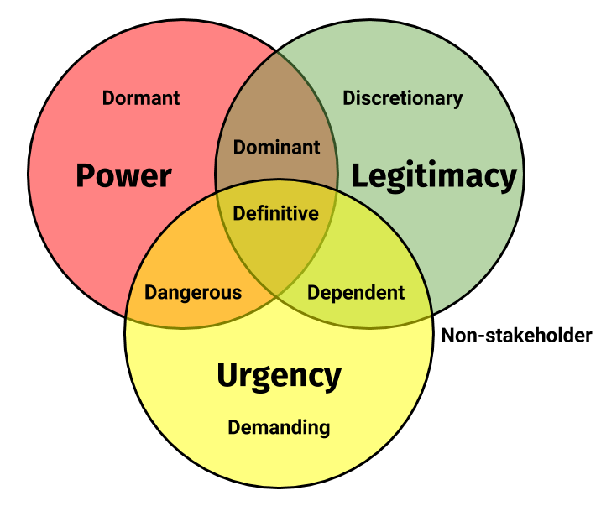
Fig: Salience Model Of Stakeholders (Ludovico,et al., 2020)
The above figure shows the Salience model of stakeholders. It can be found that this model has three circles. All the three circles are intersecting each other. The three circles denote- power, legitimacy and urgency. The three circles have a common portion that is denoted as ‘definitive’ (Ludovico,et al., 2020). The Power circle has ‘dormant’ in it. The legitimacy circle has ‘discretionary’ in it. Both power and legitimacy intersect at a portion and has a common portion which is denoted as ‘dominant’. The urgency circle has ‘demanding’ in it. Both urgency and power circles intersect and have common areas which are denoted as ‘dangerous’ (Tseng,et al., 2022). Both the legitimacy and the urgency circle intersect and has a common area which is denoted as ‘dependent’. Therefore, the above model categorises the stakeholders depending on three parameters, that is, power, legitimacy and urgency. Stakeholders are categorised under the power when they have the ability and the purpose of influencing the organisational outcome. Therefore, these stakeholders have the capability to impose their decisions based on their will. The stakeholders who have high authority and have major engagement with the organisation or institution are categorised under the parameter of legitimacy. The stakeholders who require urgent action are categorised under the category of urgency. According to the above model, there are seven types of stakeholders. The dormant stakeholders; are those who have high power in the organisation but they lack legitimacy or urgency. Therefore, these stakeholders need to be handled carefully but need not be involved deeply. The discretionary stakeholders are the ones who are legitimate and have authority but have low power and urgency. These stakeholders need to be involved but not too much. Demanding stakeholders are the ones who always seek attention but these stakeholders need to be controlled and commanded on the basis of the need of the organisation or the institution. The dominant stakeholders are those who have power as well as authority. Therefore, in the model, these two parameters overlap each other. These stakeholders are most important and their engagement in the organisational activities in all aspects is very essential. The stakeholders who are dangerous stakeholders have a mixture of power and urgency. Therefore, these stakeholders are crucial for the improvement and development of organisational activities or business operations. The stakeholders who are categorised under dependent stakeholders come under the parameters of legitimacy and urgency. These stakeholders are sometimes useful and therefore they need to be kept satisfied. The definitive stakeholders are the most important stakeholders according to this model. These stakeholders come under all three parameters, those are, power, legitimacy and urgency. This type of stakeholder needs to be given the highest priority and importance. They need to be kept informed and engaged. They also need to be satisfied within the organisation or institution. Therefore, the definitive stakeholders should be given the highest attention in the organisation or the institution. According to the above model the stakeholders need to be analysed and categorised according to the above-mentioned three categorised. The core group of the stakeholders needs to be given the highest category. The next level of priority should be given to the dominant, dangerous and dominant stakeholders as they have any of the two overlapping parameters. The least priority can be given to the stakeholders who are discretionary stakeholders, demanding stakeholders and dormant stakeholders. Using the salience model for analysing the stakeholders has several benefits through this model deep insight can be get and potential stakeholders can be identified. Through the three parameters, this model reduces complications and makes it more straight (Gyepi-Garbrah,et al., 2022). However, the disadvantages of using this model include that analysing with this model requires too much time. Stakeholders frequently move from one category to another and then it becomes more complex for the users of this model for the purpose of analysis. The model can result to be biased toward some of the stakeholders. Therefore, the classification and identifications and determinations can be sometimes incorrect or inaccurate. There are many more models which can be used for the purpose of analysing the stakeholders and categorising them according to certain parameters or basis. However, it should also be noted that the non-stakeholders are also important and analysing the positions and performance of the non-stakeholders are also an important factor for any organisation or business firm or company to establish successfully and sustain itself in the market or society working effectively.
One of the effective tools for stakeholder analysis is the power interest grid of stakeholders, which is also called the stakeholders' analysis matrix. The stakeholders' analysis matrix is known to be a highly efficient tool for analysing the stakeholders of an organisation or company. A stakeholder analysis matrix is used to analyse the interests of stakeholders in a given system and how their interests should be considered in a project policy plan or any other activity (Maqbool,et al., 2022). Thus this system is used to assess a number of changes that the given group or organization would adopt based on the interests of the various stakeholders present. This analysis, with a careful assessment, makes sure that the interests of all the stakeholders associated with the organization or group are taken into consideration and that no interest of one stakeholder overrides the other. The stakeholders' analysis matrix can be utilised to assess the post office system and the interests of the various stakeholders associated with it. In this context, this model will assist to assess the current system of the Post Office and how to consider the interests of the various stakeholders that are a part of the system.
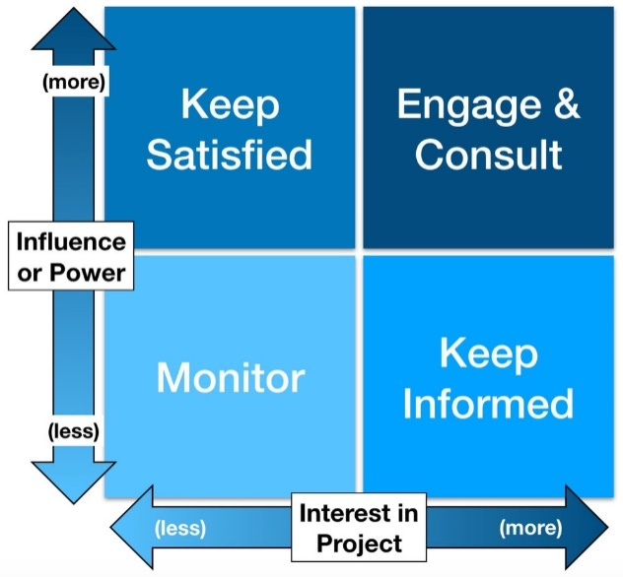
Fig: Stakeholder analysis Matrix (Maqbool,et al., 2022)
The above image shows a basic Stakeholder Analysis model. There are various types of mapping systems of the stakeholders' analysis model. The above figure shows a power-interest matrix where the stakeholders are divided into categories depending on how their interests are to be addressed in a given policy or plan. It divides the stakeholders into four different categories, the ones who would be considered the most important stakeholder and are to be kept satisfied, the ones who would be engaged and influenced closely and actively, the ones who would be monitored with minimum effort and the ones who are to be only informed and not provided with too much information. In a post office system, the stakeholders include postmasters, sub-postmasters, community representatives, staff, consumers and operators. Depending on the interests of these stakeholders, they can be put in the different categories of the Stakeholder analysis model shown above.
The various stakeholders associated with the post office can be categorised in the following manner; the first and foremost category that has to be served and kept informed sufficiently are the customers. For the success of any organization, the satisfaction of the customers is of utmost importance, because they are at the receiving end of the service (Gago,et al., 2022). Their feedback not only helps in the improvement of the system of an organization, but the positive feedback also helps in drawing the attention of more customers and also other stakeholders. Henceforth, the customers will fall under the “keep satisfied” category because their interests must be of utmost importance to the post office. The second category of “engage closely and influence actively” will mainly include the employees of the Post Office. For the smooth functioning of any organisation or institution, it is necessary to keep a careful watch and influence the workers. In the Post Office, there are various employees with different posts, including, community representatives, staff and operators. The community representatives are responsible for keeping in contact between the customers and the organisation. Thus is it crucial to monitor the community representatives to ensure that they are going by the principles of the organization, following all regulations and are sufficiently providing good service to the customers as required? There are several operators and staff in a post office that assists in the functioning of the structure. They help in the operation of all the processes, whether it’s physical work or technical jobs. The Post Office has to make sure that these staffs and operators go by the rules and regulations of the office, maintain a professional work environment and put their labour into working efficiently. All the employees must also maintain a cordial relationship with the customers so that they receive maximum satisfaction from the service. The main crux of the work of a post office is done by the postmaster. There are various sub-post offices under the main post offices and the in charge of these post offices are the sub-postmasters. It is crucial for the post office to have influence and engage these sub-post offices and the sub-postmasters in charge of these offices to ensure its smooth and proper running. Thus, the sub-postmasters would also fall under the category of “engage closely and influence actively”. Therefore, the employees' interests would be assessed accordingly.
The stakeholders in a Post Office who would fall under the category of “minimum effort monitoring” could be the service providers. These include workers in the post office who were distributed work by a post office employee. Since these workers also contribute to the functioning of the post office, it is important to monitor them, although with the minimum effort since they do not fall directly under the system of the Post office. Thus, any worker or stakeholder (except suppliers), who does not directly fall under the system of the Post Office, but in some way contributes to the service-providing process of the post office, must be monitored with minimum effort. The last category, that is, the ones whose interests are to be least entertained are the suppliers. The suppliers would have interests of their own which might not align with the interests of the Post office. Thus, it is important to only keep them informed of the processes and services of the Post Office of only as much as is necessary. If the suppliers are provided with too much information, they might try to influence the pricing structure of the Post Office, for instance. Thus their interest is to be least considered among all the other three categories. Applying this Stakeholder Analysis Matrix the interests of the Post Office stakeholders can be analysed and assessed which will enable the Post Office to look into the issue of conflicts. In this context, it is the issue of the 24-hour strike that is organised by the members of the Communication Workers Union. The grievances of the workers over the issue of frozen pay can be addressed by an assessment of the interests of the various stakeholders associated with the Post Office, and based on such an assessment, crucial and effective changes can be brought about by the Post Office to resolve the crisis and address the grievances of the workers.

Question 3: Reflecting on Thomas Kilmann’s Conflict Resolution model, critically evaluate the different resolution approaches and suggest the appropriate approach for resolving the conflict.
Scholars and researchers such as Kenneth Thomas and Ralph Kilmann were the ones who developed a model for resolving conflicts. Every great and tiny organisation in the world faces challenges which lead to conflicts. Therefore, conflict management is an essential factor for every organisation or institution. Thomas Kilmann’s Conflict Resolution model is an important development which is an approach to resolving the conflicts of an organisation or institution. Before, discussing the resolution approach it is important to know the cause of conflicts. Conflicts occur when there is any dispute or any kind of disagreement. These conflicts are, therefore, the result of any kind of misunderstanding and disagreement regarding notions, decisions, principles, actions, etc. Therefore, the causes of conflict can range to numerous levels. In this following section, several conflict resolution approaches are discussed and the main focus is on then Thomas Kilmann’s Conflict Resolution model.
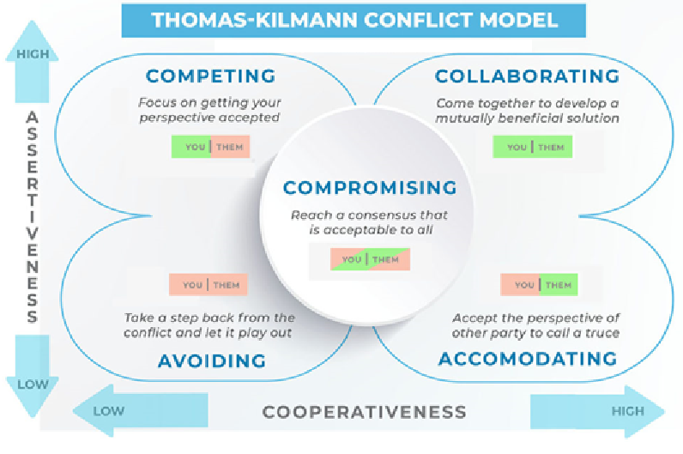
Fig: Thomas-Kilmann Conflict Model (Zhang,et al., 2020)
The above model shows Thomas Kilmann’s Conflict Resolution model. Through this model, it is possible to understand the different important aspects which need to be observed and taken care of to reduce conflicting tendencies and can resolve existing conflicts. As the above model depicts there are two dimensions of managing conflicts or disputes, one is assertiveness and the other one is empathy. The above model shows that these two dimensions, assertiveness and empathy, produce five strategies for the resolution of conflicts or disputes (Zhang,et al., 2020). Assertiveness is a dimension, according to the above model, which is indicating to the capability to come up and stand out to speak and express opinions and ideas. This dimension can be handled in both ways, that is, in a positive manner or in a negative manner. Therefore, assertiveness is a dimension which focuses on an assertive nature and it can have a positive purpose or negative purpose. Assertiveness is a dimension which seems to be violent or aggressive, but it is actually a straight and effective way of expression.
Whereas the other dimension, that is, empathy is a different dimension which is contrary to the assertiveness in resolving conflicts. Empathy is a dimension which focuses on stretching the hands of understandability toward others (Delak,et al., 2022). Through the dimension of empathy, one can understand and realise others' ideas and interests. Therefore, it can be said that the dimension of empathy is about resolving conflicts with the help of understanding the feelings and demands of others. This dimension is about realising the other person by wearing his shoes and thinking by putting oneself in the position or condition of the other person. When we put ourselves in others' positions and try to think we understand and can justify their actions and decisions and then the tendency of conflicting or conflicting situations becomes a situation of understanding.
As shown in the above figure the two dimensions give roots to five strategies for resolving conflicts, they are, competing, avoiding, accommodating, collaborating and compromising. All these strategies are useful depending on the nature of conflict and the nature of parties involved in the conflict. However, these strategies have their own drawbacks and they might not be helpful in certain situations of conflict. Competing is a strategy which comprises a high dimension of assertiveness but a low dimension of empathy. When we are in a situation where we feel to be assertive and aggressive we avoid understanding the others' point of view as it can illogical or irrational or unethical. This strategy focuses on not cooperating with the parties with whom we are in a conflicting situation. This strategy is more useful when it is used by a person who is in a commanding position. Through this strategy, one can reach their goals but the drawback of this strategy is that it gives birth to emotions which are negative in nature and can have a negative impact on the person who is applying this strategy in handling a conflicting situation. The other negative factor of using this strategy is that it does not allow the person or group of people who uses it to build up a good relationship which the person or group of people with whom he or they are using this strategy. This strategy can lead to the end of the relationship between the parties who were conflicting. The other strategy is avoiding (Joseline,et al., 2022). Through this strategy, one can avoid the person or group of people with whom a conflicting situation might arrive. This strategy comprises a low dimension of assertiveness and a low dimension of empathy. Therefore, this strategy focuses on not being too assertive and not too empathising with the conflicting party or parties. This strategy is used when the authority level is low or the interest is low between the conflicting parties. This strategy is often considered to be a weak strategy for conflict resolution, however, it is often a shrewd way of avoiding major conflicts and being in peace. The other strategy for dealing with conflicting situations is accommodating. Accommodating comprises the high dimension of empathy and a low dimension of assertiveness. This strategy is about giving space or place to others' opinions and consideration of their interests. It is an important strategy which focuses on building a good relationship with the parties or parties with whom one might end up in a conflict. Therefore, allowing others to share their problems or point of view and accommodating their ideas and demands are the basic aspect of this strategy. This is a first-class way to manage conflicting situations. The other strategy of handling conflicting situations is called collaboration as shown in the above figure. Collaboration is about having high aggressiveness and a high dimension of empathy (Raykova,et al., 2020). Therefore, this is a moderate approach toward conflict handling or controlling. This strategy is about bringing a balance between the two conflicting parties. Therefore, through this strategy both the parties gain and lose. A few terms and conditions of one party are implemented or agreed upon by the other party and vice-versa. This strategy is about mutual understanding and balancing. The other strategy of handling conflicting situations is called compromising. This compromising strategy is about choosing the path of the middle. Through this strategy, both the parties have to lose a bit and gain a bit. It is slightly different from the previous strategy, which is collaboration. In collaboration both the conflicting parties collaborated and agreed to collaborate with the ideas and interests of each other. However, in compromising strategy both the parties need to focus on compromising that is to lose some of their demands of opinions and agree to some of the opinions or demands of the other and vice-versa. This compromising strategy usually leads to a win-win situation as both the parties gain and both of them lose.
The members of the Communication Workers Union (CWU) are creating a situation of conflict as their grievances are not heard or fulfilled. Therefore, this kind of conflicting situation needs to be handled carefully. Through the competing strategy, the situation might get worse. The strategy of avoiding is also not applicable in this situation as the public of the country will have to suffer due to the strikes and stagnation of the work of the post office. The post office or the government might take an accommodating strategy to understand the point of view of the post office workers or stakeholders. Thus a proper decision can be taken if an accommodating strategy is applied to handle the conflicting situation.
One of the other effective conflict management models or approaches is presented by Richard Trevino in 2020. According to Richard Trevino, there are five cs which can help in effectively handling situations of conflict or controversy. Richard Trevino has worked in several small companies and even in Fortune 500 companies as a leadership consultant and came up with these five cs based on his experiences and knowledge. According to him, the first step towards efficiently handling conflicts is to carefully listen to both parties of conflict or both the parties should have patience and composure to lend their ears to the grievances and problems or opinions of their opponent. Without this careful listening, the conflicting situation worsens with misunderstanding and complexities. Therefore, even before making decisions regarding how to resolve a conflicting situation, it is important to listen carefully. Through this listening session, both parties get validation of their opinions. It is not about whose idea is better but it is about trying to listen and interpret each other's opinions. The other way of handling the conflicting situation is to considerately look at the situation. It is important to be able to understand nature to reduce conflicts or eliminate them. Therefore, it is not only about listening but also being able to understand the situations of the opponents and their points of view. A careful thinking process and critical understanding are important for effective conflict control. The third ‘c’ denoted calmly discussing the conflicting perspectives. The way we react or respond to a conflicting situation is an important factor. Through personalising the conflict often conflicts can take a turn into being worse. However, often high emotional handling brings down the conflict and comes to a compromising situation as well. Therefore, it is important to have an open mind and a calm mindset to handle conflicts effectively. The fourth ‘c’ denotes conscientiously looking at the facts. Therefore, in a conflict, there are a lot of things which need to be conscientiously read and understood. A logical and ethical approach toward conflict resolution is highly necessary for an effective outcome. Everyone involved in the conflict should get the chance to express their views and facts. Through this, all the parties and the diverse perceptions also come up. With an analytical mind, all these opinions and notions need to be analysed to come up with an appropriate solution to the conflict. The final ‘c’ represents cooperatively working together. This final aspect is about finally making a decision which will be cooperative in nature and compromising in approach. After all, it is important to focus on building good relations with others and work in an integrative way towards overall success and prosperity. To resolve conflicts it is important to have the mindset or intention to resolve the conflict. This cooperative mindset and an open mentality can bring productive results in conflict handling. In this case, the Post Office management should take these considerate steps towards handling the conflict. The workers have all the right to express their grievances and it is also important for the organisation of the Post Office to keep their workers happy and satisfied with their considerate policies.
Collaborating is known to be the best approach or strategy for handling situation of conflict or situations which can lead to conflict or contradiction. Therefore, in handling conflicting or contradictory situations it is important to become more and more compassionate in dealing the conflicting situations and become considerate towards the opinions and situations of others. The Post Office management should, therefore, should come up with solutions which will fulfil the interest of the workers as well as not harm the interests of the organisation, its officials and the public. The organisation should make arrangements through which the workers can complain or suggest their opinions regarding the functioning of the organisation so that situations like strikes can be avoided. The post office and its officials and the workers’ union leaders should sit and listen to each other demands and opinions to come to collaborative solutions which will be beneficial for both parties.

Conclusion
From the above discussion, a lesson can be learned that nobody will ever gain anything over a dispute. And both the party has to take the liability for the problem. In this evaluation, a number of theories are there from which the nature of the dispute can be learnt. It helps to resolve the dispute quickly (Das, 2022). Nevertheless, it will be much better for the concerned parties to avoid clash at all costs as doing this not only harms the authority, but they themselves are also hurt in the process. To achieve stability, they will have to have a lot more dialogues, as this is one of the most effective ways in dealing the problem. There are also mentions of different models, by which the conflict can be bypassed, and stability and peace can be maintained (Acuña, 2022). It will be very welcoming that no issues are there by using the above-mentioned models.

Recommendation
If one can see the whole situation from the perspective of a postal worker, then the authority may be blamed. There are also a few reasons for doing that. Firstly, the pay freeze by the authority impacts its employees directly. And, on top of it, they are doing it for a long time. They must have sympathetic approach for the employees as they are asking for their due amount and give them the revised salary on time. On the contrary, when one sees the whole situation from the angle of the authority, the complexion changes drastically. Then one can find out many new things which are missing in the previous perspective (Yi, et al. 2022). Like, the authority might have some difficulties in giving the dues; it may be in a bad state so it is unable to clear them. In this case, the workers must discuss with the authority before taking such big decision like calling strike.

References
Acuña, F., 2022. The emergence of a political-pedagogical teacher subjectivity: Chilean teachers’ struggle to bring pedagogy back into the political sphere. Education Policy Analysis Archives, 30, pp.106-106.
Ampofo, E.T., Owusu-Ansah, W. and Owusu, J., 2021. Organizational embeddedness and life satisfaction among star-rated hotel employees in Accra: The role of perceptions of organizational politics and job satisfaction. Anatolia, pp.1-15.
Bezshapkin, S., Korzh, R., Verenych, O. and Vasyliev, I., 2021. State-of-the-art Geoinformation Technologies Use in the Road Traffic Management. In ITPM (pp. 217-227).
Buchanan, D. and Badham, R., 2020. Power, politics, and organizational change. Sage.
Chowdhury, R., 2021. Self-representation of marginalized groups: A new way of thinking through WEB Du Bois. Business Ethics Quarterly, 31(4), pp.524-548.
Das, S.P., 2022. Preemptive Strikes, Can We Win the War on Terror? In Economics of Terrorism and Counter-Terrorism Measures (pp. 409-440). Springer, Cham.
Delak, B. and Širok, K., 2022. Physician–nurse conflict resolution styles in primary health care. Nursing Open, 9(2), pp.1077-1085.
Fish, M.S., 2018. When more is less: Superexecutive power and political underdevelopment in Russia. In Russia in the New Century (pp. 15-34). Routledge.
Gago, D., Mendes, P., Murta, P., Cabrita, N. and Teixeira, M.R., 2022. Stakeholders’ Perceptions of New Digital Energy Management Platform in Municipality of Loulé, Southern Portugal: A SWOT-AHP Analysis. Sustainability, 14(3), p.1445.
Gonzalez-Perez, M.A., Cordova, M., Hermans, M., Nava-Aguirre, K.M., Monje-Cueto, F., Mingo, S., Tobon, S., Rodriguez, C.A., Salvaj, E.H. and Floriani, D.E., 2021. Crises conducting stakeholder salience: shifts in the evolution of private universities’ governance in Latin America. Corporate Governance: The International Journal of Business in Society, 21(6), pp.1194-1214.
Gyepi-Garbrah, T.F. and Preko, A., 2022. Paragliding festival: understanding stakeholder perception of environmental attitudes and tourism performance. International Journal of Event and Festival Management.
John-Eke, E.C. and Akintokunbo, O.O., 2020. Conflict management as a tool for increasing organizational effectiveness: A review of literature. International Journal of Academic Research in Business and Social Sciences, 10(5), pp.299-311.
Joseline, I.A., Raj, S.V.M. and Gunaraj, R.J., 2022. A Study On Conflict Management Using Baron Model. IJNRD-International Journal of Novel Research and Development (IJNRD), 7(2), pp.362-373.
Liu, J., Cui, Z., Feng, Y., Perera, S. and Han, J., 2020. Impact of culture differences on performance of international construction joint ventures: the moderating role of conflict management. Engineering, Construction and Architectural Management, 27(9), pp.2353-2377.
Ludovico, N., Dessi, F. and Bonaiuto, M., 2020. Stakeholders mapping for sustainable biofuels: an innovative procedure based on computational text analysis and social network analysis. Sustainability, 12(24), p.10317.
Maqbool, R., Rashid, Y. and Ashfaq, S., 2022. Renewable energy project success: Internal versus external stakeholders' satisfaction and influences of power‐interest matrix. Sustainable Development.
Medvedeva, Y., Kolgan, M., Pasholikov, M., Shevyakov, Y. and Sidorenko, A., 2021. Priority goals for the strategic development of industrial enterprises based on sustainable marketing. In E3S Web of Conferences (Vol. 258, p. 06023). EDP Sciences.
Meng, T.M., 2021. Impact Investing in the Renewable Energy Sector: Stakeholder Salience, Ethical Sensemaking, Institutional Logics, and Identity (Doctoral dissertation, ResearchSpace@ Auckland).
Mitchell, R.K., Lee, J.H. and Agle, B.R., 2017. Stakeholder prioritization work: The role of stakeholder salience in stakeholder research. In Stakeholder management. Emerald Publishing Limited.
Nasr, A.K., Kashan, M.K., Maleki, A., Jafari, N. and Hashemi, H., 2020. Assessment of barriers to renewable energy development using stakeholders approach. Entrepreneurship and Sustainability Issues, 7(3), p.2526.
Nazir, S., Shafi, A., Atif, M.M., Qun, W. and Abdullah, S.M., 2019. How organization justice and perceived organizational support facilitate employees’ innovative behavior at work. Employee Relations: The International Journal.
Ogbar, J.O., 2019. Black power: Radical politics and African American identity.
Popadynets, I., Andrusiv, U., Shtohryn, M. and Galtsova, O., 2020. The effect of cooperation between universities and stakeholders: Evidence from Ukraine. International Journal of Data and Network Science, 4(2), pp.199-212.
Raykova, E., Semerdjieva, M. and Tornyova, B., 2020. Conflict management style in the work of medical specialists in hospitals. Journal of IMAB–Annual Proceeding Scientific Papers, 26(2), pp.3068-3072.
Shelton, J., 2021. Undelivered: From the Great Postal Strike of 1970 to the Manufactured Crisis of the US Postal Service.
Spânu, I.A., Ozunu, A., Petrescu, D.C. and Petrescu-Mag, R.M., 2022. A Comparative View of Agri-Environmental Indicators and Stakeholders’ Assessment of Their Quality. Agriculture, 12(4), p.490.
Speak, E.M., 2021. 11 “Why are the Canadian authorities afraid of this play?”. Performances that Change the Americas, p.202.
Stephen, M.D. and Zürn, M., 2019. Rising Powers, NGOs, and Demands. Contested World Orders: Rising Powers, Non-Governmental Organizations, and the Politics of Authority Beyond the Nation-State, p.1.
Tennakoon, M. and Kulatunga, U., Stakeholder Management Models for Solid Waste Management Projects.
Tseng, M.L., Ha, H.M., Lim, M.K., Wu, K.J. and Iranmanesh, M., 2022. Sustainable supply chain management in stakeholders: supporting from sustainable supply and process management in the healthcare industry in Vietnam. International Journal of Logistics Research and Applications, 25(4-5), pp.364-383.
Wood, D.J., Mitchell, R.K., Agle, B.R. and Bryan, L.M., 2021. Stakeholder identification and salience after 20 years: Progress, problems, and prospects. Business & Society, 60(1), pp.196-245.
Yi, X., Ye, G., Jin, S. and Wei, W., 2022. Constraints on the process and mode of the Paleo-Asian Ocean closure from the lithospheric conductivity structure of the south-eastern Central Asian Orogenic Belt. Tectonophysics, p.229485.
Zhang, X. and Roberts, J.G., 2020. Integrate a conflict resolution session into the freshman engineering problem solving course to improve students’ ability to solve interpersonal team conflicts.

