ASSIGNMENT

ON

Database Systems
ACCA7002

BY

RUI CHEN
COMPUTER SCIENCE DEPARTMENT
UNIVERSITY OF WALES TRINITY SAINT DAVID

SUBMITTED TO

Beverley Holland
Faculty of Architecture, Computing & Engineering
School of Applied Computing
UNIVERSITY OF WALES TRINITY SAINT DAVID

January, 2021

Abertawe Arts Centre Case Study
- INTRODUCTION OF SQL SERVER DATABASE

Relational database technology came into being in the 1970s. After more than 40 years of development, it has become the mainstream of database technology. At present, the main relational databases in the market are SQL server of Microsoft, DB2 of IBM and Oracle series of Oracle.

SQL server is a extensible and high-performance database management system, which provides a transaction based enterprise information management system. In relational database SQL server, data entities are composed of several relationships, and the set of all the relational tables that constitute the entities is called relational model. The content of data entities stored in SQL server and the relationship between entities are expressed in the form of two-dimensional table, which is called relational data table. As SQL server is a database product of Microsoft, it is more convenient to use with. Net platform of Microsoft products. Compared with other database systems, SQL server has a wider range of influence and a wider range of users. At the same time, other development platforms provide SQL Server related database connection.

- MAIN PROCESS OF DATABASE DESIGN

Database design is to design the structural characteristics of the database, that is to construct the optimal data model for a specific application environment.

According to the standard design method, the database design is divided into four stages
1. Requirement analysis stage
2. Conceptual structure design stage
3. Logical structure design stage
4. Database implementation phase

  - Requirement analysis stage

Requirement analysis is the first step of database design, and also the most difficult and time-consuming step. The task of requirement analysis is to accurately understand and analyze the user's requirements for the system, determine the target of the application system to be developed, and collect and analyze the user's requirements for data and processing. Demand analysis mainly considers what to do, not how to do it.

In the stage of requirement analysis, we need to focus on the information requirements, processing requirements, security requirements and integrity requirements of users. The result of requirement analysis is to produce specifications that are acceptable to both users and designers. Whether the requirement analysis is sufficient or not will determine whether the next design steps can proceed smoothly.

2.2 Conceptual structure design stage

Step 1 - initialization project

The task of this stage is to start from the purpose description and scope description, determine the modeling objectives, develop the modeling plan, organize the modeling team, collect the source materials, and formulate the constraints and specifications. Collection of source materials is the focus of this stage. Through the investigation and observation results, business process, input and output of the original system, various reports, and collection of original data, the basic data table is formed.

Step 2 - define entities

All members of the entity set have a common feature and attribute set, which can identify most of the entities directly or indirectly from the basic data table. According to the terms of objects in the name list of source materials and the terms with the end of "code", such as customer code, agent code, product code, etc., the entities represented by the noun part are identified, so as to preliminarily find out the potential entities and form a preliminary entity list.

Step 3 - define the connection

In IDEF1X model, only binary relations are allowed, and n-ary relations must be defined as n-binary relations. According to the actual business requirements and rules, the entity connection matrix is used to identify the binary relationship between entities, and then the potential, name and description of the connection relationship are determined according to the actual situation, and the relationship type is determined, including identification relationship, non identification relationship (mandatory or optional) or non identification relationship and classification relationship.

Step 4 - definition code

The cross entity is introduced to remove the uncertain relationship generated in the previous stage, and then the candidate code attribute is identified from the non cross entity and independent entity, so as to uniquely identify the instance of each entity, and then the main code is determined from the candidate code. In order to determine the validity of the main code and the relation, it should be guaranteed by non empty rules and non multi valued rules.

Step 5 - define attributes

Extract descriptive terms from the source data table, develop the attribute table, and determine the owner of the attribute. Define the non main code attribute, check the non null and non multi value rules of the attribute. In addition, we also need to check the fully dependent function rule and the non transitive dependent rule to ensure that a non main code attribute must depend on the main code, the whole main code and only the main code. In this way, we get the improved IDEF1X model full attribute view which at least accords with the third normal form of relational theory.

Step 6 - define other objects and rules

Define the data type, length, precision, non null, default value and constraint rule of the attribute. Define trigger, stored procedure, view, role, synonym, sequence and other object information.

2.3 Logical structure design stage

Transform the conceptual structure into a data model (such as relational model) supported by a DBMS, and optimize it. The design of logical structure should choose the data model which is most suitable to describe and express the corresponding conceptual structure, and then choose the most suitable DBMS.

To transform E-R diagram into relational model is to transform entity, attribute of entity and relation between entities into relational model.

2.4 Database implementation stage

After completing the physical structure stage of the database, the designer will use the data definition language and other utilities provided by the DBMS to strictly describe the logical design and physical design results of the database, become the source code acceptable to the DBMS, and then organize the data storage. It includes the following processes:
1. Use the data definition language provided by the selected DBMS to strictly understand the database structure;
2. Organize data storage;
3. It is compiled in debugging application program;
4. Database operation.

- DATABASE IMPLEMENTATION

3.1 Demand analysis

Requirement analysis is the most important part of the system design and implementation. Before the system design, we need to understand the specific needs of users, and then develop after fully understanding the needs of users. Only in this way can we develop a management system that meets the expectations of users.

This section mainly studies the business process of Art Theater objects, briefly describes each business line, and analyzes the functional modules.

From the functional structure, the management system mainly includes the following three functional modules:
1. Theater module : This module mainly realizes the management of theater venues and the management of the activity projects that have been leased and registered
2. Rental module : This module mainly realizes the rental demand of entertainment companies for theaters
3. Ticketing module : This module mainly realizes the ticketing function.

Employees are employed in the Art Center, they have job number, entry time, Department, department head and other attributes. Moreover, they are people who deal directly with entertainment companies and customers, and play an important role in both leasing and ticketing. The three theaters have different sizes, different structures and different facilities. Every theater seat is unique. After the entertainment company has officially reserved the venue, the art center needs to manage the upcoming programs. Therefore, the theater module should have four main bodies: staff, theater, location and program.

The entertainment company signs contracts with the staff of the art center to reserve free venues and determine the performance content and time. In this process, four subjects are involved: entertainment company, rental order, staff and theater

In the process of selling tickets, customers need to register before they can buy tickets, so the theater management center will record customers' personal information. Customers need to choose the program, seat and time when they buy tickets. It involves five subjects: customers, programs, locations, theaters and conductors

To sum up, the database system involves eight main entities and three modules.

3.2 Conceptual structure design stage

Conceptual structure is an abstraction of the real world. The so-called abstraction is to deal with the real people, things, things and concepts artificially and extract the common characteristics concerned. The powerful tool to describe conceptual model is E-R model, which can explain the semantic relationship between entities. In this case, the defined entities include:TheatreSpaces , Seat ,Staff ,Company ,Renting , Customer , Production , BookingTicket.

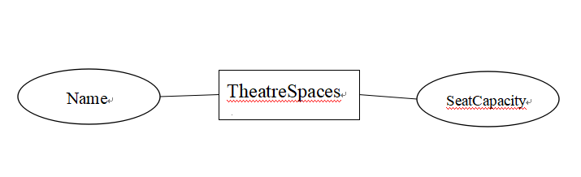
Figure 1

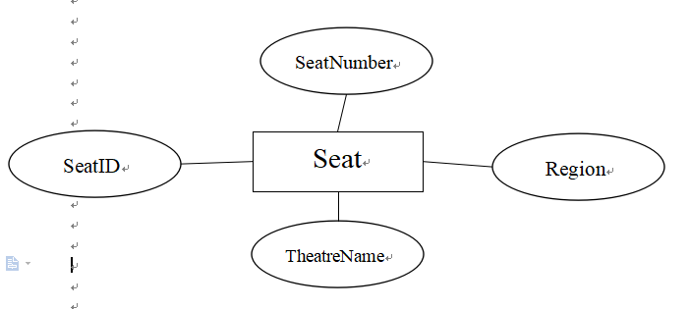
Figure 2

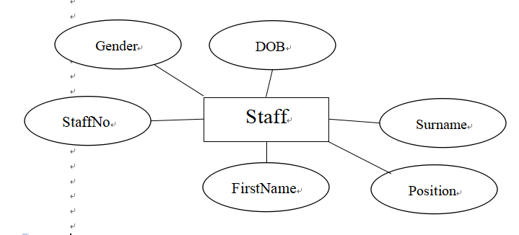
Figure 3

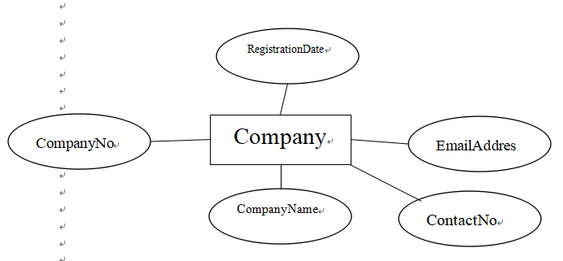
Figure 4

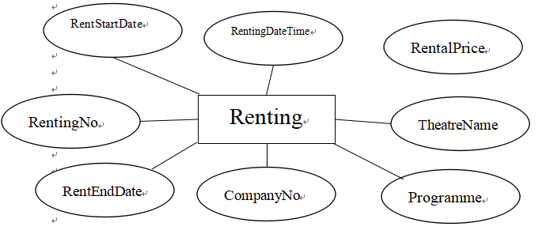
Figure 5

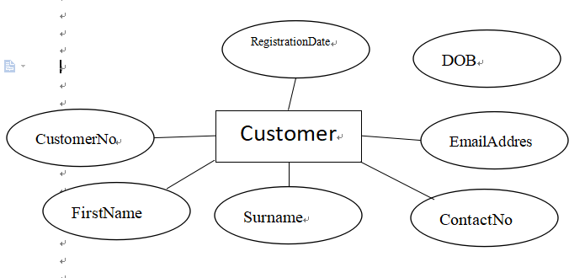
Figure 6

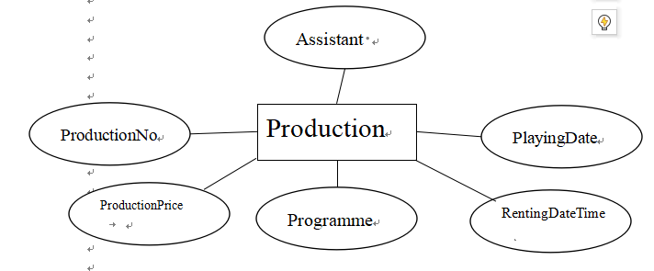
Figure 7
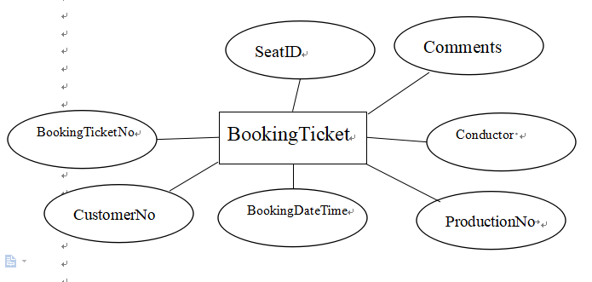
Figure 8

3.3 Logical structure design

The task of logical structure design is to further transform the conceptual structure into a data model supported by a DBMS.

In the stage of logical structure design, first of all, the conceptual structure should be transformed into a general relational, network and hierarchical model. Secondly, the transformed relational, layered and hierarchical models are transformed into data models supported by specific DBMS. The main basis of the transformation is the functions and limitations of the selected DBMS. For relational models, this transformation is usually relatively simple. Finally, the data model is optimized.

For the transformation from E-R graph to relational model, the problem to be solved is how to transform entities, attributes of entities and relations between entities into relational model.

Through the above analysis, combined with E-R diagram. In this system, the entity, entity attribute and the transformation between entities are as follows：
TheatreSpaces (Name, SeatCapacity);
Seat (SeatID, SeatNumber, Region,TheatreName )
Staff (StaffNo, FirstName, Surname, DOB, Gender, Position , Salary, EmailAddress, ContactNo, StartDate, LeavingDate, LineManager)
Company (CompanyNo, CompanyName, ContactNo, EmailAddress,RegistrationDate)
Renting (RentingNo, CompanyNo, Programme, TheatreName , RentingDateTime, RentStartDate, RentEndDate, RentDays, RentalPrice, Assistant)
Customer (CustomerNo, FirstName, Surname, ContactNo, EmailAddress, DOB, RegistrationDate)
Production(ProductionNo,ProductionPrice,Programme,RentingDateTime,PlayingDate,Assistant)
BookingTicket(BookingTicketN, CustomerNo, BookingDateTime ,ProductionNo, Conductor, SeatID, Comments)

According to the requirements of the system and the relational model, a database is established. The structure design results of each table in the database are shown in the following table
Table 1
Title | Data type | Domin | Is null | Is PK
Name | VARCHAR | 30 | NOT | PK
SeatCapacity | INT | 4 | NOT

Table2
Title | Data type | Domin | Is null | Is PK
SeatID | CHAR | 4 | NOT | PK
SeatNumber, | INT |  | NOT
Region | VARCHAR | 20 | NOT
TheatreName | VARCHAR | 30 | NOT

Table 3
Title | Data type | Domin | Is null | Is PK
StaffNo | CHAR | 4 | NOT | PK
FirstName | VARCHAR | 30 | NOT
Surname | VARCHAR | 30 | NOT
DOB | DATE |  | NOT
Gender | VARCHAR | 30 | NOT
Position | VARCHAR | 20 | NOT
Salary | DECIMAL | 12,2
EmailAddress | VARCHAR | 100 | NOT
ContactNo | VARCHAR | 12 | NOT
StartDate | DATE |  | NOT
LeavingDate | DATE
LineManager | CHAR | 6 | NOT

Table 4
Title | Data type | Domin | Is null | Is PK
CompanyNo | VARCHAR | 7 | NOT | PK
CompanyName | VARCHAR | 30 | NOT
ContactNo | VARCHAR | 12 | NOT
EmailAddress | VARCHAR | 100 | NOT
RegistrationDate | DATETIME2 |  | NOT
Table 5
Title | Data type | Domin | Is null | Is PK
RentingNo | INT |  | NOT
CompanyNo | VARCHAR | 7 | NOT
Programme | VARCHAR | 50 |  | PK
TheatreName | VARCHAR | 30 | NOT
RentingDateTime | DATETIME2 |  | NOT | PK
RentStartDate | DATETIME2
RentEndDate | DATETIME2 | 12,2
RentalPrice | DECIMAL | 8,2 | NOT
Assistant | CHAR | 6 | NOT

Table 6
Title | Data type | Domin | Is null | Is PK
CustomerNo | CHAR | 7 | NOT | PK
FirstName | VARCHAR | 30 | NOT
Surname | VARCHAR | 30
ContactNo | VARCHAR | 12 | NOT
EmailAddress | VARCHAR | 100 | NOT
DOB | DATETIME2 |  | NOT
RegistrationDate | DATETIME2 |  | NOT

Table 7
Title | Data type | Domin | Is null | Is PK
ProductionNo | CHAR | 7 | NOT | PK
ProductionPrice | DECIMAL | 4,2 | NOT
Programme | VARCHAR | 50 | NOT
RentingDateTime | DATETIME2 |  | NOT
PlayingDate | DATETIME2 |  | NOT
Assistant | CHAR | 6

Table 8
Title | Data type | Domin | Is null | Is PK
BookingTicketNo | INT |  | NOT | PK
CustomerNo | CHAR | 7 | NOT
BookingDateTime | DATETIME2 |  | NOT
ProductionNo | CHAR | 7 | NOT
Conductor | CHAR | 6 | NOT
SeatID | CHAR | 4 | NOT
Comments | VARCHAR | 100

In this system, the data nodes of attributes have been converted to 3NF, which eliminates the function dependence and transfer dependence.

- TRANSACTION AND SECONDARY INDEXES

  - Transaction

To solve two problems, we need to use transactions

Solution for problem a:
begin tran
begin try
INSERT INTO Production(ProductionNo,ProductionPrice,Programme,RentingDateTime,PlayingDate,Assistant) VALUES('P000005',16,'sdfegf,','2020-04-12','2020-07-27','S28022');
INSERT INTO Production(ProductionNo,ProductionPrice,Programme,RentingDateTime,PlayingDate,Assistant) VALUES('P000006',9,'sfefa','2020-05-12', null,'S28022');
end try
begin catch
select Error_number() as ErrorNumber,
Error_severity() as ErrorSeverity,
Error_state() as ErrorState ,
Error_Procedure() as ErrorProcedure ,
Error_line() as ErrorLine,
Error_message() as ErrorMessage
if(@@trancount>0)
rollback tran
end catch
if(@@trancount>0)
commit tran

Solution for problem b
begin tran
begin try
INSERT INTO BookingTIcket(CustomerNo,ProductionNo,BookingDateTime,SeatID,Conductor,Comments) VALUES ('CR18041','P000008','2019-03-30','m002','S28002','dfasdfhejh');
end try
begin catch
select Error_number() as ErrorNumber,
Error_severity() as ErrorSeverity,
Error_state() as ErrorState ,
Error_Procedure() as ErrorProcedure ,
Error_line() as ErrorLine,
Error_message() as ErrorMessage
if(@@trancount>0)
rollback tran
end catch
if(@@trancount>0)
commit tran

  - Secondary indexes

There are two types of indexes: clustered indexes and nonclustered indexes.

Clustered index changes the physical order of data storage and increases storage space, so it is not used.

Nonclustered index can solve practical problems well.

CREATE INDEX is_CustomerNo_BookingTicket ON BookingTicket(CustomerNo)
GO

CREATE INDEX is_BookingTicketNo_BookingTicket ON BookingTicket(BookingTicketNo)
GO
5.DISTRIBUTED DATABASE DESIGN

Distributed database system is the product of the combination of database system and computer network. It has three characteristics:
1. Physical dispersion
2. Logical integrity
3. Site autonomy

According to the design requirements of the distributed database and the specific situation of the Art Center, the design objectives of the distributed database are as follows:
1. Security: network security, database security, user security
2. Extensibility: the database should be extensible to meet the needs of business development.
3. Reliability: when the system fails, the distributed database has system recovery mechanism and data backup function.

Using distributed partition view to realize horizontal partition.

Partitioning a table is to divide the table into two or more smaller segments according to the partition key. Partition key usually selects a data field which is often used to select a specific range, so the efficiency of partition is the highest. By creating partition view and merging all partition tables, access to the whole dataset is realized. SQL server supports two types of partitioned Views: local and distributed. Distributed partition view, also known as federated database, distributes partition tables on servers of multiple sites. Using the method of linked server and distributed partition view, we can build a distributed database system with horizontal partition.

Using stored procedure to realize vertical partition (a record exists in multiple tables).

SQL server does not provide ready-made technology to realize vertically partitioned distributed database system, but it can use the method of combining linked server and stored procedure to transform the global operation submitted by users into local operation on vertically partitioned tables of multiple sites. Using stored procedure can ensure the acid characteristics of distributed transactions. A stored procedure is a set of pre compiled SQL statements stored on the server. Stored procedure is used to put the operations of vertical partitioned tables of multiple sites in a distributed transaction, either all of them are committed or all of them are fallback, which ensures the consistency of distributed database system data.

Using database replication technology to achieve hybrid data distribution.

The distributed database system must keep the consistency of redundant copies at the minimum cost, that is, the modification of a logical object of a database must be propagated to all copies of the object, and the same modification must be made at the same time. SQL server uses database replication technology to solve this complex problem. SQL Server Replication works according to the operation mode of publishing industry, which includes three agents: distributor, publisher and subscriber. In this paper, transaction replication is used to keep the data consistency of each redundant replica.

Because in the design phase, renting, production and bookingticket all establish constraint relationships with staff through foreign keys,

In addition, the assistant staff is responsible for theater rental, the conductor staff is responsible for ticket sales, and the department head staff is responsible for product planning. Therefore, the three tables can be divided horizontally by the staff.

Companies, theaters, seats and customers don't need to be divided because there is no special relationship.

Employees are classified by gender
Table 9-Female employees
StaffNo | FirstName | Surname | Gender | Position | Salary | LineManager
S28001 | Angel | Toulson | Female | Assistant | 17000 | S29011
S28021 | Arianna | Hamilton | Female | Manager | 33000 | NULL
S28022 | Aubree | Lancaster | Female | Assistant | 16000 | S29011
S29008 | Katherine | Smith | Female | conductor | 27000 | S29011

Table 10-Male employees
StaffNo | FirstName | Surname | Gender | Position | Salary | LineManager
S28002 | Jason | Cooper | Male | conductor | 29000 | S29011
S29012 | Nicholas | Swaby | Male | Assistant | 20000 | S29011
S29011 | Brooklyn | Brown | Male | Supervisor | 23000 | S28021
S29012 | Nicholas | Swaby | Male | Assistant | 20000 | S29011

The seats are divided according to the theater
Table-11 seat in Dylan 1
SeatID | SeatNumber | Region | TheatreName
d001 | 1 | Stalls | Dylan 1
d002 | 2 | Stalls | Dylan 1
d003 | 3 | Stalls | Dylan 1
Table-12 seat in The main auditorium
SeatID | SeatNumber | Region | TheatreName
m001 | 1 | Stalls seats | The main auditorium
m002 | 2 | Stalls seats | The main auditorium
m003 | 3 | Stalls seats | The main auditorium

Table-13 seat in Burton 2
SeatID | SeatNumber | Region | TheatreName
b001 | 1 | Stalls | Burton 2
b002 | 2 | Stalls | Burton 2
b003 | 3 | Stalls | Burton 2

There are two people for renting,so using userID to classify

Table14 S28001
RentingNo | CompanyNo | Programme | TheatreName | RentalPrice | Assistant
2 | CO19048 | dfasd | Dylan 1 | 300 | S28001
1 | CO19028 | hjsf | The main auditorium | 1000 | S28001
5 | CO19028 | sdfegf, | Burton 2 | 300 | S28001
6 | CO19028 | sfefa | The main auditorium | 1000 | S28001

Table 15 S28022
RentingNo | CompanyNo | Programme | TheatreName | RentalPrice | Assistant
4 | CO19040 | gawdgse | Burton 2 | 300 | S28022
3 | CO19007 | sdfdsf | Dylan 1 | 300 | S28022

The rest of tables have no obvious relationshiop and are not separated.

References
[1]Philip A. Bernstein，Vassos Hadzilacos. Nathan goodman:concurrency control and recovery in database systems［M］．Addison-Wesley Longman Publishing Co.，Inc.，1987.
[2]Li F . Cloud-native database systems at Alibaba:opportunities and challenges ［J］. Proceedings of the VLDB Endow ment，2019，12( 12) : 2263-2272.
[3]Oracle. Oracle autonomous database technical overview［R/OL］. ［2020-08-10］. https: / /www. oracle. com /cn / a / ocom / docs / database / oracle-autonomous-database-technical-overview . pdf.
[4]Janus Graph. Distributed，open source，massively scalable graph database ［EB / OL］ . ［2020-08-10］ . https: / / janusgraph. org /. Dale Woodford，Dale Woodford，Dale Woodford，et al.
[5]Spanner: becoming a SQL system ［C ］/ / Acm International Conference on M anagement of Data. ACM ，2017.

