How are twenty first century bunkers relevant today?

According to the Oxford dictionary ‘survival’ is defined as: "the state or fact of continuing to live or exist, typically in spite of an accident, ordeal, or difficult circumstances." (Oxford Languages , 2021)

Bunkers have been an essential part of history appearing consistently alongside wars or disasters. It’s evident they were a necessity in the World War due to their ease of access and simple yet effective design allowing many families to have one on their premises. Today we can still view the remains of some of these bunkers but the idea and reasons behind why they were made is something that has been brought into today, with new bunkers being built all over the world. There are lots of similarities between World War and twenty first century bunkers, but this bears the question: ‘How are twenty first century bunkers relevant today?’. This essay will be exploring the ideology between different types of bunkers we see today, providing a collection of research to scrutinise their purpose, building materials and contents. This will include an analysis of the opinions and purposes surrounding twenty first century bunkers compared to that of the classic World War bunker.

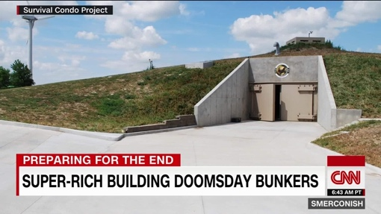
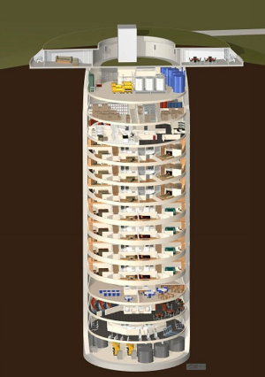
One of the most common twenty first century bunkers we see is plastered over television documentaries, movies and reality programmes. For example, the movies ‘2012’ (2012, 2009) or ‘World War Z’ (World War Z, 2013), or the Discovery Channel documentary ‘Doomsday Bunkers’. (Doomsday Bunkers, 2012) Many people have invested huge amounts of money and time into the modern doomsday bunker. As insinuated by Daisy Yuhas in her ‘Psychology Reveals the Comforts of the Apocalypse’ blog (Yuhas, 2012), around the world a number of people have invested in the idea of futureproofing themselves against an impending apocalypse. Many have been designed to sustain a nuclear war or meteor shower that could destroy a vast majority of the planet’s surface. Daisy Yuhas’s research expands on this from a psychological point of view, implying that people have developed a fear and have invested into the idea of protecting themselves against the end of the world due to the promotion of apocalyptic fiction in the entertainment industry and the true events we see around the world today on news channels that instil fear into society. (Fig. 1.) She states, “deep down for various reasons, there's something appealing at least to some of us about the end of the world.” Her paper then goes on to quote Steven Scholzman (Garrett, 2020) with “In today's complicated world with terrorism, war, fiscal cliffs and climate change, people are primed for panic.” (Yuhas, 2012) An example of someone who has created one of these bunkers is Larry Hall, an ex-government contractor from Kansas, who has built the world’s most expensive bunker called the “Survival Condo”. (Garrett, 2020) Built in an old Cold-War missile silo, this bunker is riddled with ‘top spec’ technology and entertainment to keep its inhabitants satisfied during the end of the world. In a paper written by Bradley Garret (Garrett, 2020) it is explained that Larry Hall bought this missile silo in 2008 and since has converted it into “a 15-story inverted tower block”. (Fig. 2.) Garret also indicates that the bunker can accommodate a body of up to seventy-five individuals for a period of five years to return to the post-apocalyptic world and rebuild civilisation. “A community of up to 75 individuals can weather a maximum of five years inside this subterranean, sealed, self-sufficient luxury habitation. When the event passes, residents expect to be able emerge into the post-apocalyptic world to rebuild.” (Garrett, 2020) Although some may find the theory of an apocalypse highly implausible, the idea has fuelled an architectural creativity unseen before that could, in certain circumstances, save humanity.
Fig. 1. News image of Doomsday Bunker (Image courtesy of CNN)
Fig. 2. (Image courtesy of SurvivalCondo.com)

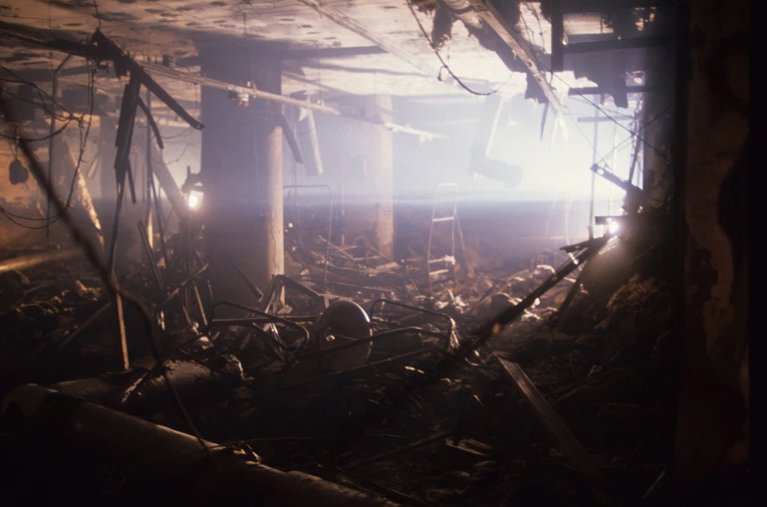
Another form of bunker we see today is the twenty first century War Bunker. This is an essential lifeline for civilians and soldiers living and fighting in active war zones. Bunkers were not only used by the soldiers and civilians but by the leaders of countries as well, as stated in a document written by M. Kets de Vries. (Vries, 2003) Furthermore, it states that Saddam Hussein, the president of Iraq during the Iraq War, “lived in a world of bunkers” providing evidence to support the importance of twenty first century War bunkers. A bunker called the Amiriyah Bunker-Shelter (Fig. 3.) was reported in the ‘Apparatus of Lies, Saddam’s Disinformation and Propaganda 1990-2003’ (Bush, 2003) to be a two-story conversion from the Iran-Iraq War, more recently used as a communications bunker. This enabled it to not only provide safety but multiple other significant uses during the Iraq War. The document also states the concrete, steel-reinforced bunker could accommodate and protect up to one thousand five hundred people at a time. The relevance of this type of war bunker is reflected in the materials used to protect its inhabitants with the same document stating that it was camouflaged and supported with barbed wire to deter opposing forces. The intention behind this type of bunker and how they are used is vastly different to the twenty first century apocalyptic bunker, however, still holds a relevant and major role in protecting and saving lives in active war zones.
Fig. 3. The internal structure of the Amiriyah bunker. (Image courtesy of Aljazeera.com)

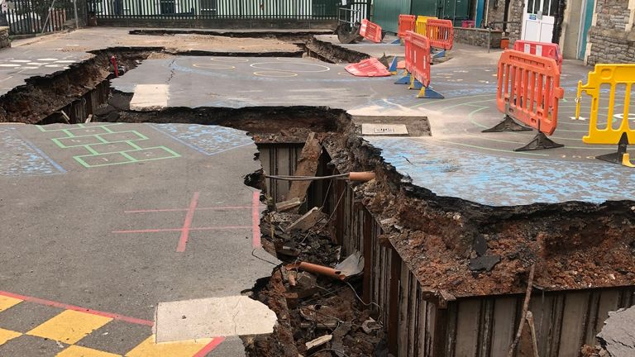
The relevance of bunkers during the Second World War is still very apparent and is voiced in the many lives that were saved during British tragedies such as The Blitz. A typical and well used bunker design during the Second World War was that of the ‘School Air Raid Shelter’. (Fig. 4.) In Archaeologist Gabriel Moshenska’s work he describes these shelters to be “reinforced basement rooms or buried concrete structures.” (Moshenska, 2015) He describes the structure further as small shelters surrounded by dirt and earth usually starting out as trenches or basements. They were built this way to increase the structural integrity against bombings within a close proximity, however, were never designed to withstand a full blast. (Moshenska, 2015) Moshenska expands, writing “None of these shelters were capable of surviving a direct hit, rather, they were designed to protect against the statistically far greater likelihood of a near miss, with the resultant shrapnel spreading across a wide area and the blast causing buildings to collapse.” The School Air Raid Shelters were widely utilised due to a bombing that occurred near a school during the First World War where a Zeppelin bomb hit resulted in the death of eighteen children and injured a further thirty-seven. (Moshenska, 2015) Many bunkers during the war were designed specifically for “less-skilled” labourers and for the quick and easy nature of instalment. They were such an essential safety matter in the lead up to the Second World War that it led to one of the “largest construction programmes of all time”. (Moshenska, 2015) There was an undeniable need for bunkers during this time period and although their original use in Britain has faded, they still hold a significant purpose through the stories they hold in their walls.
Fig. 4. School Air Raid Shelter under School yard in Bristol. (Image courtesy of Sky News)

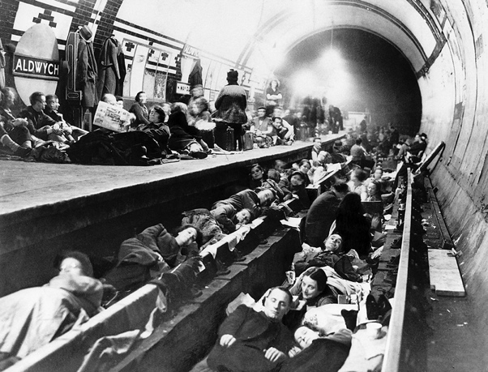
The legacy of British World War bunkers encapsulates an important part of history. As less of those who experienced the Second World War are with us today the physical memory of the War is becoming less and less visible. However according to Stephan Jaeger preserving historical artefacts is a way to “bring the past closer to the present” and should be used as a “medium of remembrance.” (Jaeger, 2020) His book then pursues talking about the ever-changing society and how it should create “forms and institutions to save artifacts and structures from the otherwise would-be-forgotten past.” (Jaeger, 2020) Public wartime bunkers that are still frequently used and visited today are the London Underground Stations. (Fig. 5.) Although their use in the twenty first century is vastly different to that of the War, their history still stands as a well-known safe house for endangered civilians during that time. “The huge impact of the Blitz on London, and the re-use of the Tube network as shelter” is still remembered today by the re-visitation of the sites. (Museum, 2021) Another bunker that is still preserved today, and attracts many tourists and visitors is the Cardiff Castle Wartime Shelter. The website advertises “You can see what the air-raid shelters looked like and hear the sounds from a bygone age” highlighting the importance of a connected experience to wartime life that could be difficult to understand for those who have lived in a peaceful society. (Castle, 2021) The remembrance and preservation of bunkers, like Cardiff Castle and the London Underground, is essential to current generations placing value on our predecessor’s sacrifice to their country and the impact of War today.
Fig. 5. London Underground Shelter. (Image courtesy of mylondon.news)

The relevance of bunkers today is embedded within their purpose similar to the bunkers produced throughout history. Each has a separate design and purpose, but in likeness, they are designed to protect humanity in the modern age. The twenty first century apocalypse bunker acts as a form of reassurance and preparation for those who are not currently in a war zone and built from a place of fear. In contrast, the design accompanied by the building materials of the twenty first century War bunker protects leaders and civilians in current war affairs. The bunkers built for the previous century are still standing and preserved today and they serve their own relevance and purpose. For many, War is a distant past-time and something they are potentially emotionally removed from. Bunkers that have been repurposed or preserved give current and future generations an emotional experience and connection to their country and a value for those who paved the way for a war-free society today. Visiting a place with significant historical value, such as these bunkers, could provoke a unity within modern culture, devolved from a war that impacted all races, ages and classes and as a result forcing society to pull together and put aside their differences. Bunkers original purpose was to protect and save lives, and this very purpose could be reflected in its relevance today.

Bibliography
2012. 2009. [Film] Directed by Roland Emmerich. USA: Centropolis Entertainment.
Bush, G. W., 2003. Apparatus of Lies, Saddam’s Disinformation and Propaganda 1990-2003. [Online]
Available at: https://www.hsdl.org/?view&did=521
[Accessed 15 March 2021].
Castle, C., 2021. Wartime Shelters. [Online]
Available at: https://www.cardiffcastle.com/see-do/wartime-shelters/
[Accessed 15 March 2021].
Doomsday Bunkers. 2012. [Film] Directed by DiscoveryChannel. USA: Discovery Channel.
Garrett, B., 2020. Doomsday preppers and the architecture of dread. [Online]
Available at: https://reader.elsevier.com/reader/sd/pii/S0016718520300804?token=B0707C3D4A79CE83030E3ECC8561250A08F6EFA73EACDE2B3DE73665979A3567B43B4408AE8F8E22B8FE46107530715C
[Accessed 15 Match 2021].
Jaeger, S., 2020. The Second World War in the Twenty-First-Century Museum. Berlin/Boston: Walter de Gruyter.
Moshenska, G., 2015. Spaces For Children: School Gas Chambers and Air Raid Shelters in Second World War Britain. In: H. Orange, ed. Reanimating Industrial Spaces. s.l.:Left Coast Press, Inc., pp. 125-136.
Museum, L. T., 2021. Shelter in Wartime. [Online]
Available at: https://www.ltmuseum.co.uk/collections/stories/war/shelter-wartime
[Accessed 15 March 2021].
Oxford Languages , 2021. google. [Online]
Available at: www.google.com
[Accessed 15 March 2021].
Vries, M. K. d., 2003. The Rise and Fall of Saddam Husein , s.l.: M. Kets de Vries.
World War Z. 2013. [Film] Directed by Marc Forster. USA: Plan B Entertainment.
Yuhas, D., 2012. Psychology Reveals the Comforts of the Apocalypse. [Online]
Available at: https://blogs.scientificamerican.com/observations/psychology-reveals-the-comforts-of-the-apocalypse/
[Accessed 15 March 2021].

