Financial and Sustainability Report:
B&M 2023/2024
By Alyssia Frampton, 2127857
Word Count: 1648

Contents:
Overview | 3
Financial Analysis | 4
Sustainability Analysis | 6
Recommendations | 8
Conclusion | 9
Appendix | 10
References | 15

Overview:
This report analyses B&M’s financial and sustainability progress in 2023 and 2024. Based on my ratio findings and sustainable knowledge, I will make recommendations as to what the chain could do to improve upon to successfully manage growth. B&M European Value Retail S.A, founded in Liverpool in 1978, runs over 750 stores in the UK, employs over 38,000 workers, and sells to around 5 million customers every week (LinkedIn, 2025).

Financial Analysis:
Gross Profit Margin
Gross profit margin is a metric used to show businesses profit after deducting the costs of being able to sell goods (Bloomenthal, 2024).
2023: | 2024:
36.1% | 37.1%
The increase of gross profit from the year 2023 to 2024 is a good sign for B&M that they are performing better financially. While the percentage seems low compared to competitors, B&M value customer loyalty, which could be a huge risk in terms of future profitability for the chain.
Average Inventory Turnover
Average inventory turnover is a formula used to measure how many times a year a business restocks inventory (Hayes, 2020).
2023- 2024:
4.48 times
B&M turns over inventory averagely 4.48 times. This shows they are selling vast amounts stock at low prices and are good at rotating stock. While this does not take seasonality into account, it does measure outgoing stock compared to profit margins.
Net Profit Margin
2023: | 2024:
8.7% | 9.08%
Net profit margin is used to regulate what percentage of revenue is left after all expenses are accounted for. It helps a business understand their level of profitability (Paddle, 2025).

Like gross profit margin, B&M have increased their revenue almost exactly inline with costs. This reflects steady growth without sacrificing their brand image.
Return on Capital Employed
Return of capital employed is a ratio that measure how effectively a business is using its capital to generate profits (Corporate Finance Institute).
2023: | 2024:
15.9:1 | 17.59:1
While the table shows that for every £1 spent, roughly 17.6 pence got reinvested in 2024, this percentage is still relatively low for a huge company like B&M. This could be due to the large costs of dividends to the company’s owners.
Current Ratio
The current ratio decides how efficiently a business can pay back debts using current assets (Tutor2u, 2021).
2023: | 2024:
1.29:1 | 1.31:1

The current ratios for B&M are low for such a huge retailer. This means that while the business can pay back short-time liabilities, it still may experience cash flow issues after these debts are paid off. Although the ratio is higher in 2024, it may be due to current liabilities being £30 million lower in 2024 compared to 2023.
Liquid Capital Ratio
The liquid ratio is like the current ratio; however, it excludes stock from the current asset list to give a more realistic idea of how quickly a business can pay short-term liabilities (TwoTeachers, 2023).
2023: | 2024:
0.36:1 | 0.34:1
B&M’s liquid capital ratio is exceedingly low in comparison to other businesses. This means that B&M may struggle to keep up with paying short-term debts. This also may lead to future cash flow issues as they are heavily reliant on stock being their main asset.

See all accounts in Appendix. Figure 1- 4.

Sustainability Analysis:
Stobierski, 2024, defines CSR as a business taking care of the communities around it. B&M has a corporate social responsibility analysis within its financial report that shows objectives, targets and progress over the 2024 year.
Environment
B&M lists its environment objectives to be to reduce emissions by 25% by 2030 (using the report of the financial report of 2021). To reach this objective, B&M’s target is to install LED lights in all stores by 2027 and introduce BeMS (computer software that optimises energy usage) across all UK stores. They also have objectives to reduce emissions through their suppliers by engaging with 67% of their suppliers by 2027 as well as reducing plastic packaging.
The progress shows that while B&M are making efforts be environmentally aware, they have not met all their targets. For example, the company have not reduced emissions enough, they are below target by 1.5%. Although, they have implemented BeMS in 89% of UK stores. There are no figures available to decide how on track the business is in terms of reaching objective 3, however the report suggests it is on target.
Colleagues
B&M’s objectives include staff development, with a target of 90 annual promotions, prominent levels of colleague engagement and ensuring an inclusive and diverse workforce. This can be achieved by keeping a 40% ratio of women as board members and increasing ethical diversity in management positions by 10% by 2027. Finally, B&M wants to offer bonuses to management who perform highly and continue their effort over 2024.
B&M successfully had 515 colleagues participate in the ‘Step Up’ programme, the board committee is 42.7% female, and bonuses were awarded to both distribution and support roles as well as high-performing leaders across stores. However, employee engagement is below target with only 71% completing an employee feedback survey, even though it provided valuable feedback in general. There is also a lack of data showing the progress on the ethical diversity within management roles therefore it is difficult to measure if true progress has been made.

Communities
B&Ms communal responsibility is divided into:
- Increasing number of stores to no less than 1200.
- Contributing to regeneration of new areas and creating new jobs.
- Support local and national charities.
The targets for these objectives are very similar and do not break them down.
These aims appear on track, however, the lack of figures and time-frames makes success difficult to measure. Over the course of 2024, BM had 47 store openings, taking their gross store total to 741 in the UK. They also worked towards their regeneration target by creating 700 retail jobs across the UK and France as well as contributing to charitable initiatives.
Supply Chain
B&Ms ethical responsibility to their supply chain is a huge part of CSR. Their main objectives are to be committed to performing ethically in terms of fair treatment and wages as well as paying suppliers fairly and treating them equally. To meet these aims, B&M targets to pay all creditors within 35 days of invoices. This helps build a stronger relationship as well as ensure prompt debt payment.
The advancement towards this is the fact that the chain came third in the ‘Annual Groceries Code Adjudicator Compliance Survey’ in 2023. Along with, trade creditor days standing at 26 days. While the survey award fits perfectly with the target, it does not show any continuation towards this goal over 2024.

See corporate social responsibility progress in Appendix. Figure 5.

Recommendations:
Financial Analysis
B&Ms financial analysis shows they are heavily focused on customer loyalty and keeping costs low to sustain their USP and brand image. While all formulas applied shows a general increase in business development (net profit margin aligns with costs), B&M could do a range of this to increase net profit even by not increasing prices. For example, the statement document shows a huge amount in annual dividends for the owners of the company. By paying out a huge amount of revenue, the business is decreasing the speed at which further growth and expansion could happen.
B&M are heavily reliant on stock as an asset and invest too little back into the company; this could be a risk to B&M in the future covering sudden debts. The potential future increase of real incomes in the general economy could mean consumers switch to more luxury items. This could mean that using stock as a main asset could risk the continuation of the business should the economy rise.
Sustainability Analysis
B&M is alluding to a success for reaching their annual goals, however, the main environmental objective of reducing emissions by 25% by 2030 seems too little for a company that is heavily contributing to single-use consumerism. With no mention of the UN sustainable goals, this could mean that B&M does not have being sustainable in mind as much as getting stakeholders to believe they are acting in a more sustainable way.
This also goes for the colleague's section within the report, B&M use the example of an employee feedback survey as a progression point. Instead of just how many employees filled out the survey, they should have included some action that has been taken to act on this feedback to truly show value towards their employees.
Another example of potential greenwashing is the idea that B&M opening new stores and expanding across the country further is a selfless act. While creating new jobs in much needed areas is a huge advantage of expansion, this is purely financial gain and therefore new targets should be made that solely support the communities around them.
Finally, the supply chain objectives are a key part of acting ethically and with social responsibility, however the measurements of these targets are not specific enough to measure, along with the rest of the targets listed. To help combat this, B&M could create more number-specific objectives that can accurately observed as a source of evidence of their progression.
Conclusion:
In conclusion, B&M should first reduce shareholder dividends to build up cashflow and then expand in both current and long-term assets. This will also help them plan for any future upturns of the economy that could mean reduced customers. Secondly, I would advise that B&M rethink their sustainable goals and align them more towards the UN goals. For example, other than just changing lightbulbs they could show actual statistics of how much plastic packaging they are reducing and improve their logistic and delivery systems to be more efficient. Including more SMART targets will help B&M to set clearer expectations. However, B&M are a remarkably successful global company, they understand their target audience and how to better distribute costs, such as cutting marketing costs, and they will continue to be successful for years to come.

Appendix:
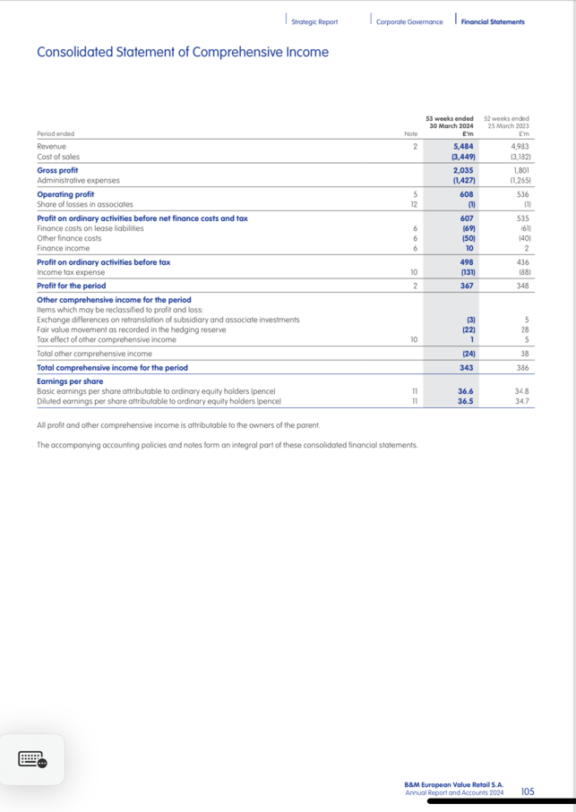
Figure 1:

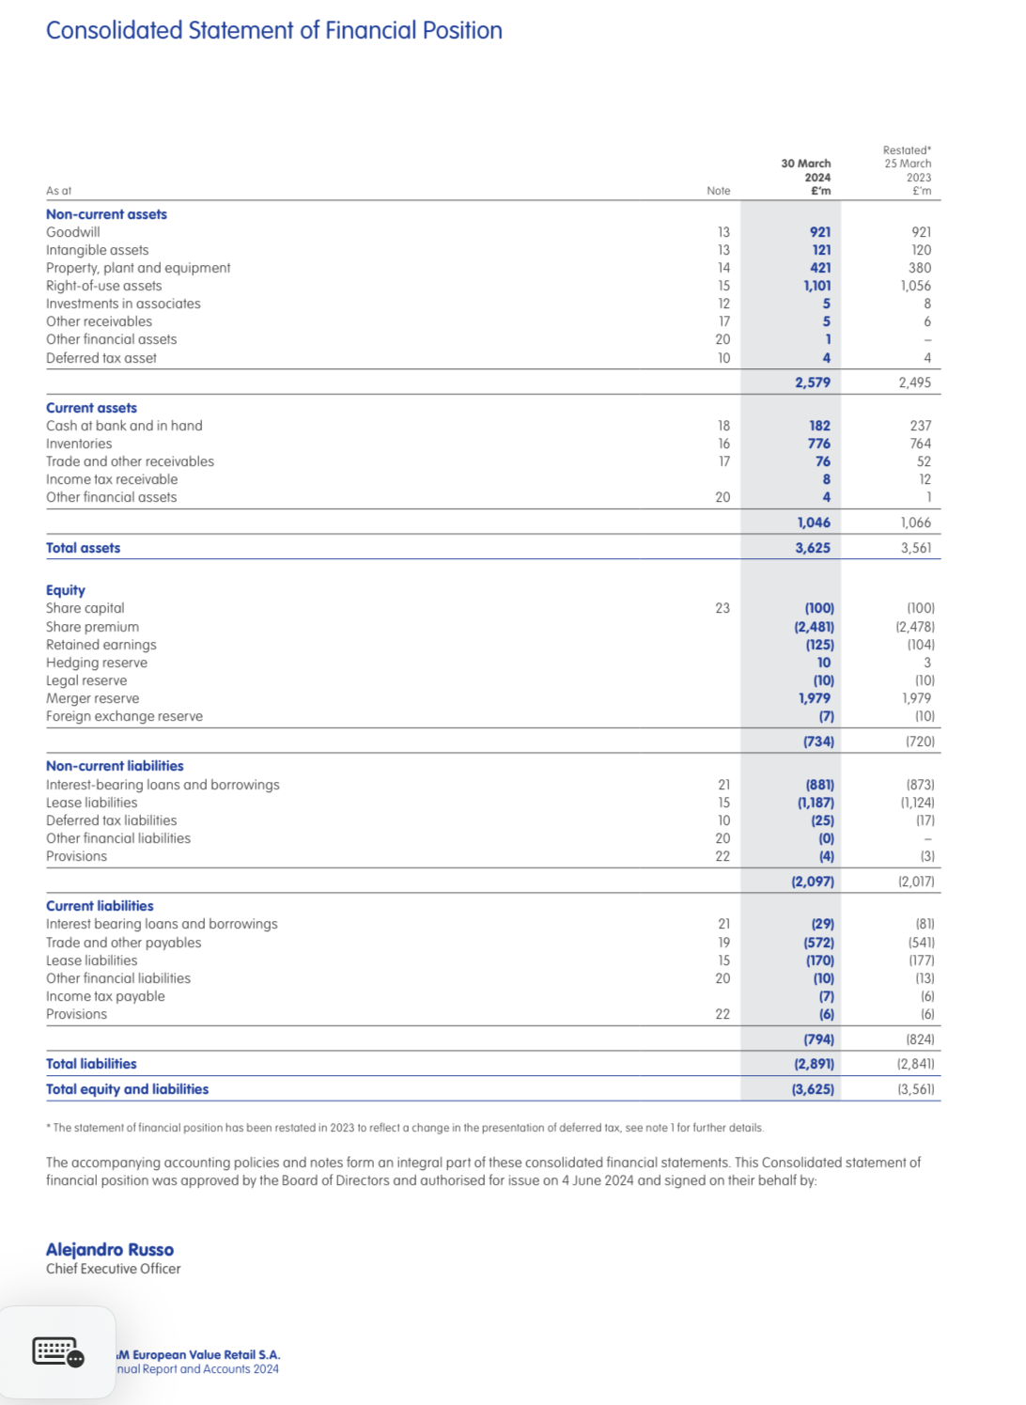
Figure 2:

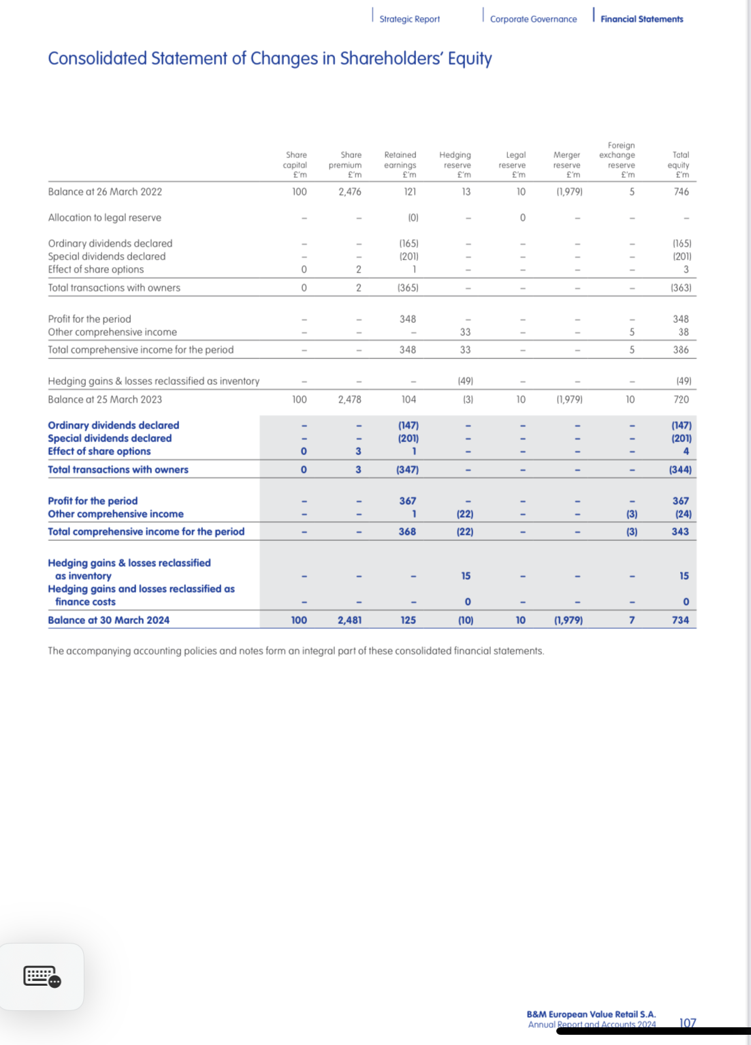
Figure3:

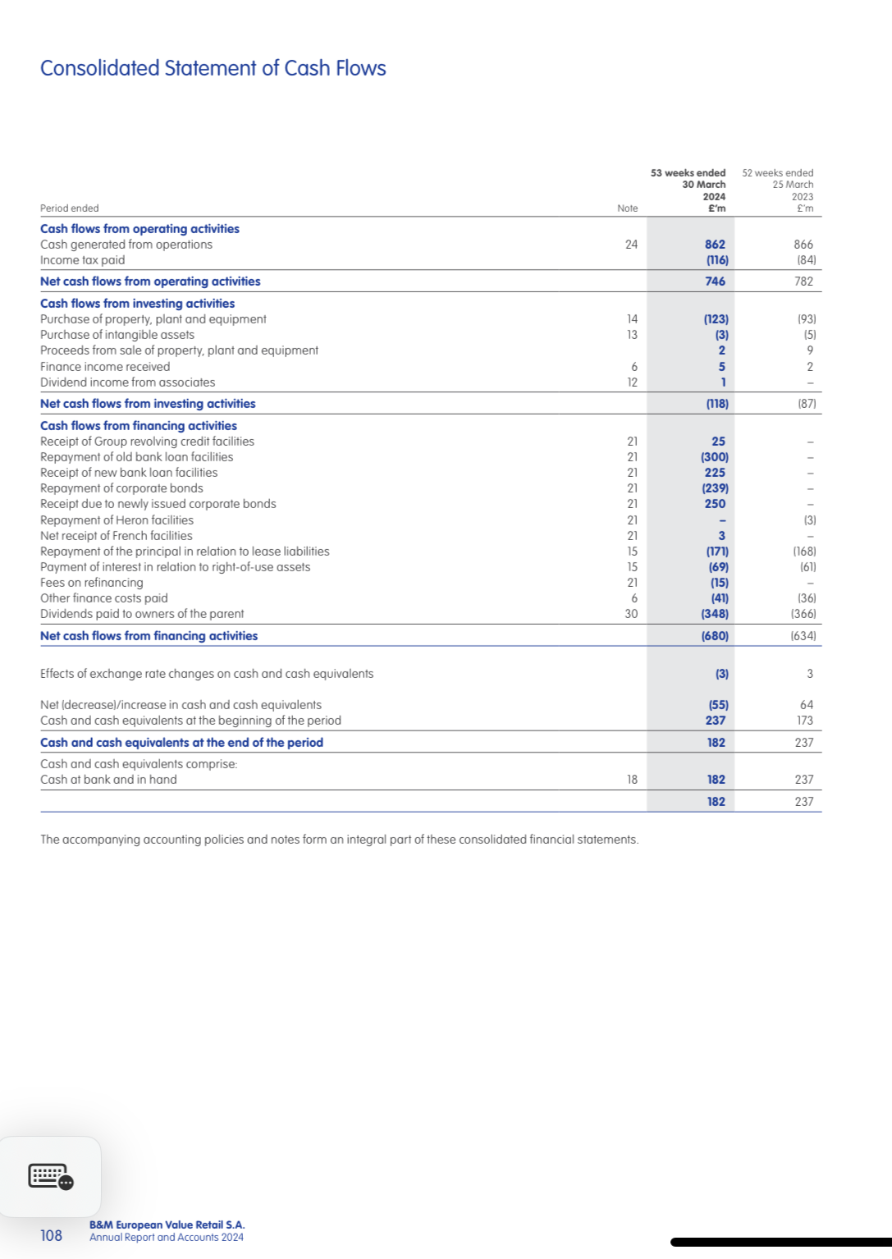
Figure4:

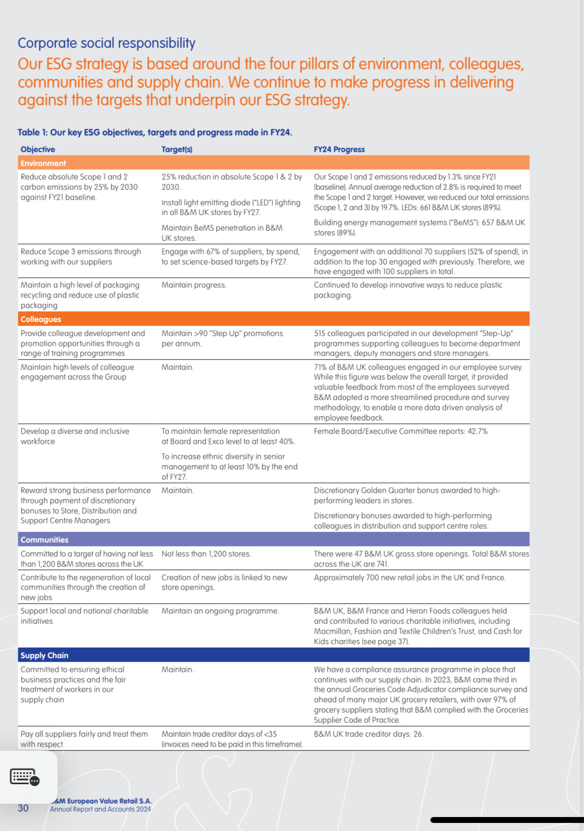
Figure5:
Bibliography:
Bloomenthal, A. (2024). Gross Profit Margin: Formula and What It Tells You. https://www.investopedia.com/terms/g/gross_profit_margin.asp.
B&M European Value Retail S.A. (2024). Annual Report and Accounts 2024. https://www.bandmretail.com/~/media/Files/B/Bmstores-Corp/documents/investors/reports-and-presentations/2024/bmstores-annual-report-and-accounts-2024.pdf.
CFI Team. Return on Capital Employed (ROCE). https://corporatefinanceinstitute.com/resources/accounting/return-on-capital-employed-roce/.
Hayes, A. (2020). Average Inventory: Definition, Calculation Formula, Example. https://www.investopedia.com/terms/a/average-inventory.asp.
LinkedIn. (2025). B&M Retail. https://uk.linkedin.com/company/b-m-retail-limited.
Paddle. What Is Net Profit & How to Calculate It Using the Net Profit Formula. https://www.paddle.com/resources/net-profit-formula.
Stobierski, T. (2021). What Is Corporate Social Responsibility? 4 Types. https://online.hbs.edu/blog/post/types-of-corporate-social-responsibility.
Tutor2u. (2021). Current Ratio. https://www.tutor2u.net/business/reference/current-ratio.
Two Teachers. (2023). Understanding Liquidity Ratios and How to Calculate Them. https://www.twoteachers.co.uk/post/understanding-liquidity-ratios-and-how-to-calculate-them.

