

University of Wales Trinity Saint David
Master of Business Administration (MBA)
Module: International Business Concepts
Module code: LCMB7034

Fast Food Industry in India: McDonald's.

Lecturer: Dr. Jean Wang

Student Name: Dishant Patel
Student ID: 2503795

Word Count:5316

Submission Date: 27th April 2026
Table of Contents
Section 1: Report 3
1. Introduction 3
2. Industry and Country Overview 3
2.1 Overview of the Fast Food Industry in India 3
2.2 Size, Scope, and Economic Importance 4
2.3 Key Players and Competitive Positioning 6
3. Analysis of Global Competitiveness Using Porter’s Diamond Model 7
4. Critical Evaluation of a Multinational Corporation in India 11
4.1 Attractiveness of the market: PESTLE Analysis. 12
4.2 Industry Attractiveness: The Five Forces Perspective of Porter. 16
4.3 Strategy factors that have contributed to the success of McDonald's. 16
5. Conclusion 19
Section 2: Reflective Account 20
References 24

Section 1: Report

1. Introduction
The fast food industry in India has become an evolving and extremely competitive market niche of the overall foodservice sector. The growth of this segment is due to rapid urbanisation, population shifts, and lifestyle changes creating more demand for convenience, value, and speed from quick-service restaurant (QSR) formats (‌Jha et al., 2022). The implementation of digital platforms, such as Zomato and Swiggy, has further driven growth by allowing customers to order online (Polke et al., 2022). As a result, many multinational and national companies are investing heavily in this segment due to increased competition and innovation.
In this report there is a close examination of the fast food industry with particular reference to India. The report first provides information about how the fast food industry in India is structured, how large it is and how important it is to the economy. It also provides an overview of the key players in this market. The second part of the fast food industry discussion uses Porter’s Diamond Model to analyse global competitiveness within the fast food industry.
In addition, the report evaluates the operational success factors of the chosen MNC within the fast food industry in India by analysing the political, economic, legal, and cultural environment, thereby offering a comprehensive understanding of the industry’s strategic landscape.

2. Industry and Country Overview

2.1 Overview of the Fast Food Industry in India
The fast food industry in India, often categorised under the quick service restaurant (QSR) segment, has confronted crucial structural transformation over the past decade. Traditionally, street food stalls, small restaurants, etc were the primary sources of Indian food consumption; however, the growing trend toward formalising the Indian food industry reflects an economy moving up along with the way people want to eat (‌Jha et al., 2022). The growth of formal, organised fast food restaurant chains is partly due to urbanisation, increased participation by women in the labour force, and an increasing wealthier class that can afford more discretionary income. This has resulted in consumers' preference for convenience-based eating habits where speed, consistency and accessibility are critical determinants of consumer choice.
Along with the social and economic influences on food purchases, advances in technology have created opportunities to further influence how the fast food industry operates in India. The use of digital order entry systems, mobile apps for food ordering and online delivery of food has greatly increased the number of consumers reached by the marketplace and enhanced convenience for consumers (Polke et al., 2022). Companies like Zomato and Swiggy have changed the distribution channels for food as well as increased the level of competition among new and emerging companies entering into the market with Cloud Kitchens by lowering the barriers to entry.
In addition to being a localized fast food market, the fast food industry in India differs from many other developed countries. Although fast food giants such as McDonald's, KFC and Domino's Pizza are established in India, their overall success in India has often depended on the adaptation of their menus. As per SAJI et al., (2024), their menus are reflecting the cultural, dietary and regional differences of the diverse Indian population by including vegetarian options and many different regional tastes. Conversely, home grown companies such as Haldiram's and Wow! Momo are using their knowledge of the Indian food palate and purchasing behaviour to effectively compete against these multinationals (Batta, 2025).

2.2 Size, Scope, and Economic Importance
India's rapid growth in the fast food industry represents an important part of its growing food service market and indicates economic importance and future growth potential. According to recent industry estimates, the fast food industry in India was valued at approximately $19.9 Billion USD in 2025 and will likely grow to a market size of about $37.6 Billion USD by 2034 with an average annual growth rate of almost 6.95% (IMARC Group, 2026). This growth will continue due to favourable demographic trends seen in India such as an increase in the number of people moving to cities (urban migration), a rise in disposable income levels and the rise in the number of young persons (15-24 years of age) in the population, all creating increased convenience food consumption.
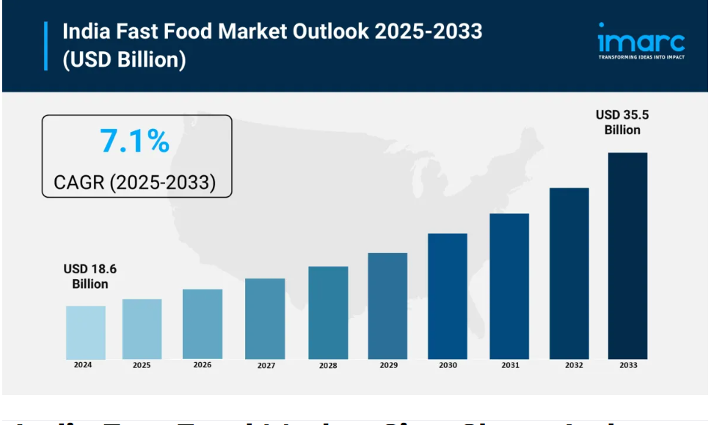
Figure 1: India Fast Food Market Size 2025-2033
Source : (‌MENAFN, 2025).
Within the overall fast service restaurant (QSR) segment represents a large percentage of all purchases at food service establishments. The total value of the Indian food service sector was estimated to be approximately 14 trillion INR in 2024 and organised fast food formats accounted for a significant portion of this amount indicating that the industry is moving from informal business structures to formal business structures (GlobalData, 2025). This transition in the fast food industry is important because it points to a standardisation of operations and improvements in hygiene practices as well as creating a greater level of consumer trust in branded food establishments versus traditional informal food vendors.
The economic importance of the fast food industry is larger than just its contribution to the GDP as it is a key provider of jobs for young and unskilled people, as well as supporting a large network of industries that are related to agriculture, food production, logistics and packaging (Batta, 2025). The franchise model used by fast food companies is used to build or expand local entrepreneurs by allowing them to finance and own a franchise of an established national or international fast food chain. Though the industry has several growth potential but it also experienced structural challenges that influence its overall performance (Acharya and Paramasivam , 2024).

2.3 Key Players and Competitive Positioning
Within the competitive Indian fast food industry, there are both global/ multinational companies and domestic companies interacting competitively, but there are key differences in how each has attempted to generate market share. The dominant players in the organised segment of the market— global companies like KFC, Domino's Pizza, McDonald's, and Burger King— have achieved considerable market power through strong brand presence, efficient operations, and using global best practices (‌Reuters, 2024). While these companies are able to leverage their strong brand equity and efficiently operate at scale, their competitive advantage is not a result of standardising their operations, rather it is derived from adapting their operations to local market conditions through creative and innovative products, pricing and partnerships (‌Reuters, 2024).
On the other hand, domestic companies like Haldiram's and Wow! Momo has grow rapidly by leveraging their extensive understanding of local tastes and cost structures. These companies offer products more competitively priced than the global companies because of their flexible business models, making them very attractive to the middle-class consumers (Batta, 2025). In this regard, domestic brands present global companies with significant competition, particularly in Tier 2 and Tier 3 cities, where consumers are more price sensitive.
Overall, the Indian fast food industry has tremendous rivalry among competitors due to factors such as pricing, diversification of menu items, technology, and expansion into new geographic markets. In addition, companies are increasingly investing in digital platforms, loyalty programmes, and delivery solutions to improve customer engagement and increase efficiency of operations (‌Jha et al., 2022). Similarly, continuous innovation will continue to be an important driver for firms to respond to changing consumer preferences and external economic conditions. As a result, the competitive environment within the Indian fast food industry has significant challenges and complexity, which emphasises the need for strategic adaptability to ensure long-term competitiveness (Batta, 2025).

3. Analysis of Global Competitiveness Using Porter’s Diamond Model
The Diamond Model by Porter offers a systematic approach to the analysis of how the state of affairs in the countries influences the competitive strength of industries within the international market. It puts emphasis on the interaction among factor conditions, demand conditions, related and supporting industries, as well as firm strategy and rivalry (Afshar and Shah, 2025). The model can be applied in the fast food industry in India to determine the role of domestic economic, social, and institutional forces in making the industry globally competitive.
Factor Conditions
India has good factor conditions, especially in terms of labour availability and cost efficiency. The domestic market is big and young, which contributes to the labour-intensive fast food industry and allows the companies to work at a comparatively lower cost (Batta, 2025). Moreover, the growing use of digital technologies like mobile payments and ordering systems on the app level makes the work more efficient.
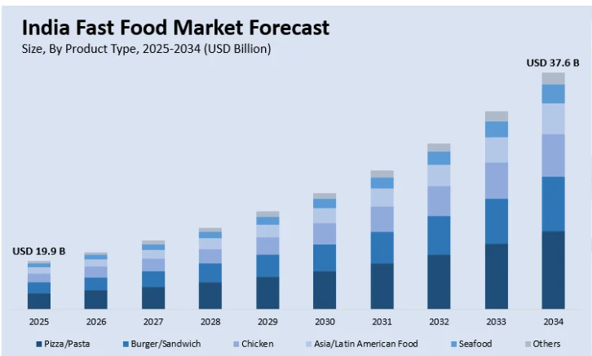
Figure 2: Indian fast-food market forecast
(Source: Imarc, 2026)
These benefits are curtailed, however, by weak infrastructures. Insufficiency in the approach of cold-chain facilities, insufficient transportation system, and sporadic power supply are among the challenges that the foodservice industry is still struggling with to augment the cost of doing business and decrease its efficiency levels (Fortune Business Insights, 2026). Thus, India has the advantage of basic factors, but structural constraints hold back its overall competitiveness. These infrastructural constraints have a direct impact on operational efficiency, which also impacts firm strategy and cost structure, as shall be discussed later.
Demand Conditions
In India, the demand conditions are very favourable to the growth of the industry. The foodservice market has reached USD 114.40 billion in 2025 and is expected to go up to USD 282.04 billion in 2034 with a CAGR of 10.55% (Fortune Business Insights, 2026). This is due to the increase in disposable incomes, rising rates of urbanisation and the changing lifestyle in which consumers are now more concerned with the convenience and food-to-eat products.
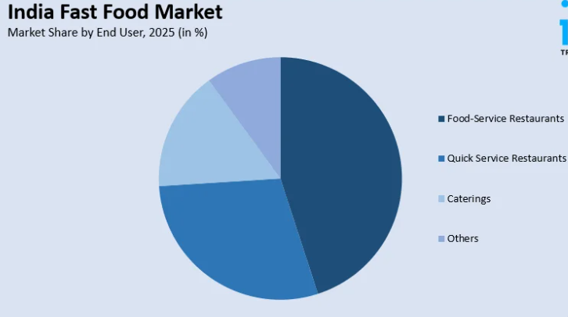
Figure 3: Indian fast-food market share
(Source: Imarc, 2026)
In addition, the globalisation of the labour force, especially the higher number of women being engaged in labour and the growth of the middle class, has further fueled the demand. Nevertheless, the market is extremely price-sensitive and culturally varied, so a company has to constantly redefine its products. Increased customer expectations as a result of the development of online food delivery platforms have led to a rise in the requirement to be fast and accessible (Polke et al., 2022). Therefore, there are high demand conditions and great complexity in the market. Urbanisation, growth in disposable income, and the changing consumer lifestyles all contribute to the rapid growth of the market size as they all lead to higher demand for convenient and affordable food products. These demand conditions promote the localisation and pricing strategy by firms to address the various consumer needs.
Related and Supporting Industries
The fast food sector in India is backed by an industrial ecosystem that has been evolving around it, such as agricultural, food processing, and digital delivery systems. Food delivery services have enhanced access to the market and efficient distribution (Polke et al., 2022). These systems help companies to increase their customer base and improve convenience in service.
Although these benefits exist, supply chain inefficiencies are also an issue of concern. A lack of resource optimisation and food wastage, among other issues, decreases the total productivity and makes the industry more costly (Shrivastava et al., 2022). Therefore, even though supporting industries play an important role in competitiveness, their inefficiencies will curtail their potential. The development of digital technologies like delivery services improves the conditions of demand as well as the competitive rivalry.
Firm Strategy, Structure and Rivalry
Competition in the Indian fast food industry is highly competitive, with both domestic and multinational companies competing with each other. Localisation, pricing innovation, and diversification of the menu are some of the strategies adopted by companies to acquire market share. The competitive rivalry is an important factor in the industry's performance and innovation (Loredana, 2024). Rigorous competition compels companies to constantly innovate, which is also connected to localisation policies and adoption of technology, as mentioned in subsequent sections.
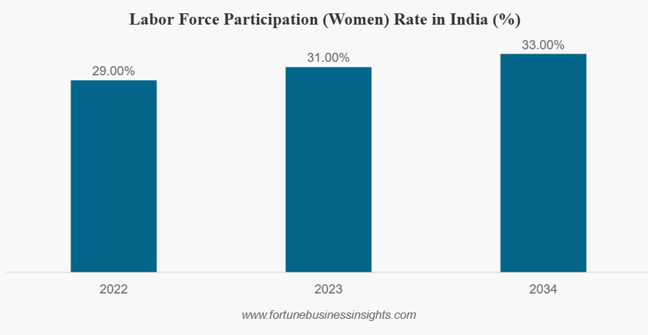
Figure 4: Labour participation in India
(Source: Fortune business insights, 2026)
Role of Government
The competitive landscape of the fast food market in India is largely influenced by Government policies and regulations. The government has a key role to play in the form of regulation, food safety and taxation. Quality compliance is guaranteed by institutions like FSSAI, which boosts consumer confidence yet contributes to the higher operational expenses of companies.
These rules affect the strategy and cost structure of firms and determine competitiveness in the industry (Constantin, et al., 2022). This has also led to an increase in the flow of knowledge within the industry.
Government policies and regulatory bodies, including the Food Safety and Standards Authority of India (FSSAI), create an environment where customers can feel secure that they are purchasing quality products and eating at establishments that comply with food quality and safety regulations (Aswathy et al., 2024).
There continue to be regulatory challenges for the fast food industry in India, including lengthy bureaucratic processes, inconsistency between state regulations, and the high cost of compliance which often creates barriers to entry and expansion (Constantin, et al., 2022).
Chance Factor
Increased environmental awareness (for example, bans on the use of single-use plastics) is forcing firms to move towards more sustainable methods of operation, which raises operating costs. While these laws and regulations are necessary for the long-term sustainability of the industry, they may present short-term issues for firms selling products in a highly price-sensitive environment (Aswathy et al., 2024). Random circumstances like the COVID-19 pandemic have greatly contributed to the uptake of online food supply services and digital platforms. This was a surprising trend that transformed consumer behaviour and provided new avenues for companies to grow using cloud kitchens and online platforms.
All in all, the fast food sector in India is highly competitive in the global market that is supported by the high demand levels, favourable labour laws, and the emerging digital ecosystem. On the other hand, the problems of infrastructural inadequacy, cultural diversity, and high competition are very difficult. Competitiveness, as Park and Park (2022) point out, is a matter of the interplay of various factors, which implies that companies have to use dynamic and localised strategies to thrive in this complicated market. Based on the findings of Porter’s Diamond Model, the fast food industry in India has a favourable environment for growth due to solid demand-led/favourable conditions, cost advantages, and increasing support from related industries. However, the industry's global competitiveness is adversely impacted by structural challenges (for example, infrastructure issues, regulatory complexities, and high levels of price-based competition).

4. Critical Evaluation of a Multinational Corporation in India
McDonald's is among the leading multinational companies within the fast food (QSR) industry in India. Since it entered India in 1996, the company has pursued a glocalisation approach, modifying its international brand to the tastes of the locals, cultural preferences and standards. As compared to the Western markets, McDonald's India has a predominantly vegetarian menu and regionally localised products, which are based on the diverse consumers of India (Kavyasri and Vaijayanthi, 2022).
The company has franchise partners, including Westlife Foodworld and Connaught Plaza Restaurants, which allows it to easily penetrate the market and scale to operate in the market. Nevertheless, its high brand equity notwithstanding, the success of McDonald's in India is determined by various macro-environmental factors, such as political, economic, legal, and cultural factors.

4.1 Attractiveness of the market: PESTLE Analysis.
Political Factors: India also has a relatively stable political environment, and this is favourable to foreign direct investment (FDI). Multinational corporations such as McDonald's have been motivated by government policies like Make in India, liberalisation of FDI policies, and others to increase their business activities. Nevertheless, regulatory nuances and differences in states may pose issues in operations.
Also, food safety policies and compliance measures imposed by government agencies like the Food Safety and Standards Authority of India (FSSAI) raise the costs of operations and necessitate constant observation (Binakar and Srivastava, 2022). India has a fairly stable political environment, which facilitates business activities. But the fragmentation of regulations between states brings about operational complexity. Food safety policies, licensing, and sustainability policies raise compliance costs with direct impacts on firm strategies and expansion choices.
Therefore, the political environment is generally favourable, but inconsistency in operations depending on regions may be influenced by the regulatory fragmentation.
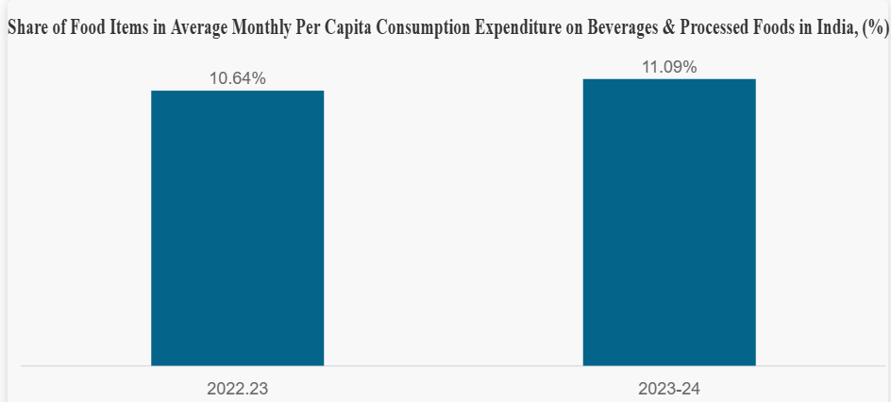
Figure 5: Share of food participation in India
(Source: Fortune business insights, 2026)
Economic Factors: The Indian fast food market is seen to grow at an impressive rate, and this has made it very appealing to multinational firms. The foodservice market size is estimated to be USD 114.40 billion in 2025 and is estimated to be USD 282.04 billion in 2034, with a CAGR of 10.55% (Fortune Business Insights, 2026).
High disposable incomes, urbanisation and the changing lifestyle contribute to this growth by exerting pressure on the need to have convenience in food. Moreover, the growth of the middle-class population has a great contribution to the purchasing power and patterns of consumption.
Nevertheless, the pricing policies of McDonald's can be affected by such economic factors as inflation and the sensitivity of prices among consumers. The value-based pricing model has to be used by companies, as many Indian consumers are still very price-conscious (Perody and Sudhakara, 2024).
Thus, as much as the economic conditions offer growth opportunities, they demand operational cost-efficiency and price flexibility.
Social and Cultural Factors: The cultural diversity within India has a great impact on consumer behaviour in the fast food industry. The dietary taste, religion and the local tastes are very important in determining the demand. The ability to localise its menu, including the introduction of vegetarian products and avoiding beef-based dishes, is regarded as the key to the success of McDonald's in India (Upadhye et al., 2024).
In addition, the growing population of working populations and two-income families has created a trend towards convenience-based consumption. A study suggests that youths and students are the main source of demand when it comes to fast food in South Asia (Saha et al., 2022).
Simultaneously, health awareness is making things more difficult, with consumers shifting towards healthier food choices. This is a trend that makes McDonald's have to be innovative and diversify its menu.
Technological Factors: The technological development has helped McDonald's to achieve high customer engagement and efficiency in its operations in India. The popular use of smartphones and internet connectivity has created an expansion of the online food delivery platform.
There are more than 954 million internet subscribers in India, so the popularity of such platforms as Zomato and Swiggy has grown, which has helped McDonald's connect to a wider audience (Polke et al., 2022).
Moreover, AI-based analytics, mobile applications, and digital ordering systems have enhanced the efficiency of services and had a beneficial effect on customer experience (Devi and Chandrasekar, 2023).
The competition, however, also gets stronger with the increased use of technology, with smaller companies able to enter the market using cloud kitchens that have a low capital investment.
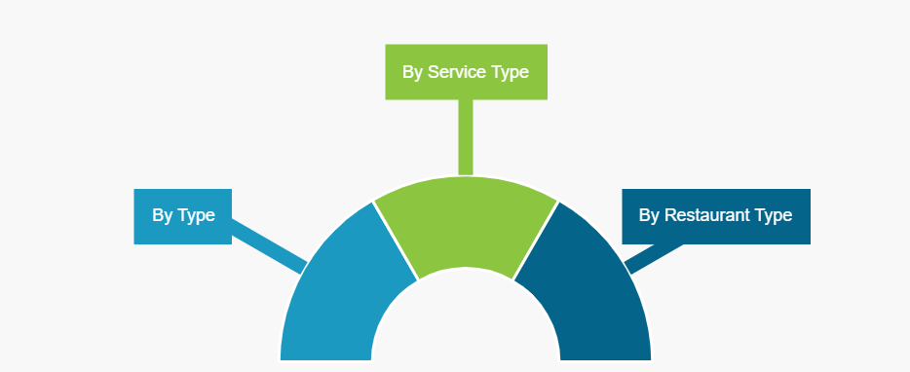
Figure 6: Indian food market segmentation
(Source: Fortune business insights, 2026)
Legal Factors: India has a legal environment in which the strict adherence to labour laws, taxation laws and food safety regulations is mandatory. McDonald's should observe licensing regulations, hygiene and employment laws, which may make the business more complex.
In addition, legal battles and issues related to franchises have traditionally influenced McDonald's work in India, and the role of appropriate governance structures cannot be ignored (Kavyasri and Vaijayanthi, 2022).
Legal compliance is therefore a necessity, which may also form an obstacle to speedy growth.
Environmental Factors: In the fast food industry, sustainability is gaining a lot of significance. The control of waste, packaging and water consumption are some of the issues that are becoming a concern to regulators and consumers.
Researchers indicate that wastewater treatment and sustainability are critical to the food industry, and the environmentally friendly operations should be prioritised (Shrivastava et al., 2022).
McDonald's has reacted by embracing sustainable sourcing and plastic reduction, but environmental pressures have been shaping the operation strategy.

4.2 Industry Attractiveness: The Five Forces Perspective of Porter.
The Five Forces by Porter can be used as a critical analysis of the competitive strength and appealability of the Indian fast food business to McDonald's. Competitive rivalry in India is hectic, given the existence of multinational and effective home brands. Hadirams and Wow! companies. Momo also enjoys competitive prices because of its localised menus, which are competitive with McDonald's market share. This high competition requires constant innovation, menu change, and pricing policies, which have put operational pressure.
The risk of new entrants is moderate and on the increase. With the emergence of cloud kitchens and online platforms, small firms have been able to penetrate the market without huge investment. This changes the competition not between dine-in and traditional format but delivery-based model, which makes the industry dynamic and unpredictable. Meanwhile, McDonald's also enjoys economies of scale, which reduces the bargaining power of suppliers to low-to-moderate levels. It has an established supply chain and long-term relationships that offer it a cost advantage and quality consistency. McDonald's was able to penetrate India despite the regulatory barriers and rivalry of the local companies due to its ability to modify its business model. Development of strategic alliances with local franchisees, adherence to regulatory requirements and unceasing development of the menu allowed the company to break the barrier to market entry and maintain the growth.
The bargaining power of buyers in India is high, though. Consumers are very price sensitive, and they have numerous substitutes such as fast food shops and home prepared meals in the neighbourhood. This compels McDonald's to have low prices, engaging in profit balancing. Also, the substitute threat is very high, because the traditional Indian street food and local cuisines are commonplace, less expensive and usually viewed as fresher or more original. These considerations suggest that the market has great growth opportunities but is very competitive as well as needs continuous differentiation and innovation to remain ahead of the pack (Loredana, 2024).

4.3 Strategy factors that have contributed to the success of McDonald's.
Localisation Strategy
The high level of localisation is one of the factors that have contributed to the success of McDonald's in India. The company has modified its menu to accommodate the Indian culture and preferences as compared to the global standardised model. This strategy has helped McDonald's to achieve confidence and approval among Indian customers.
Critically, in a culturally diversified market such as India, localisation is a strategic advantage as well as a necessity. With no such adaptation, the company would not compete favourably with the local companies that already know the local tastes. But over-localisation can also result in loss of global brand identity, and this poses a strategic dilemma between maintaining global uniformity and local responsiveness. However, innovative and offensive approaches increase the competitive edge in such complicated conditions (Al-Mamary and Alshallaqi, 2022). This localisation approach is directly related to demand factors recognised under Porter's Diamond Model, where cultural diversities and consumer tastes necessitate companies to localise their products to stay competitive.
Digital Transformation
The fast food sector in India is one of the industries that has experienced major growth as a result of digital transformation. McDonald's has been increasingly dependent on online ordering systems, mobile apps, and collaborating with delivery services like Zomato and Swiggy. These technologies enhance the convenience of customers, increase access, and improve the overall efficiency of the services.
The high rate of digital adoption in India through the use of smartphones and internet penetration has greatly increased the customer base of the firm. Digital marketing plans also enable McDonald's to get into a personal interaction with the consumers and customize products. Thus, the opportunities that digital transformation brings about in the context of expansions are, at the same time, the sources of competition in the industry (Devi and Chandrasekar, 2023).
Supply Chain Efficiency
A good supply chain network has also helped McDonald's succeed in India by ensuring consistency, quality, and efficiency in the operations of its products. Its logistics, relationship with its suppliers and cold storage have been heavily invested in to ensure that the company upholds global standards.
These strengths notwithstanding, infrastructural issues in India remain a major threat. Poor cold-chain infrastructure, poor transport network and power shortages are some of the issues that make operations more expensive and less efficient. These are the main challenges that are especially applicable in the small cities and rural regions, where there is a restriction on expansion. Consequently, as the supply chain is a competitive advantage available to McDonald's, it needs to keep evolving to overcome the structural weaknesses in the Indian market (Fortune Business Insights, 2026).
Consumer Behaviour Trends
The strategic decisions taken by McDonald's have a direct influence on the behaviour of consumers in India, which has been changing very fast. The rising urbanisation, growth of disposable income, and lifestyles have led to the demand for ready-to-eat food. Simultaneously, consumers of a younger age are more oriented towards global food trends, which promotes the development of multinational brands.
Moreover, consumer activism and social consciousness may have a strong impact on brand perception. Negative publicity and boycotts have the potential to hurt reputation and influence financial performance, especially in a digitally connected world where information travels fast. This is an indication of the value of good ethics and effective management of brands in creating long-term success (Elshaer et al., 2025).
As it can be analysed, the market environment McDonald's operates in India is quite appealing but intricate. The nation has good growth potential as it has a huge population, rising income rates and fast urbanisation. Access to the market and efficiency of operations are also increased with the growth of digital platforms.
On the whole, McDonald's in India can be successful provided it can strike a balance between international competence and local sensitivity. The firms must maintain a long-term competitiveness in this dynamic market through continuous innovation, efficient technology application, and cultural and economic sensitivity.

5. Conclusion
To sum up, the Indian fast food industry has great growth potential as urbanisation, increased incomes, and a shift in consumer lifestyles drive the growth. In the analysis, it appears that the industry is extremely competitive, but it is appealing because of high demand and growing digital ecosystems. Porter Diamond Model application shows that India is favoured in the condition of demand, factor resources, and innovation to make it globally competitive. Moreover, the analysis of McDonald's proves that success is based on successful localisation, digitalisation, and strategic flexibility. In general, companies that can be both efficient and responsive on a global scale have higher chances of having a sustainable competitive advantage in this market of dynamism. Moreover, the findings indicate that the ability of multinational corporations to successfully enter the Indian fast food market will be highly dependent on their ability to localise their products, set pricing strategies, and successfully utilise technology. The Indian fast food market holds tremendous growth opportunities, but it requires firms to navigate a complex, ever-evolving business environment.

Section 2: Reflective Account
Description
In this report, the fast food industry in India was analysed, and the competitive position of McDonald's in the country has been assessed through various international business frameworks. The identified industry and country combination with adequate academic and industry data formed the starting point of the research process. Various sources such as journal articles, market reports and industry studies were consulted to learn about the structure, growth and competitiveness of the sector. Porter's Five Forces and Porter's Diamond Model are major models that were used to critically evaluate the industry environment (Afshar and Shah, 2025).
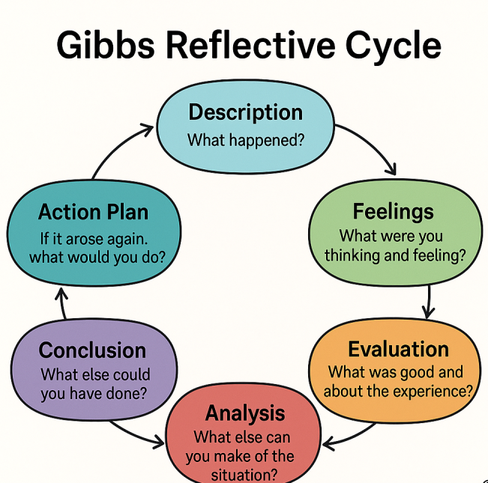
Figure 7: Gibbs reflective cycle
(Source: Author)
Feelings
The process was difficult at the start of the assignment because of the high amount of information and the necessity to critically assess various theories. It took critical judgment in the selection of proper and credible sources. But later on in the research, confidence increased, particularly when the links between theory and practical industry applications became more apparent. The deployment of systematic structures aided in the simplification of complex concepts, and the analysis became easier (Park and Park, 2022).
At the same time, I realise that the fast food industry is ever changing; therefore, it was quite difficult for me to find and to evaluate reputable and current information. To make certain that the data I was retrieving could be relied upon, it required careful consideration and avoided the use of non-academic sources too frequently. Gradually, however, my ability to synthesise data and apply theory to practice was improved and I felt more confident.
Evaluation
The ability to combine theoretical models and real-life data could be considered one of the positive results of the process. As an illustration, the application of the Porter Diamond model assisted in comprehending the severity of the competition and market forces in the Indian fast food sector (Loredana, 2024). Also, the latest market data was included, which enhanced the quality and relevance of the analysis.
Nevertheless, it had certain shortcomings as well. In some cases, it was hard to locate very specific and recent academic materials that are directly related to the Indian fast food industry. This necessitated the use of a combination of academic and industry reports, which had to be carefully assessed in terms of credibility. Moreover, it was difficult to control word limits and still maintain critical depth.
Business strategy can be greatly influenced by the economic and cultural conditions within the countries where they are operating (Afshar and Shah, 2025). For instance, I have learned that when examining the Indian market, multinational companies will need to alter their operating structure to fit the local environment if they are going to be successful in that marketplace. This has created a much deeper and better understanding of how many complexities can exist when formulating an international business strategy for a company.
Analysis
Applying theoretical frameworks helped create a greater insight into the concept of international business. The Diamond Model came up with information on the national competitiveness, and it includes demand conditions, endowments of factors, and the firm strategy (Afshar and Shah, 2025). On the same note, the application of market information, including the fast growth of the foodservice market in India, upheld the argument that the market is very appealing to multinational corporations (Fortune Business Insights, 2026).
Another key point that the research highlighted was the need to be innovative and flexible in competitive markets. The principle of proactiveness and innovativeness, in turn, was especially useful in terms of how companies like McDonald's manage to keep their competitive edge (Al-Mamary and Alshallaqi, 2022). Besides, the use of digital platforms in the revolution of the foodservice industry was seen through the research on online delivery systems and consumer behaviour (Polke et al., 2022).
Conclusion
Generally, conducting research and preparing this report helped me improve my knowledge of how theoretical models apply to the real business situation. It emphasised the need to think critically, assess the sources, and do systematic analysis when writing an academic paper. It was also realised that international business decisions can be affected by various interrelated factors such as economic, cultural and technological factors.
Moreover, the experience has also highlighted the importance of continuous improvement in academic writing and critical thinking. By reflecting on my strengths and weaknesses, I have gained greater awareness of the areas that require further development in order to achieve higher levels of academic performance.
Action Plan
In my upcoming assignments, I would strive to become more effective in conducting research by locating high-quality academic sources faster and in a more organised manner. I will also work on the development of more critical analysis in comparison of various perspectives, as opposed to trusting in one perspective. Moreover, time management will be enhanced to gain more time to revise the final work and polish it.
Besides, I will increase my knowledge of analytical frameworks by training in their usage in the various industries. It will assist in the acquisition of more confident and independent academic writing skills. Lastly, I will also keep abreast of the latest shifts in the industry and statistics so that the future job will be significant and current (Devi and Chandrasekar, 2023).

References
Abdulkader, R.S., Jeyashree, K., Kumar, V., Kannan, K.S. and Venugopal, D., 2022. Online food delivery system in india: profile of restaurants and nutritional value of food items. Vision, p.09722629221110122.
Acharya, N. and Paramasivam , P. (2024). New outlets, cheaper options fail to revive fast-food earnings in India. Available at: https://www.reuters.com/world/india/new-outlets-cheaper-options-fail-revive-fast-food-earnings-india-2024-04-24/ [Accessed 28 Mar. 2026].
Afshar, M.Z. and Shah, M.H., 2025. Leveraging Porter's diamond model: Public sector insights. The Critical Review of Social Sciences Studies, 3(2), pp.2255-2271.
Alang Ibrahim, S., 2023. Industrial training report: McDonald's Shell Bandar Botanic DT.
Al-Mamary, Y.H. and Alshallaqi, M., 2022. Impact of autonomy, innovativeness, risk-taking, proactiveness, and competitive aggressiveness on students’ intention to start a new venture. Journal of Innovation & Knowledge, 7(4), p.100239.
Aswathy, T., Rajan, S.A., Chitra, N. and Soumya, V.I., 2024. Food Safety Standards Authority of India (FSSAI): A multifaceted approach towards food safety. Agritechpublication. com, pp.1-4.
Batta, A., 2025. The Economics of Fast Food: Impact on Society, Employment, and Consumption Patterns: A Comprehensive Study Integrating Global and Indian Perspectives. Journal of Economics, Finance and Accounting Studies, 7(7), pp.12-17.
Batta, A., 2025. The Economics of Fast Food: Impact on Society, Employment, and Consumption Patterns: A Comprehensive Study Integrating Global and Indian Perspectives. Journal of Economics, Finance and Accounting Studies, 7(7), pp.12-17.
Binakar, P. and Srivastava, A., 2022. A Study of Management of Food Service In The Catering In India. Special Education, 2(43).
Constantin, M., Sacală, M.D., Dinu, M., Piștalu, M., Pătărlăgeanu, S.R. and Munteanu, I.D., 2022. Vegetable trade flows and chain competitiveness linkage analysis based on spatial panel econometric modelling and Porter’s Diamond Model. Agronomy, 12(2), p.411.
Devi, J.A. and Chandrasekar, K.S., 2023. Digital Marketing in the Food Service Industry in India: A Review. i-Manager's Journal on Economics & Commerce, 3(1), p.29.
Elshaer, I.A., Azazz, A.M., Fayyad, S., Kooli, C., Fouad, A.M., Hamdy, A. and Fathy, E.A., 2025. Consumer boycotts and fast-food chains: economic consequences and reputational damage. Societies, 15(5), p.114.
Fortune Business Insights (2026). India Foodservice Market Size, Share & Analysis, By Type (Full Service Restaurants, Quick Service Restaurants, Institutes, and Others), By Service Type (Dine-In, Takeout, and Delivery), By Restaurant Type (Chained and Independent), and Country Forecast, 2026-2034. Available at: https://www.fortunebusinessinsights.com/india-foodservice-market-114008. [Accessed on: 28.03.2026].
Frimpong, C.H.R.I.S.T.I.A.N.A., 2022. Evaluating the socio-economic impact of the fast-food industry in Ghana: a case study of Birim Central Municipal in the Eastern Region (Doctoral dissertation, University of Education, Winneba).
‌Globaldata.com. (2025). India Foodservice Market Size and Trends by Profit and Cost Sector Channels, Players and Forecast to 2028. Available at: https://www.globaldata.com/store/report/india-foodservice-market-analysis/ [Accessed 28 Mar. 2026].
Gupta, A., Yadav, R., Nair, A., Chakraborty, A., Ranu, S. and Bagchi, A., 2022, June. Fairfoody: Bringing in fairness in food delivery. In Proceedings of the AAAI Conference on Artificial Intelligence (Vol. 36, No. 11, pp. 11900-11907).
IMARC Group. (2025). India Fast Food Market Size, Share, Industry Analysis | 2034. vailable at: https://www.imarcgroup.com/india-fast-food-market [Accessed 28 Mar. 2026].
‌Jha, A., Kapoor, M., Kaul, K. and Srivastava, K., 2022. Demystifying the influence of CSR perception on the purchase intention of Generation Z in fast food industry. LBS Journal of management & research, 20(1-2), pp.1-20.
Kavyasri, S.J. and Vaijayanthi, P., 2022. Mcdonald's Entry into India. Issue 2 Int'l JL Mgmt. & Human., 5, p.1346.
Loredana, E.M., 2024. Porter'S 5 Competitive Forces. Annals-Economy Series, 4, pp.142-146.
‌MENAFN (2025). India Fast Food Market Size, Share, Industry Growth, Analysis, Trends And Research Report 2025-2033. Available at: https://menafn.com/updates/pr/2025-08/12/IG_328e0image_story.jpg [Accessed 28 Mar. 2026].
Nayak, H.S., McDonald, A.J., Kumar, V., Craufurd, P., Dubey, S.K., Nayak, A.K., Parihar, C.M., Peramaiyan, P., Poonia, S., Tesfaye, K. and Malik, R.K., 2024. Context-dependent agricultural intensification pathways to increase rice production in India. Nature Communications, 15(1), p.8403.
Park, H.R. and Park, H.S., 2022. A Study on the Industrial Competitiveness Analysis of Domestic Autonomous Operation Technology Industry Based on the Porter's Diamond Model. Journal of Navigation and Port Research, 46(3), pp.203-208.
Perody, S.H. and Sudhakara, A.M., 2024. Strategic analysis of McDonald’s global and Indian market performance. Asian Journal of Managerial Science, 13(2), pp.52-60.
Polke, N., Tripathi, S. and Chandra, R., 2022. A critical study of the demand and supply in relation to food delivery apps like Zomato and Swiggy in India. Russian Law Journal, 10(4), pp.12-23.
Polke, N., Tripathi, S. and Chandra, R., 2022. A critical study of the demand and supply in relation to food delivery apps like Zomato and Swiggy in India. Russian Law Journal, 10(4), pp.12-23.
‌Reuters (2024). McDonald’s India operator Westlife misses Q2 profit view as consumers cut back. Available at: https://theprint.in/india/mcdonalds-india-operator-westlife-misses-q2-profit-view-as-consumers-cut-back/2326665/ [Accessed 28 Mar. 2026].
Saha, S., Al Mamun, M.A. and Kabir, M.R., 2022. Factors affecting fast food consumption among college students in South Asia: a systematic review. Journal of the American Nutrition Association, 41(6), pp.626-636.
SAJI, T., VINOD, M.S. and NAIR, N.A., 2024. A STUDY ON THE INFLUENCE OF MARKETING STRATEGIES OF FOREIGN FAST-FOOD BRANDS IN THE INDIAN MARKET (Doctoral dissertation, St. Teresa'a College (Autonomous) Ernakulam).
Shrivastava, V., Ali, I., Marjub, M.M., Rene, E.R. and Soto, A.M.F., 2022. Wastewater in the food industry: Treatment technologies and reuse potential. Chemosphere, 293, p.133553.
Upadhye, N., Sharma, D., Yacin, W.M.I. and Mathur, V., 2024, February. Business Environment Analysis of McDonald’s Marketing Strategy. In Global Leadership Research Conference (pp. 95-112). Singapore: Springer Nature Singapore.

