University of Wales Trinity Saint David
Application Development (ACCA5012) – Dr Kemi Ademoye
Task 3-Report
Jack Partridge - 1702918
December 16th, 2018
Table of Contents
Introduction 1
Application Development Concepts 1
A: Design Principles- 1
B: Usability & User experience- 1
Requirements 2
Design’ section 3
Implementation section 3
Evaluation section 3
References 3

Introduction
In this report I shall be going over a 3d maze game designed to confuse the player until they reach a set goal and can only when achieved the goal can progress on. I will explain how to play the game, Important of application development, user experience and more. I hope after I finish the report I have a clear understanding on how I can improve upon applying better application skills when making my next project and giving the user a better experience.

Application Development Concepts
A: Design Principles- It is important to have design principles as it is down to how you want to make the game using its mechanics, playstyle, goals, art style and more. You want your game to be played, right? Making sure you have some simple principles can really help any application develop as it sets restriction on you to make sure people will understand the purpose of the game and that is to play.
Here are 3 principles that can help and is explained below:
“More rewards than punishments”: What this implies is that the players should get health back whilst playing instead of having health lost as they done a good job at playing etc.
“Start with a core machinic”: Having your game with your idea(s) is a dream for everyone but you’ll have to find a mechanic that suits both your idea and the games engine or player(s) needs. This means if it’s a building game you are more than likely forced to build at one point throughout.
“Easy to learn, hard to master”: This is a smart concept for a principle as a game can be so simple & easy that the player feels successful and their skill barrier is at its highest. You’ll need to find a system in the game that will allow for easy controls or abilities that can then be worked upon and mixed up to have a hard to master aspect.
B: Usability & User experience- The user experience (UX) is very important as it’s what the user will experience when the application is developed. When you make a game, you need them to have an above average UX as it entices the users to come back since their experience was so good. Making a VR horror game you’d expect the user’s experience to be amplified as you have the virtual reality inside the horror game making their experience more real. When thinking of user experience, it is best to make it enjoyable but at the same time have a challenge, so it makes them want to come back since they enjoyed it and they may have not yet finished the challenge that was set.

Requirements
A: Software requirements specification- For my software requirements I have been asked to do the following:
- Generate a maze layout-We have been given the maze generator for our project, but my goal is to implement it into a minimum of 3 levels.
- I am then required to have a minimum of at least 3 level. I will try and make the levels harder as the player progresses through them.
- For my heads up display I will keep it simple and only show the timer so that the player knows how long they have spent inside the maze. I shall also have a text that displays the button for the pause menu.
- The goal within my game shall be locating the treasure chests found around the cave maze. I aim to expand the time in which it takes to get the treasure. I can do this by making the maze bigger in size and only when the treasure is found can they move on to the next level.
- For the obstacles/opponents I shall be sticking with a gate concept when a player gets too close to a gate or near a bend that is the incorrect way and will be forced to try again.
After gaining consciousness, you find yourself cold & alone in what seems to look like an abandoned mine! Your task is to find the treasure chest(s) to escape! There is a catch as you have a time limit in which you need to complete the task to escape as fast as you can.
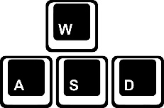
How to play:
Using the keys “W”, “A”, “S” & “D”. You can move the player in the directions the keys are located. Using these keys, you can move the player around the abandoned mine to try find that treasure & escape.

The mouse can be used to point your players camera in the direction your mouse is pointing to. This can be useful for turning around, looking in direction such as, left, up, down & right.
Also used to navigate the main menu to start the game and pause panel that can be found in game when escape button navigated on the keyboard is pressed!
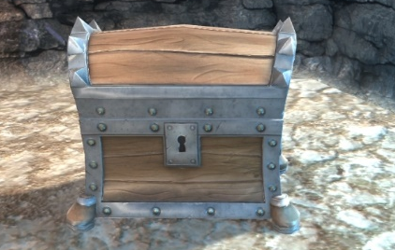
The object/Goal- You are required to go around the maze to find the treasure chests. Once located walk up towards it to collect it and progress to the next level.
As you get to higher levels there will be more chests required to collect and move on to the next level.
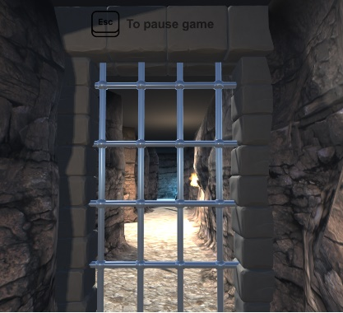
Along the way the player/user will come across some barriers and will be forced to turn around or restart. Adding the gate is a good way to add difficulty so if face to face you’ll need to find another way round to find the treasure!
Making sure to add difficulty in a game is very important as it challenges the player to think of ways around the obstacle.
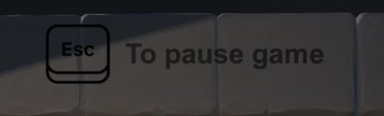
Making the game dark by changing the lighting settings within unity’s settings make it a challenge for the player to see and thus adding more difficulty to the game.
The player must use a torch to navigate around the maze and locate the treasure.
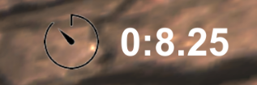
For UI, I have simply got a text and image to display so that the user knows how to/what button to pause or resume the game. I added this pause feature as I know the user may need to take a break and wouldn’t like their timer to continue to go up.
Whilst also part of the UI, I made a timer so that it can allow for a challenge as well as apply pressure to beat their previous score. It can go up to hours, but I feel the game wouldn’t need the hour timer as it’s a short game and only takes minutes to complete.
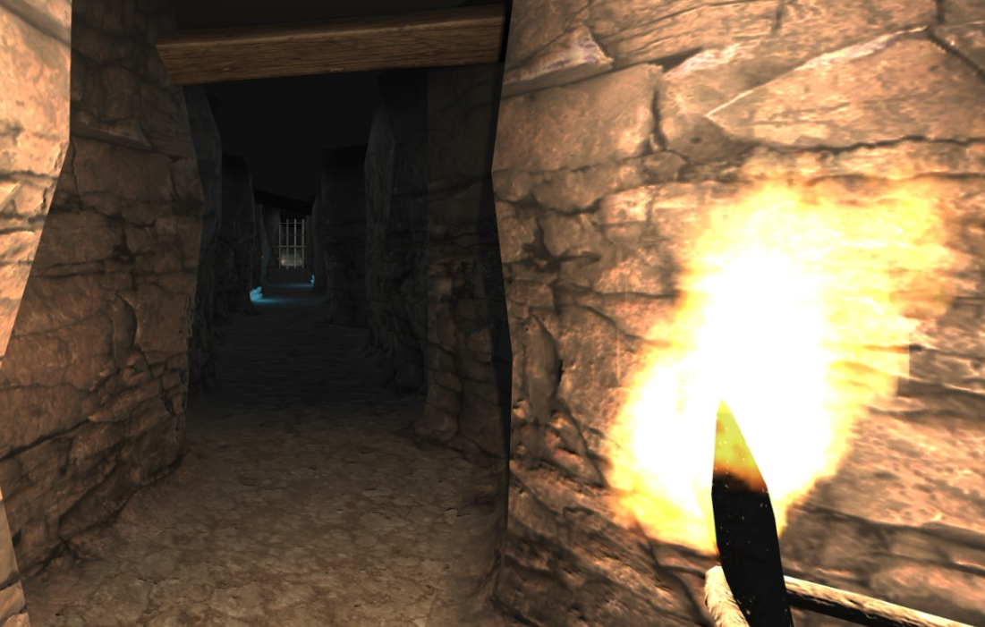
I feel by adding this detail or twist to the game can allow for the user’s experience to be amplified as it creates a fear factor and will have the user scared and confused on what the game will have to offer. Simply turning off the crystals in the maze and adding the torch can change the game’s scene up completely.
I also used the torch that was with in the maze to recycle the assets and not have to remake or find one myself. Doing so saved me a lot of time so I can focus on fine tweaking the other features within my game.

Design’ section
For the actual design of the game, I had chosen to go simple so it then allows for the user to not get confused in anyway whilst playing the game unless it’s the maze of course.
The aim was to design a maze in any way we’d like whilst adding requirements we got given. We can do anything to the game so long as it was a maze concept then we apply our take on it and implement our own ideas.
I had mixed up my design of the maze by added the goal as a treasure chest as the concept was an abandoned mineshaft, so treasure located down here would be a cool idea. I then added a main menu so that the user can toggle Fullscreen is required. I added ambient sounds to make the design of the game benefit the user(s) experience whilst playing.

Implementation section
Please find below a list of all the scripts I have made:
- Timer-This will tell the player how long they have spent in the maze and will pause if the player is to pause game & will resume to count when the player is to un-pause it.
- Fade in-Will fade in the logo for the splash screen along with the bell sound.
- Button manager- This will help me manage the buttons in the main menu for the player to navigate around.
- Next level-A script that when and only when the player/user has reached their goal it will then allow for the user to progress on to the next level.
- Maze Test-This way helped in class but made by me in which will help put the treasure around the maze so that the user/player can reach their goal.

Evaluation section
The software verification and validation are both important aspects for the software development side of things. Making sure to test the implemented features to see if they suit the needs for both the user and your intentions is a must as you are designing the software and you expect people to play it. You’ll be required to have a set balance on both as not everyone ideas are liked by others.
For future reference, I feel I have learned and improved upon the understands of software, how to meet the needs of your target audience, the designing of the mechanics and a whole load more. I know that UI I would usually take a long time on to make a main menu look nice for the user’s experience but isn’t required to waste as much time or effort on as the game is what the user would be looking for when playing or purchasing. The ideas branch can go on for a long time, but I know for a future project when doing software is to keep in mind what you want the mechanics to play like and does it suit the style you wanted for the users.

References
Please find below a list of all the materials I had used for my project.
WASD icon: https://cdn.shopify.com/s/files/1/0941/8552/products/wasd-or-wads-keyboard-_Converted_1024x1024.jpg?v=1530027844
Treasure chest model: https://www.turbosquid.com/FullPreview/Index.cfm/ID/615861
Tolling bell sound effect: http://soundbible.com/2206-Tolling-Bell.html
Mouse icon: https://cdn4.iconfinder.com/data/icons/computers-it/48/computer-02-512.png
Timer icon: https://www.freeiconspng.com/uploads/timer-icon-11.png
Principles for application development: https://www.nyfa.edu/student-resources/three-principles-every-game-designer-should-follow/
Cave sound effect: https://www.zapsplat.com/sound-effect-category/caves/
Escape button icon: https://img.icons8.com/ios/1600/esc.png
Boulder model: https://www.turbosquid.com/FullPreview/Index.cfm/ID/734788
Wind sound effect: http://soundbible.com/634-Wind-Blowing.html/

marking criteria and Student FEEDBACK

This section details the extent to which the assessment criteria are demonstrated by you, which in turn determines your mark. The marks available for each category of skill are shown. Lecturers will use the space provided to comment on the achievement of the task(s), including those areas in which you have performed well and areas that would benefit from development/improvement.

Common Assessment Criteria Applied (Assignment 1) | Marks available | Marks  awarded
1. Engagement with Literature Skills

Although a reference list has been provided, these are references for assets used in the implementation. You are required to engage with appropriate academic reference sources. Please see comment below under knowledge and understanding skills. As such, you have not really demonstrated the use of appropriate reference sources. (Grade mark: 20.00%) | 5 | 1
2. Knowledge and Understanding Skills

Although you have mentioned some good games design principles, your discussion of application development concepts is brief and does not really demonstrate a sound and critical understanding or in-depth research of the concepts. Furthermore, no reference sources have been consulted. (Grade mark: 42.00%) | 25 | 10.5
3. Cognitive and Intellectual Skills

A basic evaluation of the implemented game has been provided, while documentary evidence of testing is rather brief and could be improved beyond screenshots to further demonstrate test cases for the gameplay functionality. (Grade mark: 35.00%) | 20 | 7
4. Practical Application Skills

A good attempt featuring a simple maze game, but I would have liked to see a bit more of your own ideas implemented beyond the examples I gave to help you get started. You had some well-thought-out ideas, but unfortunately were not able to implement most of them. The game does not really dynamically generate a maze; it simply loads pre-made mazes. The main areas for improvement include knowing when and how to expose fields and also when you should make your methods public. All of your fields and methods have been made public. If you need to make fields accessible to the Inspector, then use the SerializeField attribute, if you need to make them accessible to other classes, then make use of properties and not all methods need to be made public. In terms of game play, generally you need to aim to improve the gameplay and presenting more challenges to the player. Also, learn how to correctly parent your HUD and implement the functionality for the different HUD items. Please see the comment about the doors in your report. Nonetheless, a good attempt. (Grade mark: 55.56%) | 45 | 25
5. Transferable Skills for Life and Professional Practice

The report is satisfactory Generally, aim to improve your writing style and please see comments in your report. (Grade mark: 50.00%) | 5 | 2.5

Assignment Mark (Assessment marks are subject to ratification at the Exam Board. These comments and marks are to give feedback on module work and are for guidance only until they are confirmed. ) | Late Submission Penalties (tick if appropriate) |  | 46%
 | Up to 1 week late (40% Max) |  | 46%
 | Over 1 week late (0%) |  | 46%

