Name: Sarah Ashton. Student number: 2117732. April 2022.

BMPF 7003: Working and Learning: An introduction to work-based Higher education.

This is a two-part assignment.

Part 1: Critically evaluate a range of theories and models you have recently studied, explaining the relevance to your workplace practice and procedures and develop a strategy applying what you have learnt to improve your practice.

This part of the assignment is 2700 words and worth 60%

Jaw tension: How does it affect voice production in singers and what strategies can singing teachers implement to ease jaw tension whilst singing.

Introduction

Encouraging a relaxed posture and throat, jaw and facial muscles whilst singing is important to avoid vocal damage and fatigue (Fisher et al. 2020; Dimon, 2011). Mabry (1992) p31 states “The best sound you make is the one when you are most relaxed. Sometimes less is actually more and we sabotage ourselves by trying too hard”. In my singing teaching practice where I teach adults, adolescents and children in both individual and group sessions I have noted jaw tension is a reoccurring issue. The aim of this work is to understand the main causes of jaw tension associated with singing technique to help create and implement strategies to assist my students in alleviating tension revealing a free, enjoyable and healthy singing voice.

How is the Jaw structured?

Muscle tension is caused by a muscle being over-burdened without receiving sufficient recovery time. The lack of recovery limits the amount of blood flow to the muscle and allows metabolic waste products to build up, this in turn leads to a lack of oxygen in the muscles creating pain, tenderness and a lack of flexibility (Walter Deeters, 2005). The jaw (anatomically known as the mandible) is a horse-shoe shaped bone, the two vertical parts of each side are called the rami and the horizontal part is called the body (Calais-Germain and Germain, 2013). The mandible is controlled by two symmetrical joints on each side, the Temporomandibular or TMJ Joint (Calais-Germain and Germain, 2013). At these joints the main movement of opening and closing is a hinging action. The hinge hangs from the temporal bones which also allows it to slide forwards and backwards (Dimon, 2011; Kayes, 2014) (See Fig.1).

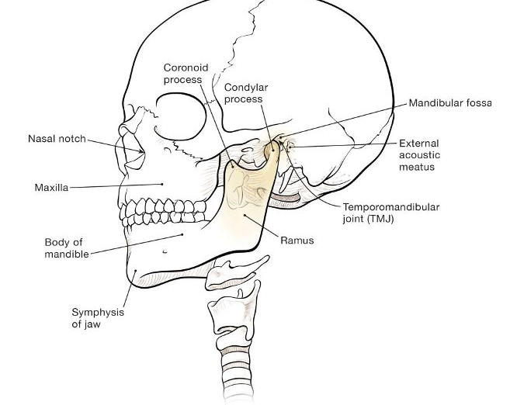
Fig 1: The Jaw (Mandible) and Temporomandibular joint

Dimon (2018).

The jaw is acted on by powerful muscles designed for grinding and chewing food; the temporalis, the masseter, the medial ptreygoid and the lateral ptreygoid (Chapman, 2017; Kayes, 2015) (See Fig.2).

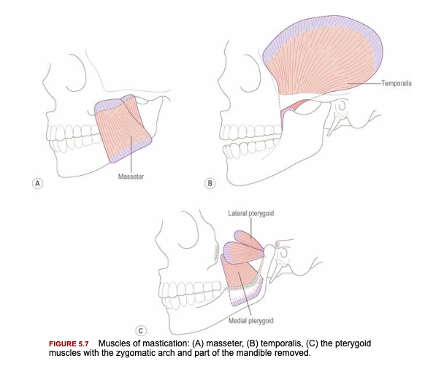
Fig 2: Muscles that operate the Jaw

Palastanga (2011).

These muscles often become tense and tight which creates excessive tension and movement in the jaw which can then lead to tension and improper function of laryngeal musculature due their close connection (Dimon, 2011). The jaw is attached to the vocal apparatus via the hyoid bone which is suspended from the skull and mandible. The hyoid is a small but important bone as many ligaments and muscles of phonation are attached to it, it is located behind the jaw and keeps the larynx tube away from the pharynx, keeping it open and allowing resonance. (Walter Deeters, 2005; Calais-Germain, Germain, 2013) (See Fig.3).

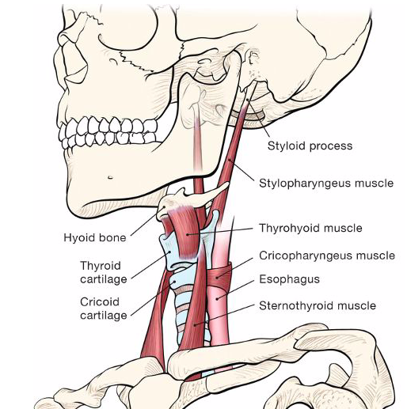
Fig 3 :How the jaw is linked to hyoid bone

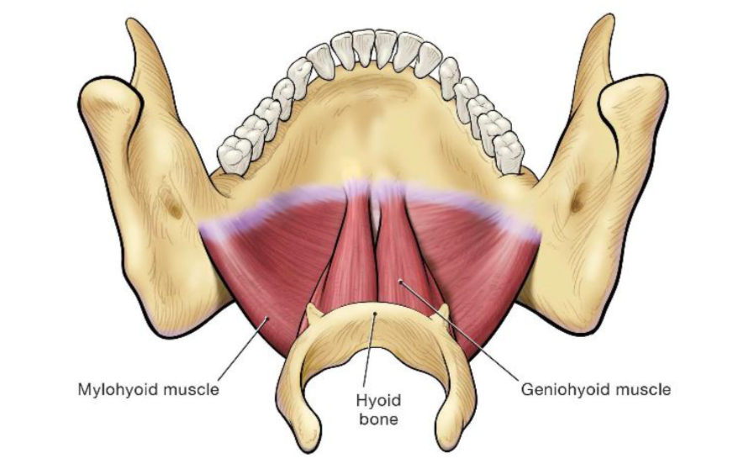

Dimon (2018).

What are the vocal risks associated with tension?

Inappropriate function of the vocal tract muscles due to jaw tension can result in a loss of voice resonance, a loss of control of pitch and loudness, hoarseness, excess vocal effort, vocal fatigue and neck tightness. With continued voice use these symptoms can intensify and result in more serious vocal issues such as vocal nodules and abnormalities with the vocal folds (Sielska-Badurek et al. 2016). It is important to note that vocal tension can have a number of different causes such as being a symptom of emotional stress, poor singing technique or be caused by a medical condition (Morrison, 1997; Walter Deeters, 2005). Therefore it is imperative to teach the student holistically and be aware tensions may not always have their roots in singing technique alone (Williams 2019).

How can jaw tension be identified in singing students?

Tension may be seen in students as jaw immobility, a forward jaw position (Williams, 2019), unclear articulation, the jaw appearing to be involved in pitching, controlling vibrato, and an effortful sound with white noise which can indicate the use of false vocal folds caused by jaw and tongue root tensions (Chapman, 2017). A tight jaw may also be noticeable by only being able to drop down less than a finger width and a bulging of the masseter muscle on the surface of the ramus (McCoy, 2019). Students may also suffer with headaches, earaches, pain in the masticatory muscles and temporomandibular joints, disturbances in jaw movements and they may also hear sounds in the jaw joints when the mouth is opened and closed (Wieckiewicz et al. 2015;Chapman, 2017).

What are the main possible causes of jaw tension within singing technique and what strategies can be utilised to help resolve them?

Poor Posture and alignment
As our voices are not solely reliant on our vocal apparatus the majority of voice practitioners will agree that an upright, relaxed and flexible posture is essential to healthy singing as without it tensions and potential vocal disorders may develop (Stadelman-Cohen and Hillman, 2014; Binkley, 2012). The position of the jaw affects the musculature of the larynx, tongue, and pharynx and due to their interconnections tensions can be easily transferred (Scott, 2010). When the jaw protrudes or becomes tense, the throat cannot release to the optimal position which is generally agreed by classical vocal practitioners to be a relatively low larynx and open pharynx; (Walters Deeters, 2005; LaFevre, 2015) an elevated larynx shortens the distance between the resonator tube, larynx and the lips which can thin out the timbre of the sound (Williams, 2019; Fisher et al, 2018; Harrison and O’Bryan,2014; Chapman, 2017; Miller, 2000). To create this optimal position the head needs to be balanced on the skull without tension and able to move freely whilst singing to allow the throat muscles to be freely suspended from the skull and the jaw muscles to release, creating an open, resonant sound (Walters Deeters, 2005; Dimon, 2011). Posture in the face and neck needs to be constantly checked to ensure the singer is not jutting their head forward when singing, as this can increase jaw tension and a dominance in the swallowing muscles rather than utilising the Sternothyroid and Omohyroid muscles (Macbry, 1992). An over-use of the swallowing muscles can create tongue root tension which can result in a lack of resonance (Chapman, 2017) due to a downward pressure of the tongue root on the larynx which narrows the pharynx (Harrison and O’Bryan,2014; Williams, 2019; Fisher et al. 2018). Dimon (2011) states that the key to tongue flexibility is linked to head balance and coordination with the supporting musculature.

Advantageous alignment and posture for the voice comes from balance, a strong core and the body feeling flexible and relaxed (Stadelman-Cohen and Hillman, 2014). Excess tension can be reduced using a full-bodied approach utilising therapies such as yoga, physical therapy, manual therapy such as massage, and chiropractic and osteopathic medicine (Tomlinson, 2015;O’Bryan and Harrison 2014; Stadelman-Cohen and Hillman, 2014). O’Bryan and Harrison (2014) p206 state that well intentioned instructions such as ‘stand up straight’ or ‘align your back to the wall’ can lead to an increase in tension including a tight jaw and instead recommend body mapping and a focus on movement. Body mapping encourages students to refine their mental representation of their body size, structure, and the function of each element (Peterson, 2006) (Gates, 2018). Gates (2018) suggests asking students to point and draw to each body part needed for successful singing to increase self-awareness. The Alexander technique has been found to be beneficial for singers and musicians and was founded by F.M Alexander (1869 -1955) an actor who struggled himself with voice fatigue through muscle tension (Brennan, 2018). He aimed to create a technique to help uncover and change unhealthy habits which may be the underlying cause for a number of ailments and problems, this is done through establishing where tensions exist and teaching students to move with ease and healthy posture through various exercises (Brennan, 2018). The method encourages a self-awareness of body movements, allowing students over time and with a trained practitioner to rid their bodies of unhelpful habits and tensions, revealing a free and healthy voice (Peterson, 2006). Lloyd (1986) found during his research on Alexander technique for singers that through focussed movement exercises and training, from a qualified Alexander technique practitioner, he was able to release his jaw tension. Feldenkrais is another useful method which through guided and directed movements from an instructor aims help students to become aware of their movements and habits, encouraging participants to let go of extra tensions and the belief that trying harder produces more positive results (Peterson, 2006;Gordon et al. 2013).During Paparo’s (2021) research on the effects of The Feldenkrais method on singers all participants experienced an increased flexibility and range in movement leading to a freer voice and less tension. Peterson (2006) and Papraro (2021) encourage practitioners to use Alexander and Feldenkrais exercises at the beginning of rehearsals replacing stretches which are suggested as usually hurried and likely to create more tension.

Excess tension can hinder the movements of the jaw and affect alignment and position, this can then lead to a limit of resonating possibilities due to it’s position as a modifier of the vocal tract (Lã and Gill, 2014). Students may often feel that opening their jaw wider will produce a louder sound however it will actually reduce the resonating space in the oral pharynx (Fisher et al, 2018; Chapman, 2017). Opening the jaw wide also requires a forward as well as downward motion, pulling the hyoid bone which will likely result in unconscious laryngeal elevation creating tension and problems with intonation (Scott 2010, Williams 2019;Harrison and O’Bryan,2014). An overly wide jaw can also result in tongue root tension which can then lead to the palate being forced down by the palatoglossus muscle (See Fig.4) causing a muffled sound (Chapman, 2017).

Fig 4 Muscles of the tongue:

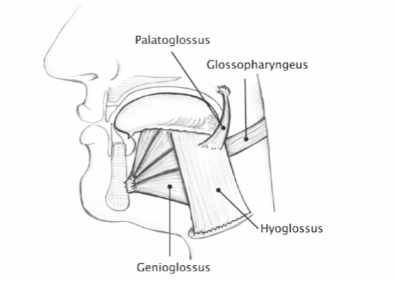

Chapman (2017)

A low-hanging relaxed jaw has been noted in high soprano voices to increase resonance due enlarging the resonating space in the mouth (Kayes,2019; Nair et al. 2016). Students should not be encouraged however to employ a low-hanging jaw for all circumstances as this can produce a dull sound as both the jaw and the tongue need to be flexible and free to produce energetic vowels and consonants (Williams, 2019; Gates, 2018; Miller, 2000).

Inadequate breath support and breathing technique
Once correct posture and alignment is understood focus needs to be given to the breath, ensuring students inhale keeping the shoulders and neck free from tension, and exhale keeping an upright posture with abdominal muscles engaged (Wilson, 1991). Melon (2013) states that focusing on strengthening and developing the core of the body is critical as without the upper body will begin to compensate and become tense. Chapman (2017) agrees and states that the voice needs active muscular support on exhalation to sing successfully, especially in a classical style, and explains that if the voice does not receive this support from the large muscles in the torso articulator muscles including the jaw, can become relied upon. If there are no other mitigating factors once the student is able to rely on the breath as the sole source of support for the voice it will become free of tension, move with flexibility and the rest of the body will relax (Wilson, 1991). Scott (2010) and Lloyd (1986) state that teachers must consistently reinforce correct breathing technique as without constant reminders bad habits such as over exaggerated mouth positions, stiff tongues and tight jaws may arise. The Accent method which was developed in the 1930s by Professor Svend Smith can be used to encourage students to engage abdominal support and has been proven to help improve airflow and normalises vocal fold closure (Harrison and O’Bryan,2014). In utilising this method students are asked to train and strengthen abdominal muscles by producing rhythmic patterns, first with unvoiced fricatives and then with alternative sounds (Melton, 2013). This method also helps the student to learn to release the breath quickly, eliminating the need for a top up breath in the chest which can often lead to tension (Melton, 2013). Stadelman-Cohen and Hillman (2014) warn that an excess of respiratory drive can lead to an increase in excessive muscle tension and teachers will need to ensure balance. Students need to understand breath support does not equal tension and it should be responsive and flexible to phrase lengths, articulation, pitch and dynamics (Harrison and O’Bryan,2014). Peterson (2006) also states that efficient breathing comes naturally after flexibility in the ribcage, lengthening and widening of the back and the gentle use of the diaphragm muscles has been achieved, rather than forcing the breath. SOVTE exercises such as singing through a straw or lip trilling have been found beneficial in releasing tension whilst also ensuring correct breath flow and energy (Dargin and Searl, 2015). Through resistance SOVTEs increase the work of the respiratory system, increasing subglottilc pressure without the risk of high impact on the glottis which can help the developing singer learn to understand and manage the airflow needed for relaxed and tension free singing (Hijleh and Pinto, 2021).

Jaw becoming overly involved during articulation
The jaw’s main function is mastication and only it’s secondary function to articulate. It is possible to clearly articulate with little involvement from the jaw (Chapman, 2017). Singers often allow movement of the articulators to alter the throat position and teachers must be attentive to this possibility and develop strategies for achieving independence between the muscles of articulation and those that affect throat shape (La Fevre 2015; Wilson 1991). The way the tongue and jaw are used when articulating can have a profound effect on larynx position and sound quality (Williams, 2019; Fisher et al, 2018). They should both be encouraged to feel free from tension, flexible (Scott, 2010) and able to move independently from one another to ensure clarity (Harrison and O’Bryan, 2014). Temporomandibular joint dysfunction (TMJD) and the use of the chewing muscles during articulation can alter jaw position which could create tension resulting in disturbed resonance and laryngeal function via the tongue, hyoid, and occipitocervical joint (Stadelman-Cohen and Hillman, 2014). If the tongue is less active during articulation the jaw will over-compensate with a forward position and excessive movement, (Williams, 2019) tongue tip alveolor sounds and some palatal sounds are the most likely to be affected (Chapman, 2017). The forward jaw position can give a ‘chewed’ quality to lyrics as the jaw is not as efficient at creating these sounds as the tongue (Chapman, 2017). Exercises which include alveolar consonants requiring a quick flip of the tongue [d] [n] [l] will help increase tongue tip strength flexibility, these consonants should alternate with an [a] to release the tongue from the jaw (Montgomery, 2018). An over forward positioned jaw can also affect vowel production and quality due to it being difficult to ensure the correct pharyngeal shape and it may also affect intonation and higher pitches (O’Bryan and Harrison, 2014). To combat this issue the teacher will need to watch the student carefully to monitor jaw position as the sounds being made may sound normal (O’Bryan and Harrison, 2014). Diversionary tactics can be also utilised, such as moving the jaw side to side or forward to back whilst vocalising (McCoy 2019), or holding the jaw manually in place until the student is used to the new sensation (Williams, 2019; Llyod,1986). Williams (2019) pp.113 suggests that to encourage the jaw to let go and for tongue movement to be activated the student should be asked to place the heels of their hands on either side of the face (ensuring the head and neck are in line) and pull down and back on the jaw for the duration of singing a whole phrase. Teachers must also be careful and give clear instructions when asking for clearer text as often broad statements can encourage more jaw activity and result in additional tension (O’Bryan and Harrison, 2014).

Conclusions
I can conclude that a broad approach to relieve tension such as massage, muscle mobility exercises and relaxation techniques will likely have more impact than purely voice specific treatment in students with muscle tension affecting the voice (Tomilnson and Archer 2015). It would appear that tension can come from a wide variety of sources and a student will need to work on their overall health and wellness in the pursuit of a tension free singing voice, seeking help from alternative professionals when applicable (Walter Deeters, 2005). During my research I have found focusing on posture, breathing techniques and articulation are of key importance when working on lessoning jaw tension during singing lessons (Chapman, 2017). When diagnosing tension in the jaw during singing it is important to understand the mechanism of the voice, continuing to enhance and refine traditional vocal techniques along with understanding and implementing new techniques (when appropriate) which arise from recent scientific discoveries (Lee, 2009).

Word Count: 2, 826

Part 2: A Reflective review comprising of two parts

This part of the assignment is 1800 words and worth 40%

A) Reflect on your recent learning experience, and the value of learning you acquired. Assess your current competences and identify your future development needs in the context of the work situation.

Introduction
Reflecting upon my work and research has been beneficial as I have been able challenge my assumptions of jaw tension, gain new insights and become more self-aware of my teaching (Finlay,2008). I have reflected upon and researched topics where I am less informed but also topics where I felt confident, with the aim of striving to improve my current working practices to avoid stagnation (Bassot, 2016). My students deserve up to date and clear scientifically proven vocal teaching, and it is important to continuously monitor and adapt my teaching style in order to move forward as a teacher (Schön,1992; Bassot, 2016). There are a number of methods and theories on how best to structure a reflective review, each one suited to different disciplines and organisations (Finlay, 2008). I have chosen to use Gibb’s reflective model which was developed from Kolb’s experimental learning cycle which suggests learning is a never-ending cycle (Finlay, 2008). Gibb’s reflective model is straight-forward and the questions are able to be transferred to a variety of settings (Hargreaves and Page, 2013). As a framework it aims to: challenge assumptions, explore different approaches and take action to improve current teaching strategies, all of which link to my aim of continuous life-long learning and development (Lia,2016).

Description
In my recent study I chose to look at the effects and strategies in releasing jaw tension due to the problem negatively affecting a number of my singing students, both during lessons and in performance. Whilst I was mindful of the importance of the need for breath support, posture and relaxation in alleviating tension I wanted to ensure I was aware of why these aspects of vocal technique are important and how to implement the most effective strategies when dealing with these problems. After a period of background reading I created a plan of the main areas I wanted to research during my study to avoid being led off track (Bell, 2017), I then focused on increasing my knowledge of the anatomical details of the jaw and its interconnections to the surrounding vocal apparatus. Once I felt I had a secure foundation of knowledge of the anatomical structure I progressed to how tension can potentially be created and how implementing certain singing techniques can be beneficial in reducing tensions during my teaching.

Feelings
Prior to beginning my research I felt positive and excited to be beginning a new area of study which would directly benefit a number of my students and help them progress more efficiently. When I began studying and researching the anatomy of the jaw I felt overwhelmed as I was not used to the anatomical terms and diagrams and I was apprehensive about the task ahead of me (Bell, 2017; Bassot, 2016). However, I could see my apprehension was I clear sign I was out of my comfort zone which indicated I was improving my knowledge and skills base (Kiknadze and Leary, 2021). When I began reading and writing notes indicating how jaw tension affects singing specifically and what can cause tension to accumulate, it quickly became clear that jaw tension can be caused by many varied reasons and should be treated by a number of different professionals. I began to feel daunted due to the specialised and scientific nature of some of the articles I was reading due to my lack of experience with scientific literature. After writing my research I felt I had added to my existing knowledge and felt reassured and confident that during my teaching I am incorporating useful strategies and promoting healthy fact-based singing techniques (Nair et al. 2016). I also feel more capable in reading around a subject area I am less familiar with. However, I still feel I will need further study due to the broad nature of the subject as I feel I have only touched upon the surface of some elements relating to tension.

Evaluation
There were a number of positive experiences during my research which have led me to feel more confident in my teaching and to a deeper awareness of what needs to be improved and developed (Gahye, 2010). I have been able to assess what additional knowledge was needed to develop a clearer understanding the anatomy of the jaw and how it is connected and affects the surrounding articulators and vocal apparatus (Bolton and Delderfield, 2018). I have also gained clearer understanding of the main causes of jaw tension and how to recognise clear physical signs. This new understanding has given me a heightened awareness during my teaching which will help me to not overlook subtleties and habits my students exhibit which I may have become over familiar with (Roffey-Barentsen and Malthouse, 2013). The negative aspects of my research were feeling overwhelmed with the many possibilities of what may cause jaw tension and frustrated when studying medical terms and treatments. A fear of not having the sufficient knowledge to advise students on beneficial professionals to engage with if needed led to a slight crisis in confidence. This however has been beneficial in allowing me to see the areas I need to develop in my working practice and take responsibility for my own professional development (Schön,1992; Tarrent, 2013).

Analysis
I believe I initially felt overwhelmed by medical and scientific terms and journals due to a fear of failing to understand them adequately or quickly enough. This could be a sign of perfectionistic traits which I will need to challenge in order to move forward in my career, allowing myself to make mistakes and be less self-critical (Greenspan, 2000). As a mature student I have more significant risk of Imposter Syndrome and a lack of academic confidence due to finding my ability tested by unfamiliar academic practices after a long break from formal education (Chapman, 2014; Dawson, 2014). The majority of what I have learnt in the past in my own formal singing education has been largely imagery and sensation based which is very subjective to the individual. This made me personally feel that I only knew half the story of what is happening to the voice and inadequate as a teacher (McCoy, 2020;De Lillis, 2020). Through my recent study of what is happening physically to the voice when the jaw is tense I know the strategies I use in my lessons are backed up by proven research which has increased my confidence in my teaching ability and my motivation to research other areas of my practice that need improvement. I have also developed an added understanding of (due to the interdisciplinary nature of vocal teaching) the importance of engaging with other professionals to advise and instruct students (De Lillis, 2020; Quigley, 2016; Harrison and O’Bryan, 2014).

Conclusion
In retrospect if I were to undertake this research again I would not initially shy away from medical and scientific journals but use them as an opportunity to learn around my subject. I have realised that in order to move forward I need to avoid being overly self-critical and use my lack of confidence and knowledge as an opportunity to see the possibilities of what I could now learn and achieve (Tarrent, 2013). My strengths lie in my ability of reflection in action during my teaching and my moral desire to challenge my assumptions and improve for my students (Warwick, 2007). In the process of my study and reflection I have learnt (according to the articles and journals that I have read) that the knowledge I was implementing in my lessons before my research was relevant, and I now feel I have a more detailed knowledge of why these strategies work and a clear understanding of how to improve my teaching. As tension can be a symptom of a number of different causes it has been important to note that I have not been able to go into sufficient detail for each area, in the future a narrower subject may be more appropriate to allow more detailed research.

Action plan
To learn affectively I need to connect the new information I have gained to what I already know, improving and modifying my current teaching techniques with the aim of then putting new additional strategies into practice (Ghaye, 2010). I feel after researching and reflecting I am now in a good position to devise a clear strategy in assessing tension with the aim of being able to suggest relevant alternative therapies and professionals for students to engage with to reduce excess tension. As well as focusing on posture, articulation and breath support in my lessons I will also further research relevant professionals and resources in alternative beneficial tension reliving activities such as Alexander technique, Feldenkrais technique, yoga, meditation and core-strengthening exercises in order to sign-post my students to them if needed. (Khalsa et al. 2013).

B) Devise a detailed personal development plan which incorporates development objectives, activities to be undertaken, methods, resources, review periods and timescales.

Personal Learning and Development plan

Why am I doing this course? | I have been a singing teacher for a number of years in group and individual settings to both adults and children. I feel to move forward and become a better teacher I need to study and research my methods thoroughly. By doing this I aim to develop a varied and detailed teaching strategy which is proven by research and effective and relevant to the students I teach.
What is the direct benefit to me? | The course will help me to improve my practice, allowing my students to progress efficiently and well-informed. In the future I would like to move into teaching students who are in higher education.  During the course I will also get the opportunity to gain inspiration and motivation from tutors and other students, and have access to numerous short courses and tutorials which will help enrich my teaching.

Developmental areas
1. Devise a strategy to help students reduce tensions whilst singing to avoid strain. | Action: Devise a teaching strategy through workplace practice research which aids in releasing tensions and promoting a voice which is relaxed and less likely to experience injury.  Attend courses and tutorials on research proven tension releasing strategies such as Alexander technique, Feldenkrais and yoga with the aim to incorporate beneficial activities into lessons and rehearsals. Researching professionals and resources which will be beneficial for students to engage with if appropriate.  Deadline: BMPF7008 5th January 2023
2. Research performance anxiety and proven ways to help students keep technical control in place at times of anxiety. | Action:  Study common causes of performance anxiety and how it can affect performance such as perfectionism, low self-esteem and self-doubt.  Design strategies to ensure techniques are grounded in students during heightened stress to limit the effect on performance.  Arrange tutorials with tutors specialising in performance anxiety.  Research proven ways to assist with anxiety during performance such as mindfulness and breathing techniques.  Deadline: BMPF7008 5th January 2023
3. Understanding registers transitions in different voice types and how best to approach strengthening them equally to avoid strain and tension. | Action: Research register transitions of the four main voice types and study what is happening physically to the voice.  Develop techniques and exercises to help students strengthen their registers evenly to avoid strain using research and advise from SLP and laryngologists.  Study various exercise and techniques to strengthen registers such as SOVTEs and vocal fry.  Deadline: BMPF7013 6th June 2023
4. Explore various approaches to breathing techniques and developing a clear strategy for teaching students about breath control. | Action: Critically research various breathing techniques, developing a clear plan of teaching.  Study ‘vocal support’, the scientific research being the term and reach a clear conclusion of how best to teach the technique to students.  Attend short courses and arrange tutorials with research specialists in this area.  Deadline: BMPF7010 2nd September 2024

Word Count: 1,944.

References

Barefield, R. (2012) ‘Fear of singing: Identifying and assisting singers with chronic anxiety issues,’ Music educators Journal, 98 (3), pp60-63.

Bassot,B. (2016) The Reflective practice guide: An interdisciplinary approach to critical reflection, Abingdon, Oxen: Routledge.

Bell, J and Waters, S. (2017) Doing Your Research Project: A Guide for First-time Researchers, 7th Ed. Open University press, McGraw-Hill Education.

Bolton,G. and Delderfield,R. (2018) Reflective practice: writing and professional development, 5th Ed. SAGE publications LTD.

Bozeman, K. (2018) ‘Voice, the muscle of the soul: Finding yourself through finding your voice’, Convocations, 9.

Brennan, R (2016) Alexander Technique: An introductory guide to natural poise for health and well-being, Pavillion books.

Calais-Germain,B. and Germain,F. (2013) Anatomy of the voice: How to enhance and project your best voice, Vermont: Healing Arts Press.

Candy, L. (2019) The Creative Reflective Practitioner : Research Through Making and Practice, London: Routledge.

Tomlinson, C. and Archer, K. (2015), ‘Manual therapy and exercise to improve outcomes in patients with Muscle Tension Dysphonia: A Case Series’, Physical therapy, 95 (1), pp. 117-128.

Chapman (2017) Singing and teaching singing : A holistic approach to classical voice. 3rd Ed. San Diego: Plural Publishing.

Dargin, T and Searl, J. (2015) ‘Semi-Occluded Vocal Tract Exercises: Aerodynamic and Electroglottographic Measurements in Singers,’ Journal of voice, 29 (2), pp155-164.

Dawson,C. (2014) The Mature students study guide: Essential skills for those returning to education or distance learning, 7th Ed. Oxford: Howtobooks.

De Lillis, A (2021) 'Imagery and Science in Singing Pedagogy: A Debate Introduction and Literature Review’, Voice and Speech Review, 15(1), pp 89-95.

Dimon,T (2011) Your body, your voice: The key to natural singing and speaking, Berkeley, California:North Atlantic books.

Dimon, T. (2018) Anatomy of the Voice : An Illustrated Guide for Singers, Vocal Coaches, and Speech Therapists. Berkeley, California:North Atlantic books.

Finlay, L. (2008) ‘Reflecting on reflective practice’,Practise-based professional learning paper 52, Open University, [Online] Available at http://oro.open.ac.uk/68945/1/Finlay-%25282008%2529-Reflecting-on-reflective-practice-PBPL-paper-52.pdf (Accessed 1 March 2022).

Gates, R. (2018) ‘Free to sing : encouraging postural release for vocal efficiency', MTNA e-Journal, 9 (4), pp 8-23.

Ghaye,T (2010) Teaching and learning through reflective practise: A practical guide for positive action. 2nd Edition, Abingdon, Oxen: Routledge.

Greenspan, T. (2000) ‘Healthy Perfectionism is an Oxymoron!’, Journal of Secondary Gifted Education, 11 (4) pp127-136.

Harrison,S. and O’Bryan, J. (2014) Teaching singing in the 21st Century, 4th Ed. Dordrecht: Springer Publishing.

Hargreaves,J. and Page, L. (2013) Reflective practice, 1st Ed. Cambridge: Polity press.

Hijleh, K and Pinto, C. (2021) ‘Realizing the effects of SOVTEs : A reflection on the research,’ Journal of singing, 77(3), pp 333-344.

Kayes,G. (2019) ‘Structure and function of the singing voices’ in Welch,G. Howard, D. Nix, J. (Ed.) The Oxford handbook of Singing, Oxford: Oxford University Press.

Kiknadze, N. and Leary, M. (2021) ‘Comfort zone orientation: Individual differences in the motivation to move beyond one's comfort zone’, Personality and Individual Differences,181, pp.111024.

Lã, F. and Gill,B. (2014) Physiology and it’s impact on the performance of singing, in Welch,G. Howard, D. Nix, J. (Ed.) The Oxford handbook of Singing, Oxford: Oxford University Press.

Lee,M. (2009) ‘Control versus strength in singing’, Journal of singing, (65) 3, p335.

LeFevre, C. (2015), 'Techniques for maintaining a low larynx and open throat in classical singing’, Journal of singing, 71(4).

Lia,P. (2016) Using Gibbs’ reflective cycle, Available at: https://moodle.nptcgroup.ac.uk/pluginfile.php/1113942/mod_resource/content/1/USING-GIBBS-REFLECTIVE-CYCLE-IN-COURSEWORK-DEC-2016-P-LIA.pdf (Accessed: 4th March 2022).

Lloyd, G (1986), The application of Alexander technique to the teaching and performing of singing: A case study approach, Unpublished MMUS Thesis, The Stellenbosch University.

Morrison, M. (1997), ‘Pattern recognition in muscle misuse voice disorders, how I do it’, Journal of Voice, 11 (1) , pp 108-114.

Mabry, G. (1992) ‘Head position and vocal production’, Choral Journal, 33 (2) , p31.

McCoy,S (2020) ‘Teaching singing in a post-truth society’, Journal of Singing, 77 (2) pp 201-204.

McCoy,S (2019) Five things, Journal of singing, 75(4) pp 429-434.

Melton, J (2013) ‘Essay the technical core: an inside view’, Voice and speech review, 6(1), pp413-435.

Miller, R (2000) Training Soprano Voices, Oxford University press: Oxford.

Montgomery, C. (2018) ‘The Voice and diction connection: A diction instructor’s approach to voice pedagogy,’ Journal of Singing, 74 (3), pp 313-321.

Nair, A. Nair, G. and Reishofer,G. (2016). ‘The Low Mandible Maneuver and Its Resonential Implications for Elite Singers’. Journal of Voice, 30(1), pp128-132.

Nanjundeswaran,C. et al. (2012) ‘Preliminary Data on Prevention and Treatment of Voice Problems in Student Teachers’, Journal of Voice, 26(6), pp 816.e1-816.e12.

Fisher,J. Kayes,G. and C,Matthews (2018) This is a Voice, London: Wellcome collection.

Palastanga, N. and Soames, R. (2011) Anatomy and human movement: structure and function, 6th Ed. Churchill Livingstone

Paparo, SA. (2021) Singing with awareness: A phenomenology of singers’ experience with the Feldenkrais Method. Research Studies in Music Education, p.1321103.

Peterson,P. (2008) 'On the voice : Alexander or Feldenkrais: which method is best?’ The choral Journal, 48 (11) pp 67-72.

Quigley,A. (2016) The Confident Teacher : Developing Successful Habits of Mind, Body and Pedagogy. London: Routledge.

Robinson, D.and Eisensmith,K. (2010) ‘Teaching students about performance anxiety : The Scratch pad pop up method’, Music educators journal, 97(2), pp31-35.

Roffey-Barentsen, J. and Malthouse,R (2013) Reflective practice in education and training, 2nd Ed. London: SAGE publications.

Schön, D. (1992) The Reflective Practitioner, London: Routledge.

Van Selms, M. et, al. (2019) ‘Are vocalists prone to temporomandibular disorders?’ Journal of Oral Rehabilitation, 46(12), 1127–1132.

Sielska-Badurek,E et al. (2016) ‘Combined Functional Voice Therapy in Singers With Muscle Tension Dysphonia in Singing’ , Journal of Voice, 31 (I), p.509.e23-509.e31.

Gordon, S et al. (2013) ‘Peer Reviewed Article Feldenkrais-based Sensory Movement Technique and Breathing for Voice Production for the Stage’, The voice and speech review, 5 (1), pp 171-182.

Shimada,A. Castrillon,E. and Svensson, P. (2019) ‘Revisited relationships between probable sleep bruxism and clinical muscle symptoms’ Journal of Dentistry, 82, pp 85-90.

Stadelman-Cohen, and T, Hillman, R. (2014) Vocal dysfunction and recovery, in Welch,G. Howard, D. Nix, J. (Ed.) The Oxford handbook of Singing, Oxford: Oxford University Press.

Stevens, L, (2003).’ Idea Bank:Avoiding vocal damage,’ Music educators journal, 89 (5), p58.

Viera, K et al. (2020) ‘wake-up headache is associated with sleep bruxism’, Headache: The journal of head and face pain, 60 (50), pp 974-980.

Walters Deeters, A (2005) ‘Overlooked and undermining: A look into some of the causes, effects and preventatives to the dysfunctions generated by excessive tension’, Journal of singing, 62 (1), pp 27-31.

Warwick (2007) Reflective practice: Some notes on the development of the notion of professional Reflection, Available at: https://www.researchgate.net/publication/242534687_Reflective_practice_some_notes_on_the_development_of_the_notion_of_professional_reflection (Accessed on 17th March 2022).

Wieckiewicz, M, et al. (2015) Reported concepts for the treatment modalities and pain management of temporomandibular disorders. Headache Pain 16, p 106.

Tarrant (2013). Reflective practice and professional development. 1st Ed. London:SAGE Publications.

Williams (2019), Teaching singing to children and young adults, Oxford: Compton publishing.

Wilson G, (1991), ‘Three Rs for vocal skill development in the choral classroom’, Music Educators Journal, (77) 7, pp 42-26.

Khalsa, S et al. (2013) Yoga Reduces Performance Anxiety in Adolescent Musicians, Alternative Therapies in Health and Medicine, 19(2) 34-45.

