

MBA DISSERTATION

МОTIVATING THE HUMAN RESOURCES IN GLOBAL TOURISM INDUSTRY

Student name: Ventsislava Gadzheva
Student number: 1922110

This dissertation is submitted in partial fulfilment of the requirements of UWTSD for the degree of Master of Business Administrative (MBA).

Abstract
Economic issues impacting global tourism sector and contribution of Human Resource Department on the employee motivation factor was evaluated in this research. This research has provided better insight on the reasons behind the reduction of employee motivation within this country. Literature review has concentrated a concept of modelling on the factors influencing the motivation and job satisfaction. Challenges, problems, and the significance related to the model of factors affecting the success of motivation and job satisfaction have been implemented. This chapter has also provided theoretical frameworks like "Herzberg motivation-hygiene theory" and "Maslow’s Hierarchy of Needs" for assessing required criteria influencing and identifying gaps in the existing literature.
Research Methodology has included whole pathways of this research. Positivism research philosophy, deductive research approach, exploratory research design, primary quantitative research strategy and primary data collection have guided this researcher in developing the adequate research outcomes from this research. Data analysis and findings were conducted by utilizing a primary data collection approach for gathering relevant data on the research topic. Utilisation quantitative data has been made for determining different aspects of human resource motivation within organisations. Moreover, a survey has been conducted on 31 participants for analysing global tourism industrial contribution on human resource motivation within organisations.
Conclusion summaries the study along with the importance of motivation among employees in terms of increasing job satisfaction. Companies can always keep places open for employees where they can come up with problems and can seek for personal loans against their job securities, and advanced salary and bonuses or any mortgage facilities from their company. All employees start their career as a ground level staff and have an aim of being one of the major officials in company management. This flexibility acts as an encouraging factor for them to increase their skill and performance in workplace. Every year companies in tourism sector are expected to hold an annual meeting of all employees irrespective of their post and give recognition to ones who have really worked for that financial year.

Table of Contents
Chapter 1: Introduction 7
1.0 Introduction 7
1.1 Research Background 7
1.2 Problem Statement 8
1.3 Research Rationale 8
1.4 Research Aim 9
1.5 Research Objectives 9
1.6 Research Questions 9
1.7 Significance of Research 10
1.8 Research Scope 10
1.9 Structure of Dissertation 11
1.10 Summary 11
Chapter 2: Literature Review 12
2.0 Introduction 12
2.1 Conceptual Layout 12
2.2 Significance of Motivation 14
2.3 Factors affecting job satisfaction and motivation among workers 15
2.4 Strategies and methods of motivation 17
2.5 Theoretical Perspectives 19
2.6 Gap in Literature 22
2.7 Summary 22
Chapter 3: Research Methodology 24
3.0 Introduction 24
3.1 Research Onion 24
3.2 Research Philosophies 25
3.3 Research Approaches 26
3.4 Research Strategies 27
3.5 Research Design 27
3.6 Time Horizon 28
3.7 Techniques and Procedures 29
3.7.1 Data Collection 29
3.7.1.1 Sample Size and Population 29
3.7.1.2 Sampling Technique 30
3.7.2 Data Analysis 30
3.8 Analysis of Capital Resources 30
3.8.1 Ethical Considerations 30
3.8.2 Reliability and Validity 31
3.9 Summary 31
Chapter 4: Data Analysis and Findings 32
4.0 Introduction 32
4.1 Data Analysis 32
4.2 Key Findings 51
4.3 Discussions 54
4.4 Summary 55
Chapter 5: Conclusion 56
5.0 Conclusion 56
5.1 Recommendation 58
5.1.1 Online employee engagement activities 58
5.1.2 Financial support and health benefits for employees 59
5.1.3 Give rewards and recognitions 59
5.2 Objective linking 60
5.3 Research limitations 61
5.4 Future scope 61
Reference List 62
Appendix 65

List of Tables
Table 1: Time Horizon 29
Table 4.1.1: Gender demographics 33
Table 4.1.2: Age demographics 34
Table 4.1.3: Association with organisation 35
Table 4.1.4: Motivation importance 37
Table 4.1.5: Employee compensation importance 38
Table 4.1.6: Factors necessary for motivating human resources 39
Table 4.1.7: Factors hinder motivating human resources 41
Table 4.1.8: Sufficient training importance 42
Table 4.1.9: Satisfaction in current working environment 43
Table 4.1.10: Strong working relationships 45
Table 4.1.11: Satisfaction with overall job security 46
Table 4.1.12: Satisfaction with paid leave 47
Table 4.1.13: Healthcare benefits as motivator 49
Table 4.1.14: Recommendations 51

List of Figures
Figure 1.2: Structure of Dissertation 11
Figure 2.1: Conceptual Layout 14
Figure 2.2: Maslow's Hierarchy of Needs 20
Figure 2.3: Herzberg’s’ Motivation Hygiene Theory 21
Figure 3.1: Research Onion 25
Figure 4.1.1: Gender demographics 33
Figure 4.1.2: Age demographics 34
Figure 4.1.3: Association with organisation 35
Figure 4.1.4: Motivation importance 37
Figure 4.1.5: Employee compensation importance 38
Figure 4.1.6: Factors necessary for motivating human resources 39
Figure 4.1.7: Factors hinder motivating human resources 41
Figure 4.1.8: Sufficient training importance 42
Figure 4.1.9: Satisfaction in current working environment 44
Figure 4.1.10: Strong working relationships 45
Figure 4.1.11: Satisfaction with overall job security 46
Figure 4.1.12: Satisfaction with paid leave 48
Figure 4.1.13: Healthcare benefits as motivator 49
Figure 4.1.14: Recommendations 51

Chapter 1: Introduction

1.0 Introduction
Employee motivation performed by Human Resource Department within tourism industries is the trending and most important discussion so that this researcher focuses on the positive contribution of employee motivation towards organisational success. In this chapter, this researcher includes a brief overview of the background of this recent research topic. On the other hand, discussions on problems are further mentioned in this study for determining the reasons behind these issues. Furthermore, this research highlights the rationale of this research for understanding the purpose of this research. Research aims and research objectives are involved in this research for determining primary vision and mission of this research. This research derives the research questions in this chapter. Significance of research, research scope and an overall summary are depicted in this research. Finally, structure of the dissertation is derived in this research for providing a better insight of this research conduction.

1.1 Research Background
Human resource management of tourism industry often has the major contribution in employee motivation factor. As observed by Azeez (2019), employee motivation is an effective factor for human resource management as this often induces efficiency and quality of performance among employees within the workplace. Employees of the tourism industry are facing a major lack of efficiency and reduction of quality due to the unstable global economic conditions. Rapid up-downs of global economic conditions during COVID 19 pandemic have a severe adverse impact on tourism business. As per the report generated by Statista, global tourism industry had incurred a significant drop by 20% during 2020 after emergence of COVID 19 pandemic (STATISTA, 2021).This information indicated market expansion strategies may likely to face major disruptions in current COVID 19 situation negatively impacting global tourism sector.

In this account, decreasing economic conditions in global tourism sector would likely create an adverse impact on employment status of workforce associated with tourism organisations across the globe. For this reason, this factor has provided a major negative impact on companies’ economy. Reduction of annual turnover and reduction of salaries among the employees has taken place within this country. This is the main reason for employees of the tourism industry having severe efficiency and quality reduction at the time of work conduction due to psychological pressure of job security in current recession period.

1.2 Problem Statement
This research has involved the major problems of employees within the global tourism industry as per the context of the worst economic infrastructure of this sector. The economic inability during a global crisis often provides the crucial negative role within annual turnover of the companies. In this account, reduction of salary, unstable working shifts and excessive work loads are suffered by the employees and for that they are facing severe mental health problems like stress, mental trauma, panic and depression. As per the report of 2017, 15-17% employees are becoming the victim of depressions (Globally Minded, 2017). In this account, motivation is a helpful factor for the employees of tourism and transport industry. Human resource management of tourism companies often implements some approaches for motivating the employees so that they cannot face mental health deterioration. In recent times, these approaches are failing to motivate employees significantly as the economic condition of this country is taking a worse position. From this account, conditions of business as well as employees are reducing. From these circumstances, this is the major challenge for employees and human resource management of global tourism industry which reduces efficiency and performance within the workplace.

1.3 Research Rationale
Employee motivational factors are facing major complications as this is unable to motivate the employees of tourism industry. As opined by Arka'a(2018), lack of employee motivation often brings severe problems like reduction of productivity and efficiency of employees. The main reason for deficiency in employee motivation is the economic condition of organisations. According to the inflation growth rate of world, it is found that in 2019, it was 2.05% and in 2020 it was 1.94% which has been increased from the previous year (Statista, 2021). This rapid increment of inflation growth is inducing the internal cost within the businesses. From this circumstance, companies are forced to reduce the facilities for employees like reduction of advanced technologies and reduction of employees. In this account, these employees are struggling with excessive workloads. As an effect, challenges of employee motivation within the tourism organisations are taking the crucial stage in tourism sector.
In recent times, due to the global pandemic, these issues have become more complicated as the global economy has struggled with the financial loss due to this pandemic. Taking these into account, these are the severe issues nowadays.
This research sheds light on the different factors that influence the job satisfaction and employee motivational factor within the workplace, strategies and process of employee motivation and issues of employee motivation within tourism industry.

1.4 Research Aim
Research aims to determine the role of the economic factor of global tourism industry in reduction of employee motivation and the approaches of human resource management in employee motivation.

1.5 Research Objectives
Research objectives are-
- To determine the current economic condition of the global tourism industry.
- To understand the factors that affecting job satisfaction and employee motivation within the global tourism industry.
- To analyse strategies and procedures of human resource management towards employee motivation within the global tourism industry.
- To determine effectiveness of employee motivation
- To understand several issues that are faced by human resources at the time of motivating employees within the global tourism industry.
- To prove some recommendation strategies for eradicating the challenges of human resource management in motivating employees within the global tourism industry.

1.6 Research Questions
- What is the economic condition of the global tourism industry?
- What are the factors that affect job satisfaction and employee motivation within the global tourism industry?
- What are the strategies and procedures of human resource management towards employee motivation within the global tourism industry?
- What is the effectiveness of employee motivation?
- What are the issues that are faced by human resources at the time of motivating employees within the global tourism industry?
- What are the recommendation strategies for eradicating the challenges of human resource management in motivating employees within the global tourism industry?

1.7 Significance of Research
This research often provides several scopes for the human resource management as well as employees of the global tourism industry for increasing employee motivation within this country. Human resource management of the global tourism industry can get the advantages from this research by determining the significance of employee motivation along with obtaining the economic conditions of the global tourism industry. In this account, they can present dedications in motivating the employees. On the other hand, human resource management can identify beneficial strategies and approaches of employee engagement from this study. In this account, they can significantly motivate the employees by avoiding severe complications. Other than this, this research has provided the advantages to employees by involving several measurements so that they can prevent their crucial mental health deterioration. Furthermore, effective recommendation strategies that have been included in this research can assist human resource managers of tourism and manufacturing industries of the global tourism industry in eradicating the issues of employee motivation.

1.8 Research Scope
This research has several scope and opportunities of attracting people by its approaches. This research has the scope of economic conditions of the global tourism industry. This research has the scope of determining detailed analysis of the economic factors of the global tourism industry. and its role in deficiency of employee motivation within the tourism and manufacturing industry of this country. On the other hand, this research has the opportunity of obtaining strategies and procedures for employee motivation within the global tourism industry. Other than this, this research has the perspective of taking into account the factors that affect job satisfaction and employee motivation in the tourism and manufacturing industry of the global tourism industry. Apart from that, this research has the effectiveness of understanding recommendations for eradicating issues of human resource management that they are being facing at the time of motivating employees. Finally, this research has the scope of mitigating severe risks and issues of employees for which they are struggling with the lack of efficiency and productivity.

1.9 Structure of Dissertation

Figure 1.2: Structure of Dissertation
(Source: Created by Author)

1.10 Summary
This chapter has discussed the major origin of economic problems of the global tourism industry. and its impact on the job satisfaction of employees. From this analysis, this researcher has found that the unstable economic condition of the global tourism industry is the main reason for lack of employee motivation within the tourism and manufacturing industry of this country. On the other hand, this chapter has depicted employees of the global tourism industry are experiencing reduction of salary, excessive workloads and irregular working shifts due to the severe economic conditions of the global tourism industry. This research further has determined from this chapter that due to the global pandemic; these financial issues have become a more crucial position within the global tourism industry. This chapter finally has discovered that this research has the scope of eradicating the problems regarding employee motivation within the global tourism industry.

Chapter 2: Literature Review

2.0 Introduction
In this research study, the literature review has been developed for the purpose of incorporating current materials along with the identification of discrepancies. The literature review section of this study has concentrated on the key factors affecting job satisfaction and motivation among workers. This specific chapter is also intended in formulating a conceptual framework which offers a comprehensive knowledge of the elements as well as intricacies which can influence a proper outline of a formulation of a system for motivation of employees. This section also outlines key methods for the purpose of undertaking a systematic strategy thereby locating suitable materials for a dissertation. The role as well as significance of motivation and challenges aids in affecting the success of job satisfaction would be implemented in this chapter. Furthermore, the chapter offers theoretical frameworks such as Maslow’s Hierarchy of Needs and McClelland's Three Needs Theory for evaluating needed criteria. It also seeks to identify gaps in the existing literature on these factors investigated as well as this issue.

2.1 Conceptual Layout
МОTIVATING THE HUMAN RESOURCES IN THE ORGANISATION – BULGARIAN CONTRIBUTION
Application theories and model
- Herzberg’s Theory of Motivation
- Maslow's Hierarchy of Needs
Decreases the challenges for implementing factors influencing job satisfaction
Strategies and methods of motivation
Strategies and methods of motivation
Factors influencing the motivation and job satisfaction

Figure 2.1: Conceptual Layout
(Source: Created by Author)

2.2 Significance of Motivation
Motivation is accounted as a discipline that assures predictable outputs as well as practices for seizing the process improvements in the business firms thereby supervising the executing of cross functional activities. As per the viewpoint of Breaughet al. (2018), motivation helps the managers to know the needs and requirements of the employees. It helps them guide and lead their attributes in the right direction. By satisfying the human requirements, motivation also helps in enhancing productivity. Optimum utilisation of the resources it aids in lowering the costs of operation and is goal directed. Other than this, “higher the level of motivation, greater is the degree of goal accomplishment.” Managers in the business firms make use of various motivational programmes thereby encouraging workers in terms of achieving maximum potential leading in terms of enhanced organisational performance. Motivated workers aid the ability as well as willingness to work thereby improving their performance level in terms of obtaining a pertinent education as well as training. For instance, a highly educated worker with experience of working abroad is employed because this worker has new learning from his experience in sharing, implementing and improving performance levels. Managers in these situations ensure the guiding and controlling behaviours of workers.
Change in the indifferent attitudes
Motivated workers aid in attempting to change indifferent as well as negative attitudes of the workers by engaging thereby supporting significant conversations. This is determined without any kind of resorting to any kind of complaining comments. It also ensures to speak up with dismissive workers and also address the inability of a worker so as to work in a team situation. Other than this, motivated workers ensure to discuss privately in terms of negative attitude thereby recognising HR policies and procedures. It also ensures listening to their problems and also supports them in a significant manner. Henceforth, with high morale building exercising can aid in minimising the key possibilities of conflicts.
Reduction in resistance to change
Changes can be stated to be uncomfortable and might force workers to think as well as act in a different manner. De Sousa Sabbaghaet al. (2018) noted that change in business might seem as a significant sign of uncertainty which might lead to anxiety among workers. In accordance with changes, workers are required to be motivated in a business for the purpose of embracing changes positively in terms of development of transparency as well as trust during the overall process of changes in a business. The management along with the workers thereby collectively recognising the benefits of possible changes creates this motivation.

2.3 Factors affecting job satisfaction and motivation among workers
Job satisfaction as well as motivation is considered as a significant factor in terms of employee engagement and highlights the key levels of discretionary effort team members. Stakovska (2017) noted that job satisfaction is potentially dependent upon the key factors in the form of “satisfaction with pay”, opportunities of promotion, security of job, and fringe benefits along with relationship with the supervisors as well as co-workers. Job satisfaction as well as motivation might lead to cost reduction thereby minimising aspects of absences, conflicts at work, and task issues along with turnovers. As work is a significant dimension of the lives of individuals and understanding the factors involved in job satisfaction is significant in terms of improvement of performance along with productivity of the workers. Solving the challenges about the motivation in terms of labour activity is accounted as a primary task within a business firm. The building as well as function of business organisation requires development of adequate instruments and mechanisms for regulation, integration as well as direction of the individual participation in solving tasks as well as challenges. The primary objective of the management of business firm is to harness the individual requirements along with abilities thereby focusing upon permanent as well as successful work-related activities.
It is necessary in providing workers with a proper work environment which is conducive to the overall development. In this regard, the workers are required to have an atmosphere which is healthy as well as safe. It caters to determine both personal comforts and at the same time seek personal comforts thereby facilitating to do a good job. For instance, if in a business firm the working conditions are clean, in such cases the personnel might find it easier in carrying out their jobs. Other than this, efficient management of the staff members through the help of relevant staff supports every business organisation to achieve a competitive advantage (Varma, 2017). On the basis of the presumption, it can be identified that the managerial function is connected directly with respect to the relationship between workers and managers. In terms of motivational structure, primary incentives include incentives for high productivity, integration as well as moral incentives. In order to seek determination of managers in better recognising the motivational structure of the workers it is essential to address the actions taken for change and identify the new needs. Henceforth, in this regard, it can be asserted that having a friendly as well as supportive environment might lead to significant increase in the context of job satisfaction. It also addresses the causes of demotivation along with dissatisfaction.
In a business firm, the managers are recommended to not forget about the significance of the communication climate. Dorta-Afonso et al. (2021) stated that the communication climate can be categorised into two dimensions which includes supportive climate as well as confined climates. Supportive climate mainly focuses upon the context of encouragement along with support and on the other side confined climate highlights upon closed mindedness in addition with cautiousness. In this the confined climate makes the employee alert and helps them to react in a defensive manner. It is therefore accounted as an utmost significance for a business to have a fair as well as equal system in terms of practices as well as policies in order to avoid any kind of discrimination and frustration. However, the work ethics of the workers are dependent upon the internal along with external factors. This means that the attributes of the workers helps constantly in remaining competitive within the global market. For the purpose of thriving in these settings, management in the industries are required to adapt quickly to the market changes thereby changing the business procedures in a potential manner. Motivated workers aid the ability as well as willingness to work thereby improving their performance level in terms of obtaining a pertinent education as well as training.
Employee motivation within the tourism as well as manufacturing industries of the global tourism industry is accounted as a trending as well as most important discussions which contributes to the aspect of employee motivation. According to Ali and Anwar (2021) employee motivation is considered as the primary responsibility of human resource management of the organisations which often aids to assist and support handling of the workforce. Furthermore, employee motivation is considered as an effective factor for human resource management as this often ensures in inducing efficient as well as quality of the performance within the workplace. On the other hand, it can be affirmed that efficient management of the staff members through the help of relevant staff through the help of relevant stimulating mechanisms, which supports every business organisation to achieve a competitive advantage. On the basis of the presumption, it can be identified that the managerial function is connected directly with respect to the relationship between workers and managers. Employees of the tourism and manufacturing industry are facing a major lack of efficiency and reduction of quality due to the unstable economic condition of the global tourism industry. Rapid up-downs of the global tourism industry have a severe adverse impact on the businesses of this country. For instance, the global tourism industry and the global revenue of travel and tourism sector have been estimated to drop by approximately $711.94 billion during 2020 to 2021 (STATISTA, 2021). This in turn indicates that the needs to be improved which might increase the context of job satisfaction. In this regard, the economic threshold of global tourism industry is accounted to be unstable in terms of average organisational income within global tourism industry. Moreover, with respect to this factor, it has also provided a major adverse impact on the business firms and their credibility. In this regard, reduction of annual turnover is also followed by the reduction of salaries among the workers that took place within global tourism industry.

2.4 Strategies and methods of motivation
Motivation is a kind of expression with respect to the behaviour of a personnel which implies conscious as well as diligent fulfilment of professional duties. It also focuses upon the context of persistence as well as targeting of goals in the process of working. The application of rewards as well as punishments in terms of training the workers aids in bringing up positive impact on the learning dimension of workers. The context of rewards and punishment tends to increase the interest of workers in a particular task thereby seeking significant growth as well as development. Primary motivational strategies include aspects of “tactics, approaches as well as techniques' ' for the purpose of encouraging learners to participate in the process of learning thereby determining proper job satisfaction. One of the key factors which contribute to employee motivation is incentive and punishments where hard work is being recognised. Other than this, in order to set clear as well as achievable goals, it aids in providing a real boost to the context of motivation. Each time it ensures to keep the workers as well as the team members on the right track. This in turn helps in determining proper growth along with development. Celebrating results acts as a setting which ensures to attain competitive advantage. In some cases, negative emotions have their place and cultural changes aids to stem up for the purpose of having tough conversations. Negative emotions truly have their own place and it is crucial to search for ways for injecting positive experience in terms of interaction with the team. This aids in formulating a net positive workplace and encourages playing a positive role in the success of the business. These methods of motivation help in attaining job satisfaction and reduce turnover of the workers.
Overall satisfaction of a worker is accounted as the outcome of a combination of key factors. In this regard, financial compensation is considered as an effective aspect which is required to be taken into account. Predominantly, the key role of management is to enhance the job satisfaction of the workers and at the same time ensure that the work environment is positive. In some cases, the morale of the workers is required to be high and workers are required to have optimum resources which they require to complete the tasks that have been allocated to them in a significant manner. Other than this, it has been observed that a generous time off policy along with options can be considered flexible with respect to schedules as well as remote work which might seem to be expensive with respect to the face value. Strategies of motivation are a complicated as well as challenging course of action which might offer tremendous advantage for successful business while it can emerge to be disastrous for the firms that intend to lack control of project implementation. Rosalie et al. (2020) stated that “Motivation in this aspect is accounted as a compilation of energising forces which originates primarily from the internal as well as external affairs in terms of individual prerequisites.” This also helps in the determination of the way of conduct which highlights the nature, direction, intensity as well as continuity in a prominent manner. In the case of motivation, it has been found that looking for the key process for satisfying needs helps in addressing the manners and attributes of the workers. In accordance with the case of individual effort, the dimension of eagerness in terms of satisfaction ceases to be a motivational factor. On the other hand, there are times when an individual keeps changing the way of conduct until he eventually achieves job satisfaction. Along with the fixation of goals of the firm, planning as well as creation of conditions needs a correct method in terms of ruling out workers behaviour on the behalf of employers in the process of working. For the purpose of attaining this particular end, there is a lack of adequate help in terms of so-called functions with respect to “governance”. It aids in exerting influence with regards to behaviour and attributes of the personnel through the diversion of both leadership as well as motivation. Accomplishing the task usually offers a proper sense of boosting motivation in the workplace by ascertaining the team understands which impacts the customers along with the community. Defaulting to the context of transparency is considered as the best way for encouraging an environment of trust amongst the individual and team members who are motivated and engaged with the work. Transparency also helps in determining that every individual is working with the same information. In order to be motivated, it is essential to understand the goals along with objectives. For many workers, understanding starts with the context of transparency and ends with clarity. Other than this, the building as well as functioning of any business firm needs development as well as formulation of adequate instruments along with mechanisms in terms of integration. It also focuses upon the regulation as well as direction of the individual participation for solving the overall tasks as well as challenges. Increasing the effectiveness as well as management of the business through the motivating of human resources is a primary factor for consistent successful growth and development. The efficient management of staff members through relevant autonomy along with the flexible work schedules which are incredibly effective motivators and also seek improvement of the efficiency thereby keeping them motivated.

2.5 Theoretical Perspectives
2.5.1 Maslow's Hierarchy of Needs
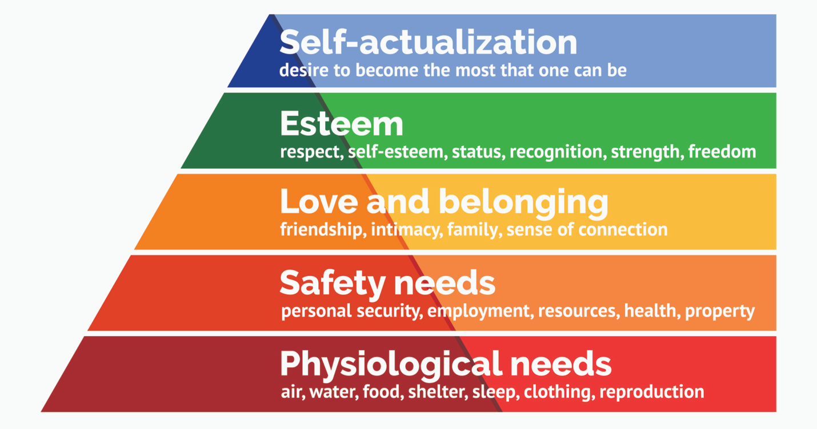

Figure 2.2: Maslow's Hierarchy of Needs
(Source: Inspired by Praise et al. 2019)
Maslow's Hierarchy of Needs is an idea in psychology which is represented in the form of a pyramid describes about the basic needs and requirements of the individuals working in a business firm. In accordance with the framework, the work ethics of the workers are dependent upon the internal along with external factors. By satisfying the human requirements, motivation also helps in enhancing productivity. This means that the attributes of the workers help constantly in remaining competitive within the global market. It has been identified that in terms of motivational structure, primary incentives include incentives for high productivity, integration as well as moral incentives. Furthermore, employee motivation is considered as an effective factor for human resource management as this often ensures in inducing efficient as well as quality of the performance within the workplace (Idiegbeyan-Oseet al. 2019). In order to seek determination of managers in better recognising the motivational structure of the workers it is essential to address the actions taken for change and identify the new needs. This aids in formulating a net positive workplace and encourages playing a positive role in the success of the business. Employee motivation is considered as the primary responsibility of human resource management of the organisations which often aids to assist and support handling of the workforce. It helps them guide and lead their attributes in the right direction. Optimum utilisation of the resources it aids in lowering the costs of operation and is goal directed.
2.5.2 Herzberg’s’ Motivation Hygiene Theory
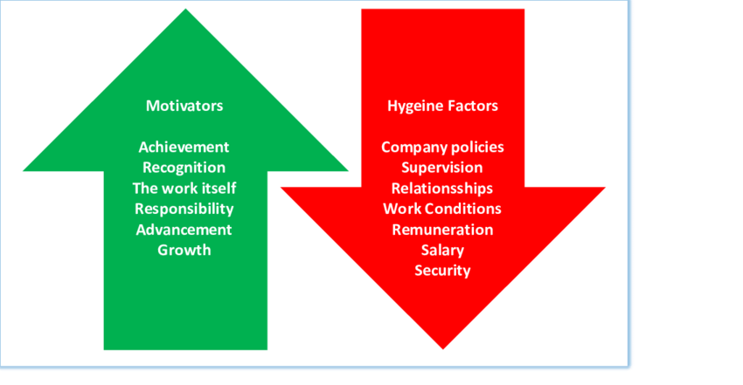

Figure 2.3: Herzberg’s’ Motivation Hygiene Theory
(Source: Created by Alshamey, 2019)
In the context of motivation, Herzberg’s’ Motivation Hygiene Theory is incorporated for the purpose of investigating the context of employee work satisfaction. The economic instability of a country offers a negative role within the annual turnover of the business firms. In this account, the employees suffer reduction of salary, unstable working shifts and excessive workloads and for that they are facing severe mental health problems like stress, mental trauma, panic and depression. In this account, reduction of salary, unstable working shifts acts as the primary reasons contributing to job shifts. There are two sorts of appropriate information within the workplace in accordance with the framework of Herzberg’s’ Motivation Hygiene. The first one is motivator which primarily includes acknowledgement, responsibilities, work progression as well as intrinsic motivators. Hygiene elements are accounted to be primary determinants of job satisfaction which are predominant reasons in terms of dissatisfied jobs. It also consists of significant elements in the form of remuneration, management policies, and link with the co-workers, monitoring as well as working atmosphere. Transparency also helps in determining that every individual is working with the same information. The concept has been developed by Herzberg in order to illustrate and at the same time demonstrate how workers at work can be both anxious and at the same time frustrated since various pairs of variables intend to operate in various pairs of motivation. In other dimensions, a pleasant working atmosphere, decent payments, as well as supporting teammates will not generate a contended individual but would create an individual who lacks satisfaction. Defaulting to the context of transparency is considered as the best way for encouraging an environment of trust amongst the individual and team members who are motivated and engaged with the work.

2.6 Gap in Literature
Literature gap is considered as a perspective of key topics which are not explored as well as revealed in literature article searches. It also provides significant scopes for further research as well as investigation. This context offers crucial viewpoints for the purpose of identification of vital points along with comprehensive insights thereby producing study questions along with key objectives. Consequently, it aids in providing assistance for the purpose of evaluating key resources and possibilities which are relevant to the modelling of the factors that influence the motivation in the past studies which includes aspects of recognising the requirements and needs for more research is a significant manner. On the account of literature review, it also assists in recognising significant gaps as well as inconsistencies in the literatures that already exist. Investigation in association with the context of motivation as well as job satisfaction plans as well as customer emphasises which can ultimately emerge as a comprehensive context in the overall field of research. It also enhances and expedites the key possibilities of the employee motivation and job satisfaction related success factors.

2.7 Summary
A crucial success factor of motivation along with job satisfaction is cantered on the basis of the project team as well as stakeholders, organisational representatives, communication, governance as well as dedication. In this particular chapter of literature review, the significance of the key factors along with related challenges along with problems intends to affect the success of business process management which has been incorporated. It has also been overlooked that the predominant methods in terms of undertaking a systematic strategy intend to begin with the locating of a suitable material for the success of job satisfaction along with motivation. Motivation and tools of job satisfaction are considered as the CSF’s due to the increase in terms of dependencies on the context of technology. Other than this, it has been identified that lack of employee motivation often brings severe problems like reduction of productivity and efficiency of employees. The main reason for deficiency in employee motivation is the economic condition of organisations. Specific theoretical frameworks such as Maslow's Hierarchy of Needs as well as Herzberg’s’ Motivation Hygiene Theory ensures to assess the required criteria which acts upon influencing the factors that have been investigated as well as addressed in a significant manner. The gap in the Literature has also evaluated as well as assessed possibilities in terms of the factors that are required to be bridged in the overall process of job satisfaction as well as motivation within the global tourism industry.

Chapter 3: Research Methodology

3.0 Introduction
In this chapter, this researcher focuses on whole research procedures of this research. In this account, this chapter has helped this researcher in determining the end of this research. This effective research procedure further assists the researcher in selecting beneficial research methods. This researcher highlights research onion, research philosophy, research strategy, research approach, research choice, and time horizon and data collection. Sampling size and populations, sampling techniques, data analysis, data analysis, discussions of capital resources, ethical considerations and reliability and validity are included in this study. An overall summary is derived in this research.

3.1 Research Onion
Research onion is an effective tool for conducting the research by including several researches procedural factors by which researchers can select their suitable research methodology for meeting the specific research aim and objectives. In the opinion of Bell et al. (2018), research onion includes research procedures within each shell of this and thus researchers can choose these research processes by determining advantageous sides of these procedures. In this account, research onion has helped this researcher in understanding required data collection process for this research. On the other hand, this further has guided this researcher in understanding pathways of this research.
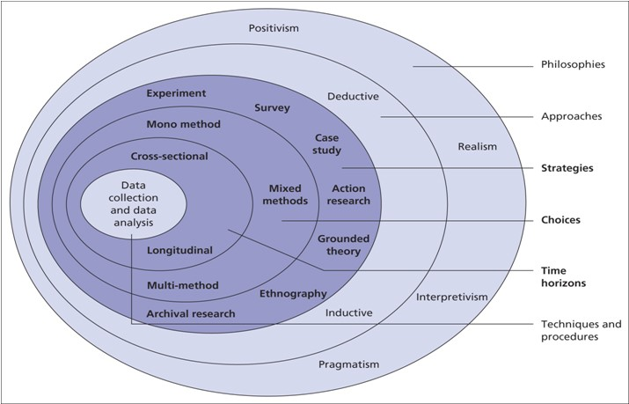

Figure 3.1: Research Onion
(Source: As influenced by Bell et al., 2018)
This research has used the mono research method for performing the research. This research has involved primary data collection. The Mono method has supported this researcher in determining the accurate, realistic and evidence-based information from the survey. From this circumstance, this researcher has been benefited by gaining the proper information which has provided a better insight towards the motivation of human resources as per the context of global tourism industrial contributions. Other than this, researcher has been able to predict the recommendations from this research. From these discussions, this researcher of this research has completed this research by getting the adequate and required information.

3.2 Research Philosophies
Research philosophy assists the researchers in establishing the effective planning for the activities and thus helps the researchers in accumulating, employing and scrutinising the information for obtaining the closure of this research. As referred to by Graue (2015), research philosophy consists of five classifications such as interpretivism, positivism, post positivism, realism and pragmatism. This research has included the positivism research philosophy for introducing the generalisation within the research. Positivism research philosophy has assisted the researcher in interpreting the major statistical information from the primary data collection. On the other hand, this specific research philosophy has supported the researcher in predicting the conclusion statements by exploring the information significantly. From this circumstance, this researcher has been able to achieve the research objectives effectively by developing the solutions of every research question from different perspectives. In this account, this researcher has completed this research within the scheduled time periods as positivism research philosophy has involved the demonstrations of casualties. Furthermore, positivism research philosophy has assisted the research in determining the employee retention and employee’s attraction rate due to the motivation of human resource as per the context of global tourism industrial contributions. From these analyses, positivism research philosophy has assisted the researcher in reaching the end of this research.

3.3 Research Approaches
Research approach manifests the researchers in planning of research pathogenesis by offering the particular process of data accumulation and data interpretation. As stated by Snyder (2019), research approach has the three divisions for instance deductive, inductive and abductive research approach. This research has involved the deductive research approach for generating the effective research results for this research. On the other hand, deductive research approach has assisted the researcher in establishing the relationship between the casualties and the variables so that this researcher has achieved the success by determining the relationships with employee motivations and its different approaches that has been adopted by the human resource managers within the global tourism industry. Deductive research approach has guided this researcher in measuring the effective quantitative information which has been found from the Survey. This researcher has been able to determine the accurate statistical information from the primary sources of information. From this, deductive research approach has guided this researcher in scrutinising this quantitative information and literature that generates the global tourism industrial economic growth rates and human resource practices within the tourism and manufacturing industry. As a result, researcher has increased the innovativeness of this research by utilising the major specific information within this research. Other than this, deductive research approach has helped the researcher in interpreting the generalised concepts which have derived from positivism research philosophy to provide the better insight to the researcher about the role of human resources in employee motivation within the global tourism industrial contribution.

3.4 Research Strategies
Research strategy assists the researchers in planning, supervising as well as executing the entire procedures of this research where specific techniques of information gathering. As regards by Dźwigoł and Dźwigoł-Barosz (2018), research strategy has several subsections such as grounded theory, case-based research strategy, archival research strategy and primary or secondary, qualitative and quantitative data collection. This research has consisted of a primary quantitative research strategy for gaining the beneficial pathogenesis for completing this within the scheduled time by maintaining the quality of this research. Primary quantitative research strategy has assisted this researcher in determining the several factors that influence the human resource of global tourism industrial contributions in involving the employee motivation factor. In this account, this researcher has been able to understand the several approaches for developing the effective survey questions so that he can determine the entire required information from the Survey Questionnaire.

3.5 Research Design
Research design offers the particular data interpretation and gathering as well as the suitable research procedures and approaches for the data interpretation and data gathering. As described by Nayak and Singh (2021), research design is divided into three different subdivisions like exploratory, explanatory and descriptive. This researcher has implemented exploratory research design by exploring the hypotheses for determining the solutions of not only the research questions but also the questions which have arisen at the time of research conduction. Exploratory research design has helped the researcher in inducing the flexibility and consistency of this research by involving the adaptability for modification of the procedure. Furthermore, exploratory research design has supported the research in reducing the time consumption of this research execution. From this incident, this beneficial research design has enabled this researcher in predicting the future scope or opportunities for increasing the efficiency of this research. Taking these into account, deductive research design has guided this researcher in developing the high quality of outputs within this research that might help the human resource managers of global tourism industrial contributions in motivating the employees significantly.

3.6 Time Horizon
Time Horizon is considered as the factor within which this researcher has completed this research. As per the basis of nature of the research, time horizon has the two separate classifications like longitudinal and cross-sectional. This research has included the cross-sectional research time horizon as this research has determined the sufficient information by comparing the human resource departments of different companies.

Key Activities | Estimated Timeframe
Determination of research topic | Week 1
Developing the outline of research | Week 2 to 6
Scrutinising the existed literatures | Week 4 to 6
Obtaining the required techniques of this research | Week 4 to 9
Accumulating the information from the primary source | Week 7 to 11
Analysing information | Week 9 to 11
Integration of information | Week 10 to 11
Understanding conclusion statements | Week 10 to 11
Rough draft and proofreading | Week 12
Final submission | Week 12

Table 1: Time Horizon
(Source: Created by Author)

3.7 Techniques and Procedures

3.7.1 Data Collection
Data collection is the most important factor which includes the process of data accumulation which has helped the researcher in determining the required research information for predicting the significant outcomes of this research. As suggested by Kothari (2004), data collection is classified into two different types such as primary data collection and secondary data collection. This researcher has included primary data collection for understanding the realistic information from the human resource managers. From this circumstance, this researcher has involved the survey questionnaire for gathering information from primary data collection. Primary data collection has helped this researcher in determining the economic factor of global tourism industry. In this account, this researcher has been able to understand the needs of employees’ motivation within the companies. On the other hand, responses that have come out from the survey have significantly guided this researcher in developing proper knowledge about the conditions of employees in current times within the global tourism industry.

3.7.1.1 Sample Size and Population
Researchers identify the sample size and population in case of primary data collection from which researchers can keep track on number of respondents. This researcher has adopted a sampling size of 31 as this researcher has involved 31 employees for conducting the survey. On the other hand, this researcher has implemented the survey questionnaire of 15 close ended questions depicting the required information for performing this research. A small sampling size has been selected by this researcher for the time constraints.

3.7.1.2 Sampling Technique
Sampling technique is the most vital process of data accumulation within the primary data collection. This research has involved the random sampling technique at the time of including the respondents as this researcher has included the employees of global tourism industry on the random basis. This random sampling technique has assisted the researcher in eliminating biases from this research.

3.7.2 Data Analysis
Data analysis assists the researchers in determining the concluding discussions by interpreting the information so that researchers can determine the beneficial recommendations by analysing the issues of the research topics. As discussed by Saunders et al. (2003), data analysis is of two types: qualitative and quantitative data analysis. This researcher has involved quantitative data analysis which comprises numerical information like revenue growth, inflation growth and employee’s satisfaction rate within global tourism industry. Quantitative data analysis has helped this researcher in transmitting adequate as well as accurate information which has brought a major innovation and efficiency within this research. This researcher further has utilised quantitative data analysis for determining the unemployment rate and average organisational income of global tourism industry.

3.8 Analysis of Capital Resources

3.8.1 Ethical Considerations
Ethical considerations are a set of principles that helps the researchers in conducting the research without facing any disruptions. As suggested by Saunders et al. (2007), ethical considerations help the researchers in gathering information by generating truth and confidentiality. Firstly, this researcher has maintained anonymity at the time of primary data collection. In this account, respondents have been able to open up comfortably towards this researcher. On the other hand, this researcher has applied some terms and conditions and consent form with this survey. From this circumstance, employees who were the participants of this research have ensured their consent for performing this research. Apart from that, this research has secured the information that has come into light from this survey within the computers with strong passwords. Furthermore, this researcher has used the “Copyright, Designs and Patents Act 1988 (c. 48)” and “Data Protection Act (c.12)” for eradicating privacy issues and protecting the copyrights. Taking these into account, ethical considerations have helped this researcher in maintaining ethics and appropriate terms and conditions for performing this research smoothly.

3.8.2 Reliability and Validity
Reliability and validity are the beneficial factors for increasing the quality of research. Reliability is defined as the procedure by which this researcher has been able to conduct this research by using the instruments for the multiple times. In this account, this researcher has induced his perceptions regarding this recent research topic. On the other hand, validity is referred to as the process by which this researcher has understood the demands of scientific approaches within this research. From these circumstances, validity has guided this researcher in maintaining innovativeness and efficiency within this research.

3.9 Summary
In this chapter, this research has included whole pathways of this research. These research procedures have assisted this researcher in meeting the research objectives and thus research aim in a proper way. Positivism research philosophy, deductive research approach, exploratory research design, primary quantitative research strategy and primary data collection have guided this researcher in developing the adequate research outcomes from this research.

Chapter 4: Data Analysis and Findings

4.0 Introduction
Data analysis and findings are crucial aspects of research work as it facilitates collection and analysis of relevant data according to requirement of research topic. In this part of research work, the researcher has utilised primary method for collecting data on the topic “motivating the Human Resources in the Organisation-TourisimContribution”. Survey method has been used in this study for assessing point of views of employees in global tourism industry about human resource motivation. Point of view of employees about human resource motivation has been assessed through 14 survey questions. Moreover, key findings include thorough discussion on overall findings of research work.

4.1 Data Analysis
Data analysis is procedure of inspecting, cleaning, transforming and modifying collected data in order to obtain relevant information on the research topic. In this research, researcher have emphasised the primary method of data collection and gathered quantitative data on the topic.
Quantitative analysis
Data has been obtained by conducting survey using questionnaire for obtaining employee's response in medium sized manufacturing companies.
Question-1: What is your gender?
Gender
Options | Response | Respondents numbers | Total respondents
Female | 52% | 16 | 31
Male | 48% | 15 | 31

Table 4.1.1: Gender demographics
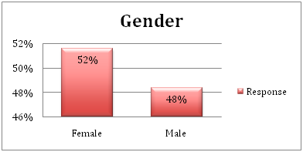

Figure 4.1.1: Gender demographics
Analysis: In the survey of 31 respondents, it has been found that 48% respondents were male and 52% respondents were female. Determining gender of respondents is helpful for the researcher in order to assess perspectives of male and female employees about human resources motivation.
Question-2: What is your age?
Age
Options | Response | Respondents numbers | Total respondents
18 to 20 years | 16% | 5 | 31
21 years-30 years | 32% | 10 | 31
31 years-40 years | 35% | 11 | 31
41 years-50 years | 10% | 3 | 31
Above 50 years | 6% | 2 | 31

Table 4.1.2: Age demographics
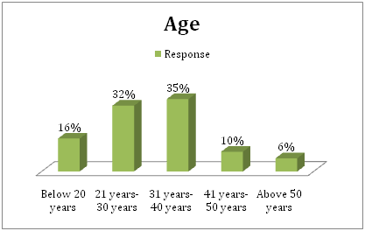

Figure 4.1.2: Age demographics
Analysis: From findings of this research, it can be seen that 16% of the respondents belong to the age group “18-20 years”, 32% respondents belong to the “21 years-30 year” age group and 35% respondents were in “31 years-40 year” age group. Besides, only 6% respondents were in age group of “above 50 years” and 10% respondent belonged to “41 years-50 years” age group. As the researcher aims to analyse concept of human resource motivation in organizations within modern global tourism industry economy, analysing different perspectives of global tourism industry employees of different ages is helpful in achieving objectives of the research.
Question-3: For how long have you been associated with your organisation?
Association with organisation
Options | Response | Respondents numbers | Total respondents
Below 6 months | 32% | 10 | 31
6 months-1 year | 29% | 9 | 31
1 year-2 years | 10% | 3 | 31
2 years-5 years | 16% | 5 | 31
Above 5 years | 13% | 4 | 31

Table 4.1.3: Association with organisation
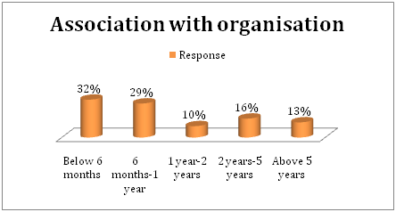

Figure 4.1.3: Association with organisation
Analysis: From the above table, it has been observed that 31% respondents out of 31 were associated with their current organisation for less than 6 months. Similarly, 29% of respondents were working in their current company for less than 1 year and 10% of respondents were working with their current organisation for less than 2 years. However, only 4 employees out of 31 were associated with the current company for more than 5 years. Analysing the association of employees with their current company is helpful for researcher to define motivation and satisfaction of employees.
Question-4: How far do you agree that motivating human resources is important for enhancing job performance?

Motivation importance
Options | Response | Respondents numbers | Total respondents
Strongly agree | 32% | 10 | 31
Agree | 32% | 10 | 31
Neutral | 13% | 4 | 31
Disagree | 19% | 6 | 31
Strongly disagree | 3% | 1 | 31

Table 4.1.4: Motivation importance
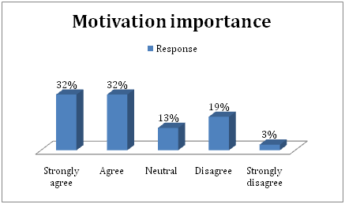

Figure 4.1.4: Motivation importance
Analysis: Above findings indicate point of views of employees working in global tourism industry about importance of motivation for job performance. In the survey of 31 respondents, 32% of respondents have stated that they strongly agree that motivation is important for increasing job performance of human resources. Besides, 3% of the participants strongly disagreed that motivation has no impact on job performance. 13% of respondents provided a neutral point of view but 19% of respondents disagreed and 32% of respondents were in favour of motivation for improving employees’ job performance.

Question-5: Do you think employee compensation in medium sized companies has exhausted its role as a sole motivator?
Employee compensation importance
Options | Response | Respondents numbers | Total respondents
Yes | 52% | 16 | 31
No | 48% | 15 | 31

Table 4.1.5: Employee compensation importance
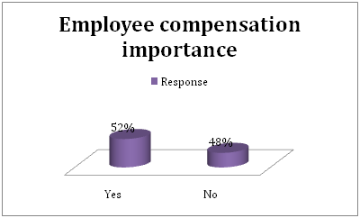

Figure 4.1.5: Employee compensation importance
Analysis: In the modern global tourism industrial sector, organisations are facing issues of high employee turnover which tend to decline overall performance of companies. Thus, the researcher has utilised employee compensation as an important factor to assess human resource motivation. As per survey, 52% of respondents out of 31 have agreed that employee compensation in medium sized companies has exhausted its role as a sole motivator. However, 48% of respondents have not agreed that employee compensation in medium sized companies has exhausted its role as a sole motivator.
Question-6: What other factors are necessary for motivating human resources?
Factors necessary for motivating human resources
Options | Response | Respondents numbers | Total respondents
Effective teamwork | 26% | 8 | 31
Work recognition | 19% | 6 | 31
Leaves | 6% | 2 | 31
Employee empowerment | 16% | 5 | 31
Training and skill development programs | 32% | 10 | 31

Table 4.1.6: Factors necessary for motivating human resources
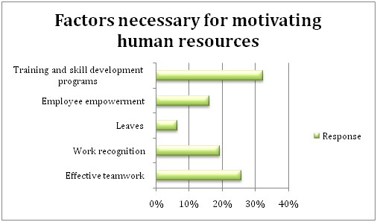

Figure 4.1.6: Factors necessary for motivating human resources
Analysis: As per researcher, it has been found that factors important for motivating human resources are employee empowerment, leaves, work recognition, effective teamwork and training & skills development programs. In 31 participants, 26% respondents are stated that training and development are effective for maintaining motivated workforce. But, 6% of respondents have point of view that leaves can motivate employees towards work. As per 16% respondents, empowering employees can motivate them and 19% respondents think that work recognition are essential for maintaining motivated workforce.
Question-7: What factors hinders human resource motivation within an organisation?
Factors hinder motivating human resources
Options | Response | Respondents numbers | Total respondents
Lack of motivation | 23% | 7 | 31
Attitude of supervisors | 19% | 6 | 31
Inadequate work atmosphere | 10% | 3 | 31
Unclear job roles | 19% | 6 | 31
Poor skills and knowledge | 29% | 9 | 31

Table 4.1.7: Factors hinder motivating human resources
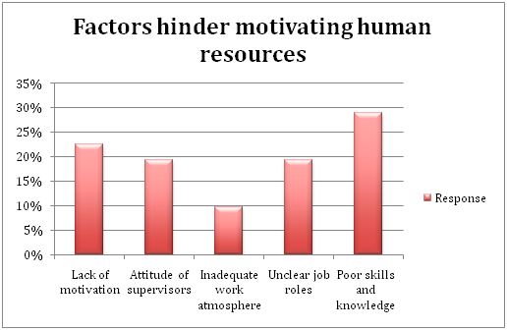

Figure 4.1.7: Factors hinder motivating human resources
Analysis: As per survey, lack of motivation, attitude of supervisor, inappropriate work atmosphere, unclear job duty and poor skills & knowledge are key challenges behind motivation of employees. 29% of respondents have point of view that presence of poor skills and knowledge act as a hindrance in motivating human resources. As per 23% respondents, lack of motivation may act as a hurdle behind the path of maintaining motivated human resources within organisations.
Question-8: Do you agree that providing sufficient training is essential for retaining motivated human resources in company?
Sufficient training importance
Options | Response | Respondents numbers | Total respondents
Strongly agree | 32% | 10 | 31
Agree | 26% | 8 | 31
Neutral | 19% | 6 | 31
Disagree | 19% | 6 | 31
Strongly disagree | 3% | 1 | 31

Table 4.1.8: Sufficient training importance
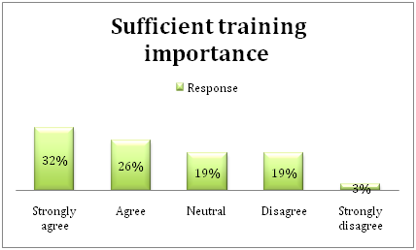

Figure 4.1.8: Sufficient training importance
Analysis: As per findings of this researcher, most of the employees’ working in global tourism industry thinks that providing adequate training and development programs are essential for maintaining motivated employees. The survey indicates that only 3% participants strongly disagreed and 19% participants disagreed that sufficient training was important for retaining motivated staff members. Moreover, 26% of respondents agree and 19% of respondents are neutral to fact that appropriate training is important for retaining a motivated workforce.
Question-9: How far are you satisfied with the work environment in the industry you are working in?

Satisfaction in current working environment
Options | Response | Respondents numbers | Total respondents
Strongly satisfied | 26% | 8 | 31
Satisfied | 19% | 6 | 31
Neutral | 19% | 6 | 31
Dissatisfied | 19% | 6 | 31
Strongly dissatisfied | 16% | 5 | 31

Table 4.1.9: Satisfaction in current working environment
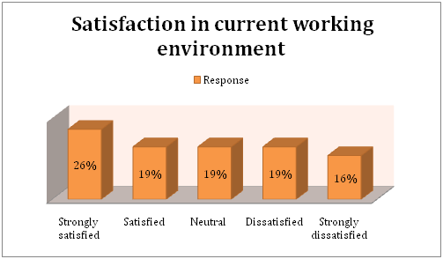

Figure 4.1.9: Satisfaction in current working environment
Analysis: Presence of sound working environment is beneficial for motivating employees towards organisational goals (Al Mamun and Hasan, 2017). As per the findings of survey, 26% employees working in global tourism industrial organisations are strongly satisfied with overall working environment. Moreover, 19% of respondents have stated that they are satisfied with overall working environment of their organisation. However, 16% of employees in global tourism industry were strongly dissatisfied with working environment their companies. 19% of respondents provided neutral point of view but 19% of respondents were dissatisfied and 19% of respondents were satisfied with working environment of their companies.
Question-10: Do you think strong working relationships act as a motivator for human resources?
Strong working relationships
Options | Response | Respondents numbers | Total respondents
Strongly agree | 32% | 10 | 31
Agree | 23% | 7 | 31
Neutral | 23% | 7 | 31
Disagree | 16% | 5 | 31
Strongly disagree | 6% | 2 | 31

Table 4.1.10: Strong working relationships
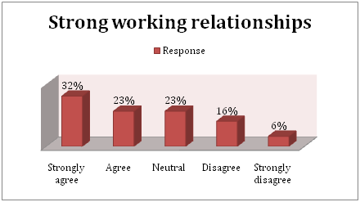

Figure 4.1.10: Strong working relationships
Analysis: Strong working relationships facilitate collaboration, communication and satisfaction of employees. So, it acts as a crucial motivator of human resources. The above findings indicate that many employees working in different industries of global tourism industry are strongly agreed that working relationships are beneficial for motivating employees. In the survey of 31 respondents, 32% of respondents have stated that they strongly agree that a strong working relationship facilitates human resource motivation. On contrary, 6% of the participants strongly disagreed that working relationship has no association with human resource motivation. 23% of respondents provided a neutral point of view but 16% of respondents disagreed and 23% of respondents were in favour of strong working relationships.
Question-12: Are you satisfied with overall job security in your organization?
Satisfaction with overall job security
Options | Response | Respondents numbers | Total respondents
Strongly satisfied | 29% | 9 | 31
Satisfied | 16% | 5 | 31
Neutral | 23% | 7 | 31
Dissatisfied | 16% | 5 | 31
Strongly dissatisfied | 16% | 5 | 31

Table 4.1.11: Satisfaction with overall job security
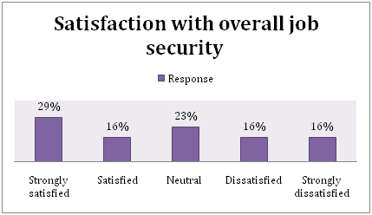

Figure 4.1.11: Satisfaction with overall job security
Analysis: Presence of overall job security is crucial for motivating workforce within organisations (Vorinaet al. 2017). The above findings indicate that many employees working in different industries of global tourism industry are dissatisfied with overall job security of companies. As per survey of 31 respondents, 29% of respondents have stated that they are strongly satisfied with overall job security of their organisation. On the other hand, 16% of employees in global tourism industry were strongly dissatisfied with overall job security facilities of their companies. 23% of respondents provided neutral point of view but 16% of respondents were dissatisfied and 16% of respondents were satisfied with overall job security.
Question-13: How far are you satisfied with the number of paid leave offered to you from your organisation?
Satisfaction with paid leave
Options | Response | Respondents numbers | Total respondents
Strongly satisfied | 26% | 8 | 31
Satisfied | 19% | 6 | 31
Neutral | 23% | 7 | 31
Dissatisfied | 16% | 5 | 31
Strongly dissatisfied | 16% | 5 | 31

Table 4.1.12: Satisfaction with paid leave
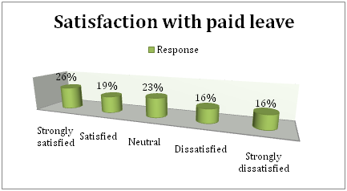

Figure 4.1.12: Satisfaction with paid leave
Analysis: The above findings indicate that many employees working in different industries of global tourism industry economy are dissatisfied with paid leave facilities of companies. As per survey of 31 respondents, 26% of respondents have stated that they are strongly satisfied with period level facilities of their organisation. On the other hand, 16% of employees in global tourism industry were strongly dissatisfied with paid leave facilities of their companies. 23% of respondents provided neutral point of view but 16% of respondents were dissatisfied and 19% of respondents were satisfied with paid leave facilities.

Question-14: Do you agree that providing appropriate healthcare benefits are important for motivating human resources?

Healthcare benefits as motivator
Options | Response | Respondents numbers | Total respondents
Strongly agree | 29% | 9 | 31
Agree | 26% | 8 | 31
Neutral | 23% | 7 | 31
Disagree | 16% | 5 | 31
Strongly disagree | 6% | 2 | 31

Table 4.1.13: Healthcare benefits as motivator
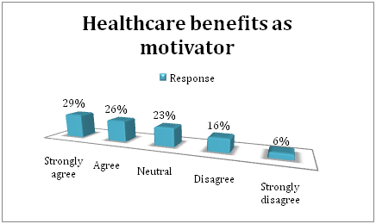

Figure 4.1.13: Healthcare benefits as motivator
Analysis: Healthcare benefits include expenses of hospitalisation, insurance expenses and coverage for daily hospital costs. As per Ali and Anwa (2021), healthcare benefit act as influential aspect in maintaining motivated workforce. Thus, researcher has included healthcare benefits for determining motivation level of employees within industries of global tourism industry. As per survey, 29% of respondents have strongly agreed that healthcare benefits are important for maintaining a motivated workforce. Similarly, 26% of respondents agreed and 23% of respondents were neutral about healthcare benefits. However, 16% of respondents disagreed and 6% of respondents strongly disagree as they think healthcare benefits are not much important in human resource motivation.
Question-15: What are your recommendations to organisations in the context of improving motivation?
Recommendations
Options | Response | Respondents numbers | Total respondents
Working hours choices | 23% | 7 | 31
Higher number of leaves | 26% | 8 | 31
Rewards and bonus on monthly basis | 23% | 7 | 31
Training and skill development programs | 16% | 5 | 31
Increasing employee accountability | 6% | 2 | 31
Free refreshments | 6% | 2 | 31

Table 4.1.14: Recommendations
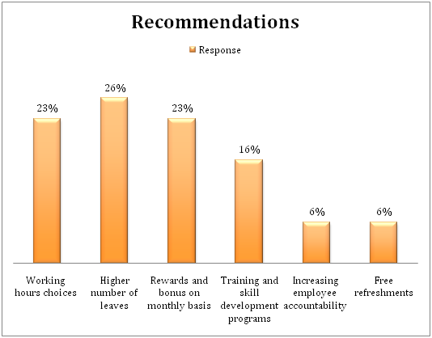

Figure 4.1.14: Recommendations
Analysis: According to the survey, it can be assessed that many employees aim to have a higher number of leaves in order to work satisfactorily within the organisation. 23% of respondents have a point of view that providing choice for working hours would be helpful for motivating workforce towards work. Besides, 16% employees think that organisations within global tourism industry must provide adequate skills and training to employees for training a strong workforce. Thus, inclusion of these recommendations would be helpful for global tourism industrial organisation in different industries for reducing staff turnover and maintaining motivated workforce.

4.2 Key Findings
In the research, the researcher has collected primary data from an online survey which was subjected to quantitative analysis. Sample population for this research work was 31 and focus was provided on employees working in global tourism industry. As per survey, the researcher found a higher number of female employees associated with organization of global tourism industry. A higher number of employees within total respondents were associated with age group 31 year-41 years. It provides an idea about age of majority of employees in global tourism industry. So, it can be assessed that global tourism industrial organisations need to focus on employees within age group of 31 years-40 years in order to retain them. As per Ullah et al. (2017), global tourism industry is facing a transition of market economy due to continuous changes in political, social, economic and technological advancements. In such a transition, industries in global tourism industry suffered from high employee turnover. Thus, it is necessary for companies in global tourism industry to acquire significant motivation strategies that would help in retaining workforce. As per survey, only 13% of respondents were associated with organisations for more than 5 years. Besides, majority of respondents were working in their current company for less than 6 months. It indicates a higher number of employees were changing their companies more frequently due to dissatisfaction and lack of motivation.
The researcher indicates that motivation is a crucial factor for developing job performance of employees. Majority of respondents have agreed that maintaining motivated employees is helpful for getting work done more appropriately. As opined by Terziev (2019), an employee is a physical resource that helps business in achieving key objectives. In organisations, different strategies were used for maintaining motivated workforce. Employee compensation acts as one of crucial factors that motivate human resources. As companies in modern global tourism industry were facing higher employee’s turnover, researcher has emphasis if employee compensation in medium sized companies has exhausted its role as a sole motivator. According to majority respondents, employee compensation is not only a motivator to employees. In contemporary business environment, employees aim to attain opportunity to build their career and enhance their performance in global business environment. So, researcher have found that other factors like effective teamwork, work recognition, adequate leave facility, training & skill development program and employee empowerment are also influential factors for motivating employees. Through the survey, researcher has found that 26% of respondents believe effective teamwork is useful for motivating human resources. But, effective training and skill development programs are utmost priority of hymn resources for working appropriately within an organisation.
As per the views of Ghimire (2019), human resource management in global tourism industrial organisations in transitional period is being carried out in conditions of strong negative influence of many internal and external factors. In this research, researcher has assessed key challenges in human resource motivation through surveys. Result of survey indicates poor skills and knowledge highly affect motivation level of employees. Another factor that impacts motivation of human resources is attitude of supervisors, unclear job roles and improper work environment. As survey indicates poor skills act as hurdle in motivation of employees, researcher surveyed importance of training and development for motivating human resources. Research shows that majority of respondents have strongly agreed that providing sufficient training is helpful for motivating workforce. Moreover, 18 respondents out of 31 were in favour of training and development for motivating workforce. Thus, organizations in global tourism industry who are facing higher staff turnover issues can utilise training and development approaches for retaining motivated employees. As per survey, 26% participants were highly satisfied with their current working environment. However, considering overall result of the survey, a higher number of participants were strongly dissatisfied and dissatisfied with their current working environment. In case of global tourism industrial organisations, presence of higher employee dissatisfaction can create higher employee turnover. Thus, the company's needs to assess key reasons behind employee dissatisfaction and mitigate them thoroughly in order to retrain satisfied and motivate employees.
In this research, the researcher has aimed to identify global tourism industry contribution in motivation of human resources within organisation. Thus, researcher have determined point of view of employees in global tourism industry about human resource motivation. In a survey, researcher has assessed which industry provides greater emphasis to employee motivation. As per 26% respondents, companies in tourism industry provide greater focus on training motivated workforce. Moreover, 23% respondents think that manufacturing industry aims to maintain a motivated workforce in order to achieve higher success in market. The survey indicates that presence of strong working relations is crucial for motivating employees towards work. As per online survey, majority of respondents are in favour of strong working relations within employees. According to Cooke et al. (2020), strong working relationships make employees more productive. Moreover, it is helpful for building professional relationships within workforce that is helpful for enhancing career of employees. Thus, in global tourism industrial organisation's perspective, presence of strong working relations is crucial for motivating employees towards work. As per the research, 29% of respondents were highly satisfied with overall job security provided by their organisations. On contrary, 16% of respondents have stated that job security within their organisation was not efficient.
As per the survey, researcher has found that appropriate leave facilities play a crucial role in motivating employees within workforce. Thus, searcher has surveyed if employees working in modern global tourism industrial economy are satisfied with leave arrangements in their current organisation. As per 26% of respondents, leave facilities within organization are satisfactory. However, 16% of respondents were not satisfied with leave arrangements within company. So, it can be said that inadequate leave arrangements hinder motivation of human resources.
As per Furunes et al. (2018), presence of sound mental and physical health motivates an employee to contribute within the success of organisation. A company needs to provide healthcare benefits to its employees in order to enhance motivation. As per survey result, majority of respondents were satisfied with healthcare benefits provided by their organisation. However, only 7 respondents out of 31 were not satisfied with healthcare benefits provided by company. So, the company needs to obtain feedback from employees for assessing their satisfaction level in organization. Providing healthcare benefits according to requirements of employees is helpful for motivating them towards work. As per respondents, employees should provide working hour’s choices, higher number of leaves and monthly rewards for motivating them.

4.3 Discussions
From the data that has been collected from 31 employees of different organisations belonging to different sectors, it has been analysed that not many employees in global tourism industry are satisfied with the work that they are doing and there is a very low percentage of employees who have been working in their organisation for more than five years. Companies also lack strategies of retaining employees and therefore this creates a sense of demotivation among employees. In most cases it has been found that employees find rude behaviour of their supervisors, improper working atmosphere, lack of motivational strategies, poor products knowledge and unhealthy work environment as mean criteria for low motivation and therefore organisations in same context have been showing very limited response in terms of making the situation better. Most of the employees feel that it is important to have a good motivation factor in an organisation which would not only help them to perform well but also make them feel valued and give job security. Effective teamwork, rewards and recognitions, on job training and employee empowerment are the major factors that can lead to motivation of employees. Therefore, this gives a clear idea of what strategies companies of global tourism industry need to adopt for enhancing employee’s job satisfaction and encouraging them to seek developmental areas. High percentage of employees also identify the importance of training in their organisation as one of the major factors that can motivate employees. Training gives employees proper product knowledge and therefore makes it easier for them to understand customer demands. Understanding customer demands and being able to work properly with sufficient knowledge at the same time also increases employee motivation. In comparison to all the sectors in global tourism industry most of the employees get encouragement in tourism sector followed by manufacturing, retailing, mining, hospitality and textile sector. Manufacturing and tourism industry helps employees to work directly with the customers and therefore their encouragement and motivational factors are taken into consideration more than other industries like textile and hospitality. Strong work relationships also play an important role in creating a healthy atmosphere for working and employee motivation. An unhealthy work environment not only creates depression but at the same time also leads to many in office abuses like bullying, workplace harassment and discrimination.

4.4 Summary
Quantitative data collection has been made by help of primary method for assessing global tourism industrial contribution in human resource motivation. The research has been conducted by using valid assumptions and research questions. Through the research, it has been found that providing adequate training and skill development programs are effective for motivating human resources. Poor skills and training act as key hinder in motivation of employees and employee compensation are important for motivating the workforce. In the contemporary business environment, human resources aim to attain opportunity to build their career and enhance their performance in global business environment.

Chapter 5: Conclusion

5.0 Conclusion
Motivation has been playing an important role for employees especially since 2020 after the outbreak of COVID-19. It allows employees to understand the capability and at the same time take up actions that can not only engage them into different self-developmental activities but at the same time also gives them job satisfaction. Employees in global tourism industry and also in other countries look for certain facilities in their organisation they have been working for years. These facilities include on-time salary clearance, rewards and recognitions, healthy workplace and on job training, medical facilities in alliance and a good future scope. These aspects motivate an employee to build up their skills and perform well in that organisation so as to get a settled future. It has been evident that the more the employee gets job satisfaction from their organisation, the more determined they become in order to play a positive role in the success of the business. Focusing on this scenario, organisation management also plays a vital role in motivating employees and making them understand the need for accomplishing organisational goals along with their individual objectives. Many organisations in global tourism industry have been using different theories like Maslow‘s hierarchy of needs and Herzberg support motivation theory that helps organisations to understand the factors that affect employee motivation and barriers that make staff demotivated. In this scenario training plays an important role for motivating employees to take up new activities and learn new things which further extends their capability of performing better. This study has been conducted using primary quantitative research methods where a survey has been conducted on employees of different sectors and industries in global tourism industry It has been noticed that with a good encouraging policy of employees in organisations, the economy of global tourism industry has been much more stable than before along with adaptation of technologies and practises for upgrading employee skills.
Out of 31 employees taken into consideration for survey in this study, most employees belonged from the age group of 21 to 30 and 31 to 40 years and only 13% of them are working for more than 5 years in an organisation. This highlighted the need for organisational motivation in organisations as it has been evident that employees due to lack of job satisfaction and motivation were compelled to change their job on a continuous basis. They could not have a long working tenure in any specific organisation. This has been an alarming statistic for global tourism industrial organisations as they believe that the first and foremost thing for an organisation is to see that its employees are well satisfied with the type of job that was provided to them by the organisation along with proper facilities. More than 50% of respondents agree that motivation plays an important role for employees in enhancing their job satisfaction and therefore human resource managers need to emphasise on motivating employees in order to trigger a self-developmental interest in them. Employees can only get engaged in self developmental activities once they are motivated enough to learn new things and have the encouragement of understanding organisational needs along with the fulfilment of their individual goals. Compensation in an organisation also plays an important role where employees feel belonged and valued by organisations they work for. In case of any mistakes by employees, punishment and penalties are often charged which creates a lesson for them to be careful in future. Similarly, any mistakes from the organisation’s side also requires compensation in order to balance employee relations and motivate them for a healthy and justified work environment. Dictatorship of organisational management over employees or extremely authoritative working environments often demotivate employees and create a burden of excess work pressure on them which brings monotonous work life. Employees often fail to maintain a work life balance which creates psychological complexities like stress, tension and depression. Therefore, human resource managers of every organisation in global tourism industry need to adopt different motivating activities that would create an interest in learning new things and give better efficiency in the organisation they work for.
The study further concludes with the different factors for motivating employees like effective teamwork, work recognition, on-time leads, employee empowerment and training them for ensuring skill development activities. HR managers of organisations deal directly with the benefits of employees and therefore are in charge of maintaining these factors as the prime one is in terms of holding a strong employee base. However, in recent times organisations have been facing issues like the wrong attitude of supervisors and team leaders, a healthy work environment, unclear job roles, lack of motivation and career growth and poor product or service knowledge among employees. When employees are unaware of their roles and responsibilities and do not find any scope of enhancing their knowledge, job satisfaction starts lacking among them. They do not find any motivation to carry forward their work other than just earning their livelihood. Other than just salary and livelihoods, employees also look for security and compassion from their organisations that encourage them to be their best in their workplace and ensure proper organisational growth. Even though 45% of the employees are satisfied with their job, a large sample size is not satisfied with the job and is looking for a change. More than 40% of the employees considered as a sample size are dissatisfied with their job and the organisation, they are working for which clearly gives a hint of poor organisational management for employee development. This dissatisfaction to some extent has been because of the issues faced by organisations in managing their employees and lack of interest they have shown in satisfying employees. Most organisations in global tourism industry are customer centric and they place emphasis more on customer satisfaction, leaving behind the notion of understanding what employees require. Organisations in many instances fail to understand that customer satisfaction is a result of employee satisfaction. The companies in global tourism industry need to encourage and motivate employees thereby creating a transparent and healthy employee relation so that they can increase the quality of product or service manufacturing and present them to customers ensuring good customer service. Customers look for high-quality services and products which are ultimately produced by employees in an organisation and therefore employee satisfaction is very important. For operating in a competitive market and aiming for long-term sustainability, organisations need to emphasise more on employee benefits, understand their needs and give an open channel for communication. A two-way communication between the management and employees can enable proper exchange of ideas and motivate them to be a part of an organisation where their opinions are taken into consideration for the decision-making purpose.

5.1 Recommendation

5.1.1 Online employee engagement activities
Online employee engagement activities are very much required keeping the current scenario in mind. Organisations in global tourism industry need to be adaptive enough to online employee engagement especially when employees are working in a prolonged work from home time period. While employees working from home often get demotivated as they do not get the chance of proper communication with other members which creates a sense of insecurity among them. Therefore, online engagement of employees can create a sense of belonging among them and would reduce the communication gap to great extent. Activities like online games, group discussions, debate and self-development of activities can be adopted by organisations in order to promote better collaboration through online engagement. This would further help employees to know their field of interest and at the same time can explore other areas through different online portals. Activities can enable employees to get an exposure of a large database through the internet, which gets difficult when manually practicing. Therefore, online engagement also gets an exposure of better technological adaptation of employees and training them in order to sustain the digitisation process in different organisations.

5.1.2 Financial support and health benefits for employees
Other than monthly salary employees also seek for emergency financial support from their organisation in forms of loans and credits along with special health benefits like health insurance and medical treatment expenses. Organisations always run with the notion that management and employees are like a family and therefore it becomes important for organisations to support the professional family members in times of need and emergencies. At times of increased demand in the market employee’s work overnight to help the organisation overcome the crisis period therefore similarly employees also look for organisational support when they come in a crisis time period like personal health issues, family crisis, financial needs and medical treatments. These are the major areas that employees prefer to fall back to their organisations for support. In terms of health benefits, employees can get medical insurance on behalf of their company where companies would be in charge of all medical expenses of employees and their family members thereby creating a sense of belongingness and security for them in future. These strategies not only help in building up motivation and increasing job satisfaction among employees but at the same time also attracts potential employees to be a part of their organisation and enjoy best facilities given by the organisation to them.

5.1.3 Give rewards and recognitions
Giving rewards and recognitions to employees is one of the major steps of creating employee engagement and motivating them for better performance. Organisations always preferred to retain experienced employees so that there is quality production of goods and services. In such a scenario they always emphasise on holding back their employees by giving them better work culture and facilities. At same time employees also look for a good future growth in organisation and prefer not to change organisations. Having a common interest of sustaining in one organisation for a longer time, it is important that employers give their staff a good future scope and sustainable goal for achievement. This can be in terms of rewards, incentives, recognition in organisation or increment in post and promotions. Annual meetings and get-togethers should not only focus on financial performance of companies but at same time also need to highlight employee performance by giving awards and recognitions. Posts like Employee of the Year, Most Hard-working Employees, The Most Punctual Employee and High Incentive Gainer can be the genres for company awards. These are awards and recognitions that employees take as a goal for achieving and therefore policies of their performance giving a better output to organisation. Such developmental activities and employee retention also gets a positive outlook by applying this reward and recognition strategy. Employees rather than seeking better job opportunities at other companies prefer to find a careerist opportunity in company they are currently working for.

5.2 Objective linking
Objective 1: To determine the economic condition of global tourism industry.: This objective have been well accomplished in Chapter 2 literature review.
Objective 2: To understand the factors that affecting job satisfaction and employee motivation within global tourism industry: This objective has been met in Chapter 2 literature review and Chapter 4, data collection and analysis.
Objective 3: To analyse strategies and procedures of human resource management towards employee motivation within global tourism industry: This objective has been successfully identified in Chapter 2 literature review and Chapter 4, data collection and analysis.
Objective 4: To determine effectiveness of employee motivation: This objective have been identified in Chapter 2 literature review.
Objective 5: To understand several issues that are faced by human resources at the time of motivating employees within global tourism industry: This objective has been successfully met in Chapter 2 literature review and Chapter 4, data collection and analysis.
Objective 6: To prove some recommendation strategies for eradicating the challenges of human resource management in motivating employees within global tourism industry: This objective has been successfully identified in Chapter 4, data collection and analysis and Chapter 5, Conclusion.

5.3 Research limitations
The major limitations while conducting this study were lack of time and financial resources. Due to lack of sufficient time, the study could not be conducted through secondary sources that it would require time for doing an extensive study of different secondary sources. At the same time, many areas of focus were overlooked. Financial constraints also acted as a barrier in conducting the survey on a large population size.

5.4 Future scope
The study in future is capable of being a credible secondary source for other authors who would be conducting the research on similar topic. This would help readers to get a clear view of how employee motivation can be enhanced. At the same time, this research paper can also be further extended to other countries and can be made specific to any particular organization or sector.

Reference List
Al Mamun, C.A. and Hasan, M.N., (2017). Factors affecting employee turnover and sound retention strategies in business organization: A conceptual view. Problems and Perspectives in Management, 5(1), pp.63-71.
Ali, B.J. and Anwar, G., (2021). An Empirical Study of Employees’ Motivation and its Influence Job Satisfaction. Ali, BJ, & Anwar, G.((2021)). An Empirical Study of Employees’ Motivation and its Influence Job Satisfaction. International Journal of Engineering, Business and Management, 5(2), pp.21-30.
Ali, B.J. and Anwar, G., (2021). An Empirical Study of Employees’ Motivation and its Influence Job Satisfaction. Ali, BJ, & Anwar, G. ((2021)). An Empirical Study of Employees’ Motivation and its Influence Job Satisfaction. International Journal of Engineering, Business and Management, 5(2), pp.21-30.
Ali, B.J. and Anwar, G., (2021). An Empirical Study of Employees’ Motivation and its Influence Job Satisfaction. Ali, BJ, & Anwar, G.(2021). An Empirical Study of Employees’ Motivation and its Influence Job Satisfaction. International Journal of Engineering, Business and Management, 5(2), pp.21-30.
Alshamey, O.A., (2019). Factors that affect motivation and job satisfaction of employees within hospitality industry. Journal of University Studies for inclusive Research, 2(1), pp.220-237.
Arka'a, A., (2018). THE EFFECT OF MOTIVATOR FACTORS AND HYGIENE FACTORS ON EMPLOYEE WORK MOTIVATION. University Library of Munich, Germany.
Azeez, S., (2019). A Critical Review of Impact of Job Enrichment and Employee Performance, Motivation and Productivity.
Bell, E., Bryman, A. and Harley, B., (2018). Business research methods. Oxford university press.
Breaugh, J., Ritz, A. and Alfes, K., (2018). Work motivation and public service motivation: disentangling varieties of motivation and job satisfaction. Public Management Review, 20(10), pp.1423-1443.
Breaugh, J., Ritz, A. and Alfes, K., (2018). Work motivation and public service motivation. Public Management Review, 20(10), pp.1423-1443.
Cooke, F.L., Schuler, R. and Varma, A., (2020). Human resource management research and practice in Asia: Past, present and future. Human Resource Management Review, 30(4), p0.100-178.
da Cruz Carvalho, A., Riana, I.G. and Soares, A.D.C., (2020). Motivation on job satisfaction and employee performance. International Research Journal of Management, IT and Social Sciences, 7(5), pp.13-23.
De Sousa Sabbagha, M., Ledimo, O. and Martins, N., (2018). Predicting staff retention from employee motivation and job satisfaction. Journal of Psychology in Africa, 28(2), pp.136-140.
De Sousa Sabbagha, M., Ledimo, O. and Martins, N., (2018). Predicting staff retention from employee motivation and job satisfaction. Journal of Psychology in Africa, 28(2), pp.136-140.
Dorta-Afonso, D., González-de-la-Rosa, M., García-Rodríguez, F.J. and Romero-Domínguez, L., (2021). Effects of High-Performance Work Systems (HPWS) on Hospitality Employees’ Outcomes Through Their Organizational Commitment, Motivation, and Job Satisfaction. Sustainability, 13(6), p.3226.
Dźwigoł, H. and Dźwigoł-Barosz, M., (2018). Scientific research methodology in management sciences. Фінансово-кредитнадіяльність: проблемитеоріїтапрактики, 2(25), pp.424-437.
Furunes, T., Kaltveit, A. and Akerjordet, K., (2018). Health‐promoting leadership: A qualitative study from experienced nurses’ perspective. Journal of clinical nursing, 27(23-24), pp.4290-4301.
Gheitani, A., Imani, S., Seyyedamiri, N. and Foroudi, P., (2019). Mediating effect of intrinsic motivation on the relationship between Islamic work ethic, job satisfaction, and organizational commitment in banking sector. International Journal of Finance and Management.
Ghimire, B., (2019). Factors Affecting Employees’ Trust in Management. NCC Journal, 4(1), pp.31-39.
Graue, C., (2015). Qualitative data analysis. International Journal of Sales, Retailing & Marketing, 4(9), pp.5-14.
Idiegbeyan-Ose, J., Opeke, R., Aregbesola, A., Owolabi, S. and Eyiolorunshe, T.A., (2019). Relationship between motivation and job satisfaction of staff in private university libraries, Nigeria. Academy of Strategic Management Journal, 18(1)
Kothari, C.R., (2004). Research methodology: Methods and techniques. New Age International.
Nayak, J.K. and Singh, P., (2021). Fundamentals of Research Methodology Problems and Prospects. SSDN Publishers & Distributors.
Priarso, M.T., Diatmono, P. and Mariam, S., (2019). The Effect of Transformational Leadership Style, Work Motivation, And Work Environment on Employee Performance That in Mediation By Job Satisfaction Variables In Pt. GynuraConsulindo. Business and Entrepreneurial Review, 18(2), pp.165-176.
Rosalia, P.D., Mintarti, S. and Heksarini, A., (2020). The Effect of Compensation and Motivation on Job Satisfaction and Employee Performance at SMK MedikaSamarinda. Saudi Journal of Business and Management Studies, 5(7), pp.448-454.
Saunders, M., Lewis, P. and Thornhill, A., (2003). Research methods forbusiness students. Essex: Prentice Hall: Financial Times.
Saunders, M., Lewis, P.H.I.L.I.P. and Thornhill, A.D.R.I.A.N., (2007). Research methods. Business Students 4th edition Pearson Education Limited, England.
Snyder, H., (2019). Literature review as a research methodology: An overview and guidelines. Journal of business research, 104, pp.333-339.
Statista.com (2021). COVID 19 Impact On Global Tourism Industry. Available at: https://www.statista.com/topics/6224/covid-19-impact-on-the-tourism-industry/ [Accessed on: 1st October 2021]
Ullah, Z., Khan, M.Z. and Siddique, M., (2017). Analysis of employees' perception of workplace support and level of motivation in public sector healthcare organization. Business & Economic Review, 9(3), pp.240-257.
Varma, C., (2017). Importance of employee motivation & job satisfaction for organizational performance. International journal of social science & interdisciplinary research, 6(2).
Vorina, A., Simonič, M. and Vlasova, M., (2017). An analysis of the relationship between job satisfaction and employee engagement. Economic themes, 55(2), pp.243-262.

Appendix
Quantitative data analysis
Name:
Email ID:
Dear participant, your participation is solemnly solicited.
Q 1) What is your gender?
Options
Female
Male

Q 2) What is your age?
Options
18- 20 years
21 years-30 years
31 years-40 years
41 years-50 years

Q 3) For how long have you been associated with your organisation?
Options
Below 6 months
6 months-1 year
1 year-2 years
2 years-5 years
Above 5 years

Q 4) How far do you agree that motivating human resources is important for enhancing job performance?
Options
Strongly agree
Agree
Neutral
Disagree
Strongly disagree

Q 5) Do you think employee compensation in medium sized companies has exhausted its role as a sole motivator?
Options
Yes
No

Q 6) What other factors are necessary for motivating human resources?
Options
Effective teamwork
Work recognition
Leaves
Employee empowerment
Training and skill development programs

Q 7) What factors hinders human resource motivation within an organisation?
Options
Lack of motivation
Attitude of supervisors
Inadequate work atmosphere
Unclear job roles
Poor skills and knowledge

Q 8) Do you agree that providing sufficient training is essential for retaining motivated human resources in company?
Options
Strongly agree
Agree
Neutral
Disagree
Strongly disagree

Q 9) How far are you satisfied with the work environment in the industry you are working in?
Options
Strongly satisfied
Satisfied
Neutral
Dissatisfied
Strongly dissatisfied

Q 10) In your perspective, which industry in Bulgaria provides greater emphasis on human resource motivation?
Options
Manufacturing
Tourism
Mining
Retail
Textile

Q 11) Do you think strong working relationships act as a motivator for human resources?
Options
Strongly agree
Agree
Neutral
Disagree
Strongly disagree

Q 12) Are you satisfied with overall job security in your organization?

Options
Strongly satisfied
Satisfied
Neutral
Dissatisfied
Strongly dissatisfied

Q 13) How far are you satisfied with the number of paid leave offered to you from your organisation?

Options
Strongly satisfied
Satisfied
Neutral
Dissatisfied
Strongly dissatisfied

Q 14) Do you agree that providing appropriate healthcare benefits are important for motivating human resources?

Options
Strongly agree
Agree
Neutral
Disagree
Strongly disagree

Q 15) What are your recommendations to organisations in the context of improving motivation?

Options
Working hours choices
Higher number of leaves
Rewards and bonus on monthly basis
Training and skill development programs

