
Cover Page
Name Tazeem akhar
Student;2333384

Task 1 – Concept Map
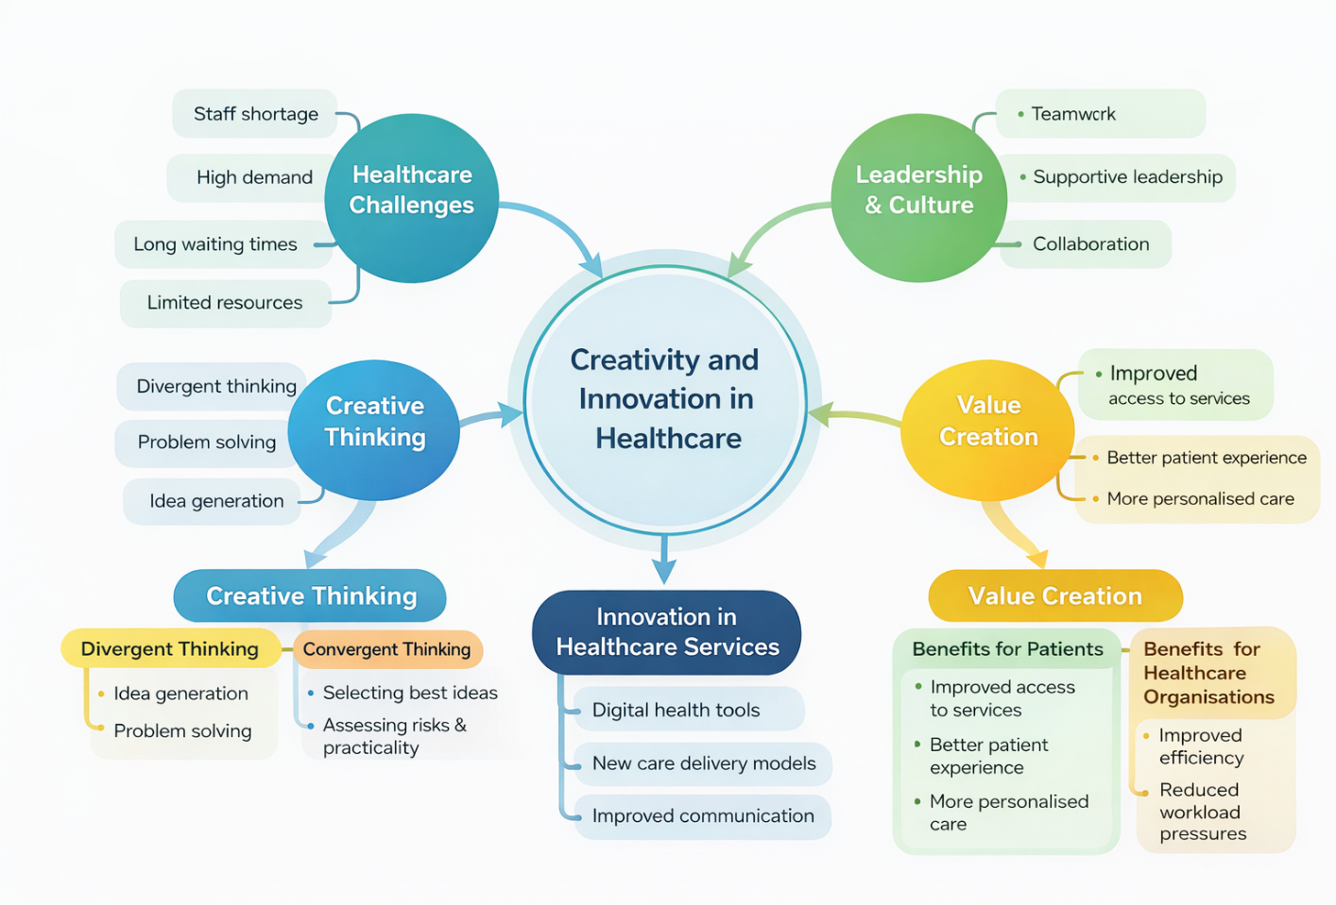
Figure 1: Concept map of creativity and innovation in healthcare practice.
The concept map depicts the ways in which creativity and innovativeness can be implemented in healthcare practice in order to deal with the challenges in the NHS. The healthcare organisations are under more pressure due to staff shortages, high patient demand, long queues, and scarce resources (Van Merode, Groot, and Somers, 2024). These obstacles compel the medical workers to be innovative and formulate innovative strategies to enhance services and care delivery to the patients.
Innovation includes creative thinking. Divergent thinking enables healthcare workforces to come up with numerous ideas and seek potential solutions to challenges (Brewster et al., 2021). It is a stage where one can talk and be imaginative without any judgment. These ideas are then analyzed by convergent thinking in order to see the most effective and viable solution. Using the hybrid combination of the two kinds of thinking, the healthcare professionals can turn an idea into a realistic improvement.
Creativity is also promoted by leadership and organisational culture. Leaders who are supportive encourage teamwork and openness to communicate, build an atmosphere in which employees feel comfortable sharing ideas and making contributions to change (Mwamba, 2023).
With effective application of creativity, the result may be healthcare service innovation, including digital health technologies, enhanced communication systems, and novel means of patient care. These innovations are used to add value by enhancing patient
experience, enhancing access to services, and making the delivery of healthcare services more effective.

Task 2 - Self-Reflection of Group Activity

In the paperclip group activity, we were to experiment with how we could use a simple object in various ways through the application of divergent and convergent thinking. In the first stage of the exercise, the emphasis was on the number of ideas that would appear. This step promoted the level of creativity and enabled the group to go beyond the literal use of a paperclip. I helped in coming up with some of the ideas, some of which were practical and some were unusual. The activity provided us with an open and free atmosphere in which everyone was comfortable sharing their ideas.
As the exercise continued, the group shifted towards idea evaluation rather than idea generation. This necessitated the application of convergent thinking to evaluate the ideas that were realistic and helpful. At this step, I was engaged in the debates concerning which recommendations were most feasible and why. By doing so, this process allowed the group to reduce the number of options and choose the ideas that were most appropriate.
The exercise made me realize the way that creativity operates in an organized manner. Divergent thinking gives a chance to explore numerous options, whereas convergent thinking narrows down these ideas into more viable solutions (Runco, 2022). Another important lesson I acquired is that of working in a team to solve a problem. Hearing varied points of view enabled the group to come up with sound ideas, and we understood how to cooperate effectively.

Task 3 - Case Study of a UK innovation

The introduction of NHS Virtual Wards is an example of an innovation in the UK healthcare system (Kanyimo, 2022). This project represents how creative thinking and digital technology can revolutionize the manner in which the healthcare service is provided to patients by providing them with the care on the level of a hospital at the comfort of their own homes with the help of digital technology and remote monitoring. This solution was implemented to enhance patient care in addition to curbing pressure on hospitals and medical personnel.
The virtual wards concept was created with regard to the growing demand for hospital beds and the necessity to enhance NHS efficiency (McGowan et al., 2024). Rather than retaining patients in the hospital, medical providers are now able to observe patients remotely with the aid of digital technologies that record vital signs like heart rate, oxygenation, and temperature. The healthcare teams then review the data and are able to respond promptly in case the condition of a patient alters.
This innovation was developed as a result of creativity. The collaboration between the professionals in the hospital industry and the technology experts helped redefine conventional hospital care (Bidoli et al., 2023). They did not believe that they had to always treat the patient inside a hospital building, but they investigated the idea of providing care safely at home. This necessitated innovative problem-solving, such that the patients may receive high-quality monitoring and support even when out of the hospital environment.
Virtual wards have brought about a lot of value in terms of patients and healthcare delivery (Norman, Bennett, and Vardy, 2023). To patients, it can be less stressful and more comfortable to receive treatment at home than to be in the hospital. It also minimizes the chances of contracting hospital-acquired infection and enables people to be with their families in the recovery phase.
In terms of healthcare organisations, virtual wards are useful in releasing hospital beds and reducing overcrowding in the emergency departments (Jalilian et al., 2024). This enables hospitals to prioritize patients involving intensive care and, at the same time, assist other patients capable of recuperating at home safely. Moreover, remote monitoring can guide medical personnel to monitor the progress of a patient effectively and respond in time when it is needed.
On the whole, NHS Virtual Wards show that innovative solutions and creative thinking can revolutionize healthcare delivery. This initiative is an effective solution to some of the most significant issues the modern healthcare systems have through the integration of digital technology with patient-centred care.

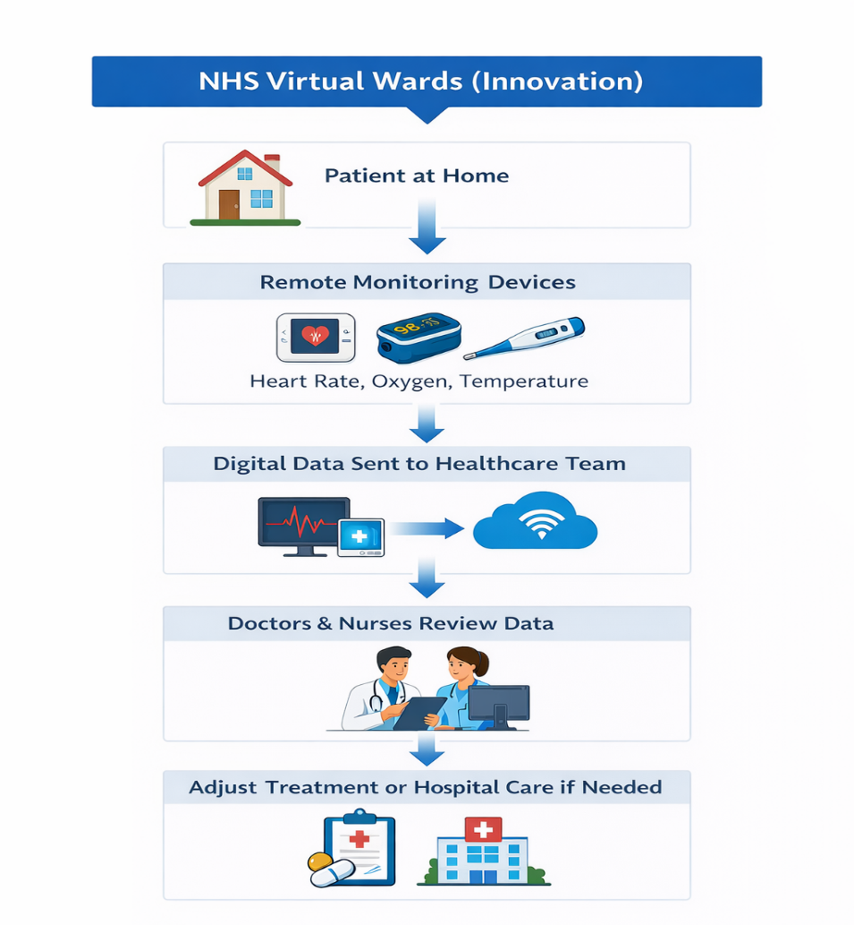

Figure 2: NHS Virtual Wards remote patient monitoring model.

Task 4 - Research Task

The problem of equal access to healthcare services does not apply to everyone, and certain groups of people experience more difficulties in seeking proper medical attention. Poverty, homeless people, migrants, long-term health conditions, and people with disabilities are often vulnerable populations (Kasi and Saha, 2023). Such groups can have various social and economic problems that can influence their access to healthcare services on a regular and effective basis.
Financial instability is one of the serious impediments. People who have low income find it hard to pay for transportation to their medical appointments, or they may have priorities like food, rent, or utilities over healthcare (Im et al., 2025). Homeless people may resort to further challenges as they may lack a permanent address, which can complicate the process of addressing GP practice (Crane et al., 2023). In the absence of regular access to primary healthcare, people can wait until their health conditions get more severe to seek help.
Limited health literacy is another factor that is important (Shahid et al., 2022). Not all people are aware of the functioning of the healthcare system and how to find their way through the provided services. The booking systems of appointments, medical terminology, and complicated procedures may confuse and discourage patients from seeking assistance (Nanteza, 2025). Patients who feel confused about the way to access services can avoid healthcare.
Other influences on access to healthcare include language barriers and cultural differences. A non-English speaker might not be able to express their health issues clearly or interpret medical recommendations given by medical practitioners. Levels of trust and willingness to seek care may also be affected by cultural beliefs and past negative experiences with healthcare systems (Tefera, 2024).
These obstacles tend to intersect, generating additional disparities in health care. Consequently, the vulnerable groups can have delays in diagnosis and treatment, which can result in worse health outcomes and increased workloads on healthcare services.

Task 5 - Podcast

This podcast is an innovative concept that tries to enhance access to primary healthcare services in the NHS through integrating digital assistance systems with community-based assistance to patients.

Title: Improving Access to Primary Healthcare through Community Digital Support
Hello, my name is [your name], and in this podcast I will introduce an innovative idea designed to improve access to primary healthcare services within the NHS.
Healthcare systems across the UK are currently experiencing increasing demand for services. Many GP practices face challenges such as long waiting times, staff shortages, and growing patient needs. These pressures highlight the importance of developing creative and innovative approaches to healthcare delivery.
The idea I am proposing focuses on a community-based digital support programme that helps patients access healthcare services more easily while also providing personal support when needed. The concept combines digital healthcare tools with support from trained staff located in community spaces such as pharmacies, libraries, or local health centres.
Patients would be able to use digital platforms to book appointments, request prescriptions, and access reliable health information. At the same time, individuals who may feel less confident using technology could receive guidance from trained support staff. This approach ensures that digital healthcare services remain inclusive and accessible to a wide range of patients.
Creativity plays a key role in this innovation by rethinking how healthcare services are delivered. Instead of relying only on traditional face-to-face appointments, this approach creates a blended model of care that combines technology with human support.
The potential benefits include improved access to healthcare services, reduced pressure on GP practices, and greater patient confidence in managing their own health. By supporting both efficiency and inclusivity, this initiative could contribute to a more sustainable healthcare system.
In conclusion, innovative ideas such as community digital support programmes demonstrate how creativity can help address current challenges in healthcare while improving patient experience and service delivery.
Thank you for listening.

Task 6 - NHS Leadership Framework Analysis

Part A: Key Components of the NHS Leadership Framework
The NHS Leadership Framework explains behaviours and values needed to promote good leadership in health and social care organisations (Barr and Dowding, 2022). The framework will focus on producing leaders who will enhance healthcare services, assist staff, and provide high standards of patient care. Self-awareness is one aspect, as it prompts leaders to get to know their strengths, values, and influence on others (Kohn, 2024). Self-aware leaders are in a better position to develop trust and effective communication with their teams.
One more important element is collaboration. This reinforces the values of collaboration, teamwork, and developing good working relationships beyond professional borders. There is a tendency to engage many professionals in healthcare delivery, and effective leadership assists in aligning these efforts.
Another aspect of the framework that is important is the enhancement of services. Leaders are advised to constantly review the existing practices and facilitate changes that improve quality and efficiency. The NHS Leadership Framework enhances the establishment of good working environments through patient-centred care and staff growth to facilitate learning, innovation, and continuous improvement.
Part B: Using One Component to Encourage Creativity and Improve Care
PProviding a conducive workplace to staff members is one of the key aspects of the NHS Leadership Framework. Open communication and the ability to listen to various opinions by leaders will foster a culture where workers feel free to exchange ideas (Subrahmanyam, 2025). When employees feel important and encouraged, they tend to offer innovative solutions to the problems in the healthcare services.
Teamwork and collaboration also help to encourage nurses to share their experience and learn new ways of treating their patients. Fostering creativity through team discussion and reflection, as well as problem-solving, allows leaders to foster creativity (Royston and Reiter-Palmon, 2022). This strategy not only aids in innovation but is also useful in enhancing the quality, safety, and effectiveness of healthcare services.

Task 7 - Self-Reflection Journal Entry

My perception of creativity and innovation as applied to healthcare practice has evolved throughout this module. I originally perceived creativity as primarily the creation of new ideas at the start of the module. Nevertheless, the learning activities and portfolio assignments have taught me that creativity also includes teamwork, problem-solving, and enhancing the current systems to provide more effective healthcare services.
The group activity was one of the most useful learning activities as we discussed the various applications of a paper clip. This practice enabled me to realise the value of divergent and convergent thinking in the act of innovation. Divergent thinking enables people to create as many ideas as possible, and convergent thinking enables people to consider and narrow down the ideas to workable solutions. This experience showed me the applicability of structured creative thinking to real-life problems.
The module also made me realize that innovation can add value to healthcare systems. The analysis of healthcare innovations revealed how innovative solutions can help patients have improved access to services, increase efficiency, and contribute to improved healthcare outcomes. I also got to know that leadership and organisational culture are important factors in promoting creativity in healthcare teams.
Altogether, this module has made me more robust in critical and creative thinking in regard to healthcare practice challenges. It has built my self-esteem in offering ideas during group discussions and problem-solving sessions. As a prospective professional, I will strive to implement innovative thinking and collaboration to foster service delivery and help achieve favorable patient outcomes.

Reference List

Barr, J. and Dowding, L. (2022). Leadership in Health Care. 5th ed. SAGE.
Bidoli, C., Pegoraro, V., Dal Mas, F., Bagnoli, C., Bert, F., Bonin, M., Butturini, G., Cobianchi, L., Cordiano, C., Minto, G., Pilerci, C., Stocco, P., Zantedeschi, M. and Campostrini, S. (2023). Virtual hospitals: The future of the healthcare system? An expert consensus. Journal of Telemedicine and Telecare, [online] p.1357633X231173006. doi:https://doi.org/10.1177/1357633X231173006.
Brewster, A.L., Lee, Y.S.H., Linnander, E.L., and Curry, L.A. (2021). Creativity in problem solving to improve complex health outcomes: Insights from hospitals seeking to improve cardiovascular care. Learning Health Systems, 6(2). doi:https://doi.org/10.1002/lrh2.10283.
Crane, M., Joly, L., Daly, B., Gage, H., Manthorpe, J., Gaia Cetrano, Ford, C., and Williams, P. (2023). Integration, effectiveness, and costs of different models of primary health care provision for people who are homeless: an evaluation study. Health and social care delivery research, 11(16), pp.1–217. doi:https://doi.org/10.3310/wxuw5103.
Im, H., Li, F., Stover, S., Abel, C., Farmer, J., García, C.M., Lee, J.-A. and Wyczalkowski, C.K. (2025). Overcoming Transportation Barriers for Low-Income Individuals with Chronic Conditions: Identifying Barriers and Strategies in Access to Healthcare and Food as Medicine (FAM). Healthcare, 13(22), p.2869. doi:https://doi.org/10.3390/healthcare13222869.
Jalilian, A., Sedda, L., Unsworth, A., and Farrier, M. (2024). Length of stay and economic sustainability of virtual ward care in a medium-sized hospital of the UK: a retrospective longitudinal study. BMJ Open, 14(1), pp.e081378–e081378. doi:https://doi.org/10.1136/bmjopen-2023-081378.
Kanyimo, E. (2022). Using virtual wards and long-term conditions management networks to improve practice and performance. BMJ Open Quality, 11(4), p.e001952. doi:https://doi.org/10.1136/bmjoq-2022-001952.
Kasi, E. and Saha, A. (2023). Vulnerability and Vulnerable Groups of People. Springer eBooks, pp.1528–1534. doi:https://doi.org/10.1007/978-3-319-74319-6_369.
Kohn, P. (2024). Reflection and Self-Awareness: Cultivating Effective Leadership Mindset. Emerald Publishing Limited eBooks, [online] 1(1), pp.91–118. doi:https://doi.org/10.1108/978-1-83549-564-320241007.
McGowan, L.J., Graham, F., Lecouturier, J., Goffe, L., Echevarria, C., Kelly, M.P., and Sniehotta, F.F. (2024). The Views and Experiences of Integrated Care System Commissioners About the Adoption and Implementation of Virtual Wards in England: Qualitative Exploration Study. Journal of Medical Internet Research, [online] 26, p.e56494. doi:https://doi.org/10.2196/56494.
Mwamba, J. (2023). Effective Leadership in Change Management: Ensuring Success in Organizational Transformation. Journal of Policy Options, [online] 6(1), pp.28–38. Available at: http://resdojournals.com/index.php/jpo/article/view/280.
Nanteza, A. (2025). Reducing patient wait times: a digital booking system for consultant doctor appointments at Nakasero Hospital. Mak.ac.ug. [online] doi:http://hdl.handle.net/20.500.12281/22042.
Norman, G., Bennett, P., and Vardy, E.R.L.C. (2023). Virtual wards: a rapid evidence synthesis and implications for the care of older people. Age and Ageing, 52(1). doi:https://doi.org/10.1093/ageing/afac319.
Royston, R. and Reiter-Palmon, R. (2022). Leadership and Creativity. Routledge eBooks, pp.305–326. doi:https://doi.org/10.4324/9781003233923-26.
Runco, M.A. (2022). Divergent Thinking. Springer eBooks, pp.429–436. doi:https://doi.org/10.1007/978-3-030-90913-0_31.
Shahid, R., Shoker, M., Chu, L.M., Frehlick, R., Ward, H., and Pahwa, P. (2022). Impact of Low Health Literacy on Patients’ Health outcomes: a Multicenter Cohort Study. BMC Health Services Research, 22(1), pp.1–9. doi:https://doi.org/10.1186/s12913-022-08527-9.
Subrahmanyam, S. (2025). Fostering a Collaborative Culture. IGI Global eBooks, [online] pp.377–396. doi:https://doi.org/10.4018/979-8-3373-0710-7.ch020.
Tefera, G.M. (2024). Exploring lack of trust and its impact on access and utilization of primary healthcare services among African immigrant women in the United States: a qualitative study of Ethiopian immigrant women. BMC Health Services Research, 24(1). doi:https://doi.org/10.1186/s12913-024-11798-z.
Van Merode, F., Groot, W. and Somers, M. (2024). Slack Is Needed to Solve the Shortage of Nurses. Healthcare, [online] 12(2), p.220. doi:https://doi.org/10.3390/healthcare12020220.

