

TC-GAT: A Temporal Convolutional Graph Attention Network for Traffic Flow Prediction
by
Yang Lu

Supervisor: Dr Gordon Dickers

Project submitted as part of the requirements for the award of MSc Applied Computing

September 2023
DECLARATION

I, ............................................Yang Lu………………………………… declare that I am the sole author of this Project; that all references cited have been consulted; that I have conducted all work of which this is a record, and that the finished work lies within the prescribed word limits.

This work has not previously been accepted as part of any other degree submission.

Signed : .......... 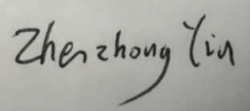................

Date : ...... September 7, 2023......

FORM OF CONSENT

I ............................................Yang Lu………………………………… hereby consent that my Project, submitted in candidature for the M.Sc. Applied Computing degree, if successful, may be made available for inter-library loan or photocopying (subject to the law of copyright), and that the title and abstract may be made available to outside organizations.

Signed : .......... ................

Date : ...... September 7, 2023......

Abstract
With the development of society, the number of cars continues to increase, and traffic congestion has gradually become the main problem hindering urban development. Traffic flow data records the number of traffic entities passing through a certain section of the road for a period of time, and its real-time and accurate prediction plays an important role in improving traffic congestion. Therefore, it is of great significance to study the theory and method of traffic flow forecasting to better utilize the performance of urban traffic road network. However, due to the complex pattern of traffic flow changing rapidly in time and space, it is difficult for existing prediction methods to accurately capture the spatio-temporal coupling characteristics of traffic data. Therefore, based on the research and analysis of urban road traffic data, this thesis proposes a traffic flow prediction model TC-GAT (Temporal Convolutional Graph Attention Network) based on Temporal Convolutional Network (TCN) ,Graph Attention Network (GAT) ,and Transformer. In order to solve the problem that Graph Convolution Network (GCN) can only statically fuse the features of road network nodes, TC-GAT uses GAT to dynamically aggregate spatial features to model the spatial dependence of traffic flow. Aiming at the poor long-term prediction effect of traffic flow, TCN is used to model temporal dependence by capturing the dynamic change of traffic flow on roads. In addition, the highly parallelized self-attention mechanism in Transformer is introduced to improve prediction accuracy by adjusting the importance of different time points and assembling global temporal information. The experimental results show that TC-GAT achieves better prediction performance than the comparison model. Meanwhile, the necessity of each module in the model is evaluated by ablation experiments.

Content

Abstract 3
Content 4
CHAPTER 1: INTRODUCTION 5
CHAPTER 2: LITERATURE REVIEW 6
2.1 Temporal feature dependence extraction 7
2.2 Spatial feature dependence extraction 8
2.3 Graph Structure Learning 9
2.4 Attention Mechanism 10
CHAPTER 3: Methodology 12
3.1 Traffic flow knowledge 12
3.1.1 Temporal dependence. 12
3.1.2 Spatial dependence. 12
3.1.3 Problem Definition. 13
3.2 Framework 14
3.2.1 Spatial-Dependent Feature Extraction Module 15
3.2.2 Temporal-Dependent Feature Extraction Module 16
3.2.3 Attention mechanism layer 17
CHAPTER 4: Experimental Design 19
4.1 Data Description 19
4.2 Data Processing 20
4.2 Evaluation Metrics 21
4.3 Loss Function 21
4.4 Baselines 22
4.6 Experimental settings 23
CHAPTER 5: Results & Discussions 23
CHAPTER 6: Conclusions and Recommendations 25
CHAPTER 7: REFLECTION 27
REFERENCES 29

CHAPTER 1: INTRODUCTION
In sync with the rapid development of Transportation Systems (ITS) [1], traffic flow prediction is gaining popularity because of its potential to provide valuable data support for urban planning, including road construction, public transportation planning, to help cities achieve a rational transportation layout and development. Accurate traffic flow prediction can help traffic management departments and drivers to understand the future road conditions, so as to reasonably plan travel routes and time, reduce traffic congestion, improve road use and transportation efficiency, and thus reduce energy consumption and environmental pollution. In addition, traffic flow prediction provides important data support for urban transportation planning, which can help planners optimize road layout, public transportation routes and transportation facilities, and improve the overall efficiency and sustainability of urban transportation systems. At the same time, accurate traffic flow prediction can help travelers plan the best travel plan, choose the shortest route and the most suitable travel time, reduce travel time and uncertainty, and improve the comfort and convenience of travel. Hence, traffic flow prediction can help traffic management and drivers to understand traffic conditions in advance and avoid traffic accident-prone areas and high-risk roads, thus reducing traffic accidents and improving traffic safety.
Traffic data can be regarded as a kind of time-series data, but compared with other time-series prediction problems, traffic flow prediction is more challenging, which is mainly manifested by the complex spatio-temporal correlation of traffic data and the influence of some external factors [2]. The spatio-temporal correlation of traffic data includes complex spatial dependence and dynamic time dependence. Spatially, different neighboring nodes in the traffic network have different impacts on other nodes, and the impacts of the same node on other predicted locations change with time; in terms of time, the observed data of the same node at different time steps are nonlinear, and the influence between multiple time steps is often long-term. At the same time, traffic data usually show periodicity, such as seasons, weekdays and days off. External influences on traffic data mainly include weather states, emergencies, and road attributes. In summary, traffic data exhibit complex dynamic correlations in both time and space, and how to tap into such nonlinear spatio-temporal connections for accurate traffic prediction is an important topic.
After years of development, research on traffic forecasting has made great progress. Current traffic flow prediction methods can be divided into two categories: traditional methods and deep learning methods. Traditional methods mainly include classical statistical methods and machine learning methods. Classical statistical methods build statistical models based on data to predict the data, represented by the Historical Average (HA) [3] and the Auto-Regressive Integrated Moving Average (ARIMA) [4]. However, these methods are usually only applicable to relatively small datasets and difficult to capture complex nonlinear relationships, and thus cannot meet the current traffic prediction needs. To address the above problems, researchers have proposed many machine learning methods, represented by Support Vector Regression (SVR) [5] and Random Forest Regression (RFR) [6]. However, machine learning methods are highly dependent on feature engineering and usually require additional manual features to be designed in advance by experts in their fields, making it difficult to mine complex spatio-temporal patterns. With the growing datasets related to the transportation field and the development of artificial intelligence technology, more and more researchers are trying to use deep learning methods to study the traffic prediction problem, including recurrent neural networks of recurrent neural networks (e.g., Long Short-Term Memory (LSTM) and Gate Recurrent Unit (GRU)) [7], and the Seq2seq model [8] based on encoding and decoding structures. However, traditional shallow deep learning networks are difficult to achieve accurate prediction results in current complex traffic situations, and earlier prediction methods also lack modeling of spatial dependence, and there is still room for improvement in prediction accuracy.
With the rise of graph neural networks, Graph Convolution Network (GCN) [9] is often used to capture spatial correlation. Traditional GCN uses a predefined fixed adjacency matrix to characterize the adjacency between traffic nodes, but it is not possible to judge the importance of different traffic nodes adequately, and in addition to the spatial correlation between neighboring nodes, there may be a certain degree of correlation between some remote nodes in the city, i.e., they will share a similar "time" pattern. In addition to the spatial correlation between neighboring nodes, there may also be some correlation between some remote nodes in the city, i.e., they share a similar "time" pattern. Secondly, the effectiveness of the existing methods to learn the time dependence is low. Recurrent Neural Networks (RNNs) suffer from the problem of gradient vanishing, which makes them unable to capture the dependency between traffic data at long time intervals.
Hence, based on the above description, we propose a novel traffic flow prediction method called the Temporal Convolutional Graph Attention Network (TC-GAT), which uses Graph Attention Network (GAT) [10] to capture spatial dependence and Temporal Convolutional Network (TCN) [11] to model temporal dependence also we adopt the Attention mechanism ^{[12]} to adjust the importance of different traffic node. To the greatest of our knowledge, this is the first attempt to integrate the TCN and the GAT. We believe that our pioneering effort will cast light on how to enhance the accuracy of traffic flow prediction. I evaluate this model by adopting the taxi speed data of the Luohu District in Shenzhen and Los-loop datasets. The experimental results show that under different evaluation metrics, the performance of TC-GAT has a good improvement compared to other models.
The rest of this paper is organized as follows. In CHAPTER 2, I first conduct a comprehensive literature review on four topics: temporal feature dependency extraction, spatial feature dependence extraction, graph structure learning, and attention mechanism. In CHAPTER 3, I define the problem mathematically, describe essential technologies employed in the model, and then elaborate on the whole model architecture in depth. In CHAPTER 4, I describe the data collection and experimental context, followed by my experimental design, which includes baselines and assessment procedures. After that, I analyzed the experimental data in CHAPTER 5 and compared my results to baselines to ensure the suggested model's validity. In CHAPTER 6, I reviewed the whole project and discussed potential future model enhancements, as well as my future research plans. At last, I talked about my experience in the whole work in CHAPTER 7, and summarized my efforts for the experiment.

CHAPTER 2: LITERATURE REVIEW
Traffic flow prediction uses spatio-temporal data collected by various sensors to predict future traffic conditions, involving both spatial and temporal features, so it can be regarded as a kind of spatio-temporal prediction task, and the research in recent years has mainly focused on improving the prediction performance from these two aspects. Specifically, in terms of temporal feature extraction, it is mainly divided into methods based on traditional statistical theory, methods based on machine learning and methods based on deep learning; in terms of spatial feature extraction, the modeling methods for traffic networks in recent years can be divided into methods based on Euclidean space and methods based on non-Euclidean space. Since non-Euclidean space-based methods mainly use graph convolution to model spatial dependencies, but the traditional predefined adjacency matrix cannot adequately express the spatial connections of traffic nodes, so graph structure learning has also become a hot spot of researchers' attention.

2.1 Temporal feature dependence extraction
Research on time-dependent modeling of traffic flow has a history of several decades. Early research on traffic flow was mostly based on traditional statistical methods and focused on temporal modeling. After the development of computer hardware, various types of machine learning methods and deep learning methods have been applied to traffic flow prediction, and in view of the strong expressive ability of deep learning, deep learning-based methods have become the focus of researchers.
Among the methods based on traditional statistical theory, the Kalman Filter (KF) [14] based method uses a series of time-varying observations containing noise and other errors to produce estimates of unknown variables; such methods are difficult to deal with the stochastic and cyclical nature of traffic data, and their application in the field of traffic flow prediction has major limitations. HA [3] uses a set of recent historical data to predict the future period or periods of data. This method is simple and easy to implement, and has good prediction effect in the case of time series without seasonality and periodicity, but it is weak on time series data with obvious periodicity. The ARIMA-based method [4] adds the operation of difference on the basis of ARMA, and its basic idea is autoregression, i.e., the value of the current point is regressed from the value of the previous several adjacent points; ARIMA model fits each sequence individually, which is less efficient in dealing with the large-scale time series, and due to the fact that each sequence is fit individually and independently, it is not possible to share the similarity law that exists among the different scenes.
Among the machine learning-based methods, SVR model-based methods [5] predict future traffic data by adjusting the regression plane so that the sum of the distances from the training data to the plane is the closest; however, SVR is not suitable for large datasets, and it performs poorly when there are many error data in the traffic dataset, or when the dimension of the features of a single data point is larger than the sample size of the data. The prediction method based on Bayesian network [15] analyzes the neighboring information between adjacent roads through mathematical statistics to extract the spatial characteristics of the traffic data and determine the future trend of the current prediction point; however, due to the expressive ability of machine learning, Bayesian network is difficult to achieve good modeling effect for large-scale datasets. The K-nearest Neighbors Algorithm (KNN) based method [16] uses Euclidean distance, Manhattan distance and other distance metrics to predict the future trend of the traffic data. KNN does not require data input assumptions, and the outliers in the data have less influence on the KNN model, but its computational and spatial complexity is high.
With the development of artificial intelligence technology and the improvement of related hardware, deep learning is increasingly used for traffic flow prediction. Dougher firstly applied neural networks to the task of traffic flow prediction, and Polson et al. established a deep learning architecture for traffic flow prediction [9]. After the emergence of RNNs for capturing time series dependence and Convolutional Neural Network (CNNs) for extracting spatial features, related studies have gradually combined CNNs and RNNs for traffic flow prediction, but the models that simply combine the two have yet to be improved in terms of obtaining the spatial and temporal dependence of high-dimensional traffic data.
In terms of capturing temporal dependencies, RNNs can preserve the previously input sequence information with their internal vectors, which is widely used in the field of traffic flow prediction [17]. However, RNNs still have some drawbacks. First, RNNs-based methods cannot process time series in parallel, which increases the training time. Second, when RNNs are combined with graph convolutional networks, it is more likely to encounter the problem of gradient vanishing [18].
In response to the above limitations of RNNs, deep learning methods such as CNNs and attention mechanisms have been used in several studies to model temporal dependencies. CNNs have been favored by researchers in recent years because of their ability to process time-series data in parallel. Among them, Extended Convolutional Networks are a special form of CNNs, consisting of null CNNs, which do not have to be processed sequentially like RNNs, and gradient backpropagation does not keep accumulating along the time dimension, thus avoiding the problem of gradient dispersion. Due to the above advantages, more and more studies have used extended convolution for traffic flow prediction, and STFGNN [19] and GraphWavenet [20] use parallel gated expansion CNNs to capture the temporal properties of traffic data from different dimensions through a gating mechanism and an expansion factor that increases with the number of layers. However, the capture of long-term dependencies still requires stacking a large number of expanded convolutional layers to increase the sensory field of the CNN, and how to better capture long-term dependencies is still an area that requires in-depth research. Recently, The proposal of the TCN [11] proves that a simple convolutional network is more effective than the RNN across a variety of tasks of late. Hence, in [21] , a novel local temporal convolutional mechanism is proposed to capture the long-term local dynamics effectively.
Attention mechanisms, with their ability to learn temporal inter-signal dependencies, have been widely introduced into automatic coding, deep convolutional and generative networks with favorable results. In time series prediction studies, the attention mechanism has been shown to be an effective technique for extracting data features. For example, Wu et al [22] proposed a multi-component attention approach for time series prediction, in which a bidirectional LSTM model is used to capture seasonal trends and temporal features, a CNN model is used to capture local trend features of residual units, and the introduction of an attention module allows the multi-component streaming data to connect highly correlated historical information in the final prediction. ASTGCN [23] and DGCN [24] use the attention mechanism to directly correlate links between traffic data at different time points, thus improving the model's ability to perceive long-term series. Google proposed to utilize the self-attention mechanism to replace the traditional recurrent neural network in Transformer, which has been successfully applied in the field of natural language processing. Compared with other time-series prediction methods, the auto-attention mechanism is better at capturing the internal correlation of time-series data, and the intrinsic structure of CNNs is hardly better than autoregressive models like the auto-attention mechanism [25], and the auto-attention mechanism shows outstanding advantages in long-term dependency capturing.

2.2 Spatial feature dependence extraction
In terms of capturing spatial dependence, some studies [26-27] modeled the traffic network as a regular two-dimensional grid based on Euclidean space, and the two-dimensional traffic grid data can be processed by CNN to capture spatial dependence because CNN has stable and invariant properties, and can extract the spatial features of the image very well. However, the topology does not have the translation invariance of the image, so the traditional convolution method is no longer applicable, and the research on traffic flow prediction based on non-Euclidean space modeling has gradually become a hot spot.
In the study of traffic flow prediction using Euclidean space, the Conv-LSTM [28] model firstly maps the traffic flow information into a one-dimensional vector space, then combines the one-dimensional vectors into a traffic information matrix and extracts the spatial and temporal features of the traffic data by combining the CNN and the LSTM; the ST-ResNet [29] model divides the trajectory information of cities into grid maps representing different regions according to different geographic locations, counts the inflow and outflow of each entrance and transforms it into a two-channel matrix, and processes the traffic data in a way similar to image processing; Zhang et al. [30] model the grid maps as weighted directed graphs on the basis of dividing the actual geographic information into grid maps, and then inputs them into the CNN for spatial feature learning after graph embedding operation. RSTN [31] combines CNN, LSTM, and Conv-LSTM modules through residual networks to capture spatio-temporal dependencies, and treats the traditional traffic prediction problem as a residual function of travel density in each time interval. MGSTC [27] explores different levels of spatio-temporal correlations through multiple spatio-temporal convolutional branches and dynamically combines spatio-temporal features with external factors to improve model prediction performance.
In traffic flow prediction studies using non-Euclidean spatial modeling, graph convolution is often used to capture spatial correlations. There are two main types of graph convolution, one is the spectral-based approach [32] and the other is the spatial-based approach [33]. STGCN [34] uses a generalized graph structure to model the traffic network in order to make full use of the spatial information, where stations in the network are modeled as nodes, and nodes in the graph contain a series of observations measured at different times, and then the spatial and temporal features are extracted by using the GCN and GRU, respectively; Chai et al [35] used a multi-graph convolutional network to predict traffic flow by building multiple graphs based on distances, traffic interactions, and correlations between stops in the traffic network and performing graph fusion, and then learning spatial-temporal features through GCN and Encoder-Decoder networks. However, although GCN models achieved outstanding prediction accuracy, most of them tend to extract static spatial dependencies in traffic, while these dependencies may evolve over time. Recently, since GAT incorporates an explicit attention mechanism to extract the topology relationship dynamically between the target street and its adjacent streets, it is gradually employed to model spatial-dependent feature for traffic prediction. [36] employed GAT to model spatial-dependent feature among streets. Also, a long short-term memory network is used to extract temporal-dependent feature.

2.3 Graph Structure Learning
Current graph structure learning mainly obtains the adjacency matrix by calculating the similarity between time series, which can be divided into two categories: static and dynamic graphs. Static graph construction methods aim to use existing knowledge to construct graph structures during preprocessing, and early graph construction methods only use the connectivity between roads to obtain a binary adjacency matrix. To further improve the graph structure, some studies have introduced methods to measure the static similarity of the time series, such as the DTW [37] and the Pearson coefficient method, to obtain static graphs based on the temporal similarity between nodes. degree to obtain the static graph.
The application of dynamic graphs is to further improve the representation ability of the adjacency matrix. Due to the dynamic characteristics of the traffic network, static graphs have natural deficiencies in describing complex road networks, and some studies have introduced an attention mechanism based on the binary adjacency matrix, so as to make the influence weight of the nodes change dynamically, and then to adapt to the dynamic changes of the road network. However, in addition to neighboring nodes, some more distant traffic nodes may also have a certain degree of correlation, so more in-depth research is needed for dynamic graph structure learning. At this stage, the implementation of dynamic graphs mainly relies on two types of methods: node embedding [38] and dynamic time series similarity metric. The performance can be improved by obtaining adaptive adjacency matrix through node embedding, in which the parameters of the adjacency matrix can be learned through the training process; and the dynamic similarity metric captures the dynamics of the traffic data by real-time calculation of the similarity of the traffic sequences and updating the adjacency matrix. The dynamic similarity measure captures the dynamic connection of traffic data by calculating the similarity between traffic sequences and updating the neighbor matrix in real time.
Time series similarity measures are also widely used in graph structure learning. The existing correlation measures can be roughly categorized into the following three types. One is based on Euclidean distance, for sequences of the same length, calculate the distance between every two points, and then sum up, the smaller the distance, the higher the similarity; however, this method can not distinguish between shape similarity, and can not reflect the similarity of the dynamic range of changes in the time series trend. The second is based on pattern distance, this type of method divides the time series into different subsets according to the change trend, and each subset represents a class of change patterns. The third is based on shape distance, such as DTW [37], where DTW first aligns the time series in terms of shape, and then calculates the sum of the distances from points on one sequence to each point on the other sequence by dynamic programming and takes the The similarity of the sequences is measured by calculating the sum of distances from points on one sequence to points on the other sequence by dynamic programming and taking the minimum of the sum of distances, but the generation of neighbor-joining graphs by using the DTW algorithm has high However, the generation of neighbor graphs using the DTW algorithm has a high time complexity.
Although graph neural networks can deal with graph structure data, there are limitations: they can only be applied in static graphs, and it is not feasible to deal with dynamic graphs for the time being; there is a great obstacle to applying graph networks on large-scale data; The network structure is shallow, generally up to 3 layers are stacked, and too many layers will lead to the problem of oversmoothing. Based on the above problems, researchers later proposed a variety of improved models on the basis of GNN [51], including graph attention network, graph convolutional network, graph isomorphic network, etc. Most of these models have improved the problems of GNN, and the performance of the model has been greatly improved.

2.4 Attention Mechanism
In deep learning, the attention mechanism is equivalent to the human visual attention mechanism [40]. When people obtain information about something, they usually scan the overall information quickly to determine the important parts, and then devote greater attention and energy to the important parts and further analyze them to obtain the corresponding detailed information, which essentially realizes the efficient allocation of information processing resources [41]. This mechanism not only helps people to quickly access the most effective information, effectively saving attention resources, but also according to the actual situation of selective access to some of the information, help people faster and better. This mechanism not only helps people to obtain the most effective information quickly and save attention resources, but also selectively obtain part of the information according to the actual situation, which can help people to complete the in-depth study of important information faster and better, and efficiently process existing information.
Similarly, the main role of the attention mechanism in deep learning is to select the information that is more critical to the current subject from the massive information [42]. In deep learning, on the one hand, the attention mechanism assigns weights to the input information, and the more important the feature information is, the larger the weight is, which avoids the model from giving too much weight to irrelevant features, and effectively reduces the model's computational and storage costs, helping the model to produce more accurate results; on the other hand, it also improves the model's processing efficiency of the huge amount of data to a certain extent, helping the model to make faster judgment, effectively saving computer resources. In conclusion, the core purpose of the attention mechanism is to rationally allocate attention resources, filter out the noise from the redundant information, so as to make efficient information selection, and obtain the information that is more related to the target of attention and more critical.
Most of the current research on the application of the attention mechanism is mainly based on the Encoder-Decoder model [43]. In the simple Encoder-Decoder model, the Encoder is responsible for inputting the data ($X_{1}, X_{2} …, X_{n}$), encoding the input data into a fixed-length vector and encoding it into a series of hidden states, and then connecting to the last hidden state of the Decoder, and decoding the hidden state into the output ($Y_{1}, Y_{2} …, Y_{n}$), which is a process that requires that there is enough hidden information stored in the hidden states, which is susceptible to the long-distance dependency problem.
In addition, the Encoder-Decoder framework requires the encoder to compress the input into a single vector of predefined dimensions, regardless of the size or amount of information in the input, which leads to a degradation of the model's performance and to the phenomenon of "limited capacity of context vectors". The interpretability of a simple encoder-decoder is very low because all the information needed by the decoder to generate the output is compressed in a context vector without any predefined structure, so this structure is ineffective.
Separate from the Encoder-Decoder framework, the structure of the attention mechanism can also be applied separately in other deep learning models to improve the feature representation of the model [44]. The attention mechanism was initially applied to sequence processing tasks to learn the degree of dependency between the target sequence and the input sequence, so that the majority of the attention can be focused on the sequences that are the most relevant to the task, and the interference caused by sequences that are less relevant to the task can be reduced. sequences that are less relevant to the task and reduce the interference caused by less relevant sequences. In recent years, the attention mechanism has been applied in a number of domains such as data repair [45], sentiment classification [46], image segmentation [47], etc. In addition to the superior performance it provides, the attention mechanism can be used to extract potential mappings between two completely different modalities without explicit supervision of the mappings, and this attention-based model can be used to extract these potential , complex mappings and dependencies. Therefore, in this paper, we incorporate the attention mechanism in the traffic flow prediction model to achieve better results.

CHAPTER 3: Methodology

This chapter first introduces the spatiotemporal characteristics of traffic flow and mathematically describes the task of traffic flow prediction; Subsequently, the network architecture and implementation principles of TC-GAT will be presented.

3.1 Traffic flow knowledge

3.1.1 Temporal dependence.
Figure 3-1 shows the traffic flow data of Bantian Street, Longgang District, Shenzhen City, five and Jiaxian intersection for ten days, as can be seen in the figure, the same traffic node of the traffic data in many days shows a cyclical nonlinear law of change, but also in the holidays and weekdays with different traffic patterns, and due to the regularity of human social activities, the morning and evening for the travel peak, the traffic flow in the night to reach a low peak. And because of the sensor's measurement error or the impact of emergencies, there is a significant deviation from the cycle curve of the data, in the historical data curve for obvious burrs. In addition, weather, traffic control and other influencing factors further enhance the non-periodicity of traffic flow data.
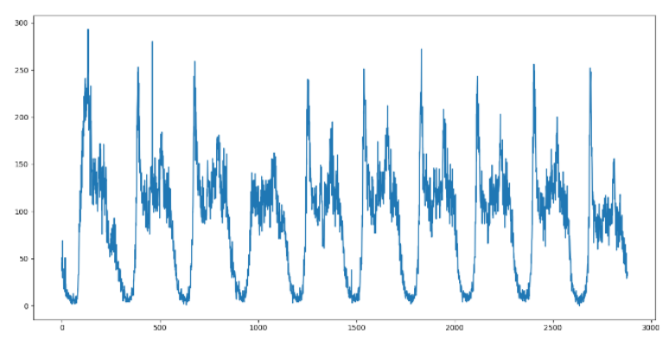
Fig. 3-1 Historical traffic flow at Wuhe-Jiaxian intersection

3.1.2 Spatial dependence.
Traffic flow data is obtained from the measurement of sensors set in different spatial locations in the real world, and the traffic flow sequence measured by a single sensor has temporal autocorrelation, so it can be processed using time series processing methods; the measurement nodes of multiple sensors constitute a complex connectivity system, and the traffic situation of the upstream traffic nodes in the same direction has an obvious influence on the downstream, and the adjacent nodes will have a strong spatial connection, as illustrated in Figure 3-2; however, the more distant nodes may also have similar traffic patterns due to similar social functions, such as highway entrances and exits, shopping malls and hospitals. spatial connection; however, more distant nodes may also have similar traffic patterns due to similar social functions, such as highway entrances and exits, shopping malls, and hospitals. Therefore, there is spatial correlation in traffic flow, which is the most obvious difference between traffic flow data and other time series data.
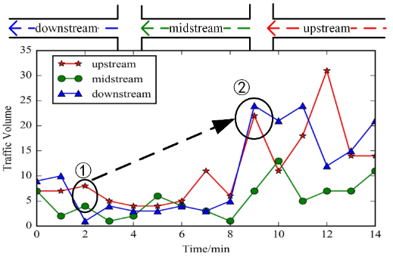
Fig. 3-2 Spatial dependence of traffic flow

3.1.3 Problem Definition.
In the traffic forecasting scenario, two main elements are taken into account: the structure of the entire road network, and traffic flow information. In this essay, I build a road topology network with streets as nodes. Traffic speed is used as an example of traffic information in the experiment section.
- Definition 1: Road Network G. As shown in Figure 2-3, the topological structure of an urban street network is constructed as an unweighted graph G = (V, E), where V is a set of street nodes, V= {$v_{1}, …, v_{n}$ }, N is the number of the nodes, and E is a set of edges. I use an adjacency matrix A to represent the connection between roads, A is in $R^{N∗N}$, where rows and columns are indexed by street sections, and the value of each entry indicates the connectivity between corresponding street sections. The adjacency matrix contains only elements of 0 and 1. The element is 0 if there is no link between streets and 1 denotes there is a link.
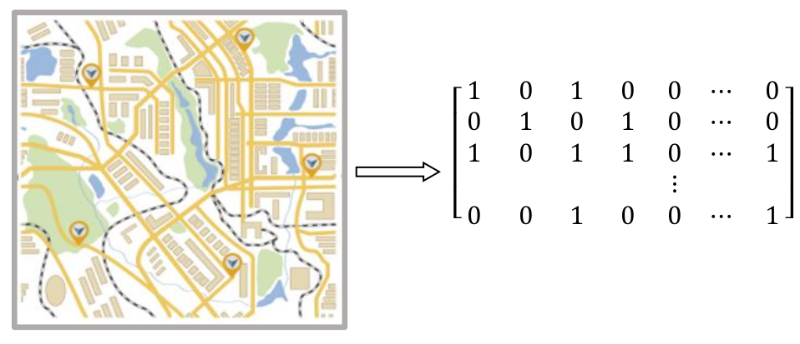
Fig. 3-3 Adjacency matrix of traffic road network

- Definition 2: Traffic flow feature matrix $X^{N∗P}$. I regard the traffic information on the road network (i.e. traffic speed and bus number) as the attribute feature of the node in the network, where P represents the number of node attribute features (the length of the historical time series) and $X_{t}$∈$R^{N∗i}$is used to represent the speed on each road at the time i.

Hence, the traffic forecasting modeling temporal and spatial dependencies can be defined as learning a mapping function $f$ based on the road network G and feature matrix X of the road network. The traffic speed of future T moments is calculated as shown in Equation 3-1:
[$X_{1}, X_{2} …, X_{t}$] = $f(G;(X_{t−n},…, X_{t}))$, (3-1)
where n is the length of historical time series and T is the length of the time series needed to be predicted.

3.2 Framework
In this part, I introduce the framework of TC-GAT. Generally, this model consists of three parts: GAT, TCN, and Multi-head attention module. First, to improve the accuracy, the GAT is employed to extract spatial dependency by capturing the topological structure of the urban street network. Afterward, to improve the speed and extract the long-time series more effectively, the TCN is adopted to record the dynamic fluctuation of vehicle density on streets in order to establish temporal dependency. To tune up the importance of different time points, a Multi-head attention module is introduced. Finally, I use two fully connected layers to get results. Figure 3-4 shows the entire structure of my model.

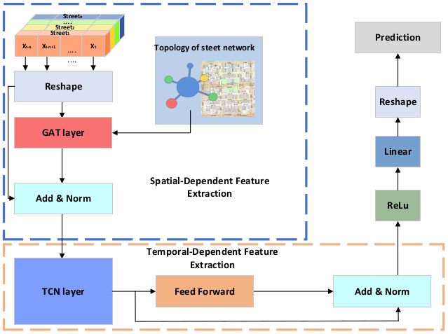
Figure 3-4: Structure of TC-GAT

3.2.1 Spatial-Dependent Feature Extraction Module
Clear that traditional CNNs are restricted to be used in Euclidean space, such as images, a regular grid, etc. An urban street network is in the shape of a graph rather than a two-dimensional grid, which means the CNN model cannot reflect the complex topological structure of the urban street network and thus cannot accurately capture spatial dependence. GCN [52] is one of its developments that expand CNN to graph domains. The GCN model constructs a filter in the Fourier domain, the filter acts on the nodes of a graph and its first-order neighborhood to capture spatial features between the nodes, and then the GCN model can be built by stacking multiple convolutional layers. Currently, GCN-based approaches are among the most advanced techniques in traffic prediction research.
Although GCN models achieved outstanding prediction accuracy, most of them tend to extract static spatial dependencies in traffic, while these dependencies may evolve over time. To deal with this, GAT is used in my model instead of GCN to extract spatial features from traffic data. GAT extends GCN by incorporating an explicit attention mechanism. In Figure 3-5, assuming that node i is the central street, GAT can extract the topology relationship dynamically between the central street and its adjacent streets, the topology of the street network and the features on the roads are encoded to obtain spatial dependencies.
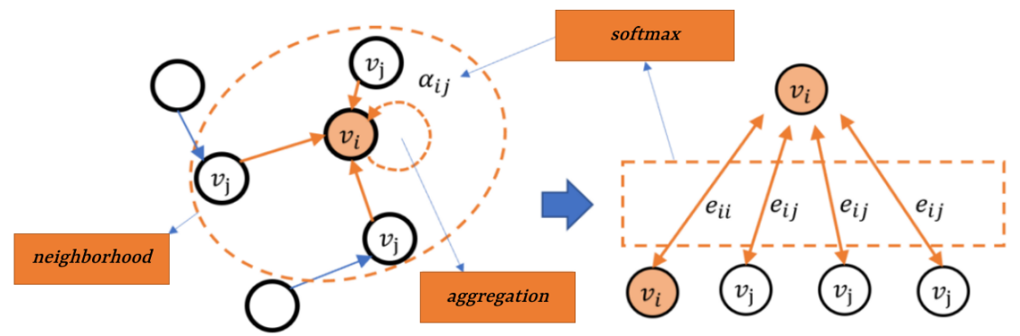
Figure 3-5: GAT mechanism
Specifically, to learn traffic as a graph, I first divide the urban area into streets. Assuming that the input to the GAT layer is a set of reshaped street features, $f= \{{\tilde{f}}_{1}, …, {\tilde{f}}_{n}\}, f$∊ $R^{F}$, where N is the number of streets, F represents the dimension of features in each street, the layer generates a new set of street features. The attention coefficients which indicate the importance of adjacent street j's features to street i can be expressed as:
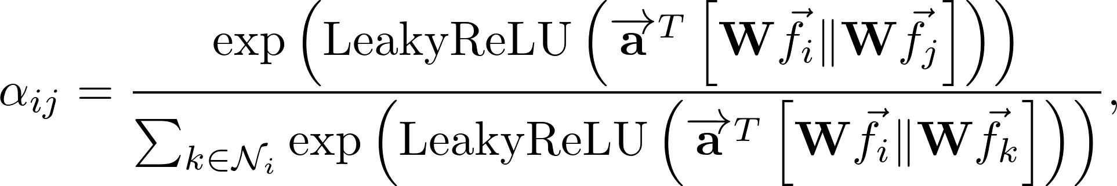 (3-2)
where W represents the weight matrix, a represents a shared attentional mechanism which is a single-layer feed-forward neural network, parameterized by a weight vector $\tilde{a}$. T denotes transposition, || is the concatenation operation, and LeakyReLU represents the activation function.
The output feature of street i after aggregating the features of its adjacent streets is illustrated as:
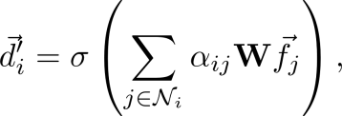 (3-3) where Ϭ denotes a non-linearity.
In the end, I adopt a residual connection [39] followed by layer normalization. Hence, the output of the spatial-dependent feature extraction module is:
(3-4)
where $X_{t}$ is the feature matrix of street features at time t, A is the adjacency matrix of street topology, and P($X_{t}$ , A) stands for the graph attention process explained by Equation (3-3).

3.2.2 Temporal-Dependent Feature Extraction Module
The traffic speed at the current moment will be influenced by that at the previous moment and even longer, which means traffic speed prediction is a time series problem. Currently, the mainstream approach is to use RNN such as LSTM, and GRU to process time series. Recently, the proposal of TCN proves that a simple convolutional network is more effective than the RNN across a variety of tasks. In the copy memory task, TCN exhibits 100% accuracy for all sequence lengths, the LSTM and GRU degenerate to random guessing as the sequence lengths grow. Meanwhile, convolutions can be done in parallel since the same filter is used in each layer which means TCN is faster than LSTM, and GRU. Therefore, I decide to use TCN instead of RNN to extract time-dependent features.
TCN proposes a hierarchical structure based on a 1D fully-convolutional network (FCN) architecture and causal convolutions. 1D FCN is used to make sure that the network produces an output of the same length as the input. The function of causal convolutions is to ensure no leakage from the future into the past. Figure 3-6 shows an example of the temporal convolutional unit with dilated factors d = 1,2,4 and filter size q = 3.
Since convolutions can be done in parallel, TCN is faster than the RNN-based method. For every input within the past flow sequence to be extracted by the filter, we can choose a large filter size k and step up the dilation factor d. The number of the extracted input of one such layer can be expressed as (k-1) d, which is capable of exponential growth d times, so it is more effective when facing long sequential data.
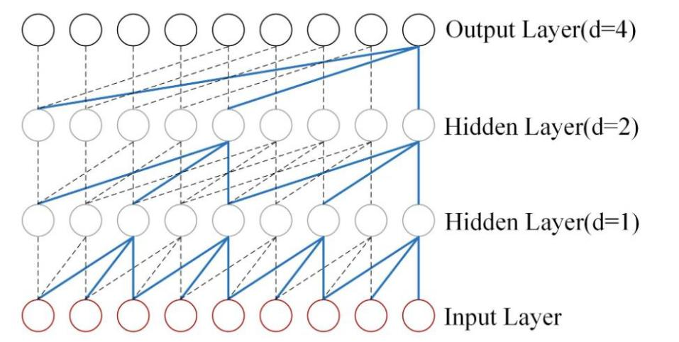
Figure 3-6: An example of Temporal Convolutional Unit.
The output of the spatial-dependent feature extraction module will become the input of the temporal-dependent feature extraction module as the hidden state${ h}_{t}$, assuming that the TCN has k layers, the output of the $k^{th}$ layer can be expressed as:
(3-5)
where $h_{t}^{i}$ represents the hidden state of the $t^{th}$ time in the $k^{th}$ layer for a specific region i, ReLU is an activation function,${ f}_{dr}$ represents a dilated residual block that embodies dropout and ReLU.
Then, to extract deeper features and improve prediction accuracy, a fully connected feed-forward network consisting of two linear transformations with a ReLU activation in between is adopted to handle the output of TCN. A residual connection followed by layer normalization is also adopted in the end. Hence, the output of temporal-dependent feature extraction module is:
(3-6)

3.2.3 Attention mechanism layer
Google proposed to utilize the self-attention mechanism to replace the traditional recurrent neural network in transformer, and it has been successfully applied in the field of natural language processing, and later applied in the fields of temporal prediction and image processing, etc. Applying the advantages of the self-attention mechanism in the long-time prediction to the prediction of traffic flow is a feasible research direction;
Due to the long time span and large dimension of traffic flow data, TCN is still a CNN, although it is more suitable for dealing with long time sequences compared with RNN, TCN still suffers from the phenomenon of "forgetting", and the longer the sequences are, the more obvious the forgetting characteristics are. With the continuous input of traffic flow data, TCN is unable to capture the important information of traffic flow data features, and the key feature information will be lost in the prediction, thus affecting the accuracy and efficiency of prediction. In order to solve the problem that the TCN model cannot well "remember" the information of long time ago, the introduction of the attention mechanism can better capture the potential and complex mapping and dependency relationship between the modes of the traffic flow data, and make the model focus on the more important data features.
The Attention mechanism assigns different weights to the features of traffic flow data in the prediction model, and the more important the feature information is, the larger the weight is, which enables the prediction model to discard non-important information, effectively capture the important feature information of traffic flow data fluctuations, and obtain traffic flow information with high impact on the predicted value, and at the same time, utilize the high-impact traffic flow information in the traffic flow data to perform traffic flow prediction, update the header parameter in a timely manner, and correctly capture the long term interdependence in the traffic flow sequences, so as to improve the prediction accuracy of the model.
First, the attention mechanism consists of three main components: Query Q : an attention computation is performed to get the target output value; Key K : the context vector corresponding to the value; Value V : the selected input vector. The process of calculating Attention value in this work is illustrated in Fig. 3-7:
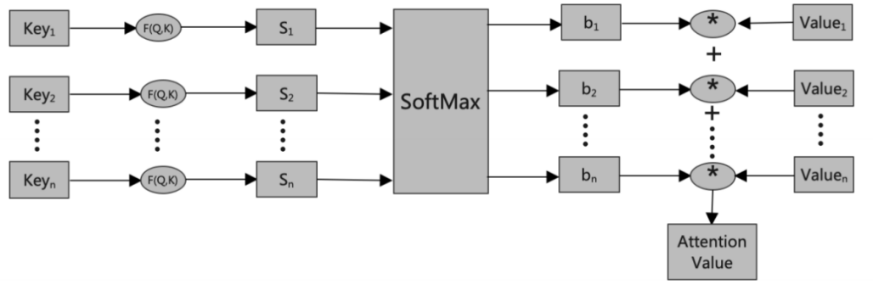
Figure 3-7: The process of calculating Attention Value.
First of all, according to Query and ${ Key}_{i}$ for correlation calculation to get the weights, generally use the vector dot product, c similarity and add additional neural network to find the value of three methods, the specific formula as shown in (3-7), (3-8) and (3-9), and the similarity between a and b is represented by d, and the range of the weights is also different using different methods.
(3-7)
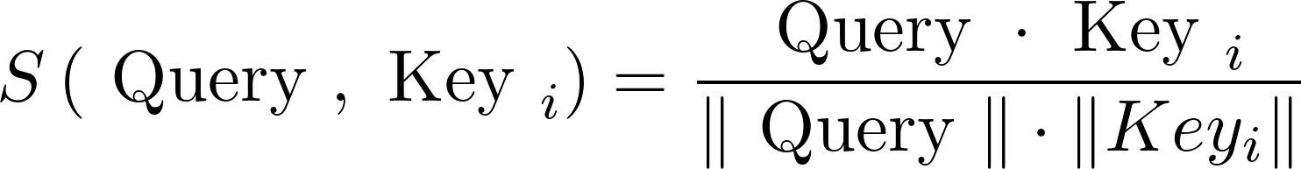 (3-8)
(3-9)
Next, the normalized weights are obtained to the corresponding weight coefficients, and the weights of the first step are numerically converted by the introduced Softmax calculation method, which is mainly for normalization and highlighting the important features in the traffic flow data, and the specific calculation formula is shown in Equation (3-10):
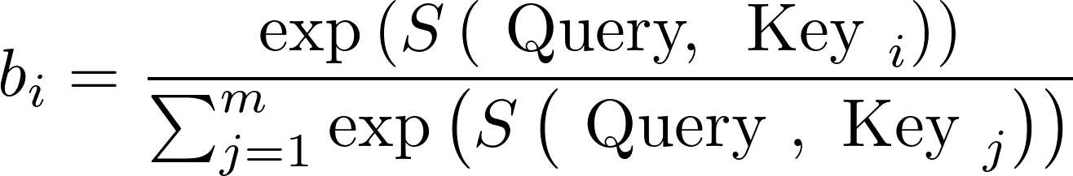 (3-10)
Finally, the weight coefficients corresponding to the weights ${ b}_{i}$ and Value obtained in the second step are weighted and summed to obtain the Attention value. The calculation formula is shown in Equation (3-11):
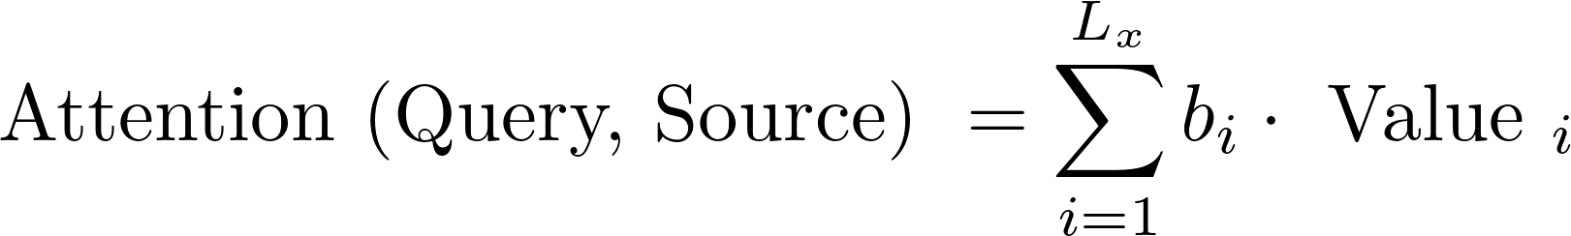 (3-11)
The significance of joining the attention mechanism is reflected in the following three aspects: First of all, by adding the attention mechanism, the model can obtain the ability of "focusing", and its weight matrix assigns corresponding weight values to different features according to the degree of influence on the traffic flow, and these weight values are multiplied with the output vector of the TCN to calculate the product, and the values obtained from the product calculation are obtained by the weighted average operation to get the value of the weight matrix. The values obtained from the product calculation are weighted and averaged to obtain the values of the weight matrix. Secondly, by utilizing the attention mechanism to selectively memorize the feature information, the model can capture the long-term dependency relationship well when facing the problem of long time series. Moreover, the Attention mechanism can be used to extract potential mappings between two completely different modalities and assign weights to them for different relationships, by adding Attention, the potential and complex mappings and dependencies between modalities of traffic flow data can be better captured.
Therefore, this paper incorporates the Attention7Importance mechanism into the traffic flow prediction model to obtain better prediction results, and find the important factors affecting the fluctuation of traffic flow by calculating the Attention Importance Score of the traffic data and its features and assigning weights to them.

CHAPTER 4: Experimental Design

4.1 Data Description
Accurate traffic flow data collection is crucial for traffic flow prediction, the source and quality of the data are factors to be considered, and a complete and accurate traffic flow dataset can maximize the accuracy of the prediction. Early research in the field of transportation was mainly conducted by manual data collection, but this method has too many disadvantages, such as low accuracy of the collected data, high labor consumption and low efficiency, affecting the normal operation of the road traffic, and the personal safety of the collection personnel. With the gradual maturity of data collection technology, sensors and other collection devices are gradually used instead of manual labor for automatic real-time traffic flow data collection. The collected data are transmitted to the traffic data management center in various ways, and after data cleaning and processing, they are organized and summarized and opened to the public, giving researchers in the field of transportation great data support.
In this section, I evaluate the prediction performance of the TC-GAT model on two real-world datasets: SZ-taxi dataset and Los-loop set. Since these two datesets are all related to traffic speed. Without loss of generality, I use traffic speed as traffic information in experiment section.
- SZ-taxi: This dataset represented Shenzhen's taxi trajectory from January 1 to January 31, 2015. Luohu District's 156 key roadways are selected as the study region. We chose the Luohu District's 156 key roadways as the study region. One illustrates the spatial relationship between roadways using a 156*156 adjacency matrix. Each row represents one road and the values in the matrix represent the connectivity between the roads. Another one is a feature matrix, which details how each road's speed varies over time. Each row represents one road; each column is the traffic speed on the roads in different time periods. The traffic speed on each road is aggregated every 15 minutes.
- Los-loop: This dataset was gathered in real-time by loop detectors on a Los Angeles County highway. From March 1 to March 7, 2012, 207 sensors and their traffic speed were chosen. Every 5 minutes, we summed up the traffic speed. Similarly, the data provides an adjacency matrix and a feature matrix. The distance between sensors in the traffic networks is used to calculate the adjacency matrix. The linear interpolation method is employed to fill in the missing values.

4.2 Data Processing
Due to aging sensors, human factors, and weather conditions, the traffic flow data collected on many roads may be abnormal, missing, or duplicated. If the original traffic flow dataset is used directly, it will cause deviation in the prediction of traffic flow data, which will lead to deviation in road management and related resource costs, resulting in unnecessary waste. Therefore, data preprocessing is a necessary process for traffic flow prediction.
For the abnormal, missing and duplicate problems in the original data, the corresponding methods are used to detect and repair to ensure the completeness and accuracy of the predicted sample data, which is also of great significance to improve the accuracy of the traffic flow prediction model.
The traffic flow dataset used in this paper is the information directly collected by the detection site, which contains a large amount of noise information and missing information, which will affect the prediction results of the model if not processed, and the model prediction will be unstable, inaccurate or even erroneous. Therefore, according to the problems existing in the datasets used in this paper, it is necessary to preprocess the two datasets. The preprocessing process for these traffic datasets consists of three main aspects: data repair, denoising and normalization.
First, data repair. Traffic data contains two kinds of anomalies: the first is missing data, due to the failure of traffic sensor equipment, transmission interruption between the sensor and the system, etc., resulting in a longer period of time without obtaining any data; the second is the data errors, such as the appearance of negative values and far beyond the historical values of the same period of time to take the value, single-value repetition of the anomalies, and so on. For the above two kinds of abnormal data, appropriate methods are selected to repair them. For the missing data, the traditional methods include historical mean estimation method, lane ratio method and linear interpolation method. In this paper, the historical mean estimation method is chosen to fix the missing data. As for the error data, it is first recognized and then deleted, and then the data is made up as in the case of missing data.
Second, denoising.When the traffic sensor collects data, if the sampling interval is short it is easy to appear Gaussian noise, noisy data will directly affect the prediction effect of the model, so it is necessary to reduce the noise in the data. Common noise reduction methods include wavelet algorithms, exponential smoothing and Kalman filtering. In this paper, the exponential smoothing method is selected for denoising.
Third, normalization. When modeling traffic data using deep learning models, the data needs to be normalized. Normalization removes the effect of the magnitude of the data and improves the accuracy of the model. In this paper, Z-score standardization is used to process the data so that the mean of the data is 0, the standard deviation is 1, and the relative size and trend of the data do not change, which is convenient for comprehensive analysis.

4.2 Evaluation Metrics
The evaluation index of the model is to compare the predicted value and the real value from multiple angles, quantitatively analyze the difference between the two values, so as to compare the performance difference of the model. In traffic flow prediction, the degree of coincidence between the predicted value and the real value is positively correlated with the prediction accuracy of the model, the higher the degree of coincidence indicates that the prediction accuracy of the model is higher; on the contrary, the prediction ability of the model is poorer. In order to evaluate the performance of TC-GAT model, several popular evaluation indicators are introduced.
- Root Mean Square Error (RMSE). It is obtained by averaging the difference between the value predicted by the model and the true value after the square sum, and the value range is [0, +∞). When the predicted value is completely consistent with the true value, its value is 0. The better the model prediction effect, the closer the RMSE value is to 0; the worse the model prediction effect, the greater the error, the greater the RMSE value. To a certain extent, the value of MSE can be used to evaluate the changes of data. The more the value of RMSE tends to 0, the stronger the ability of the established prediction model to describe the experimental data and the higher the accuracy of the model [49].
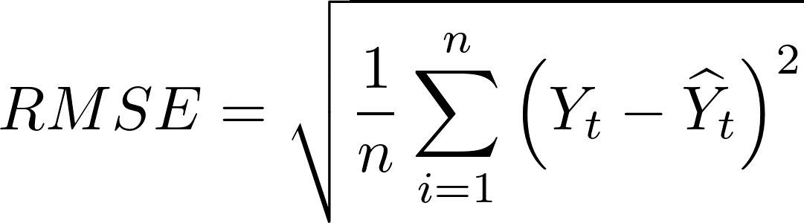 (4-1)
- Mean Absolute Error (MAE). When the value of MAE is , it means that the prediction effect of the model is absolutely perfect. Compared with RMSE, MAE is equivalent to normalizing the error of each point, reducing the influence of the absolute error caused by individual outliers. But note that when the real value has data equal to 0, there is a problem that the denominator may be 0, and this formula is not available. In view of the fact that MAE can more intuitively reflect the actual situation of the error between the predicted value and the true value, the MAE indicator is chosen as one of the evaluation criteria of the model in this article [50].
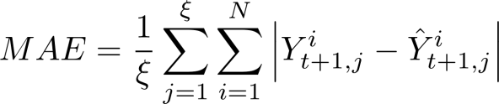 (4-2)

4.3 Loss Function
Traffic flow time series measured by sensors have many significant errors, and the presence of these significant error data increases the prediction error of traffic flow series. Traditional deep learning networks use the mean square error as the loss function for gradient updating, which is prone to overfitting when the input data contains a lot of noise. In order to reduce the impact of noisy data on the gradient update during model training, this model uses an improved loss function for model training, and the loss function is shown below:
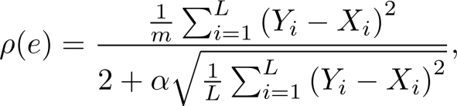 (4-3)
where Y and X are the predicted and true values of the model, respectively, L is the step size, e is the predictive error value. The larger the value of a, the greater the suppression of the loss function on the gradient updating due to the measurement error.
For different values of a, the value of this derivative function varies with the error e as shown in Figure 4-1:
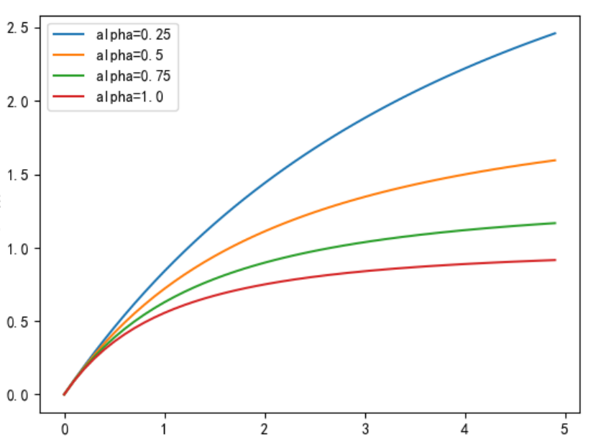
Figure 4-1: Variation curve of influence function with measurement error.
It can be seen that the value of the derivative function of the loss function converges to a constant value with the increasing error between the real data and the error data, which indicates that when the measurement error increases infinitely, the value of the loss used for the gradient backpropagation will not increase rapidly, thus suppressing the impact of the measurement error on the model training. Moreover, the second-order derivative of the loss function is always positive, so the loss function is a convex function, which is conducive to the iterative learning of the learnable parameters in the deep learning model, and effectively avoids the model falling into the local minima in the gradient descent process.

4.4 Baselines
I compare the performance of the TC-GAT model with the following baseline methods:
- History Average model (HA). The historical average model predicts future flow values by using average values from previous periods. The inputs are the data from the local flow.
- Autoregressive Integrated Moving Average model (ARIMA). Autoregressive integrated moving average is a well-known time series prediction method that takes both moving average and autoregressive components into account when fitting time series.
- Support Vector Regression model (SVR). The model is trained using historical data to determine the relationship between input and output, and it then predicts using future traffic data. The linear kernel is used, and the penalty term is 0.001.
- Gated Recurrent Unit (GRU). This approach derives the traffic status at time t by accepting the hidden status at time t-1 and the current traffic information as inputs. While capturing current traffic data, the model keeps the changing trend of prior traffic data and has the capacity to capture temporal dependency.
- Temporal Convolutional Networks model (TCN). We choose a temporal convolutional networks model with a filter size of 3 and dilation factor of 2.
- Temporal Graph Convolutional Network (T-GCN). The GCN and GRU models are utilized to encode spatial and temporal information, respectively, for better performance on traffic flow prediction tasks.
I also analyze the effects of the various components presented in our model. The following two alternative models are offered to validate distinct sections of my design.
- TCN+GAT. In this structure, I use only GAT and TCN to extract temporal and spatial features respectively,without combining the Attention mechanism to adjust the importance of different time points.
- TCN+Attention. This structure combines TCN and Attention mechanism to extract temporal feature but ignores spatial feature.
I utilize the identical testing data for all models and replicate the training data for each model separately to ensure fair comparisons. Furthermore, all models employ the same loss function as this model.

4.6 Experimental settings
The experimental equipment for this paper is a server with Intel Core i9-9900X processor, 128G RAM, NVIDIA GeForce RTX 3090 graphics card, running Linux, and python3.9 development environment.On this equipment, the algorithms of this chapter and various baseline models are implemented respectively.
The models in this paper are built using Pytorch+Keras and some commonly used Python libraries. In this paper, the batch_size is set to 256, the Epoch size is 500, and the Dropout loss rate is 20%. Dropout can effectively prevent overfitting, and the key idea is to temporarily discard a portion of the intermediate layer units from the network according to a certain probability during network training, which provides a way to efficiently combine many different It provides a way to effectively combine many different neural network structures [48], and is a way to add noise to the hidden units of the neural network to regularize the neural network, which can effectively improve the generalization ability of the model.
The hyperparameter ɑ in the loss function determines the ability to suppress the measurement outliers during the model training process; too small a value of ɑ makes the outliers have a greater impact on the model training, whereas too large a value of ɑ reduces the training speed of the model and introduces the problem of oversmoothing. Therefore, the model prediction accuracy is compared here for different values of the parameter ɑ of the improved loss function. After calculation, relative to the case of ɑ = 1, the prediction accuracy of the model decreases with the increase of the value of ɑ, and the prediction accuracy of the model is gradually lower than that of the model trained with the standard loss function, and when the value of ɑ decreases, the prediction accuracy of the model also decreases but its prediction effect is better than that of the standard loss function. The prediction effect of the trained model, it can be seen that 1 is a more appropriate value for ɑ.

CHAPTER 5: Results & Discussions
Traffic flow data show great regularity in a certain time period, but there are differences in different time periods. On the one hand, the fluctuation of traffic flow on the same road section is similarly affected by people's life pattern, and the traffic flow between road sections in the city is correlated, and the historical traffic condition of adjacent road sections also affects the traffic condition of future road time periods. On the other hand, there are differences in the form and characteristics of traffic flow on different roads in the road network and at different time points or monitoring points on the same road. In general, traffic flow data are characterized by large dimensions, many features, and large computation volume. For these complex multiple features in traffic flow data, this paper first uses GAT to extract the spatial features of the data to achieve the effect of compression of data, which can reduce the complexity of the traffic prediction calculation and improve the operational efficiency; then the output of GAT is used as the input of TCN, which can effectively solve the time-dependence problem in the traffic flow data, and finally Attention is used to assign weights to the multiple features of the traffic flow data. Multiple features of the data are given weights to find the "important influencing factors" of the traffic flow fluctuations, so as to improve the accuracy of traffic flow prediction. Table 5-1 illustrates our prediction model and alternative baseline approaches on the SZ-taxi and Los-loop datasets for 15 and 30 minutes. It can be demonstrated that our model achieves the best prediction performance across all evaluation metrics and prediction horizons, demonstrating the model's usefulness in spatio-temporal traffic forecasting. Meanwhile, this model not only can effectively reflect the general trend of traffic flow changes in a day, and the predicted values are smoother than the actual values of the data, but also can effectively fit the cyclical characteristics of the traffic flow data, and its predicted values overlap well with the actual values.
Method | SZ-taxi |  |  |  | Los-loop
Method | 15min |  | 30min |  | 15min |  | 30min
Method | RMSE | MAE | RMSE | MAE | RMSE | MAE | RMSE | MAE
HA | 7.9198 | 5.4969 | 7.9198 | 5.4969 | 7.4427 | 4.0145 | 7.4427 | 4.0145
ARIMA | 8.2151 | 6.2192 | 8.2123 | 6.2144 | 10.0439 | 7.6832 | 9.3450 | 7.6891
SVR | 7.5368 | 4.9269 | 7.4747 | 4.9819 | 6.0084 | 3.7285 | 6.9588 | 3.7248
GRU | 4.0483 | 2.6814 | 4.0769 | 2.7009 | 5.2182 | 3.0602 | 6.2802 | 3.6505
TCN | 4.0021 | 2.6955 | 4.0114 | 2.6530 | 5.1056 | 3.0079 | 6.1265 | 3.6428
T-GCN | 3.9162 | 2.7061 | 3.9617 | 2.7452 | 5.1264 | 3.1802 | 6.0598 | 3.7466
TCN+GAT | 3.8451 | 2.6513 | 3.9024 | 2.6378 | 5.0894 | 2.9877 | 5.9685 | 3.6112
TCN+ATT | 3.9755 | 2.6654 | 3.9987 | 2.6934 | 5.0986 | 2.9986 | 6.0053 | 3.6357
TC-GAT | 3.7487 | 2.5865 | 3.8857 | 2.6015 | 4.9852 | 2.8657 | 5.9177 | 3.5981
Table 5-1: Comparisons with Different Baselines
- High predictive accuracy. We can see that neural network-based approaches that concentrate modeling the temporal characteristic have higher prediction precision than other baselines, such as the HA model, the ARIMA model, and the SVR model.This is mostly due to the difficulty that approaches have in dealing with complicated, nonstationary time series data,they only rely on the numerical features but ignore the spatial and temporal correlations. Furthermore, as a mature traffic forecasting method, the ARIMA's prediction precision is lower than that of the HA, owing to the ARIMA's difficulty dealing with long-term and nonstationary data, and the ARIMA is calculated by calculating the error of each node and averaging; if there are fluctuations in some data, it will also increase the final total error. Moreover, affected by people's lifestyles, the data fluctuation of traffic flow is cyclical, the overall fluctuation of traffic flow is large, and the fluctuation of traffic flow on weekdays and rest days is significantly different, while the prediction results of the method are basically the same as the fluctuation trend of the actual traffic flow during the peaks and valleys, and the trend of the overall traffic flow can be accurately predicted, regardless of whether it is a weekend or a weekday.
- Spatio-temporal prediction capability. To evaluate whether our model can depict spatial and temporal features from traffic data, we compare it to the TCN+Attention model. We can obviously observe that the model based on spatiotemporal characteristics (TC-GAT) has higher prediction precision than those based on a single component (TCN+Attention), demonstrating that our model can extract spatial and temporal information from traffic data. It can see that my model can roughly predict where the overall traffic is going. The RMSE and MAE of our model are reduced by roughly 3.3% and 2.9%, respectively, when compared to the TCN + Attention model, which analyzes just temporal aspects, demonstrating that our model can capture temporal dependency well.
- Effectiveness of capturing the importance of different time points. Our model and TCN+GAT model were compared to test the effectiveness of capturing the importance of different time points. We can see that our model shows approximately 0.86% lower RMSE and approximately 0.32% higher accuracy than TCN+GAT model under 15 minutes time series.This is because Attention mechanism is adopted to dynamically adjust the contribution degree at different time points.Hence, the prediction accuracy is improved. In addition, the model can also realize effective prediction for some local mutation data, indicating that the model proposed in this paper can not only effectively extract the characteristics of time correlation and periodicity in the traffic flow, but also effectively find the important influencing factors of the fluctuation of the traffic flow, which is also effective in predicting the mutation flow.
- Effectiveness of Temporal Convolution Network. With the same length of input data, training our model and the standard GRU-based model takes 30 minutes and 50 minutes, respectively, proving that TCN is more efficient than GRU. It is because TCN operates in a hierarchical structure, processing data in different time periods to efficiently produce predictions based on large amounts of historical data. Unlike GRU, which requires sequential prediction, TCN can handle a lengthy input sequence since each layer employs the same filter. It also shows that the model used in this paper not only improves the accuracy of prediction, but also effectively improves the fitting performance of the model.

CHAPTER 6: Conclusions and Recommendations
Through the research and analysis of previous research scholars in the field of transportation and the challenges and techniques of existing traffic flow prediction research, it is found that traffic flow data is different from general time series data, and the change of traffic flow data is affected by people's living habits, weather conditions, personal vehicle speed, road network structure and other multiple factors, but it is difficult to take these factors into account in the actual research. However, in actual research, it is difficult to take these factors into account in the research method, and the traditional traffic flow prediction model assumes that the traffic flow sequence contains only linear correlation structure, and it is difficult to deal with non-linear correlation of traffic flow data effectively, and the feature extraction of the multilayer non-linear mapping principle of the deep learning model can effectively obtain the high-dimensional non-linear correlation features of traffic flow data, and the use of deep learning techniques and theories to build scientific and efficient traffic estimation and prediction system can effectively reduce traffic congestion. The use of deep learning technology and theory to construct a scientific and efficient traffic estimation and prediction system can effectively reduce traffic congestion and improve road capacity and utilization. Therefore, in this paper, I construct a traffic flow prediction model by using deep learning models and techniques such as GAT, TCN and attention mechanism, and the main results of this work are summarized as follows:
- This research status and research history of traffic flow prediction algorithms at home and abroad are described, the necessity of traffic flow prediction, the prediction principle are given, the shortcomings of the existing traffic flow prediction methods and the direction to be improved are described in detail, and a good foundation is laid for the subsequent proposal of new prediction models.
- According to the problems encountered in previous research on traffic flow prediction, a fusion model based on GAT-TCN is constructed to predict traffic flow, in which GAT is mainly responsible for data spatial feature extraction and TCN layer is responsible for data prediction, and the experimental results show that the prediction results of the model can follow the general trend of the actual values very well, but for some of the peaks and valleys of the traffic flow can not be predicted very well, although compared with the separate TCN model, the prediction accuracy is improved considerably, but the improvement in the performance of its fitting is not obvious.
- According to the problems encountered in the GAT-TCN fusion model, the TC-GAT model based on the attention mechanism is constructed by adding the Attention layer to the model to obtain the traffic flow information that has a high influence on the prediction value. The model first uses GAT to obtain the high-dimensional potential spatial features in the multi-mixed features in the traffic flow data, and reduces the dimensionality to achieve the purpose of data compression, which can effectively reduce the workload of the traffic flow prediction network at a later stage; and then it uses the TCN network module to extract the time-dependent features in the traffic flow data, which reduces the influence of time-dependent features on the prediction results and effectively improves the accuracy of the traffic flow prediction. The TCN network module is used to extract the time-dependent features in the traffic flow data to reduce the influence of time-dependent features on the prediction results and effectively improve the accuracy of the traffic flow prediction. The experimental results show that compared with the original model, the TC-GAT model based on the attention mechanism has improved both the error and fitting performance.
- SZ-taxi and Los-loop are selected as two public datasets for experiments. Due to the different road structures of the two datasets, the fluctuations of their traffic flow data are also significantly different, and the tests on the two different datasets can better verify the applicability and effectiveness of the model. The experimental results show that the TC-GAT model based on the attention mechanism constructed in this paper can effectively capture the time dependence, periodicity and nonlinearity among the sequences, and has good prediction effect on both datasets. Finally, the model proposed in this paper is compared with the baseline model, and by comparing their prediction errors, it is concluded that the model proposed in this paper has better prediction performance. Meanwhile, the necessity of each module of the model, such as the graph attention network layer, the time coding module, and the attention mechanism, is verified through ablation experiments.
However, in this paper, two problems in the task of traffic flow prediction: spatio-temporal correlation modeling and the balance between prediction accuracy and time overhead have been studied in depth and certain results have been achieved, but there are still many deficiencies that need to be investigated and solved in future work.
(1) The TC-GAT proposed in this paper only considers the spatio-temporal correlation of traffic flow data, and in real scenarios, many external factors also have a large impact on the traffic flow state. Meanwhile, TC-GAT constructs asynchronous spatio-temporal links based on spatial distances, ignoring the rich semantic information between nodes. In addition, due to the mechanism of constructing asynchronous spatio-temporal graphs in TC-GAT, its performance will be degraded when dealing with very large-scale traffic networks.
(2) The self-attention mechanism enhances the long-term prediction ability of the model, but increases the complexity of the model and the computational cost, adopting a certain sparse method to simplify the computation of the self-attention value so as to reduce the complexity of the model is a direction that needs to be studied in depth.
(3) The model in this paper is currently only applied to traffic flow prediction tasks, and has not been applied in other spatio-temporal tasks. However, the prediction model in this paper should be general and can be applied to any data prediction with spatio-temporal characteristics. And different tasks may have different graph structures, which is a challenge for GAT. So future research work should also aim to extend the application of the model.
(4) The traffic dataset used in this paper does not contain detailed information about the location of traffic nodes, weather, traffic accidents, and other factors affecting traffic flow, and these factors are not taken into account when constructing the model. Therefore, it will be helpful to collect more detailed traffic information and take it into account when constructing the model, which will help to improve the prediction performance of the model.
In view of the above shortcomings, this paper will next consider extracting more complex traffic flow feature information, comprehensively analyzing the impact of multiple factors on traffic flow and assigning corresponding weights to them for model training and prediction, and validating the model on multiple road datasets at home and abroad in various aspects. In addition, processing traffic flow big data and applying it to real-time traffic prediction research is of fundamental significance to the construction of new smart cities in the future, and it is an important part of the future transportation research field to realize a more timely presentation and application effect in the road by continuously improving the accuracy of the prediction model and updating it timely, accurately, and dynamically to the intelligent transportation system to be ultimately applied to the vehicular network, and distributing it to the vehicles and intersections of each road and other nodes. Transportation research field is an important content.

CHAPTER 7: REFLECTION
In this project, I gained a lot of practical experience and learned a lot of technical knowledge. This knowledge not only involves the basic models of machine learning and deep learning, but also involves the field of spatio-temporal data processing and data cleaning. I learned the basics of machine learning from Mr. Gordon's course, and his wonderful explanation made me interested in using machine learning to solve practical problems. My research direction in China is VANET, so I decided to do a topic related to traffic flow prediction. By reading relevant literature at home and abroad, I initially understood the basic research content and the latest research progress of deep learning and traffic flow data mining. By reading the representative literature in this field in recent years, I have a better understanding of its research background, current status and significance, as well as the current state-of-the-art methods. After analyzing the current challenges of traffic flow prediction and the shortcomings of the existing research methods, a preliminary research proposal for this topic is proposed. The purpose of the spatio-temporal correlation mining task of traffic flow is to distinguish the degree of contribution of different traffic nodes/time nodes to the whole traffic road network, which can then be used to achieve more accurate prediction.
In the course of completing this subject, I also learned how to identify problems, think about them, solve them, improve my methods, and develop the habit of actively collecting and searching for information. It was very interesting to combine the techniques learned with real-world problems. Finally, in the process of writing my thesis, I improved my English writing skills, as well as my skills in entering formulas and drawing diagrams. In the process of completing the whole project, I still have some problems that need to be improved. I did not do a systematic enough job in my literature research work. I did not do a thorough research on the latest work. I spent a lot of time reading and summarizing different types of work. This also made me realize that I need to read more literature to improve my summarizing skills. During the course of the experiment, I still have some ideas that I have not realized. On the one hand, I haven't mastered the realization techniques well, and on the other hand, the reproduced models didn't achieve good results. Therefore, I will continue to improve my coding ability in the future. In addition, I had less contact with my mentor and did not discuss my work with him more and get advice from him. In the future, I also need to improve my English to communicate more naturally and fluently with people from different countries.
It has been an exciting and memorable year of learning. It has been an honor to learn from all the wonderful teachers. Even though I didn't go to Swansea for offline study, the online courses have also greatly improved my English and knowledge skills. In the process of completing various course tasks, I have improved my abilities in all aspects, especially code writing and essay writing skills. Time is like the sea, everyone is trying to build a huge ship belonging to their own, and in the sea of time that will never return to travel, we have different speeds, different purposes, sometimes clear skies, sometimes encounter a whirlpool, sometimes encounter a storm, some people go with the wind, some people want to turn back the same way, and some people have accidents. Slowly, we found that once the ship began to move it will not stop because of a certain person, and the time will not be stopped by any one person, we have to build a huge ship that can carry the wind and two in a limited time, we have to spend more time in the pre-build the foundation, and only a strong and solid foundation can withstand the test of time. Last but not least, I will always remember those things that I was lost, entangled, and found difficult at the moment, as well as those classmates and friends who walked with me in the darkness, and those UWTSD teachers who gave me a lot of guidance in my life and academics at important moments. Maybe this time is only a small part of my long life, but your companionship and support will be with me throughout the rest of my journey. Last but not least, I wish you all the best of luck in your future life, sail away, and arrive at your ideal island soon.

REFERENCES
- Mori U, Mendiburu A, Álvarez M, et al. A review of travel time estimation and forecasting for advanced traveller information systems[J]. Transportmetrica A: Transport Science, 2015, 11(2): 119-157.
- Meng, M. (2012). Spatial and Temporal Characteristics for Congested Traffic on Urban Expressway. Journal of Beijing University of Technology,Journal of Beijing University of Technology.
- Duan, Y., Lv, Y., Liu, Y.-L., & Wang, F.-Y. (2016). An efficient realization of deep learning for traffic data imputation. Transportation Research Part C: Emerging Technologies, 168–181.
- Mehdi, H., Pooranian, Z., & Vinueza Naranjo, P. G. (2022). Cloud traffic prediction based on fuzzy ARIMA model with low dependence on historical data. Transactions on Emerging Telecommunications Technologies, 33(3).
- Zhang, Y., & Hou, Z. (2018). Short Term Traffic Flow Prediction Based on Improved Support Vector Machine. Journal of Applied Science and Engineering,Journal of Applied Science and Engineering.
- [6]Johansson, U., Boström, H., Löfström, T., & Linusson, H. (2014). Regression conformal prediction with random forests. Machine Learning, 97(1–2), 155–176.
- Fu, R., Zhang, Z., & Li, L. (2016). Using LSTM and GRU neural network methods for traffic flow prediction. 2016 31st Youth Academic Annual Conference of Chinese Association of Automation (YAC). Presented at the 2016 31st Youth Academic Annual Conference of Chinese Association of Automation (YAC), Wuhan, Hubei Province, China.
- Mao, J., Huang, H., Lu, W., Chen, Y., & Liu, L. (2022). Multi-precision traffic speed predictions via modified sequence to sequence model and spatial dependency evaluation method. Applied Soft Computing, 130, 109700.
- Zhao, L., Song, Y., Zhang, C., Liu, Y., Wang, P., Lin, T., … Li, H. (2020). T-GCN: A Temporal Graph Convolutional Network for Traffic Prediction. IEEE Transactions on Intelligent Transportation Systems, 3848–3858.
- Liu, Z., & Zhou, J. (2020). Graph Attention Networks. In Synthesis Lectures on Artificial Intelligence and Machine Learning,Introduction to Graph Neural Networks (pp. 39–41).
- Bai, S., Kolter, J. Z., & Koltun, V. (2018). An Empirical Evaluation of Generic Convolutional and Recurrent Networks for Sequence Modeling. arXiv: Learning,arXiv: Learning.
- Vaswani, A., Shazeer, N., Parmar, N., Uszkoreit, J., Jones, L., Gomez, AidanN., … Polosukhin, I. (2017). Attention Is All You Need. Neural Information Processing Systems,Neural Information Processing Systems.
- Stephanedes, YorgosJ., Michalopoulos, P., & Plum, R. (1981). IMPROVED ESTIMATION OF TRAFFIC FLOW FOR REAL-TIME CONTROL (DISCUSSION AND CLOSURE). Transportation Research Record,Transportation Research Record.
- Okutani, I., & Stephanedes, Y. J. (1984). Dynamic prediction of traffic volume through Kalman filtering theory. Transportation Research Part B: Methodological, 1–11.
- Zheng W, Lee D H, Shi Q. Short-term freeway traffic flow prediction: Bayesian combined neural network approach[J]. Journal of transportation engineering, 2006, 132(2): 114-121.
- Lin, G., Lin, A., & Gu, D. (2022). Using Support Vector Regression and K-Nearest Neighbors for short-term traffic flow prediction based on Maximal Information Coefficient. Information Sciences, 517–531.
- Ma, X., Dai, Z., He, Z., Na, J., Wang, Y., & Wang, Y. (2017). Learning Traffic as Images: A Deep Convolutional Neural Network for Large-Scale Transportation Network Speed Prediction. Cornell University - arXiv,Cornell University - arXiv.
- Seo, Y., Defferrard, M., Vandergheynst, P., & Bresson, X. (2018). Structured Sequence Modeling with Graph Convolutional Recurrent Networks. In Neural Information Processing,Lecture Notes in Computer Science (pp. 362–373).
- Li, M., & Zhu, Z. (2022). Spatial-Temporal Fusion Graph Neural Networks for Traffic Flow Forecasting. Proceedings of the AAAI Conference on Artificial Intelligence, 4189–4196.
- Wu, Z., Pan, S., Long, G., Jiang, J., & Zhang, C. (2019). Graph WaveNet for Deep Spatial-Temporal Graph Modeling. Proceedings of the Twenty-Eighth International Joint Conference on Artificial Intelligence. Presented at the Twenty-Eighth International Joint Conference on Artificial Intelligence {IJCAI-19}, Macao, China.
- Ren, Y., Zhao, D., Luo, D., Ma, H., & Duan, P. (2022). Global-Local Temporal Convolutional Network for Traffic Flow Prediction. IEEE Transactions on Intelligent Transportation Systems, 1578–1584.
- Wu, K., Wu, J., Feng, L., Yang, B., Liang, R., Yang, S., & Zhao, R. (2021). An attention-based CNN-LSTM-BiLSTM model for short-term electric load forecasting in integrated energy system. International Transactions on Electrical Energy Systems, 31(1).
- Guo, S., Lin, Y., Feng, N., Song, C., & Wan, H. (2019). Attention Based Spatial-Temporal Graph Convolutional Networks for Traffic Flow Forecasting. Proceedings of the AAAI Conference on Artificial Intelligence, 922–929.
- Guo, K., Hu, Y., Qian, Z., Sun, Y., Gao, J., & Yin, B. (2022). Dynamic Graph Convolution Network for Traffic Forecasting Based on Latent Network of Laplace Matrix Estimation. IEEE Transactions on Intelligent Transportation Systems, 1009–1018.
- Xu, C., Feng, J., Zhao, P., Zhuang, F., Wang, D., Liu, Y., & S. Sheng, V. (2021). Long- and short-term self-attention network for sequential recommendation. Neurocomputing, 580–589.
- Zhang, J., Zheng, Y., Sun, J., & Qi, D. (2019). Flow prediction in spatio-temporal networks based on multitask deep learning. IEEE Transactions on Knowledge and Data Engineering, 32(3), 468-478.
- Chen, C., Li, K., Teo, S. G., Zou, X., Li, K., & Zeng, Z. (2020). Citywide traffic flow prediction based on multiple gated spatio-temporal convolutional neural networks. ACM Transactions on Knowledge Discovery from Data (TKDD), 14(4), 1-23.
- Liu, Y., Zheng, H., Feng, X., & Chen, Z. (2017, October). Short-term traffic flow prediction with Conv-LSTM. In 2017 9th International Conference on Wireless Communications and Signal Processing (WCSP) (pp. 1-6). IEEE.
- Zhang J, Zheng Y, Sun J, et al. Flow prediction in spatio-temporal networks based on multitask deep learning[J]. IEEE Transactions on Knowledge and Data Engineering, 2019, 32(3): 468-478.
- Zhang, J., Zheng, Y., & Qi, D. (2017, February). Deep spatio-temporal residual networks for citywide crowd flows prediction. In Proceedings of the AAAI conference on artificial intelligence (Vol. 31, No. 1).
- Guo G, Zhang T. A residual spatio-temporal architecture for travel demand forecasting[J]. Transportation Research Part C: Emerging Technologies, 2020, 115: 102639.
- Defferrard, M., Bresson, X., & Vandergheynst, P. (2016). Convolutional neural networks on graphs with fast localized spectral filtering. Advances in neural information processing systems, 29.
- Hamilton, W., Ying, Z., & Leskovec, J. (2017). Inductive representation learning on large graphs. Advances in neural information processing systems, 30.
- Yu, B., Yin, H., & Zhu, Z. (2017). Spatio-temporal graph convolutional networks: A deep learning framework for traffic forecasting. arXiv preprint arXiv:1709.04875.
- Chai, D., Wang, L., & Yang, Q. (2018, November). Bike flow prediction with multi-graph convolutional networks. In Proceedings of the 26th ACM SIGSPATIAL international conference on advances in geographic information systems (pp. 397-400).
- Cao, X., Zhong, Y., Zhou, Y., Wang, J., Zhu, C., & Zhang, W. (2017). Interactive temporal recurrent convolution network for traffic prediction in data centers. IEEE Access, 6, 5276-5289.
- Tormene, P., Giorgino, T., Quaglini, S., & Stefanelli, M. (2009). Matching incomplete time series with dynamic time warping: an algorithm and an application to post-stroke rehabilitation. Artificial intelligence in medicine, 45(1), 11-34.
- Deng, A., & Hooi, B. (2021, May). Graph neural network-based anomaly detection in multivariate time series. In Proceedings of the AAAI conference on artificial intelligence (Vol. 35, No. 5, pp. 4027-4035).
- Szegedy C, Ioffe S, Vanhoucke V, et al. Inception-v4, inception-resnet and the impact of residual connections on learning[C]//Proceedings of the AAAI conference on artificial intelligence. 2017, 31(1).
- Shi, X., Qi, H., Shen, Y., Wu, G., & Yin, B. (2021). A Spatial–Temporal Attention Approach for Traffic Prediction. IEEE Transactions on Intelligent Transportation Systems, 4909–4918.
- Tang, J., & Zeng, J. (2022). Spatiotemporal gated graph attention network for urban traffic flow prediction based on license plate recognition data. Computer-Aided Civil and Infrastructure Engineering, 37(1), 3–23.
- Posner, M. I. (1994). Attention: the mechanisms of consciousness. Proceedings of the National Academy of Sciences, 91(16), 7398–7403.
- Chen, L.-C., Zhu, Y., Papandreou, G., Schroff, F., & Adam, H. (2018). Encoder-Decoder with Atrous Separable Convolution for Semantic Image Segmentation. In Computer Vision – ECCV 2018,Lecture Notes in Computer Science (pp. 833–851).
- Yuan, Y., Xiong, Z., & Wang, Q. (2019). VSSA-NET: Vertical Spatial Sequence Attention Network for Traffic Sign Detection. IEEE Transactions on Image Processing, 3423–3434.
- Juddoo, S. (2022). Investigating Data Repair steps for EHR Big Data. 2022 3rd International Conference on Next Generation Computing Applications (NextComp). Presented at the 2022 3rd International Conference on Next Generation Computing Applications (NextComp), Flic-en-Flac, Mauritius.
- Du, Y., Liu, Y., Peng, Z., & Jin, X. (2022). Gated attention fusion network for multimodal sentiment classification. Knowledge-Based Systems, 240, 108107.
- Huang, Z., Wang, X., Huang, L., Huang, C., Wei, Y., & Liu, W. (2019). CCNet: Criss-Cross Attention for Semantic Segmentation. 2019 IEEE/CVF International Conference on Computer Vision (ICCV). Presented at the 2019 IEEE/CVF International Conference on Computer Vision (ICCV), Seoul, Korea (South).
- Srivastava, N., Hinton, GeoffreyE., Krizhevsky, A., Sutskever, I., & Salakhutdinov, R. (2014). Dropout: a simple way to prevent neural networks from overfitting. Journal of Machine Learning Research,Journal of Machine Learning Research.
- Zhang, Y., Wang, S., Chen, B., Cao, J., & Huang, Z. (2021). TrafficGAN: Network-Scale Deep Traffic Prediction With Generative Adversarial Nets. IEEE Transactions on Intelligent Transportation Systems, 219–230.
- Yao, H., Tang, X., Wei, H., Zheng, G., & Li, Z. (2019). Revisiting Spatial-Temporal Similarity: A Deep Learning Framework for Traffic Prediction. Proceedings of the AAAI Conference on Artificial Intelligence, 5668–5675.
- Scarselli, F., Gori, M., Ah Chung Tsoi, Hagenbuchner, M., & Monfardini, G. (2009). The Graph Neural Network Model. IEEE Transactions on Neural Networks, 61–80.
- Kipf, T., & Welling, M. (2016). Semi-Supervised Classification with Graph Convolutional Networks. arXiv: Learning,arXiv: Learning.

