Effective Team Working and Communication Skills
BMSW4002
(Speaker Note)
Student Name: Ana Maria Stanciu
Student Number: 1909953
Lecturer Name: Hossein Shokri

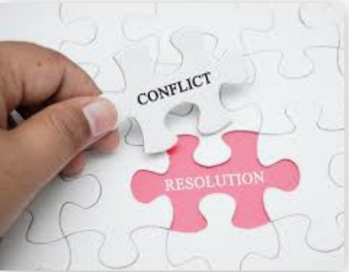
Table of Contents
1.0 Managing conflict 2
1.1 References 4

1.0 Managing conflict

According to Webster’s dictionary (2014) conflict is a strong controversy or resistance of interests or ideas.

At workplace conflict can often be distinct as:
• Responsibility conflict -includes different points of view, different ideas and opinions.
• Process conflict- implicates difference in the logistics of accomplishing a consequence or change. For example, who assigns on who or who accepts which commitment.
• Relationship conflict –this can often be the most harmful form of a conflict, because it can be on the purpose of personal values, morals or attitude aspects.

A conflict can be a result of a change, which can stimulate a range of feelings in people, which are avoiding a change and try to impede the process.
Signs like, can identify conflict within the workplace:
• People who were participating in meetings and joining tasks decreasing numbers
• Enthusiasm and team motivation reducing
• Changing the way of proposing ideas or communicate feelings sincerely
• Boost in disappointment or the improvement
• The avoidance between team members

After noticing these signs conflict can be:

1. Controlled from arising and intermediate by follow steps:
• Identifying the type of conflict (process or relational)
• The context of the conflict
• The direction that the conflict is taken
• How to intervene
• What will happen now?

2. Understanding and value the differences between the parties implicated which can very well be the person who is trying to manage the conflict.
Likewise, the person who is trying to manage the conflict must:

• Recognize their own technique with its stability and restrictions
• Rather than indicating motives, listening and trying to understand the other implicated parties
• Develop knowledge of other parties’ and being objective by asking open questions
• Reframing the conflict to make it less subjective
• Trying to find solutions that integrate different opinions

3. Managing the conflict by taking positive steps to deal with the issues and awareness of the outcome. To do that there are some thing to take into consideration:
• Ensures that the issues are fully outlined
• Acknowledging the emotions and the different styles
• Insurance of a comfortable environment for any meeting
• Setting time for discussions
• Good report established
• Using the name and appropriate title throughout
Respecting the above tasks, the intergroup conflict will bring achievement to management teams. According to Jehn (1992), task conflict can be either helpful to groups that are non-routine or destructive to those performing routine. Therefore, if management teams will be engaged in complicated tasks are more likely to make better decisions.

1.1 References

Grand Valley State University (2014) ‘What is workplace conflict?’ Human Resources, 14 September. Available at:
- https://www.gvsu.edu/hro/what-is-workplace-conflict-85.htm (Accessed: 24 April 2020).

Huczynski, A. and Buchanan, D. (2013) Quality, ‘Service Improvement and Redesign Tools: Managing conflict’, ACT Academy. Available at:
- https://improvement.nhs.uk/documents/2130/managing-conflict.pdf (Accessed: 24 April 2020)

Dechurch, L. and A Marks, M. (2001), Maximizing the benefits on task conflict: The role of conflict management, Research Gate, 12 (1), pp.4-22

