

Independent Project (ACCA6020)
Development of a Frequency Modulated Continuous Wave Radar

Matthew Prentice (2116359)

Contents
Introduction 2
Literature Review 3
References 4

Introduction
Surveying landscapes is a key enabler of the safe movement of people through an environment, enabling the identification of safe zones and routes in areas suffering from natural disasters. Additionally the ability to understand an environment is critical to the development of self-driving vehicles and autonomous drones which are increasingly operating in already congested environments.
Typically a fusion of lidar, radar and IR/visual cameras would be used [1] to develop the best possible multi-spectral image of the operating environment, however it’s not always possible to integrate all 3 into a platform. Of the 3 sensing technologies, radar is the most robust due to not being affected by weather conditions (compared to lidar or IR/visual) but suffers from a requirement for high levels of power amplification to achieve long range detection.
The traditional form of radar is known these days as Pulse radar, sends out a series of pulses and measures the time it takes for the echoes to return. Pulse radar is commonly used in air traffic control and weather forecasting. Another form of radar is Continuous Wave (CW) radar and Frequency Modulated Continuous Wave (FMCW) radar which are both used in scenarios where high speed responses are required. CW radar operates by measuring the doppler frequency shift of a continuous signal, while FMCW modulates the frequency of the transmitted signal and compares the received signal to that of the transmitted signal. Finally there is Phased Array Radar and Synthetic Aperture Radar (SAR), both of which utilise the moving radar beam to produce high resolution imagery however SAR relies on the movement of the radar itself meanwhile Phased array radar uses an array of antennas to steer the radar beam electronically without any physical movement. [2]

This project aims to develop a linear Frequency Modulated Continuous Wave Radar of low enough size, weight and power (SWaP) to be mounted to a UAV platform.
I will undertake this by initially working with a Xilinx RF System on Chip (RFSoC) development board and a modular RF front end.
Objectives
The main research objectives for this project are:
• To research the theory of FMCW radar signal processing and evaluate the signal processing architectures.
• To develop an efficient front end to support FMCW radar on the Xilinx RFSoC.
• Investigate opportunities to reduce the Size, Weight and Power draw of the system to optimise for UAV operation.
Technical Challenges
The project will not be without its challenges, namely working with a complex system such as the Xilinx RFSoC will be a steep learning curve. The miniaturisation of an RF Front End onto a PCB will be a new experience and require significant background reading into best practice design methodologies.
Planning
While the plan is expected to be adaptive, the initial timeline features a month of familiarisation with the Xilinx RFSoC before working towards developing a FMCW Radar with discreet RF Front End components. Finally I will be looking to miniaturise the system in the new year.
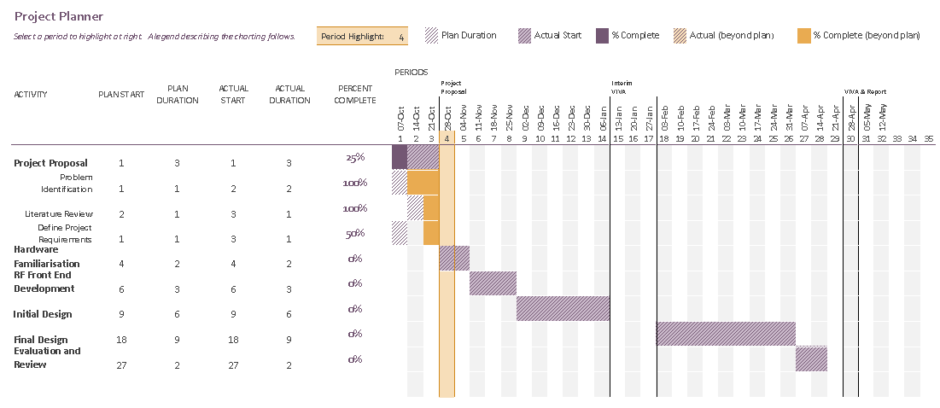

Conclusion
Much like the accreditation of this degree course, the outcome has not been desirable.

References
There are no sources in the current document.

