Viability analysis: High rise in Birmingham
By James Bradley and Andrew Bloxham 2 April 2020. (Source: Building Magazine – April 2020; https://www.building.co.uk/data/viability-analysis-high-rise-in-birmingham/5105331.articlehello
Key design metrics of tall residential buildings in Birmingham, UK. and how to optimise viability
01 / Introduction
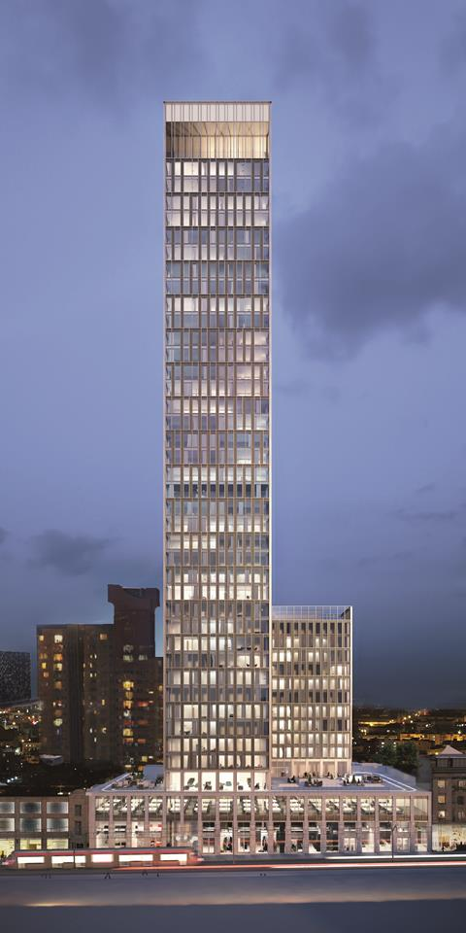
Source: Glenn Howells Architects
The Mercian, designed by Glenn Howells for Moda, will be one of Birmingham’s tallest buildings when complete
Tall buildings are complex, risky and visible, so it is imperative that the right team are in place to deliver any high-rise project. At the time of writing, there are 17 projects either in planning or on site that exceed 25 storeys (see figure 2), as well as many more residing in drawing on the desks of consultants across the city as densification gathers pace.
Yet, despite the appetite for reaching up to the city’s sky, the conversion rate is low. It is not a question of endeavour, but of commercial viability coming under increasing pressure from land values and the fine margins of building tall in a regional city. Ultimately, success is reliant upon achieving a balance between revenues and cost. This requires careful consideration of quality and meeting key metrics for an efficient design.
With sales/rental values, planning requirements and end user expectations providing constraints before the design of a tall building is even considered, figure 3 (below) shows the key design metrics that should be targeted to optimise viability during the feasibility, design and construction stages, and their relative importance. This article reviews each stage, alongside commentary from industry voices.
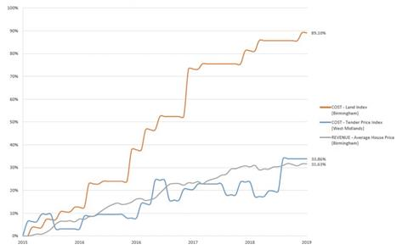
Figure 1: Sales value versus input costs (land and construction costs)
Source: Sources: Knight Frank (for Land data), RICS Building Cost Information Service (for Build Cost data), Office of National Statistics (for Sales Revenue data )
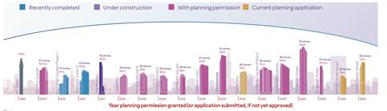
Figure 2: Tall buildings in Birmingham granted planning approval since 2015
Source: Turley
Notes
“Tall” in this context refers to buildings at least 25 storeys. Residential only (commercial excluded). Includes developments within Birmingham city centre (inside ring road). Data obtained from planning application data available on Birmingham city council’s online access website.
* Resolution to grant planning permission (section 106 not yet signed) ** Extant permission

02 / Planning context
The primary planning guidance is set out in High Places, published in 2003 by Birmingham city council. This allows tall buildings to be generally located within a defined Central Ridge Zone where development can “emphasise the city’s topography or help create a memorable skyline”. The guidance also supports tall buildings that mark the sense of arrival at the city centre, terminate a key view or are near to major public transport interchanges.
With ambitious plans for growth and increasing pressure to densify outside of the Central Ridge Zone, an updated planning and design framework is anticipated. It should be one that provides the tools to robustly promote and assess tall buildings across the city. This should give clarity to developers and provide a basis for constructive dialogue on key design matters at the pre-application stage.
The key planning challenges in Birmingham are:
- Demonstrating design quality – relationship to viability and construction certainty, while ensuring a positive impact on the skyline
- Microclimate issues – modelling of wind conditions to avoid pedestrian safety concerns
- Daylight/sunlight/overshadowing – early testing to avoid later objections
- Townscape and heritage – agreement on key views and rigorous assessment including input from Historic England (where appropriate)
- Aviation safeguarding – addressing potential interference with Birmingham airport’s radar and other systems.

The agent’s view
In 2013, we saw land prices averaging around £12,000 to £16,000 per unit – this year we have seen prices in excess of £36,000.
Birmingham continues to outperform many parts of the UK in house price growth, with some best-in-class open-market developments now being priced at £450/ft² net internal area (NIA). We forecast that residential property prices in the West Midlands will rise by 13% over the next five years.

The architect’s view
With the anticipated growth in Birmingham, coupled with the impact of climate change, the city needs robust, sustainable criteria for justifying building tall that takes into account carefully their physical, social and environmental impact.
Tall buildings can be justified as locators, markers, wayfinders or gateways, which can start to map the dense urban fabric of Birmingham. Identifying the role and contribution of tall buildings as part of a joined-up vision for the city is needed more now than ever before.
Some important metrics or parameters are useful to help understand the viability of the design at early stages. These include wall-to-floor ratio, the efficiency of net-to-gross ratio, the number of units per floor and the floorplate size. If these are considered early on, the higher costs of building tall can be managed and prioritised.
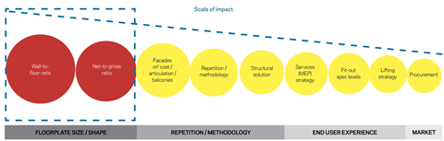
Figure 3: Key design metrics to optimise viability, ordered by scale of impact
Source: Core Five

03 / Wall-to-floor ratio
Wall-to-floor ratio – the quantity of external wall per unit of floor area – is intrinsically linked to shape, form and efficiency. A wall-to-floor ratio within the range of 0.40-0.55 is essential in keeping facade costs – which are typically up to 20% of construction costs for tall buildings – to an optimum. By comparison, this range would ordinarily extend to 0.60+ when considering a tall building in London, because of the flexibility offered by increased sales values. In Birmingham this critical design metric must be subject to finer margins.
Storey heights
In addition to building shape and proportions, target storey heights of a maximum 3m are central to achieving the target wall-to-floor ratio. Notably, this has the supplementary benefit of reducing overall building height, affording the luxury of lowering capital costs or including additional storeys; as an example, a 0.1m decrease in storey height across 30 storeys allows for the inclusion of one additional storey – and the additional revenue this brings – for no increase in overall building height.
Any rise in wall-to-floor ratio is compounded by a consequential impact on building services. A larger envelope area leads to greater solar gain, which can affect the requirement for potentially costly solar control measures.
Floorplate size
Figure 4 demonstrates how wall-to-floor ratio can vary by building shape. Circular floorplates provide the most efficient wall-to-floor ratio, but do not perform as well as more conventional shapes in respect of net-to-gross ratio and are more costly and time-consuming to fit out. Floorplate size is of equal importance. Highlighting this are buildings B and C: while relatively similar in shape, the wall-to-floor ratio is significantly increased by the smaller typical floorplate size of C. As with all key design metrics, there is an optimum to be found for residential developments to ensure adequate depth of units and avoid adversely affecting the net-to-gross ratio through addition of inefficient core and circulation space.
In addition to influencing the wall-to-floor ratio, floorplate size dictates the number of apartments that can be accommodated per core. What constitutes the optimum will vary by building shape, but a sub-optimal floorplate will either struggle to accommodate the requisite number of apartments per core to achieve optimum viability, or truncate the average unit size, increasing costs in terms of £/ft² NIA. This, in addition to giving a less efficient net-to-gross ratio due to the proportion of core area to floorplate, will negatively affect viability and constrain subsequent rationalisation of design.
To put the importance of this metric into context, a wall-to-floor ratio increase of 0.1 can add approximately £10/ft² GIA to build costs (see figure 5). While this may be less than 5% of overall costs, it can affect viability in the current market of narrow margins.

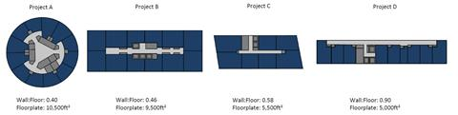
Figure 4: How wall-to-floor ratio varies by building shape
Source: Core Five

04 / Net-to-gross internal area ratio
A number of factors influence the net-to-gross ratio of residential developments. However, an inherent consequence of building tall is reduced floorplate efficiency: the need for additional structure to resist wind loads, increased core sizes, more lift provision and plant space, and changing riser size requirements affect net internal area (NIA). A ratio of 80% should be targeted with a typical floorplate, though this is challenged as height increases (see figure 6).
Beyond the official skyscraper yardstick of 100m in height (around 33 storeys), intermediate plant space is likely, as a result of excessive vertical distribution distances, potentially losing NIA while adding to shell and core costs.
Build-to-rent schemes typically see lower overall net-to-gross internal area ratios than other residential schemes, due to amenity provision, which while being central to the model increases £/ft² NIA costs. It is therefore important to ensure amenity space allocation achieves the optimum balance between added value or marketability and net-to-gross internal area ratio.
Further challenges to NIA may materialise in the near future as and when building regulations make the inclusion of two stair cores in tall buildings mandatory and net-zero carbon residential buildings necessitate thicker wall insulation. This may reduce NIA by 2%-4%.
Design teams should meticulously review every element – from wall thicknesses to circulation, plant, lift and riser requirements – to maximise net-to-gross ratios. There is a magnification effect in decision-making on tall buildings, making it necessary to refine and optimise the design constantly. A 1% NIA improvement across 30 storeys with target sales values of £450/ft² can result in about £1m of additional income.
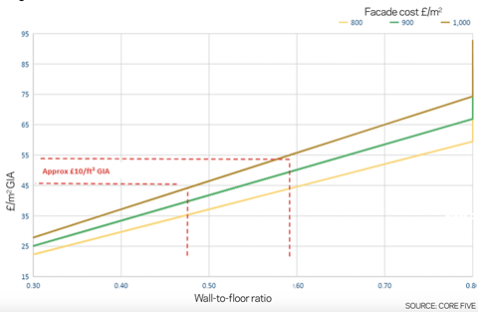
Figure 5: How wall-to-floor ratios affect construction costs
Source: Core Five

05 / Facades
The challenge in terms of facades is to select a repetitive system with the requisite aesthetic, thermal and acoustic properties. A solid-to-glass ratio of 70:30 is optimal to mitigate the requirement for solar control – for instance, using interstitial blinds – though this is not ideal architecturally and inhibits natural light.
Alternative options include changing building orientation, shading via window reveals or a specification of unitised facades capable of mitigating solar gain to avoid the requirement for cooling. From a cost perspective, it is important to assess the implications of increased reveal depths or facade specification against the cost of providing other means of solar control, but the solution is to mitigate through passive means – in other words, through the building fabric – rather than mechanically. Recent examples in Birmingham have seen inward-opening windows screened by perforated panels to avoid wind effects.
A sealed facade mitigates noise and air quality issues, though this can introduce the requirement for additional mechanical ventilation and removes tenant flexibility. While the choice of openable windows is dictated by site location, they are optimal from both a cost and end-user perspective, provided that a solution to avoid the impact of wind velocities at height can be identified.
Buildings with fewer than 30 storeys can consider non-unitised alternatives, but anything taller will typically require a fully unitised system. While a unitised facade in London would cost anywhere from £1,000 /m² to £1,500/m², in Birmingham this falls to £900/m² to £1,000/m².
The mechanical and electrical engineer’s view
Controlling solar gain is vital to reducing summertime thermal comfort issues, especially where noise and air quality issues exist. A 70:30 solid-to-glass ratio (certainly no higher than 60:40) for the east, south and west elevations is optimal.
Ideally, external shading should be provided. While internal blinds control glare effectively, they are less effective at controlling solar gain, making external or interstitial blinds on south-facing facades the ideal.
For net-zero carbon buildings, the optimum glazing ratios are 25% on the south-facing elevation, no more than 20% on the east/west elevations and as little as possible on the north-facing elevation.
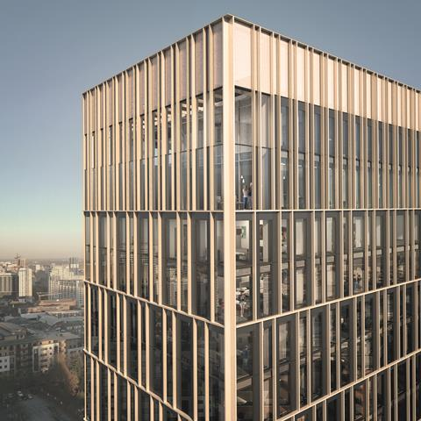
Source: Glenn Howells Architects
The Mercian is 42 storeys high and will provide 481 apartments for rent

06 / Repetition and methodology
A common barrier to building tall is programme; many are perturbed by the additional costs of preliminaries associated with lengthy build durations, the delay in investment returns for funders, the requirement to commit to a large number of units in one go (unlike similarly sized phased low-rise developments) where a large number of units are released to market at a similar point in time, and the inherent market risks of building contracts spanning across such durations.
Fully volumetric modular solutions often drive certain product (in terms of unit mix), structural and architectural compromises that are typically only acceptable for a small proportion of towers. However, the need for speed and repetition means that localised prefabricated solutions are often used wherever possible (such as unitised facades, prefabricated risers and utility cupboards, bathroom pods, precast columns and core walls). The boundaries are constantly being pushed on this to find the most efficient construction methods.
The major opportunity of tall buildings is economy of scale. Design should take advantage of this through widescale repetition, speed and consistency of fit-out. Do the floorplates repeat? Does vertical distribution stack? Do the floorplate layouts minimise frame and upper-floor cycle disruption? Has the facade been designed to accommodate standardised unitised panel sizes with maximum repetition? Has the building been designed to accommodate bathroom pods? All these must be considered.

The structural engineer’s view
The repetitive floor cycle defines a large portion of the critical path. Consideration needs to be given to optimise cycles. Additional blade walls off a central core provide an efficient way to improve the overall stiffness of the building, but can impact distribution of materials around a floorplate. While post-tensioned slabs can be a main contractor concern with an additional trade and lengthening cycle times, typically requiring an additional day on the floor cycle, they do reduce overall storey heights.
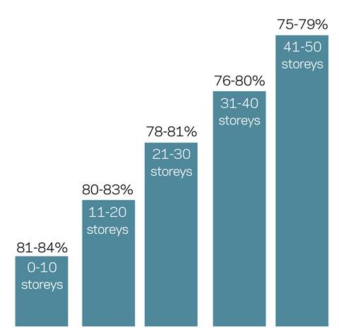
Figure 6: Typical net-to-gross ratio per floor as number of storeys increases
Source: Core Five

07 / Structural solution
The size, proportions and external pressures on tall buildings dictate a significant structural response, which for a residential tenure is almost universally a reinforced concrete frame. Such structures are costly and, built traditionally, slow to construct; their optimisation is central to the viability of tall buildings in the Birmingham market.
From a cost perspective, shear walls are significantly more expensive than columns, remove flexibility from the end user, slow floor cycles and add weight to buildings. Beyond certain tipping points in respect of height, however, they become a necessity (see figure 7). Our research indicates that tall buildings in Birmingham should be structurally led, with architecture reacting to structural layout constraints. Where architectural layouts dictate structural design, this can lead to a suboptimal frame solution, attracting significant cost and time premiums.
Figure 7 is based on a parametric design exploring the structural configuration for a square floorplate of around 7,000ft² as the number of storeys increases. This illustrates the compromise (percentage increase/saving in concrete volume) to be quantified and allows other factors such as floor cycle issues and imposition on the residential layout by blade walls to be assessed holistically.
For example, a core and single blade wall layout becomes more efficient than a standalone core and associated columns in terms of overall concrete volume beyond approximately 29 storeys, but any benefit may be offset by the lengthened floorplate cycle and the difficulty of distributing unitised curtain walling panels and bathroom pods around a floorplate compartmentalised by continuous blade walls.
The architect’s view
A key part of this approach requires an in-depth understanding of the structural strategy from the outset. The stability provided by a central core on, say, a 26m x 26m floorplate with apartments wrapped around helps minimise lateral distribution of services from risers to individual units, all contributing to efficient design. Stacking services, structure and layouts create further efficiencies and help prioritise costs in areas that add value.

The structural engineer’s view
A baseline solution of a reinforced concrete frame with a central core for a residential tower may be the optimal solution when viewed against material cost, construction durations and diversity and availability of supply chain.
As the height and slenderness of a building increases, second-order effects such as axial shortening and dynamic response to wind loads become key constraints governing aspects of the design.
Efforts should be made to reduce the structural mass present at each floor level. This would typically be achieved through increasing concrete strength in vertical elements, controlling floor slab spans or introducing post-tensioned slabs. Aside from reducing material volumes, reduced frame weight will have a beneficial impact on substructure costs. Birmingham benefits from shallow sandstone across large parts of its centre, allowing for relatively efficient piled foundation designs.
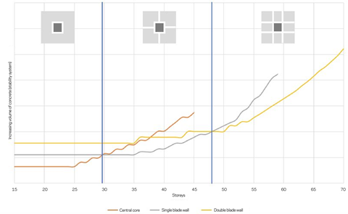
Figure 7: Optimal core and shear wall layouts and associated tipping points
Source: Cundall

08 / Services (MEP strategy)
There is potential for mechanical, electrical, and plumbing services and lifts to account for around 20%-30% of total construction costs. Therefore the means of heating and cooling the building, adequately mitigating solar gain, and providing ventilation where facades are potentially sealed in a noisy city environment suffering from air quality issues is pivotal to a tall building being viable in Birmingham.
The major issue typically encountered is thermal comfort, though this can be overcome by introducing purge ventilation to sealed facades. Several developments are now adopting a decentralised
all-electric strategy for heating, hot water and kitchen hobs, which improves net-to-gross efficiency, while offering some cooling to prevent overheating. Cost of electrical distribution also increases with height.
Central plant systems for buildings more than 60m high (about 20 storeys) increase in cost due to pressure breaks through hydraulic separation and a general increase in the pressure rating and relief of pipework. Typically, separation will be at about 60m but could be as high as 100m, although this may not be cost-effective. Additional cost is encountered through increased electrical distribution and enhanced protection via sprinklers and wet risers.
Mechanical and electrical engineer’s view
Traditional central plant with gas-fired CHP and boilers is being superseded by lower electric grid carbon factors. Direct electric heating, however, is more costly to the end user than electric heating generated via heat pumps. It also requires larger electrical utility infrastructure, which may be a site-specific factor if limited by available capacity. While direct electric heating is currently cheaper from a capital cost perspective, heat pump technology is becoming increasingly viable and cost-effective.
Looking to the immediate future, localised, holistic heating, ventilation, air-conditioning and domestic hot water heat pumps can help meet the requirements of zero-carbon buildings without a requirement for central plant, which saves riser and plant room space. These use electric heat pumps within the MVHR unit for heating the apartment, fresh air supply and domestic hot water. While cooling is not usually commercially viable for residential developments in Birmingham, a significant amount of cooling can be generated as a by-product of summer domestic hot water generation, also mitigating solar gain issues.
This overheating mitigation can be used as a solution to apartments with noise and/or air quality issues that cause facades to be sealed, and without having to resort to full cooling solutions. This emerging technology has been market tested on Birmingham high-rise schemes with such issues and has proved cost-effective and capable of meeting all design targets, including summertime thermal comfort without needing to open windows. Consideration will, however, need to be given to the facade and, in particular, air permeability.

Figure 8: Lift size/speed versus number of storeys
Source: Cundall

09 / Fit-out specification
While differences in labour rates and issues surrounding material delivery costs lead to increased installation rates in London, our analysis of the London and Birmingham markets points to specification levels (and hence supply costs) being the key cost differentiator regarding fit-out.
It is therefore essential to align fit-out specification with sales/rental values to ensure suitability and viability for a particular market.Examples of specification differences are shown in the table below.
It should be noted that Birmingham does not tend to see significant cost differences in specification levels between open market and private rented sector scheme.

The agent’s view
Branded appliances, kitchens and sanitaryware are not drivers for rental tenants in the same way they may be for the owner-occupier market. For the rental market, functionality and durability are key, not only for convenience but when taking into consideration the lifespan and replacement costs of these items.

 | Finishes | Fittings | Tech
Birmingham  £350/ft²- £450/ft² | - Metal studwork with plasterboard and paint finish  - Proprietary primed/site painted or laminated entrance door, proprietary ironmongery, painted internal doors  - 50% ceramic tile coverage to bathrooms (standard range)  - Carpet to bedrooms, off-the-shelf laminate or timber-effect vinyl flooring to other areas  - Plasterboard ceiling with paint finish | - Proprietary kitchen units, composite worktop, splashback with undermounted stainless steel sink and mixer taps  - Proprietary wardrobe with laminated-finish doors to master bedroom only including high-level shelf and hanging rail (secondary by purchaser)  - Proprietary vanity unit with integrated ceramic basin  - Mirror only, bathroom storage excluded  - Glass shower screen | - Heating via electric panel heaters with heated towel rail in bathrooms  - Cooling – none  - White plastic switches and sockets  - Pendant lighting excluded, LED downlighters to bathrooms, strip lighting to kitchen  - Local rocker switches  - Data cabling to living room only for video, TV, telephone and superfast broadband
London  £800/ft²-£1,000/ft² | - Metal studwork with plasterboard and paint finish  - Timber-veneered hardwood entrance door, medium-quality ironmongery, painted internal doors  - 100% ceramic tile coverage to bathrooms  - Good-quality carpet to bedrooms, off-the-shelf engineered timber flooring to other areas  - Plasterboard ceiling with paint finish | - Medium-quality kitchen units, Silestone worktop, splashback with undermounted stainless steel sink and mixer taps  - Fitted wardrobe with mirror- or veneer-finish doors to master bedroom only, including high-level shelf and hanging rail (secondary by purchaser)  - Porcelain vanity unit with integrated ceramic basin  - Overhead bathroom storage including mirror and lighting  - Frameless glass shower screen | - Wet underfloor heating with electric underfloor and heated towel rails in bathrooms  - Cooling – none, other than penthouses  - White plastic switches and sockets  - Pendant lighting, LED downlighters to bathrooms, strip lighting to kitchen  - Local dimmer switches  - Data cabling to all rooms for video, TV, telephone and superfast broadband

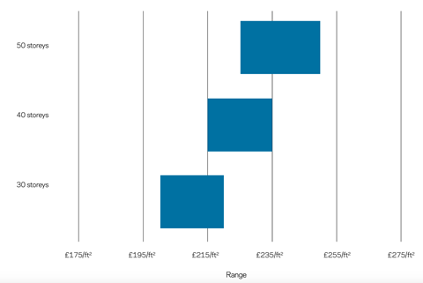
Figure 9: GIA costs for tall residential buildings in Birmingham

10 / Lifting strategy
There are two benefits from giving early consideration to a tall building’s vertical transportation strategy. Finding the optimum balance between the number of lifts and lift speeds will minimise capital costs while offering acceptable waiting times to the building populace and will have a significant bearing on the attainability of the target net-to-gross ratio of 80%.
While lift traffic analysis can be used to determine the optimum number of lifts relative to waiting times, this must be balanced with sales values. Lifting strategy (and what is deemed an acceptable waiting time) needs to be considered as part of an initial brief due to the significant impact on core sizes and therefore NIA-to-GIA.
For example, the simulated building profile modelled in figure 8 indicates that for this example more than three lifts are required typically above 35 storeys. But this is unlikely to be commercially viable as the NIA-to-GIA, which already diminishes with height, is further impacted by introducing more lift cores. This could be mitigated by zoning the building into low-rise and high-rise groups of lifts. By adopting this approach, floorplate efficiency can be improved to the high-rise core by reducing the number of lifts servicing these levels. The table (right) suggests the following approximate tipping points with regard to building height. Knowledge of such tipping points can improve viability by exploiting height within these technical parameters.
The vertical transportation engineer’s view
There is a common misconception that faster lifts are required for tall buildings. For the purposes of this article, a lift traffic calculation has been carried out for a theoretical building with a typical floorplate containing a mix of 10 varying sized apartments, a storey height of 3m, and following the guidance provided in CIBSE Guide D:2015 applying a number of typical assumptions. Obviously every building is different and requires its own lift analysis.
When setting a lift strategy, key considerations include:
- While increasing lift speed can increase the height capability for a certain quantum of lifts, the extra height offered by the increase in speed is typically only one or two additional floors before waiting times become an issue. The cost rise caused by the boost in lift speed is likely to outweigh the benefit of adding these floors.
- Buildings above approximately 33 storeys (100m) typically require a machine room above the lift shaft.
- Buildings above 40 storeys could require 4nr lifts, significantly increasing lift core size.
Figure 8 shows the lift speed required versus increasing building height, for example two lifts could be suitable for up to 27 storeys, and three lifts up to 37 storeys.

Approximate tipping points
- 20 storeys: Hydraulic separation, ie pressure breaks within pipework
- 25 storeys: Increase from 2nr to 3nr lifts
- 30 storeys: Single blade wall structural layout, unitised curtain walling
- 33 storeys: Lift machine room required above lift shaft
- 37 storeys: Double blade wall structural layout
- 40 storeys: Possibility of 4nr lifts

11 / Conclusion

Tall buildings, by their physical scale, complexity and quality requirements, are costly. Primary benefits of high-quality landmark buildings include acting as key wayfinders, attracting tourists and encouraging an increase in surrounding development. That said, beyond certain tipping points at which additional technical considerations come into effect, the overall £/ft² of a tall building will increase and floorplate efficiency will decrease. Figure 9 outlines anticipated £/ft² GIA costs for tall residential buildings in Birmingham.
Tall buildings are becoming more common in regional cities, where the challenge of achieving viability is all the greater and parameters applied to key design criteria must be tightened accordingly. By adhering to the design principles set out in this article, considering and rationalising each at the outset of the project, inherent constraints can be mitigated to the greatest possible extent. To achieve this amid the constraints of sales values and planning requirements, building tall requires an engineering-led solution combined with skilful and sensitive architecture that responds to place.
The introduction of net-zero carbon targets and the regulatory implications for residential developments in a post-Grenfell world will put build costs under additional pressure, further highlighting the need to maximise design efficiencies and adopt an engineering-led approach to maintain viability.
There is, however, the question of procurement when looking to further improve viability. While this article has principally addressed the optimisation of tall buildings from a design and construction perspective, the procurement of tall residential buildings plays a crucial role in successfully marrying the client’s key objectives of time, cost and quality. Coupled with this, contractor pipeline, capacity and capabilities at a point in time dictates the market’s approach to risk and therefore influences the selected route.
Contractors in the region are getting to grips with building tall, and new entrants are providing alternatives to what has traditionally been a
two-stage or negotiated process. Teams are considering alternative hybrid procurement routes. While allowing for early specialist input that reduces design risk, a hybrid two-stage method can provide up to two-thirds cost certainty at the end of the first stage, a proportion often sought by investors.
A scheme’s attractiveness to the market via the combination of client body, future pipeline, consultant team, equitable risk allocation, optimised design and site particulars/logistics will also ensure competition and contractor interest. Ultimately, the most appropriate procurement route will need to be determined on a project-by-project basis and procurement offers a further final opportunity to improve viability.

The architect’s view
We know more dense, compact cities lead to better transport accessibility; this in turn means better access to workplaces, reduced congestion and fewer carbon emissions, thereby providing the opportunity for more sustainable places. Though taller buildings have an inherently higher embodied energy, designers need to strive for much greater resilience, lower energy in use and for structures to last long enough to justify their need.
The delivery of tall buildings demands a holistic approach to design. Birmingham should adapt the guidance on tall buildings from the Design Council and Historic England as part of assessing forthcoming proposals so that they may be delivered sustainably and responsibly. Tall buildings will play a vital role in shaping Birmingham as a global city and redefining its skyline. These research case studies will help us address the challenges in a more informed way.

Acknowledgments
The authors would like to acknowledge contributions from Glenn Howells Architects, Cundall (structure, MEP and vertical transportation), Knight Frank (agents) and Turley (planning).

