In this essay, I will explore how visual storytelling is used to address dark themes, with a particular focus on death. I will begin by analysing specific examples and then examine how books that tackle such topics can be valuable for younger audiences.
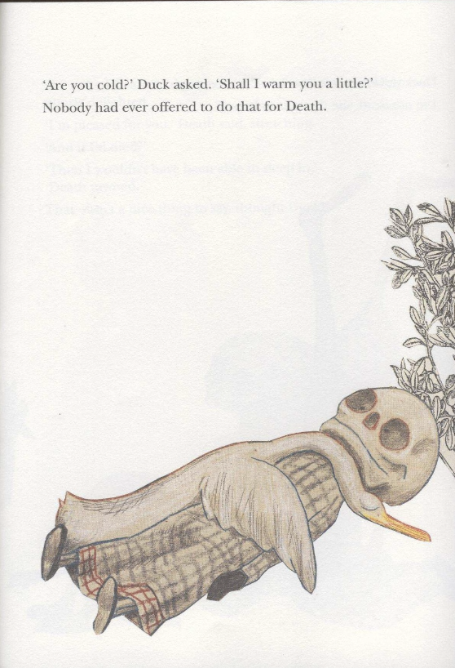
Wolf Erlbruch was a German illustrator and children's book author, as well as a professor at multiple universities. He employed a variety of techniques in his illustrations, such as cutting and pasting, drawing, and painting. His style, which often had a surrealist quality, became highly influential and is widely imitated both in Germany and internationally. He released his book Duck, Death and the Tulip in 2007 and went on to win the Astrid Lindgren Memorial Award in 2017. The book follows Duck as she realises her own mortality and worries about what will be left behind or where she’ll go when she dies. Death reassures her that she will not mourn all that she’s left behind.

(Figure1) Wolf Elbruch, Duck, Death and the Tulip, 2007, pg. 15.

The first image I want to analyse (fig.1) depicts Duck snuggling up to Death to help warm him after they’ve been swimming in her favourite pond. There’s a noticeable tenderness between Duck and Death, with the text stating, “Nobody had ever offered to do that for Death” (Wolf Elbruch, 2007). This suggests that Death is typically feared or misunderstood, yet Duck feels comfortable enough to fall asleep beside him. In fact, Death even appears to be smiling in this image. Erlbruch’s use of pencil and warm colours enhances the peaceful atmosphere, contributing to a sense of calm and gentleness surrounding Death. This portrayal is significant because it shows young readers, in particular, that Death need not be something to fear, which is the overall aim of the story.
The imagery is particularly intriguing because the page feels quite simple and uncluttered. Although Duck and Death are lying horizontally, they are positioned at a diagonal angle. This is an important detail to consider when analysing picture books, as it helps convey the emotional tone of the image. Molly Bang notes that “horizontal shapes give us a sense of stability and calm” (Bang, 2016), while “diagonal shapes imply motion or tension” (Bang, 2016). While calm and tension, or stability and motion, may seem contradictory, they can coexist in a single image. The scene on this page feels peaceful and still, yet the diagonal angle subtly hints that time is moving forward and death remains inevitable. This can also be understood in the context of the tree extending beyond the image. While Duck and Death are in a moment of peace, the larger world around them continues to move forward, reflecting a feeling commonly experienced during grief.

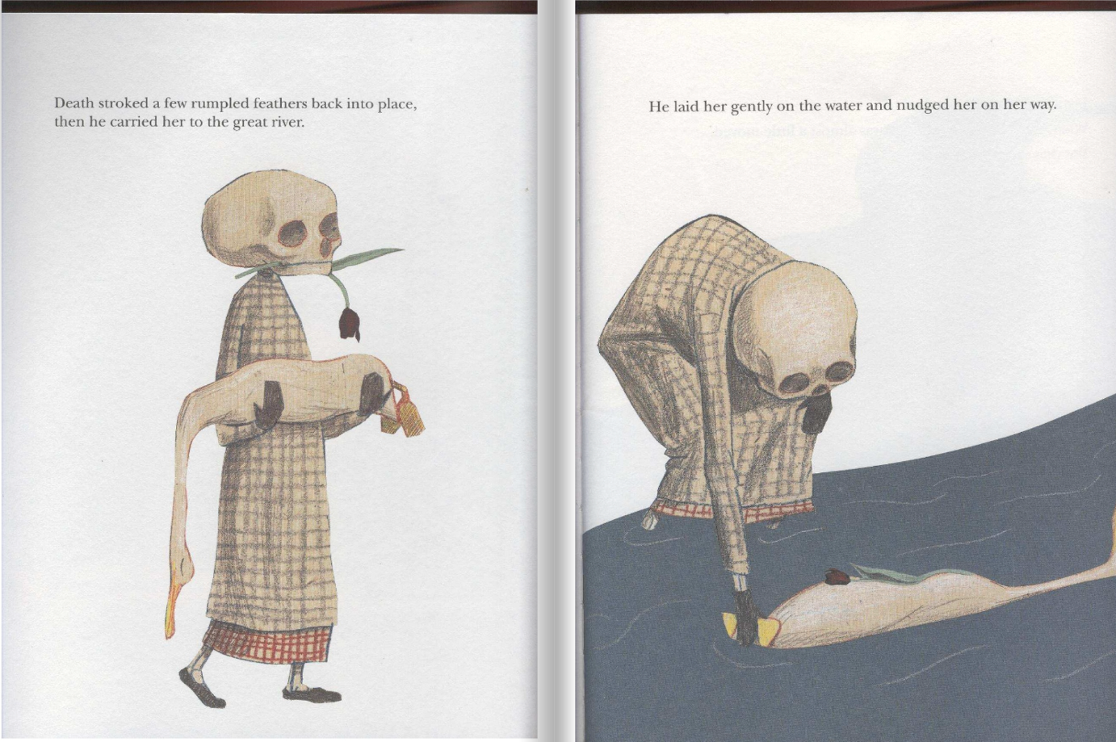

(Figure2) Wolf Elbruch, Duck, Death and the Tulip, 2007, pg. 30-31.)

Similar to page 15, this double-page spread (fig. 2) portrays Death as gentle and calm. Although the tulip is never explicitly mentioned in the text, its presence here reveals its symbolic significance. Tulips are traditionally associated with rebirth (admin_blog, 2024), and black tulips are often linked to strength (Anon., 2024). In the context of this story, the tulip can be seen as representing both of these ideas: death as a necessary step toward renewal and the courage required to confront grief. Death guiding Duck along the river may symbolise the beginning of her next journey, offering her strength as she moves forward.
Once again, the positioning of Death and Duck evokes an emotional response. Death stands tall and vertical, while Duck lies horizontally. According to Molly Bang, “If a horizontal bar is placed across the top of a row of verticals, stability reigns” (Bang, 2016). Although Duck isn’t placed above Death, the composition still conveys a sense of stability, suggesting that Duck is not alone and has support, even as she lies lifeless. “The bottom half of a picture feels more threatened, heavier, sadder or constrained; objects placed in the bottom half also feel more grounded” (Bang, 2016). The placement of Duck on the recto reinforces a sense of heaviness, conveying an emotion of sadness that aligns perfectly with the context of the scene.
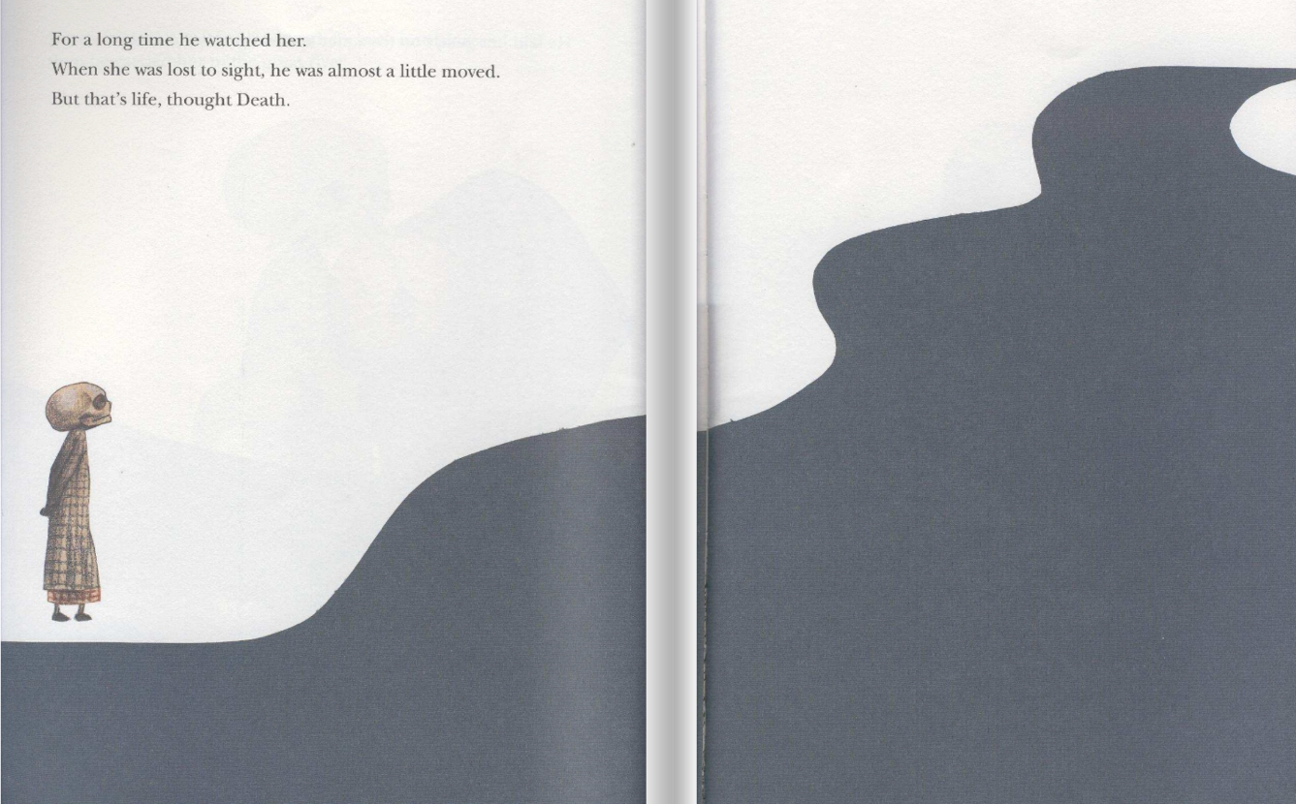

(Figure3) Wolf Elbruch, Duck, Death and the Tulip, 2007, pg. 32-33.)

The final spread of the book offers a poignant and reflective moment, showing Death standing by as Duck drifts peacefully down the river. His expression is one of calm acceptance, and the text suggests that he has come to terms with her loss. The river, depicted at a diagonal angle, is a powerful visual cue of movement, symbolising Duck’s transition from the life she once knew and perhaps even the beginning of a new journey. The diagonal positioning of the river reinforces the idea that life, like the flow of water, is constantly moving forward, with no way to stop its course.
Death’s still presence, watching quietly from the shore, is another indicator that he has come to accept Duck's passing. This sense of acceptance is further emphasised by his internal reflection when he thinks, “But that’s life.” (Wolf Elbruch, 2007). This simple yet profound statement encapsulates the inevitability of death, reminding us that it is an integral part of the natural cycle. In this final moment, there’s a sense of closure, but also a quiet understanding that life and death are intertwined, and both must be embraced with a sense of peace. The image and text together invite the reader to accept the ebb and flow of life’s transitions and to find comfort in the natural progression of things. The shape of the river is significant also, as according to Molly Bang, “curved shapes embrace us and protect us” (Bang, 2016). She further explains that the earliest and most powerful connection we have with curves is to the human body, noting that as infants, there was no place more secure or comforting than the warmth and embrace of our mother's body. The shape of the river evokes a sense of comfort, suggesting that it is gently embracing Duck as she moves forward. This adds to the sense of reassurance around Death, reinforcing the tranquillity of the moment.

Michael Rosen’s Sad Book was written by poet Michael Rosen and illustrated by Quentin Blake. Sir Quentin Saxby Blake is an English cartoonist, caricaturist, illustrator, and author of children's books. He has illustrated more than 300 books, including 18 written by Roald Dahl, which are some of his most beloved and widely recognised works.
Michel Rosen’s Sad Book, published in 2004 by Walker Books Ltd, explores the theme of death as Rosen reflects on his grief following the loss of his son, Eddie. He treats sadness almost like a separate entity, saying, “Sometimes sad is very big. It’s everywhere. All over me” (Rosen & Blake, 2004)
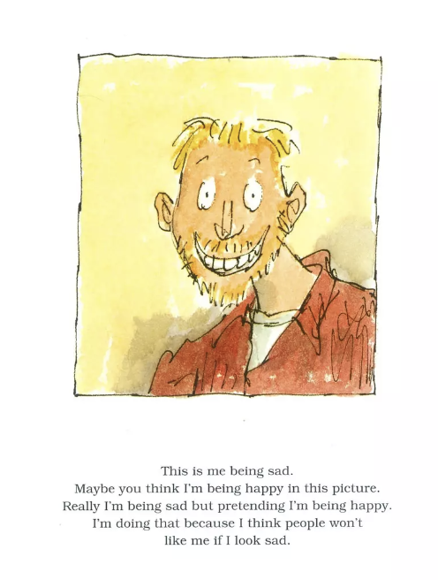

(Figure4) Michael Rosen and Quentin Blake, Michael Rosen’s Sad Book, 2004,pg.1)

The first page discusses the complex emotions that come with grief, sharing how, at times, he feels the need to conceal his sadness because he worries that others might not accept him or might think less of him for being upset. This quietly describes the pressure to appear happy, even when he doesn’t feel that way, as a way to protect himself and avoid the discomfort of others’ reactions. However, there are other moments when the sadness is so overwhelming that it becomes impossible to hide, and his true feelings break through despite his best efforts.
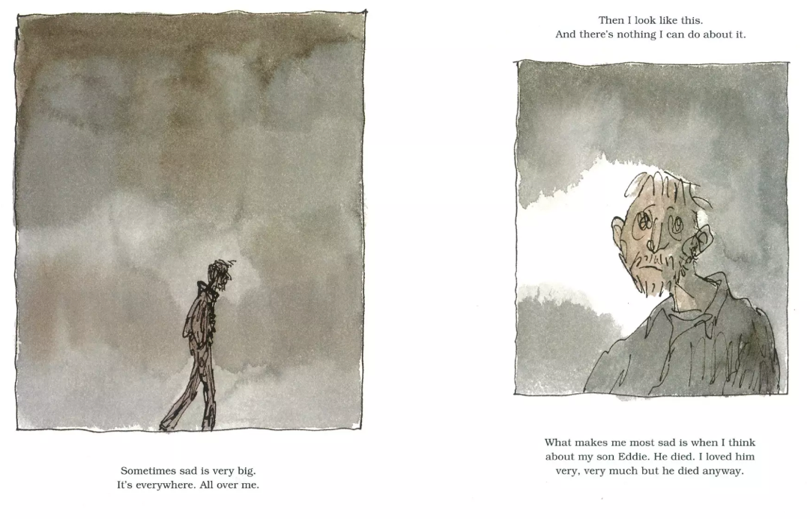
The illustration (fig. 4) vividly captures this internal struggle. Rosen is depicted with a wide smile against a bright yellow background, a cheerful image that starkly contrasts with the sadness he is describing. The smile, however, feels unnatural—almost forced—conveying an uncanny and somewhat unsettling quality. This visual reinforces Rosen’s words about faking happiness, highlighting the tension between the outward appearance he feels pressured to present and the deep sadness he is trying to mask. The bright background, often associated with cheerfulness, only amplifies the dissonance, drawing attention to the discrepancy between how he feels inside and how he is presenting himself to the world. This illustration, paired with Rosen's reflections, powerfully communicates the emotional complexity of grief and the difficult balance between personal sorrow and the societal expectation to appear "okay."

(Figure5) Michael Rosen and Quentin Blake, Michael Rosen’s Sad Book, 2004, pg.2-3)

As we learn more about his son, Eddie, it becomes clear that Sad Book is not merely about sadness—it delves into the complexities of grief and depression. Rosen guides us through the stages of grief, helping us understand that these emotions are a natural part of the mourning process, particularly when losing someone close. The illustrations (fig. 5) contrast sharply with those on the previous page (fig. 4), where Rosen's character is depicted with a bright, forced smile. In figure.5, the backgrounds are dark and sombre, and Rosen's figure is stripped of colour, reflecting the depth of his sorrow. This stark shift in imagery mirrors the emotional shift from a facade of happiness to the raw reality of grief, emphasising the darkness and isolation often felt during such times. The absence of colour and the heavy, muted tones serve as a visual representation of the emotional weight of loss, reinforcing the book's exploration of the painful yet normal experience of grieving. While the style is the same with the scribbled fine liner and watercolour, Quentin Blake does an amazing job at creating such a difference between the illustrations and capturing the deeper emotions within them.
“White or light backgrounds feel safer to us than dark backgrounds because we can see well during the day and only poorly at night” (Bang, 2016). Molly Bang’s insight helps explain the stark contrast between the first page (fig. 4) and the second and third pages (fig. 5). On the first page, Rosen is depicted with a bright background, and although his smile feels unsettling, the vibrant colours create a sense of security. This sense of comfort is then completely removed in the following pages. The absence of colour, particularly in Rosen’s figure, signals a dramatic emotional shift, with the lack of life in his eyes being a subtle but essential detail. This emptiness in his gaze highlights the profound void he feels after his loss, emphasizing the deep emotional impact of grief.
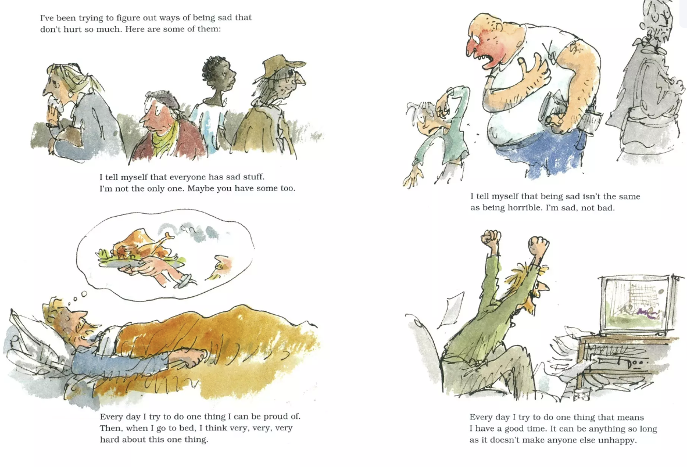

(Figure6) Michael Rosen and Quentin Blake, Michael Rosen’s Sad Book, 2004, pg.12-13)

This double-page spread (fig. 6) depicts Rosen employing various coping strategies to help him navigate his daily life. The pages are filled with colour, even in the illustrations that aren't overtly cheerful. This shift in the use of colour reflects a change in Rosen’s perspective, showing that he no longer views sadness as something purely negative. Instead, he begins to see it as a natural part of life- an experience that everyone must face at some point. This double-page spread gives the reader hope, not only for Rosen but for the inevitability of experiencing grief. It shows ways to deal with sadness and grief and that even though they are only small actions, they still have a big impact on your overall well-being.
There are three ways of writing for children. The third way, which is the only one I could ever use myself, consists in writing a children’s story because a children’s story is the best art form for something you have to say.
(Lewis, 1952)
Teaching children about emotions from a young age is crucial, just as teaching them about death, which is an inevitable part of life. However, many parents tend to shy away from or avoid the subject due to its discomforting nature. Both Sir Quentin Blake (and Michael Rosen) and Wolf Erlbruch, however, take a different approach.
Erlbruch presents death as a neutral and unavoidable fact of life, neither inherently sad nor happy. His portrayal of Death is strikingly different from the typical, grim image of the Grim Reaper—a figure shrouded in darkness and wielding a menacing scythe. Instead, Erlbruch's Death is depicted in a more approachable, even friendly, manner, challenging the usual morbid representations and offering a more comforting perspective. According to Martin Salisbury in his book “Children’s Picturebooks: The art of visual storytelling, second edition”, Erlbruch was asked if he personally believed that English-speaking children were being deprived of quality visual literature, and he states “Absolutely so. Their childhood is being stolen by the rubbish given to them by their marketing-and-telly-conditioned parents!” (Erlbruch with Salisbury and Styles, 2020). It’s clear that Erlbruch believes children can benefit from more direct visual storytelling such as Duck, Death and the Tulip. According to Sheila Egoff:
The picture book, which appears to be the cosiest and most gentle of genres, actually produces the greatest social and aesthetic tensions in the whole field of children’s literature.
(Egoff, 1981)
While Duck, Death and the Tulip wasn’t necessarily made for children, it is important to recognise that the younger audience will be the majority, which, according to Egoff, is a very productive way of starting a conversation.
The death of a parent is a subject most people instinctively shy away from. That is, until it hits home; then parents, teachers, therapists and other caregivers are grateful for picture books that grapple with the hardest stuff faced by young children.
(Paul, 2013)
Michael Rosen’s book, paired with Sir Quentin Blake’s illustrations, offers a powerful exploration of the complex emotions that accompany grief, including feelings like anger and depression. These emotions, even for adults, can be difficult to fully comprehend, which makes them even more perplexing and overwhelming for children. By being so open and transparent about the stages of grief, Rosen and Blake not only facilitate an important conversation about death, but they also reassure readers—regardless of age—that their feelings are valid. Whether it's the confusion, frustration, or sorrow that arise when faced with loss, the book emphasizes that these emotions are a natural part of the grieving process.
What makes this author-illustrator duo even more impactful is that they go beyond simply acknowledging these feelings. They also offer subtle insights into ways of coping with such difficult emotions and challenging times. Through the story and illustrations, readers are shown that it's possible to navigate grief and find support, comfort, and resilience in the face of loss. Rosen and Blake’s work encourages openness and emotional expression, making it clear that it’s okay to feel and that healing can take many forms. Their approach serves as a guide for both children and adults, helping to normalize and demystify the emotional experience of grieving.
In these books, death has been portrayed as a complex part of life that we will all go through. It’s not a punishment or an evil being made to cause suffering but a part of the circle of life. Books that cover dark topics such as death have the potential to teach us more about life, how to cope with it and help develop our understanding. Of course, just like with all media, it should be done in a way that takes the audience into consideration, and if done effectively, can be an amazing tool for young minds and old.

Bibliography
admin_blog, 2024. The Meaning of Tulips. [Online]
Available at: https://www.interflora.co.nz/blog/tulips/#:~:text=Rebirth,would%20make%20a%20wonderful%20gift.
Anon., 2024. Flower Meanings: What do tilips symbolise?. [Online]
Available at: (Figure1) Wolf Elbruch, Duck, Death and the Tulip, 2007, pg. 15.
Bang, M., 2016. Picture This: How Pictures Work- Revised and Expanded 25th Anniversary Edition. San Francisco : Chronical Books.
Egoff, S., 1981. Thursday's Child: Trends and Patterns in contemporary Childrens Literature. s.l.:American Library Association.
Lewis, C., 1952. On Three Ways of Writing for Children. s.l.:s.n.
Paul, P., 2013. s.l.:New York Times.
Rosen, M. & Blake, Q., 2004. Michael Rosen's Sad Book. London : Walker Books Ltd.
Salisbury, M. & Styles, M., 2020. Children's Picturebooks: The art of visual storytelling. 2nd ed. London: Laurence King Student & Professional.
Wolf Elbruch, 2007. Duck, Death and the Tulip. s.l.:Gecko Press.

