
LCBB5000 Data handling and business intelligence assessment 2 resit
MODULE LEADER: Joy Botu

student name: LACHEZAR NIKOLOV
student id: 1916906
Table of Contents
PART 1 2
Introduction 2
Crime Rate Analysis 2
Use of Excel in Business Intelligence 7
PART 2 9
References 11

PART 1

Introduction
Individuals utilise a collection of tools and processes known as business intelligence in order to acquire data, analyse that data for crucial insights, and then make decisions that are more informed as a result. Business intelligence specialists are able to easily manage the data that has been handed to them by making use of technologies developed by Microsoft, such as Excel (Chen, Chiang and Storey, 2012). Pivot Tables and a wide variety of functions available in Excel are two of the most important data analysis tools for data mining (Cleff, 2020).
Excel is utilised in the process of data processing and visualisation.
We have a better chance of coming to the right conclusions since Excel's capabilities allow us to more readily visualise the data, and because everything is organised, we have a better chance of figuring out what those data mean. Excel's user interface is intuitive, making it an easy tool for performing basic mathematical and statistical computations (Keller, 2016). Because of its capabilities, it is an excellent instrument for charting and graphing basic data. Spreadsheets, despite their extensive use and adoption, are only capable of satisfying a portion of the business intelligence requirements of an organisation. The number of the line that corresponds is 1040.
First and foremost, we have to make the most of the potential of the programme. After applying the filter selection in order to segment the data, the following findings were discovered:

Crime Rate Analysis
Crime Rate | Crime Rate (10) | 103 | 103.5
45.5 | 26.5 | 104.3 | 104.5
52.3 | 35.9 | 105.9 | 106.4
56.6 | 37.1 | 106.6 | 107.8
60.3 | 42.7 | 107.2 | 110.1
64.2 | 46.7 | 108.3 | 110.5
67.6 | 47.9 | 109.4 | 113.5
70.5 | 50.6 | 112.1 | 116.3
73.2 | 55.9 | 114.3 | 119.7
75 | 61.8 | 115.1 | 124.5
78.1 | 65.4 | 117.2 | 127.8
79.8 | 71.4 | 119.7 | 129.8
82.3 | 75.4 | 121.6 | 130.7
83.1 | 77.3 | 123.4 | 132.5
84.9 | 78.6 | 127.2 | 134.6
85.6 | 80.6 | 132.4 | 137.5
88 | 82.2 | 135.5 | 140.5
92.3 | 87.5 | 137.8 | 145.7
94.3 | 92.9 | 140.8 | 150.6
95.3 | 94.1 | 145.4 | 157.3
96.8 | 96.2 | 149.3 | 162.7
97.4 | 97.8 | 154.3 | 169.6
98.7 | 99.9 | 157.7 | 177.2
99.9 | 101.4 | 161.8 | 178.2

Now, with the help of the average function, we are able to determine the Northern and Southern regions' typical rates of criminal activity, wages, and labour forces.
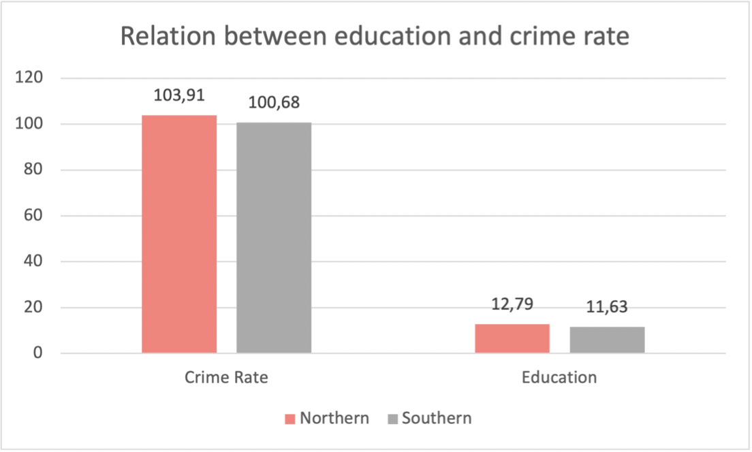

Following an in-depth investigation of the data that was presented before, we are able to arrive at a number of distinct findings.
The graphic presents information regarding rates of criminal activity as well as educational attainment. Excel tools that provide essential data can help organisations overcome the challenges they might have when attempting to analyse their data by reducing the amount of time and effort required. The crime rate that is typical for both the Northern and Southern regions is represented by the graph below. According to what is shown in the graphic, there is a significant correlation between a low level of education (or no level of education at all) and a high crime rate. The colourful columns of the picture make this connection clear. According to the pattern, there is a connection between the level of education and the incidence of criminal activity. In point of fact, the probability that the theory is correct emphasises the fact that it is valid in both settings where it is applied.
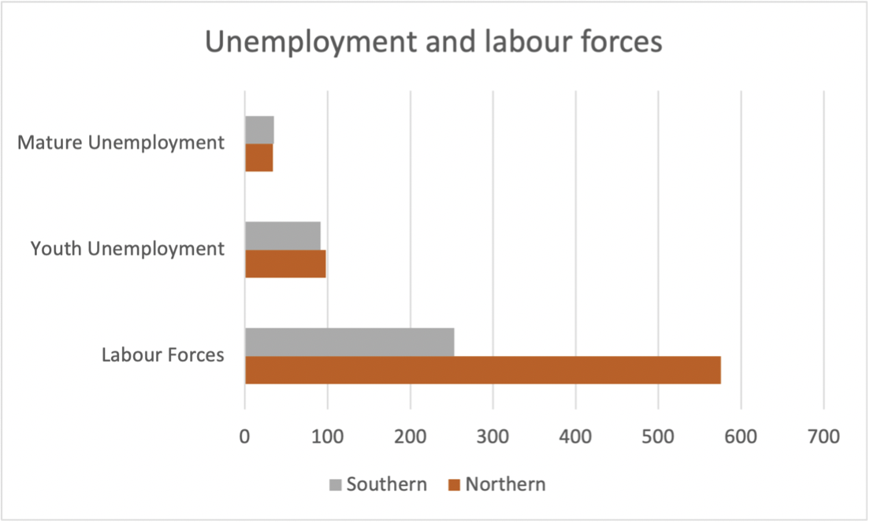
Labour Force | Labour Force (10) | 595 | 599
540 | 564 | 623 | 622
535 | 540 | 553 | 562
512 | 529 | 601 | 602
480 | 497 | 542 | 549
599 | 602 | 537 | 529
624 | 621 | 497 | 501
641 | 641 | 519 | 510
537 | 549 | 574 | 581
523 | 538 | 574 | 581
599 | 600 | 521 | 524
533 | 552 | 560 | 571
526 | 529 | 560 | 563
595 | 599 | 564 | 560
547 | 538 | 571 | 567
521 | 543 | 567 | 571
632 | 620 | 591 | 590
602 | 599 | 531 | 539
536 | 530 | 542 | 548
586 | 571 | 583 | 612
510 | 515 | 580 | 580
530 | 541 | 577 | 578
522 | 533 | 631 | 632
515 | 520 | - | -

The inequality between the Northern and Southern regions depicted in the graph that came before can be understood better with the help of the information that can be found in the original text. An investigation is being conducted on the average unemployment rates of both adults and adolescents, as well as the rate of participation in the labour force. Analysis of this data can be done most effectively through comparison of different aspects of it. Both adults and children experience comparable levels of unemployment on a day-to-day basis. It is clear that there is a high value when one considers the size of the labour force in relation to the relatively low unemployment rate (in both teens and elders). On the other hand, there is a significant gap between the two values (in the Northern and the Southern regions). Because there are a lot of different reasons that could explain the appearance of these anomalies, organisations need to spend extra time analysing how they came about (Keller, 2016).
Excel is frequently utilised in the process of data visualisation. Finding specific information when there is such a large number of columns can be a time-consuming and ineffective process (Anderson, 2019). You can search a large spreadsheet with the VLOOKUP function of Excel, and you can also get the same kind of data many times. This function will bring up a webpage that, by using the registered attribute as a guide, will allow us to find a value that is comparable to the one we are looking for.
For instance, we would be interested in examining the area where a certain crime rate was recorded (Anderson, 2019). The following are some instances of how the VLOOKUP value can be utilised, as well as the capabilities that it possesses. We utilised it to discover specific areas where an estimated crime rate had been recorded so that we could evaluate both its operation and its usefulness. Additionally, this choice can be made for values that are accurate (such as prices). As can be seen in the tables that came before, the software took the value of the crime rate, which was 57, and transformed it to a value of 56,6 before selecting area 1 as the winner. The second figure depicts the same situation as the first.
A pivot table is a simple but effective tool that can quickly summarise massive amounts of data. You can perform a thorough analysis of numerical data with the help of a pivot table, which can lead to the discovery of unexpected discoveries. A PivotTable's principal function is to allow users to query enormous volumes of data using a number of user-friendly methods. This is the table's raison d'être. This Excel function enables us to quickly generate totals for the data that has been provided, as well as the percentages that each data point represents in relation to the overall total. In our circumstance, we can use this Excel function to do both of these things. (Anderson, 2019).
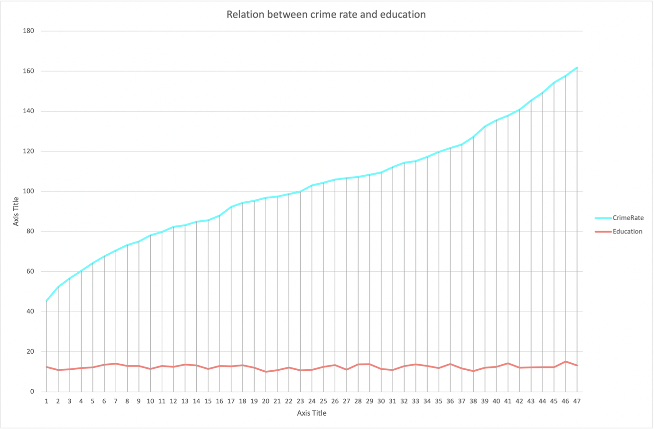

We are able to view values for the overall crime rate, youth, education, expenditure year, labour force, males, state size, below wage, and wage by utilising the Pivot Table that has been provided. The data that was presented earlier has been saved in a format that makes it possible for us to arrange it into tables and see how its presence influences the operation of a company.
Excel's Pivot Charts are an additional useful capability that the programme offers. They depend on the information that is provided in the pivot tables. Large amounts of data that have been summarised can be analysed in a hurry and in a number of different ways using pivot charts. Pivot charts, as opposed to normal charts, are able to display data that contains hundreds or even thousands of rows.
The pivot chart that accompanies this paragraph shows that there is a significant gap between the two regions in terms of the significance of young people and educational achievement. The analysis of data is frequently made a great deal more difficult as a result of the vast number of different variables and pieces of information. One example of a tool that can assist us in accelerating and simplifying the tasks that we need to do is a pivot chart.
Excel has the advantage of being incredibly dependable and being able to provide multiple strategies for visually analysing data as well as the necessary tools with just one click. This is only one of Excel's many useful features. The following are the distinguishing features of the two graphics.
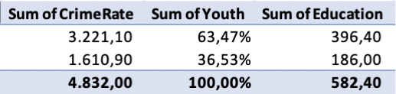

The intricacy of the second is higher than that of the first (in relation to all the data – the first chart presents the sum of all the data, whereas the one provided above breaks the data down into a detailed graph). This graphical depiction makes it easier to comprehend the issue at hand and paves the way for us to arrive at the appropriate conclusions by allowing us to make comparisons and consider a number of divergent points of view. In this particular instance, we can see that the crime rate has increased despite the levels of education being largely unchanged. Subjectivity comes into play at this point, which helps explain why we arrived at a different conclusion based on the graph that came before it. On the other hand, it is clear that there may not be a connection between the rates of criminal activity and the levels of education in this particular instance.

Use of Excel in Business Intelligence
Excel has become increasingly appropriate for extensive deployments as a result of the development of tools such as Power Business Intelligence, which are used by analysts, reporting experts, and business intelligence specialists (Power Pivot, Power Query, Power View, Power Maps, and other features that naturally integrate with Excel). The rephrased version of [CITE Inv16 l 1040] in formal language
Using the spreadsheet feature of Excel, one is able to not only store but also analyse and report on significant amounts of data. Although it is most commonly used by accounting teams for financial analysis, any knowledgeable person can use it to manage large and complicated information. For the purpose of demonstrating the adaptability and functionality of Excel, the most widely used spreadsheet tool, we have made available to businesses a variety of Excel applications. Excel is quite familiar to seasoned finance professionals because they have used it for a number of years. [CITATION] Kat221 l 1040
As was demonstrated in earlier sections of this document, Excel is among the most effective programmes for generating charts. This section includes several types of graphs, including scatter plots, line graphs, bar graphs, area graphs, column graphs, and pie charts. If an organisation needs to show data in a more visual and clear manner, Excel's ability to convert rows and columns of statistics into beautiful charts is the ideal approach to simplify massive volumes of data for accurate and concise analysis.
Excel contains a wide number of practical functions that simplify and expedite everyday tasks. The VLOOKUP function is a useful tool for locating information within spreadsheets that contain what seems to be a limitless quantity of data, as was demonstrated in the preceding section. In spite of the fact that setting it up is a bit of a challenge, it is really dependable. It is recommended that the AVERAGE function of this application be included as well. According to our analysis, using this function to prepare data for use in charts is the most time- and resource-effective technique. It offers a statistical summary and contributes to the formation of an opinion regarding the typical goals and operations of a company.
In addition, Excel's Pivot Table and Pivot Chart options provide users with an add-on that is not overly complicated to operate and is capable of computing a wide range of different values and data while also providing assistance with statistics. Users are able to personalise the presentation of their data in pivot tables with the use of this function. For instance, if users wish to view exact percentages of the total, they are able to do so with the help of this function. Pivot Charts are another tool that may be used to provide a graphical representation of the data that has been saved. You will be able to see the data that was computed on and given a value for by visiting the Pivot Tables (Wixom et al., 2014). This will let you to see how the computations and operations were carried out.
Excel is one of those programmes that appears to be too good to be true; as a result, if we want our report to be professional and comprehensive, we need to examine some of Excel's limitations. The number of companies that are able to make productive use of data is growing at a rapid rate in tandem with the rapid evolution of the world (Wixom et al., 2014). In addition, those working in the finance industry can use business intelligence tools in place of more traditional data analysis programmes like Microsoft Excel. With the help of business intelligence software, you can automate the collection of data, the classification of that data, and the provision of insights that will be of use to your organisation in its pursuit of success.
One of the most obvious drawbacks of Excel is that it has a size restriction on the files that can be saved. Excel has significant shortcomings when it comes to the administration of very large data sets. An error message might appear on the screen of the application if it attempts to open a file that contains an excessive number of megabytes or rows, for example. In order to get around this, the major file needs to be partitioned into several smaller files, which can make data processing more difficult. On the other hand, business intelligence systems are able to easily manage enormous amounts of data. Bi allows you to open a huge file rapidly and analyse the data set in depth. Additionally, BI makes it easy to combine and blend diverse data sets (Wilson, Keating and Beal-Hodges, 2016).
Microsoft Excel has millions of users globally, making it a global power to be reckoned with. This sophisticated spreadsheet application is very popular in the financial sector (Wilson, Keating and Beal-Hodges, 2016). Chief financial officers (CFOs) have relied on Excel for data analysis and visualisation for over two decades. Excel is a fantastic programme for preprocessing, analysing, and visualising data, based on what we have seen thus far and the examples supplied (Larson and Chang, 2016). Excel remains a viable data processing tool despite substantial limits in its capacity and ability to generate relevant and user-friendly charts when dealing with massive amounts of data.

PART 2
1) What proportion of students favour vanilla flavour?
Using Excel and the COUNTIF function, we can determine the number of individuals who prefer vanilla, chocolate, or strawberry ice cream, as shown in the table (Debortoli, Müller and vom Brocke, 2014):
These data points may appear as follows in a pie chart:
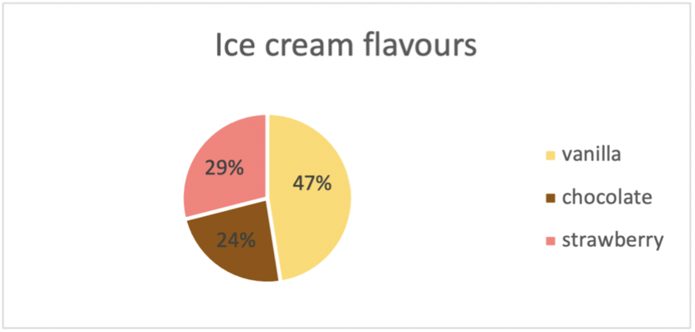

The preceding pie chart and table demonstrate that 47% of the 200 students polled preferred vanilla flavour (95 students) (95 students).
2) What is the gender distribution of the student body?
Category | Frequency | Percent | Valid percentage | Cumulative percentage
Male | 91 | 45.5 | 45.5 | 45.5
Female | 109 | 54.5 | 54.5 | 100
TOTAL | 200 | 100 | 100

As seen in the table below, the COUNTIF function in Excel can be used to count the number of men and women.
These data points may appear as follows in a bar chart:
The bar graph and table above plainly reveal that 109 of the 200 students questioned are female and 91 are male.
3) What are the mean and median preferences of the participants for chocolate and strawberry flavours?
We are aware that the following information pertains to individuals who enjoy chocolate and strawberry flavours.
We will determine the Mean and Median of these individuals using Excel tools. After computing the Mean with the AVERAGE function, the same program's MEDIAN function is used to get the Median (Debortoli, Müller and vom Brocke, 2014).
The following are the results:
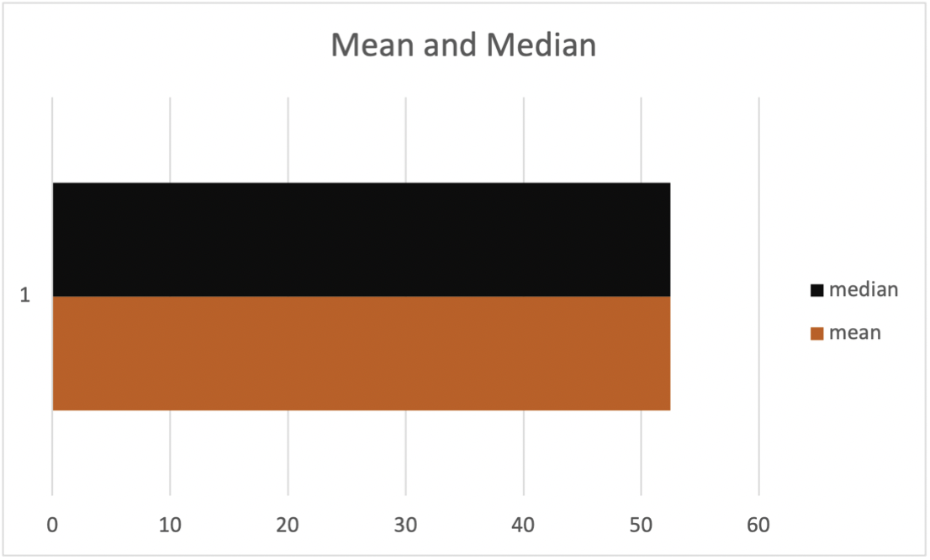
Using the information we have gathered, we can build a bar chart like follows:
Clustering of data and K-means
Clustering is the practise of classifying a collection of abstract elements into groups of those with similar characteristics. Clustering, also referred to as cluster analysis, is a method for organising data into understandable and manipulable structures. Clustering data with K-means can be utilised in unsupervised machine learning. It can cluster unlabelled data into a predetermined number of groups based on similarities (Debortoli, Müller and vom Brocke, 2014).

References
Anderson, D.R. (2019). Essentials of statistics for business and economics. Mason: South-Western.
Chen, H., Chiang, R.H.L. and Storey, V.C. (2012). Business Intelligence and Analytics: From Big Data to Big Impact. MIS Quarterly, 36(4), p.1165. doi:10.2307/41703503.
Cleff, T. (2020). APPLIED STATISTICS AND MULTIVARIATE DATA ANALYSIS FOR BUSINESS AND ECONOMICS: a modern approach using spss, stata, and excel. S.L.: Springer Nature.
Debortoli, S., Müller, O. and vom Brocke, J. (2014). Comparing Business Intelligence and Big Data Skills. Business & Information Systems Engineering, 6(5), pp.289–300. doi:10.1007/s12599-014-0344-2.
Keller, G. (2016). Statistics for management and economics abbreviated. Boston: Cengage Learning.
Larson, D. and Chang, V. (2016). A review and future direction of agile, business intelligence, analytics and data science. International Journal of Information Management, 36(5), pp.700–710. doi:10.1016/j.ijinfomgt.2016.04.013.
Wilson, J.H., Keating, B.P. and Beal-Hodges, M. (2016). Regression analysis: understanding and building business and economic models using Excel. New York, New York (222 East 46th Street, New York, NY 10017): Business Expert Press.
Wixom, B., Ariyachandra, T., Douglas, D., Goul, M., Gupta, B., Iyer, L., Kulkarni, U., Mooney, J.G., Phillips-Wren, G. and Turetken, O. (2014). The Current State of Business Intelligence in Academia: The Arrival of Big Data. Communications of the Association for Information Systems, [online] 34. doi:10.17705/1cais.03401.

