BMIH5006
Sustainable Hospitality and Tourism Management
Student Name: Mioara Grigore
Student id: 2017709
Destination Management

Table of Contents
Introduction 3
A case of the hospitality and Tourism Industry 4
Three pillars of sustainability 4
These principles are closely associated with the general principles 5
The advantages and disadvantages of cruise tourism 6
Butler’s life cycle model 7
Doxey’s irridex model 8
Use of data and statistics to back up evidence 11
Provide recommendations for the future development of the destination 11
There are 4 Strategies to keep constant Tourists 11
Conclusion 13
References 14

Introduction
The principles of sustainable tourism as present in the development manager will be employed. various theoretical frameworks will be described to assess better appreciation. Cruise line water transportation was working to reform tourists' participation as review and feedback from visitors. This assignment will work as an evaluative report regarding tourism destinations according to data plan and choice. It will evaluate various principles regarding sustainable development and sustainable tourism.

A case of the hospitality and Tourism Industry
This case happened at the Cruise Line hospitality service. during the pandemic, they have emphasized service quality rather than a better transformation of services. They have utilized their lowest number of efficient crews and hosts to provide quality service to travelers. One day, a guy has been booked a service in a separate cabin. Crise line service ensured a luggage service for them who has been collected all their packing. Cruise line authority has conducted a change management plan (Subadra, 2021). Under this plan, they have invested in quality service for them as per requirement. This trip has selected the destination in Australia. But visitors were infected by the Covid and they needed a separate room for better isolation. Cruise line authority was unable to break the rules of the medical team (Gajdošík, 2022). Because they were unable to improve the service quality except for influential reorganization.

Three pillars of sustainability
the cruise line has developed its new and sustainable mechanism for a better development framework
Economic: Informative data and information will be needed to assess the economic performance. In 2022, the impact of the Covid 19 has created a visible crisis in the economic sector. Tourism Sector organizations were bound to stop their business wheel during the lockdown period (Mizik and Gyarmati, 2022). But the cruise line continued their trips. They have maintained a hygienic travel environment. They have decreased services and kept priority on quality. As a result, their investment was also increased (Mukherjee, 2018)
Socio-cultural: The consideration of social and cultural factors is not simple to handle within a short time. People usually choose their social needs for the institution. Their tendency is to work or choose within relaxation environment. Australian trips will have different food and accommodation system than the middle east. People will buy and wear
clothes from the market as support for winter. On the other hand, middle, east guests will not wear heavy clothes.
Environmental: The environment is a very important issue for the sea level journey. Important factors will be developed under particular requirements of the environment. Australian vessel is very flexible in sea transportation. Because there are no heavy waves or devastating moments. Consequently, they have decided to go there.

These principles are closely associated with the general principles
General principles of sustainability indicate the general outlook of the tourism business. Or their overall facilities and framework to improve or reduce the transformative challenge. Practices of these rules and guidelines have been identified through the better accumulation of plan and execution (Gerhard and Florian, 2014). All the requirements will be counted as common style for all vessels. Every vessel crew was Outlining regulations and organizations who are responsible for the implementation. The traveling aspect of the industry should also be analyzed, exploring how they are closely related.
Small and Mega ships: are able to place on ocean, river, or fjords. Cruise tourism is very famous in the Caribbean, Mediterranean, and Arctic in comparison with other destinations (Daniel J., 2015).
Luxurious form of traveling: the involvement of a luxurious cruise for at least 24 hours. The services will be included a specific itinerary, in which the cruise ship will call different ports or cities.
Cruise operation management: This feature allows people to get involved in studying or teaching about cruise tourism. Consultancy service will be available for the texts of Cruise Ship Tourism and Cruise Operations Management with the Hospitality Perspectives (Gibson, 2017).
Round Trips: Cruise tourism line has introduced round trips to keep a wide range of destinations. in the late 19th century, Albert Ballin was sent on a transatlantic ship for the first time. So, they ran away regarding the director of the Hamburg-America Line. This trip was developed in the north Atlantic.
The Cruise Lines International Association: has started offering reports for the profile maintenance of average cruise passengers since 2008 (Klein, 2016). The average household income has earned of UK pound 90,000. Because cruise ships become diversified in their services. They prepare a checklist of passengers among demographic groups - couples, families, children, the younger generation, medical experts, sports enthusiasts, and the older generation, etc.
Cruise types as a specialty:
Cruise tourism companies are currently dominated by the most important 5 names:
- Cunard: it is operating for more than 180 years. They are currently operating among specialized services in luxury cruises with personal and famous White Star Service (Kim, 2015). This vessel has planned to go with the older and young generations to new destinations, especially in Australia
- Royal Caribbean Royal Caribbean cruises are special for innovation services. This cruise line will have surfing to Broad Way shows. Solo travel is getting popularity.

The advantages and disadvantages of cruise tourism
- cruise tourism is currently growing tourism around the world. This industry not only contributes to employment generation but also industrial partnerships with them make a high network base for students (Juan, 2015). However, only economic benefit cannot be the base of assessing absorbed large corporation performance.
- Large corporations make Cruise ships the contributory part of these cruise ships. Although it is a very small number of benefits and destination desire except. cruise tourists usually spent little money on the destinations that they visit (Semrad K, 2015). It means local people will have less recognition to reap few rewards for this arrangement of tourism.
- In addition to this, cruise tourism may impact the natural environment. But when Ships dock in shallow waters, the large vessel may turn into numerous dangers. Even when garbage is not cleared properly especially if it is not disposed of responsibly. Over-tourism may involve special problems internationally if they plan randomly.

Butler’s life cycle model
Butler's Tourism Area has thought of a Life Cycle Model. This cycle was found realistic and great because it drives simple theoretical guidelines for tourism stakeholders. Many more researchers are currently suggesting this cycle as a better strategy to apply step by step. It will enhance the rationality of every decision made if they plan it well. expertise suggestion was especially focused on the startup tourism companies that are just starting. They can utilize this model to plan and execute their tourism infrastructure (Merriam, 2019). This model is the specification and simplification of the real-world tourism destination to understand reality. Professor Richard Butler has suggested this life cycle for a particular tourist destination. There is a significant number of tourist destinations and steps. But specificity will bring effectiveness and efficiency through this model application (Mukherjee, 2018). The steps are as follows,
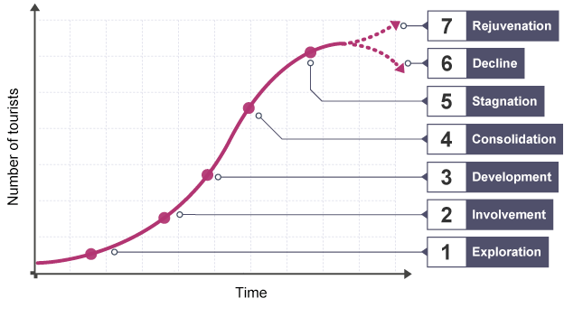
Figure 01: Different Stages of Richard Butler Cycle Model
Source: (Onaolapo, 2017)
Stage 1: Exploration: several tourist facilities will be visited by a small number of adventurous. But the adventure is not possible without travelers
Stage 2: Involvement: Local people will start different facilities if proper identification and realization take place. Tourist consent is the primary need of the destination specification. It indicates the resource for realization.
Stage 3: Development: development in the tourism sector is not possible without Tourist facilities and accommodation services. Especially, the number of tourists will be increased if they need recognition through luxurious service integration (Mukherjee, 2018).
Stage 4: Consolidation: as Cruise line Trips introduce better transformation through legal and informational service into practice, it will deliver Tourist facilities in hotels. They often receive support from the ownership of large multinational companies. It keeps constant support for large numbers of tourists. Tensions have developed due to the impact of the pandemic. But they have arranged various common services in the Australia trip as follows- Shops, Swimming pools, Fitness centers, Restaurants, theatres, cinemas, casinos, Bars, spas, etc.
Stage 5: Stagnation: Important checklists have been developed under large numbers of tourist peaking; the Australian resort begins to have a large number of sides which has become less fashionable. A large number of tourists damage the environment through their material appearance (Semrad K, 2015).
Stage 6: Decline: Tourist will have significant numbers of declining result which seeks new, exciting and unspoiled destinations.
Stage 7: Rejuvenation: this segment will have significant Investment criteria to have a separate marketing system - new facilities, advertising, and attractions for new visitors

Doxey’s irridex model
Doxey’s irridex model has been developed through particular indexing which was established by Doxey in 1975. It was based on a particular understanding of residents who feel great about particular destination features. For example, all the transformation of changing their attitude toward particular development and tourists’ mechanism (Schwartz, 2019). The development of tourism will have different stages to mediate the destination’s life cycle. This model was proposed by George Doxey. He is specialized in particular destinations and mechanisms to have little importance and regulations.
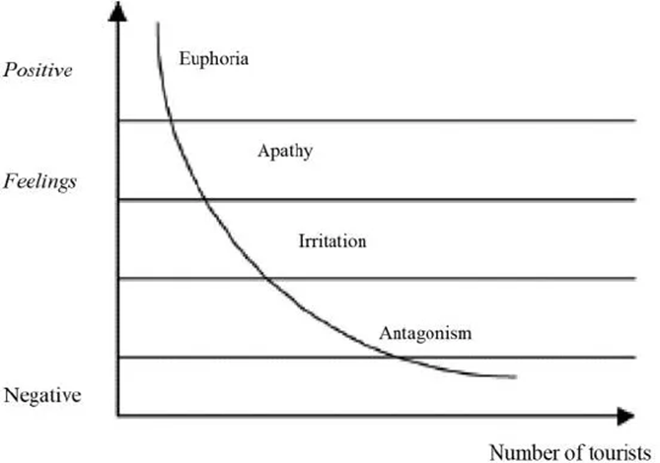
Figure 02: Doxey’s Irritation
Source: (Combe and Gebhard, 2018)
It started with positive feelings or feedback and ends up negative, with attitudes sliding from one end to the other as time passes. It is theoretical, but it has a place in the reality of tourism. The four stages are laid out again below with the destination’s response for each level of tourism.

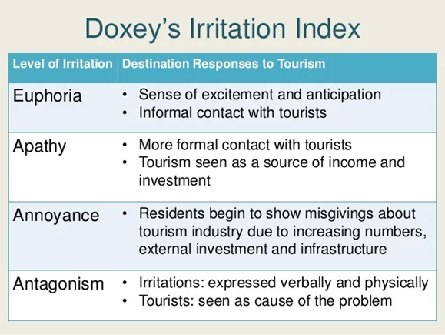

Figure 03: Doxey’s Irritation Index
Source: (Merriam, 2019).
There are four steps to maximizing tourism opportunities:
Euphoria: all the sense of excitement will be developed through better transformation and implications to reduce the challenges. Consequently, tourists can utilize informal communication channels with tourists.
Apathy: there are various formal contacts with tourists from the Cruise Line authority. It has helped them to find out a realistic view of income and investment.
Annoyance: this step is a negative externality of the tourism business in Australia. Because travelers will bring important resources to specific places and demand will increase because of the currency problem. The government of that country can stop particular product entrance. So, it can damage traveler choice to mention better opportunities.
Antagonistic: verbally and physically, tourists can damage the real structure of operation in terms of improvement and growth. all the regular problems are assessed by operation managers to increase the real spectrum of improving the regular strip.

Use of data and statistics to back up evidence
This round target has been employed by Caribbean cruises which is probably the most expensive cruise line vessel. Any kind of service reorganization and reformation can be added but it needs financial support. The last cost of a particular destination was £9,000 upwards. Due to the severe impact of the covid, all the services were bounded to increase investment in hygiene services but they were able to reduce the number of travelers. Some luxury rounds can cost up to £200,000 in the world cruises per traveler. They will typically last around 90-120 days. It allows close passengers as embarkment and dismemberment to enhance various places across national and international borders (Semrad K, 2015).

Provide recommendations for the future development of the destination
There are 5 Ways to improve the City or Town to Increase travel comfort.
- Highlight Every destination and it's the history and culture for recognizing a unique story
- Inform and share particular tasty tips and mark notable avoidance area (Mizik and Gyarmati, 2022).
- It will offer visitors lots of equipment and a breath of fresh air
- All the Suggested local stores, improvement mechanisms, and businesses
- Different enhancement and personal testimony will develop future destination

There are 4 Strategies to keep constant Tourists
- Apply the storytelling opportunity through web blog social media posts.
- The use of memorable experiences through delivering speech and affirmation
- publishing valuable content which will optimize website circumstances for SEO
- Managing reviews on TripAdvisor
- keeping sustainability considerations for further recommendations.

Conclusion
All the stage of Irridex entails particular sufferings and reorganization. This theory focused on Doxey’s Irritation Index as the scale of sorts. But the sale will be specific in ratio to manage positive and negative sources. Actual development will be derived from every stage of rationality. Planning and execution will be different for every particular step. It encourages the most important critical thinking and long-term posting and thinking (Mizik and Gyarmati, 2022).

References
Combe, A. and Gebhard, U. (2018) “Irritation, erfahrung und verstehen,” Irritation als Chance, pp. 133–158. Available at: https://doi.org/10.1007/978-3-658-20293-4_4.
Daniel J., B. (2015) “Small watercraft and yacht security,” Maritime Security, pp. 173–177. Available at: https://doi.org/10.1201/b18926-8.
Gajdošík, T. (2022) “Tourism destination governance and its challenges,” Smart Tourism Destination Governance, pp. 7–28. Available at: https://doi.org/10.4324/9781003269342-3.
Gerhard, W. and Florian, J. (2014) “Part Two: General principles,” Principles of International Criminal Law [Preprint]. Available at: https://doi.org/10.1093/law/9780198703594.003.0002.
Gibson, P. (2017) “Talent management and the cruise industry.,” Cruise ship tourism, pp. 161–176. Available at: https://doi.org/10.1079/9781780646084.0161.
Juan, H. (2015) “Advantages and disadvantages of college English grading teaching mode,” Proceedings of the Information Science and Management Engineering III [Preprint]. Available at: https://doi.org/10.5220/0006025703380342.
Kim (2015) “Interaction analysis between construction business indicators and business performance indicators of specialty contractors depending on operation types,” Journal of the Korean Society of Civil Engineers, 35(1), p. 193. Available at: https://doi.org/10.12652/ksce.2015.35.1.0193.
Klein, R.A. (2016) “Crime at sea: A comparison of crime on Carnival Cruise Lines, 2007–2011,” Cruise Business Development, pp. 17–28. Available at: https://doi.org/10.1007/978-3-319-27353-2_2.
Merriam, S.B. (2019) “Butler’s Life Review: How universal is it?,” The Meaning of Reminiscence and life Review, pp. 7–20. Available at: https://doi.org/10.4324/9781315227269-1.
Mizik, T. and Gyarmati, G. (2022) “Three pillars of Advanced Biofuels’ Sustainability,” Fuels, 3(4), pp. 607–626. Available at: https://doi.org/10.3390/fuels3040037.
Mukherjee, S. (2018) “Reigniting GIS's application in Ecotourism,” GIS Applications in the Tourism and Hospitality Industry, pp. 98–115. Available at: https://doi.org/10.4018/978-1-5225-5088-4.ch005.
Onaolapo, A.J. (2017) “Analysing life cycle stages of Indian meal moth, Plodia Interpunctella (hübner) on four different diets,” International Journal of Scientific Research and Management [Preprint]. Available at: https://doi.org/10.18535/ijsrm/v5i9.16.
Schwartz, R.E. (2019) “Properties of the model,” The Plaid Model, pp. 25–34. Available at: https://doi.org/10.23943/princeton/9780691181387.003.0003.
Semrad K, B.K. (2015) “Advantages and disadvantages of using flash sales in the lodging industry,” Journal of Tourism and Hospitality, 04(03). Available at: https://doi.org/10.4172/2167-0269.1000161.
Subadra, I.N. (2021) “Destination Management Solution Post covid-19: Best practice from Bali – a world cultural tourism destination,” Tourism Destination Management in a Post-Pandemic Context, pp. 25–36. Available at: https://doi.org/10.1108/978-1-80071-511-020211024.

