Postgraduate/Distance Learning
Assignment coversheet & feedback form

For completion by the student:
Student Name: Keith Huggins

Student University Email: 1812645@student.uwtsd.ac.uk
Module code: AHAN7028  Module title: Heritage: Representation and Interpretation | Student ID number:  1812645 | Educational support needs:  No
Assignment title: Keith_Huggins_Assignment2

Assignment due date: 10 January 2020
This assignment is for the 1st 2nd 3rd 4th 5th x 6th module of the degree
I confirm that this is my original work and that I have adhered to the University policy on plagiarism.
Signed ……………………………………………………………
Email submission:if you are submitting this form via email, please tick this box X
(as a substitute for your signature) to confirm that you agree to the above declaration.
Assignment Mark
1st Marker’s Provisional mark
2nd Marker’s/Moderator’s provisional mark
External Examiner’s mark (if relevant)
Final Mark

NB. All marks are provisional until confirmed by the Final Examination Board.

For completion by Marker 1 :
Comments:

Sovereign Hill

Introduction

Sovereign Hill Mission Statement -1969
‘The Ballarat Historical Park Association (Parent Body of Sovereign Hill) was established to provide present and future generations a worthy reminder of the lives and work of men and women who, in so many fields of endeavour, pioneered and developed Ballarat’ (Evans, 1991).

The subject of this research is Sovereign Hill. It is a living museum based in Ballarat, that is a regional city in the state of Victoria, Australia.
The basis of its existence is to re-create the first ten years following the discovery of gold, in 1851, that initiated a global miner’s rush to the area.
A Fact Sheet issued by Sovereign Hill, Sovereign Hill (n.d.) declares it to be the re-creation of a gold-fields township on a 25-hectare site that attracts some 500,000 visitors per annum; it opened in 1970 (Frost, 2005) and includes the town, goldmine, a panning area and a Chinese village.
Sovereign Hill is owned and operated by a non-profit community organisation that is the Ballarat Historical Park Association.
It has been the recipient of State and National awards as a major tourist attraction and is an inductee to the Victorian Tourism Hall of Fame (Sovereign Hill, n.d.).
According to the fact street, Sovereign Hill (n.d.) it claims to provide tourists with a living history and heritage during the Gold Rush era by re-creating the day-to-day lifestyle of the goldfields.
Sovereign Hill is therefore an appropriate example of Heritage site that aims to combine an active museum with a tourist attraction that this paper assumes will broaden its potential target demographic.
This paper assumes that tourism is an extremely competitive industry, Sovereign Hill has to overcome the threat from Theme Parks by adding an educative component and providing a potential heritage link both individually and societally.
Other Sovereign Hill Attractions and Venues.
The Gold Museum, Sovereign Hill (n.d.) presents the history of gold and its effect on the growth of Ballarat that has a collection of gold nuggets, alluvial deposits, artefacts and coins.
Aura, Sovereign Hill (n.d.) is multi-sensory, open-air, 3D immersive theatre, spread over 64 acres that relates the history of the Wadawurrung people including gunfights, protests and the gold rush.
Sovereign Hill Hotel Sovereign Hill (n.d.), is a 4-star facility that acts a base for tourists; overnight visitors are considered more valuable.
Narmbool Sovereign Hill (n.d.), is a 200-hectare pastoral property (sustainable farm) that is part of the Sovereign Hill operation and is a residence for full range of Australian animals and fauna plus 20,000 merino sheep; its purpose is act as an educational resource.
Costumed School Sovereign Hill (n.d.) has a two-day program for primary school children to experience the social conditions and life as child in 1851 Ballarat.

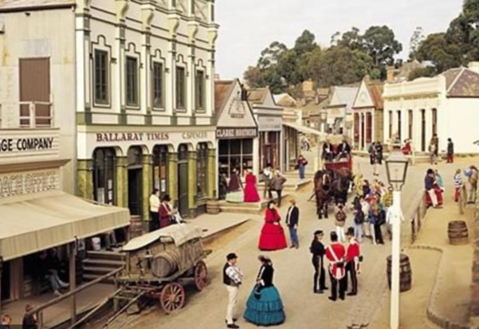
Sovereign Hill - Main Street

Discussion
Frost (2005) states that Sovereign Hill attempts a high level of authenticity where the majority of its buildings are re-constructs based on photographs and drawings from the era that it represents. Sovereign Hill (n.d.) report that players, musicians and actors, parade in period costume; children, also in period costume, enact schooling of that time.
Moscardo & Pearce (1986, cited by Frost, 2005) research showed that the degree of authenticity exercised by Sovereign Hill was highly regarded by the tourists, but has been criticised by Goodman (1994, cited by Frost, 2005) that historians have been deflected as the main interest in the Gold Rush era was for tourists and children.
Ham & Weiler ( 2004, cited by Frost, 2005) suggest that the interpretations at Sovereign Hill have been more like ‘infotainment’ where the focus has been on authentic clothes and exact reconstructions, De Lyser (1999, cited by Frost, 2005),
rather, this paper assumes, than the reality and day-to-day life of the era.

Frost (2005) discusses Sovereign Hill’s development of the Chinese village and its population of Chinese people (university students) and a construction of a Chinese quartz mine that adds to Australian schools multi-culturism and Chinese tour groups.
One perhaps, unfortunate aspect of reliving the period is an enactment of Sovereign Hill actors plying abuse at the Chinese characters parading through the town (Frost, 2005).
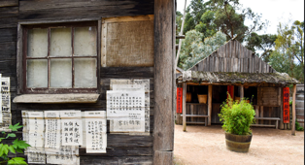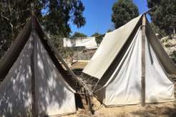
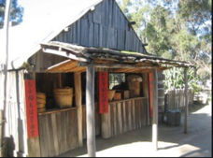 Chinese Village

Interpretation of the Sovereign Hill story, according to Frost (2005) has resulted in the exclusion of any Aboriginal people, contrary to their participation at the time; Sovereign Hill considered that showing Aboriginal society in decline would upset the sensibilities of tourists, although in a contrary argument an inclusion without these issues could be considered to be sanitising history.
Frost (2005) notes that Sovereign Hill is a successful tourist attraction (unlike its counterparts of pioneer villages); this paper suggests that its success is perhaps due to its interpretation of the historical heritage and a careful consideration of where to apply authenticity to its maximum effect.
Sovereign Hill according to Frost (2005) to maintain its high tourist flow and returnees, continually opens new venues, that changes content and a re-interpretation of its approach; variations of underground mine tours that tell of actual miners and their stories, rather than just a glossary of facts.

Evans (1991) observes that Heritage sites may attract criticism by sanitising history where according to Lowenthal (1985) re-enactments are a purging of guilt over the past. Davison (1988, cited by Evans, 1991) makes the point that the re-constructed goldmine township of Sovereign Hill is a quieter, cleaner and more orderly town than the original. The contemporary version has middle class ladies in period finery, Davidson (1988, cited by Evans, 1991) rather than the historical fact of young male miners and prostitutes.
This paper will suggest that true authenticity has to be tempered with the more family-based tourists and as such Davidson (1988, cited by Evans, 1991) suggests that Sovereign Hill selectively distort history and provide a sentimental view of the past.

Heritage
Howard (2003, cited by Frost, 2006)defines heritage as that something which is required to be preserved for passage to future generations whereas Timothy & Boyd (2003, cited by Frost, 2006) narrow it down to an inheritance to be passed on to later generations. Timothy & Boyd (2003, cited by Frost, 2006) determine three categories of heritage: tangible immovable (buildings); tangible movable (artefacts); intangible ( customs & practices). Ahmad (2006, cited by Frost, 2006) states the trend being to treat the tangible and intangible equally. This would conform to the strategic plans of Heritage sites to represent and interpret a sense of the era they are portraying as in Sovereign Hill.
Heritage vs History
A view considered by Frost (2006) is that history is objective based on documented facts whereas heritage is subjective. Timothy & Boyd (2003, cited by Frost, 2006) state that history is an accurate account of what happened whereas heritage is what the current generation choose to highlight and pass on.
Continuing the argument Timothy & Boyd (2003, cited by Frost, 2006) state that Heritage theme parks present selective recreations and is therefore according to Hewison (1987, cited by Frost, 2006) a distortion that fantasises a history that did not exist. Loewen (1998, cited by Frost, 2006) states heritage to be a manipulation of the past to satisfy current aims.
The view of this paper is that the ‘facts’ of history are also capable of distortion dependent on who produced them (victors in war, for example).
When considering the requirements of the tourist industry and the legal necessities of contemporary health & safety regulations coupled with a duty of care, Heritage sites can never replicate the perceived knowledge of history. The supply of quality foodstuffs and sanitary services can only exacerbate the differences between historical actualities and an entertainment/ educational narrative.
The use of words and phrases such as ‘distortion’ or ‘partisan perversion’ as used by Lowenthal (1998, cited by Frost, 2006) is, in this paper’s view as an irrelevance and highly critical of tourist venues.
Frost (2006) concurs with this point, where academic thought suggests that History is ‘good’ and heritage ‘bad’, is a flawed argument and contemporary historians are also interested in how history is interpreted rather a hunt for dates and facts. Davison (2000, cited by Frost, 2006) states that historians have abandoned the notion of objectivity where it was written to satisfy a certain point of view.
Frost (2006) argues that history is dynamic, subject to revision where societal attitudes may reinterpret it; contemporary views concerning the Gold Rush pivoted away from Nation building and technology to regarding the lives and efforts of women, Aborigines , Chinese, environment and the less successful miners at the time. Frost (2005) suggests this provides a dilemma for heritage sites as to the interpretation of their history and which view to follow, especially in the case of Sovereign Hill and its strategic plans.

Heritage and the Community
As discussed, heritage is the collection of something(s) to hand to future generations and this can be subject to societal attitudes at the time, that raises the question by Frost (2006) as to how can the society’s views and attitudes be gleaned and realised? The Australian Heritage Commission (2001, cited by Frost 2006). suggests involving the local community as this avoids issues with local sensitivities but allows for a true representation of the area and its people. This paper will suggest that this may not be in agreement with the community and tourists at large, who may hold different affectionate views given potential individual and societal links to the heritage site; considering the financial health is dependent on this demographic.
Where the local community is affected and to be considered, regarding Sovereign Hill, is the boost to the local economy in terms of employment (in a rural area) and the supply of goods and services (Hotels, taxis, suppliers and tradesmen, for example).

Authenticity
Tourists according to MacCannell (1976, cited by Frost, 2006) have a nostalgia for a view of the less complicated lives of the past and to look at the ‘behind the scenes’ of other people’s lives in workplaces in commercial, industrial, domestic or public institutions. There is a desire to gain, according to MacCannell (1976, cited by Frost, 2006), an authentic experience to satisfy their needs. The tourist experience can never replicate the original, MacCannell (1976, cited by Frost, 2006).
Sovereign Hill has been criticised for appealing to children and tourists Goodman (1994, cited by Frost, 2006) due to its predilection with the look (equipment, clothes, buildings) of the venue and has been accused of inconsistent conservation and an interpretation based on, according to Stratton (1996, cited by Frost, 2006), of an educative form of entertainment; however; there has been praise of Sovereign Hill’s interpretative programs of authenticity (Clark & Cahir, 2003, cited by Frost, 2006).
Cohen (1988, cited by Frost, 2006) argues that authenticity has become negotiable where tourists depending on their level of engagement have a varied criterion of what is authentic; time changes attitudes.

Exclusion of Aborigines at Sovereign Hill
Sovereign Hill has been used as case study by Clark & Cahir ( 2003) to discuss the responsibility of the Heritage Tourist Industry to include the Aboriginal contribution within the interpretation of the cultural heritage site. Clark & Cahir ( 2003) determine that in mainstream history in Australia, the Aboriginal people had been airbrushed from the landscape; however, Aboriginal people had been present in the goldfields in a variety of jobs, positions and partners.

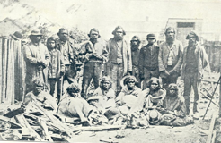
Ballarat Miners & Aboriginals.
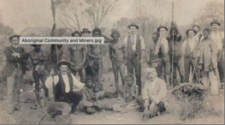
Victoria celebrated 150 years since the discovery of gold and according to Clark & Cahir ( 2003) that were given a Eurocentric and Sinocentric interpretation of the event(s) and disregarded anything Aboriginal.
The early plans for Sovereign Hill encompassed a mythological view that as recorded by Evans (1991), was as remembered by the local community that included the Chinese community but ignored the Wathawurrung Aboriginal people.
Sovereign Hill altered its presentation between the years 1975 -1980 from interpreting the day-to-day life in Ballarat in that era to telling the story of ‘everyman’ and his quest for gold/ better life that mirrored the growth of Ballarat. The president of the Ballarat Historical Park Association (1982/3, cited by Clark & Cahir, 2003) stated that Sovereign Hill represented Ballarat as it was in 1851-1861, during its gold rush years together with the people from all over the world and to differentiate from contemporary life; but not including the Aboriginal people.
As further confirmation the curator of Sovereign Hill stated that they had a moral responsibility and an obligation to show life as authentically as possible Ballarat Historical Park Association (1982/3, cited by Clark & Cahir, 2003).
Sovereign Hill, Clark & Cahir ( 2003) re-creates the era by the use of duplication original of buildings and activations by actors of potential past events and houses replete with period people and artefacts. Evans (1991, cited by Clark & Cahir, 2003)
states that tourists will as ‘Anthropologists arriving in an alien place observing what the natives are doing and the meanings behind the activities; contending it to be ‘living history’.
During the 1990’s,according to Clark & Cahir ( 2003), Sovereign Hill carried activities and functions to carry out the aims of Museums Australia to celebrate the indigenous people; hosted a travelling exhibition of Koorie art; employed ‘one’ local indigenous musician; a mobile exhibition depicting removal of Aboriginal children; a sound and light show focussing on the Wathawrrung people, funded by the Aboriginal Affairs Victoria and Sovereign Hill; a 1999 exhibition in collaboration with Ballarat and District Aboriginal Co-operative featuring artwork; received a grant from the Local History Grants program to build and educative activity space focussing on Aboriginal History and culture.
It is an observation by this paper that all these events have little regard and relevance to Sovereign Hill’s aim to depict life in Ballarat’s goldfield 1850 history while the funding of exhibitions was gained from outside organisations. The exhibitions that were presented appear to focus on Indigenous art and culture in a general sense rather than discuss any Aboriginal contribution to the history of Ballarat as depicted at Sovereign Hill.
Clark & Cahir ( 2003) point out that while Sovereign Hill’s website emphasises its adherence to the history of Ballarat between 1851 and 1861, its attached research notes discuss Law and Order, Women, Chinese and Life in the Goldfields but only a secondary one concerning the heritage of Aboriginals; nothing concerning Aboriginals and the Goldfields.
Clark & Cahir ( 2003) endeavour to explain the exclusion of the Aboriginal’s contribution and experience in the goldfields; an answer being the potential negative connotations of destruction as experienced by the indigenous people.
Pretes (2002, cited by Clark & Cahir, 2003) surveyed Mining / Heritage cultural tourists’ sites in South Africa, Australia and Canada and observed that discussions concerning indigenous peoples have been ‘distorted, suppressed or omitted’ and silenced; Sovereign Hill has no discussion concerning Aboriginal presence or the effect of mining on them.
The goldfields of Ballarat were located on tribal lands, according to Clark & Cahir (2003) but were seen by the Aboriginal people as a potential for trade and exchange.

The Chinese at Sovereign Hill
https://youtu.be/SX15I6RI4eM

According to the Sovereign Hill Education Blog (2017) Chinese miners arrived in Ballarat a few years after the initial gold rush of 1851 and their numbers grew to 7,542 which was the equivalent of 20% of the town’s population.
They had to live in segregated camps unlike other ethnic groups and based in the least desirable areas as at the bottom of hills which had the run-off of sewage, Sovereign Hill Education Blog (2017); that proved an advantage in growing vegetables by the use of free fertiliser.
Unlike other groups the Chinese were forced to pay a Residence Tax and Protection fee of 10 Pounds, Sovereign Hill Education Blog (2017) for everyone arriving by boat and were discriminated against by the miners (and Government) due to the difference in language, culture and religion; the Chinese being of a rural background, the Europeans coming from industrial societies.
Kyi (2017) explains Sovereign Hill has two new exhibits based on the role of the Chinese immigrants, one being an underground quartz mine and the other being a recreation of a Chinese camp. Kyi (2017) notes that the Chinese were considered to be ‘sojourners’ or temporary residents who return home after finding gold. They were considered as assumed by Kyi (2017) to be the opposite of the prevailing view of the Westerners to be of an opposing culture; not Christian, ancestor worship, dress, language. Also, according to Kyi (2017) they were considered an economic threat, given their mining skills from China that they had brought with them; the government introduced restrictions on their travel and impose taxes to stem the flow of immigrants from China.

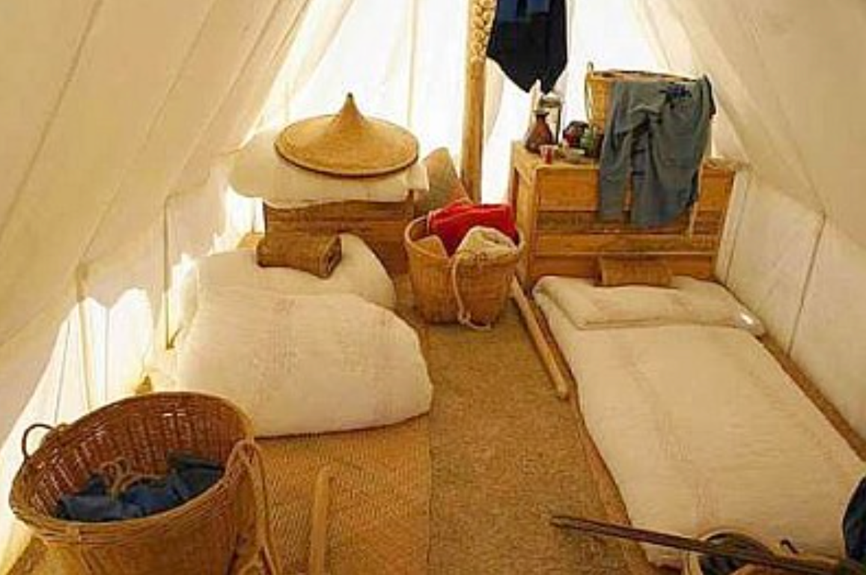
Chinese Tent

Sovereign Hill is now benefitting from its connection to the early Chinese mining immigrants and has opened its own office in China, according to Kirkham (2019) to attract the growing Chinese market that is adapting to independent travel, rather than the group tours.
Elg H. (2019) reports that Sovereign Hill has been focussing on the potential Chinese market for twenty years, has incorporated Chinese speaking guides and a program at the open mine venue that presents Chinese digging, camp and digital displays.

Sovereign Hill Annual Report 2017/8
In its latest published annual report, Sovereign Hill Museums Association (2018) states a new branding called ‘The Story Lives On’ that alters the easy glamorous. depiction of the era to a more realistic view of a hard life experienced by the hopeful miners of the day. This does appear to be a venture away from the education/entertainment genre of the Heritage Culture normally seen in such venues.
The Sovereign Hill Mission Statement, Sovereign Hill Museums Association (2018) has been changed to say, ‘to collect , conserve and interpret the mining, social cultural and environmental heritage of the region’.
Sovereign Hill Museums Association (2018) reported an annual visitation by tourists of 546,000 and an operating profit of $1,296,356 for the business year.
There are plans by Sovereign Hill Museums Association (2018) to upgrade all the venues and add new ones, costing $50m and hope to raise the visitor numbers to 1million by 2025.
An interesting comment in the report discusses an exchange program with The Black Country Living Museum in Dudley, UK to trade ideas and experiences. The report discusses a range of international activities to advertise Sovereign Hill on global markets.
Therefore, it is assumed the potential growth market for global participation in the Heritage/ Cultural Living Museum business, where the origins and venues differ, but the forward plans, by not having stagnating venues with tired tourists and refreshing the stories and regular intervals.


Sovereign Hill Handmaiden in period costume

Conclusion
The major barrier that Sovereign Hill has had to overcome is its regional location, given that the main tourist destinations of Australia are its cities, Sydney & Melbourne and its natural attractions, Great Barrier Reef & Uluru. It is therefore dependent on the largesse and goodwill of the National and State Governments to provide suitable infrastructure such as road, air links and an appropriate business friendly environment.
Fortunately, Sovereign Hills contribution to the tourist industry in general and the boost to the local economy is recognised, by the Government in terms of the growth of local businesses and employment in a rural area of traditionally low business expectations and job prospects.
The Victorian State Government reinforced this view by its media release, Delivering for all Victorians (2015), stating that Sovereign Hill is Victoria’s most valuable tourist icon. This is from the Minister for Regional Development. Sovereign Hill, according to Delivering for all Victorians (2015) boosts the region’s economic growth and employment, contributes $228 million economic benefit to the State while creating 1442 jobs.
The media release, Delivering for all Victorians (2015), reports that Sovereign Hill is a two times winner of the National Tourism award for best attraction and had over 700,000 visitors in 2012/2013.
Delivering for all Victorians (2015) also reports a State Government commitment of $8 million to assist in the upgrade of venues at the site; and a political statement that Ballarat has a rich History and the Government ensuring a great future.

From an Australian perspective, Sovereign Hill has tapped into the people’s psyche concerning the growth and development of a new country, overcoming impossible odds and supporting the family.
From and International perspective, the growth of emergent middle classes in India and China and an interest in a culturally different country, Sovereign Hill provides a living museum that provides experiences not known in their own countries.
It is interesting to note Sovereign Hill’s manipulation of its mission from one of pioneering efforts to develop Ballarat to conserving and interpreting the social and environmental aspects of the period.
The annual report states new venues that will reflect the more realistic darker times experienced by the miners and their families during the early years of Ballarat that shows a shift from the pioneering spirit (an everyman endeavour) to one of survival.
This paper would be interested in further research to ascertain whether Sovereign Hill’s polling has revealed a change in the tourist’s expectation and a shift from the purely entertainment aspect of a living museum to a more educative version. It must be assumed that Sovereign Hill’s preoccupation is to increase visitation numbers to remain a viable operation and their change in presentation reflects the tourist’s attitudes, especially concerning the environment.
As pointed out previously it is a fine line between authenticity and a sanitised view, as presented by a living museum, and to produce a satisfied visit by the tourist and their families.
A positive aspect of the Sovereign Hill operation, Sovereign Hill Museums Association (2018) is to conserve an maintain traditional trades and crafts such as wheelwrights, coachbuilding and candle manufacture which are exhibited at other regional venues; together with produce such as sweets sold at other retail outlets.
Sovereign Hill has proved to be a successful business in providing a living museum in the Cultural Heritage genre by possibly effecting constant change in its presentations and venues, thereby perpetuating a rationale for return visitors.
In regard to Sovereign Hill’s commitment to presenting the plight of the Chinese miners, this has a two-fold strategy by appealing to the growing Chinese tourist market and showing a political correctness by reflecting the multiculturism of contemporary Australia. It is perhaps indicative of modern society and social media that venues wishing to have a viable and sustainable business, there has to an honest debate concerning history as was, rather than written by the dominant culture at the time. Is Sovereign Hill is merely reflecting the generational changes in societies attitudes?
Sovereign Hill is entering its 50th anniversary and has proved that with the correct planning and vision, a viable and sustainable business model may be achieved in an extremely competitive market. The location is rural Australia has disadvantages in terms of infrastructure and logistics but has the advantage of low setup costs and the assistance of a grateful Government that wishes to boost the economy in area that may have been deficient in local business and employment.
With a reputation now secured, the availability of professional and academic positions is now accessible.
The challenge for Sovereign Hill, this paper assumes, is the vision to keep abreast of societies attitudes, in politically correct times, retaining the attributes of creating entertaining experiences for a public (that has no particular loyalty) while ensuring a degree of Authenticity.
A note of caution from the US Heritage industry that as determined by Hargrove C. (2003) is that the American tourist expects the truth when regarding the preservation and presentation shown at heritage sites. Hargrove C. (2003) warns against political boundaries or mandates when creating an authentic experience.
This paper suggests that sixteen years later, attitudes may have changed.

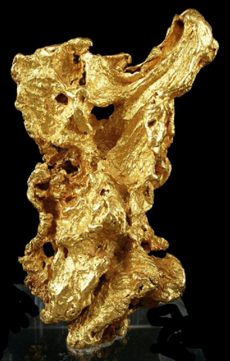
References
Clark I. D. & Cahir D. A. ( 2003) Aboriginal People, Gold and Tourism: The benefits of inclusiveness for Goldfields Tourism in Regional Victoria. Tourism Culture & Communication [online] Available from: DOI: 10.3727/109830403773043693 (Downloaded 5 November 2019).
Delivering for all Victorians, 2015. Sovereign Hill: Victoria’s most valuable Tourist Icon [media release] 6 February 2015 Available from: https://www.premier.vic.gov.au/sovereign-hill-victorias-most-valuable-tourist-icon/ [Downloaded 14February 2019].

Elg H. (2019) New statistics reveal Chinese visitors are leading the growth of Australia's spiking tourism, with Ballarat benefiting from the increase in international visitors to regional areas. The Courier [online] Available from: https://www.thecourier.com.au/story/5842870/ballarat-is-benefiting-from-national-tourism-growth-as-more-international-visitors-travel-to-regional-areas/?cs=62 (Downloaded 7 November 2019).

Evans M. (1991) Historical Interpretation at Sovereign Hill. Australian Historical Studies vol 24, no 96 pp 22, 142-152

Frost W. (2005) Making an Edgier Interpretation of the Gold Rushes: Contrasting Perspectives from Australia and New Zealand,International Journal of Heritage Studies, 11:3, 235-250, DOI: 10.1080/13527250500160526

Frost W. (2006) Cultural Heritage and Tourism in Australia: Concepts and issues. Working Paper 35/06: Monash University, Business and Economics [online] Available from: https://figshare.com/articles/Cultural_heritage_and_tourism_in_Australia_concepts_and_issues/5073511/1 (Downloaded 1 November 2019).
Hargrove C. (2003) Authenticity in Cultural Heritage Tourism. Save our heritage organisation [online] Available from: http://www.sohosandiego.org/reflections/2003-4/authenticity.htm [Downloaded 14February 2019]

Kirkham R. (2019) Sovereign Hill strengthens China appeal as more visitors travel independently. The Courier [online] Available from: https://www.thecourier.com.au/story/5857738/sovereign-hill-strengthens-china-appeal-as-more-visitors-travel-independently/ (Downloaded 7 November 2019).

Kyi A. 2017. Interview by Culture Victoria. Interviewed by Linda Horrocks. Digital Film, 5 May 2017 [online] Available from: https://cv.vic.gov.au/stories/immigrants-and-emigrants/many-roads-chinese-on-the-goldfields/anna-kyi-full-interview/ (Downloaded 7 November 2019)

Lowenthal D. (1985) The Past is a Foreign Country (Cambridge: CUP 1985) 224-231.
Sovereign Hill (n.d.) About Us [online] Available from: http://www.sovereignhill.com.au/sovereign-hill/about-us/ [Downloaded 18 October 2019
Sovereign Hill Education Blog (2017) What was the Anti-Chinese League? [online] Available from: https://sovereignhilledblog.com/2017/01/30/what-was-the-anti-chinese-league/ (Downloaded 7 November 2019)
SovereignHill (n.d.) Fact Sheet [online] Available from: https://www.sovereignhill.com.au/media/uploads/Sov_Hill_fact_sheet_2.pdf [Downloaded 18 October 2019]
Sovereign Hill Museums Association (2018) Sovereign Hill Annual Report [online] Available from: http://www.sovereignhill.com.au/media/uploads/Annual-Report-2017-18_LR.pdf
(Downloaded 7 November 2019).

