


Wide area Networks (WANs)

Tutorial 4 and 5

Faculty of Architecture, Computing and Engineering
School of Applied Computing
Mount Pleasant Campus
Swansea
SA1 6ED

- INTRODUCTION AND OBJECTIVES OF THE Exercises
In the lecture, you learnt about Pont to Point Connections. Apply your understanding and knowledge from what you learnt in the lecture about the topic by doing the following exercises:

Use your lecture notes, the library databases and/or the Internet to answer the questions.

1. What is difference in using a serial connection to that of a parallel communications?

2. Explain the three serial communication standards for LAN to WAN connections.

3. Point to Point communication links cannot connect countries and continents, true or false; justify your answer.

4. Multiplexing is an old scheme that still uses today. It allows multiple logical signals to share a single physical channel. Explain the two common types of multiplexing with an example.

5. Explain the following terms:
- Demarcation point
- DTE
- DCE

6. From the diagram below labelled and explain any four layer 2 encapsulation protocols
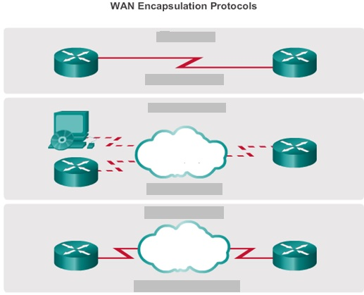

7. In the figure below the two show commands were used to troubleshoot a serial interface.
- The show interfaces serial command can return one of six possible states, name them.
- Explain the output of the show controllers serial
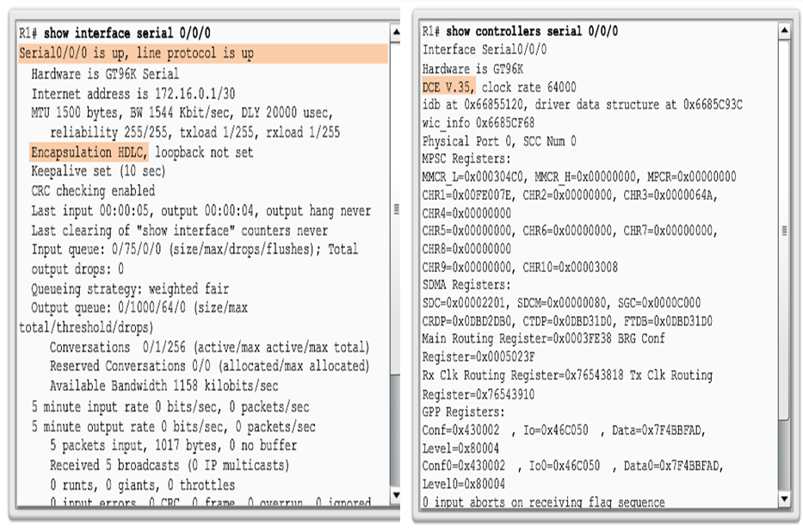
8. Explain the three phases when establishing a PPP session.

9. The following are PPP configuration options, explain them:
- Authentication
- Compression
- Error detection
- PPP Call back
- Multilink

10. Explain the below output of the show ppp multilink command.
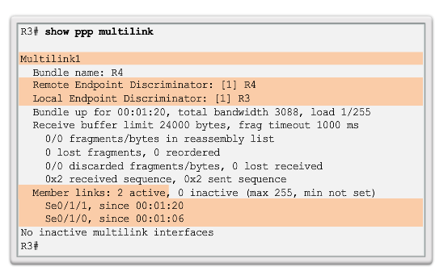

- Use a flow chart to illustrate the process of PPP encapsulation and Authentication

- The “debug ppp authentication” command below was used to troubleshoot a PPP configuration with authentication. Explain the output.



