
Module Name: Academic Skills in the Digital Era
Module Code: BMSW4013
Assessment 1: E-Portfolio
Student Name: Mohammad Sahel Wafa Atayee
Student Number: 2523023
Lecturer: Ffion Cumberpatch
Deadline: Friday 27th February 23:59PM

Wordcount: 1250
AI Acknowledgement
I acknowledge the use of ChatGPT (https://chat.openai.com) on 12 February 2026 to support structure academic tone.
I used the below prompts:
- “Help the academic words synonyms”
- “Check my writing for academic tone”
I confirm that I have not presented any AI-generated text as my own work. I confirm that I have retained copies of drafts, notes, and resources used before and after the use of AI tools.

Contents
1. Component 1: Development of Academic Skills 4
2. Component 2: Applicataion of Academic Skills 7
3. Component 3: Academic Poster ……………………………………………………………….……11

Component 1: Development of Academic Skills

1. Evaluating Academic Sources Using the CRAAP Test
Source 1:
Mexhuani, B. (2025) ‘Adopting Digital Tools in Higher Education: ‘Opportunities, Challenges and Theoretical Insights’, European Journal of Education, 60(1).
The source was obtained through Google Scholar
Currency: The article was published in 2025, so it is very recent and relevant at the moment of the digital transformation of higher education. Because of the high dynamism of the technologies including learning management systems (LMS), artificial intelligence tools, and learning analytics, the timeliness of the presented study makes it even more relevant.
Relevance: The article is focused on the institutional adoption of digital tools, such as online platforms, digital assessment system, and analytics dashboard. The technologies are directly associated with employability skills of students especially with digital fluency, adaptability, and independent learning.
Authority: The article has been published in the peer-reviewed European Journal of Education which is a reputable academic journal. Mexhuani makes a contribution to the study of the digital transformation of higher education, and the source is placed into the context of the established academic discourse
Accuracy: Using qualitative and quantitative data, the study is based on theoretical premises. Its results are consistent with other studies on the topic of digital transformation and institutional change, which makes it more credible.
Purpose: The article critically evaluates the digital adoption and provides policy and leadership recommendations. It is not commercial and academic in nature.
Source 2:
Daniela, L. (2022) ‘Inclusive technology-enhanced education’. ‘In Inclusive digital education’, Springer Nature, (pp. 1-11).
The source was obtained through Google Scholar

Currency: However, the book was written in 2022; therefore, it is still topical since it is devoted not to the two-month trends in the technological sphere but to pedagogical models.
Authority: Linda Daniela is an educational professor at the University of Latvia. The book is a compilation of scholarly articles by an editorship that is published by Routledge, a reputable scholarly publishing house. The writing of chapters is by experts in the area of digital pedagogy enhancing its scholarly validity.
Accuracy: The chapters rely on research findings and theories including blended learning, digital feedback systems and e-portfolios. The arguments are underpinned by the comparative studies and the established pedagogical theory.
Purpose: The book will educate teachers and scholars about practical online pedagogy. It is not advertisement focused and is academic in nature.

2. Synthesis of Academic Sources
The two sources investigate the idea of digital learning in a complementary way. Mexhuani, B.(2025) uses the macro-institutional perspective, claiming that to transform successfully, a digital transformation has to be led, invested in infrastructure, trained staff, and culturally changed. The article points out that the failure of digital initiatives usually occurs when there is no coordination during the implementation and long term planning. Conversely, (Daniela, 2022) dwells on the micro-level pedagogy. The book goes on to emphasis on blended learning models, digital assessment methodology as well as feedback systems that incorporate technology in designing learning. It does not focus on policy but rather looks at the effect of digital tools on student interaction and skills acquisition.The sources taken together prove that technology is not the sole factor that enhances education. Pedagogical quality (Daniela, 2022) has to be in line with institutional readiness (Mexhuani, 2025). Online learning is thus a challenge to an organization and a teaching opportunity.

3. Identifying a key Challenge and Opportunity
One of the most significant problems of digital higher education is the lack of equal access and disparities in digital competence. Mexhuani, B. (2025) states that infrastructural constraints, employee resistance and lack of training are some of the obstacles to successful implementation. In cases of fragmentation, the students can have access to poorly organized materials, lack of communication and support. According to (Daniela, 2022), less structured digital information has been reported to have a negative impact on concentration and academic performance, as it adds cognitive load. Digital inequality thus has another impact on access on top of the students developing employability skills including independent learning and critical thinking.
However the above challenge, a key opportunity is a Customized and Student-Centered Learning. Online learning presents the possibilities of personalized and flexible learning. Daniela, L. (2022) emphasises blended learning and digital feedback systems that enable students to re-watch the lectures they have already attended and track their progress. The flexibility permits self-reflection and learning. Mexhuani, B. (2025), however, warns that these benefits should be anchored on institutional support and how these are to be implemented. Efficient pedagogy can help digital learning foster self-determination and digital ability.
4. Academic Planning
In component 2 I will prioritize the main body which include the challenges and opportunities for the students in the digital era and will be evaluated by using recent literature. Beside that, strategies will be suggested with describing the importance of using digital leaning methodology. The report is a structured as follow format: introduction, challenges, opportunities, strategies and conclusion.

Task | Date/ Deadline
Finish research | 07/02/2026
Draft first section | 12/02/2026
Complete first draft | 17/02/26
Final editing | 26/02/2026

Reference List – Component 1
Daniela, L. (2022) ‘Inclusive technology-enhanced education’. In Inclusive digital education (pp. 1-11). Springer, Cham, available at: https://doi.org/10.1007/978-3-031-14775-3_1
Mexhuani, B. (2025) Adopting digital tools in higher education: Opportunities, challenges and theoretical insights. European Journal of Education, 60(1), available at: https://doi.org/10.1111/ejed.12819

Component 2: Application of Academic Skills
Online transformation has impacted the sector of higher education by affecting the structure of the curriculum, evaluation, and communication (Mexhuani, 2025). It is necessary to understand both challenges and opportunities since employability is becoming more and more digitally competent, as self-regulation and critical literacy (Mexhuani, 2025).
Challenges
Student learning can be compromised in the event of poorly organized digital environments. Daniela, L. (2022) states that ambiguous online resources raise the cognitive load. Students find it difficult to priorities, take notes and manage time when they are provided with the fragmented material without any guidance. According to (Dhawan et al., 2022), most of the students do not have sufficient self-regulation skills when it comes to online situations. Digital systems hence demand greater independent measures hence necessitating adaptation to be successful in academics.

Opportunities
Flexibility and collaboration can be increased with the help of digital platforms. According to (Mexhuani, 2025), online teamwork can be more active when organized. The reflection and communication are promoted through discussion boards, shared documents and analytics tools. These routines reflect digitized collaboration at work where employability is enhanced. Online education can hence bridge the gap between education and career building.
How Students Can Adapt to Succeed
Strategy 1: Enhancing Self-Managed Learning
Students need to have weekly targets, to devise some organized plans of studying and tracking their advancement by the use of digital applications. As (Dhawan et al., 2022) demonstrate, active planning contributes to the motivation and performance. Separating tasks into milestones and periodically examining the progress will help to achieve independence and accountability.
Strategy 2: The Cultivation of the Critical Digital Literacy
Students should be critical of information that is available online. According to (Daniela, 2022), in digital learning, the passive versus critical consumption needs to shift. These techniques allow checking the credentials of authors, date of publication and reliability of the source, which increases the accuracy of the research and the quality of analysis.
Strategy 3: Intended Online Cooperation
Teamwork and communication are facilitated by active involvement in organized group activities. Mexhuani, B. (2025) describes the collaborative approach to be most successful when it is associated with specific academic aims. Delegation, deadlines and communication through common platforms also build some skills that are important in any employment situation.
Conclusion
There are challenges and opportunities which come with digital higher education. The problems of cognitive overload and unequal access can impede the process, but the strategic adaptation allows students to enhance employability competencies (Bond & Bergdahl, 2022). Through the enhancement of self-control, the acquisition of critical digital literacy and intentional cooperation, students will be able to man oeuvre in the digital environment and promote long-term academic and career achievement
Reference List – Component 2
Bond, M. and Bergdahl, N., (2022). ‘Student Engagement in Open, Distance, and Digital Education’. (pp. 1-16), Springer Nature, available at: https://doi.org/10.1007/978-981-19-0351-9_79-1
Dhawan, N., Behera, B. and Gaur, M., (2022). ‘Effect of Online Education on Learning Styles, Social Life and Mental Health of Students & Trainees during COVID-19 Pandemic’: ‘A Review of Literature Findings’. IJSRED, 5(5), available at: https://ijsred.com/volume5/issue5/IJSRED-V5I5P65.pdf
Daniela, L. (2022) ‘Inclusive technology-enhanced education’. In Inclusive digital education (pp. 1-11). Springer, Cham, available at: https://doi.org/10.1007/978-3-031-14775-3_1
Mexhuani, B. (2025) ‘Adopting digital tools in higher education’: ‘Opportunities, challenges and theoretical insights’. European Journal of Education, 60(1), available at: https://doi.org/10.1111/ejed.12819

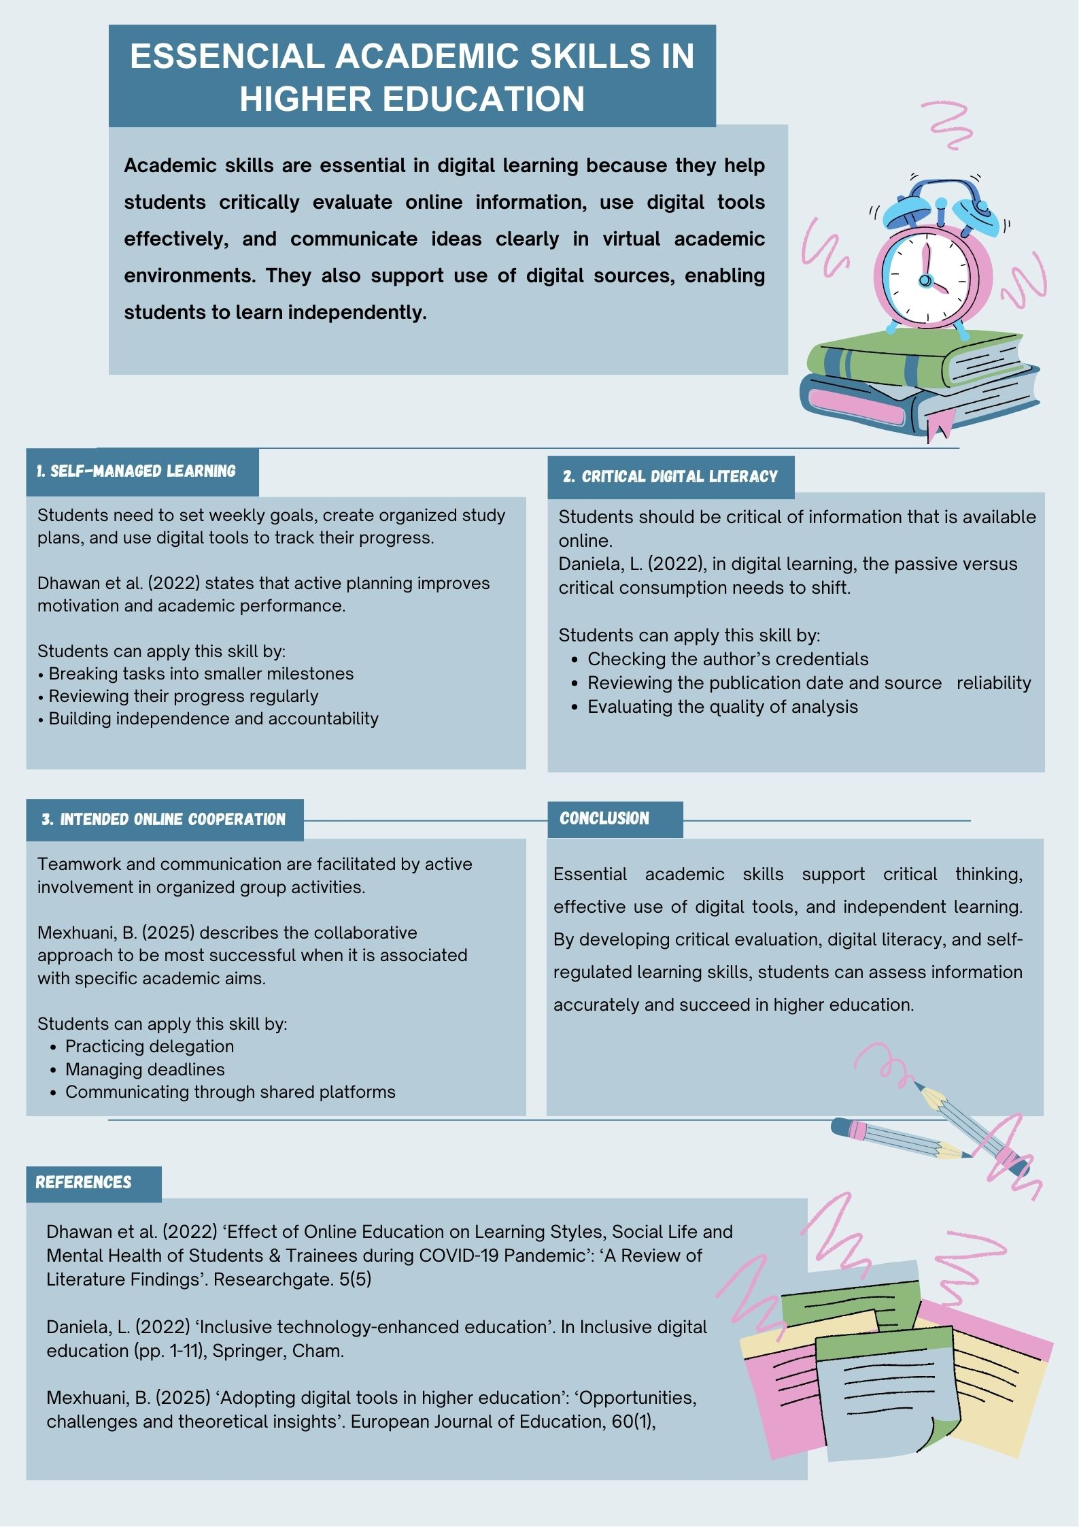
Component 3: Academic Poster

