HOTEL ADMINISTRATION AND FRONT OFFICE OPERATIONS

BMIH4004
LECTURER: MUHAMMAD CASSAMO
STUDENT: ALIN AXINTE 2234129

Table of Contents
Component 1: Learning log 3
Component 2: Practical task 7
Trip Advisor review 7
Letter of complaint 8
Component 3: Portfolio 10
Introduction 10
Element 1 – Pre-arrival 10
Element 2 – Arrival 11
Element 3 – Duration of stay 11
Element 4 – Departure 12
Conclusion 12
References 14

COMPONENT 1: Learning log
I am going with Gibb’s reflective model in terms of reflecting on the skills, experiences, and theoretical principles along with exemplifying industry examples of the identified key skills.
Gibb’s Reflective Model
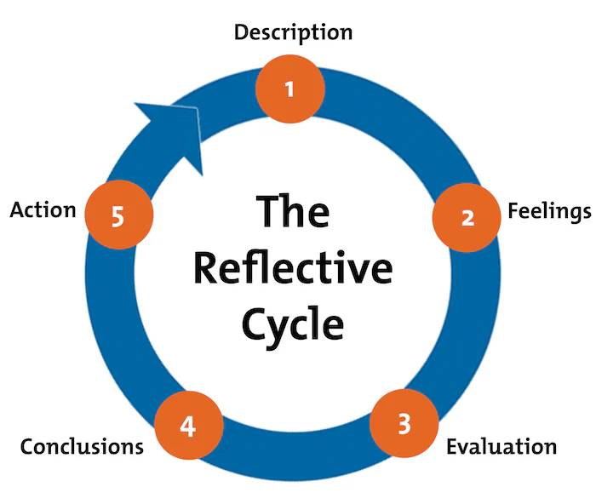
Figure 1: Gibb's reflective model
(Source: Mindtools.com, 2023)
Description
Firstly, I would like to say that I have learned so many things from this course. Then we have informed the importance of identification of the primary skills. I learned and got to know the most required skills which include communication skills, multitasking, technological skills, problem-solving skills, adaptability skills, conflict resolution skills, and many more. During the entire course, I have experienced that there was a need to have all the mentioned skills in terms of dealing with the guests in a better way. We were taught each and every important factor that the employees of the hotel front office need to have for better consequences. The course stressed the development of all above mention skills so that they can be beneficial for the hotels. Hence, I think that good communication skills would definitely help both my professional as well as personal life along with my academic career.
Feelings
I have some positive feelings about what I experienced from this course. Identifying all the required skills for the hotel front office makes me confident as communication is one of my biggest strengths. It has been noticed that Hilton Worldwide and Marriott International focused on effective communication in terms of delivering excellent hospitality-related services. Jawabreh et al. (2022) argue that better communication with customers leads to significant satisfaction. I got to know that communication theories like cognitive dissonance theory, the Lasswell communication model, and so on predominantly emphasize the importance of active listening, empathy as well and clarity with the guests.
Evaluation
I have got to know about various important things in terms of the hotel front office. As per the opinion of Kijpoonphol and Linh (2021), the front office staff needs to have communication skills for better coordination and collaboration. I learned that communication skills are one of my biggest strengths. I also learned that I have the potential in terms of multitasking. During this course, I also addressed my weaknesses in some skills, like problem-solving skills, technological skills, and conflict-resolution skills. The lack of all these skills creates hindrances in providing quality services to the guests. According to Ekhsan et al. (2020), good communication will help in resolving any misunderstanding with the guest. However, the experiences that I have acquired helped broaden my learning process effectively.
Analysis
I always aim to take on all advantages of the course on needs skills for the hotel front office and I believe that this will open up many new ways of opportunities for me. However, I have learned that both the skills of customer service and communication were deeply rooted in the hotel front office and there was the need to focus on developing such skills. According to Mendoza (2023), customer service has been considered the foundation of hospitality. I applied all gathered knowledge both for my real life as well as towards continuous learning so that it will be beneficial for my personal as well as professional life. I have experienced some challenges regarding issues related to customer services, guest-staff interaction, handling operational challenges, and so on due to the lack of problem-solving skills, conflict resolution skills as well and technological skills. This makes me determined to focus on the enhancement of these skills so that they will be helpful in providing the guests with better experiences.
Conclusion
I have experienced a wide range of knowledge and I am sure that this will be advantageous for me. On the other hand, I also think that acquiring knowledge would add value in terms of dealing with the especially the real world. I learned that there was a need to focus on developing all required skills to deliver an exceptional guest experience as well thereby ensuring the efficiency of hotel operations. This is a well-known fact that all these required skills with aligning the theoretical principles of hotels severely emphasizing operational efficiency, guest satisfaction, and a collaborative and good work environment.
Action plan
Objectives | Action plan | Resources | Time -duration
Problem-solving skills | Problem-solving tools, as well as techniques, and continuous learning, can be helpful | Join online workshops, online courses, and industry conferences can provide better results | 2-3 weeks
Conflict-resolution skills | Development of empathy, the development of emotional intelligence, development of negotiation skills | By going to empathy exercises and assessments, attending negotiation workshops could be helpful in this context | 2-4 weeks
Technological competencies | Continuous learning, adaptation, and following of the industry trends, the development of advanced skills | Attending online learning-related platforms, following tech blogs and podcasts, and attending tech webinars can be advantageous in this context | 5-6 weeks
Table 1: Action plan
(Source: Self-developed)

COMPONENT 2: Practical task

Trip Advisor review
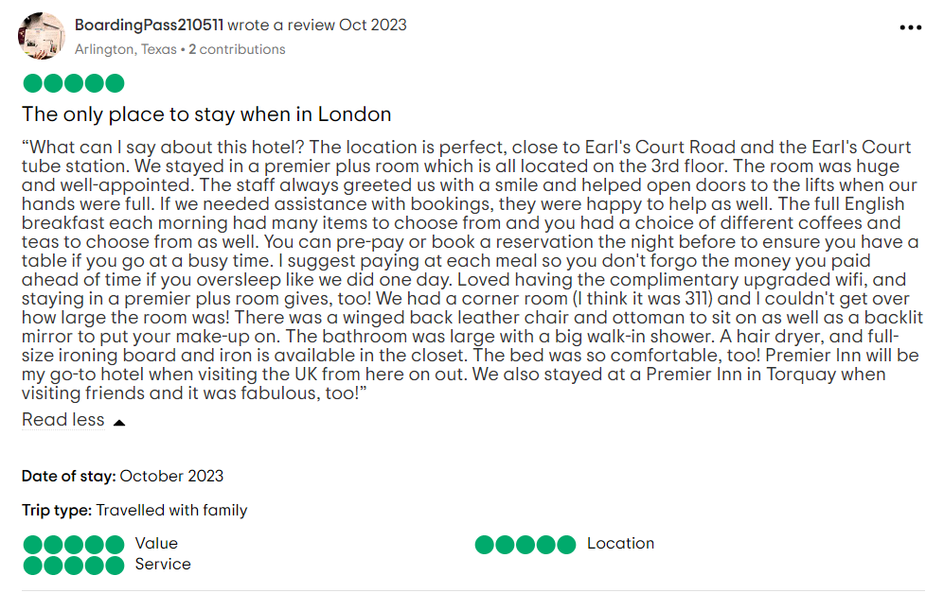
Figure 1: Positive review of Premier Inn London
(Source: Tripadvisor, 2023)
Dear Guest,
First, we are grateful to you for such delightful feedback, and at the same time, we were very much overjoyed by hearing about such a positive experience at Premier Inn, London. Moreover, your kind words about the wellness of our hotel rooms, very well-trained staff, their behaviour, as well as services and meals and so on have hugely and truly enlightened our day. Moreover, your appreciation has been working as the motivation factor in order to maintain excellence and commitment.
This makes us look forward mainly to welcoming you back for the next tour and at the same time ensuring such a beautiful memorable stay. Hence, please do not make any hesitation mainly in terms of reaching out if you want any specific arrangement for a return. This is because your satisfaction is the biggest priority to us.
Warm regards, from Premier Inn, London

Letter of complaint
Premier Inn, London, UK
Date: 13.11.2023

[Subject: Seeking apology for the inconveniences]

Dear Mr. Ronald Federick,

We trust that this letter encounters you very well and at the same time appreciate you for taking your valuable time to give us feedback with us. Your positive experience is the utmost priority to us and at the same time, we regret that we are not able to meet all your expectations.
Please accept our apologies for such inconvenience that you have encountered mainly with the quality of morning breakfast, noise, and hygiene. We took all these facts very seriously.
Therefore, we become more concerned and thereby conduct a thorough review in an effective manner mainly about breakfast services and addressing the improvement areas. We know the significance of providing a higher state of dining experience. Your comments will guide us in terms of enhancing our service offerings in the future. On the other hand, for noise disturbances, we strictly review all the room-assigned protocols mainly to minimize such kinds of disturbances that you encounter and thereby ensure a more healthy and peaceful environment. Moreover, in terms of hygiene matters, we are also reinforcing the housekeeping procedures, and based on that we conduct additional training to ensure standards level of cleanliness have been consistently upheld.
However, we are committed to mitigating all such issues and we would also like to provide you with special discounts of nearly 25% the coupon code has also been attached to the mail and that can be availed during booking by our app or official website as a gesture of goodwill. We expect that you will definitely give us that opportunity to serve and thereby rectify all such mistakes. Besides this, we also understand that regaining trust twice is not easy but we hope you accept our apologies and stay with us again to encounter better experiences first-hand. We assure you that we will be taking care of our team's engagement, their proper training, making a transparent conversation, focusing on continuous improvement, implementation of immediate solutions, and so on. We ensure that focusing on our employment, problem-solving skills, and ownership helps in changing negative feedback into the biggest opportunity for robust growth and improvement and enhancing reputation as well as overall experiences of the guests regarding the establishments. We all know that employee satisfaction is one of the biggest factors in increasing your likelihood and giving positive feedback to us. One thing if you are willing to give us your additional staying details it will be very helpful for us to conduct a thorough investigation. Moreover, please feel free and contact us while you want directly through our email address or phone number from our official website. Your feedback is very important and invaluable to us and therefore we take the needed steps and focus on all these matters seriously.
Once again, we really feel sorry for such inconvenience, and thank you for bringing all these matters to light. We look forward to possibly welcoming you to Premier Inn and thereby providing the best experiences that you deserve.

Warm regards
Customer Service Manager, Premier Inn

COMPONENT 3: Portfolio

Introduction
This study has shed light on the primary elements that were required for managing the hotel guests' cycle’s four stages in an effective manner. This study has therefore focused on providing an overview of the elements including pre-arrival, arrival, duration of stay, and departure in a hotel that may provide positive experiences to the guest and thereby the organization reach the summit of succession.

Element 1 – Pre-arrival
The key elements that this stage includes are better communication with the guests, reservation management, personalization, and so on. As per the opinion of Özdemir et al. (2019), the reservation procedures in the pre-arrival stage played a significant role in ensuring the suitability of the rooms. Therefore, it can be worth mentioning that this stage is considered the most instrumental, especially in creating a positive experience by setting expectations, offering personalized services, streamlining operations, and thereby improving guest convenience. As argued by Volchek (2020), a personalised service leads towards tourists’ satisfaction. This is a vital phase, especially in terms of managing effectively that significantly contributes to the entire loyalty as well as the satisfaction of the guests. Hence, for example, the Hilton Honors name is well-going as Hilton has invested in a mobile app that helps enhance guests’ pre-arrival experiences (Hilton.com, 2022). Moreover, the guests will be able to use such apps for booking, check-in, selecting rooms, and so on. Therefore, in the opinion of Shvaikovskaia (2022), innovative design and technology-driven approach helps to streamline the process of pre-arrival and at the same time provides guest convenience. On the other hand, the mobile check-in of Marriott International also allows the visitors to check in mainly before their arrival thereby enhancing their pre-arrival experience (Marriott.com, 2023). A well-managed state of the pre-arrival stage has the potential to fix the foundation for better experiences in aligning with services offered and guests' expectations.

Element 2 – Arrival
This stage include some key elements like personalization opportunities, effective communication, proper guidance and manual, smooth transitions, cultural sensitivity, room readiness, safety protocols as well as security assurance, and many more (Ihmshimla.org, 2023). As argued by Lukanova and Ilieva (2019), the second stage of the guest cycle includes and should focus on the welcoming procedures of the guests. Therefore, for instance, here it is worth mentioning the name of The Ritz-Carlton which is known for its unique and exceptional services mainly during the time of arrival stage (Ritzcarlton.com, 2023). This has been noticed that the staff is also well-trained and well-educated in terms of offering assistance, providing personalized greetings and thereby creating a good and warm atmosphere in the hotel. On the other hand, as per opined by Hsiao et al. (2023), culture have the potential that can facilitate positive exchanges that severely contributes to the pleasant service experiences. Additionally, a welcoming and smooth arrival experience significantly contributes to the whole impression of the guests and that makes them interested to stay.

Element 3 – Duration of stay
The primary elements of this stage include service quality, guest engagement, facility maintenance, and so on. The consistency of high-quality service including dining, housekeeping, and many amenities indeed needed in terms of guest retention. As per the opinion of Xie and Sun (2021), the perceived quality services of the different stages of hotel services influence customer satisfaction. The commitment of The Four Seasons has been noticed towards providing attentive and personalized services (Fourseasons.com, 2023). There was the need for regular maintenance as it helps in ensuring all kinds of facilities at the optimal conditions of guests’ staying. This is because it contributes to creating positive experiences for the guests. Apart from this, the offers an ample amount of opportunities to the guests in terms of participating in the activities as well as enjoying the best ever experiences throughout their staying in hotels. On the contrary, Abdel‐Hamid et al. (2022) argued that regular maintenance and following up the trends help enhance the staying experience of the guests. Kimpton Hotels’ name is worth mentioning here for their unique initiatives and social hours for guest engagement to enhance guests' experience (Ihg.com, 2023). Hence, it is worth mentioning that sustaining a higher quality of service as well as an effective engagement of visitors positively contributes in terms of providing the best experiences. This leads to greater satisfaction as well as loyalty of the guests.

Element 4 – Departure
There is also a need to focus on ensuring the positive and smooth departure of the guest is significant in terms of guest satisfaction. The primary elements that this stage includes are express check-out, farewell experience, feedback collection, after departure customer service, and so on. This is because offering the scope of express check-out helps streamline the departure process which leads to guest satisfaction. As per the views of Youssofi et al. (2023), designing and incorporating digitalized experiences for guests helps to remain competitive in the business market. Nowadays, many hotels offer express check-out options through mobile apps that give more comfort and a positive experience to the guests. On the other hand, the feedback of the guests is also helpful in identifying and thereby continuous improvement areas and robust development. On the contrary, Narayan et al. (2022), stated that the incorporation of the feedback system in hospitality can be helpful in terms of understanding the improving areas. It has been noticed that Marriott doing post-stay surveys in terms of gathering up the guests' opinions (Marriott.com, 2023). Apart from this, providing a memorable and at the same time positive farewell has the potential and play a critical role regarding guests' satisfaction and appreciation. Therefore, it is well argued that a positive and good departure experience leads towards lasting influences and impressions of likelihood in terms of repeating the business as well as positive reviews. Mandarin Oriental is well going in this context, as the staff members were focusing on ensuring this fact mainly by identifying any kind of needs of guests, offering their assistance and at the same time expressing their ample gratitude for stay (Mandarinoriental.com, 2023).

Conclusion
It can be concluded from the above discussion that it is needed for hotel managers to have a better understanding of the hotel guest cycle in order to create a memorable and seamless guest experience. Moreover, by leveraging technology and best practices, the hotels can focus on optimizing each and every individual stage of this guest cycle and thereby foster loyalty, satisfaction as well and positive reviews of guests.

References
Abdel‐Hamid, T.A., Ahmed, M.A.E.A.S., Zohry, M.A.F., Elshabrawy, G.A. and Elgohary, E.M., 2022. The role of digital transformation in improving customer satisfaction: An empirical study on Egyptian hotels. The Electronic Journal of Information Systems in Developing Countries, 88(6), p.e12234.

https://www.researchgate.net/profile/Ghada- Elshabrawy/publication/362041340_The_role_of_digital_transformation_in_improving_customer_satisfaction_An_empirical_study_on_Egyptian_hotels/links/63b5839303aad5368e64a201/The-role-of-digital-transformation-in-improving-customer-satisfaction-An-empirical-study-on-Egyptian-hotels.pdf

Ekhsan, M., Badrianto, Y., Fahlevi, M. and Rabiah, A.S., 2020, February. Analysis of the effect of learning orientation, role of leaders and competence to employee performance front office the Sultan Hotel Jakarta. In 4th International Conference on Management, Economics and Business (ICMEB 2019) (pp. 239-244). Atlantis Press. https://www.atlantis-press.com/article/125934113.pdf

Fourseasons.com, (2023). SERVICE CULTURE. Available at: https://www.fourseasons.com/about_four_seasons/service_culture/[accessed on: 11th Nov 2023]

Hilton.com, (2022). Unlock your stay with the Hilton Honors app. Available at: https://www.hilton.com/en/p/hilton-honors-mobile-app/ [accessed on: 11th Nov 2023]
Ihg.com, (2023). Being Best Comes First. Available at: https://www.ihg.com/kimptonhotels/content/us/en/press/kimpton-history#:~:text=Kimpton%20has%20been%20awarded%2C%20%E2%80%9CHighest,or%20get%20fussy%20about%20size. [accessed on: 11th Nov 2023]

Ihgplc.com, (2023). How our business works. Available at: https://www.ihgplc.com/en/about-us/how-our-business-works#:~:text=We%20operate%20hotels%20in%20three,meet%20guests'%20needs%20and%20occasions. [accessed on: 11th Nov 2023]
Ihmshimla.org, (2023). FRONT OFFICE AND GUEST HANDLING. Available at: https://ihmshimla.org/wp-content/uploads/2020/03/UNIT-2-Guest-Cycle-FO-Notes-By-Priya-Sharma-March-2020.pdf[accessed on: 11th Nov 2023]

Jawabreh, O., Al Fayoumi, T. and Bareya, A., 2022. Customer Satisfaction towards Communication Skills of Front Office Staff at the Hotel (Case Study Five Stars Hotels in Aqaba). Geo Journal of Tourism and Geosites, 44(4), pp.1312-1318.

https://www.researchgate.net/profile/Raed-Masadeh/publication/365342389_CUSTOMER_SATISFACTION_TOWARDS_COMMUNICATION_SKILLS_OF_FRONT_OFFICE_STAFF_AT_THE_HOTEL_CASE_STUDY_FIVE_STARS_HOTELS_IN_AQABA/links/636fa54354eb5f547cc86b25/CUSTOMER-SATISFACTION-TOWARDS-COMMUNICATION-SKILLS-OF-FRONT-OFFICE-STAFF-AT-THE-HOTEL-CASE-STUDY-FIVE-STARS-HOTELS-IN-AQABA.pdf

Kijpoonphol, W. and Linh, N.D., 2021. Needs of front office staff’s English communication skills. Journal of Thai Hospitality and Tourism, 16(1), pp.92-105.

https://so04.tci-thaijo.org/index.php/tourismtaat/article/download/148487/168771

Lukanova, G. and Ilieva, G., 2019. Robots, artificial intelligence, and service automation in hotels. In Robots, artificial intelligence, and service automation in travel, tourism and hospitality (pp. 157-183). Emerald Publishing Limited.

https://www.researchgate.net/profile/Georgina-Lukanova 2/publication/337022595_Robots_Artificial_Intelligence_and_Service_Automation_in_Hotels/links/5dc147a44585151435e992f9/Robots-Artificial-Intelligence-and-Service-Automation-in-Hotels.pdf

Marriott.com, (2023). Discover Your Member Benefits. Available at: https://www.marriott.com/loyalty/member-benefits.mi [accessed on: 11th Nov 2023]
Marriott.com, (2023). Mobile Marriott. Available at: https://www.marriott.com/en-us/hotels/mobmc-mobile-marriott/overview/[accessed on: 11th Nov 2023]
Mendoza, D.V., 2023. Analysis Of The Filipino Brand Of Customer Service In The Accommodation Sector. Journal of Namibian Studies: History Politics Culture, 33, pp.4685-4704.

https://namibian-studies.com/index.php/JNS/article/download/2830/2086
Mindtools.com, (2023). Gibbs' Reflective Cycle. Available at: https://www.mindtools.com/ano9qiu/gibbs-reflective-cycle[accessed on: 11th Nov 2023]

Narayan, R., Gehlot, A., Singh, R., Akram, S.V., Priyadarshi, N. and Twala, B., 2022. Hospitality Feedback System 4.0: Digitalization of Feedback System with Integration of Industry 4.0 Enabling Technologies. Sustainability, 14(19), p.12158.

Özdemir, A.İ., Çolak, A. and Shmilli, J., 2019. Business process management in hotels: with a focus on delivering quality guest service. Quality & Quantity, 53(5), pp.2305-2322. https://avesis.agu.edu.tr/yayin/fa8c9bb1-6e10-4910-9a44-7657214eeedf/business-process-management-in-hotels-with-a-focus-on-delivering-quality-guest-service/document.pdf

Ritzcarlton.com, (2023). The Gold Standard ABOUT THE RITZ-CARLTON. Available at: https://www.ritzcarlton.com/en/about-the-ritz-carlton/[accessed on: 11th Nov 2023]

sciencedirect.com, (2021). How and when does multitasking affect customer orientation of hotel employees? Available at: https://www.sciencedirect.com/science/article/pii/S1447677021000590 [accessed on: 11th Nov 2023]

Xie, C. and Sun, Z., 2021. Influence of perceived quality on customer satisfaction in different stages of services. Nankai Business Review International, 12(2), pp.258-280.

https://www.researchgate.net/profile/Chunchang-Xie/publication/353108480_Influence_of_perceived_quality_on_customer_satisfaction_in_different_stages_of_services/links/630d5d4d5eed5e4bd12d7cc4/Influence-of-perceived-quality-on-customer-satisfaction-in-different-stages-of-services.pdf

Youssofi, A., Jeannot, F., Jongmans, E. and Dampérat, M., 2023. Designing the digitalized guest experience: A comprehensive framework and research agenda. Psychology & Marketing. https://onlinelibrary.wiley.com/doi/pdf/10.1002/mar.21929

