Tracy Webb 1706861
SJYW5009

The aim of this essay is to recognise an issue that affects young people in today's society and to plan a six-week programme of summer activities to address the issue posed. The programme will address the needs and interests of young people and will represent the purposes, principles and values of youth work.
An issue that I feel has become a concern is the number of teenagers reluctant to try various new things within their daily lives. Being a teen in today's competitive world is no easy task. Peer pressure, body image, harsh competition in every field, puberty, high parental expectations and other pressures can lead a teenage girl or boy to think they are not cut to survive, let alone succeed as stated by Psychology today they believe that One of the most common fears that young people face early in their lives is to try something new. It can be overwhelming the fear and anxiety of failure, and if it isn't resolved as a child it can torment you throughout life. www.psychologytoday.com
Fear is a traditional response to new or experiential challenges. These situations make children feel confused, helpless, weak and anxious. We take off the sense of security and power that an individual has. According to the NHS website the reason teenagers and young people are reluctant to try new things is down to low self- esteem and lack of confidence. If you have low self-esteem or confidence, you can hide from social situations, stop trying new things and avoid challenges. In the short term avoiding difficult and challenging situations leaves you feeling much safer however, this can backfire in the longer term, because it strengthens the underlying doubts and fears. It teaches you the unhelpful rule that avoiding things is the only way to cope. https://www.nhs.uk/conditions/stress-anxiety-depression/raising-low-self-esteem/
There are many factors that can contribute to a teen having low self-esteem. Appearance (self-image)- It may seem superficial, but most teens are concerned about their appearance to some extent. This can be difficult to deal with, because in some cases changing one's appearance can be difficult. Teens who are overweight often feel bad about themselves, as do teens who think that the way they look is some sort of irregularity. Peers— Teenagers can have peers making fun of them or putting them down. If a teen feels like an outcast, it can affect the self-esteem he or she has. Parents, coaches and teachers who are constantly criticising can make a teenager feel like he or she can never do anything right, and is never valued. Such constant criticism can make him or her feel disliked. We are all keen to live up to our potential. But teenagers sometimes feel the pressures of unrealistic expectations. Sometimes, a teenager can be his or her own biggest critic. As Harrison and Wise states ‘The purpose of youth work is to facilitate and support young people’s growth through dependence to interdependence, by encouraging their personal and social development and enabling them to have a voice, influence and place in their communities and society’. (Harrison and Wise 2005, p17)
I spoke to the young people who attend the youth club and discussed with them what I had to do and asked them would they like to participate and did they have any ideas that they thought would be appropriate or any areas of the subject they would like covered for their own benefit. When young people are active in planning and making decisions, the events of the youth group are more likely to be meaningful and enjoyable for young people. It ensures young people are more likely to attend, and when they do, they demonstrate positive behaviour. http://www.youthworkessentials.org/volunteer-induction/involving-young-people-in-the-youth-group/guidelines-for-youth-participation.aspx
The six-week programme of activities which will be discussed will focus on confidence building. The programme will be carried out at my local youth centre where I am currently employed as a trainee Youth Worker. It will take place every Wednesday. The young people who attend the youth centre are aged between eleven and Sixteen years old. I have already obtained a good relationship with the young people and have gained their trust. Firstly, I will provide the young people with a leaflet (see appendix 1), which be a plain leaflet hoping to achieve two goals, one to make them smile and two encourage them to attend. The various information regarding the programme will be in a form of a session plan (see appendix 2). I am going to use a NAOMI model to demonstrate the six-week programme preparation. (see appendix 3)
As youth workers, it is important to note that we provide learning opportunities to encourage young people to grow and develop and to support them be who they are and help them to do what they would like to do in their current life and future. (Harrison and Wise, 2005)
Links to Government Policy for Young People
Youth policy is: “Government's commitment and practice towards ensuring good living conditions and opportunities for the young population of a country” (Finn Denstad, Youth Policy Manual, 2009)
There are many significant government policies which can be connected to this project, with the significant one being 5 pillars of Youth Work. Informal and non-formal learning supports wider learning, development and participation in society. This is underpinned by the five pillars of youth work in Wales7. https://gov.wales/national-youth-work-strategy-2014-2018 A common vision for the future of youth work in wales is set out in the plan. The strategy points out that it has not yet completely understood the strength and value of youth work in Wales. It describes how youth work can mean different things to different individuals and how youth work is not limited to a single background or environment. The six-week activity plan relates to this government policy as the policy states that youth benefits all youth, but maximises the impacts of assistance for the most disadvantaged youth, which is also the focus demographic for the six-week plan. The policy also notes how trustworthy partnerships led young people to make better decisions, which is the young worker's desired outcome The importance of youth work is founded on empathy for youth and the ideals of equality and equal opportunities. Through its collaborative partnership with youth it provides learning opportunities which are Educative, Expressive, Participative, Inclusive and Empowering. https://www.wlga.wales/youth-service
A very important government policy I would like to link in to the programme is the Engagement and Progression Framework (Welsh Government) The plan aims to reduce the number of young people between the ages of 11 and 25 who are not engaged in schooling, work or training (NEET). This includes a review of the Youth Engagement and Change-Implementation Plan executive. To implement this strategy effectively, all aspects of the network including the Welsh Government, regional agencies, local authorities and suppliers will have to work together. The strategy lays out the different positions and responsibilities of key players and anticipates how each partner will perform. This seeks to promote reform through the whole system in Wales and explains how local government, together with the Welsh Government and partner organisations including Careers Wales and educational and training providers can put in place more successful processes to facilitate this transition. https://gov.wales/youth-engagement-and-progression-framework-implementation-plan . Another important policy is The 5 ways to well-being. The 5 ways of well-being were first introduced in 2008 by the New Economics Foundation (NEF), an organisation aimed at changing the economy, while working for people and the world. The Children's Society partnered with NEF to develop their methods of reporting on wellbeing, which was published in 2014. The Children's Society conducted centred groups with 70 children aged 8-15 in 6 different schools all over the country, and found that the NEF's Ways to Well-being also worked for children and youth, except to adapt the last from giving to creative and play. The last government policy I would like to link in to the 6-week programme is the Well being of Future Generations Act 2015 (Wales). This is an act about improving the social, economic, environmental and culture well- being of Wales. This act believes Wales faces several challenges now and in the future. The policy focuses on their 7 well-being goals, these are a globally responsible Wales, a prosperous Wales, a resilient Wales, a healthier Wales, a more equal Wales, a Wales of cohesive communities, a Wales of vibrant culture and thriving Welsh language. These well-being goals reflect the kind of Wales that many people would like to witness. There are several different public bodies including Welsh government, local councils, local health boards and national libraries whose job is to work toward achieving the critical 7 goals. I understand that this incredibly critical government policy is related to the programme, as the programme focuses on positive youth well-being.

Outcomes
Before I begin the sessions I need to be clear on my expected boundaries including behaviour with staff members and with the young people It is argued that the experience of positive, safe and stable relationships helps children and young people build secure attachments, develop self-confidence, self-esteem and self-reliance and contributes to a strong sense of identity and belonging (Fahlberg,1994; Ryan, 2012; Care Inquiry, 2013), however Sapin (2013) explains that "shared activities enable young people with similar situations, identities or experiences to build meaningful relationships, to learn from one another and to have a voice in issues that concern them”. I will start each session with an ice breaker which will include a small “get to know each other” game. I believe this is important as any young person can attend the youth club and the young people may not know each other. An example of the game I would use is the “Me,Too game! Where the leading youth worker will ask the group to sit or stand in a circle, all you will need is a ball of wool. The person who starts will have the ball of wool and they start by saying something positive for example something that they like or enjoy doing and if someone in the group enjoys the same they shout out “Me, Too, if there is more than one person then you give the ball of wool to the person who said it first but keep hold of the end and go back to where you were standing. So by the end of the game there will be a web style of wool which just adds to the fun. As the main part of the session I will use a physical activity, I believe it is a good way to encourage team building. I will introduce yoga. Yoga has been linked to decreased stress, depression anxiety, as has any form of exercise. One research also found that in people with schizophrenia, this was helpful. Many who do yoga also often show improved feelings of health, joy and overall satisfaction. https://www.forallourwellbeing.co.uk/wellbeing/yoga/benefits-of-yoga (See appendix 4)
At the end of each session I will do an evaluation which will be in the form of traffic lights. Traffic Light Assessment is a rating method for measuring results against a target. It is a good way to effectively communicate performance information, and has the benefit of being widely recognised by all countries https://citoolkit.com/articles/traffic-light-assessment/ . I will have a set of traffic lights on a large piece of card and at the end I will give each young person who participated a post it notes it will be their choice if they were to right anything on it but they will be asked to place it on the colour of how they feel the session went and if they feel they gained anything from it. Green being yes they thought the session was really informative and beneficial to them, Amber was the session was ok, maybe a little more information could have been given or Red, no the session was a complete waste of time and they did not learn anything from it. (See appendix 5)

I was of course looking for positive results from the sessions and for the young people to have fun while attending. As a youth worker team, we all wanted the youth to come away from the sessions and feel good about themselves, and have a more positive perspective. As a team, we wouldn't talk about something negative around the youth and everything we learned negative from the youth or if we were to indulge in a negative discussion, we'd turn it into something positive or constructive and offer explanations why it had a stronger effect on how we felt. Our main goal was to make sure the youth had fun and the events related to the youth, but at the beginning of each session I made it clear to all the youth that we were here for them if they wanted to speak with someone as “Youth Workers make themselves approachable to any young person who might need to talk” (Jeffs and Smith, 1987).

Personal Strengths and Challenges Faced
I feel that I have used my best practise and have implemented the National Occupational Standards (NOS) for young people to achieve the best possible result from the programme. I believe that one of the key strengths of the six-week programme was the team work from the youth team. Overall the support and interaction was excellent, without this the sessions would not have been possible to deliver This allowed the young worker to concentrate on the core session planning and delivery. I felt like I had engaged the young people incredibly well as I was familiar with many of the young people who attend the youth club. The new young people to the session could see how comfortable and settled the current people were so I also believe it enabled the young people to become acquainted with me, which led to the active involvement and engagement of the young people in the sessions. According to Ord (2007), positioning young people as border pedagogy and information development site expands opportunities for collaborative learning between young people and youth workers, as well as offering places where young people can learn together and become involved in social activities such as group work or involvement.
I thought that there were just a few flaws in the six-week plan. One was the timing because half way through the session some more youth would come and try to see what we were doing but couldn't participate because we'd already begun so I think more publicity would be helpful.

Monitoring and Evaluation
To assess the success of the 6-week programme, I will look at the method of assessing the outcomes, Outcome evaluations measure a program's success in achieving progress. Outcome evaluations concentrate on tough questions about what happened to people in the programme and how much of a difference the programme made for them. Outcome evaluations evaluate the efficacy of a system in bringing about change. I will do this each session by using an evaluation in the form of the traffic light game. I will take in to consideration all the feedback from the young people and change things if needed.

Appendix 1

Come and join the fun………..
We will be doing a 6-week programme focusing on self- esteem
Every Wednesday 7pm – 8pm

Friends, games, take part, activities, fun, learn new things

Appendix 2
Session Plan Week 1 01/08/20- 7pm – 8pm
Lead Youth Worker- Tracy Webb
Tanyard Youth Project
Activities Materials Learning objectives Potential Challenges
Wool Game Ball of wool Speaking to new not enough YP
(15 mins) people Shy YP
--------------------------------------------------------------------------------------------------------------------------------------
Warm up Yoga Mats Relaxation Skills Physical issues
(10 mins)
Yoga Stop watch Teamwork Not appropriate
(20 mins) clothing
Warm down Exercise
(5mins)
Traffic lights coloured paper Listening to others Run over time
Evaluation made in to Thinking Not knowing what to
(10 mIns) traffic light write

Appendix 3

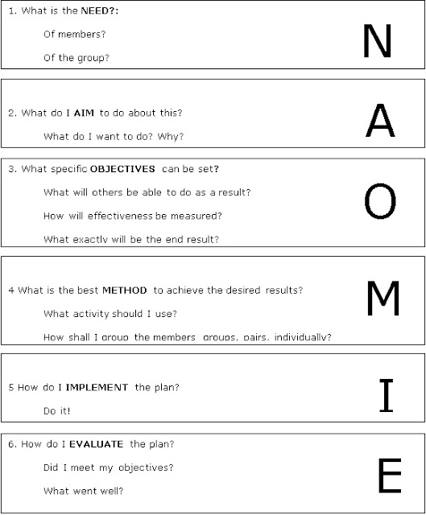

Needs
To decide upon an issue that is affecting young people in today’s society
To deliver a 6-week programme on the chosen issue
Provide relevant information and required information on the chosen issue to the young people
Raise awareness within the centre to the young people especially the t the young people facing the issue.

Aims
For the youth worker to use their learned skills to lead the programme
That the results of all the sessions are both beneficial and encouraging for the youth
To ensure the programme relates to Government policies
Supervising and reviewing the project over the 6-week time period

Objectives
To make young people feel more positive about their self-esteem
Measuring the program's success through conversations with young people
To further the young people’s knowledge of relevant issues
For enjoyable games and meaningful knowledge for young people

Method
Place ice breakers at the start of each session
Focussing on positive outlook
The main part of each session will be fun activities
To make sure every session will end with an evaluation

Implementation
Will include the wool activity as the icebreaker
Main part will be yoga to relax the mind
Evaluation will be the traffic lights game
All staff who are involved will join in.
Evaluation
I was really pleased with the attendance over the 6 weeks.
Young people enjoyed the sessions
The feedback from the young people was very positive
New friendships were made

Appendix 4

Yoga Poses
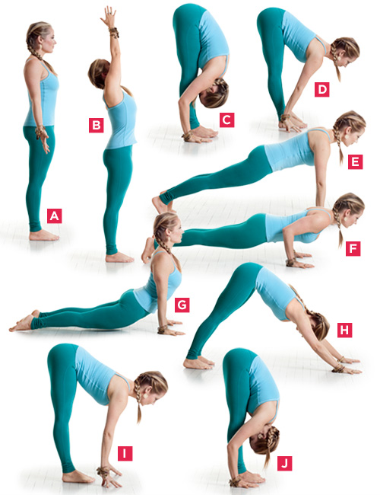

Appendix 5



