
PLC Assignment 1

  - HND in Electrical and Electronic Engineering

  - University of Wales Trinity Saint David

  - Steffan Weaver

  - WEA19853802

  - GOEE5002

  - PLC’s and Control

Table of Contents
Introduction 3
Task 1 4
Principles of PID 4
Zeigler Nichols tuning method 4
Task 2 5
Signal Flow diagram 5
Mason’s Gain formula 5
Task 3 6
State Space modelling 6
Obtaining a state space model 6
Task 4 7
Root Locus Analysis 7
Root locus diagram 7
Task 5 9
What is a Bode diagram? 9
How to make a Bode diagram 9
What is a Nichols chart? 10
What are the advantages of using a Nichols chart? 10
How to plot using Nichols chart 10
References 11

Introduction
In this assignment the tasks require me to research and get a better understanding into the different factors that make up a control system. This will involve research into PID (Proportional Integral Differential) control, along with its benefits and relative effects of the three terms, with a detailed description of the two Zeigler Nichols tuning methods and examples of how each method may and may not be applied with any limitations. The assignment also requires research into Signal flow diagrams and applying Mason’s Gain, State Space modelling and obtaining it, Time domain analysis which includes the concept of root locus and representing systems using root locus whilst finding out values and finally, in depth research into Bode diagrams and Nichols chart along with a brief discussion on how they are to be used.

Task 1

Principles of PID
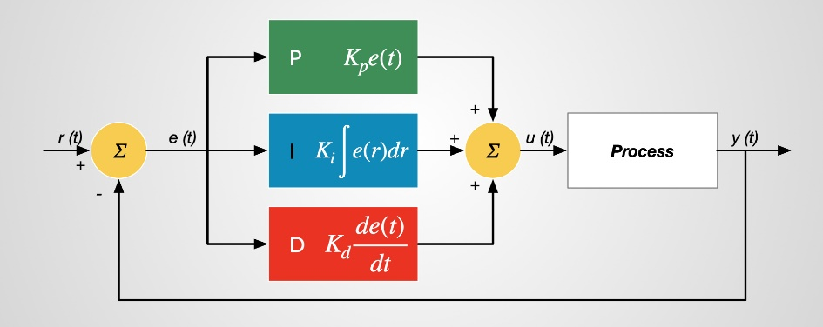 (McAleer, 2023)
The basic concept underlying a PID controller is that each of the three terms proportional, integral, and derivative needs to be independently "tuned." An input is subjected to a correction factor that is computed based on the variation between these values. For instance, the heat will be turned up if the oven is colder than needed. The three steps are as follows:
- Adjusting a target in proportion to the difference is known as proportional tuning. Because the applied correction decreases as the difference gets closer to zero, the goal value is never reached.
- Integral tuning tries to address this by increasing the correction factor by efficiently cumulating the error result from the "P" action. For instance, "I" would act to raise the delivered head if the oven continued to be below temperature. But when the target is attained, "I" tries to drive the cumulative error to zero, which causes an overshoot, instead of stopping the heating.
- By reducing the correction factor as the target gets closer, derivative tuning aims to reduce this overshoot.
(Omega, n.d)

Zeigler Nichols tuning method
Ziegler-Nichols guidelines are frequently used in the industry. These restrictions usually lead to aggressive control performance. Maximum step overrun of 25% is the design condition for the Ziegler-Nichols tuning rules.
The step response method and the frequency response method are the two approaches offered by the Ziegler-Nichols tuning method. When using the step response tuning method, it can only be used on stable processes. Open loop tests are required to estimate process characteristics. Only stable processes can be employed with the step response tuning method. To evaluate the characteristics of a process, open loop experiments are necessary. The frequency response tuning technique can be applied exclusively to closed loop PID controllers. The goal is to get estimated process characteristics by pushing the controller to its limits of stability. (incatools, n.d)

Task 2

Signal Flow diagram
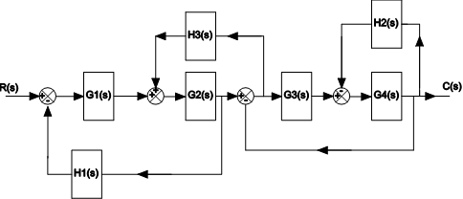
The nodes in the diagram below are created by any points from the signal flow block diagram that have more than two points of connection.
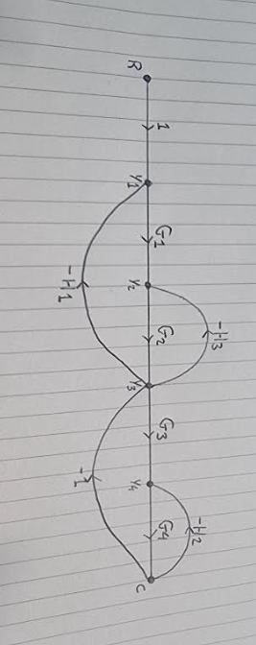

Mason’s Gain formula
By making a sum of all individual loop gains, adding them to the sum of all possible two non-touching loops and subtracting the sum of all possible three non-touching loops, we get the equation below which is Mason’s gain formula. By doing this we get the transfer function.
$$T= \frac{C(s)}{R(s)}= \frac{\sum_{i=1}^{N}{Pi∆i}}{∆}$$
$$∆=1-\left(-H1G1G1+H3G2+-1G3G4+-H2G4\right)+\left(H3G2+-H2G4\right)-(0)$$
$$∆=1-\left(-H1G1G1+H3G2+-1G3G4+-H2G4\right)+H3G2+-H2G4$$
$$T=\frac{C(s)}{R(s)}=\frac{G1G2G3G4}{1-\left(-H1G1G2+H3G2+-1G3G4+-H2G4\right)-(H3G2-H2G4+-H1G1G2-H2G4)}$$

Task 3

State Space modelling
A physical system can be mathematically represented using state space modelling (SSM), which uses differential equations, state variables, and a set of inputs and outputs. SSM is constructed using two different kinds of equations known as state equations. (Farhan Mumtaz, 2021)
In order to characterize physical systems, control engineering and system theory regularly use the state-space representation. A system can be represented as a collection of input, output, and state variables connected by first-order differential equations by specifying appropriate internal states. (Presonus, n.d)

Obtaining a state space model
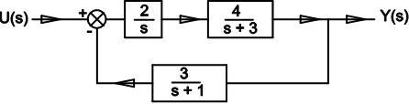
$$G\left(s\right)= \frac{\frac{2}{s}+\frac{4}{s+3}}{\frac{3}{s+1}}=\frac{Y\left(s\right)}{U(s)}$$
$$G\left(s\right)= \frac{\frac{6}{s^{2}+3}}{\frac{3}{s+1}}=\frac{Y(s)}{U(s)}$$
$$\frac{6}{s^{2}+3}U=\frac{3Y}{\dot{Y}+1Y}$$

Task 4

Root Locus Analysis
The root locus is symmetrical about the real axis and can be represented graphically in the s-domain. Due to the fact that the open loop poles and zeros have values that might be either real or complex conjugate pairs in the s-domain. (tutorialspoint, n.d)
The contributions of each open-loop pole and zero to the locations of the closed-loop poles are clearly displayed in the root-locus plot. The root-locus plot also illustrates how the open-loop zeros and poles should be adjusted to ensure that the response satisfies requirements for system performance. (K.Craig, 2001)

Root locus diagram
$$G\left(s\right)=\left(s+2\right)\left(s+3\right)(s+4)$$
$$G\left(s\right)=\left(s^{2}+5s+6\right)\left(s+4\right)$$
$$G\left(s\right)=s^{3}+4s^{2}+5s^{2}+20s+6s+24$$
$$G\left(s\right)=s^{2}+9s^{2}+26s+24$$
$$G\left(s\right)=s^{3}+9s^{2}+26s+24$$
$$\frac{1}{(s+2)(s+3)(s+4)}=\frac{1}{s^{3}+9s^{2}+26s+24}=3s^{2}+18s+26$$
$$\frac{-b±\sqrt{b^{2}-4ac}}{2a}=\frac{-18±\sqrt{{18}^{2}-4×3×26}}{2×3}$$
$$-3±3\sqrt{{18}^{2}-4×3×26}$$
$$-3±3\sqrt{{18}^{2}-4×3×26}$$
$$-3±3\sqrt{12}$$
$$root1=-3+3×3.46=7.38$$
$$root2=-3-3×3.46=-13.38$$
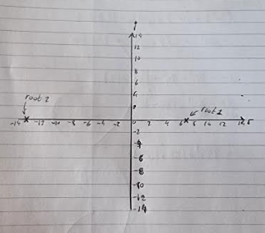
$$G(s)\frac{K}{(s+1+2j)(s+1-2j)(s+2)}$$
$$G(s)\frac{K÷(s+1+2j)(s+1-2j)(s+2)}{1+K÷(s+1+2j)(s+1-2j)(s+2)}$$
$$G(s)\frac{K}{\left(s+1+2j\right)\left(s+1-2j\right)\left(s+2\right)+K}$$
$$\left(s+1+2j\right)\left(s+1-2j\right)\left(s+2\right)=0$$
$$\left(jw+1+2j\right)\left(jw+1-2j\right)\left(jw+2\right)+K(-1)=0$$
$$\left(s+1+2j\right)\left(s+1-2j\right)\left(s+2\right)+K\left(-1\right)=0$$
$$s^{2}+s-4+s^{2}+2+K(-1)=0$$
$$s^{3}-2+s^{2}+K(-1)=0$$

$$K=\frac{s^{3}-2+s^{2}}{-1}$$
$$\frac{d}{dx}\left(\frac{u}{v}\right)=\frac{v\left(du÷dx\right)-u(dv÷dx)}{v^{2}}$$
$$\frac{dK}{ds}=\frac{\left(-1\right)\left(2s^{2}+2s\right)-(s^{3}-2+s^{2})(-1)}{{-1}^{2}}$$
$$\frac{dK}{ds}=\frac{-s^{3}-2+s^{2}}{s^{3}+2-s^{2}}$$
$$-s^{3}-2+s^{2}=0$$
$$\frac{-b±\sqrt{b^{2}-4ac}}{2a}$$

Task 5

What is a Bode diagram?
A bode diagram is a plot used to analyse the stability of control systems. An example of this is when designing and analysing power supply feedback loops. Dr Henrik Wayne Bode created the first Bode plots in the 1930s while he was employed by Bell Laboratories. Bode plots have the benefit of being a simple and widely used method for characterising a linear time invariant system's frequency response.
(R&S Essentials, n/a)
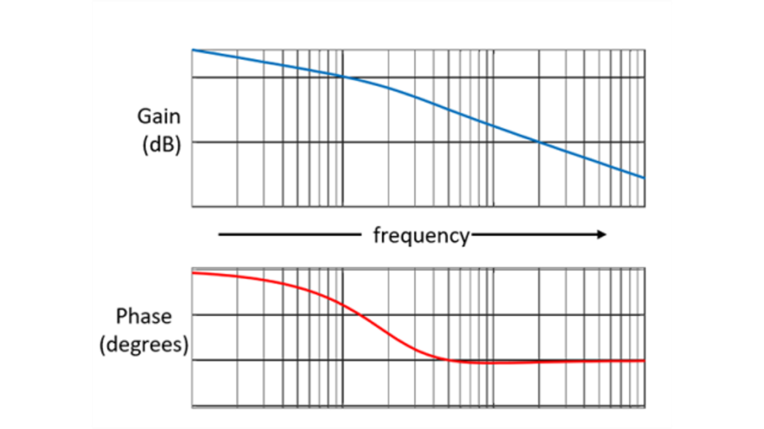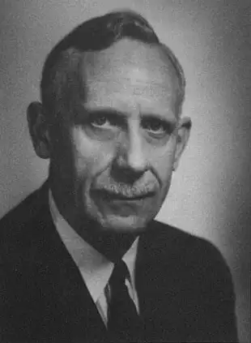
(ROHDE&SCHWARZ, n/a) (Brooks, n/a)
“Bode plots show us magnitude and phase, but only for an open loop transfer function KG(s) evaluated at s=jω, 0<ω<∞, whereas the root locus, using some open loop L(s), shows the complex trajectory of closed loop poles when ranging some parameter K∈(0,+∞).” (Liberzon, 2019)
Bode graphs display the variations in phase and magnitude as a function of frequency, or the frequency response. Two plots with semi-log scales are used for this. Usually, the magnitude, or "gain," is plotted at the top in dB. Phase is plotted at the bottom, usually expressed in degrees.

How to make a Bode diagram
There are two plots that make up the Bode plot or Bode diagram.
- Plot of magnitude
- Phase diagram
The logarithmic scale of angular frequency is represented by the x-axis in both plots. On the other hand, the y-axis in the magnitude plot and the phase angle in the phase plot, respectively, show the magnitude (linear scale) and phase angle (linear scale) of the open loop transfer function.
The open loop transfer function's dB magnitude is -
M=20log|G(jω)H(jω)|
The open loop transfer function's phase angle, expressed in degrees, is -
ϕ=−G(jω)H(jω) (tutorialspoint, n/a)

What is a Nichols chart?
A Nichols Chart, sometimes referred to as a Nichols Plot, is a plot used in signal processing and control system design to ascertain a feedback system's stability and closed-loop frequency response. It is known as the superior practical method for feedback loop design and test, the creator of the Nichols chart was Nathaniel B. Nichols in 1947. (Electrical4U, 2022)
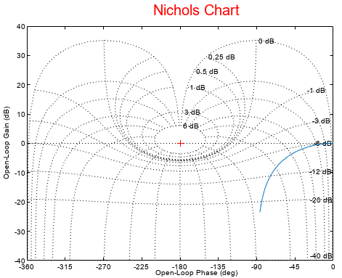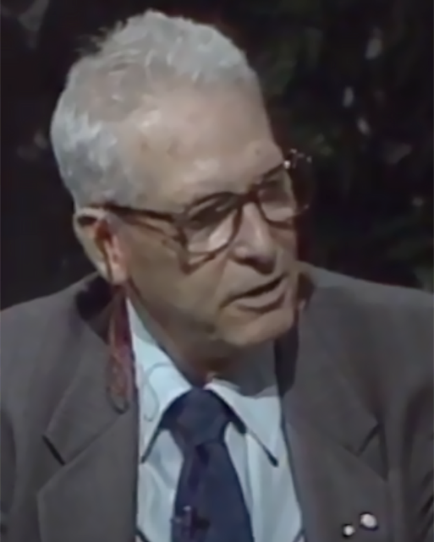
(MathWorks, n/a) (IEEE Control Systems Society, n.d)

What are the advantages of using a Nichols chart?
The Nichols plot has several benefits in the field of control systems engineering. They are as follows:
- Gain and phase margin are readily and graphically established.
- Specifications for frequency domain are given by the Nichols chart.
- From the open-loop frequency response, the closed-loop frequency response is derived.
- The system's gain can be changed to appropriate values.
(testbook, n.d)

How to plot using Nichols chart
The phase of G(jw) in deg and magnitude of G(jw) in dB are computed for different values of w and tabulated in order to create the Nichols plot. Corner frequencies are typically the ones chosen. Select the proper scales for the y-axis magnitude. Place all of the points on a regular graph sheet, connect them with a smooth curve, and then add the mark frequencies that go with each point. (Mishra, 2011)

References
Brooks, H., n/a. Hendrick Wade Bode 1905-1982. [Online]
Available at: https://www.nae.edu/189189/HENDRIK-WADE-BODE-19051982
[Accessed 11 April 2024].
Electrical4U, 2022. Nichols Chart: What is it?. [Online]
Available at: https://www.electrical4u.com/nichols-plot/
[Accessed 11 April 2024].
Farhan Mumtaz, N. Z. Y. S. T. M. B. S. R. K. O. I., 2021. Review on non-isolated DC-DC converters and their control techniques for renewable energy applications. Ain Shams Engineering Journal, 12(4), pp. 3747 - 3763.
IEEE Control Systems Society, n.d. Nathaniel Nichols. [Online]
Available at: https://ieeecss.org/contact/nathaniel-nichols
[Accessed 11 May 2024].
incatools, n.d. Explore the 3 PID tuning methods. [Online]
Available at: https://www.incatools.com/pid-tuning/pid-tuning-methods/#:~:text=The%20Ziegler%2DNichols%20tuning%20method,and%20the%20frequency%20response%20method.&text=This%20method%20can%20only%20be,required%20to%20estimate%20process%20characteristics.
[Accessed 16 May 2024].
K.Craig, n.d. Root Locus Analysis & Design. [Online]
Available at: http://engineering.nyu.edu/mechatronics/Control_Lab/Criag/Craig_RPI/2001/RLocus_Analysis_Design.pdf
[Accessed 11 May 2024].
Liberzon, P. M. R. a. P. D., 2019. ECE 486 Control Systems. In: Y. Han, ed. ECE 486 Handbook (from Fall 2019). Illinois: ECE ILLINOIS, p. n/a.
MathWorks, n/a. nicholsoption. [Online]
Available at: https://uk.mathworks.com/help/control/ref/nicholsoptions.html
[Accessed 11 April 2024].
McAleer, K., 2023. PID CONTROLERS. [Online]
Available at: https://www.kevsrobots.com/resources/how_it_works/pid-controllers.html
[Accessed 14 May 2024].
Mishra, A., 2011. Control Systems Engineering. [Online]
Available at: https://avitec13.weebly.com/uploads/7/8/6/9/7869447/cs_unit_iii_6.pdf
[Accessed 11 May 2024].
Omega, n.d. How Does a PID Controller Work. [Online]
Available at: https://www.omega.com/en-us/resources/how-does-a-pid-controller-work#:~:text=The%20working%20principle%20behind%20a,and%20applied%20to%20the%20input.
[Accessed 14 May 2024].
Presonus, n.d. What is State Space Modeling?. [Online]
Available at: https://legacy.presonus.com/learn/technical-articles/What-Is-State-Space-Modeling#:~:text=The%20state%2Dspace%20representation%20is,by%20first%2Dorder%20differential%20equations.
[Accessed 16 May 2024].
R&S Essentials, n/a. Understanding Bode plots. [Online]
Available at: https://www.rohde-schwarz.com/uk/products/test-and-measurement/essentials-test-equipment/digital-oscilloscopes/understanding-bode-plots_254514.html
[Accessed 11 April 2024].
ROHDE&SCHWARZ, n/a. Understanding Bode plots. [Online]
Available at: https://www.rohde-schwarz.com/uk/products/test-and-measurement/essentials-test-equipment/digital-oscilloscopes/understanding-bode-plots_254514.html#gallery-5
[Accessed 21 March 2024].
testbook, n.d. Frequency Response Aanlysis. [Online]
Available at: https://testbook.com/question-answer/consider-the-following1-bode-plot2-nyquist-p--5f64f40ca3e528c250aed4df
[Accessed 11 May 2024].
tutorialspoint, n.d. Construction of Root Locus. [Online]
Available at: https://tutorialspoint.com/control_systems/control_systems_construction_root_locus.htm
[Accessed 14 May 2024].
tutorialspoint, n/a. Control Systems - Bode Plots. [Online]
Available at: https://www.tutorialspoint.com/control_systems/control_systems_bode_plots.htm
[Accessed 11 April 2024].

