“I Finally Found Someone to Talk To”:
A Study of Life in Mensa
and People with High IQs

Kristi Prewitt

M.A. in Engaged Anthropology
University of Wales Trinity Saint David
May 31st, 2020


Master’s Degrees by Examination and Dissertation
Declaration Form
1. This work has not previously been accepted in substance for any degree and is not being concurrently submitted in candidature for any degree.
Name Kristi Prewitt
Date May 31, 2020
2. This dissertation is being submitted in partial fulfilment of the requirements for the degree of
Name Kristi Prewitt
Date May 31, 2020
3. This dissertation is the result of my own independent work/investigation, except where otherwise stated.
Other sources are acknowledged by footnotes giving explicit references.
A bibliography is appended.
Name Kristi Prewitt
Date: May 31, 2020

4. I hereby give consent for my dissertation, if accepted, to be available for photocopying, inter- library loan, and for deposit in the University’s digital repository
Name Kristi Prewitt
Date May 31, 2020
Supervisor’s Declaration.
I am satisfied that this work is the result of the student’s own efforts.
Signed: …………………………………………………………………………...
Date: …………………………………………………………………………..

ABSTRACT

The following research was conducted on those who have IQs in the top 2% of the world’s population. The primary participants were members of a non-profit high IQ society known as Mensa. My ethnographical research consisted of participant observation, virtual ethnography, and structured and unstructured interviews. To properly understand ‘intelligence’, it was important to recognize and define specific terms. ‘Unisan(s)’ was termed created to define those who did not have a reported IQ within the top 2% of the world’s population. Mensan(s) were designated as those who did have IQs in the top 2% and were member of the Mensa organization. ‘Hyper-intelligent’ is a general term for those scoring in the top 2% and not dependent on membership to Mensa. However, ‘genius’ is a reserved term for mainly the ‘hyper-intelligent’ who have achieved exceptional accomplishments that have been used for the betterment of humankind. Mensa was discovered to offer a safe social framework for its members and due to the many differences and challenges Mensans have, it offers a ‘safe space’ for its members to meet and socialize. Unfortunately, hyper-intellectuals are met with much adversity due to their differences and are often abused verbally and physically. Most are socially rejected and find maintaining relationships outside of Mensa challenging. However, due to current research more efforts are being made to understand and help the hyper-intelligent live more satisfying lives. This study highlights the past problems, recognizes gaps in incompatibilities in Unisan society such as sociolinguistics and suggests how future research may benefit those with the hyper-intelligent.

ACKNOWLEDGEMENTS

I would like to thank Mensa for the overwhelming support in helping not only with my dissertation but in helping me have a better understanding of myself.

And I would also like to thank my supervisor, Luci Attala, for the patience, guidance and knowledge she provided during the writing of this dissertation.

TABLE OF CONTENTS
ABSTRACT ii
ACKNOWLEDGEMENTS iii
LIST OF FIGURES vi
LIST OF TABLES vii
INTRODUCTION 1
LITERATURE REVIEW 2
CHAPTER ONE: METHODOLOGY 7
CHAPTER TWO: DEFINING LEVELS OF INTELLIGENCE 12
CHAPTER THREE: THE SOCIAL STRUCTURE OF MENSA 16
CHAPTER FOUR: MEETING THE MENSANS 21
Linguistic Phenomena 21
Cognitive Phenomena 23
Problem-Solving 24
Hypersensitivities 26
‘Autism’ 28
Reflexive Experience 29
Life Outside of Mensa 30
CHAPTER FIVE: MENSAN ETHNOLOGY – FINDING A REFUGE FROM A WORLD OF ABUSE 31
General Population and The ‘Myth’ of Genius 31
Family 32
School 33
Romantic Relationships 33
Career 35
Reflexive Predicaments 35
CHAPTER SIX: MENSAN ONTOLOGY – A STATE OF CONFUSION 38
Ontological Confusion 38
Anxiety/Fears 38
Lack of Compassion From Unisan Society 39

‘Imposter Syndrome’ 39
Isolation and Rejection 40
Anomie 40
Other Negative Affects 41
CHAPTER SEVEN: DISCUSSION 43
Positive Observations 47
CONCLUSION 49
BIBLIOGRAPHY 51
REFERENCES 56
Figures 56
APPENDIX 57

LIST OF FIGURES

FIGURE 1.1 9
FIGURE 3.1 25
FIGURE 6.1 45

LIST OF TABLES

TABLE 1.1 29

INTRODUCTION
“Mensa became my tribe.” - Max

The purpose of this research is to study the ethnography of people who are known to have very high IQs. I explore and attempt to understand these people of ‘higher intelligence’, often referred to as ‘geniuses’. I will be conducting this research mainly through the non-profit organization, Mensa, the world’s oldest and largest high IQ society. In order to obtain membership, a score in the top 2% or higher of the world’s population on specific and designated intelligence tests must be obtained. (The Official Website Of British Mensa - The High IQ Society, 2020) But what makes a ‘genius’ a ‘genius’ besides a high IQ score? Are they different from people with lower IQs and if yes, then how? I set out in my dissertation to ask ‘who are these people, where are they and most importantly, what do they do? Do they live special lives or have secret privileges given their exceptional IQ?’

Since I, too, have an IQ in the top 2% as evidenced through intelligence tests supervised by Mensa this research will also include a reflexive approach. And therefore, I also ask does my high IQ make me different? Do I have special abilities or characteristics that I’m not aware? Since, I’m not rich, have a high profile job, or consulting with government officials ‘to save the world’ then what purpose does my high IQ serve?’ Although I was granted membership into Mensa, I have never participated in the organization in any way prior to my research.

Mensa adopts a very strict ‘members only’ policy so therefore, obtaining information about its members and activities is difficult without membership but as a member and with special permission, I was allowed to conduct ethnographical research on this rare and mysterious subculture. (The Official Website Of British Mensa - The High IQ Society, 2020)

LITERATURE REVIEW
“And then there is the difficulty of researchers starting from different bases so that comparing like with like becomes problematic. However, in spite of the difficulties inherent in the production of any review, it is still perfectly possible to succeed.” (Bell 2010, p. 107)

In approaching my literature review, I found it exceptionally challenging in finding previous literature specifically related to ‘higher intelligence’ and within the anthropological domain. The predominant discipline is psychology and although, I was able to find a plethora of studies provided from various psychological disciplines, I found no prior research in the field of anthropology. My attempts resourcing the Bodleian Library at Oxford University, the library at University of Wales Trinity Saint David, Academi.eu, as well as extensive online research using primarily the search engine Google, all proved to be remarkably unsuccessful in providing anthropological studies in any version of ‘higher intelligence’. I was, however, inundated with research in regards to race and IQ (Kalantzis and Cope, 2020) that proved to be quite a controversial topic for many years but found it was not referencing the focus of my research, and that is those with very high IQs. Or I had the conundrum of ‘higher intelligence’ also meaning reconnaissance used by various government agencies. This posed a considerable problem in researching my topic and it became apparent that the term ‘intelligence’ needed greater clarification and as ‘higher intelligence’ was used to describe both spy activities and those who did have exceptional intelligence, the term was not specific enough to locate information focused only on those with IQs in the top 2% of the world’s population, which was, of course, my subject of study. But mostly A.I., artificial intelligence, that has profound interest from scientific, computer, psychological and anthropological communities, not to mention the worldwide population in general, represented the majority of my search results.

The germ ‘gifted’ also proved to be a too wide or general term. But more importantly I would later discover it was a term shunned by most of my participants as it invokes false ideologies of the subculture by being “judgment-laden and evokes unhelpful connotations of privilege.” (Falck 2020, p. 5)

After interviewing relevant officers and professionals who are in supportive and/or administrative roles in MENSA, they were also unable to produce any research either from published or non-published works from the organization itself in an anthropological field. Due to the lack of research results, I focused on published works that have concentrated on the higher IQ community regardless of discipline. But as mentioned prior, the primary field was psychology. The most relevant resources were produced and written by fellow Mensa members, notable psychologists Sonja Falck, Roland Persson, and Noks Nauta. Also, Bernard Mulholland, a historian and Grady Towers, a member of several high IQ societies had written about living life with a very high IQ that proved to be resourceful. However, I was able to find literature written by Leta Hollingworth, a psychologist who performed a great deal of foundational studies in high IQ by using anthropological methods specifically participant observation in a longitudinal study of high IQ children and adults. She is termed the ‘great observer’ (Towers, 1987) and cited often by those studying high IQ. Falck, Persson, Towers, Mulholland, Nauta and now, I, too, have cited Hollingworth’s valuable work even though it originated in 1926. The importance of her observations and findings has been well documented with many studies being repeated with similar findings. (Hollingworth, 1926)

“Some of them she had followed for as long as twenty years, taking a personal interest in the individual children and their problems, advising them, assisting them, continuously observing them, and frequently testing and measuring them.” – (Hollingworth 1926, Foreword)

I cited heavily from author Sonja Falck’s book, Extreme Intelligence. Sonja is also a psychotherapist and Senior Lecturer at the School of Psychology, University of London, UK. However. Her book is the most comprehensive up-to-date study on people with very high IQs and the most relevant literature to my research.

“Dr. Falck’s book is of singular importance for adults with exceptional intelligence and clinicians who work with them therapeutically. She places her data, observations, suggestions, and conclusions in the context of an extensive literature review, making her book comprehensive and up to date…this is a compellingly-written work that makes a major contribution this field.” – Dr. Jerald Grobman, Distinguished Fellow of the American Psychiatric Association, USA (Falck 2020, back cover)

In October 2019, I attended her book launch where the book was issued as an early release. I did, however, acquire her book post my fieldwork. Much of the information provided in her book strongly correlated with many of my findings particularly in the various aspects of social rejection. It’s important to note that the actual publishing date was in February 2020 and I have cited accordingly. Furthermore, as Dr. Falck and I are members of Mensa, two of the clients mentioned in her book I met at meetings and were willing participants in my research as well. Specifically, my study correlated with her findings in the many difficulties and challenges faced in relationships, romantically and through family members. Comparable findings in regards to abuse and isolation were also noted. But most importantly, we share the same conclusion that the hyper-intelligent have special needs. (Falck, 2020)

Bernard Mulholland (2017) reveals certain aspects about Mensa’s history that proved useful in understanding Mensa’s origination. I was able to correspond via email with Dr. Mulholland but unfortunately he declined an interview and did not give permission to use any materials we discussed. However, since his works are published and available from a reputable resource, Academia.edu, he was content for me to cite him. I used a few quotes from the co-founders of Mensa, Lionel Ware (1996) and Sir Cyril Burt to help emphasize the philosophy and nature of Mensan ethnology (Mulholland, 2017). Grady Towers (1987) and Leta Hollingworth (1926) provided information on the difficulties surrounding relatability with others for those with very high IQs of which was a central theme in my research. Nauta and Ronner (2016) focused their research specifically to career difficulties amongst the hyper-intelligent and confirmed the challenging ethnology in the workplace reported by the members.

Persson (2007) and VanTassel-Baska and Benbow (1998) identified the same strong empathic nature of the hyper-intelligent as I did revealing a unique characteristic and insight to their nature.

Ethnographically, the importance and relevance of ‘space’ in a virtual capacity (Miller, 2011) became socially vital as much of my research resorted to online interaction because of the coronavirus pandemic. Before that, participant observation was the main fieldwork tool I utilized allowing me to immerse myself fully in the subculture of Mensa. As such, I choose Bell (2010) and Okley (2016) to help me understand the intricacies of such a method so I could properly acquire maximum relevant information. As I am also a member of Mensa, I had to carefully balance my perspective from a reflexive standpoint and relied on Davies (2008) for guidance.

Eriksen (2001) and Haviland (2008) were anthropological resources that helped me to correlate and root my research as much as possible to anthropology.

It was important to clearly present the fact that intelligence is genetically determined and that the hyper-intelligent are anatomically, physiologically and cognitively different than those with lower IQs. I relied on Hunt (2011), Herrnstein and Murray (1997), Haier (2017), Plomin and Caspi (1998), who are all scientists contributing to this discovery and I relied on them to help relay this information. Robert Plomin (2019) in particular is the geneticist and psychologist who proved that genes and intelligence are indeed linked. Galton (1874) emphasizes that it is not only nature that determines intelligence but also the nurturing aspect and it was necessary to illustrate its affects to obtain a more clearly defined view of the levels and variations of ‘intelligence’. I also utilized the documentary What Makes a Genius? directed by Dan Walker (2010) to illustrate these biological and cognitive differences more clearly.

Battle (2012) and Sacks, Schegloff and Jefferson (1974) were resource authors in paralanguage and linguistics that helped me explain the phenomena I was witnessing in speech patterns.

Providing valuable insights into the faster cognitive processing experienced by Mensans were Kanazawa (2012) and Meier, Vogl and Preckel (2014). Reading their research, I was able to understand further why this unique cognitive process creates a bonding process amongst Mensans. But can also cause insecurities such as ‘Imposter Syndrome’, as explained by fellow Mensa member Orla Carty (2019).

Mendaglio (1995) as well as Karpinski, Kinase Kolb, Tetreault and Borowski (2017) provided comprehensive information on hypersensitivity that was reported by many members. I, too, have hypersensitivity so I found this helpful from a reflexive perspective.

Garofoli (2019) provided information on those with lower IQ cognitive abilities and slower speech patterns. This was needed to illustrate the two extremes on the Bell Curve, there suggests special needs at both ends of the spectrum.

To detail the competitive and negative emotional situations experienced by many of the members, ‘Tall Poppie Syndrome’ was used to define this predicament. I relied on Falck (2020) and Feather (2012) to help explain why this phenomenon happens from a psychological and anthropological point of view.

In finding that linguistics plays a pivotal role in the social aspects of the hyper-intelligent due to biological and cognitive differences. And along with a lack of anthropological research, I felt that an interdisciplinary approach would prove quite useful in future research. I found that I was not alone in that regard as Everett (2009) and Alterman (2001) also expressed similar opinions.

Although in some ways, I found not having an undergraduate degree in anthropology (but in biology) quite challenging. Nevertheless, my prior biological education proved to be a valuable asset in my dissertation research as a much of the data was biological in nature including genetically and physiologically.

CHAPTER ONE: METHODOLOGY

“Nancy Lindisfame volunteered the core of anthropological practice:
‘The importance of the ethnographic method is this intimacy of detail [my emphasis].
Which, even if it doesn't make it into the writing, is informing. Even the most banal or the
most cold, distant description is still informed by having been there.’” (Okley 2012, p. 87)

My ethnographical research is on members of British Mensa, a non-profit organization and society where membership is based on people who have scored IQs in the top 2% of the world’s population. I originally began my fieldwork in June of 2019 and ended September 2019. As a result of medical issues, I was forced to pause from continuing further fieldwork until March 2020 where I resumed again until April, 2020. As I was a previous member of Mensa, I easily gained access to British Mensa and its members by transferring my records from American Mensa and paying membership fees and thereby once again becoming a member. The purpose of this research is to acquire a better understanding of how people with higher intelligence interact amongst themselves and within society.

John Stevenage, Chief Executive of British Mensa, acted as the primary gatekeeper. Permission to do my research was granted by him but I was instructed to contact the hosts to any event prior as a formal courtesy and to acquire further permission of which I did. I informed the hosts who I was and that I wanted to conduct research at the event they were hosting. Therefore, prior to any event I would either call or email the event coordinator(s) to acquire preliminary consent as well as have them sign the consent form at the event. The event coordinator would either email or announce my presence as a researcher to the attendees. This happened on two occasions. Otherwise, the meetings were small and I would make an informal announcement. Permission forms were then given to participants (see Appendix A). For virtual participation, I would email the consent form and obtain their permission via electronically. All participants were instructed they could withdraw their participation at any time. Only one person refused to participate for reasons they did not want to disclose.

My research was conducted in various locations. I was required to travel to different locales throughout the United Kingdom including Scotland, Reading, Oxford and London. However, there were a large amount of virtual interactions. All structured and unstructured interviews were conducted via internet through either Skype or Zoom. From March 2020, the coronavirus global pandemic with the ensuing mandatory lockdown prevented my attendance of other scheduled events as they were cancelled and I was ordered to ‘stay home’. Only virtual ethnography was conducted from that point to the end of May 2020 when my dissertation was due.

For the purpose of this research, it was important to distinguish between groups. In order to do this, I had to create terminology, except for the word ‘Mensan(s)’, to properly represent these groups. ‘Unisan(s)’ was derived from both Latin and French and meaning “one(s) without” with ‘uni’ meaning ‘one’ from a Latin derivative and ‘sans’ meaning ‘without’ in French. Unisans are defined as people who have not been identified through formal testing as having an IQ higher in the top 2% of the world’s population and represent the mainstream society. Mensans are current active members of Mensa who have recorded IQs within the top 2%. Hyper-intelligent, represent people who have tested in the top 2% but may or may not be a member of Mensa. Specifically this includes people who have qualified who are no longer members, joined other high IQ societies or those who simply refused Mensa membership. ‘Unisan society’ is referred to as mainstream society and those whose IQ ranges from 70-130 on the Stanford-Binet scale (See Appendix B).

It is important to note that several scales with which IQ is measured depends on the specific test used and not all tests use the same scoring method. One test may require a score of 145 to be qualified as the top 2% and yet another may only require a score of 130 (See Figure 1.1). Therefore, it is important to note that qualifying IQ scores be measured in percentage and not rely on the score itself. (About Mensa - FAQs | British Mensa, 2020)

Figure 1.1
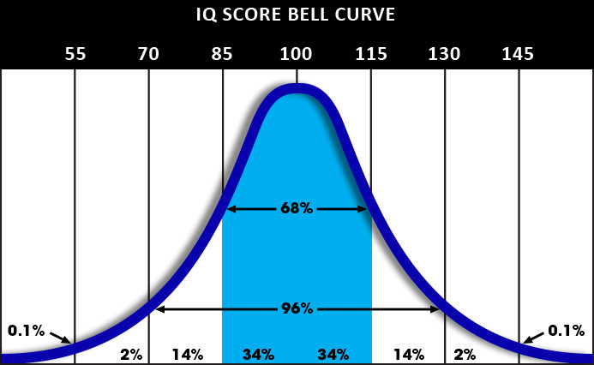
*This graph represents IQ scores based on the Stanford-Binet IQ test (130 IQ Score & Percentile | IQ Test Prep, 2020)

My research was qualitative and included ethnographical methods such as participant observation, virtual ethnography, reflexive ethnography and unstructured and structured interviews.

The primary methodology I used is participant observation. I attended several events, home meetings, pub gatherings as well as special interest group meet-ups where I was able to immerse myself with the Mensan community as a member. It was important “to share the same experiences as the subjects, to understand better why they act in the way they do”. (Bell 2010, p. 15). But also to fully grasp the concept and “‘the heart of the participant observation method’ as: involvement and detachment. Its practice is both an art and a science. Involvement is necessary to understand the abstract reality.” (Okley 2012, p. 76) In my case, I found this very helpful advice in keeping a balanced perspective, as I was both an observer and a subject of my own research.

Virtual ethnography was discovered to be an integral part of my fieldwork not only because of the isolating nature of Mensans but also because of the coronavirus pandemic that required people to ‘stay home’ during enforced lockdown measures so means of communication and socialization was greatly limited with the internet being the primary source of ‘meeting space’ (Miller, 2011). During digital research conducted by Miller and Slater, they had determined “that place did not matter in regards to online spaces. Although it isn't a physical interactive space, the case study still observed a rich, immersive culture.” (Eriksen 2001, p. 81) I found this to be true in regards to my research. In regards to the Internet, “…these spaces are important as part of everyday life, not apart from it.” (Miller, 2011) In many instances, the Internet provided a place of refuge for much of the hyper-intelligent, a way to be a ‘part of everyday life’ while socializing in what they would consider a ‘safe space’ so it proved to be a viable and integral part of my ethnographical fieldwork.

Unstructured interviews were used with two participants, Lyn Kendall, M.Ed., Dip.Psychol., Adv.Dip.Inclusion, MBPsS, Mensa’s consulting psychologist and educator working with both children and adults at both ends of the IQ ability scale and Sylvia Herbert, a board member of British Mensa from 1999-2009, Chairman of the board of British Mensa between 2003-2005 and Mensa International Director from 2009-2013. The purpose of conducting the unstructured interviews was to gain preliminary information as to where my primary research should focus. As having limited time and resources, the interviews specifically were to gain knowledge “as to which areas should be explored” (Bell 2010, p. 164) for maximum efficiency and acquiring information. The interviews were conducted at the beginning of my research and via internet using Skype.

Structured interviews were used to extract specific information from willing Mensa members. As a pattern of information was being seen over the course of time, follow-up interviews helped to solidify, recognize and elaborate further details in regards to those patterns observed in my research “…to ensure all topics which are considered crucial to the study are covered.” (Bell 2010, p. 165)

For part of my reflexive research, I kept a journal noting any feelings, memories and similar experiences I encountered in my past in an effort to stay objective both as a member of Mensa and as an anthropologist conducting fieldwork. However, I realize that by me being a member that my story is important to my research and that “in this process of interaction between ethnographer-as-self and ethnographer-as-other that social knowledge of general interest and significance is produced” (Davies 2008, p. 228).

When I was younger, I exceled at school and was considered ‘gifted’. I graduated two years early by taking extra classes. At 18, I decided to join the military and scored the maximum score possible on one section of the ASVAB (the American military IQ test). From there, I would be sent to San Francisco, California to a language institute to learn fluent Japanese in nine months. I would then be relocated to Japan where I would work as a linguist in diplomatic affairs. However, I became pregnant and was not able to proceed with a military career. I continued my education and completed my undergraduate studies with Honors. I knew I was intelligent but I had never imagined myself to have an abnormally high IQ until I was dared by a friend to take a Mensa pre-test after seeing an advert, at the age of 33. I took the pre-test and was informed I could possibly qualify for Mensa membership but I would have to take a supervised IQ test at a testing center first. Once again, I did and scored in the top 1% (see Appendix C). I joined Mensa for a year but never participated or attended any events so I did not have any experiences with Mensa prior to the start of my dissertation. I had no knowledge of Mensa ethnology and had met only one person prior to the start of my research who was a member of Mensa but also did not participate in any regard.

CHAPTER TWO: DEFINING LEVELS OF INTELLIGENCE

“The ability to score well on an intelligence tests (sic) does not make a person able, or likeable, any more than the possession of a Rolls Royce engine in your car makes you a good driver. Each is a source of potential that requires appropriate training and use.” - Lionel Ware, co-founder of Mensa (Ware 1996, p.19-20)

In order to properly understand the findings of my research, distinction between levels of intelligence must be defined accordingly. Cambridge defines ‘intelligence’ as “the ability to learn, understand, and make judgments or have opinions that are based on reason” and that ‘ability’ is meant to be the physical or mental power needed to achieve something. (Cambridge Dictionary: Find Definitions, Meanings & Translations, 2020)

But physical and mental power is not the same for everyone and therefore creating and defining a space for those who have different neurological and cognitive differences is necessary to distinguish while also understanding the importance of the equation of nature (genetics) and nurture (environment).

First, the nurturing aspect of intelligence is an influencing feature and is dependent on environmental factors such as ambition, encouragement or lack of, suitable education, resources, nutrition, etc., (Hunt, 2011). However, it is not the dominant feature in determining IQ whereas IQ is the quantitative factor used in measuring intelligence and stands for ‘intelligence quotient’.

And secondly and from the genetic perspective, it has been proven that both biological structure and functioning of the brain correlates with intelligence (Falck, 2020) and that originally intelligence heritability was approximated at between 40 to 80%. (Herrnstein and Murray, 1994) But with technological advancements, the ability to study the brain and its function has revealed it “has over 80% heritability” and is “one of the highest heritabilities of any human characteristic”. (Falck 2020, p. 40) Increased brain size, volume of grey matter and density of white matter is directly proportionate to increased intelligence (Haier, 2017). In 1998, Robert Plomin, a psychologist and geneticist, along with Avshalom Caspi discovered that genes were linked to intelligence (Plomin and Caspi, 1998) and continues to further argue its heritability (Plomin, 2018). Furthermore, a study in 2009 determined that a difference in myelin insulation that determines the rate and speed of neural transmission is related to genes that determine intelligence.

“A new type of brain imaging scanner shows that intelligence is strongly influenced by the quality of the brain's axons or wiring that sends signals throughout the brain. The faster the signaling, the faster the brain processes information. And since the integrity of the brain's wiring is influenced by genes, the genes we inherit play a far greater role in intelligence than was previously thought.” - (Chiang et al, 2009)

So what does this mean exactly? In those with high IQs, their brains are anatomically and physiologically different producing faster cognitive processing that leads to a greater than average ability to learn, store, retrieve and analyse information, a ‘hyper-intelligence’.

Using the introductory quote above let us imagine a Rolls Royce V-8 engine to be analogous to the brain of those with ‘hyper-intelligence’ and an average car having a V-4 engine being that of an Unisan brain and that these brains represent ‘nature’, a fixed component. The Rolls Royce engine certainly has greater ability both physically and ‘mentally’ to reach a destination. But if it doesn’t have enough fuel, no matter how well it is designed, it will only go so far. It is important to note that fuel represents the ‘nurture’ part of the equation, and it is a variable factor. (What Makes a Genius?, 2010)

“IQ is about potential…achievement takes effort and motivation. Having a high IQ is just something you have from birth.” – Sylvia (Herbert, 2019)

“Thus the elements of the ‘nature and nurture’ equation both have a part in producing different intelligence achievements”. (Galton, 1874) So, intelligence is fluid based on environmental factors as well as cultural context meaning that what is important in one culture, may not be in another. A tribal man creating a new spear that kills faster and more efficient ensuring the livelihood of the tribe could be considered ‘genius’ to the tribe of which he belongs but Einstein’s theory of relativity would not be considered valuable or of interest, and conversely a new and improved spear would bear little or no significance to computer programmers and developers working in Silicon Valley.

For the purpose of clarity, ‘hyper-intelligence’ (and ‘hyper-intellectual’ as a variation where appropriate) will be defined in this dissertation as a genetically acquired high IQ (particularly for those scoring in the top 2% of the population) giving one the greater ability and capacity to achieve accomplishments quicker and easier than those of a lesser IQ (‘Unisans’) in any given population. And ‘intelligence’ will remain within the Cambridge definition parameters given previously and will refer predominantly to Unisan Society.

But what is the meaning of ‘genius’? The etymology of the term genius is Latin and means ‘guardian spirit’. (Definition of genius | Dictionary.com, 2020) To gain more insight, I post a question on Mensa’s Facebook page asking what it is like to be a ‘genius’? I receive many responses and I am quickly admonished and corrected. That term is taken ‘very seriously’ and is ‘only awarded to a rare few’. Mensa members are extremely careful about labeling themselves geniuses. That is a term used for people who have used their hyper-intelligence for a good and higher purpose. They have proven themselves or made advanced accomplishments such as Alan Turing, Isaac Newton or Albert Einstein. Many noted that there are many members who make no or little contributions to society and that simply a high IQ score does not a genius make. Genius is only for those ‘who truly apply themselves and truly achieve whether it’s recognized or not’ but is definitely not based solely on the accumulation of knowledge. The consensus by Mensans is only a very rare few are given the honorary title of ‘genius’. However, it is far more likely that a genius is also hyper-intelligent.

From a reflexive standpoint, I was curious to see if my rather reluctant son also had a high IQ so I paid for him to be tested at a Mensa testing centre. His results were an IQ of 130 on the Cattell B scale falling under the ‘superior intelligence’ category and scoring within the top 10% of the overall population. (See Appendix D) Later at one of the annual meetings, I met a woman who took the test only because her sister had become a member. She was admittedly jealous so she decided to take the test too. Now, they are both members. These personal findings correlate with the research that it is indeed genetic.

From here is where I take my first steps inside the mysterious world of Mensa, the world’s oldest and largest high IQ society.

CHAPTER THREE: THE SOCIAL STRUCTURE OF MENSA

“I joined the “club” out of curiosity. What I found was a huge playground beyond imagination!” – Louis, (Home Page | Mensa International, 2020)

To become a member of Mensa of member, one needs to prove they have a high IQ within the top 2% of the overall population. To prove this, you will have needed to take an accepted and supervised IQ test such as the Stanford-Binet, Culture Fair, Cattell III B or other tests that have passed the long and rigorous qualifications of IQ test development. Certain military tests in the United States and in Britain are also acceptable. Mensa does offer supervised testing using these tests at certain locations at regularly scheduled times for a fee. (IQ Tests | British Mensa, 2020) And once you have achieved a qualifying score, you do not have to take the test again to apply for membership if you had lapsed.

Upon rejoining and paying for my membership fees for British Mensa, I received a large packet in the mail along with a certificate, membership card and the Constitution of Mensa setting out the social structure of the organization including its conditions, rules, functions and duties as well as defining the ‘nature of Mensa’. It had a governing board with regularly held elections.

Using the membership code given to me in my packet, I’m able to access and log into the British Mensa website. On the home page is a quote that indicates it is a safe place for its members emphasizing its aim is ‘to create a society that is non-political and free from all racial and religious distinctions’. (The Official Website Of British Mensa - The High IQ Society, 2020) But most importantly, I notice there is an emphasis that Mensa is for members only. However, concessions are allowed for certain family members on an online Facebook closed group called Family Mensa and allows Mensa members with children or grandchildren, or the parents and grandparents of young Mensa members to socialize.

Mensa is devoted to ‘identifying and fostering human intelligence, to encourage research into the nature, characteristics, and uses of intelligence and to provide a stimulating intellectual and social environment for its members’. (The Official Website Of British Mensa - The High IQ Society, 2020)

As I peruse the site, I see that not only have I been granted membership into British Mensa (each member becomes a member in their country of residence first), but also into Mensa International and Mensa Foundation. Mensa has members from over 100 different countries with the youngest member being only 5 years old and the oldest is 109.

Current membership in British Mensa consists of approximately 22,000 members and Mensa International estimates 140,000 members overall. Given that the current world population is approximately 7.8 billion (World Population Clock: 7.8 Billion People - Worldometer, 2020), then 2% of that figure equals 156,000,000. This current overall membership represents only .000018% of the world population.

The Mensa Foundation has the unique charge of ‘inspiring and empowering intellectual giftedness for the benefit of society’ (The Mensa Education & Research Foundation, 2020) and offers scholarships and grants for its members pursuing research into intelligence or for innovative ideas or creations that can help humankind.

In 1946, Mensa was founded by Lionel Ware and Roland Berrill in Oxford, England. Sir Cyril Burt would become an integral part a few years later. The impetus being World War II and the two men, both with high IQs, thought it would be of importance to have some of the brightest minds in the U.K. under one umbrella so that the government could easily access these minds should the need ever arise again. And it would “conduct research in psychology and science”. (Mulholland, p. 4, 2016) Mensa means ‘table’ in Latin and the idea being that these people would come together like the knights of a round table in the hopes of solving difficult issues. However this did not come to fruition and Mensa has remained ‘wisely and masterly inactive’ towards politics in general. (Serebriakoff and Burt, 1966) Mensa started expanding to other countries in 1960 where it eventually established a branch in America.

Mensa offers many children educational programs and events along with support and guidance to parents. Mentorship programs are available and considered to be especially important to children with parents who are not members. Mensa places a strong emphasis on the welfare and appropriate education given to its child members.
The society has a gifted child consultant, Lyn Kendall, who is a very experienced teacher and psychologist working with high IQ children.

For adults, Mensa offers many opportunities to socialize. This social framework consists of but is not limited to:

- Special Interest Groups – there are currently more than 100 groups
- Monthly magazine and regional newsletters keeping members informed of the latest Mensa events and opportunities
- Local meetings – pub gatherings, breakfasts, coffees, walks, etc.
- Annual Gatherings – where members meet annually usually over a weekend in a specified location to meet up, tour the area, conduct icebreakers for new members, lectures, dinners, dancing and more.
- Social networking platforms including Facebook
- Weekend getaway trips
- Conferences and seminars
- Gaming championships and weekly gaming tournaments
- Science and career fairs
- Forums
- Online gaming and Zoom quiz nights
- Learning activities provided by members (such as learning to sail, knitting, etc.)
- Mentorships/Apprenticeships

Sometimes Mensans are offered unique opportunities such as being contestants on games shows such as ‘Who Wants to Be a Millionaire’. Some companies specifically seek out Mensans for advice. For example, The Coca-Cola, Co. offered a one off payment for anyone able to help them solve a unique problem they were having. Other agencies will offer jobs that require in depth pattern recognition. The popular T.V. show ‘Mindhunters’, about serial killers, was looking for Mensans who could act as profilers and consultants to the show.

Mensa offers a plethora of membership benefits and activities purposefully to where its members can exist with having little to no interaction with the mainstream world. It is a subculture with the intent to provide safe social interaction for Mensa members only.

“It’s just like regular society except you’re surrounded only by people with very high IQs.” – Lisa

Mensa could safely be described as nurturing but I wouldn’t go so far as to officially call it a support group. I have not discovered any therapy groups offering group counseling although there are individual psychologists available for anyone seeking therapy.

For me, joining Mensa was like stepping into a new world, an intellectual candy store of sorts. One filled with an infinite number of possibilities and opportunities. I quickly began regretting not joining sooner. I joined 24 special interest groups (a.k.a. SIGs) specifically the philosophy, psychology, film, genealogy, Africa, cat, cooking, travel, codes & ciphers, and of course, the wine and chocolate groups to name just a few. Monthly newsletters are sent via email to keep members in contact and some meet regularly. I attend many events including some pub meetings in Oxford, a home meeting, the Scottish Annual Mensa Gathering, the British Annual Mensa Gathering, an annual philosophy SIG sponsored meeting, a special organized trip to the Synchratron in Didcot, my fellow member, Sonja Falck’s book launch for her book “Emotional Intelligence”, and online quizzes.

But the largest social meeting place for Mensans is the closed Facebook group, ‘BrightSpace’. Here, there is a constant flow of conversation at all times ranging across all topics; there is always someone there for a chat. Sometimes people will organize polls on various matters. One informal poll revealed that over 70% of members subscribed to atheism or agnosticism when asked if they were devoted to any religious branch. Current research also correlates with these findings. (Falck, 2020) Others will post puzzles to solve or ask help with personal problems. There is so much activity it is hard to keep up with all the posts. As one new member posted,

“I do like this group, which I have recently joined. The drawback is that so many people write on it so often I can’t read everything. Please slow down!”
– Amy

BrightSpace is easily not only the safest place to meet up with fellow Mensans but also the most socially active ‘space’.

CHAPTER FOUR: MEETING THE MENSANS

I have always been a misfit. I took the test to see if I really do differ from the average. And then during the first meeting with fellow Mensans, I had this sense of homecoming as if arriving from another galaxy to a place where I belong. I met plenty of valuable people, many of them I consider friends and there are lots of them I look up to.” – Andrea, (Home Page | Mensa International, 2020)

Linguistic Phenomena

“I was looking for a community, new friends and an environment where I can speak faster. And yes, I found it.” – Andrew, (Home Page | Mensa International, 2020)

The first available meeting I could attend was held in Oxford. It was an annual meeting called ‘Think! At Oxford’ held by the philosophy special interest group. I had contacted the host to let him know I as a student doing research and a new member. He was very welcoming and accommodating. I arrive at Balliol College late afternoon on a Friday to find a small crowd in the meeting area. I find my host and he quickly announces to everyone that ‘we have a new member’. The response is a warm and loud ‘welcome home’! My fellow members go out of their way to introduce themselves, ask me questions and offer me drinks. It is a diverse group with most being from the U.K. Many are between the ages 50-80 and are either retired or making a career as computer programmers, engineers or work in the arts. I meet one elderly woman who worked on the team created to decipher the German decoding machine used during World War II. One woman, approximately my age, introduces herself and we quickly see we have much in common. But as our conversation continues, I notice that we are speaking at an usually fast pace certainly much faster than I normally speak but it feels natural, almost a relief (Falck, 2020). I can keep up easily. Later that evening as we were all having dinner at a nearby pub, I notice distinct linguistic differences. The conversations tend to be far more analytical and carry on much longer than a common Unisan conversation. I’m given instructions by one man to stop him talking should I feel the need as he has a habit to ‘bang on’. Everyone is concise in their speaking with clear diction with no ‘ums or ers’. I observe unique paralanguage characteristics specifically a much faster tempo in conversation (Haviland, p. 117, 2008), kinesics such as prolonged eye contact (Battle, 2012) and shorter turn-taking gaps (Sacks et al, 1974). Conversations naturally flowed at a faster pace and with a higher degree of intensity. However proxemics seemed to be within the cultural norm. (Haviland, p. 116, 2008)

After interviewing a fellow Mensan who is known as a 999 (‘Triple Niner’, a member of a high IQ society only for those who score in the .1%) he informs me that it is common for many of them to ‘abbreviate’ meaning they just use a few key words as they all ‘understand’ what the other is trying to say (Aus, 2013).

After immersing myself in Mensa and attending many of the events, I noticed some members did not speak unless spoken to but appeared quite content being in the group by their body language cues. ‘John’ would immerse himself in the group, not walking behind, smiling often and as a smoker was very keen to be mindful and respectful of those around him making concerted efforts to make sure the second hand smoke did not waft anywhere near the group or individuals. ‘Sam’, too, would smile and join in the group shaking his head in agreement and appearing to be fully engaged with conversation. When I asked him a question, he answered but with the least amount of words possible and would not reciprocate. During an interview with Mensa’s certified psychologist, Lyn Kendall, I mention the mutism I witnessed to her and her reply was “this is a product of abuse causing them to have a very low self-esteem and hesitancy to engage.” This is attributed to psychogenic mutism that is acquired through post trauma.
(Psychogenic Mutism - GoodTherapy.org Therapy Blog, 2020)

After attending many events, I conclude this is a normal speech pattern for Mensans and that it must have ethnolinguistic meaning. And perhaps this culture is affecting my speech as the Sapir-Whorf hypothesis suggests (Eriksen, 2001). But then I realize that perhaps this isn’t the case. These speech patterns are innate.

I recall my mother telling me to ‘slow down, you’re talking fast again’. And amongst my friends, I am notoriously ‘chatty’. My son claims I ‘skip words’ when I’m talking too fast and I regularly find when proofreading that I leave out words as I type. I had just assumed I was excited and needed to calm down but this wasn’t the case. This was normal for this group of people. (Falck, 2020)

Cognitive Phenomena

Mensans have an insatiable desire for knowledge. This desire for continuous knowledge can be described as ‘a need to feed the brain’ and is likened to a thirst that is never truly quenched. It has been identified as a “need for cognition”. (Meier et al, 2014) One could describe Mensans as being extremely curious individuals but couple this with faster thinking can leave you in a lonely place. Not everyone can keep up resulting in what is described as ‘cognitive conversation fatigue’.

“As Mensans we process everything very quickly. No matter what other talents or faults we might have, this is what unites us as a group. I think we could all agree that when your processing is of a certain speed, you realize it. Growing up, you talk in information faster than your peers. You see solutions to the problems that others can’t and wonder why. You may not be the best at everything or look like some king or “genius” as people expect. Your brain simply spiderwebs thoughts in overtime.” – (Carty 2019, p.12)

But the most important element is that conversation flows easily and everyone can keep up. One woman, a librarian, told me ‘I love talking to Mensans, I don’t have to stop and explain everything’. Being with other Mensans, allowed members to speak at their own innate rate. During the pub meetings, the topics of discussion were usually not the ‘norm’ such as weather, sports and politics and tended to vary considerably.

“People group together with similar likes like going to the pub or to the football match. Most people want to socialize and for the majority there are more of them, just look at the Bell Curve, so it’s easier to find somebody who shares your likes, football, Love Island type reality TV, so those programs are aimed at mainstream but what about us? Not many. They have so much more to chose from and don’t have to try very hard. Those things are there for them automatically. We don’t have that. We have to search out and look for people who will like us so it is a trick and journey and we are lucky to find not only someone who has the same interest and the same level of IQ but it also makes it very difficult to find a life partner.” - Lyn (Kendall, 2019)

“They term this ‘homophily’ and place it at the core of socialisation.” (Falck, pg. 81, 2020)

But there is one topic of conversation that is common amongst Mensans and that is quantum physics. A special group tour had been arranged to the Synchratron in Didcot. A synchrotron is a type of particle accelerator that can produce a certain type of intense light that is used to study atomic structure of matter. It’s similar to watching a movie of moving atoms with a super microscope. (What is the ESRF?, 2020) The tour began with an introductory lecture about how the synchrotron operates but our host was quickly overwhelmed with questions and eventually conceded to not having some answers. ‘This is not a normal group’ he said.

But this is intense desire for ongoing intellectual stimulation can cause parents of child Mensans to become overwhelmed. When attending the book launch for Extreme Intelligence, I met a mother of a Mensan who was seven years old. She had come to ask Sonja, the author and psychologist, for advice. She was uncertain as to what was the appropriate and best course to properly care for the needs of her son. Mensa had approached her about putting him into a child program for the gifted but she was reluctant due to the normal social expectations she had envisioned for him. She described her child as ‘continuously curious with high energy levels’ that left her feeling ‘exhausted’.

Problem-Solving
Mensans love puzzles, quizzes and games of all sorts. This is evidenced by the many apps, online games and board games, as well as tournaments and championships that Mensa provides and that many participate in outside of Mensa. This is because they are innate problem-solvers and often seek out or see everything as a game. (Kanazawa, 2012) One member told me he acquired an extremely high credit score because he was bored and needed a ‘game’ to play so he would keep opening accounts, pay them off and repeat. He wanted to see how high he could get it. He reported his score to be 949. On the Facebook group you often get people posting puzzles to solve. Below is an example. (See Figure 3.1)

Figure 3.1
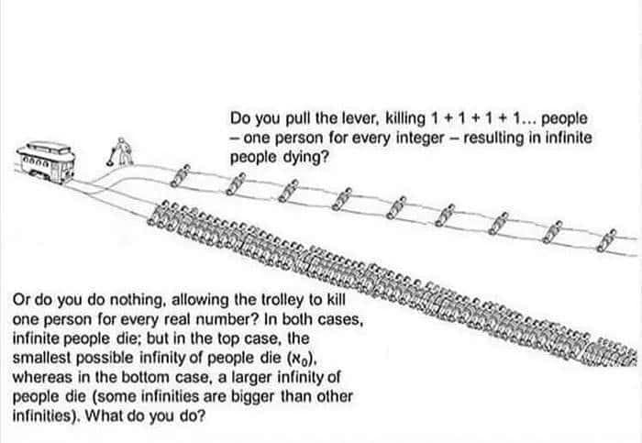
*Figure obtained from a Mensa Facebook ‘BrightSpace’ post.

“Our entertainment is problem-solving.” – Gwen

Mensans are very intense debaters and can be quite passionate about the subject but there is rarely any true conflict.

I enjoy encountering many different opinions within Mensa. In most cases, we manage to exchange opinions and discuss even sensitive topics without major fights. My horizon definitely became broader and I have been enriched with lots of new information. And yes, the daily dose of humuor is addictive! Thank you all for adding colour to my days (and grey matter as well)! – Amy (Home Page | Mensa International, 2020)

I witnessed this at the Scottish annual gathering after there was much discussion after listening to an expert lecture on the historical accounts of the suffragettes. It was clear there is no one was trying to win the argument. Trying to win an argument does not provide a productive outcome I’m told. It hinders the further accumulation of acquiring knowledge and expanding and analyzing all viewpoints collectively. It is simply trying to get as many points of views out into the open so they can be analysed. Perhaps, this is subtle in nature from the mainstream perspective but the effects are tremendous and obvious amongst them. There is no concern of ending in conflict, no jealousy, no judgment, just an attempt to understand. That’s not to say no one ever has had a conflict (they are still human) but this particular characteristic specifically provides, ‘a freedom, a safety if you will, to express one’s self, that is not granted elsewhere’. Furthermore, no topic is off limits. Everything is fair game. Mensa keeps an arbitration service open for members but it has only been used 2-3 times in 5 years. There appears, to me, to be an different form of emotional maturity.

Hypersensitivities
Since it’s proven that the hyper-intellect have different brains, is it just cognitive processes that affects them? The answer is ‘no’. Emotions, interpersonal and intrapersonal aspects play a distinctly different role in a Mensans life specifically in ‘self-awareness, perspective taking, emotional experience, and empathy’. (Mendaglio, 1995)

“Why do I care so much?” - Lisa

It appears their problem-solving nature manifests itself as emotional reasoning. Attempts to understand issues and ‘work through’ relationship problems were common.

“By not saying what you really feel and think, it just wastes time in solving the problem” - Alexander

Most Mensans mentioned they felt a strong innate feeling to help the world, i.e., solve its problems. Fellow hyper-intelligents such Alan Turing, who was the primary decoder of the enigma machines used by German forces, later became known as the creator of the computer. Temple Grandin who has been revolutionary in the cattle trade helping slaughter houses develop a more humane way of killing cattle at the same time making it more cost effective. They saw problems that needed to be fixed or ways to make things better. It‘s not about arrogance or competing to win, it’s just about making it better or preventing something bad from happening.

“We are idealistic. We know things can change.” - Jenny

In one study focusing on the socio-emotional aspects of the hyper intelligent, the results showed 287 Mensans were “highly empathic, responsible citizens who tended to possess a flair for societal involvement and a strong interest in societal development”. (Persson, pg. 19, 2007) Gifted individuals have been noted to experience emotional reactions at a deeper level than others and a strong sense of justice. (VanTassel-Baska and Benbow, 1998) They also noted that this can be ‘irritating’ to Unisans as it is viewed as a constant ‘need to be right’.

“My friend was angry with me and asked me, ‘why do you always have to be right’? I said it’s not because I want to be right, it’s important to be right because so much rests on it. Otherwise, what are you basing your decisions on?” – Lauren

“We question everything and that is not always comfortable for people but particularly for those in authority.” - Oliver

Other hypersensitivities presented themselves in physical manifestations such as Cocktail Syndrome, the phenomenon of the brain's ability to not focus one's auditory attention (an effect of selective attention in the brain) on a particular stimulus as when a partygoer can is unable to focus on a single conversation in a noisy room. Others report they can see, smell and hear things people can’t. An irritating example would be tags in clothes are uncommonly scratchy. These types of hypersensitivities are thought to be caused by a lack of myelin sheathing (protective coating on nerves) creating a nerve-to-nerve synapsis at a higher rate and intensity. Where ordinary people can filter information or feel less sensation, hyper-intellectuals’ brains cannot and thus they absorb and feel everything causing cognition and sensations to be heightened. Although, there were some benefits to the physicality of the condition as some Mensans reported having an ‘incredible sex life’.

‘Autism’
Others mentioned being diagnosed with Asperger’s syndrome, a form of high-functioning autism. But Lyn Kendall, the certified psychologist for British Mensa, has contradictions about these diagnoses and feels that there is a need for more research, as although the hyper-intelligent do have similarities to Asperger’s, they are not identical. Some even expressed ‘it’s not the same as Asperger’s, it’s different’ or ‘I know that’s what they’ve labeled me but it doesn’t fit’. (See Table 3.1) It has been strongly suggested that this diagnosis needs to be revisited and re-examined in greater detail.

“One of the problems today is for a kid to get any special services in school, they have to have a label. The problem with autism is you’ve got a spectrum that ranges from Einstein to someone with no language and intellectual disability…Steve Jobs was probably mildly on the autistic spectrum. Basically, you’ve probably known people who were geeky and socially awkward but very smart. When do geeks and nerds become autism? That’s a gray area. Half the people in Silicon Valley probably have autism.” - Temple Grandin (Welcome to Temple Grandin's Official Autism Website, 2020)

Table 3.1
Differences Between Autism and High IQ
Autism High IQ
ANXIETY | Change of routine such exams or school trips | Over-thinking or a fear of failure
SOCIAL DIFFICULTIES | Play is repetitive, object based, lacking in imagination | Play is more sophisticated and complex
SPECIAL OR UNUSUAL INTERESTS | Tend to be long-term and all consuming | Will do a topic to death then move on to something else
MELTDOWNS | Overload, too much going on or too far out of their comfort zone | Frustration, an old head on young shoulders
CRASHING | Overload or lack of understanding of what is required | Over-thinking or anxiety, emotional understanding can’t keep up with head
SENSITIVITIES | Difficulty integrating information from senses (e.g. lack of awareness of hear, cold, pain, thirst, hunger) | Lack of filtering, ability to absorb more information due to working memory and speed of cognitive processing
*Table has been provided by Lyn Kendall, Board Certified Psychologist of British Mensa, M.Ed., Dip. Psychol., Adv. Dip. Inclusion., MBPsS

Reflexive Experience
For me reflexively, people understood me, could keep up me, they didn’t become insecure or defensive. I felt safe. I felt at ‘home’. I started to understand why ‘welcome home’ was the one of the first things said to me as a new member at the meeting in Oxford. From the inside Mensa was a place filled with hyper-intelligent people who appeared amicable, jovial, eager, friendly and warm. I heard the term ‘safe’ repeatedly when asked about how members felt about being a part of Mensa. Relationships within Mensa were primarily very positive. And others expressed similar feelings.

“I’m grateful to Mensa. It shifted my self-belief, to know I’m not wrong. It’s been incredibly healing.” - Lisa

Life Outside of Mensa
Mensans think different, feel different and act different. They are different. So how does that affect them outside of Mensa?

“Given that the extremely intelligent child’s particular biology and associated character traits and behaviours make him or her in certain aspects of experience and functioning dissimilar from at least 98% of the population, such a child might in their early influential environments encounter, few, or zero, others who understand this and/or relate to this and/or themselves have similar experience and functioning.” (Falck, 81, 2020)

For many Mensans, their ‘difference’ has created extreme challenges in their lives particularly in relating to those in Unisan society.

CHAPTER FIVE: MENSAN ETHNOLOGY –
FINDING A REFUGE FROM A WORLD OF ABUSE

“The world was a hostile territory. In order to preserve my human relationships, I had to wear a mask of courtesy. Still, under this mask, I was alone. Alone and lonely. I wanted to get rid of this mask; I was looking for an environment where people can understand me. And at the end, the people I found in Mensa tamed me: they made me a better person. I entered the community like a strange, wild animal – and some members reached out for me and took me in. I am grateful.” Sam - (Home Page | Mensa International, 2020)

General population and the ‘Myth of Genius’
“High intelligence is touted as being predictive of positive outcomes including educational success and income level. However, little is known about the difficulties experienced among this population.” - (Karpinski, et al, 2017)

‘Tall Poppies’ phenomenon is used to described as when cultures can feel resentment towards others who appear to be getting ahead faster and easier than themselves. In that success is perceived as undeserved and that should someone who has reached that level experience some form of failure, that is greeted with pleasure from that culture. (Feather, 2012) This phenomenon is something that most Mensans contend with throughout their daily lives, but particularly in their careers.

“But because the hyper intelligent are able to achieve goals usually with far less effort, they are particularly vulnerable to having others rejoice in their misfortune.“ - (Falck, 2020)

Unisans often see them as ‘elitists’, the belief that some things are only for a few people who have special qualities or abilities. ‘Gifted’ is a term that is paradoxical to the true state of hyper-intellectuals and being given that label has continued to bring ongoing negativity, misunderstandings and lack of compassion to ‘who we truly are’. This conundrum causes Unisans to feel insecure and at times threatened. One question many Mensans get is, ‘if you’re so smart, why aren’t you rich?’ as if being ‘gifted’ magically makes that happen. The myth that great wealth, fame, and great accomplishments come with great ease only compounds the false perception of this group and acts to hinder their survival. Many members reported they just ‘went with flow’ in order to avoid conflict.
Family
Mensans reported mixed experiences growing up with their families. If the parents were also hyper-intellectual, then there is a better chance at adjusting positively (Towers, 1987). I met a three generational family of Mensans who all attended Cambridge University, two of which became computer programmers. They expressed a satisfactory life and held positions on the board of Mensa. One hyper-intelligent woman whom I met, her hyper-intelligence was discovered during school at a very young age, but had been exploited by her parents. She had been pushed to excel and was told ‘you have to do this, you have to do well’. She had taken her GCSE exams three years early. (Falck, 2020) Some, and particularly women, experienced jealousy or envy from their fathers. ‘He definitely didn’t like the fact I was smart. It was threatening to him. He’s the one who is always supposed to be right and hearing it from a girl, just made it worse!’ ‘Rebecca’s’ father knew about her gift and didn’t want to talk about it. She had developed ‘deviance fatigue’ meaning she hid her gift to fit in with Unisan society (Falck, 2020) and only attended Mensa meetings from time to time. She described it as ‘a soul crushing experience’. Sadly, many experienced various levels of neglect and abuse. ‘It was like I was born into enemy territory. I just learned to keep quiet and do what I was told. It was very lonely’.

“In my own family I was bullied big time, especially by my father, yes. So he felt intellectually threatened…definitely ‘til 11 I used to get beaten big time by my father.” – Avi (Falck 2020, p. 61)

Still another reported that her mother became frightened by her hyper-intelligence.

“I remember when I was one-year old and understanding what my mother was saying. She had given me a bath and had forgotten the towel as she was very tired. I had learned how to talk so I fetched the towel. After that, she really didn’t know what to do with me. It scared her.” - Lyn

School
School gave both positive and negative experiences for hyper-intellectuals. Some did very well and did not have many problems matriculating through their course. However, some found it too easy and became bored. (Hollingworth, 1926)

“Where the gifted child drifts in the school unrecognized, working chronically below his capacity (even though young for his grade), he receives daily practice in habits of idleness and daydreaming. His abilities never receive the stimulus of genuine challenge, and the situation tends to form in him the expectation of an effortless existence” (Towers, 1987).

This would cause them to seek stimulation elsewhere becoming a ‘problem child’. Several members had dyslexia and/or dyscalculia presenting difficulties in their studies particularly in math. However, this was considered more of a challenge rather than a disability and one woman claimed, ‘I created a different way to learn math for myself and now I have no problems’. I, too, struggled with math but insisted on seeing a tutor three times a week during university and soon after found it to be fun. However, one unfortunate but common theme was being bullied. After meeting a teenager member, he confessed he often encounters altercations at school, saying ‘they just don’t understand’. Notable hyper-intelligents such as “Elon Musk and Alan Turing were badly bullied at school” (Falck, pg. 97, 2020)

Romantic Relationships
Most Mensans have had some difficulty establishing romantic relationships due to their unique characteristics. So much so, the popular online dating website Match.com created a platform just for Mensans called Mensa Match.com. ‘The service allows members to narrow their dating search to easily identify other Mensans with whom they might have traits in common.’ (Nelson, 2020) It can only be accessed if you are a member. However, when I was researching sites to verify that Mensa Match does exist although not advertised outside the Mensa community except when it originally launched. The launch of the website made the news and I found one website that surmised the whole principle behind wanting to meet only our like-minded members, the title read, ‘Match.com and Mensa team up to find true love for insufferable snobs’. (Tang, 2014) The article is continuously verbally abusive against Mensa members throughout its entirety. Many Mensans marry other Mensans as there is a ‘mutual understanding’. Some who did not marry other hyper-intellectuals reporting problems in the marriage directly related to their high IQ.

“It just became a competition. He felt threatened and I became more introverted.” – Amanda

I met two Mensans who had not yet found their partners that were in their 30’s and both who wanted children. They decided to co-parent but yet were not in a relationship. They have two daughters whom they share custody and live together. Although some people have accused Mensans of eugenics, the belief that only certain people should be able to breed to improve the human race (EUGENICS | meaning in the Cambridge English Dictionary, 2020), my research suggests it is endogamous simply due to the lack of compatibility with potential partners in Unisan society.

Some choose not to have children because “…not having their intellectual needs understood or catered for were so miserable that they did not want to watch a child of their own going through that.” (Falck 2020, p. 6)

I, personally, have never been married and have found relationships to be difficult but ironically one man I met whom and had an intense love affair with, I later found out was a member of Mensa. He shared his thoughts about our first encounter as such,

“…the conversation came pouring out of us, the way it does when you finally meet someone that you can actually talk to about the things you think about, the one’s other people never bother to…we talk about life, the universe, social mechanics, and everything in between. Maybe her views are different, but she delivers them with such eloquence and brilliant clarity that I can actually believe her in a way, and I hang on her sentences, instead of just waiting for my chance to speak.” – Alex

Although we are no longer in a relationship, we are still friends.

Career
Since people with hyper-intelligence are natural problem solvers they also have the ability to see several steps ahead such as an accomplished chess player can. In playing chess, you have to be able to strategize what moves are the best way for you to win while outsmarting any negative consequences. This skill is easily applied in the workplace but garnering acceptance from such a skill is often not the case. Fellow employees often become jealous or concerned about their positions and therefore react defensively, even aggressively. One member told me about his experience after solving a difficult mathematical equation at MIT. Even though everyone was put to the challenge to solve the problem when he did in a less than expected time, no one liked him after. Many said they had a natural tendency to see ahead possible outcomes that others do not but if they warned people about possible negative ones, they were often or always ostracized or ridiculed. ‘Keep your eyes open, head down and mouth shut’ is a common motto when it comes to work. ‘Just go with the path of least resistance and you will be ok’, I’m told.

One member’s father was the CEO of a well known large corporation and went on to tell me that he didn’t like hiring the ‘highly intelligent’ because they weren’t ‘team players’. Furthermore, he would immediately dispose of anyone’s application if they mentioned being a member of Mensa.

Reflexive Predicaments
When one of my closest friends asked what my dissertation was about so I told her. Her first reaction was hesitation, as if it was a bit of a shock, but then she quickly followed with supportive comments. Within the next few weeks, it was obvious her demeanor had changed towards me with her gradually becoming more and more distant. In one conversation, she accused me of being condescending and even voluntarily suggested that I needed to downplay my intelligence as she felt I made people ‘feel inferior’. This was one criticism of many and I found myself apologizing to her on a regular basis when this was previously never an issue. Before my admission, we had enjoyed each other’s company with great ease and spoke often throughout the week. Over the following six months, she became more and more distant and ultimately culminating in the end of our friendship.

A fellow member was having a going away party and she invited me. I asked her what should I say when people ask me how we met. I suggested that we say we met through Mensa, as she knew I was conducting research, and she enthusiastically agreed. We agreed also not to volunteer any further information but only respond when prompted by her guests. Over the course of the night, she and I would tell people the truth of how we met. The reactions were mixed. I overheard a group of people speaking negatively of me saying ‘they didn’t believe it and I was arrogant for mentioning it’. However, there were others who saw it as an opportunity for personal troubleshooting. Some attendees asked me a lot of questions regarding their problems and when I could offer them any positive guidance they expressed sincere gratitude. One man in particular yelled ‘top tip!, spinning around and giving me a hug seemingly to be extremely relieved by a solution I had offered him.

As I began my Master’s course, I found myself starting to have panic attacks. I associated them with some external stress I was experiencing at the time but once the situation resolved the panic attacks continued and even worsened. I had never experienced them before and it wasn’t until I read Sonja Falck’s book, Extreme Intelligence, that my intelligence may have some correlation. After meeting with Sonja, a psychotherapist, it was discovered that I was associating my present academic status with my past academic experience. On my graduation day for my undergraduate degree, my father was jealous and sulked like a child. He had always wanted to be a doctor and I was graduating Pre-Med. I thought he would be proud and excited for me but that was not the case at all. I remember feeling guilty. Also, my boyfriend, who I was in love with, had become insecure after accompanying me to several events honoring my achievements. His friends had told him, ‘she is out of your league’ but I assumed they were just teasing him. On graduation day, he had agreed to come the ceremony and to meet my family. When he didn’t show, I called him only to discover he hadn’t had the heart to break up with me yet and didn’t think it was fair to come to my graduation. I cried during the entire ceremony. That day had left with me unresolved trauma and my mind was associating my impending Master’s completion with another potential trauma, one it was subconsciously adamant about not repeating. It had impaired my work, concentration and dedication to what I had previously loved and that was the acquisition of knowledge. Procrastination had become a serious problem and my grades suffered. I grew more and more depressed. Prior, I had found academia stimulating as it gave me great joy and a feeling of acceptance. Professors and fellow students were exceptionally encouraging and supportive. I easily thrived. From an anthropological viewpoint, my graduation ceremony was a rite of passage strongly focused on academic and intellectual achievement, one that should have been a celebration but instead it was a punishment for being too intelligent. I graduated Magna Cum Laude w/Honors with a nomination by my professors into a National Honor Society, Phi Kappa Phi. I had become a ‘tall poppie’. My achievements were met with jealousy, insecurity and even disdain from two of the people I cared about the most. My boyfriend and I never reconciled. My father and I only spoke occasionally afterwards. When my mother died we stopped talking altogether. That was 17 years ago.

CHAPTER SIX: MENSAN ONTOLOGY – A STATE OF CONFUSION

“Why was I born into a world that hates me?” - Ruth

Ontological Confusion
Several members expressed confusion over their existence with Mensa being the only place where they could ‘be themselves’. But outside of Mensa they had to learn to adapt or ‘transform’ so their difference didn’t stand out. Overall, the majority of Mensans had a difficult time obtaining understanding and acceptance of their hyper-intelligence in Unisan society and often times were met with harsh reactions to their nature creating a feeling of ‘disorientation’ and ‘a life without purpose’.

Anxiety/Fears
Given that there are a large amount of misunderstandings and conflict between Mensans and Unisan society, this has created anxiety amongst the members.

“It’s like a constant equation going through my head. What should I say, when should I say, should I say at all and why? All this drama in my head everyday just trying to figure out what will give the least negative reaction.” - Shaun

When I posed a question on the Mensa FB page about adopting a new word that would help identify Mensans versus people who do not have IQs in the top 2% the initial reaction was one of worry as to how the mainstream society would react. One person posted, ‘no, we don’t need any more negative attention!’ Another sent me links regarding the abuse Mensans already suffer from being different. To emphasize that difference even more was something they wanted to avoid altogether. However, after prompting from other professionals in Mensa and my reassurance that any label would be used for academic purposes only and I that I would use a very vague term that did not seem to be derogative, they agreed but it was after 170 comments. Having to constantly think about one’s position in the world and keep safe from scrutiny is a constant issue leading to increased rates of high anxiety, mental illness and even institutionalism. (Falck, 2020)

Lack of Compassion from Unisan Society
Due to the unknown plight of the hyper-intelligent followed by false misperceptions that the hyper-intelligent seem to have it easy and are ‘gifted’, there is a lack of compassion generated towards them. On the Good Morning Britain show hosting Sonja Falck, the author of Extreme Intelligence, she tries to explain the abuse and these misperceptions but it is not fully recognized by the hosts and other guests of the show. The topic was bullying towards the high IQ and that it should be considered a hate crime particularly if they are called specific names such a ‘nerd’ and ‘geek’ and that being called these names were not recognized as positive or a trending ‘cool’ term to them. It was almost always meant with contempt and not used in any positive context towards the hyper-intellect. Being seen as ‘gifted’ often voids any potential understanding and compassion of the hyper-intellects true nature and societal struggles. (Falck, 2020)

‘Imposter Syndrome’
“Imposter syndrome is a psychological pattern in which an individual doubt their accomplishments…it involves a constant fear of being exposed to others as a fraud…” (Carty 2019, p. 12) This can be particularly apparent amongst the younger Mensans. ‘As a 22-year-old, with long hair and a high-pitched voice, I’m overlooked. My opinion can’t be valid. I surely can’t have a better understanding of a situation than my 50-year-old, male, bearded colleague, can I?’

Isolation and Social Rejection
According to Kaufmann (1992), 67% of hyper-intelligent individuals did not participate in any social activities outside of work. (Falck, 2020) And as IQ increased so did the desire for solidarity away from ‘hostile’ society. (Hollingworth, 1926)

Social rejection is commonplace even from parents as I too, experienced from my father. Arthur Schopenhauer was rejected by his own mother as evidenced by her letter. In it she wrote:

“You irritate me to no end and you are extremely difficult to deal with. Your extreme intelligence casts a dark cloud over your good characteristics – so nobody can benefit from them…you criticize everything and everyone, except yourself…so it is not surprising that you become alienated from the people close to you. Nobody enjoys being corrected and exposed.” - (Falck 2020, p. 97)

Others were told their hyper-intelligence was a handicap and should be avoided.

“My mother thought it was a handicap. You won’t adjust with the rest of the people. If you’re too smart, see too much, ask too many questions, it’s not comfortable for the people around you.” – Mathew

“Social rejection activates the same part of the brain that is activated by physical pain.” (Falck 2020, p. 97) This may explain why so many hyper-intellectuals find solace in Mensa. They are allowed to be themselves without harsh criticism, abuse and rejection. What others find intolerable, Mensans find acceptable and understands the dynamics of their unique cognitive processing.

Anomie
One potential problem of being so isolated and socially rejected is the development of Durkheim’s anomie. One member, after losing his job as an investment banker, divorced with two children, then ultimately suffering a mental breakdown, and now living with his parents. He is known to have an IQ within the 0.1% (a ‘Triple Niner’), and claimed that life had become ‘senseless’ and at one point during the course of our conversation we were discussing physics, he stopped talking, leaned his head back, closed his eyes and said, ‘please disagree with me’. The reason for that statement was because, he felt, there was ‘little intellectual stimulation’ left for him and as a member of Mensa perhaps I could offer some. Having no ‘normal’ place in the world had left him without a sense of purpose along with feeling disorientated and frustrated with society. “Anomie is a real threat, as the candidates are for the first time able to see themselves – and society – from the outside, and perhaps reflect critically on it”. (Eriksen 2001, p.64)

Being misunderstood, overlooked and left to an educational system that is not suitable can lead some to develop “a contempt for authority that will carry over into adulthood, causing…lifelong problems.” (Towers, 1987) Often times, some will seek out creative yet dishonest acts to channel their hyper intelligence just to see if they can get away with it ….and once they do, it can create a false sense of power and fulfillment. (Falck, 2020)

Frank Abagnale, the subject of the movie, Catch Me If You Can starring Tom Hanks and Leonardo di Caprio, was a 21-year old counterfeiter who also successfully impersonated a doctor, pilot and lawyer. When asked why he did it, he replied it was ‘the thrill of the scam’. (Falck, 2020)

Jimmy Saville, the notorious sex offender, was also a member of Mensa. I was unable to interview anyone who knew him but I was able to verify his membership through a member on the board.

Other Negative Affects
Not surprisingly, hyper-intellectuals exhibit higher than normal substance abuse “to dull their feelings of being different, or to try to fit in more with dissimilar others”. (Falck 2020, p. 117). Hyper-intellectuals are also twice as likely to commit suicide or suffer from mental illness. (Falck, 2020) Several members admitted to being on anti-depressant or anti-anxiety medication. ‘Social anxiety’ was one of the primary reasons given followed by depression.

CHAPTER SEVEN: DISCUSSION

“Every culture must liberate its creative potential by finding the correct equilibrium between isolation and contact with others”. - Claude Lévi-Strauss (Eriksen, pg. 294)

My observations correlated with much of Sonja Falck’s studies. Many members reported being bullied, alienated and abused but had found that Mensa provided an atmosphere where they felt safe and accepted. That it essentially provided a safe place to meet others who share their differences and struggles. And accordingly, I agree strongly with Falck’s claim that the hyper-intellect has special needs that are not currently addressed by appropriate organizations or authorities. But a potential disability being labeled ‘gifted’ and even envied can be challenging to present in its true and real form without prejudice.

The natural empathic effect reported by Persson was also found in my research. There does seem to be not only cognitive affects but also emotional ones in the hyper-intelligent. However, there is so little research available and it is only just recently been accepted that genetic differences of the hyper-intellect’s anatomical structure has affects on IQ but also suggest it can affect emotional characteristics. I would agree this is also something that requires further research.

Hollingworth, Towers and Nauta had researched relatability of those with high IQs. Hollingworth had reported that there was more compatibility within a 30-point spread of one’s IQ meaning if someone had an IQ of 130, they were more likely to be socially compatible to those with IQs between 115 to 145. Towers also confirmed this as well (Towers, 1987) as Noks Nauta but she her studies suggested the range was closer to a 20-point spread (Nauta and Ronner, 2016). My research clearly evidenced there were social incompatibilities directly related to IQ. However, I could find no literature directly relating high IQ sociolinguistic patterns to that of compatibility or lack thereof but interestingly enough I found that these authors’ conclusions about the 20-30-point range to hold some bearing even amongst Mensans. Upon meeting a fellow Mensan and telling him about my research, he made an interesting statement, ‘I’m on the lower end of the scale but if you want more information about physics and stuff like that then go talk to the freaks at Cambridge’. Even within the 2%, the range is wide depending on the IQ tests that are administered and can be more than a 70-point range suggesting incompatibility amongst the hyper-intellect. Towers refers to David Wechsler’s work but states, “Wechsler is saying quite plainly that those with IQs above 150 are different in kind from those below that level. He is saying that they are a different kind of mind, a different kind of human being.” (Towers, 1987) This profound claim along with my observations does suggest that there are significant differences that have not been fully examined between IQ ranges but it could help shed light on how the hyper-intelligent and Unisan society communicate. And, that a need to understand linguistics in conjunction with an anthropological approach could be the key to understanding those differences and help find solutions to integrate and alleviate unnecessary harm towards the hyper-intelligent.

“This also means that linguistics is not so much a part of psychology, as most contemporary linguists believe, as part of anthropology, as Sapir believed (in fact, this could meant that psychology itself is part of anthropology, as Sapir also believed). Linguistics apart from anthropology and field research is like chemistry apart from chemicals and the laboratory.” – Daniel Everett (Everett 2009, p. 259)

In discovering the unique linguistics of Mensans, I reflected on Sapir-Whorf’s theory claiming that ‘the language you speak determines how you think’. In regards to language, it is something you normally learn from the culture from which you are born but for Mensans they are born with a set of linguistic traits of speaking faster, faster turn-time gaps and extended analytical conversations. Although, most of the people I observed spoke English, many spoke other languages that still exhibited those same characteristics but yet shared similar perceptions and opinions of the world within Mensa with many migrating to other areas to be with more like-minded people and/or rejecting the religion and socioeconomic conditions that were imposed upon them from birth while others had been rejected by their families and/or friends. (Falck, 2020) This suggests that although we may speak different languages, how we think determines the way we speak. And how we speak and think has determined our culture. So, in this way, I believe Mensans portray an opposite version of the Sapir-Whorf theory.

However, I feel it is important to analyze the sociolinguistic patterns and cues of Mensans as further research could help identify how Unisans and the hyper-intelligent differentiate. Furthermore, this could provide a key in understanding the lack of relatability and compatibility between Mensans and Unisans. As it is known, people with mental impairment or delays, representing people with approximately IQs of 70 or in the lower 2% on the Bell Curve (with a standard deviation of +/- 15 points) usually speak at a lower rate or have difficulties in speech due to genetic conditions such as Down’s Syndrome or other mentally impaired or delayed disorders and have special needs (Coppens-Hofman et al, 2016). Then accordingly, given the genetic differences at the top 2%, the difference in faster rate of speech along with the abuse and difficulties experienced by Mensans that it is entirely appropriate to suggest that the top 2% would also have special needs. (Falck, 2020)

Looking at Figure 6.1, the average IQ of 100 (+/- 20 point) constitutes a higher population range and therefore a larger and predominant relatability range. People are able to communicate with one another without great difficulty the majority of the time, generally speaking. There are IQ and speech commonalities as well as common interests. Differences in speech, if any, may not be unnoticeable or easily tolerated. But those in the lower 2% grow increasingly dependent on caretakers the lower their IQ due to their cognitive and sociolinguistic differentiation. (When Down Syndrome Grows Up, 2020)
And, although the top 2% demonstrates more independence, this is due to social rejection and/or socio-incompatibilities experienced in Unisan society also contributed to cognitive and sociolinguistic differentiation. And the higher the IQ, the more difficult it is to adapt to Unisan society.

“To be different by any means in any given context can be construed as something positive to a degree. If deviance increases it may possibly become ‘eccentric’ but still remains tolerable. Finally though, the difference becomes intolerable because too great a deviation from tacit cultural or sub-cultural norm is unacceptable for most. At this point, it is fairly easy to understand why such reactions are perceived as a threat to the social order.” – (Persson, 2007)

Figure 6.1
Optimal IQ Relatability and
Sociolinguistic Compatibility
Average IQ 100
+/- 20 points deviation

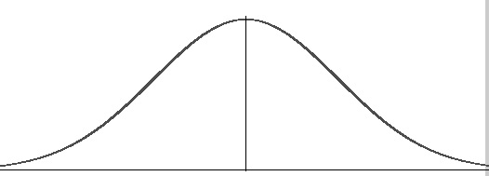
70

Increasing Dependence and Sociolinguistic Incompatibility
IQ 70 or lower
(+/- 20 points deviation)
130

Increasing Independence and Sociolinguistic Incompatibility
IQ 130 or higher
(+/- 20 points deviation)

Where structuralism is understood to be ‘a position that assumes uniformities in human thought, particularly classification, resting on universal features of the human brain’ according to Claude Lévi-Strauss (Macfarlane, 2020) so if this IQ scale is uniform throughout the world, as the universal IQ testing results from Mensa indicate (Mensa Intl, 2020), then could this represent some type of ‘universal cognitive culture’? One that is revealed through specific linguistic traits, suggesting there is ‘cognitive linguistics’? As for Ferdinand de Saussuere’s views on arbitrary words, I would agree but I would argue that there are universal linguistic traits that are not arbitrary as exhibited by those with high IQs universally. This is perhaps a sociolinguistic phenomena based on the genetic structure of the mind that warrants further research.

And perhaps it is possible to argue that to a large degree that IQ may be a structure in determining how society functions? As my research evidences there are strong possibilities that with differences in IQ, there are also significant differing societal dynamics.

“Structuralism developed the idea that the structure of mind (i.e., cognitive structure) is the result of evolutionary and genetically determined biological forces and that the products of human effort reflect the biological basis of structure. An issue for structuralism is to identify where the biology of structure ends and structures created by humankind begin: To what degree is the structure of language, behavior and society determined by the biological?” (Alterman, 2001)

Positive Observations
Although they hyper-intelligent were often seen as threatening, competition, or ‘too different’, I observed several situations that offered positive responses where Mensans were seen as helpful and had been sought out for their advice. But the key was it was done in a context where Unisans approached Mensans. Mensans did not engage them in any way and it was set in an environment where the Unisans did not feel the need to perform in any capacity, i.e., only in a social context and free of expectations of any kind including engaging in conversation. The Mensans were seen as just ‘available’.

As mentioned before, when I was attending a party where they know I was a member of Mensa, a man approached me solely for seeking my advice that he deemed to be a ‘top tip!’ and that many organizations or institutions regularly approach Mensa members for consultation. When I attended the Scottish Mensa Annual Gathering in Perth, several of us went on an archeological tour of a crannog, artificial islands found in the lakes of Scotland and believed to be built before Stonehenge. As our group had been arranged months prior, the archeologists knew a group of Mensans were scheduled to visit. When we arrived, they expressed enthusiasm in sharing the history of the crannog but were particularly curious to see if we could shed some light on some findings that were perplexing this group of archaeologists. Two members offered some further helpful insight that excited these archeologists a great deal.

In the situations mentioned above, all parties expressed exceptional gratitude without jealousy or feeling threatened in any capacity. It was the social alignment and approach that seemed to make a difference. Given the empathic and problem-solving nature of the hyper-intelligent perhaps they do have a purpose in society that has not been fully realized or understood yet; that they have simply been grossly misunderstood. From an anthropological perspective, this could be a source of further research into understanding the social implications between they hyper-intelligent and Unisan society.

“Now almost all the important questions of modern life – whether social or political, religious or philosophical – have become so intricate and tangled that only persons of first-class intelligence can unravel them and reduce them to manageable proportions [...] When the pioneer has hewn a route through the jungle the rest can follow in his track. It needed the brain of a Newton to discover and demonstrate the law of gravitation: but, once discovered and demonstrated, an average schoolboy can understand it.” - Sir Cyril Burt, co-founder of Mensa (Mulholland, 2017)

CONCLUSION

“Extreme intelligence is strongly correlated with the highest of human achievement, but also, paradoxically, with higher relationship conflict, career difficulty, mental illness, and high-IQ crime. Increased intelligence does not necessarily increase success; it should be considered as a minority special need that requires nurturing.” – Sonja Falck (Falck 2020, back cover)

Generally, the hyper-intelligent are a deeply misunderstood subculture. Coinciding greatly with Sonja Falck’s book, Extreme Intelligence, overall, my findings have unveiled a subculture that has and continually suffers ongoing abuse and social rejection from Unisan society, with many living in isolation and relying heavily on virtual socialization.

The non-profit organization, Mensa, provides a ‘safe place’ where the hyper-intelligent can socialize with other like-minded members. Furthermore, it provides an extensive and ongoing intellectual stimulating social structure conducive to the cognitive needs of its member. One of the most utilized social ‘spaces’ in Mensa was found to be the closed Facebook group, ‘BrightSpace’.

I observed many unique characteristics amongst Mensa members but the prominent feature was the linguistic phenomena specifically a fast rate of speech, shorter turn-taking gaps and prolonged eye contact. In addition, cognitive traits were described as faster cognitive cognition and manifested as an insatiable desire to ‘problem-solve’ as well as strong empathic commonalities. ‘Autism’ was a common diagnosis found in members but who also contested it as it does not accurately describe symptoms they experience.

Many members reported suffering hostility from those in Unisan society and experienced often times extreme social difficulties with their families, romantic relationships, and careers that often led to depression, substance abuse and even suicide. Ontological confusion was very relevant in my findings. Many felt there was ‘no place or purpose’ for them.

I observed linguistics could be a key factor in social incompatibility between Unisan society and the hyper-intelligent just as those on the lower end of the IQ spectrum also display sociolinguistic difficulties. I believe this warrants further research using ethnographical methods as it has been proven to be successful in the past by Hollingworth (1926) but I also agree with Everett (2009) and Alterman (2001) that it should be considered as an interdisciplinary approach. In addition, it is my recommendation that the term ‘hyper-intelligence’, and its variables, be fully distinguished between other ‘intelligence’ definitions as it is refers to a specific biological condition resulting in a range of very high IQ.

Personally, the therapeutic help I received through Mensa but particularly Sonja Falck, has been positively instrumental. I am once again passionate about my academic and career future.

In summary, Mensa is a subculture formed through social exclusion based on biological, genetic, cognitive and sociolinguistic differences of the hyper-intelligent. These differences also suggest a high possibility of meeting special needs criteria. With further study more could be learned in order to help establish the implementation of special need guidelines within the proper organizations that not only help Mensa culture but perhaps the world as a whole. Perhaps the hyper-intelligent have a purpose within society that has not been fully realized or understood.

“I think people see us as arrogant and that’s where it ends. I get that. But what they’re missing is, we really care. We care about everything. It makes it extra hard when you don’t fit in”. - Alexander

BIBLIOGRAPHY

2020. What Is The ESRF?. [online] Available at: <https://www.esrf.eu/home/education/what-is-the-esrf.html> [Accessed 18 May 2020].

Alterman, R., 2001. Modularity versus Interactive Processing, Psychology of. International Encyclopedia of the Social & Behavioral Sciences, pp.9971-9973.

Aus, A., 2013. Andrew Aus: Gifted Workers: Hitting The Target. [online] YouTube. Available at: <https://www.youtube.com/watch?v=eq266v2Jth0> [Accessed 29 April 2020]. (Timestamp: 1:07:56-1:08:41)

Battle, D., 2012. Communication Disorders In Multicultural Populations. 4th ed. London: Elsevier Health Sciences.

Bell, J. and Waters, S., 2010. Doing Your Research Project. 5th ed. New York: McGraw Hill.

Carty, O., 2019. Imposter Syndrome. Mensa Bulletin, (8), pp.12-13.

Chiang, M., Barysheva, M., Shattuck, D., Lee, A., Madsen, S., Avedissian, C., Klunder, A., Toga, A., McMahon, K., de Zubicaray, G., Wright, M., Srivastava, A., Balov, N. and Thompson, P., 2009. Genetics of Brain Fiber Architecture and Intellectual Performance. Journal of Neuroscience, 29(7), pp.2212-2224.

Coppens-Hofman, M., Terband, H., Snik, A. and Maassen, B., 2016. Speech Characteristics and Intelligibility in Adults with Mild and Moderate Intellectual Disabilities. Folia Phoniatrica et Logopaedica, 68(4), pp.175-182.

Davies, C., 2008. Reflexive Ethnography. 2nd ed. Routledge.

Dictionary.cambridge.org. 2020. Cambridge Dictionary: Find Definitions, Meanings & Translations. [online] Available at: <https://dictionary.cambridge.org/us/> [Accessed 13 May 2020].

Dictionary.cambridge.org. 2020. EUGENICS | Meaning In The Cambridge English Dictionary. [online] Available at: <https://dictionary.cambridge.org/dictionary/english/eugenics> [Accessed 27 May 2020].
DOI: 10.1523/JNEUROSCI.4184-08.2009

Eriksen, T., 2001. Small Places, Large Issues. 2nd ed. London: Pluto.

Everett, D., 2009. Don't Sleep, There Are Snakes. New York: Vintage Departures.

Falck, S., 2020. Extreme Intelligence. 1st ed. London: Routledge.

Feather, N., 2012. Tall poppies, deservingness and schadenfreude. The Psychologist, 25(6), pp.434-437.

Galton, F. (1874) English Men of Science: Their Nature and Nurture. London: MacMillan.

Garofoli D., 2019. Embodied Cognition and the Archaeology of Mind: A Radical Reassessment. In: Prentiss A. (eds) Handbook of Evolutionary Research in Archaeology.
Springer, Cham

GoodTherapy.org Therapy Blog. 2020. Psychogenic Mutism - Goodtherapy.Org Therapy Blog. [online] Available at: <https://www.goodtherapy.org/blog/psychpedia/psychogenic-mutism> [Accessed 4 May 2020].

Haier, R. J. (2017). The Neuroscience of Intelligence. Cambridge: Cambridge University Press

Haviland, W., 2008. Cultural Anthropology. Belmont, CA: Thomson Wadsworth, p.117.

Herbert, S. (2019) Interviewed by Kristi Prewitt, 29, July.

Herrnstein, R. and Murray, C., 1997. The Bell Curve. New York [u.a]: Free Press.

Hollingworth, L., 1926. Gifted Children: Their Nature And Nurture. 1st ed. New York: MacMillan.

Hunt, E., 2011. Human Intelligence. Cambridge: Cambridge University Press.

Jones, G., 2003. Mystery of Genius: Masters and Madmen. 2003. [video] Directed by G. Jones. A&E Television Networks. TIMESTAMP: 59:10 – 1:02:50

Kalantzis, M. and Cope, B., 2020. Chomsky On IQ And Inequality - New Learning Online. [online] Newlearningonline.com. Available at: <https://newlearningonline.com/new-learning/chapter-6/supporting-material/chomsky-on-iq-and-inequality> [Accessed 14 April 2020].

Kanazawa, S., 2012. The Intelligence Paradox. Hoboken, N.J.: Wiley.

Karpinski, R., Kinase Kolb, A., Tetreault, N. and Borowski, T., 2017. High intelligence: A risk factor for psychological and physiological overexcitabilities. Intelligence, 66, pp.8-23.

Kendall, L. (2019) Interviewed by Kristi Prewitt, 23 July.

MacFarlane, A. Cambridge – a personal dictionary comprised solely for the use of his students provided by Luci Attala.

Meier, E., Vogl, K. and Preckel, F., 2014. Motivational characteristics of students in gifted classes: The pivotal role of need for cognition. Learning and Individual Differences, 33, pp.39-46.

Mendaglio, S., 1995. Sensitivity among gifted persons: A multi‐faceted perspective. Roeper Review, 17(3), pp.169-172.

Mensa Education and Research Foundation. 2020. The Mensa Education & Research Foundation. [online] Available at: <https://www.mensafoundation.org/> [Accessed 1 April 2020].

Mensa.org. 2020. Home Page | Mensa International. [online] Available at: <https://www.mensa.org/> [Accessed 20 March 2020].

Mensa.org.uk. 2020. IQ Tests | British Mensa. [online] Available at: <https://www.mensa.org.uk/iq-tests> [Accessed 4 April 2020].

Mensa.org.uk. 2020. Mensa Login | British Mensa. [online] Available at: <https://www.mensa.org.uk/members/family-mensa-facebook> [Accessed 27 May 2020].

Mensa.org.uk. 2020. The Official Website Of British Mensa - The High IQ Society. [online] Available at: <https://www.mensa.org.uk/> [Accessed 14 May 2020].

Miller, D. and Slater, D., 2003. The Internet. Oxford: Berg.

Miller, D., 2011. Tales From Facebook. 1st ed. Cambridge: Polity Press.

Mulholland, B., 2017. 'The Man From MENSA' - 1 Of 600. 2nd ed. p.4.

Nauta, N. and Ronner, S., 2016. Gifted Workers: Hitting The Target. 1st ed. Big Business Publishers.

Nelson, K., 2015. Mensa Match Is Online Dating For Smart People. [online] Mashable. Available at: <https://mashable.com/2014/06/25/mensa-match-is-online-dating-for-smart-people/?europe=true> [Accessed 19 March 2020].

Okley, Judith, (2012) Anthropological practice: fieldwork and the ethnographic method, London: Berg Publishers

Persson, R., 2007. The Myth of the Antisocial Genius: A Survey Study of the Socio-Emotional Aspects of High-IQ Individuals. Gifted and Talented International, 22(2), pp.19-34.

Plomin, R. and Caspi, A., 1998. DNA and personality. European Journal of Personality, 12(5), pp.387-407.

Plomin, R., 2019. Blueprint. [London]: Penguin Books.

Sacks, H., Schegloff, E. A., & Jefferson, G. (1974). "A simplest systematics for the organization of turn-taking for conversation." Language, 50, 696–735.

Serebriakoff, V. and Burt, C., 1966. IQ. A Mensa. Analysis And History. London: Hutchinson.

Tang, D., 2014. Match.Com And Mensa Team Up To Find True Love For Insufferable Snobs. [online] GQ. Available at: <https://www.gq.com/story/match-com-mensa-online-dating> [Accessed 19 March 2020].

Templegrandin.com. 2020. Welcome To Temple Grandin's Official Autism Website. [online] Available at: <https://www.templegrandin.com/> [Accessed 28 April 2020].

Towers, G., 1987. The Outsiders. [online] Cpsimoes.net. Available at: <http://www.cpsimoes.net/artigos/outsiders.html> [Accessed 9 July 2019].

VanTassel-Baska, J. and Benbow, C., 1998. Gifted And Talented Learners. 3rd ed. Denver: Love, pp. 173-191.

Ware, L., ‘Foreword’, British Mensa golden anniversary yearbook (Wolverhampton, 1996), v. 50 p. 19-20.

Web.archive.org. 2020. Cognitive Science Society :Home. [online] Available at: <https://web.archive.org/web/20160328074705/http://cognitivesciencesociety.org/index.html> [Accessed 24 May 2020].

WebMD. 2020. When Down Syndrome Grows Up. [online] Available at: <https://www.webmd.com/a-to-z-guides/tips-adults-down-syndrome#1> [Accessed 23 May 2020].

What Makes a Genius? 2010. [video] Directed by Dan Walker. United Kingdom: British Broadcast Corporation (Producers). Retrieved from https://video.alexanderstreet.com/watch/what-makes-a-genius (Timestamps: 9:08-11:00 and 23:12-28:15)

Worldometers.info. 2020. World Population Clock: 7.8 Billion People (2020) - Worldometer. [online] Available at: <https://www.worldometers.info/world-population/> [Accessed 27 May 2020].

www.dictionary.com. 2020. Definition Of Genius | Dictionary.Com. [online] Available at: <https://www.dictionary.com/browse/genius?s=t> [Accessed 15 May 2020]
YouTube. 2019. Is Calling Someone A Nerd A Hate Crime?. [online] Available at: <https://www.youtube.com/watch?v=bErlrHGUc9g&t=5s> [Accessed 17 May 2020].

REFERENCES

Figure 1.1

Iqtestprep.com. 2020. 130 IQ Score & Percentile | IQ Test Prep. [online] Available at: <https://iqtestprep.com/130-iq-score-percentile/> [Accessed 10 May 2020].

APPENDIX

Appendix A

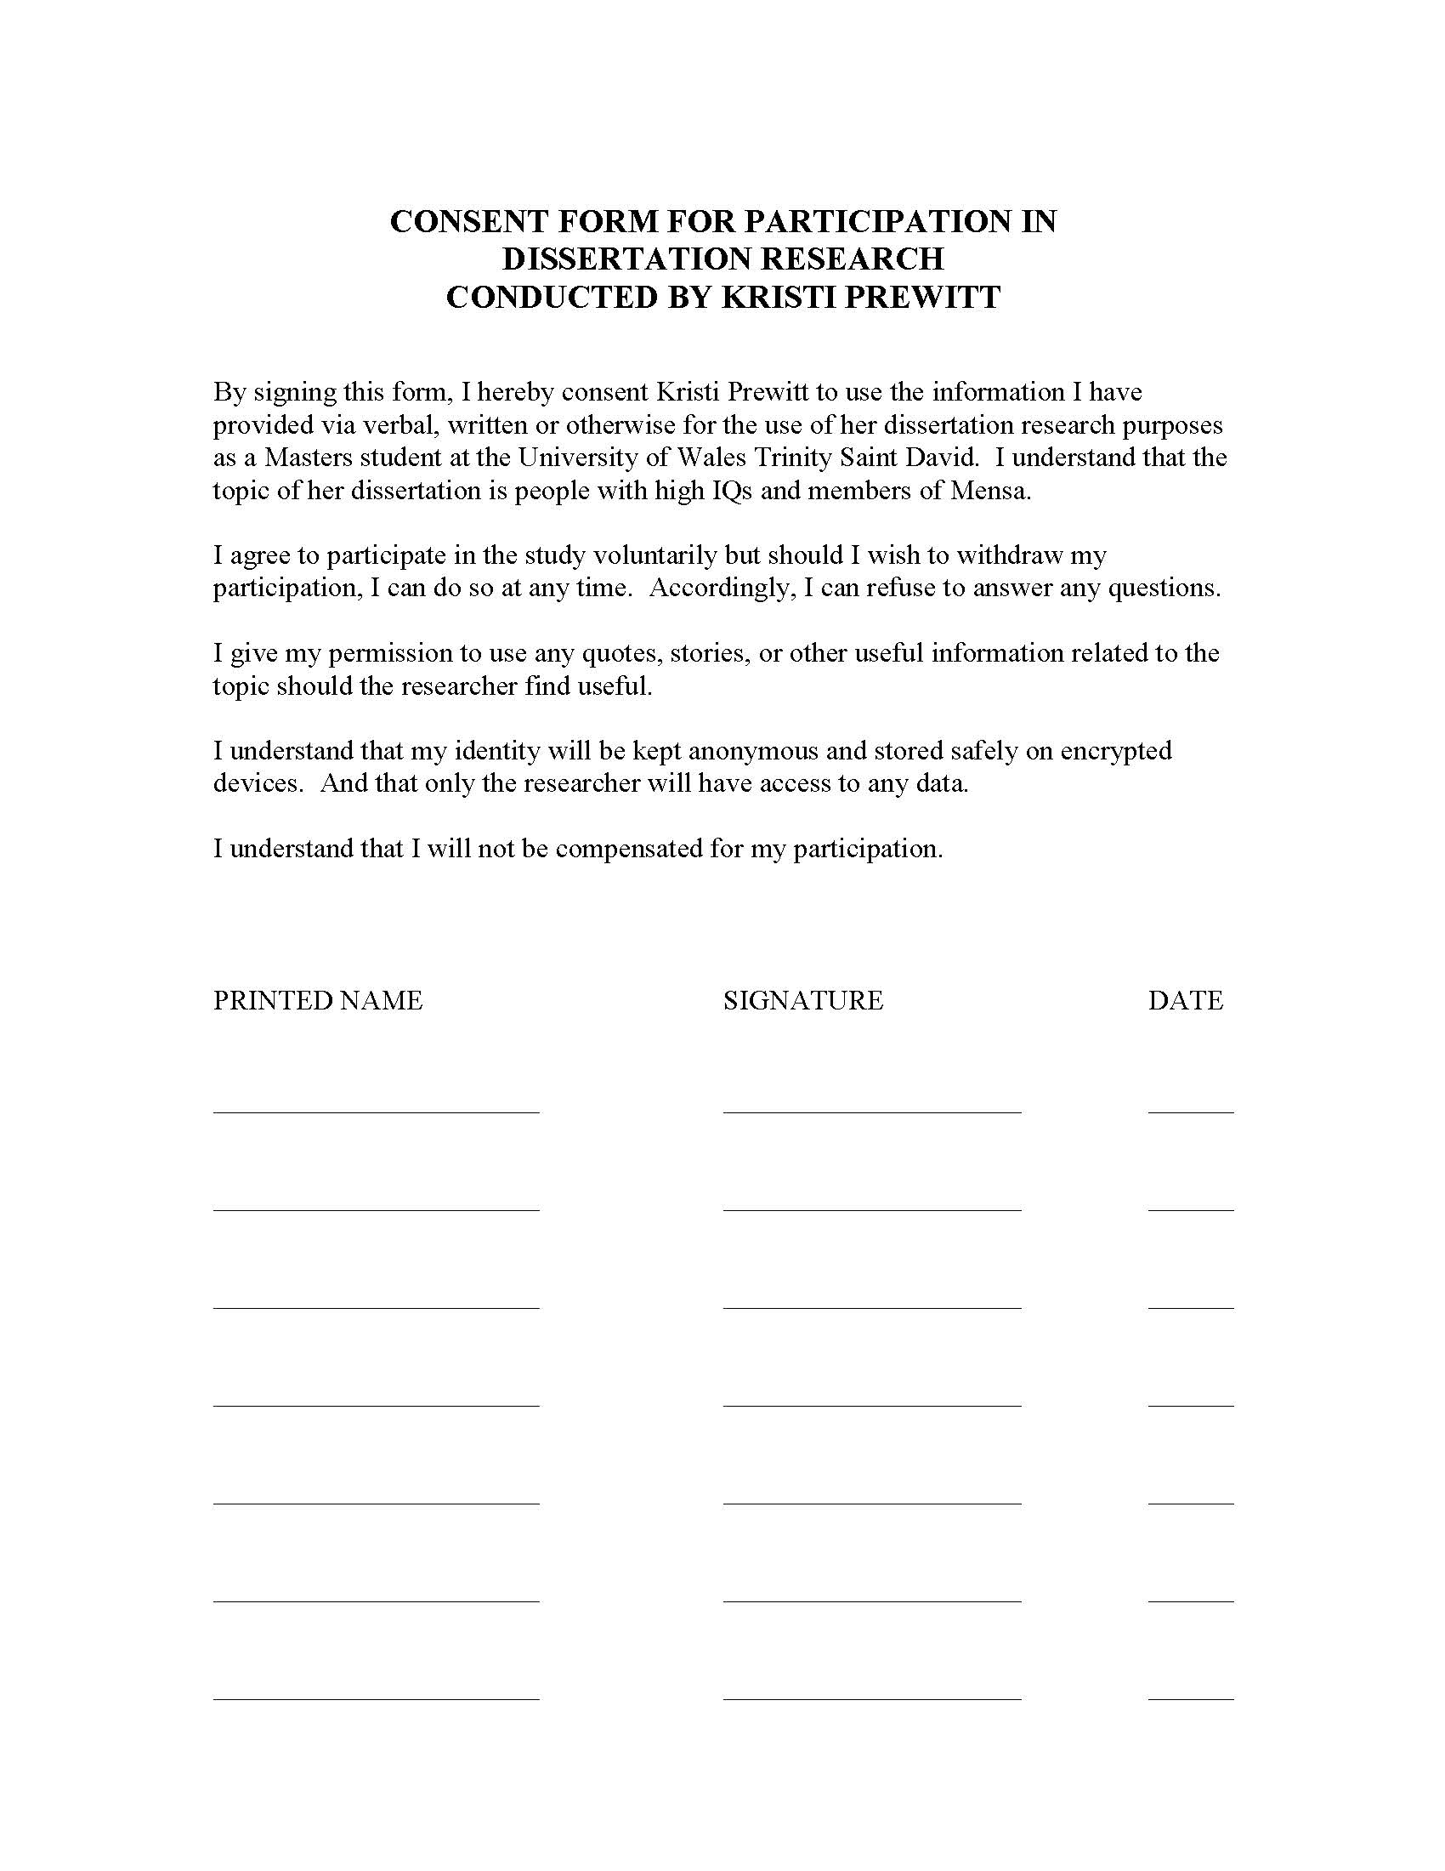

Appendix B

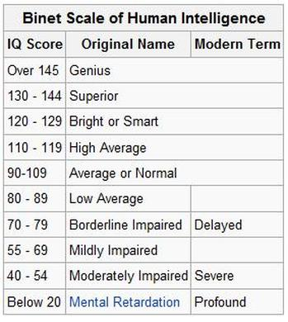

Appendix C

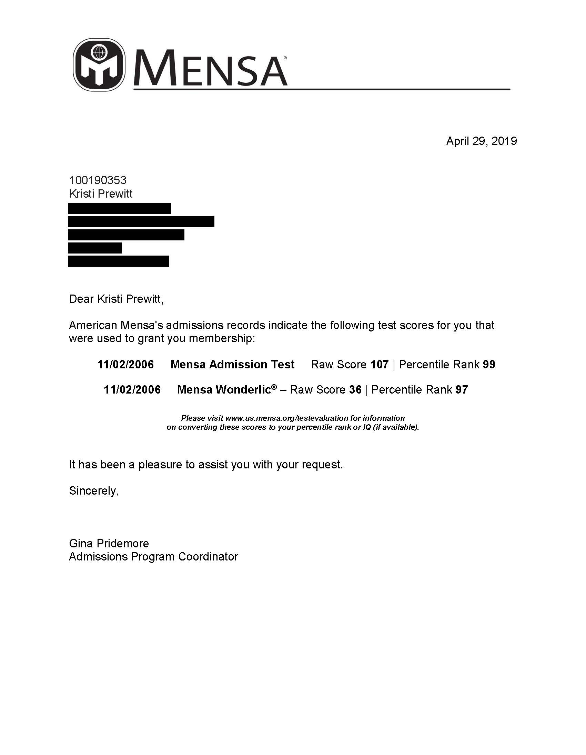

Appendix D

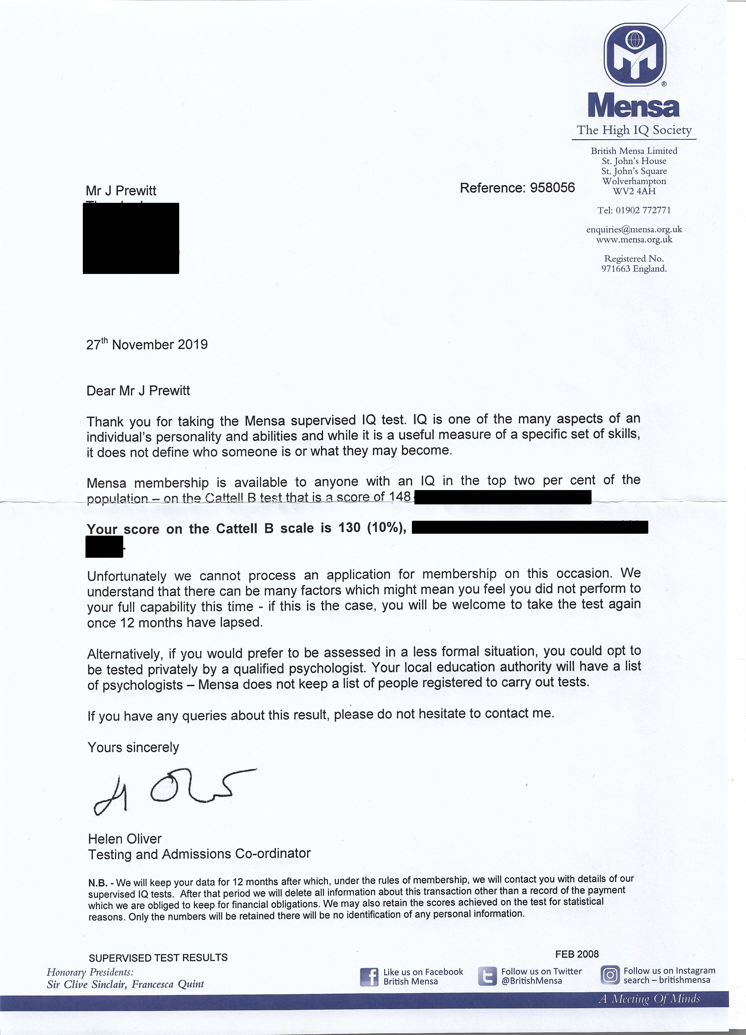

In the documentary What Makes a Genius?, the anatomical structures of the brain are evidenced here. (What Makes a Genius?, 2010)
The affects of ‘nature’ versus ‘nurture’ are emphasized in the documentary, What Makes a Genius?
At one of the annual gatherings, a meeting was held to discuss the latest concerns Mensans were having. ‘Intellicide’ was one subject meaning that there is a fear that some people wish to eradicate or harm the top 2%. And it was confirmed that Mensa was creating its own computer language so that members could speak safely to one another without fear of privacy breeches.
The entire segment on Good Morning Britain can be seen by following this link: https://www.youtube.com/watch?v=bErlrHGUc9g&t=4s (Is Calling Someone a Nerd a Hate Crime?, 2019)
The story of Kevin Metnick is a good illustration of this condition and can be viewed on the documentary, Mystery of Genius: Masters and Madmen (Jones, 2003)

