Electronic And Electrical Principles –
Resonance

ACDA4006

Measure and observe the behaviour of resonance in Simulation and Physical circuit

Mehrshad Jafari - 2410644

Table of contents

1. Abstract
2. Introduction
3. Simulation Setup
3.1 Theory
3.2 Proteus Setup
3.3 Proteus Results
3.4 Breadboard Setup
3.5 Breadboard Results
4. Discussion
4.1 Resonant Frequency
4.2 Bandwidth
4.3 Q Factor
5. Conclusion

- Abstract
This report will give a detailed insight into the work conducted through the process of creating a simulation and physical circuit, with the aim of measuring and observing the resonance behaviour in both simulated and physical environments in order to gain relevant results to further compare against theory. This was achievable due to the use of varies measuring tools, as a frequency generator and oscilloscope were utilized to measure resonance frequency, Q factor and attenuation. Firstly, the results for the theory parallel resonance circuit were derived, this was used as a foundation for the theoretical behaviour. The parallel circuit was then replicated for Proteus simulation and physical Breadboard testing, for experimental validation and theoretical comparisons.
Results derived for resonance frequency and Q factor were performed by standard RLC circuit formulas. Regarding Proteus simulations the resonance frequency was observed to be 4950 Hz, with a Q factor of 24.75. Furthermore, physical measurements on the breadboard revealed a resonance frequency of 5000 Hz and a Q factor of 2.5. These results show reasonable agreement while also showing some discrepancies regarding the Q factor. These differences regarding the results of the different environments will be discussed further in detail within the report.
- Introduction
An RLC circuit, which is the circuit being simulated for this project, are electrical circuits which contain resistors, inductors and capacitors either connected in series or parallel. Within this circuit each component has its own path for current which can vary however they all share the same voltage which remains the same over the components. [1]
RLC circuits have numerous practical applications, such as:
- Signal filtering – allowing certain frequencies to pass while blocking others (low-pass, high-pass, band-pass filters).
- Oscillators – given a specific frequency, circuits can generate sinusoidal signals
- Impedance matching – matching the impedance of a load to the source
[1]
And many more applications in communication, signal processing or audio systems. These applications allow RLC circuits to play a fundamental role due to their ability to filter, resonate, and store energy ensuring electrical components function effectively.
The theory of resonance plays a key part for this project, at resonant frequency, the inductive and capacitive reactance balance, or cancel, each other out. leading to a high impedance state resulting the circuit to become intensely resistive.[2]
The theory and use of Q Factor. The Quality Factor measures the performance of the circuit, more specifically the inductor or capacitor, in terms of how much energy is lost. A higher Q Factor implies the circuit is more efficient and has less energy loss.[3]

- Simulation setup
This part of the report will include set up and testing parameters in order to observe and analyse parallel RLC circuits, one from a software simulation and the other conducted from a physical breadboard. Both simulations have mirrored parameters and fixed variables such as the input voltage to ensure a fair test has been conducted. With the primary goal of retrieving and comparing results such as, the resonance frequency, quality factor and impedance across different frequencies.

3.1 Theory
This section provides the Theory based results for the simulations. Theory is an expected outcome or explanation based on fundamental rules or principles which provide an understanding of why the expected outcomes are what they are [4]
This project includes the resonance behaviour of parallel RLC circuits, the core theory of this experiment is based on three components, the resistor, inductor and capacitor. At resonant frequency the reactance's balance or cancel out and circuit becomes resistive [2] Formula for resonant frequency of a parallel RLC circuit:
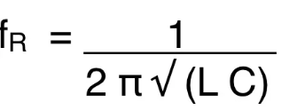
Figure 1: shows the formula for resonant frequency

Formula for Q Factor:
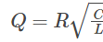
Figure 2: shows the formula for Q Factor

The results obtained for theory are as shows below:
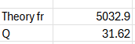

3.2 Proteus Setup
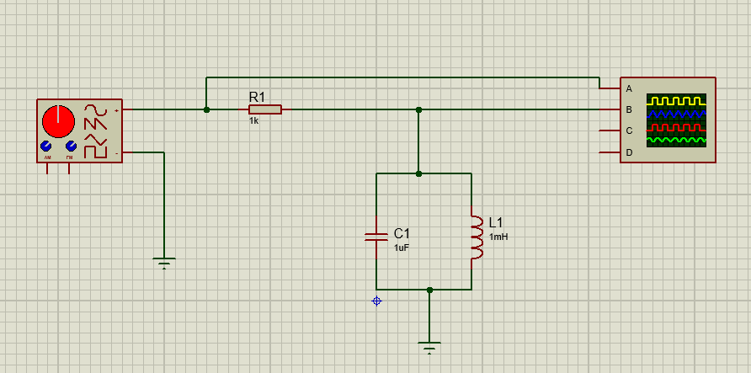
Figure 3: simulation created on proteus
This circuit was created by the following components such as a capacitor, inductor, signal generator, resistor and oscilloscope.
The circuit is powered by the signal generator which allows you to simulate a wide range of input signals with adjustable frequency to measure and observe the results.
The oscilloscope is used for observing and analysing waveforms at different frequencies, this allows for precise results as it provides an ideal environment without real world effects such as noise and current loss.
A key parameter for these tests was to set the signal generator output to 2v peak to peak at 100Hz. Once this has been done, the output voltage should not be changed during testing.
Testing Proteus simulation
The method of testing for this circuit is required to measure the voltages across the components at a range of frequencies, these frequencies range from 100Hz to 20KHz
Parameters for testing included, that the output voltage is fixed at 2V peak-to-peak to ensure consistent testing conditions across the different frequencies.
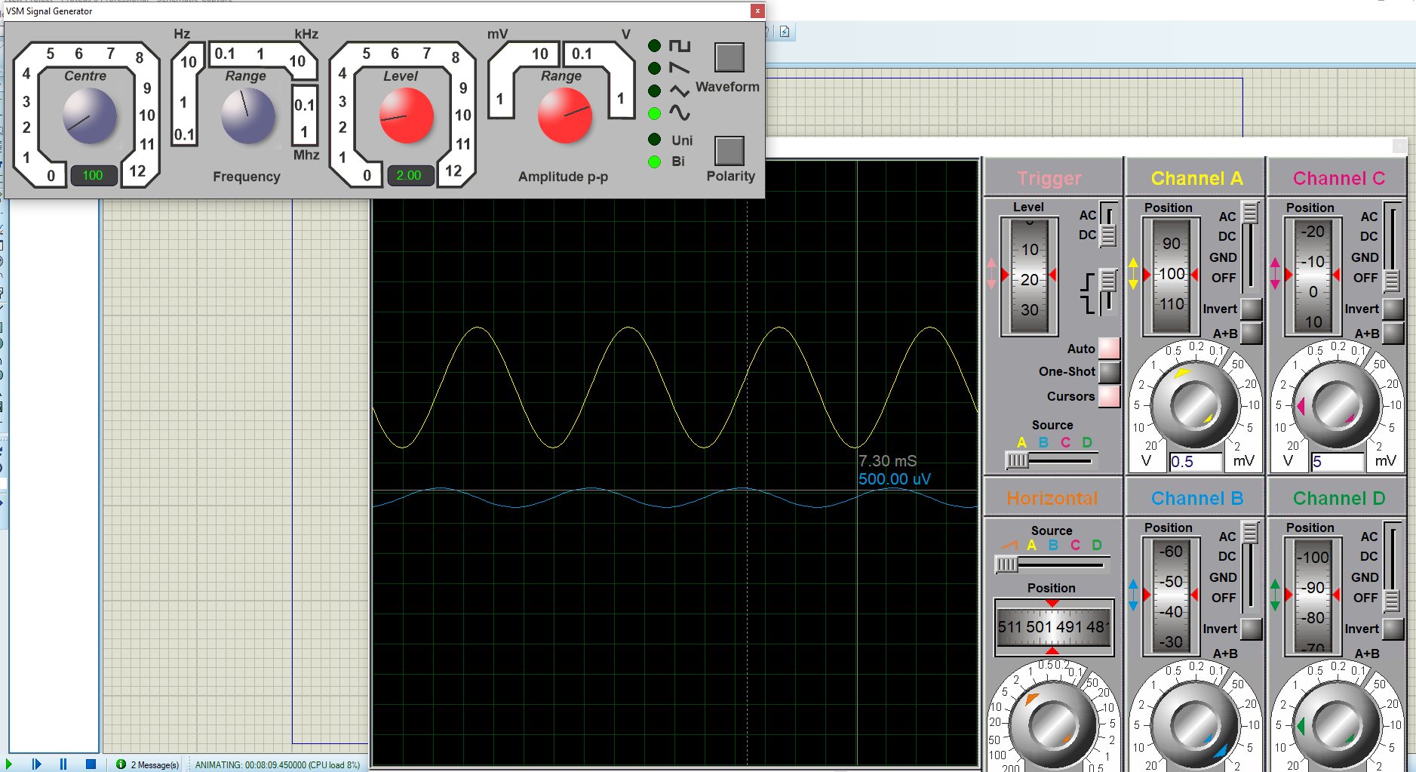
Figure 4: shows the testing values and results of the first tested frequency, at 100Hz.

3.3 Porteus Results
The following set of results were derived from the circuit shown in figure 4 when tested to a maximum frequency of 20KHz
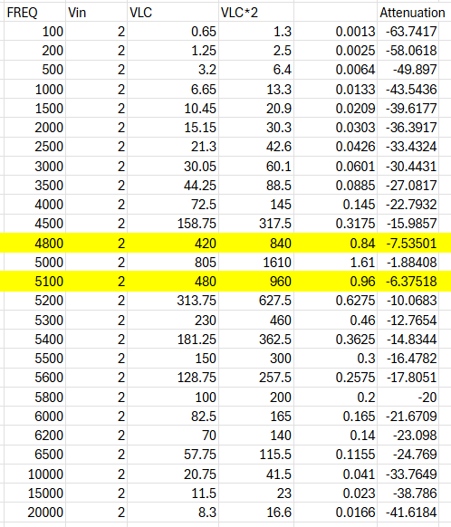
Figure 5: Results gained from simulation testing

Maximum and half maximum Voltage
Furthermore, after adjusting the frequency to obtain the results within the table. As evident from the results the maximum voltage derived from the simulation across the inductor is at 5KHz at 1610mV:
Frequency | VLC
5KHz | 1610mV

Moreover, the half maximum is found below and above the maximum Voltage, as there is one point before approaching the peak and another after the peak has taken place. Therefore, giving two values for the half maximum voltage across the inductor.
- The first point being below the peak at a frequency of 4800Hz with a voltage of 840mV.
- And the second point, after the peak at a frequency of 5100Hz with a voltage of 960mv
To check if the results are correct, the answers should approximately be half of the maximum, which is 1610mV. And 840mV for point 1 and 960mV for point 2 are approximately half of the maximum.
Figure 6: shows the half maximum which is highlighted

Attenuation
In order to calculate the attenuation, the given formula will be used:
A = 20 x log10 (VL/Vin)
Before proceeding with this step, the correct values are needed in order to obtain the attenuation. As the VLC in figure 4 is in mV it must be converted to V.
The equation to change the values from mV to V is,
= VLC x 10⁻³
Which give the following results:
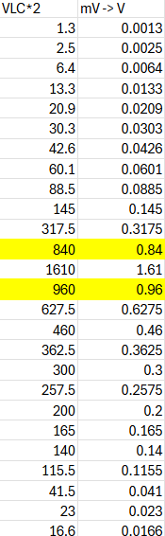
Figure 7: shows the VLC values converted from mV to V
Attenuation results can be seen below:
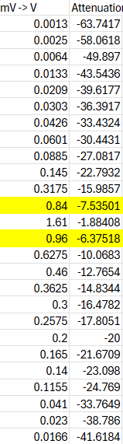
This was the formula equation used in a spreadsheet application to derive the given results for attenuation.

Figure 8: shows the completed results for the attenuation
With given results, the graph below was constructed to show the attenuation against the frequency.
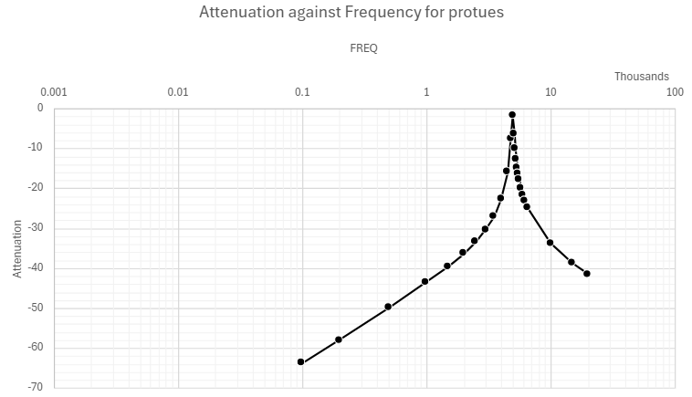
Figure 9: shows the attenuation against the frequency.
X axis: frequency, unit = Hz
Y axis: Attenuation, unit = dB

To determine the resonant frequency from figure 6. The peak attenuation of –1.88 must be subtracted by 3 in order to give the minimum graph points for the resonant frequency.

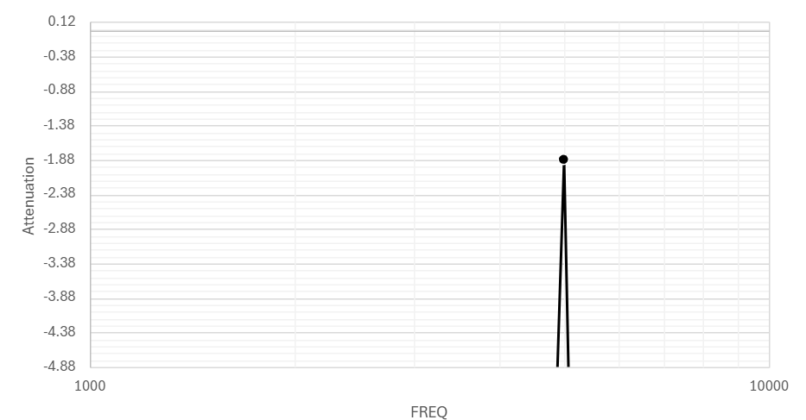
Figure 10: shows the graph data from the minimum plot of –4.88
The following data was retrieved from the graph above in figure 7
- Resonant Frequency (f_{r}) = 4950
- Lower Band (f1) = 4850
- Higher band (f2) = 5050
The equation used to work out the bandwidth (BW) is:
Bandwidth = (f1) - (f2)
With the help of this equation, the Bandwidth is the result of 4850 subtracted from 5050 which gives the BW as 200.
In order to determine the ‘Q factor’, it is a result of the resonant frequency (f_{r}) divided by the Bandwidth (BW), which when calculated:
4950/200= 24.75
Therefore, the Q factor is 24.75

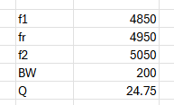
Figure 11: shows table with final results

3.4 Breadboard Setup
The same steps for testing were repeated for the physical component.
As for creating the breadboard, the following components were used:
component | Value
1x Capacitor | 1uf
1x Resistor | 1K
1x Inductor | 1mH

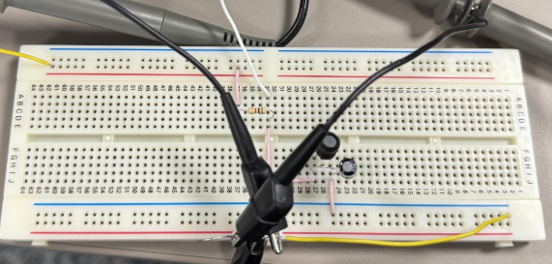
Figure 12: shows completed set up of physical breadboard
To create fair and mirrored results, the same parameters were placed on the breadboard testing components along with the same values being tested.
These include setting the signal generator voltage to 2v Peak to peak and testing the values from 100Hz to the maximum 20KHz.
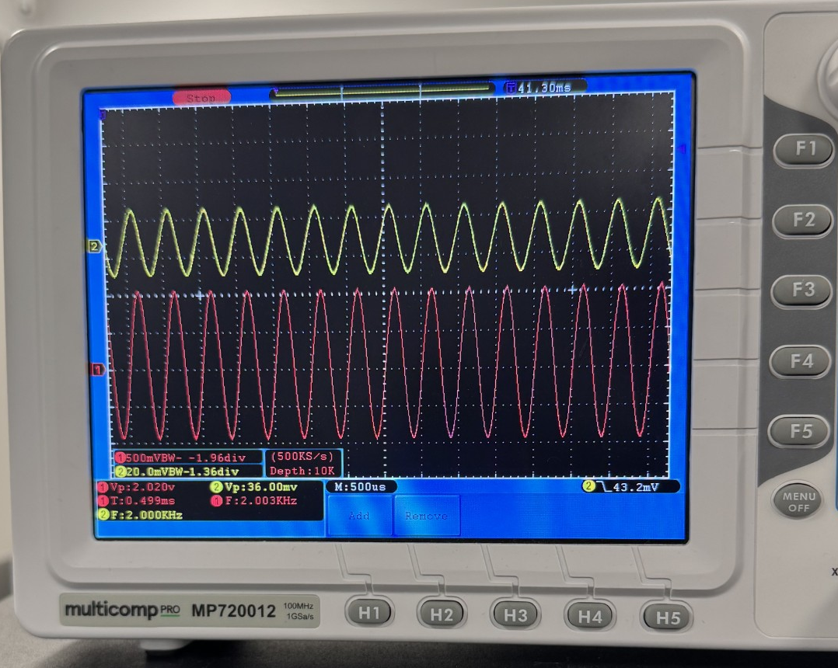
Figure 13: shows the oscilloscope when breadboard testing is conducted
When testing, the frequency values are evenly spaced, progressing every 500Hz until reaching 5KHz, then the values are closely measured, this is due to determine the peak and half amplitude points more accurately.
3.5 Breadboard Results
The following results were derived from the testing of the physical breadboard circuit. The test was conducted from a frequency of 100Hz to the maximum of 20KHz.
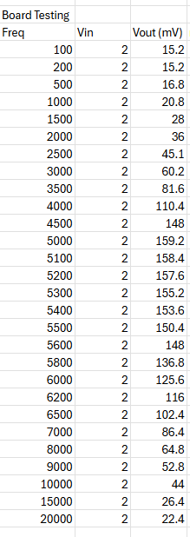
Figure 14: shows the results of the Breadboard after testing.
To accurately determine the peak and half amplitude closer readings were taken, therefore as evident from the results the maximum voltage derived from the physical testing across the inductor is at a frequency of 5KHz and an output voltage of 159.2mV.
Moreover, given the task to find and determine the half amplitude, it can be identified that there are to half points, one below the peak and one after the peak, consequently giving the results:
- Half amplitude 1 (before Peak) = 3300Hz at 74.8mV
- Half amplitude 2 (After Pak) = 7300Hz at 75.4

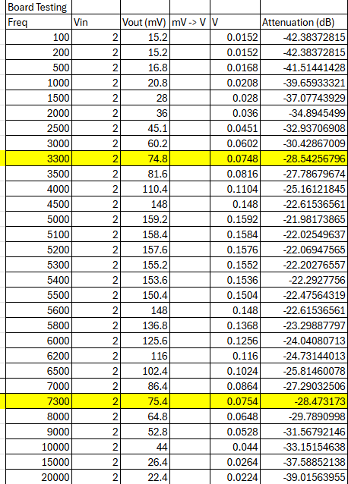
Figure 15: shows breadboard half powers

Attenuation
In order to calculate the attenuation, the given formula will be used:
A = 20 x log10 (VL/Vin)
Before proceeding with this step, the correct values are needed in order to obtain the attenuation. As the VLC in figure 11 is in mV, it must be converted to V.
The equation to change the values from mV to V is,
= VLC x 10⁻³

Which give the follow results:

The diagram below demonstrates and combines all the relevant collected data derived from testing the physical breadboard
Figure 16: shows all relevant data retrieved from testing

After obtaining these results, the necessary frequency and attenuation data achieved will be plotted on a graph.
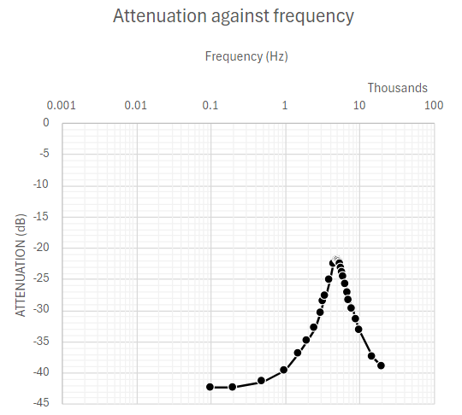
Figure 17: Is the graph plotted for breadboard results

To determine the resonant frequency from figure 17. The peak attenuation of –21.9 must be subtracted by 3, in order to give the minimum graph points for the resonant frequency. Which is –24.9
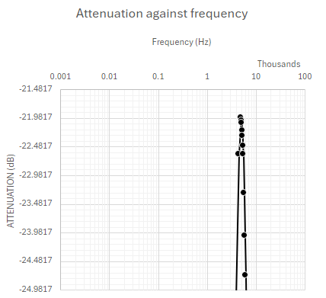
Figure 18: shows the graph data from the minimum plot of –24.9
The following data was retrieved from the graph above in figure 13:
- Resonant Frequency (f_{r}) = 5000
- Lower Band (f1) = 4000
- Higher band (f2) = 6000
The equation used to work out the bandwidth (BW) is:
Bandwidth = (f1) - (f2)
With the help of this equation, the Bandwidth is the result of 4000 subtracted from 6000 which gives the BW as 2000.
In order to determine the ‘Q factor’, it is a result of the resonant frequency (f_{r}) divided by the Bandwidth (BW), which when calculated:
5000/2000= 2.5
Therefore, the bandwidth is 2000
And Q factor is 2.5

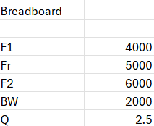
Figure 19: shows results for breadboard
- Discussion
The results derived from the Parallel RLC circuit via the software simulations and physical breadboard testing show the insight in the two different environments of the circuit, as well as sharing similarities in the results, as expected they also show discrepancies.
4.1 Resonant frequency
Simulation Via | frequency
Theory | 5033Hz
Proteus | 4950Hz
Breadboard | 5000Hz

The results for the resonant frequency were very similar with a close range of 80Hz difference. This small variation can be described as and due to factors, such as component tolerances. However overall, the minority in the difference indicates that the testing via simulation and breadboard are fairly accurate and reflects the expected theory results.
4.2 - Bandwidth
The discrepancy with the bandwidth testing is more noticeable between the breadboard and proteus simulation. The breadboard results show a bandwidth of 2000Hz which suggest a wider peak resonance which indicate low selectivity [5]
In contrast the Proteus results show a narrower bandwidth of 200Hz indicating higher selectivity which allow for better isolation of desired frequencies [6]
The difference can be due to real world factors and components not having ideal values or energy loss occurring when testing
4.3 - Q factor
The Q factor is where results vary the most as for the simulation and theory, they both share a high Q factor of 24.75 for Proteus and the theory Q factor of 31. A high Q Factor indicates it is more efficient as less energy is lost. However, there is a significant difference in the breadboard, which shows a Q factor of 2.5, this shows that there is a high level of energy loss compared to its efficiency. This large difference in Q Factor could be attributed to the real world set up of the breadboard which could have additional resistance in wiring and connections resulting in energy loss. Furthermore, as physical components are not perfect there could be factors like resistance in inductors and leakage in the capacitors which contributed to the energy loss. [3]

- Conclusion
in this experiment it has been determined the Proteus results show more similarities to the expected theory results, as they all share a small difference in the resonant frequency which can be attributed to component tolerances. However, the larger discrepancies in bandwidth and Q factor highlight the limitations of real-world physical circuit compared to ideal simulations. Overall, this demonstrates that while simulations provide accuracy and better behaviour in Favour of theory, real world components are affected by non-ideal factors, which lead to discrepancies in bandwidth and quality factor. These findings emphasize the importance of considering real-world factors when designing and analysing electronic circuits.

6. References
[1] “What Are RLC Circuits?” Ansys,[Online].Available: https://www.ansys.com/en-gb/simulation-topics/what-are-rlc-circuits#what-is. [Accessed 8 January 2025].
[2] “Parallel Resonance” fiveable,[Online].Available: https://library.fiveable.me/key-terms/principles-physics-ii/parallel-resonance. [Accessed 6 January 2025].
[3] Vidya Muthukrishnan, “Q factor: What is it? (How do you measure it?)” Electrical4U, 9 June 2024.[Online].Available: https://www.electrical4u.com/q-factor/#:~:text=Q%20factor%20%28also%20known%20as%20Quality%20Factor%20or,in%20terms%20of%20its%20losses%20and%20resonator%20bandwidth. [Accessed 8 Janaury 2025].
[4] “Concept vs. Theory” This vs That,[Online]. Available: https://thisvsthat.io/concept-vs-theory. [Accessed 7 January 2025].
[5] Mumbai University, “Explain the terms: selectivity, fidelity, sensitivity, AGC” Ques10, 2019.[Online]. Available: https://www.ques10.com/p/37204/explain-the-terms-selectivity-fidelity-sensitivi-1/. [Accessed 9 January 2025]
[6] “Selectivity” Fiveable, [Online]. Available: https://library.fiveable.me/key-terms/electrical-circuits-systems-ii/selectivity. [Accessed 7 January 2025]

