27-03-2020

A review of active and semi-active motorcycle suspension.
Simon Hughes
UWTSD

Abstract.
Though having been fitted to cars for many years semi-active suspension is only recently seeing a surge into the motorcycle market.
Many motorcycle manufacturers and suspension suppliers now produce semi-active solutions for high end and performance motorcycles, suppliers such as WP suspension and Ӧhlins supply mainly to manufacturers but several other suppliers offer setups that are more plug and play.
There has been much research into the field of semi-active suspension, mostly on how to increase the speed of the control systems to make the internal decision making and reaction faster and more accurate.
Introduction.
Many of today’s current motorcycles use passive suspension which provides a relatively small amount of external adjustability, these adjustments usually involve some system of incremental change, therefore providing a finite amount of adjustment.
Fork adjustment is usually at the top or bottom where it is easily accessible, though the rear shock absorber is usually obscured. With these adjustment methods, they can only be undertaken when the motorcycle is stationary or in a workshop with specific tools.
To advance this adjustability any further, more intensive external methods are required, this is where an electronic system would prove beneficial, this where active and semi-active systems come in.
Active and semi-active suspension has existed in several forms for many years, mainly on cars, but has only recently made its way on high end motorcycles. Much research has been conducted into the design and control of these systems form many years.
Many of the large motorcycle manufacturers now produce high end motorcycles that use some form of semi-active suspension.
Active vs semi-active suspension.
Most manufactures use semi-active suspension on their motorcycles, though Aprilia claim to use an active system.
Semi-active suspension normally uses dual accelerometers to measure the acceleration of the front and rear of the motorcycles, it also uses two position sensors to measure the relative location of the rear wheel and the amount that the front suspension has compressed, the system then uses these measured values of the vehicle to determine what needs to be done with the damping of the suspension system.
Active suspension refers to a system where the wheels of the vehicle act on surface changes before the vehicle has reached them, whereas semi-active suspension is still only reacting as conditions change in real time.
Magnetorheological fluid dampers, MRF.
Magnetorheological fluid dampers use a type of fluid that has a fine metallic powder suspended within it, this fluid is accompanied by a setup of electromagnets.
When more damping is required the fluid is subjected to a magnetic field whose strength is varied depending on how much damping is required. These fields align the magnetic particles within the fluid, causing chain like structures to form (figure 1), creating a resistive force that causes the fluid to become more viscous, this viscosity results in the amount of damping changing.
So far only one producer of motorcycle suspension uses MRF technology, Mupo race suspension showcased at EICMA 2015 a magnetorheological suspension setup, though no more than a technical show case can be found and no price is available, therefore possibly meaning they are not available.
Despite the Mupo showcase this this technology seems to only be used on vehicles such as cars and vehicles with more than four wheels.
One major downside of MRF is that it introduces a certain factor of wear, due the fact that there are small particles within the fluid it can erode the areas where flow is restricted. This causes then need for wear locations to have parts that are easily replaceable and a stringent service interval to avoid failure.
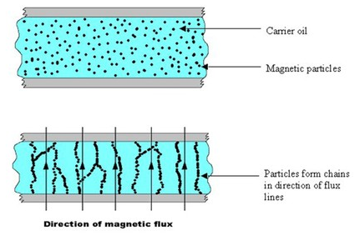
Figure 1 MRF with and without a magnetic field applied. [1] [2]

Solenoid dampers.
Solenoid dampers are the most common type of semi active suspension found on modern motorcycles; they use a small amount of current to move a valve in or out to restrict the flow of oil. When the valve restricts the oil, it creates a higher damping value leading to more damping of the suspension, and when the restriction is lessened the oil pass faster therefore reducing the damping of the suspension.
These electronic solenoid valves react within fractions of a second, making them ideal for this high-speed task. To control these valves the sensors mentioned earlier are fed in to either the ECU or into a separate processing unit, which then works out the damping scheme required via a specific algorithm.
Figure 2 Solenoid damper schematic [3]
Many different suspension manufacturers such as Ӧhlins, Marzocchi, Sachs [4] [5] and WP all produce product lines of semi-active suspension.
Although the basic principal is the same the different manufacturers implement it in differing ways, with the forks it is difficult because of their design to control them in any other way than from the top but with the rear the electronic valves can be in the piston or fixed to the outside of the unit.
The Ӧhlins rear shock absorber as seen in figure 3, has two externally mounted valves that independently control damping and rebound, as can be seen in figure 2, the unit utilizes an accumulator as a backup to relieve excess pressure.
Ӧhlins Semi active suspension is used on several Ducati motorcycles.
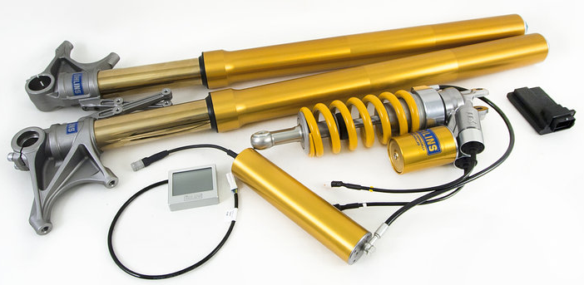
Figure 3 Mechatronic kit for Ducati Multistrada [6]
Marzocchi supply kits that fit several BMW motorcycles but also supply different standalone kits that can be fitted to several other motorcycles. [7]
WPs version, as seen in figure 4, is used on KTMs Super duke and adventure motorcycles. The fork design is split into two, one side only having the spring and sensor arrangement and the other side housing the adjustable damper; the damping adjustment is achieved in this case with a single valve.
Triumph also use WP technology but under the name of TSAS, or Triumph Semi Active Suspension. [8]
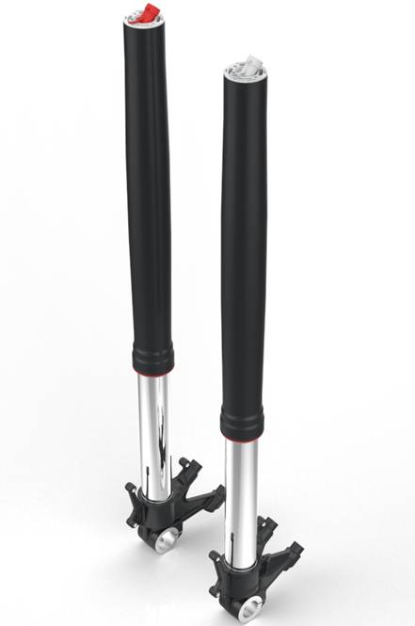
Figure 4 WP semi-active forks [9]
Most of these systems implement the damping and preload in different forks on the front of the motorcycle, doing this provides more space withing the already small envelope of the fork to implement slightly larger systems for damping control.
Aprilia use a system that was designed in house called ADD, Aprilia Dynamic Damping, that they claim it to be the first active suspension system on a motorcycle. This active claim is due to the system analyzing the load of the motorcycle and adjusting the preload of the rear suspension to keep the motorcycle in an optimum position [10]. Though it could be considered active suspension it falls short of the car definition of active suspension which many would compare it against.
Safety.
Much thought about safety will have been put in by the suppliers of the suspension as well as the motorcycle manufactures, this may be one of the reasons that there are no fully active systems, like cars, on the market today.
Semi-active suspension helps maintain contact of both wheels in a heavy breaking situation by increasing the compression damping on the forks to reduce the dive effect motorcycle suffer from [11], due to this reduction in dive the geometry of the motorcycle stays in a more level position, therefore maintaining rear wheel contact so rear brake application is possible.
Semi-active suspension can also be programmed to work in conjunction with the motorcycles ABS and traction control systems, TC, therefore increasing the safety of the motorcycle even more, doing this increases the amount of different, potentially dangerous scenarios that the bike can help the rider overcome.
Conclusion.
The systems that have been implemented by manufacturers have gone a long way to improving the overall riding experience. Though this may be the case many riders would likely not notice the benefits compared to a well setup conventional suspension system.
The cost of the system is one of the reasons why semi-active suspension remains on only the high-end motorcycles and why many riders will never benefit from it if the price of it doesn’t reduce.
From a comfort point of view these systems would certainly decrease the amount of fatigue endured by the rider as it would lessen the harshness of many different types of road condition.
Through a fully integrated system of ABS, TC and damping control a motorcycle can become a much safer platform, as it takes some of the fine control burden off the rider in an emergency situation and potentially preventing injury to the rider or damage to the motorcycle.
MRF dampers could prove to be a useful technology in the future as they could offer much larger windows of adjustability. The switch to this technology would require only small changes to much of the already existing infrastructure as things such as sensors would remain much the same. With the main drawbacks being the amount of time it takes to generate the amount of damping required, the power it takes to create the conditions to provide the damping and the possible wear aspects.

References

[1] | W. Becker, "Smart fluid off state," 27 03 2020. [Online]. Available: https://commons.wikimedia.org/wiki/File:Smart_fluid_off_state.jpg.
[2] | W. Becker, "Smart fluid on state," 27 03 2020. [Online]. Available: https://commons.wikimedia.org/wiki/File:Smart_fluid_on_state.jpg.
[3] | P. Svennerbrandt, "Force Feedback Control of a Semi-Active Shock Absorber," 06, 19, 2014.
[4] | zf, "A complex challenge: Two wheel CDC," zf, [Online]. Available: https://www.zf.com/products/en/motorcycle/home/two_wheel_cdc/two_wheel_cdc.html. [Accessed 27 03 2020].
[5] | ZF, "CDC - faster and safer in any situation," ZF, [Online]. Available: https://www.zf.com/products/en/motorcycle/home/cdc_faster_and_safer/cdc_faster_and_safer.html. [Accessed 27 03 2020].
[6] | Öhlins, "TTX 36 & TTX 39 EC Adventure DU 871," Öhlins, [Online]. Available: https://www.ohlins.eu/en/products/motorcycle/du-871--4772/. [Accessed 27 03 2020].
[7] | marzocchi moto, "Exclusive cooperation between Marzocchi and Tractive Suspension in semi-active front forks and rear shock absorbers," marzocchi moto, [Online]. Available: https://www.marzocchimoto.com/en/marzocchi-tractive-suspension-agreement/. [Accessed 27 03 2020].
[8] | K. Condon, "Tech Review: Triumph Goes All Electronic-y with the New Tiger Explorer ADV For 2016," [Online]. Available: https://www.motorcyclistonline.com/tech-review-triumph-goes-all-electronic-y-with-new-tiger-explorer-adv-for-2016/. [Accessed 27 03 2020].
[9] | Pamp-Kinn, "KTM 1290 SUPER ADVENTURE: Semi-active suspension from WP," KTM, [Online]. Available: https://blog.ktm.com/ktm-1290-super-adventure-semi-active-suspension-from-wp/. [Accessed 27 03 2020].
[10] | Aprilia, "ADD Aprilia Dynamic Damping," Aprilia, [Online]. Available: https://www.aprilia.com/us_EN/technology/add/. [Accessed 27 03 2020].
[11] | V. Cossalter, Motorcycle dynamics, 2006.

