

MSc in LOGISTICS
MODULE: Research Methods
(M7X01272)
Critically appraise the questionnaire content and suggest improvements for future surveys.
Review the data coding and data held in the SPSS file and discover where the student has created new variables and also carry out data cleansing to correct any anomalies and then conduct analysis to extract as much reliable information as possible.

STUDENT NAME: KWAKYE AKWASI

STUDENT NUMBER: P146938

LECTURER: Graham Orr

DATE: 31 Oct. 2017.
Contents Page
1.0 Introduction 4
2.0 The Critical Appraise of the Visit to Local coastal area Survey 5
2.1 Critic on Survey Introduction and Heading. 5
2.2 Critic on the Survey Structure. 6
2.3 Critic on the question formation. 6
2.4 Critic on the Offering Escape Answers. 7
2.5 Critic on the Vague Questions and Answers. 7
3.0 Data Cleaning 8
3.1 Using SPSS to identify the Anomalies of Respondents data 8
3.2 Using SPSS to Clean the Anomalies Found 9
4.0 Data Analysis 11
4.1 Chi-Square Test Analysis. 12
4.1.1 Interpretation of the Chi-Square Output 14
4.2 T- Test Data Analysis. 14
4.2.1 Interpretation of the SPSS T-Test Output. 16
4.3 Bar Chart Data Analysis. 17
4.3.1 Interpretation of the Bar Chart Data Analysis. 19
4.4 Pie Chart Data Analysis. 19
4.4.1 Interpretation of the Pie Chart Data Analysis. 20
5.0 Conclusion and Recommendation 20
5.1 Conclusion 20
5.2 Recommendation 21

List of Figure Page
Figure 1: Proposed Introductory Heading for the Welsh Tourist Board Survey. 5
Figure 2: Suggested Answers for Questions1 8
Figure 3: Cross tabulation output of Age and Gender with abnormalities variables. 9
Figure 4: Capturing of Correct Coding Equation(Cleaning). 10
Figure 5: A Cleaned Cross Tabulation Output of Age and Gender (without the abnormalities variables). 11
Figure 6: The Output of Male’s and Female’s Household Income Statistical Test. 13
Figure 7: Independent Samples T-Test on variables “Stay Overnight” and for “Pleasure”. 16
Figure 8: Independent Sample Test Box. 16
Figure 9: First Output of SPSS Bar chart analysis on Enough Parking and Gender. 17
Figure 10: Final Output of SPSS Bar chart analysis on Enough Parking and Gender(with no irregularities). 18
Figure 11: The Output of SPSS Pie Chart Analysis of Visitors Age. 19

1.0 Introduction
In all academic Dissertations, Data analysis is inevitable, its help researchers to make accurate judgment on their Hypotheses without critics. More so, a well-presented data analysis is initially done through the collection of data from the population sample.
For a researcher to obtain accurate data from respondents, he/she has to set out questions (Questionnaire) and send to respondents for answers. The engagement with the respondents for data does not have to be direct or face to face as most students are taught. It could be done through a variety of methods; postal survey, personal interview, telephone interview and email interviews. However, the foundation anchor behind this source is a set of questions (Ghauri and Gronhaug 2005),

Ghauri and Gronhaug (2005), simply, stated that questionnaires are a way of collecting primary data. On another note, they are further defined it as
“…an effective tool to get opinions, attitudes and descriptions as well as for the cause- and-effects relationship”.
Sometimes, researchers fail to collate data from respondents because of how and when they conduct their data collection. In 21 century, the world has been more conscious about Time. Therefore, a questionnaire must be simple, easy to understand, no duplication of questions, no ambiguity, easy to read and answer.
Ghauri and Gronhaug (2005), also reviewed that the appearance, layout, length and even the colour of the paper used have an influence on whether the questionnaire will be responded to properly or not.
There have been vast amounts of teaching on the constructing of questionnaires, but there is one important philosophy which needs to be applied in constructing a good questionnaire that is; the consideration of the respondent’s educational levels and other factors like their culture. As certain languages or words are prohibited in some cultures. ie research questions on pigs at Muslim community. (Malthotra, 1996; Schwartz and Sudman, 1996; Craig and Douglas, 2000).

2.0 The Critical Appraisal on the Visit to Local coastal area Survey
The survey has a lot of irregularities, according to guidelines for constructing of questionnaires. see appendix 1:

2.1 Critic on Survey Introduction and Heading.
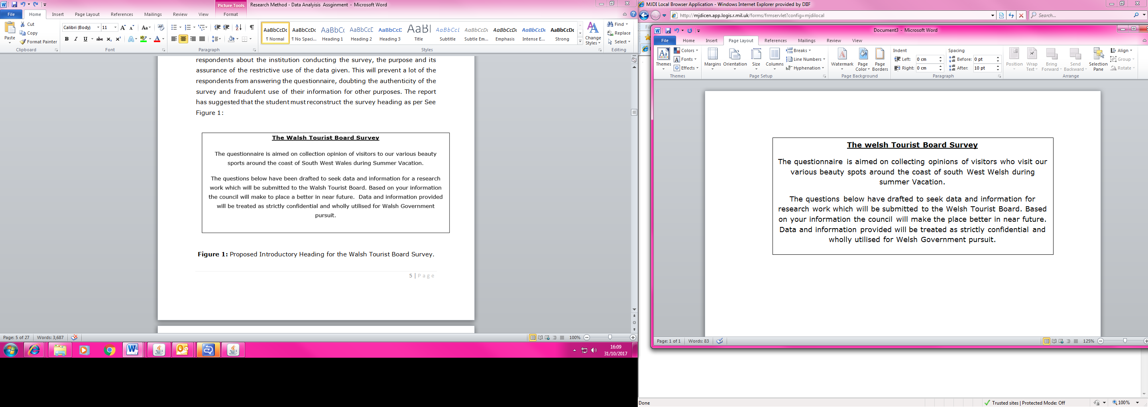
In the appendix, the survey does not have an introduction heading to inform its respondents about the institution conducting the survey, the purpose and its assurance of the restrictive use of the data given. This will prevent a lot of the respondents from answering the questionnaire, doubting the authenticity of the survey and fraudulent use of their information for other purposes. The report has suggested that the student must reconstruct the survey heading as per See Figure 1:
Figure 1: Proposed Introductory Heading for the Welsh Tourist Board Survey.

2.2 Critic on the Survey Structure.
The survey is not well structured or arranged. Questions 19, 20, 21 and 23 are supposed to be the leading questions rather than question 1, 2, 3 and 4. A well-structured survey is at least is formed up into two sections A and B, where Section A consist of the personal questions of the respondent leading into the main section B. Section B always consist of the other major questions that relate to the hypothesis and reports objectives.
Ghauri and Gronhaug (2005) seconded that questions should be placed in a right order. They also said that easy -to- answer questions and positive types of questions should be placed first. If hard questions are placed first, the visitors will refrain from responding thinking they are all difficult questions. The survey is made up of 25 main questions and 27 sub questions under Q4 and Q4a, which is too lengthy for visitors who are coming for their holiday to complete. Some could be driving or flying from other countries to the venue. Most of holidaymakers will not be happy to answer correctly due to fatigue.
Finally, the format, font size and layout of a questionnaire are also important; it makes the survey look neat and tidy. The survey looks untidy, which respondents will find difficult to answer?

2.3 Critic on the Question formation.
Most of the survey questions are not specific but general in nature. So that the respondent does not give several answers. An example is question 19 as “which area/country do you live?” These questions will result in a numerous answer. The more specific and concise the questionnaires are, the easier to interpret these questions. And it’s easier for the researcher codifying into value for data analysis. On the other hand, some of the questions in the survey are too personal to be answered by respondents like question 12 -15. It suggested that such questions have to be deleted from the survey and the SPSS database.

2.4 Critic on the Offering Escape Answers.
There are escape answers option like “Don’t know, prefer not to say and No commit” giving out in the survey see question 4, 4a, 20 and 22. It suggested that questions should be formulated in such a way that there is no escape route in the questions. It’s proposed that all escaped answers have to be deleted from the questionnaire, so that respondents pick their option.

2.5 Critic on the vague Questions and Answers.
The survey has a lot of ambiguous answers to questions 1 and 23. The answers do not make sense and it would be very difficult for respondents to answer. The proposed answers must be clear see Figure 2. More so, most of the questions can confuse respondent like questions 3, 5, 17 and 8. They do not make sense and must be reconstructed; again in a simple and concise form like “which activities is your favorite?” and” Your purpose of visitation?” . Cannel et al., (1981), advocated that well-constructed question being asked gives a better response rate.
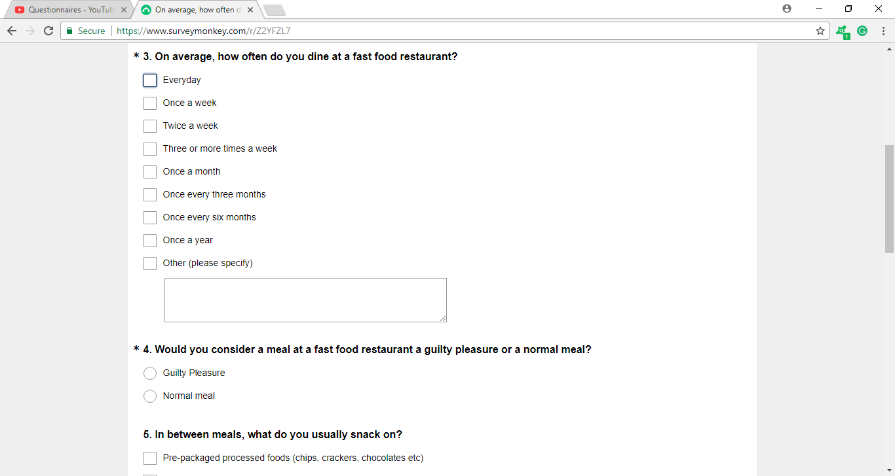
Figure 2: Suggested Answers for Questions1

3.0 Data Cleaning
The Data cleaning is a process of finding error data and eliminating it from the database SPSS. The process requires careful consideration and adequate knowledge in the use of SPSS. The cleansing process guided by the preliminary plan of data analysis, which was articulated in the research hypothesis testing.
During Cleansing data, the researcher must be consistent on checking any strange data produced by SPSS, out of range data, logically inconsistent or has extreme values.
Sometimes the researcher must assign a suitable value (neutral) to replace the missing data or missing data can be discarded from the data analysis. However, the researcher should be aware that 10% of missing response can pose a problem as its substantial to the effect of the final judgment.

3.1 Using SPSS to identify the Anomalies of Respondents data
To identify the irregularities in data, the researcher has to follow the subsequent process below:
- Click on SPSS icon and open up SPSS
- Click on the “data View” at the bottom left.
- Click on “analysis”
- Click on “descriptive statistics”
- Click on “crosstabs”
- Select “gender” and move it into the “row” box at right-hand
- Select “Age” and move it into “column” box at right-hand
- Click on the “statistics”, select “chi-square” and click continue.
- Click on the “cells”, select “observed”, select “Expected” and click continue.
- Click “OK”
Now the SPSS will produce Output see Figure 3. It was found that there are other variables in the gender and age of the respondents which are out of range and anomalies to the data analysis. They are “joint”, “No Reply” and “Prefer not to say”.
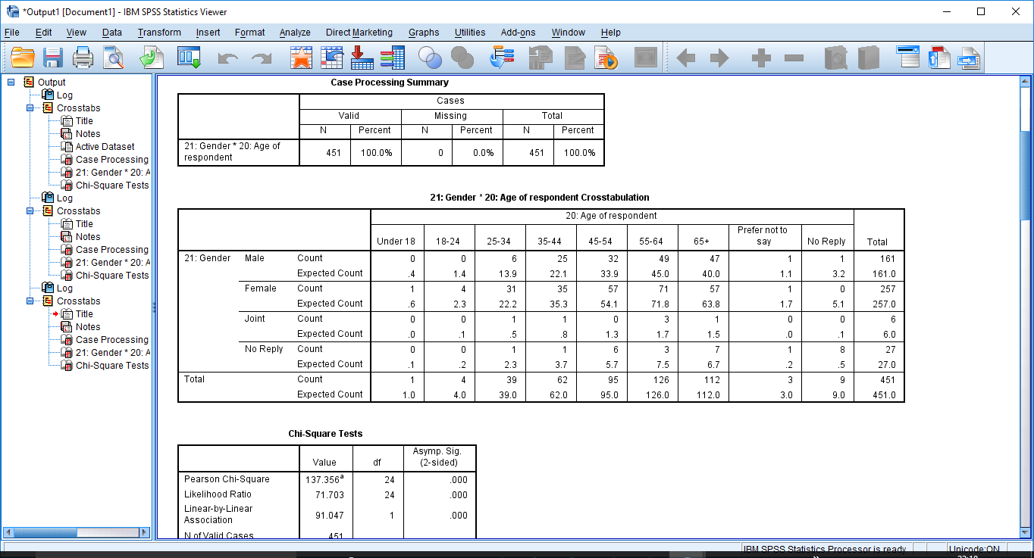
Figure 3: Cross tabulation output of Age and Gender with abnormalities variables.

3.2 Using SPSS to Clean the Anomalies Found
Now, it has been identified that “Joint”, “No Reply” and “Prefer Not to Say” are irregularities data found in the result (output), which will give room for critics to criticizes the data analysis. Therefore, the researcher has to eliminate them from the SPSS database to produce the correct data output.
To clean the anomalies from the database (SPSS), the researcher has to follow the subsequent process below:
- Click on “data”.it can be seen at the top page.it next to file.
- Click on “select cases”
- Select “if condition is satisfied”
- Click on “if”
- Select “gender” move to the right box with <3. This means that the SPSS must capture only coding 1 and 2 see figure 4
- Tab space and type “&”
- Select “age” move to the right box with <=7. This means that the SPSS must capture only coding 1 to 7 see figure 2
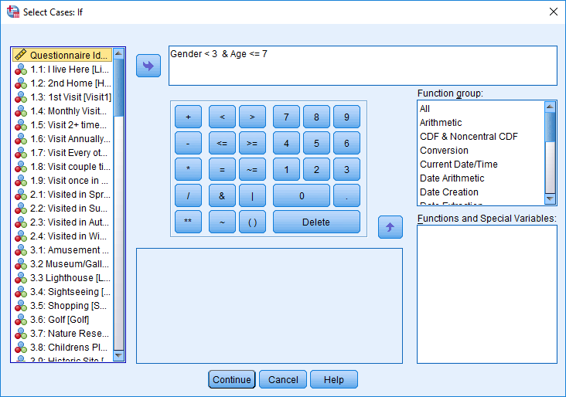
- Click on “continue”
Figure 4: Capturing of Correct Coding Equation(Cleaning).

Now the SPSS will produce a new Output see Figure 5. It has eliminated the abnormality “joint”, “No Reply” and “Prefer not to say”. Therefore, the data analysis can be used to make decisions or test the hypothesis without any critics.
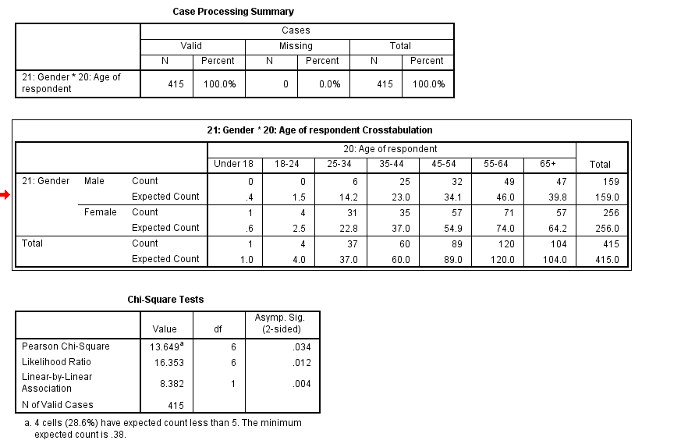
Figure 5: A Cleaned Cross Tabulation Output of Age and Gender (without the abnormalities variables).

4.0 Data Analysis
Ghauri and Gronhaug (2005), said that in the field of research statistics must involve a method for describing and analysing data for making decisions on the data collected. They stated that there are two types of statistics: they are descriptive and inferential. The descriptive statistics enable the researcher to summarise and organise data in an effective and meaningful way, whereas the inferential statistics are used to make a decision by interpreting patterns. For example, if we hypothesis that blue-collar workers are less politically conservative than professionals. After data collection an inferential statistic, is deployed to determine whether differences between the groups support our expectation.
The SPSS application will be utilised to analyses the collected data from the visitors to the Welsh Tourist Board. Through the SPSS application, it will round the Chi-square test analysis, T-test analysis, Bar chart and Pie data analysis.

4.1 Chi-Square Test Analysis.
There are three stages in utilising the chi-square analysis to interpret data collection. They are:
- Established the Hypothesis (Null and Alternative) to be tested
- Carry out an appropriate statistic Test (chi-square) via SPSS
- Interpret the result of the test.
According to the research, a chi-square test of an association will be conducted on Gender and Household incomes using the SPSS cross tabulation.
The set-up hypothesis to be tested is:
H_{o}: There is no difference between males and females in their household income?
H_{A:} There is a difference between males and females in their household income?
The researcher can conduct a chi-square test to determining whether there is an association between males and female’s household income see Figure 6 for the SPSS output.

Note: if p-value is greater than 0.05, we will accept Null Hypothesis. Vice versa.
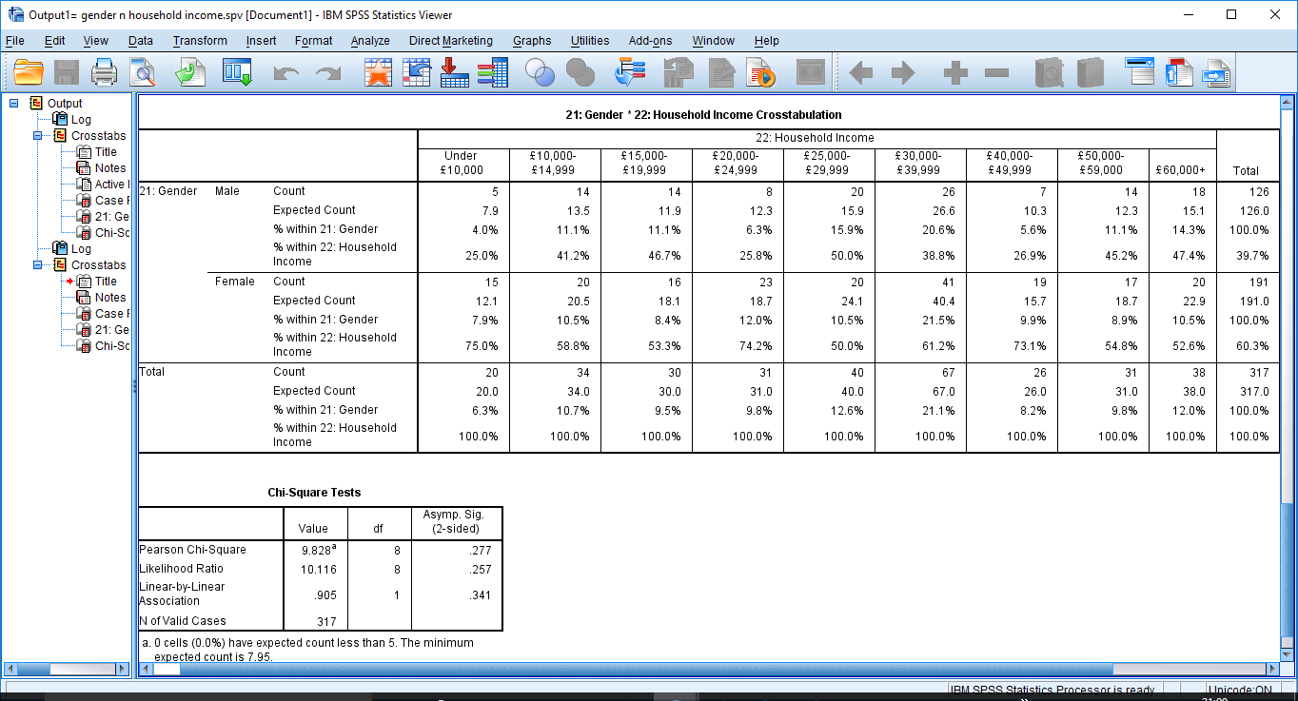
Figure 6: The Output of Male’s and Female’s Household Income Statistical Test.

4.1.1 Interpretation of the Chi-Square Output
The result of Pearson chi-square is (x=9.8267, p=0.277, df=8) is statistically significant and indicates that the Null Hypothesis must be accepted: There is no difference between males and females in their household income and reject the alternative.
However, the statistical test result it supported by percentage evidence as 14.3% of male visitor’s household income is £60,000+ whereas 10.5% of female visitor’s household income is £60,000+. Items of household income 47.4% of male visitor’s income is £60,000+ and 52.6% of female visitor’s income is £60,000+.
This is an evidence (a proof) that there is no difference between males and females’ visitors in their household income as the percentage difference is not significant and the probability value is 0.277, which is greater than 0.05.

4.2 T- Test Data Analysis.
The researcher can conduct SPSS on independent Two-sample T-test on overnight stay visitors and visitor’s pleasure.
To conduct a T-test the researcher has to follow 4 steps:
- Having a research question in mind as a reaserher which is:
Does staying overnight or not staying overnight create a signficant difference between the number of visitors who visit for pleasure ?
- Before conducting the test on SPSS we should have to sample two groups:
Group 1 ( “0 in our dataset) is visitors who did not stay overnight.
Group 2 (“1 in our dataset) is visitors who did stay overnight.
- Then set up a Hypothesis and the Hypothesis for the T-test is :

Ho: mean number of visitors for pleasure for Group 1 ≠ mean number of visitors for pleasure for Group 2?
Ha: mean number of visitors for pleasure for Group 1 = mean number of visitors for pleaseure for Group 2?

- Now Conduct the T-Test using SPSS Application by following the step below:
- Click on “analysis”
- Select “compare means”
- Select “independent sample T-Test”
- Select “grouping variables” “overnight”
- Click on “define group” “group 1=0” and “Group 2 =1”, click on continue
- Select “Here on Pleasure” to the Test Variable box and click OK
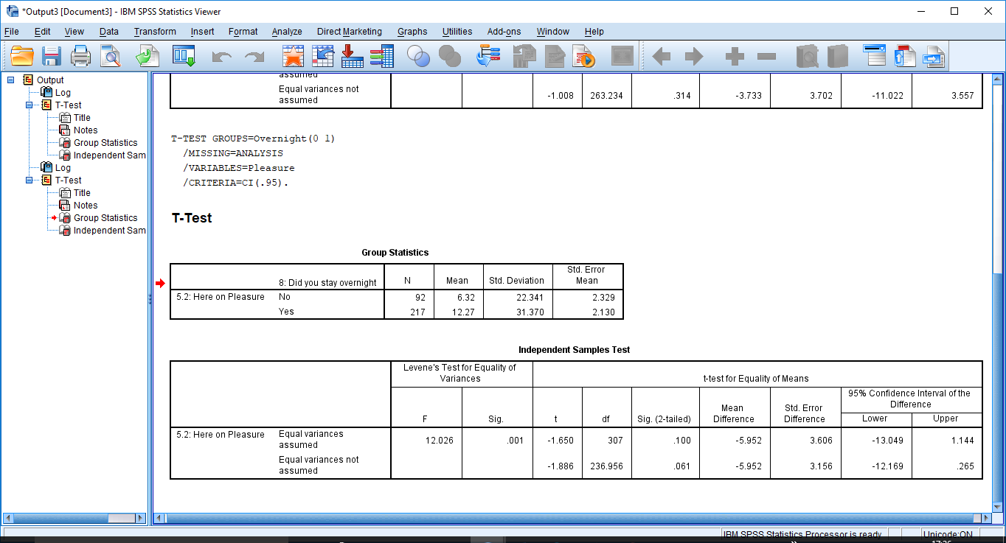
- The SPSS will produce as T-Test Result see Figure 7
Figure 7: Independent Samples T-Test on variables “Stay Overnight” and for “Pleasure”.

4.2.1 Interpretation of the SPSS T-Test Output.
Looking at the Group statistics Box see Figure 5:
The mean number of visitors who did not stay overnight due to pleasure is 6.32 whereas the mean of visitors who did stay overnight due to pleasure is 12.27. Therefore, it can be suggested that there is a no significant difference (6.32 and 12.27 are closed mean). The T-test will let the researcher Accept the Null Hypothesis and Reject the Alternative.
To determine the conclusion of the T-test, we must apply the rule below to the sig (p-value) .001 for the F-test see figures
If .001 < 0.05. then the variances are not assumed to be equal. Then we will focus our attention the bottom row for the t-test results see Figure 8.
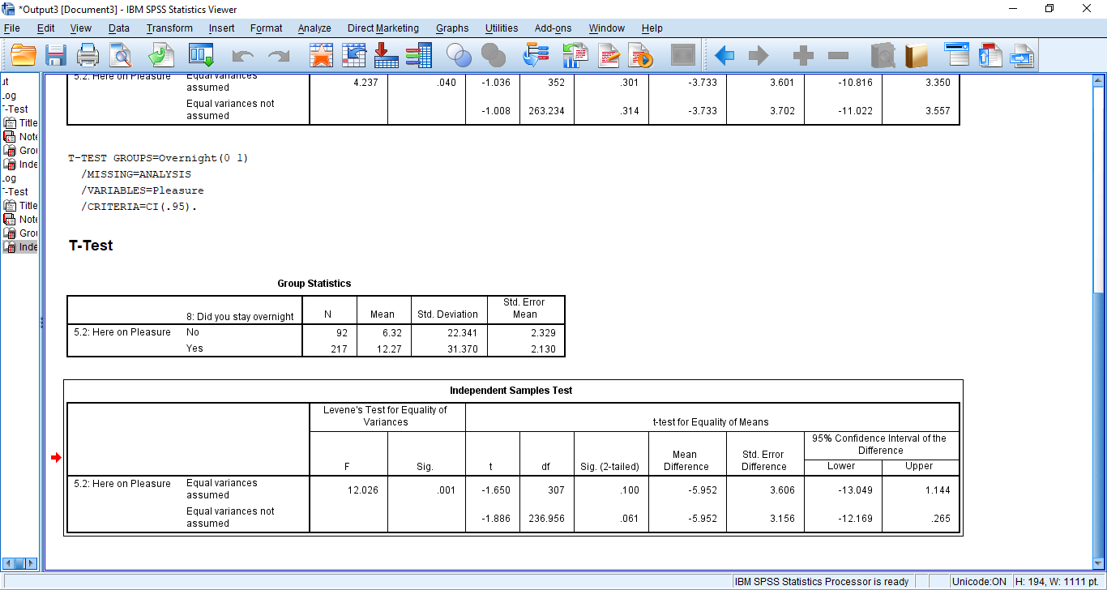

Figure 8: Independent Sample Test Box.

Then if alpha = 0.05 using the bottom row, t= -1.886, p-value for this t-test is .061 see figure 6. Because p-value 0.06 > 0.05, then we must Accept the NULL Hypothesis and Reject the Alternative. Therefore, we can conclude that the T-test has proof that there is a significant evidence to support that overnight visitors stay does not influenced by their pleasure to visit.

4.3 Bar Chart Data Analysis.
The researcher can also conduct a bar chart data analysis on two variables that are: the option of males and females about if there is sufficient car parking for visitors.
The researcher has to follow the process on SPSS:
- Click on “analysis”
- Select “descriptive Statistics”
- Select “crosstabs”
- Then drag “gender” to the Columns box on the right hand-side
- And drag “sufficient parking” to the row box on the right hand-side
- Click on the “display clustered bar charts” box
- Click “ok”
- The first output has abnormality variables which will need cleansing see Figure 9.
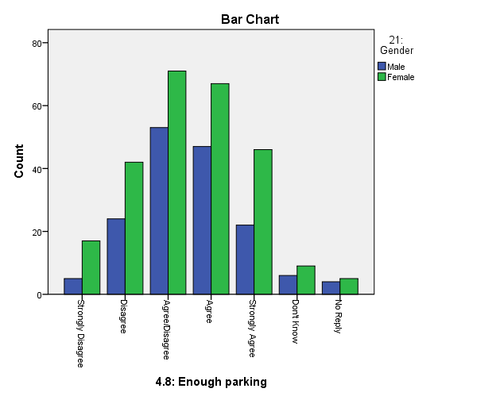
- The final SPSS output sees Figure 10.
Figure 9: First Output of SPSS Bar chart analysis on Enough Parking and Gender.
4.8: Enough parking * 21: Gender Crosstabulation
Count
 |  | 21: Gender |  | Total
 |  | Male | Female | Total
4.8: Enough parking | Strongly Disagree | 5 | 17 | 22
4.8: Enough parking | Disagree | 24 | 42 | 66
4.8: Enough parking | Agree/Disagree | 53 | 71 | 124
4.8: Enough parking | Agree | 47 | 67 | 114
4.8: Enough parking | Strongly Agree | 22 | 46 | 68
Total |  | 151 | 243 | 394
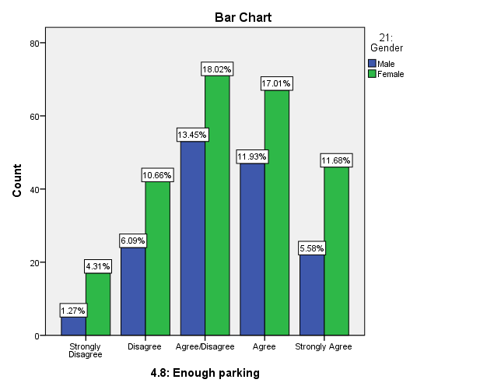Figure 10: Final Output of SPSS Bar chart analysis on Enough Parking and Gender (with no irregularities).

4.3.1 Interpretation of the Bar Chart Data Analysis.
As the chart has indicated that females have the higher percentage across than the male visitors. Its means that, females visitors strongly disagree, disagree, agree and strongly agree that there is enough car parking for visitors than males.

4.4 Pie Chart Data Analysis.
The researcher can you utilised this pie chart data analysis to determine the age range of visitors to the coast of south-west Wales during the summer vacation. To conduct SPSS pie chart data analysis the researcher must follow:
- Click on the “graph”
- Select the “chart builder” and click “ok”
- Select the “pie/polar” from bottom left box
- Click the “pie/polar” and drag it to top right box
- Click the “age of respondents” and drag the set “color box”
- Select the titles/footnote, tick title 1 and type Visitor Age Range
- Click “ok” see the output Figure 11.
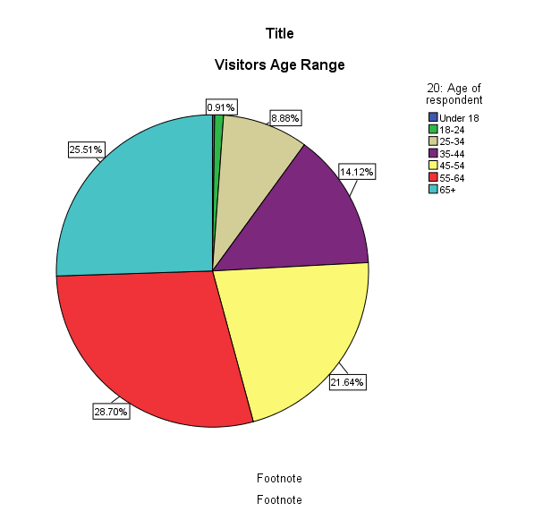
Figure 11: The Output of SPSS Pie Chart Analysis of Visitors Age.

4.4.1 Interpretation of the Pie Chart Data Analysis.
The pie chart explains itself; it shows that visitors aged between 55-64 years are higher visitors to the coast during the summer vacation with 28.70% and followed by visitors aged 64 plus years with 25.51%. The least age group visitors are under18 years with 0.91%.

5.0 Conclusion and Recomendation

5.1 Conclusion
The report has critically exposed most of the irregulalities in the survey like poor questionnaire layout, incorrect languages and word usage, overlapping optional answers, escape answers, sensetive and general questions. It explianed how abnormlites data are clean using SPPS. The report has explained how the researcher has to tackle all the issues within the questionnire for future benefit.
The report conducted a chi-square test on gender and their household income, which proved that there is no difference between males and females’ visitors in their household income as the percentages difference are not significant and the probability value is 0.277, which is greater than 0.05.
It’s also conduct T-test on overnight stay visitors and pleasure purpose see figure 6. The p-value was 0.06 > 0.05, therefore the Null Hypothesis is Accepted and Reject the Alternative. Therefore, there is significant evidence to support those overnight visitors stay is not influenced by their pleasure purpose of the visit.
Finally, it utilised SPSS to conduct data analysis Bar chart and Pie chart, that visitors aged between 55-64 years are higher visitors to the coast during the summer vacation and followed by 64 plus years visitors with 25.51%. It shows that under18 years with 0.91% are the least visitors.

5.2 Recommendation
There are a number of proposed recommendations for the improvement for Welsh Tourist Board future survey. They are:
- To reduce the survey questions to at least 10 questions (5mins) by collasping all long questions to single brief questions.The 24 questions and other numerous subquestions bore the visitors, they will think that its time wasted.
- During Coding of the variables, the researcher has to use numerical value rather than long phrase (words). Like: 0,1,2---5 or Yes/No Unlike: names of town.
- Using of comprehensive and soft language (words) to construct the survey.
- The researcher needs to undergo SPSS application training to acquire knowledge on the cleansing of abnormilties.
- The future researcher can introduce phone or email-based surveys by contacting visitors after their vacation. So that they can truly provide accurate answers on how the coast visitation experience was.
- The Tourism authorities have add incentive pack for visitors that will complete their survey and return them. Like free car pack, free or discount ticket and etc.
- The next survey questionnaire should provide clear instructions on how to use the questionnaire and provide rating scales.

Word Count:
Reference:
Cannel, C. F., Miller, P.U. and Oksenberg, L. (1981), ‘Research on interviewing techniques’, in S. Leinhardt(ed.), Sociological Methodology, pp. 389-437, San Francisco, CA: Jossey-Bass.
Craig, C.S. and Douglas, S.P. (2000), International Marketing Research, 2nd Edition, New York: Wiley.
Ghauri, P. and Gronhaug, K. (2005), Research Method in business Studies, A practical Guide, Data Collection, Survey, 3rd Edition, Harlow: Pearson Education Limited.
Malthotra, N. (1996), Marketing Research: An Applied Orientation, 2nd Edition, Englewood Cliffs, New Jersey: Prentice Hall.
Schwartz, N. and Sudman, S. (1996), Answering Questions: Methodology for Determining Cognitive and Communicative process in Survey Research, San Francisco: Jossey Bass.

Bibliography
BrunelASK (2013), Chi-Square test in SPSS +interpretation [online] https://www.youtube.com/watch?v=wfIfEWMJY3s, Accessed 18/10/2017.
BrunelASK (2013), Interpret SPSS output for an independent t-test, [online] https://www.youtube.com/watch?v=quZAwDmcEbE, Accessed 16/10/2017.
Dwr447(2013), SPSS-Summarizing Two Categorical Variables, Cross-tabulation table and clustered bar. [online] https://www.youtube.com/watch?v=r5-qn8AAA-c, Accessed 21/10/2017.
Manship J. (2013), SPSS Pie Chart, [online] https://www.youtube.com/watch?v=NjASouxPXy0 Accessed 20/10/2017.
Profkelley (2011), Paired Samples T-test: Using SPSS & Writing Up Your Results, [online] https://www.youtube.com/watch?v=Uji6DugIvww, Accessed 16/10/2017.
Rocchi M. (2014), Tutorial: Data Cleaning [online] https://www.youtube.com/watch?v=2ZMXjDVIdd8, Accessed 18/10/2017.
Stone J. (2012), Making a Histogram with SPSS, [online] https://www.youtube.com/watch?v=zMTblnyblkI, Accessed 19/10/2017.

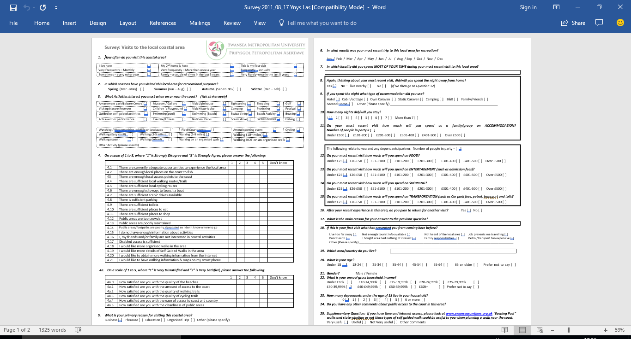
Appendix 1: The Survey for Welsh tourist Board on Visits to the Local Coastal Area.

