Göbekli Tepe – the Stone Age Sanctuaries.
New results of ongoing excavations with a special focus on sculptures and high reliefs
Klaus Schmidt
Jo McConaghy Assignment One – November 2025
A critical review
The first tantalising clues that something was hidden beneath the tell known as Göbekli Tepe were seen in 1963, during a surface survey. Over 30 years would pass before Klaus Schmidt, the author of this article, fresh from his success as part of the rescue operation of a similar nearby site, Nevali Çori, would lead a team from the German Archaeological Institute to uncover what would become the most significant archaeological discovery of modern times. In this seminal article he fleshes out the most recent excavations to 2010, focusing on the carvings and sculptures that had been unearthed at that time. Göbekli Tepe is a dynamic site, with new artefacts discovered on an ongoing basis. Some of knowledge contained in this article has been superseded as more of the site is revealed and more research is carried out.
In his conclusion, Schmidt calls the site ‘a splendid and colourful new chapter’ (p.253) evoking the sense of Göbekli Tepe being a new part of the human saga, sited in between the old ways of the Stone Age and the transformation to the settled, agrarian communities of the Fertile Crescent.
Throughout the article, Schmidt alludes to the magnetic draw and significance of the area, stating that it has ‘lost nothing of its magic appeal’ (p.239) by alluding to a local myth that the Prophet Abraham was born nearby, also that there are whispers of another nearby Neolithic site that had been buried by construction in the 1990s. (p. 247) He sets the scene well – Göbekli Tepe did not appear in isolation; the land it is on has always been sacred.
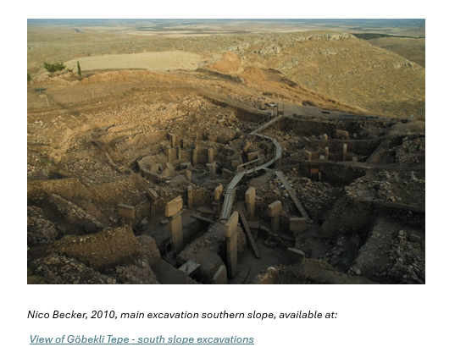
Schmidt goes on to describe the setting – high on a bluff, visible from miles around. He uses natural sciences to outline the physical appearance of the excavation area, narrating for the reader the size and weight of the pillars, the width of the enclosures and the ages of the layers of sediment that have been identified. (pp. 239-241) It is as though you are being given a guided tour by Schmidt himself and it is easy to immerse yourself in the scene. He determines that the lack of residential buildings implies that the site was ritualistic only. (p.241) The vast majority of scholars since are in assent; however, one article (Banning, 2011) counters this by suggesting that the enclosures could have housed large extended families or ‘clans,’ using the space as both ritualistic and domestic space. Banning doesn’t disagree that the spaces are sacred, but asserts that both can exist simultaneously, with ritual behaviours being framed in different ways – gesture, words, decorating a doorway etc. to delineate between the two spheres. New research into large-scale cereal processing at the site has gone some way to proving that there may well have been a small-scale residential element at Göbekli Tepe, possibly to support large groups using the site in a seasonal pattern, maximising the availability of food to facilitate feasting as an incentive for completing works on the enclosures. (Dietrich et al, 2019)

Without a doubt, the T pillars are the most powerful objects found to date. Schmidt meticulously describes the largest anthropomorphic pillars and his interpretation of them as possibly gods – the special pieces of clothing and their ‘mysterious, faceless anonymity.’ (p.248) He references back to his time at Nevali Çori, where similar pillars were also found, and asserts that they are deliberately simply carved to preserve the sense of stark ambiguity – other carvings display a higher degree of craftsmanship, so the simplicity was intended. The impact that these structures would have had on a person inside the enclosure, perhaps for the first time, could be explored at this point and would further illustrate how they might have been perceived as deities – Clinton Briar does this very successfully when he imagines the thoughts of a person sat for the first time next to a gigantic T pillar - ‘The hunter-gatherer is not confused by the symbols and imagery surrounding him. Instead, he is being dramatically affected by it in a way before not thought possible.’ (Briar, 2020)
As Schmidt explains, other human-like statues and figures uncovered at Göbekli Tepe are presumed to be guardians of the spaces – of high status, but likely to be ‘real people’ due to their more naturalised appearance – again, he links back to the material remains found at Nevali Çori to emphasise this, showing the reader that similar ideas spread across the region through cultural diffusion. (p. 254) This invites the reader to speculate as to how many more similar sites are hidden in the hills. Illustrated here is something that I feel that Schmidt does very successfully, if unintentionally, throughout the article - the writing style is straightforward, clear and concise – the fluidity with which it can be read means that it allows the reader’s mind to conjecture further about the theories and hypotheses contained in the text.
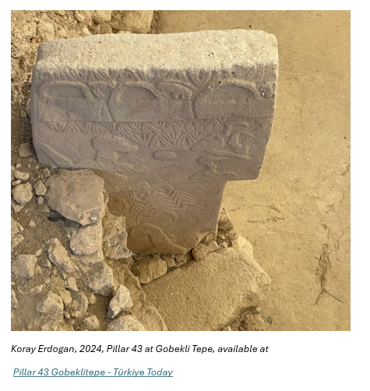
A modest amount of the text relates to the animal carvings on pillars and elsewhere. They are also naturalistic and would appear to represent the fauna that the people of the time would have recognised. (p.246) Schmidt suggests that they might be totems, (p.246) or possibly even a ‘new and unique pictorial language’ (p. 245) but I do feel that more elaboration would be useful at this point, particularly considering the numerous vultures and other scavenger animals identified. Both animal and human bones are commonly found in the spoliae used to cover the site, and Schmidt touches on skull culture when discussing the spoliae further. It contained numerous animal and human bones, showing signs of cut marks. (p. 243, p.249) A discussion here of how other Neolithic communities handled their dead, along with an overview of the process of excarnation might have been pertinent. Since the article was written, modified skulls have been found with sagittal grooves carved into them, and one with a hole bored in the top – possibly evidence of them having been displayed in some way, (Clinton Briar, 2020) so clearly there was an intention to handle skulls in a particular way, perhaps as part of a death ritual or ancestor worship, at Göbekli Tepe.
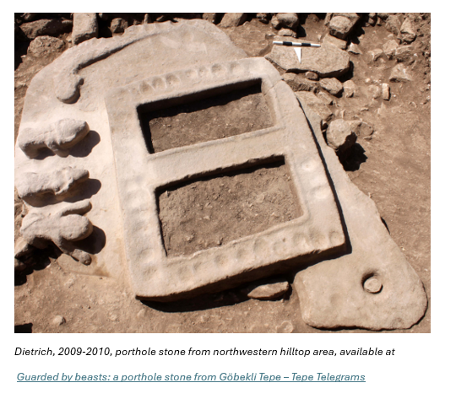
Often overlooked, Schmidt devotes a significant part of the article to the enigmatic portholes – huge, collared ‘frames’ made of stone – just the right size for a human to crawl through. Schmidt calls them ‘unique so far and very exciting’ (p. 250) and I’m inclined to agree. In describing these portholes, Schmidt hints at a phenomenological approach to the artefacts; he concludes that they would have been used as portals into the enclosures, that is it likely that they were physically climbed through to access the ritual spaces. Where and in which orientation they would have been erected or whether or not the enclosures had roofs remains a mystery – thus far no clear evidence has been identified to clarify this.
This article has acted almost as a porthole for me as a reader – I already had a modicum of understanding about Göbekli Tepe but the clarity of description of the site and its contents served as a foundation stone for my own research – I started the read knowing a little, learnt a great deal and established that there was much more that I wanted to know – the 15 years that have elapsed since the article was written and the huge wealth of new study of the site have meant that what wasn’t known by Schmidt in 2010 is now out there waiting to be discovered by new enthusiasts like me. Using this piece of writing as a springboard, I found myself researching further and learning about the strategic position of the site, (Dendrinos, 2016) Neolithic skull cults, (Clinton Briar 2020) the evidence found at the site for cereal processing on a large scale, (Dietrich et al, 2019) the ways that hunter gatherer societies changed during the shift from the late Pleistocene to the early Holocene periods, (Dendrinos, 2020) the likely seasonal use of the site and the reasons behind that. (Briar, 2020)
Schmidt’s reportage-style of writing is concise and factual, easy to digest and I found that I was able to easily visualise and understand the spaces and things he was describing. Schmidt of course was the first to describe and contextualise the site, and as such his work has generated an abundance of scholarly theories and writings about Göbekli Tepe – most of these aligning and building upon the reports and early interpretations that he has given us. It is telling that the majority of citations in the article are from Schmidt’s own catalogue, or the work of his colleagues in the field, establishing that he and his peers are the forerunners on this site. Any later works by other authors are reliant upon his work as a starting point to further develop understanding of the sanctuaries, deities and the human stories that have lain dormant on this hill since.
Following the dissection and analysis of this article I feel armed with a robust overview of Göbekli Tepe in terms of the geographical space it holds, its construction, location and alignment, and an understanding of the most significant material remains found there. Huge questions have arisen for me… How did Göbekli Tepe expedite the shift from hunter gatherer to farming societies? Were the repeated motifs on the stones a very early form of pictorial language? Is there any evidence for a celestial aspect to the site’s location? Are the T pillars the very first depictions of a supernatural deity that we have? Additionally, where gaps exist in this article in terms of an anthropological and phenomenological approach, they have served to generate a curiosity which I aim to satisfy through the remaining pieces of my research portfolio - I consider the article to have been instrumental in framing the next steps in my research.

References

Banning, E.B. 2011. ‘So Fair a House. Gobekli Tepe and the Identiﬁcation of Temples in the Pre-Pottery Neolithic of the Near East’ Current Anthropology, Volume 52, Number 5, October 2011.
Can be found here: So Fair a House [Accessed 10th November 2025]

Briar, C. 2020. ‘Carving Space from Place: Possible Phenomenological Scenarios at Göbekli Tepe.’
Can be found here: Clinton_Briar_Carving_Space_from_Place-libre.pdf [Accessed 17th November 2025]

Dendrinos, D. 2016. ‘Gobekli Tepe: a 6th millennium BC monument’
Can be found here: Microsoft Word - Gobekli Tepe Layer III [Accessed 19th November 2025]

Dietrich et al, 2019. ‘Cereal processing at Early Neolithic Göbekli Tepe, southeastern Turkey’ plos.org, May 2019
Can be found here: Cereal processing at Early Neolithic Göbekli Tepe, southeastern Turkey | PLOS One [Accessed 17th November 20025]

Gresky, Haelm and Clare. 2017. ‘Modified human crania from Göbekli Tepe provide evidence for a new form of Neolithic skull cult’ Science Advances, volume 3, issue 6.
Can be found here: Modified human crania from Göbekli Tepe provide evidence for a new form of Neolithic skull cult | Science Advances [Accessed 16th November 2025]

Schmidt, K. 2010. ‘Göbekli Tepe – the Stone Age Sanctuaries. New results of ongoing excavations with a special focus on sculptures and high reliefs’ Documenta Praehistorica XXXVII
Can be found here: View of Göbekli Tepe – the Stone Age Sanctuaries. New results of ongoing excavations with a special focus on sculptures and high reliefs [Accessed 8th November 2025]

