HOW TO USE AutoSum {∑} IN EXCEL
2
1
- Go to Microsoft 365 app, open Microsoft Excel and select a blank workbook.
- Feed all the data/ information (ref: pic below):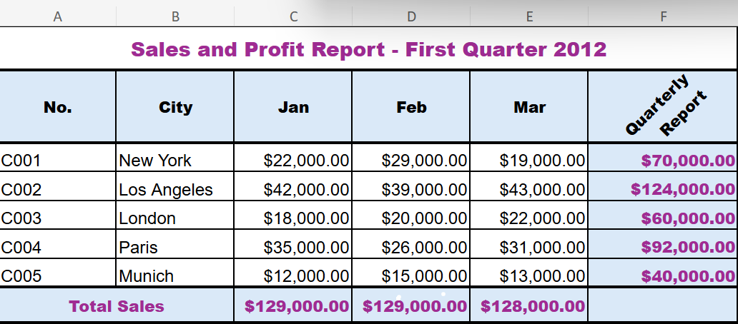

AutoSum {∑} is the built-in command to perform additions for large sets of numerical data
USAGE:
- It saves time and effort by automatically generating sum formulas for selected ranges of cells, it could be applied to both columns or rows.
- Also reduces the chances of human error.

Follow easy
step-by-step
instructions

AutoSum for Columns AutoSum for Rows
3
- Put your cursor in the empty cell (where AutoSum {∑} to be done) (row F3 is selected in the pic below)
- Press the “AutoSum”{∑} button (II) under Home bar (I). It automatically selects the cell range (ref pic below, C3:E3 is selected)
- Click “Enter” and see the magic happen
- (II)

- Put your cursor in the empty cell (where AutoSum {∑} to be done) (column C8 is selected in the pic below)
- Click “Formulas” button (I) (displayed at top bar) followed by “AutoSum”{∑} button (II), it automatically selects the cell range (ref pic below, C3:C7 is selected)
- Click “Enter” and see the magic happen
(II) (I)
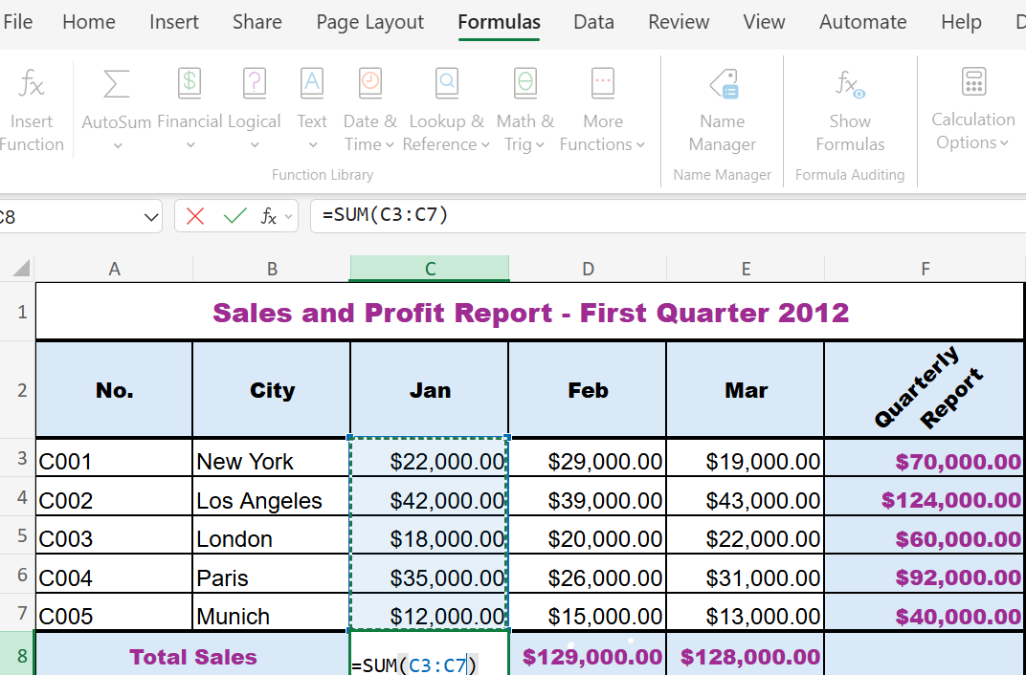

4

Or
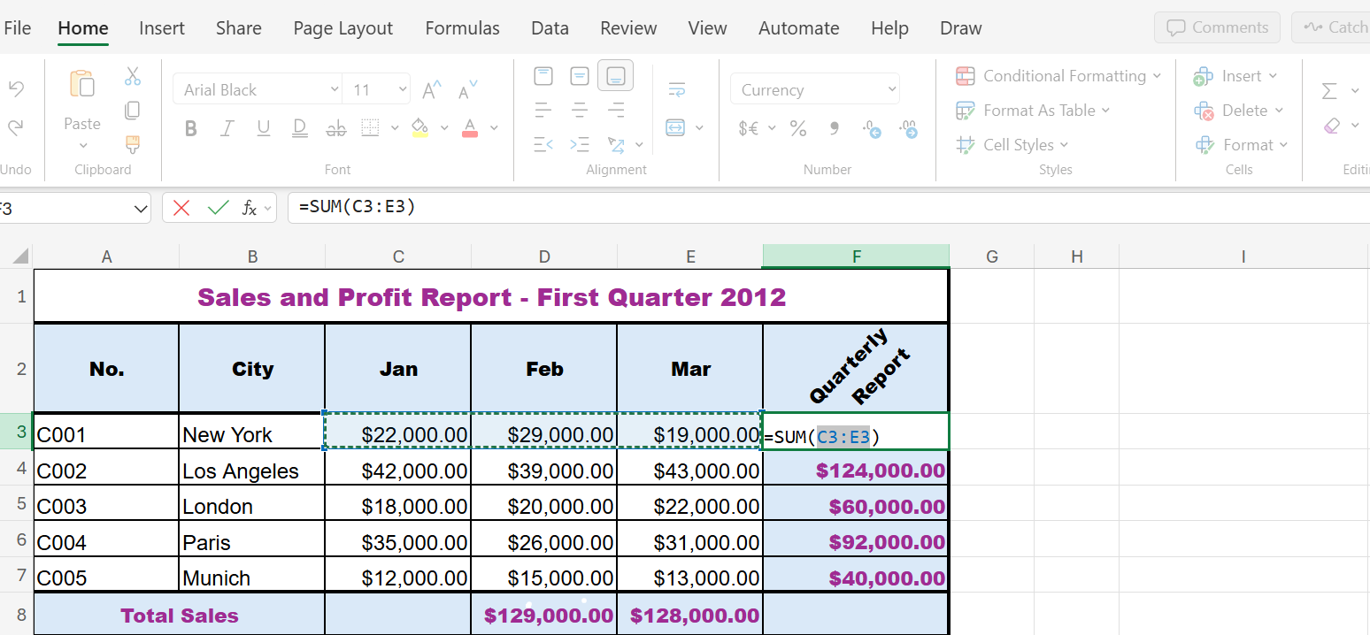

TIP : 1)Double-check the auto-selected range to make sure it includes all the cells you want
2) Use Excel to insert charts and graphs for projects that need more visual information

#

