
School of International Hotel Management

BA (Hons) International Hotel Management

Module Handbook Summer Term 2023
Marketing Essentials
BMIH4005
LEVEL 4

Module Lead:

Chris Wilkin
C.Wilkin@uwtsd.ac.uk
The title: Individual Presentation & Supporting Marketing Plan
Name: Gabriela Rujala
Student ID number:2243925
The module title: Marketing Essentials BMIH4005
lecturer’s name: Chris Wilkin
Word Count : 1516

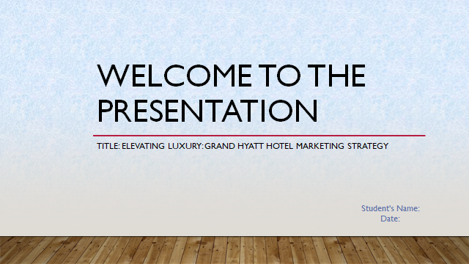
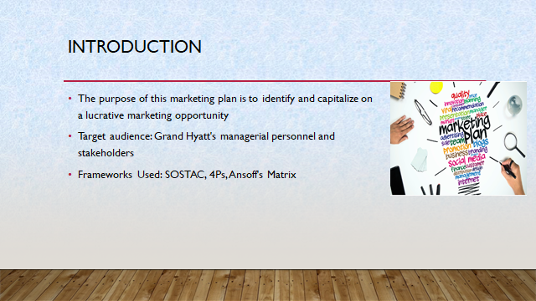

Speaker notes:
The purpose of this marketing strategy is to identify a profitable marketing opportunity and create a comprehensive communication plan specifically for the Grand Hyatt Hotel in light of the current international situation. The management team at the hotel and other interested parties are the plan's intended audience. This strategy will make use of well-known frameworks like SOSTAC, 4Ps, and Ansoff's Matrix in order to provide a clear and informative path for the organisation (Brassington & Pettitt, 2021). The strategy will provide a route for navigating the modern hospitality landscape and capitalising on the potential that has been recognised via their application.
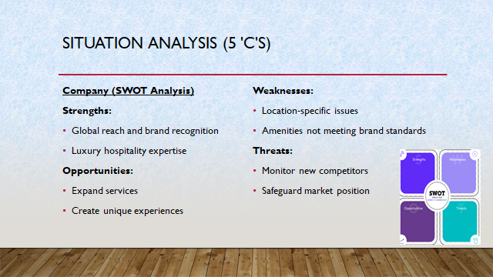

Speaker notes:
Company (SWOT Analysis):
The Grand Hyatt Hotel benefits from its worldwide reach and well-known brand identity to excel in the field of upscale hospitality. The development of competitive advantages can be facilitated by using these qualities. There are many chances to expand service offerings and create distinctive experiences that might appeal to a changing consumer base (Clow & Baack, 2013). To improve the entire customer experience, it is essential to address flaws, particularly in specific areas or facilities that might not adhere to brand standards. To protect the hotel's position in the market, vigilance is necessary to keep an eye out for any dangers, particularly from new competitors.
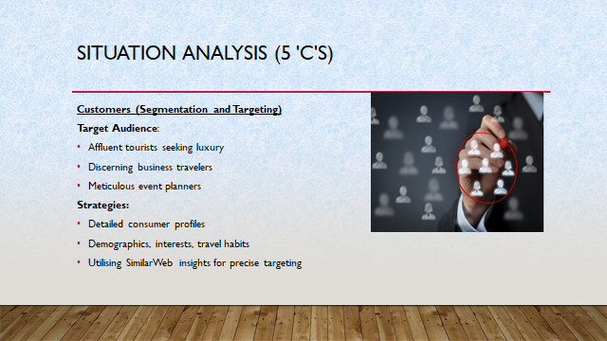

Speaker notes:
Rich tourists seeking lavish experiences, discriminating business visitors, and fastidious event planners should be the primary focus of attention for the Grand Hyatt (Ghauri, 2014). Creating thorough consumer profiles that include demographics, interests, and travel habits is essential. Information gleaned from sites like SimilarWeb can help target audiences more successfully by enhancing the targeting approach.
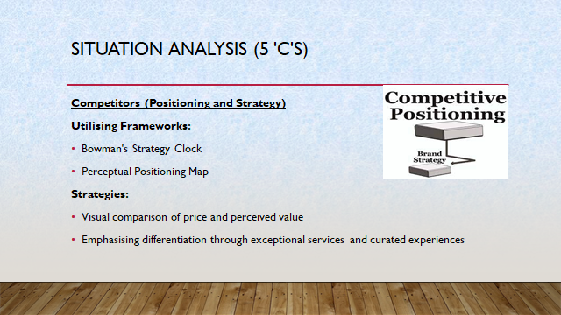

Speaker notes:
The Grand Hyatt can use Bowman's strategy clock and a perceptual positioning map to get an advantage over rival hotels. This will make it easier to visually compare the hotel's rate and perceived value to those of its rivals. Its distinct position in the industry will be further cemented by a deliberate focus on distinguishing through great services and carefully selected experiences (McDonald and Malcolm, 2016).
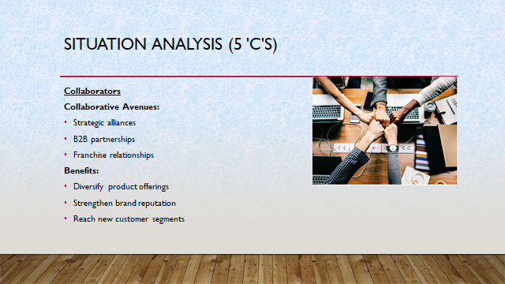
Speaker notes:
Strategic alliances, B2B partnerships, and franchises with Grand Hyatt offer priceless growth opportunities. Collaborations can broaden the hotel's product options, strengthen its brand reputation, and reach new client demographics (Armstrong et al., 2021). These alliances may play a key role in growing the hotel's market reach and broadening its range of services.
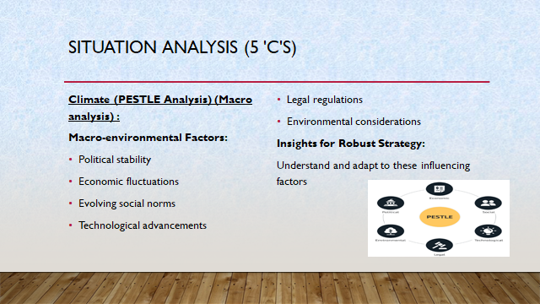
Speaker notes:
The macroenvironmental variables affecting the hotel business may be understood through a thorough PESTLE analysis. The landscape of the sector is significantly influenced by political stability, economic changes, shifting social standards, technological breakthroughs, regulatory restrictions, and environmental concerns (Kokemuller and Neil, 2013). Forging a robust and flexible corporate strategy requires gaining an understanding of these factors.
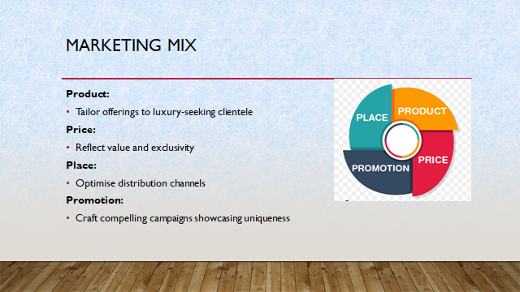
Speaker notes: The 4Ps (product, price, place, and promotion) must be thoroughly reviewed and adjusted in light of the opportunities and client preferences revealed. Grand Hyatt's competitive position will improve with the adaptation of the product and service offerings to meet the needs of the luxury-seeking clientele, pricing strategies that reflect value, distribution channel optimisation for maximum reach, and the creation of effective promotional campaigns (Spear and Carl, 2018).
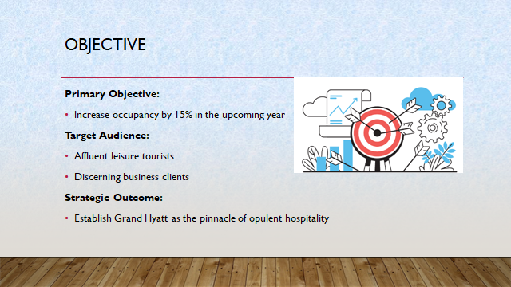
Speaker notes:
The primary objective is to increase overall occupancy by 15% in the forthcoming year, focusing in particular on affluent leisure tourists and selective business clientele. By reaching this goal, Grand Hyatt hopes to become recognized as the region's premier example of opulent hospitality. This tactical move not only strengthens the hotel's position in the market but also secures its standing as the ideal option for guests seeking unrivaled elegance and first-rate service.
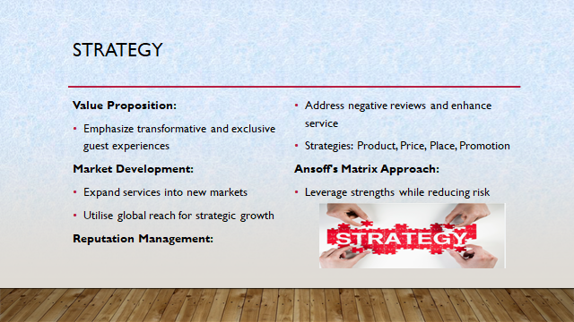
Speaker notes:
A redesigned value proposition will place a focus on developing transformational and exclusive guest experiences in order to increase Grand Hyatt's attractiveness and address any issues (Housden, 2008). High-end guests seeking unrivalled luxury will be drawn to accommodations that emphasise distinctive features like specialised concierge services and bespoke facilities.
A market development approach will be used, following Ansoff's matrix. Utilising the hotel's worldwide reach, this entails expanding current services into new markets—both geographically and by consumer group. This strategy leverages current strengths while reducing risk (Trott, 2021).
A reputation strategy for management might be used, for instance, if it were essential to repair a bad reputation brought on by unfavorable evaluations. Addressing issues, raising service standards, and aggressively seeking out input from customers are all part of this. The introduction of unique packages (product), a review of pricing tactics (price), the optimisation of distribution channels (place), and the promotion of these enhancements through targeted campaigns (promotion) are examples of changes to the marketing mix (Kotler et al., 2017). This all-encompassing plan guarantees a unified and successful method to overcome obstacles and improve the Grand Hyatt's reputation.
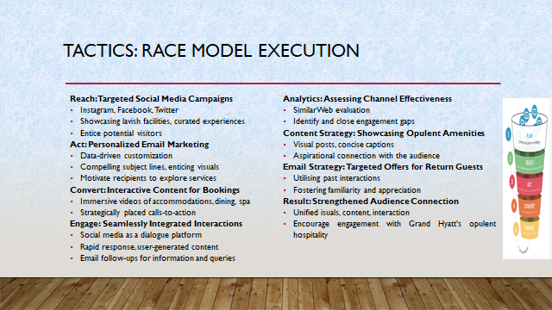
Speaker notes:
Grand Hyatt's communication plan will orchestrate a comprehensive strategy for engaging its target audience by utilising the RACE model, which stands for Reach, Act, Convert, and Engage.
Reach: Targeted social media campaigns will be developed on websites like Instagram, Facebook, and Twitter to increase visibility (Bowie et al., 2017). The information will highlight the hotel's lavish facilities, carefully chosen experiences, and scenic settings to entice prospective visitors to learn more.
Act: A key component of engagement will be personalised email marketing. Data analysis will reveal visitor preferences and previous actions, enabling the development of customised messaging (Smith & Zook, 2020). With appealing subject lines and alluring images, you may entice recipients to investigate the hotel's services and motivate them to proceed.
Convert: To convert attention into bookings, interactive material will be essential. Immersive movies highlighting opulent accommodations, fine restaurants, and spa centres will inspire a sense of exclusivity and desire (Kotler et al., 2020). The reservation procedure will be prompted by calls-to-action that have been thoughtfully positioned across the material.
Engage: Online and offline interactions will be seamlessly integrated during the engagement phase. Social media will serve as a forum for conversation, rapid responses to questions and comments, and the dissemination of user-generated material. Parallel to this, targeted email follow-ups will give further details and a way to address queries and concerns (Chaffey and Ellis-Chadwick, 2019).
Through SimilarWeb analytics, the efficiency of the current communication channels will be evaluated. To ensure a coherent and effective communication strategy, engagement gaps will be found and closed.
Social media posts will be carefully chosen to highlight the hotel's opulent amenities. Posts that are visually appealing will be complemented by concise subtitles that weave stories of indulgence and refinement (Ghauri, 2014). The objective is to establish an aspirational connection with the audience and match their needs with Grand Hyatt's offers.
In addition, email marketing will send targeted offers to past visitors based on their choices. This specialised strategy makes use of data-driven insights to deliver alluring offers that are consistent with their prior interactions and stays, generating a feeling of familiarity and gratitude (Housden, 2008).
The Grand Hyatt's communication mix will create a lasting connection with its audience through the union of alluring graphics, tailored content, and purposeful interaction, encouraging them to partake in the hotel's highest calibre of opulent hospitality.
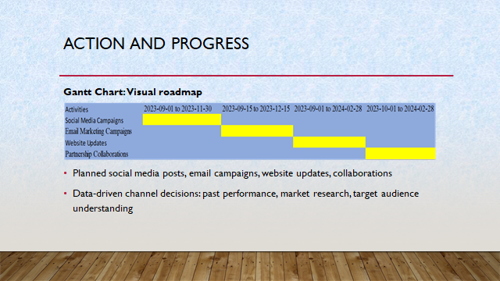
Speaker notes:
A precisely constructed Gantt chart will work as a visual roadmap, outlining a timeframe for important marketing operations. This all-encompassing strategy includes pre-planned social media postings, clever email campaigns, frequent website updates, and cooperative relationships (Jobber and Ellis-Chadwick, 2020). A combination of previous performance data, insightful market research findings, and a thorough comprehension of the discovered tastes and behaviours of the selected target group will serve as the foundation for decisions on the choice of marketing channels.
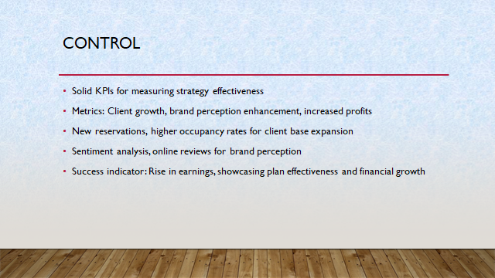

Speaker notes:
A solid set of measurements and key performance indicators (KPIs) will serve as the foundation for measuring the effectiveness of our marketing strategy. We will use a variety of metrics to evaluate our progress, such as attracting more clients, boosting brand perception, and generating higher profits (Brassington & Pettitt, 2021). Metrics will include the expansion of the client base, which is demonstrated by an increase in new reservations and higher occupancy rates. Sentiment analysis and the monitoring of internet reviews will be used to measure improvements in brand perception. The ultimate indicator of success is the rise in earnings, which not only shows how effective the plan was but also how it helped Grand Hyatt continue to develop and succeed financially.
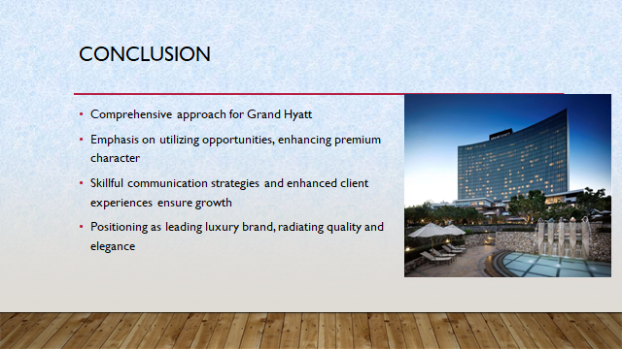

Speaker notes:
In conclusion, this marketing strategy painstakingly lays out a comprehensive approach for the Grand Hyatt Hotel. The strategy emphasises the hotel's route to success by carefully utilising opportunities, enhancing its premium character, and successfully overcoming hurdles. Grand Hyatt is well-positioned to achieve its growth goals because of the skillful application of cutting-edge communication strategies and a zealous commitment to upgrading client experiences. With this deliberate effort, it is positioned to solidify its status as the leading luxury hotel brand in the sector, exuding an air of quality and elegance.


