

UNIVERSITY OF WALES
TRINITY SAINT DAVID

DIGITAL DEGREE APPRENTICESHIP
APPLIED DATA SCIENCE

LEARNING IN THE DIGITAL ERA
ACCA4025

NICHOLAS ALDOUS
2237649

CONTENTS

PORTFOLIO 3
HOMEPAGE 4
TASK 1 5
TASK 2 7
TASK 3 9
TASK 4 11

PORTFOLIO

https://sites.google.com/view/naldous2237649/home

HOMEPAGE



TASK 1

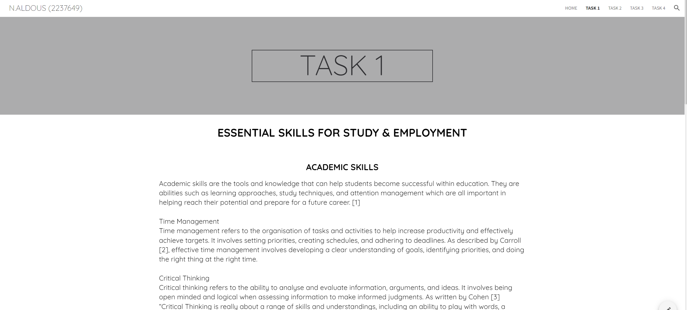

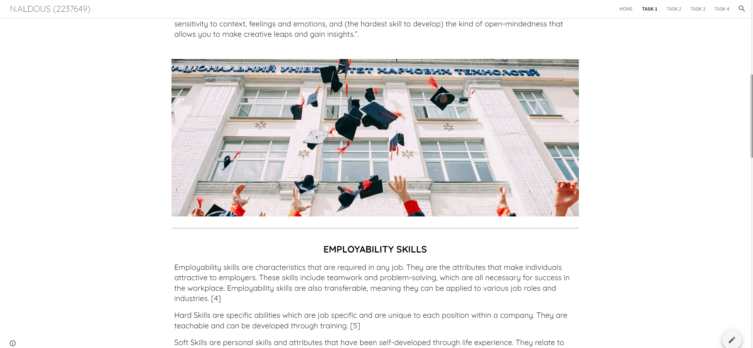
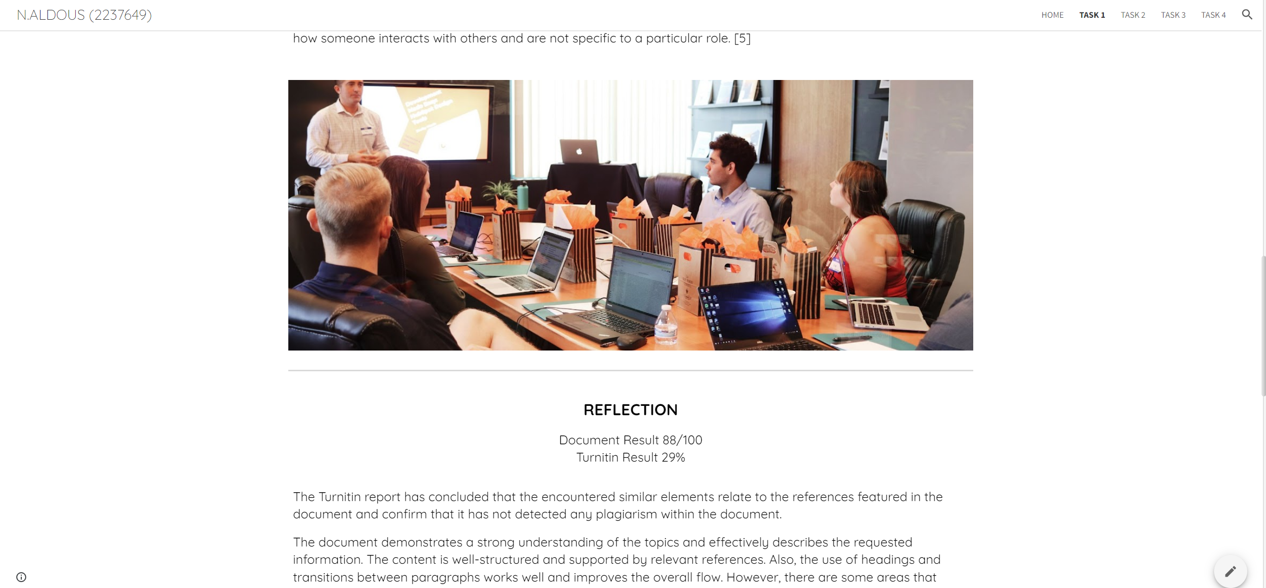
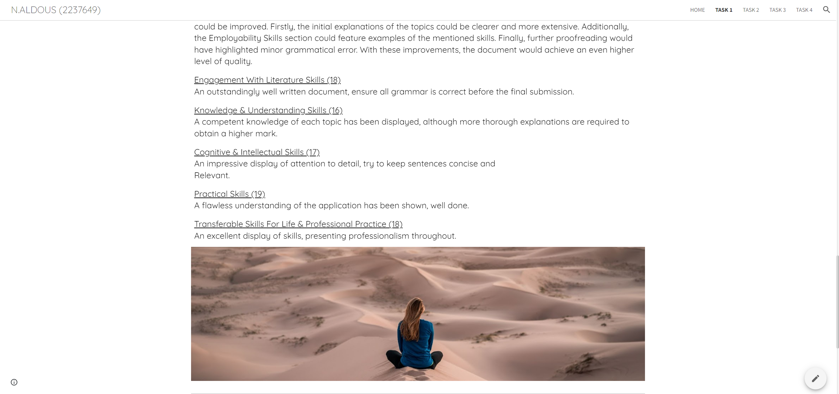
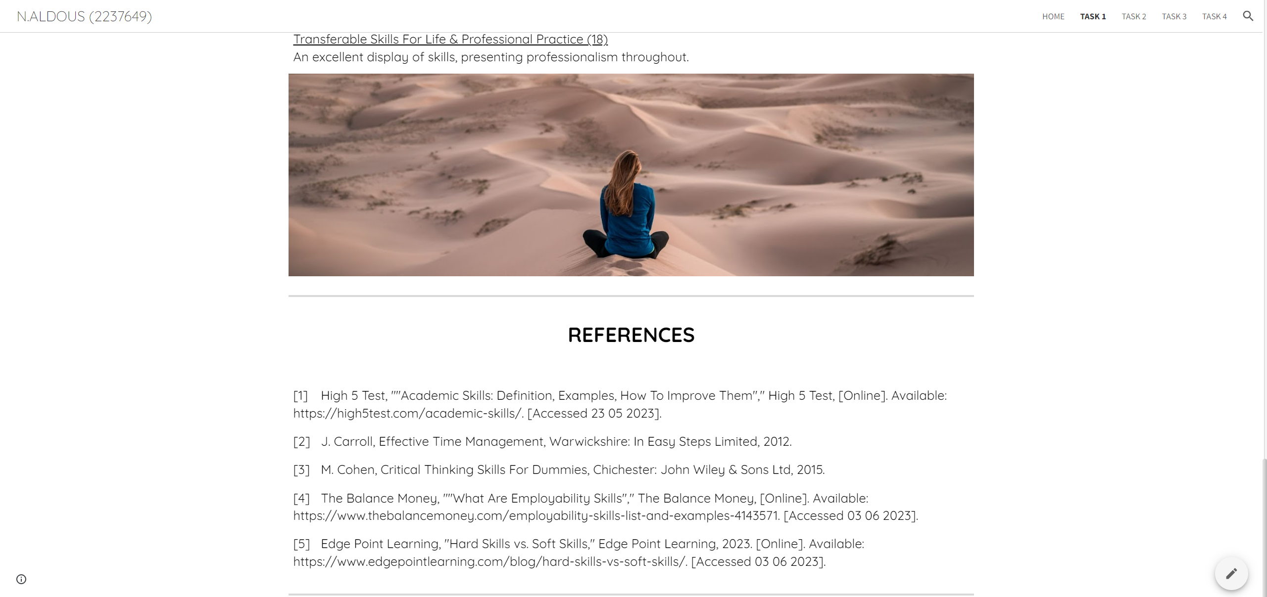

TASK 2

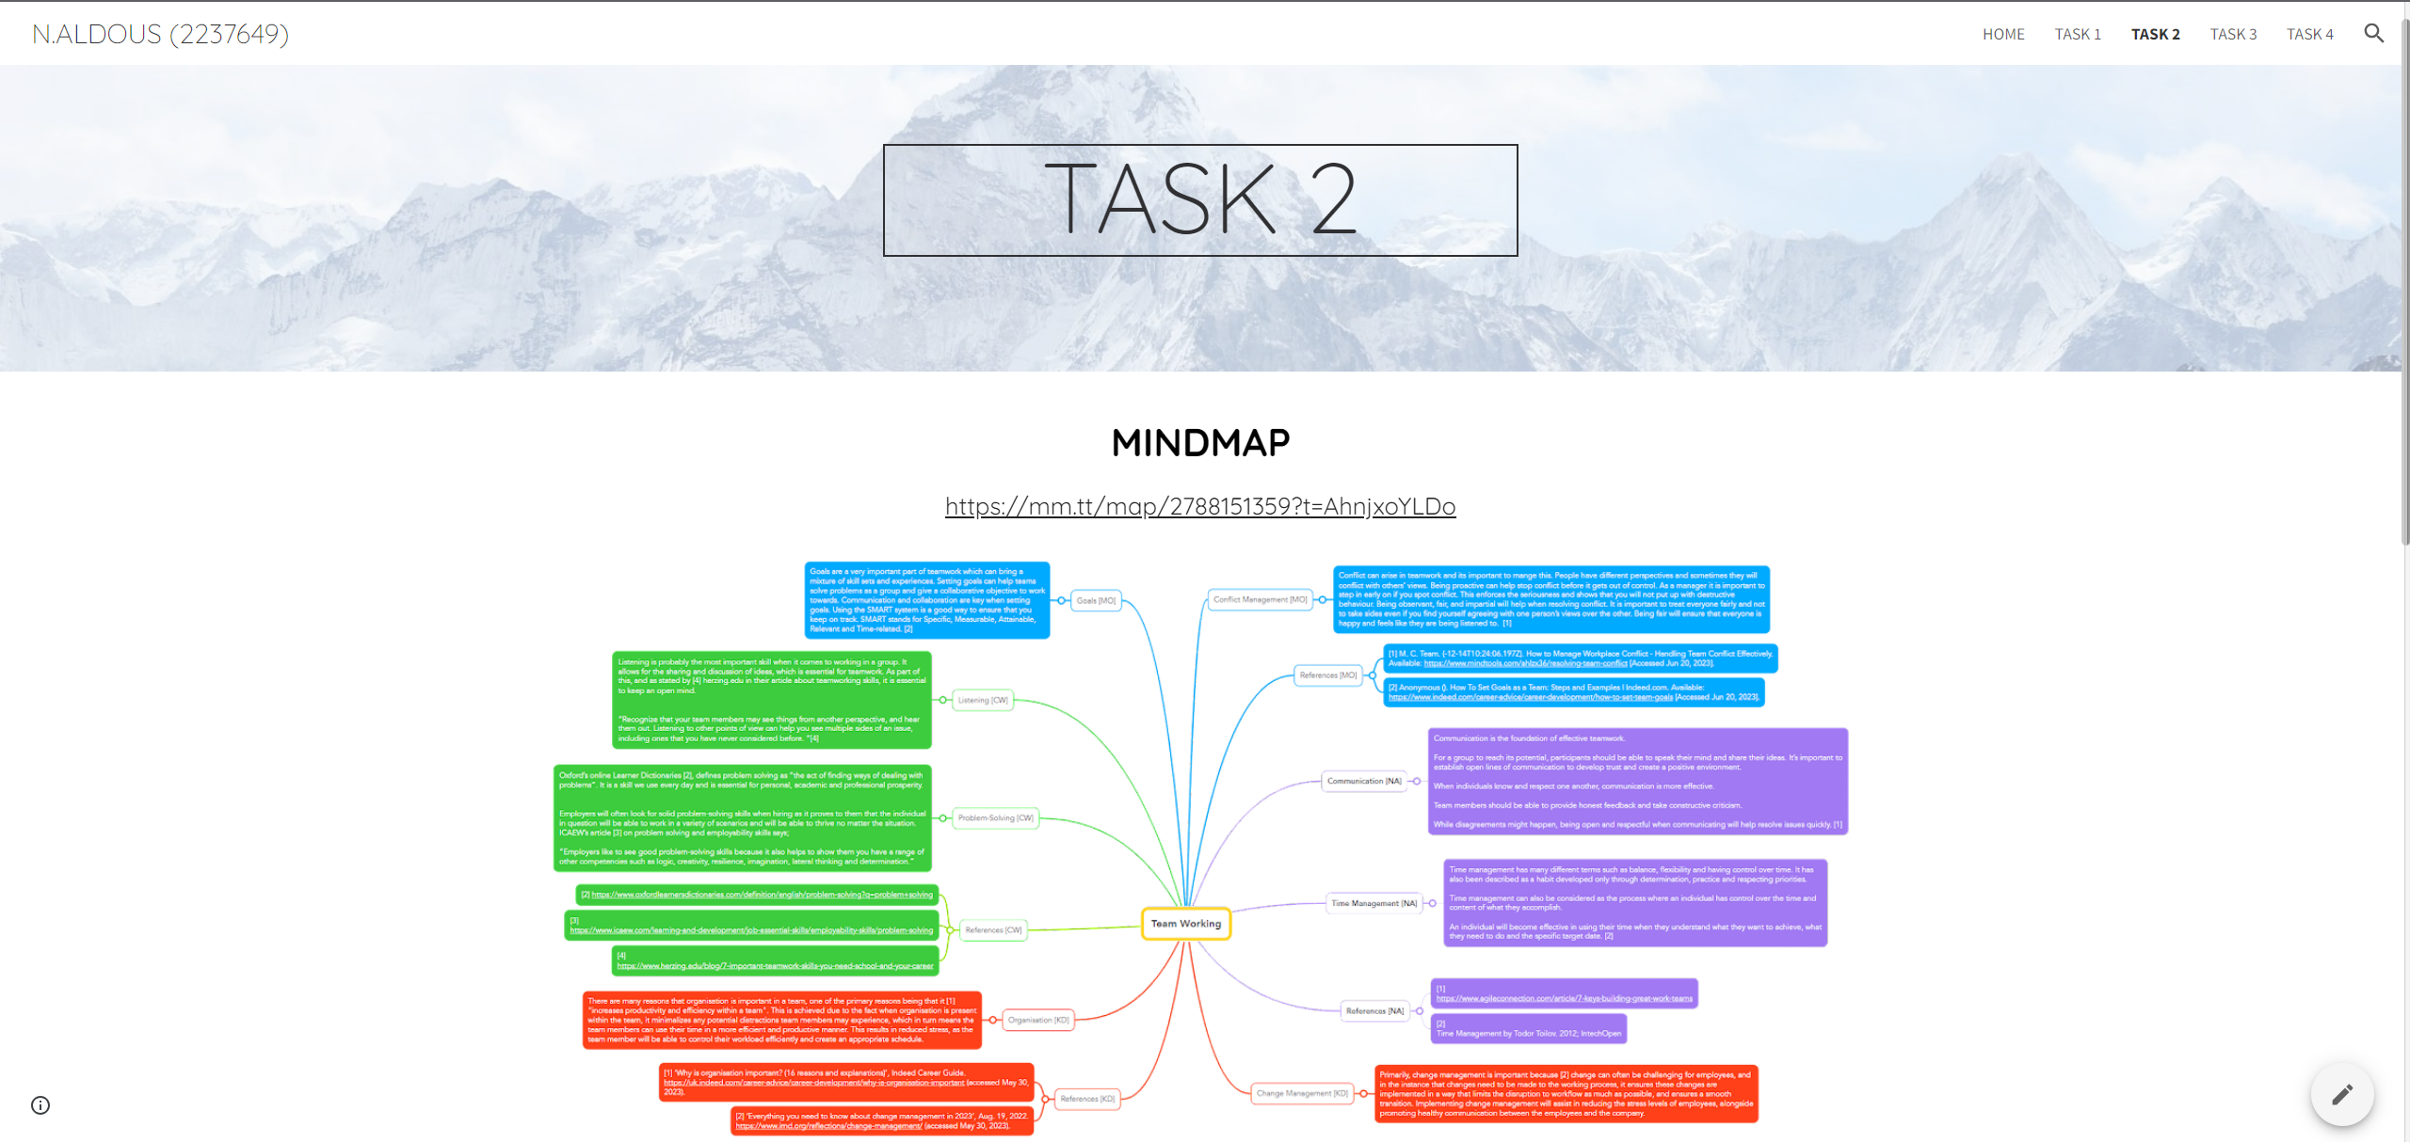
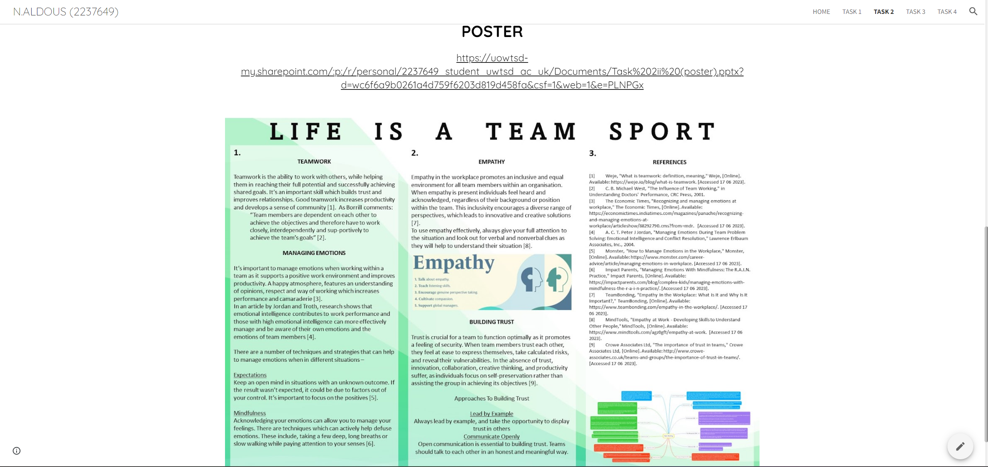

MINDMAP
https://www.mindmeister.com/map/2788151359?t=AhnjxoYLDo

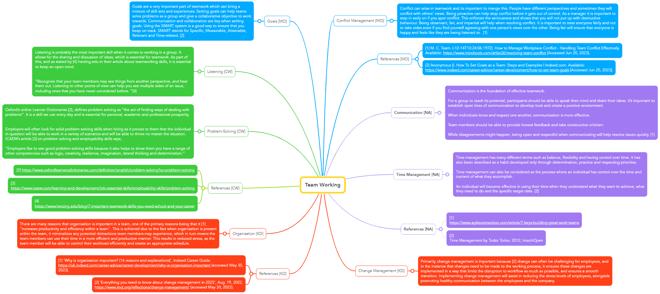

POSTER

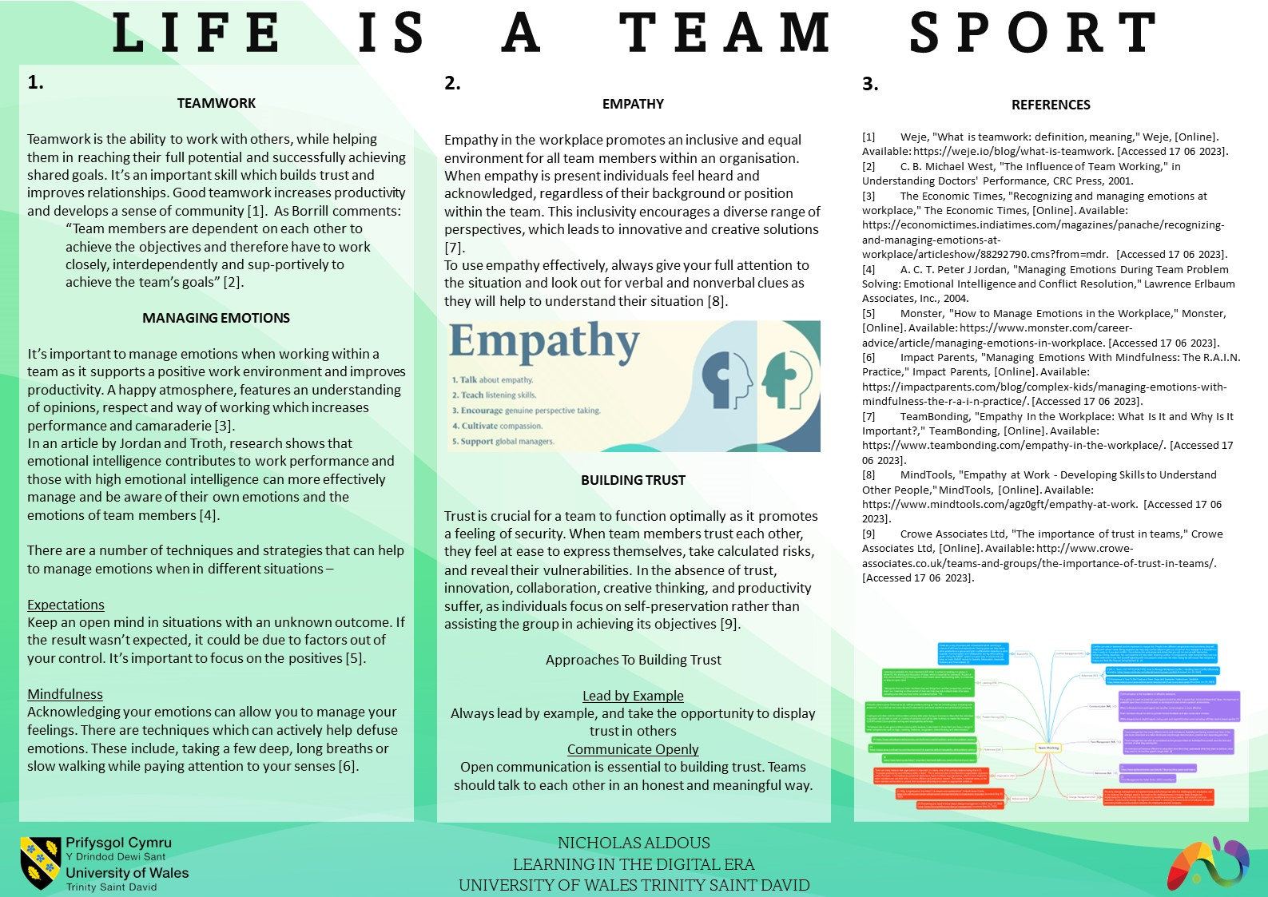

TASK 3

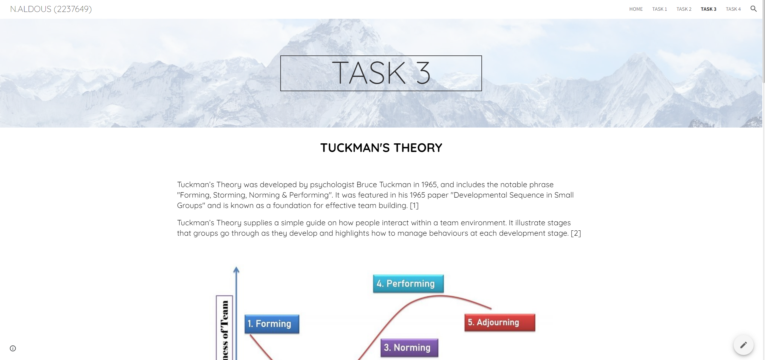
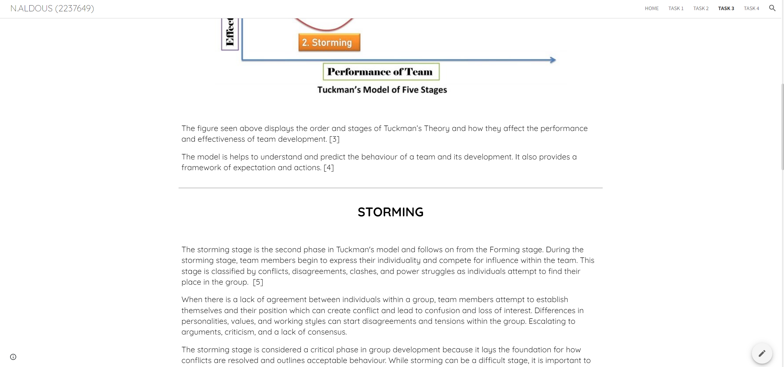

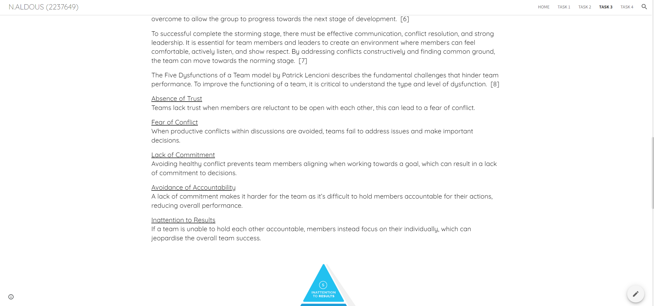
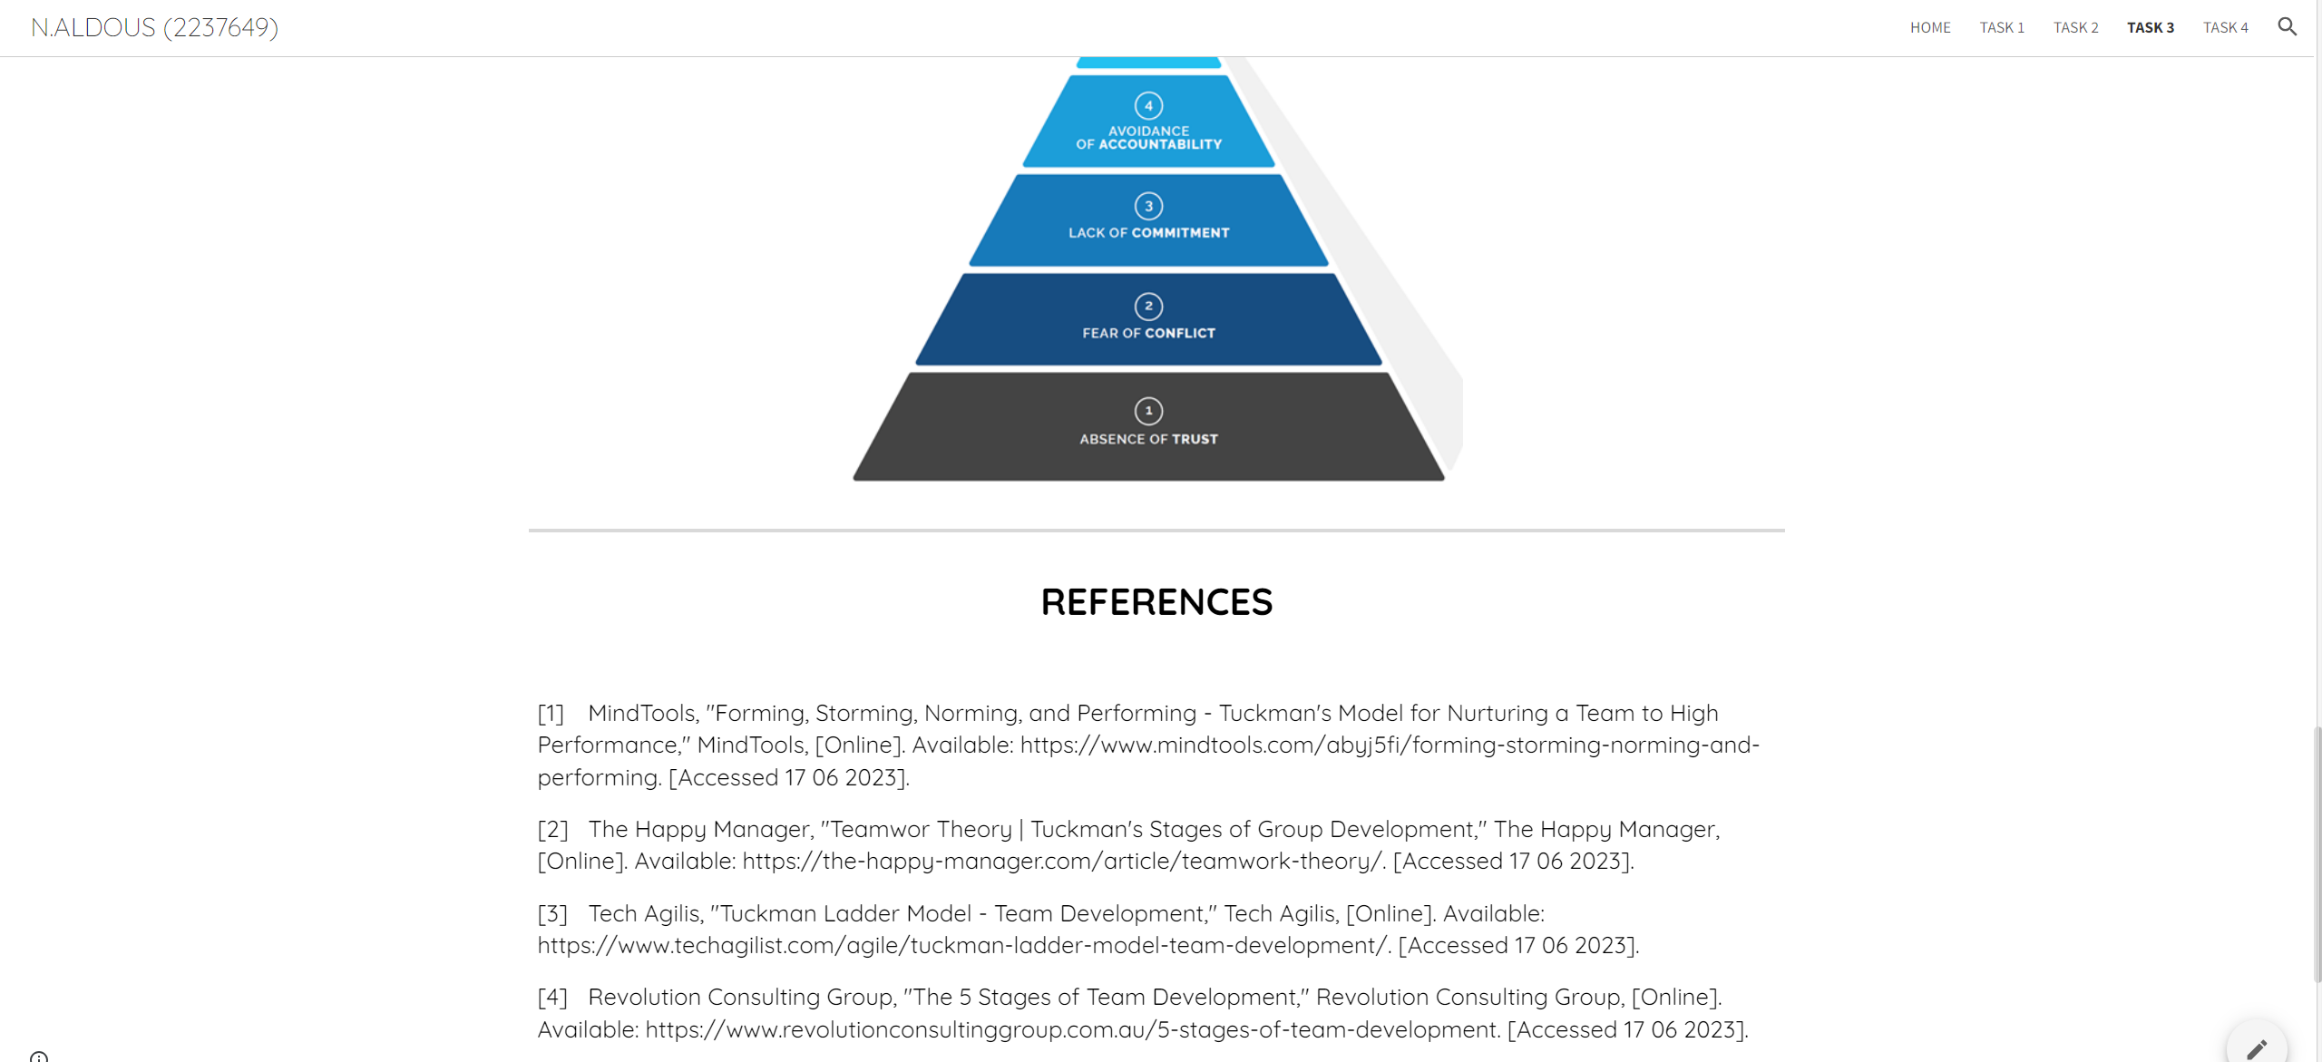
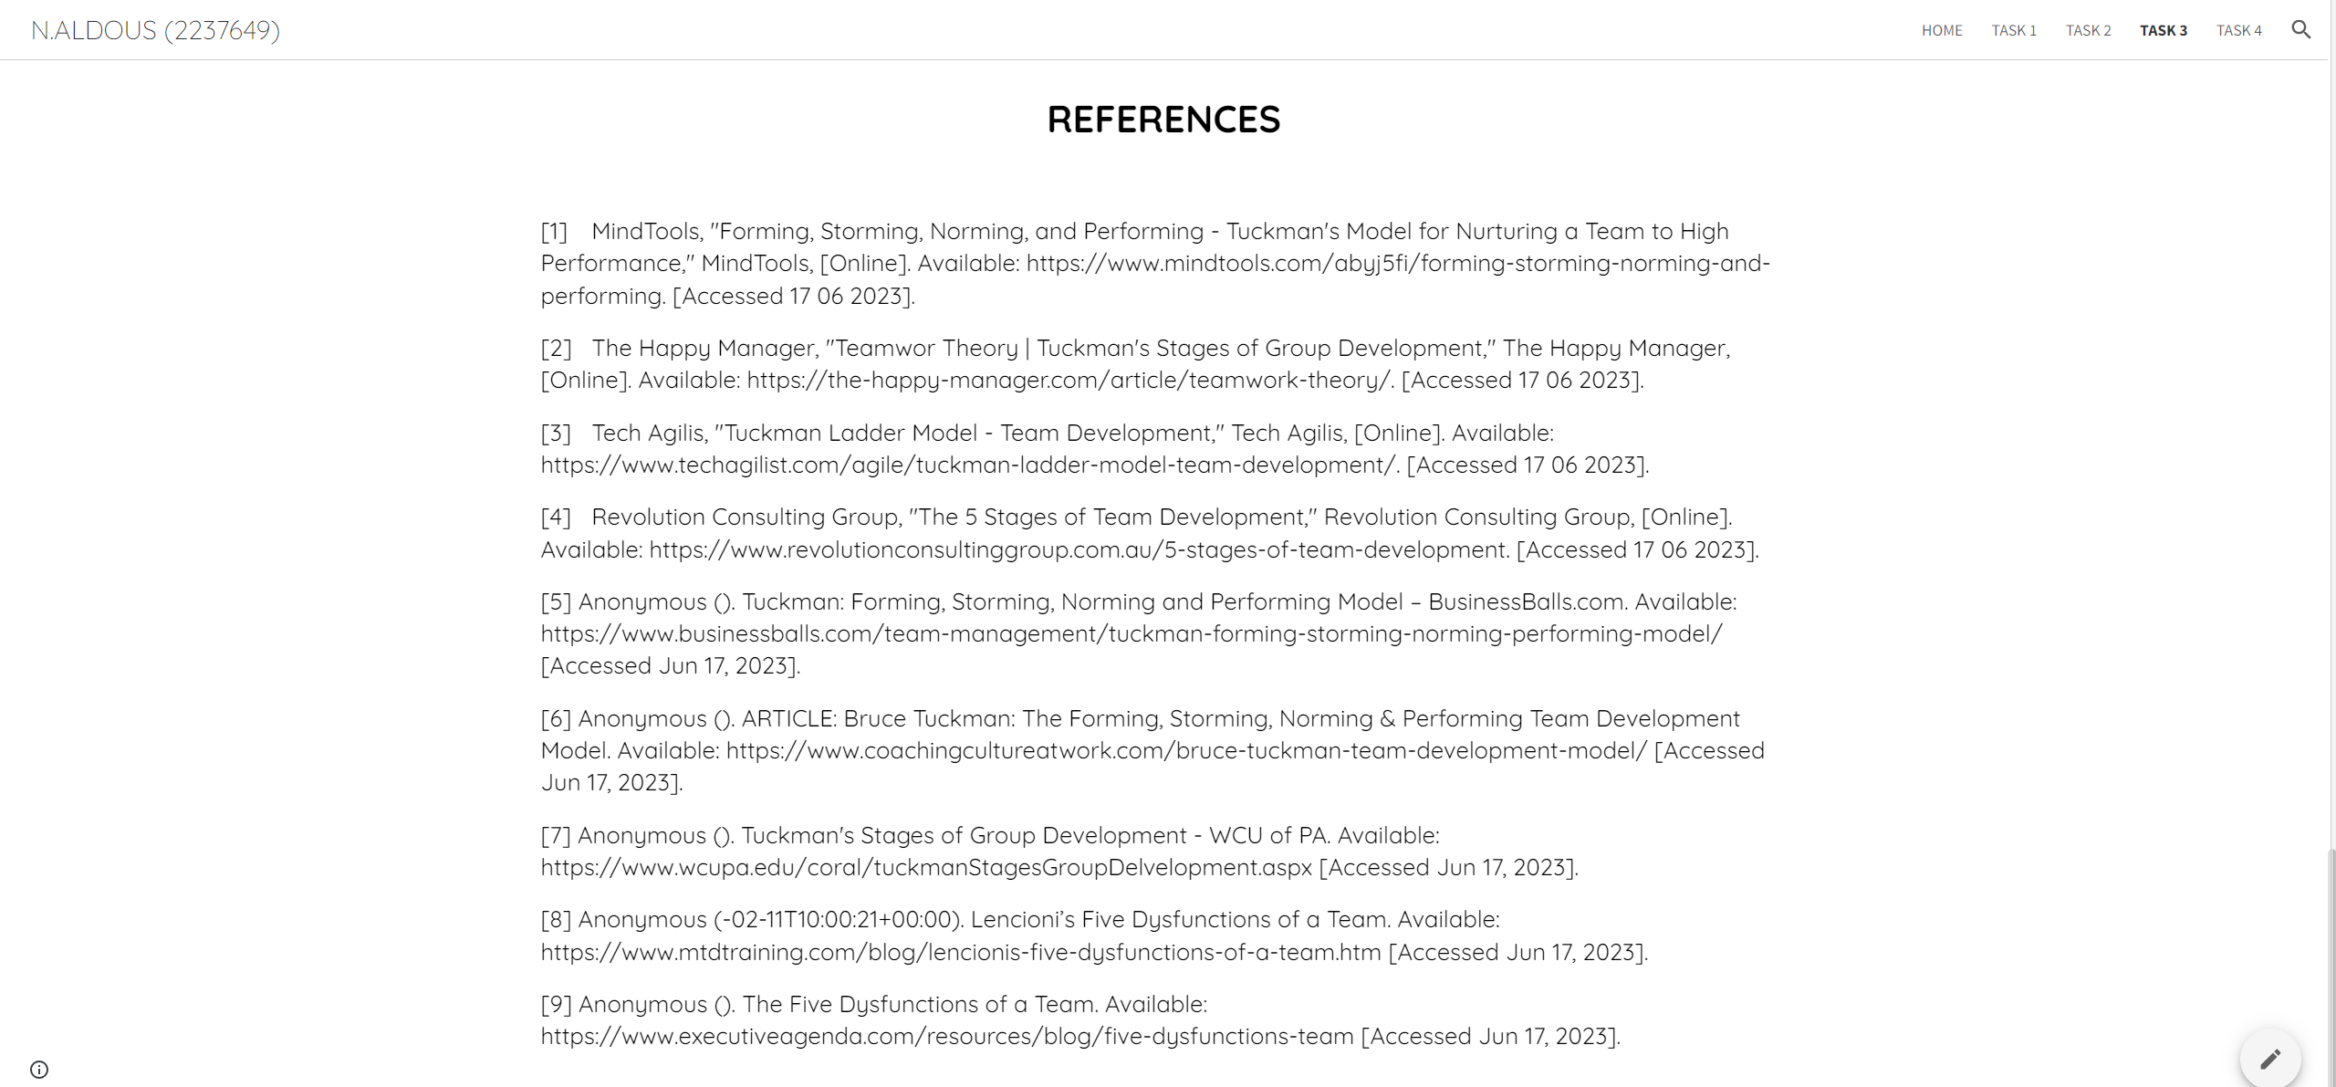

TASK 4



