 | University of Wales  Trinity Saint David
Programme | BA Business management
Module code | LCBB4005
Unit tittle | The global Business Envoirnment
Lecturer | Nadeem Mirza
Student ID | 1916917

TESCO

Student: Silviya Lazarova

Contents
Introduction 2
Analysis of different business models for understanding both micro- and macro-environment of Tesco in the current business context 2
Changes made by Tesco to run the business in the light of the Covid-19 pandemic 5
Discussion and Recommendations 7
Conclusion 7
References 7

Introduction
Business environment means those factors that make of a business, including some internal and external ones, which affect the business enterprise (Cherunilam, 2016). Between these two factors, things that are completely in the control of the organisation and can be modified if needed are known as internal factors, whereas the things that are not within the control of the business are called external factors (Hamilton and Webster, 2018).These external factors are again categorised into micro and macro environment. For business enterprises, handling external environment becomes quite tough as has been proven due to the critical situation of world economy by the Covid-19 pandemic. Here, it has been seen that those businessesthat are flexible and adaptable and able to make necessary changes in response to the global pandemic remain succeed and become more competitive (Amankwah-Amoah, et al., 2020).In this report, with the application business models, the present external environment for the business of Tesco has been analysed as well as in the later part, the significant changes that the organisation has brought for coping up with the present business scenario due to Covid-19 and their sustainability vale for long term have also been discussed.
Company overview:
Tesco Plc. is a multinational grocery and leading merchandise retailer in the UK. Founded in the year 1919, it serves in the UK, Ireland, Czech Republic, Hungary and Slovakia through its approximately7000 stores across the world and onlinestores as well. Around 420,000 employees are working there in Tesco. As per August, 2020, the market share of Tesco is 27%, showing relatively less as compared to the previous years. In the event of the global pandemic, the Tesco has faced serious hardships as the retail sector of the UK has been affected majorly. But it has made significant changes in its operations to remain competitive.

Analysis of different business models for understanding both micro- and macro-environment of Tesco in the current business context
PESTLE analysis
Political: Like the home market, i.e. the UK, its other operating markets are relatively stable. But in the UK, the event of Brexit has affected Tesco Plc., such as high price rise along with the wholesaler disputes.As a result, the organisationhas to engaged itself in certain near-term steps for compensating the issues created by Brexit. Its stores in the Ireland has to face impacts of disruptions in supply chain, in the words of Ken Murphy, CEO of Tesco, supply of certain products such as fresh fruits, processed foods and ready meals have been impacted (Chapman, 2021). But Tesco management takes it as a challenge rather than obstacles as they think due to issues of price hike, the supermarket can focus on local suppliers more instead of importing them from the EU (BBC News. 2020).Tesco head has also added that the customers can witness price rise between 3% and 5%.
Economical: The crisis created by the Covid-19 pandemic impacts on the buying behaviour of the customers. It has been identified that there has been more or less similar trends as well as differences in the pattern consumers of retail industry of the UK. In accordance to that, Tesco hasexpanded its scale of E-commerce operations in order to cater to the needs of the customers. It has increased the home-delivery slots to double over the last months. Apart from this, the issues of inflation and disruption in the exchange rate have impacted Tesco significantly (Adamyk, 2019.).
Social:Based on the current situation, the purchasing behaviour of the customers has changed to a great extent. The economic crisis has resulted into job loss; hence, the sale of the supermarket has also faced hardships. Moreover, the early stages of the pandemic have forced the consumers developing panic buying behaviour, led to empty shelves for others (Tesco PLC. 2021). In addition to that, Tesco has large customer base comprising loyal shoppers, whom the organisation is able to serve to its best amidst this crisis. It has retained its employees as much as possible with additional employment.
Technological:Tesco has introduced technology such as RFID to better the customer experience in store. With the application of this technology, Tesco can easily manage its stocks.Big data analytics, NFC technology and Tesco Clubcard along with Tesco Pay+ are the examples of technological advancement of Tesco (Benady, 2017).
Legal: Tesco has faced issues such as misleading its investors and paying low-wages to its workers. It has to be suggested that Tesco should continue its operation maintaining strict codes of practice of FRC.
Environmental: Tesco is environment friendly as it has made commitments to producezero deforestation products and recyclable and compostable packaging. They use fuel- and cost-saving routes and planned to use 100% renewable resources by 2030 (Circular Online. 2019).

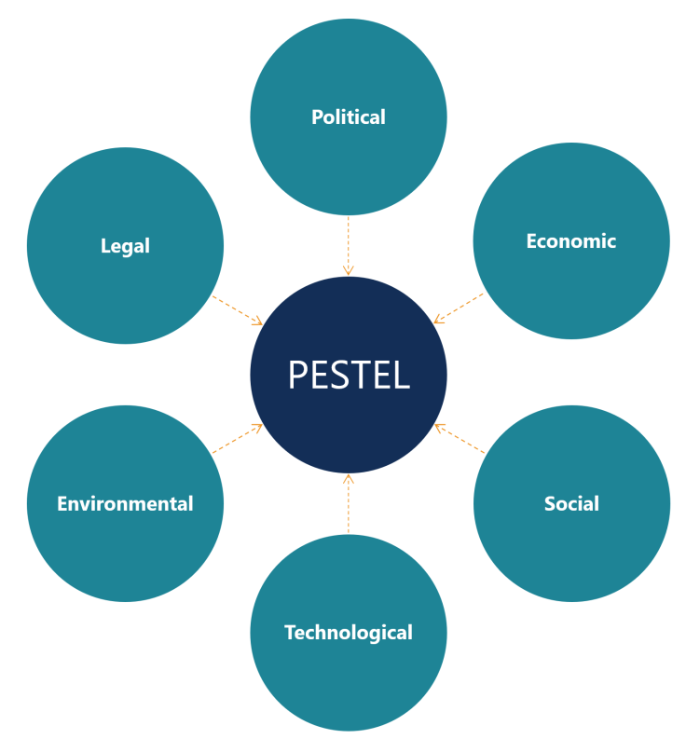
Porter’s Five Forces model
Bargaining power of suppliers: For the context of Tesco, it can be confirmed that the bargaining power of the suppliers is less. The organisation deals with many suppliers. Moreover, it can easily bargain the prices with the suppliers on the basis of its wide business scope and scale. Tesco can negotiate well the product prices from the suppliers supplying high-quality products (thegrocer.co.uk. 2019).
Bargaining power of customers:For Tesco, bargaining power of the customers is high because there are a number of high supermarkets in the retail industry, giving the customers freedom to choose one over others. But it has been found in present scenario, the customers are leaning more towards the discount providers such as Aldi rather than retailers. Tesco should consider this new trend in the customer’s behaviour seriously.
Threats of substitutes: Tesco offers various food as well as non-food products, which are highly comprehensive as well. On the basis of scale of effect of economies, Tesco even offer substitute products at cheaper rate, which makes their customers more attractive, resulting into medium threat of substitution (Xinyun, 2018,).
Threats of new entrants: The retail industry of the UK has already the presence of the major retailers and Tesco being one of them. All-new entrants in this market will require high capital investment along with innovation and more exclusive strategies, without which they cannot operate their business in this competitive sector.
Industrial rivalry: In the context of Tesco, industrial rivalry is quite high and strong. Aldi, Sainsbury’s, Morrison etc. play the role of major competitors for Tesco. They also have large customer base and provide the customers different attractive offers to switch.AldiandLidlhave become discounted supermarkets to attract the shoppers by offering them branded items in cheaper prices than others (Rosnizam, et al., 2020).
Limitations:
From this analysis it can be said that, Tesco holds a significant position in the UK retail industry by offering a number of products in cost-effective prices to the customers and having good advantage such as low bargaining power and less threats of new entrants in the market. But, Tesco should innovate its product range and offer new products on cheaper and user-friendly rates. In this way, it can fair its sales process and maintain the large customer base.
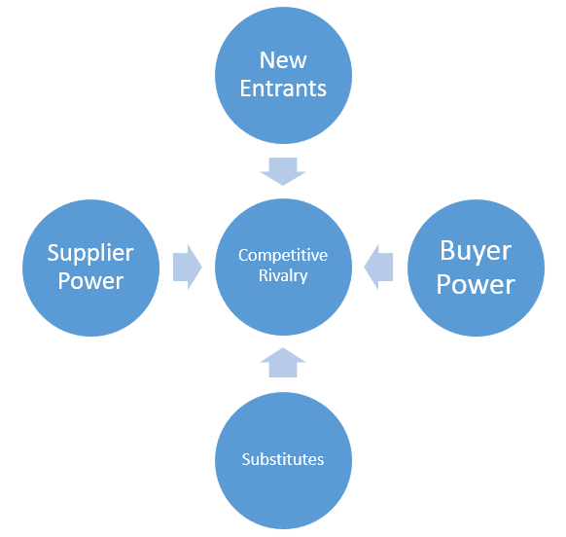

Changes made by Tesco to run the business in the light of the Covid-19 pandemic
In the context of critical scenario created by the Covid-19 pandemic across the globe, Tesco has mainly focussed on the change in the buying pattern of the customers. It has shifted its business focus to E-commerce. The organisation has faced high increase in its online sale and its profit gets double since the last few months (BBC News. 2020).
It has been found that more and more customers are turning to become online shoppers considering the new-normal situation includingnation-wide lockdown for three times in the UK and social distancing norms. Tesco has increased its delivery capacity more than double to meet the 1.5 million delivery slots per week during the 1st half of the Covid-19 event. In this way, like the other retail organisations Lidl and Aldi, Tesco has created approximately 16 thousands job opportunities that are permanent for supporting the tremendous growth that its online business is achieving at present. Among the 16 thousands posts, 10 thousands will be pickers for collecting the orders of the customers and 3 thousands drivers together with a number of different other posts in the stores (ETRetail.com. 2020).
As per September, 2020, the market share of the top supermarkets in the UK has shown significant picture amid the Covid-19 scenario:
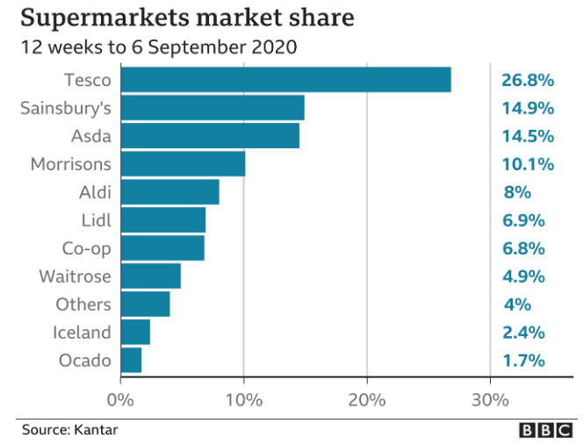
With the third lockdown, the E-commerce will continue to rise in 2021 also. As found in the retail growth rate of 2020 during the Christmas, Tesco announced to enjoy£ 1 billion grocery sales online. Tesco establishes more warehouses and distribution centres.
Tesco has changed policies for people who shop in-store for providing them required convenience. For that purpose, the organisation has extended its working hours in most of their shops, though it has seen majority of them closed overnight.For people who are in self-isolation,Tesco has introduced facility to let the drivers know about this in the section of delivery note in the app, so that the drivers deliver the parcel to the customers’ doorstep. Instead of carrier bags, the products can be packed in tray liners as per the guidelines from the UK government.
The organisation is also sending E-mail to the customers asking them to come and shop from the stores as per the convenience of the customers. In this way, they can save the delivery slots for the vulnerable ones who need this online service most (Gordon, 2020). In addition to that, the organisation is encouraging its customers to opt for Click+Collect to free up the delivery slots. And it has been found there is option of one-time delivery per week for the customers (Gordon, 2020). In order to prevent the panic buying behaviour of the customers, Tesco has introduced purchasing limits on flour, dried pasta, toilet paper, anti-bacterial wipes etc., allowing only three of them per customers. In the online purchase, canned vegetables and rice are limited among the others (Partridge, 2020). Tesco stores are opened throughout the day for the customers to avoid long queues and ask the customers to pay through contactless payment or by card.
Social distancing protocols (introducing tapes on the shoppingfloor) guide and protect the customers at every checkpoint (ITV News. 2020).It has helped 110,000 vulnerable people in the UK as received list from the government. Tesco also has decided to pay back relief given by the government for its business during pandemic of £ 585 million (Tesco PLC. 2020).The ‘doomsday exercise’ that is basically a contingency planning, including staff working remotely, launched in 4 years ago has been proved successful for Tesco to deal with the current pandemic situation (Butler, 2020).

Discussion and Recommendations
As discussed in the earlier section, it has been found that Tesco has adopted significant measures in order to adapt to the current business situation. It has greatly focussed on E-commerce, in which it increases slots and appoints more people to create permanent jobs. Moreover, by taking proper measure in the stores, they ensure safe service to the customers.By helping vulnerable ones, they are contributing their best service to the people. All these above-mentioned measures taken by Tesco are praiseworthy. But at the same time, only recruiting staff is not enough, Tesco should revamp the infrastructure of its whole supply chain for the long term as this present situation can have great impact on the business, which will continue in the future as well. Its warehouses or fulfilment centres should be functioned through automation, thus it will be cost-effective and more fast service delivery is possible such as delivery in 1 day or 10 days and even Click+Collect service can be improved.Second, Tesco should completely adopt contactless payment channel in all of its stores. Along with that, the organisation need to find new ways to reward and praise its loyal customers through digitalized loyalty schemes or programmes as it will be beneficial for the organisation to remain successful and competitive than others (Coker, J., 2020).

Conclusion
The overall discussion has highlighted the major changes occurred in the present global business environment due to the Covid-19 pandemic. It has been realized that Tesco has successfully identified the changing scenario of the business, including the customers’ shopping behaviour. And for that purpose, it has also made significant changes in its business operation, which are quite commendable.By following some recommendations given at last, Tesco is able to sustain its business for the long term.

References
Cherunilam, F., 2016.Business environment.Himalaya Publishing House.
Hamilton, L. and Webster, P., 2018. The international business environment.Oxford University Press.
Amankwah-Amoah, J., Khan, Z. and Wood, G., 2020. COVID-19 and business failures: The paradoxes of experience, scale, and scope for theory and practice. European Management Journal.
BBC News. 2020. Tesco: Brexit impact on food prices 'very modest'. [online] Available at: <https://www.bbc.com/news/uk-55460948> [Accessed 1 February 2021].
Chapman, B., 2021. Tesco hit by Brexit disruption shipping goods from Great Britain to Northern Ireland. [online] The Independent. Available at: <https://www.independent.co.uk/news/business/brexit-food-tesco-northern-ireland-b1787272.html> [Accessed 1 February 2021].
Adamyk, K., 2019. PESTLE Analysis on Tesco PLC.
Circular Online. 2019. Tesco launches measure to map environmental impact of food production. [online] Available at: <https://www.circularonline.co.uk/news/tesco-launches-measure-to-map-environmental-impact-of-food-production/> [Accessed 1 February 2021].
Benady, D., 2017. RFID technology is boosting sales and customer engagement for retailers - Raconteur. [online] Raconteur. Available at: <https://www.raconteur.net/retail/rfid-technology-is-boosting-sales-and-customer-engagement-for-retailers/> [Accessed 1 February 2021].
Tesco PLC. 2021. Covid-19. [online] Available at: <https://www.tescoplc.com/covid-19/> [Accessed 1 February 2021].
thegrocer.co.uk. 2019. suppliers of tesco - Google Search. [online] Available at: <https://www.google.com/search?q=suppliers+of+tesco&oq=Suppliers+of+tesco&aqs=chrome.0.0j0i10i22i30j0i22i30l3.61356j1j4&sourceid=chrome&ie=UTF-8> [Accessed 1 February 2021].
Rosnizam, M.R.A.B., Kee, D.M.H., Akhir, M.E.H.B.M., Shahqira, M., Yusoff, M.A.H.B.M., Budiman, R.S. and Alajmi, A.M., 2020. Market Opportunities and Challenges: A Case Study of Tesco. Journal of the Community Development in Asia, 3(2), pp.18-27.
Xinyun, T., 2018, December. A Multimodal Critical Analysis in Business Discourse: the Case of the Corporate Annual Report of Tesco. In 5th International Conference on Education, Language, Art and Inter-cultural Communication (ICELAIC 2018) (pp. 433-440).Atlantis Press.
Gordon, N., 2020. Asda, Morrisons, and Tesco supermarket delivery policies. [online] Prima. Available at: <https://www.prima.co.uk/diet-and-health/a31701586/coronavirus-supermarkets-home-delivery/> [Accessed 1 February 2021].
Partridge, J., 2020. Tesco limits sales of key items to stop Covid panic-buying. [online] the Guardian. Available at: <https://www.theguardian.com/business/2020/sep/25/tesco-sales-covid-rationing-toilet-roll-flour> [Accessed 1 February 2021].
ITV News. 2020. Coronavirus: What are supermarkets doing to enforce social distancing? | ITV News. [online] Available at: <https://www.itv.com/news/2020-03-26/coronavirus-what-are-supermarkets-doing-to-enforce-social-distancing> [Accessed 1 February 2021].
BBC News. 2020. Tesco profits surge as online orders double. [online] Available at: <https://www.bbc.com/news/business-54445399> [Accessed 1 February 2021].
ETRetail.com. 2020. Tesco to create 16,000 more permanent jobs in online boom - ET Retail. [online] Available at: <https://retail.economictimes.indiatimes.com/news/food-entertainment/grocery/tesco-to-create-16000-more-permanent-jobs-in-online-boom/77737548> [Accessed 1 February 2021].
Tesco PLC. 2020. Tesco decides to repay business rates relief. [online] Available at: <https://www.tescoplc.com/news/2020/tesco-decides-to-repay-business-rates-relief/> [Accessed 1 February 2021].
Coker, J., 2020. Tesco’s response to sustained eCommerce demand. [online] Essential Retail. Available at: <https://www.essentialretail.com/features/tesco-response-sustained-ecommerce/> [Accessed 1 February 2021].
Butler, S., 2020. How Tesco's 'doomsday exercise' helped it cope with the coronavirus. [online] the Guardian. Available at: <https://www.theguardian.com/business/2020/may/03/how-tesco-doomsday-exercise-helped-it-cope-with-the-coronavirus> [Accessed 1 February 2021].

