

L7: Data Security, Governance and Compliance
(ACCA7028)

Information Security Management System Construction of CoffeeBlue

MSc Data and Artificial Intelligence

Wales Institute for Science and Art (WISA)
University of Wales Trinity Saint David

January 4th, 2022

Task 1
- P2DR2
P2DR2 dynamic security model is a dynamic security model structure based on enterprise network objects, according to time and Policy characteristics (Policy, Protection, Detection, Response, Recovery). It is a dynamic security model based on closed-loop control and active defense. Through the analysis and formulation of routing and security policy of regional network, the real-time detection, monitoring and audit mechanism is established inside and outside the network, and the methods of disaster backup and recovery of diversified systems and redundancy design of key systems are applied to construct a multi-level, all-dimensional and three-dimensional regional network security environment.
A good network security model should express the security architecture through the security model on the basis of fully understanding the security requirements of the network system. It usually has the following properties: accuracy and unambiguousness; Simplicity and abstraction; Having generality; Fully displayed security policies.
  - Security Model
- Policy:
Define the monitoring period of the system, establish the system recovery mechanism, formulate the network access control policy, and define the overall security planning and principles of the system.
- Protection:
Make full use of firewall system, implement packet policy-based routing, routing policy and packet filtering technology, and apply access control rules to achieve safe and efficient access. NAT and mapping technology are used to protect and isolate IP addresses.
- Detection:
Using the intrusion detection technology and system scanning tool of firewall system, and with other special monitoring software, the access control subsystem ACS is established to realize the intrusion monitoring and log auditing of network system, so as to timely discover the intrusion behavior through ACS.
- Response:
Under the guidance of the security policy, the control rules of the access control system are dynamically adjusted to detect and timely truncate suspicious links, eliminate suspicious backdoors and loopholes, and start relevant alarm information.
- Recovery:
On the basis of various backup mechanisms, the emergency response recovery mechanism is enabled to achieve the instantaneous restoration of the system. Conduct on-site recovery and reproduction of aggressive behavior for research and evidence collection; Implement high-speed and reliable backup for heterogeneous storage and environments.

- COBIT
COBIT is an IT governance and Control framework for the Objectives of Information and Related Technology. It builds a bridge between business risks, control needs and technical issues. It can assist management in IT governance, guide organizations to effectively use information resources and manage risks related to information.
Focus on what needs to be done, not how. Research, develop, publish and promote an authoritative, up-to-date, internationally recognized IT governance and control framework for the daily work of business managers, IT specialists and quality assurance specialists in enterprises.
Business orientation is the theme of COBIT, which is designed not only for users and auditors, but more importantly as a comprehensive guide for managers and owners of business processes. Help businesses determine whether they are doing what they say they will do and whether they can prove it.

Control Objectives
(1) Effectiveness -- Information systems provide information that is "valid" for business processes.
(2) Efficiency -- Use resources and provide information "efficiently".
(3) Confidentiality -- Protect sensitive information and avoid information leakage.
(4) Integrity -- Ensure that information is "authentic", that is, accurate, complete, and valid in terms of business value and business needs.
(5) Availability -- Information is readily available when the business needs it.
(6) Compliance -- Comply with relevant laws, regulations and contracts on business processes.
(7) Reliability -- Provide appropriate information for management to maintain the operation of the organization and to carry out the responsibilities assigned to it.

- ITIL
ITIL (Information Technology Infrastructure Library) is a set of service management standard library for IT industry developed by British Central Computer and Telecommunications Agency (CCTA) in the mid-1980s.
The background of ITIL is that at that time, the British government, in order to improve the quality of IT services in government departments, launched a project to invite well-known IT manufacturers and experts at home and abroad to jointly develop a set of standardized, financial measurement of THE USE of IT resources. This approach should be vendor-independent and adaptable to organizations of different sizes, technologies, and business needs. The result was what is now widely recognized as ITIL.

Service Operation
(1) Help Desk: The IT service desk can realize efficient IT operation and maintenance management, greatly improve IT operation and maintenance benefits and reduce risks and costs, control IT resources, optimize resource allocation, standardize the operation and maintenance management process, and record, track and count every event.
(2) IT operations Management: Monitor and monitor events and operational activities in IT infrastructure, console management, application status, backup and recovery, performance maintenance activities, and more. In addition, manage physical IT environment, such as data center, recovery center, server, storage, network, power supply, air conditioning, etc.
(3) Skill management: Complex accident treatment, solution, provide technical expert advice, responsible for IT infrastructure technology management.
(4) Incident management and problem management: The purpose of event management is to recover faults as soon as possible so as to minimize the loss of faults and meet service requirements as far as possible. When an emergency failure is dealt with, the information center moves to the problem management level in order to find the cause of the failure and thus change the situation from one that is often dealing with an outstanding incident. The fundamental difference between event management and event management is that event management aims to restore enterprise production, while problem management aims to identify the root cause of IT failures and formulate solutions to prevent similar failures from happening again.
- Why we need to constantly have new or updated regulations and standards?
The system construction is an extremely important part of enterprise standardized management, and the standardized management level of each work is directly reflected in the system construction. The basic flow of system construction is system compilation, system implementation, system revision and perfection. The standardization and systematization of the three links play a decisive role in gradually forming a standardized system that can meet the development needs of the enterprise, and is also the key to further improve the standard management level of the company.
With the operation of the information security management system, in the operation process we will continue to find that the original design of the process does not adapt to the work link. At the same time, the internal and external environment of the information security system is changing all the time, and the business strategy is also facing constant adjustment. It is necessary to optimize the relevant process adjustment.
In the process of system operation, it also needs necessary supervision, inspection and continuous improvement of the process to ensure that the company's information security management system can be sustained, stable and effective. By monitoring the various control measures implemented in the company's information security management system, audit the degree of completion of the predetermined target and the level of compliance, provide data decision-making basis for the PDCA recycling of the information security management system.
Therefore, the information security management system must be adjusted in time.
Task 2
Information security management system
Construction of CoffeeBlue
  - Demand analysis of CoffeeBlue
The company has a lot of online business and advertising. Its staff and clients mainly access services on the cloud. Recently, the company is in urgent need of opening access to their networks and resources. Because of no appropriate information security frameworks, it is under data security risks and a data security management system is needed to protect the properties of the company and clients.
  - Information security system architecture

  - Overall architecture
Combined with the content of ISO 27001 information security management system framework^{[1]}, CoffeeBlue's information security management system architecture can be divided into organizational structure file system and technical management support system. Referring to the contents of ISO 27001 information security management system standard framework, the main function modules can be set up^{[2]}.
Table 1 Relationship between the information security management architecture module of CoffeeBlue and ISO 27001 framework
Information security management architecture of CoffeeBlue |  | ISO 27001
Organizational structure document system | Information security management organization structure | Information security organization
Organizational structure document system | Information security knowledge management | Asset management, information security event management
Organizational structure document system | Information security management policy | Information security policy
Organizational structure document system | Information security system document management | Human resource security, supplier management, access control, passwords, compliance
Technical management support system | Information security risk management | Physical and environmental security, operation security, communication security, system acquisition development and maintenance
Technical management support system | Business continuity management | Business continuity management
(1) Organizational structure document system
By establishing the organizational structure of information security management, the problem of unclear internal information security management responsibilities of CoffeeBlue can be solved. Through strengthening information security knowledge management construction, improve the company's staff's basic information security awareness and common information security management skills. Through the development of information security management strategy, the development of information security management programmatic documents, expounds the company's information security management vision and goals. Through the establishment of detailed information security management system documents, build the company's system management firewall.
(2) Technical management support system
Through information security risk management, identify the company's information security and potential risks, take network isolation, hardware firewall, network antivirus software and other measures to complete the transfer, avoidance, mitigation or acceptance of information security risks. Through business continuity management, factors affecting the company's business development of information security identification, adopt measures to establish a file backup, database mirroring, in strict accordance with the drilling of business continuity management plan, improving the capacity of information security management technology, reduce the effects of information security event for the company's business strategy.
  - Solution details
On the basis of completing the overall architecture of the information security management system, the solution details can be developed^{[3]}.
- Project objectives
In order to cope with the requirements of information security management, reduce the information security risks brought by the continuous deepening of the application of information technology in the enterprise, improve the rapid response capacity of the company's core business, and establish the company's information security management system.
- Core modules
As mentioned above, the information security management architecture of the company includes two sub-systems, namely, the infrastructure sub-system and the management support sub-system. The core modules of infrastructure sub-system include: security management organization structure, information security management strategy, information security knowledge management, information security system file management. The core modules of the management support sub-system include information security risk management and business continuity management.
(3) Keypoints
① Establish a sound information security management organization structure
By establishing and improving the organizational structure of information security management in CoffeeBlue, the identity and responsibilities of information security management personnel are clarified, the management right of information security management personnel in information security is enhanced, the corresponding power is given to the information security management personnel, and the work enthusiasm of relevant personnel is enhanced. For the company's information security management, can also play a positive role in promoting, in order to avoid buck-passing phenomenon in information security management.
② Establish information security document system framework
Through the establishment of information security document system framework, so that the importance of information security management from the company's decision-making staff to the management, executive staff heart rapidly spread, and strive to make it become a part of the enterprise culture. According to the requirements of ISO 27001 information security management system and the actual situation of CoffeeBlue, the company can limit the content of information security document system framework to three parts: information security management strategy, information security knowledge management and information security system document management.
③ Establish and improve the technical management support sub-system
Through information security risk management and business continuity management, the company's internal information security management loopholes and technical information security risks are fully controlled to solve the company's existing information security risks.
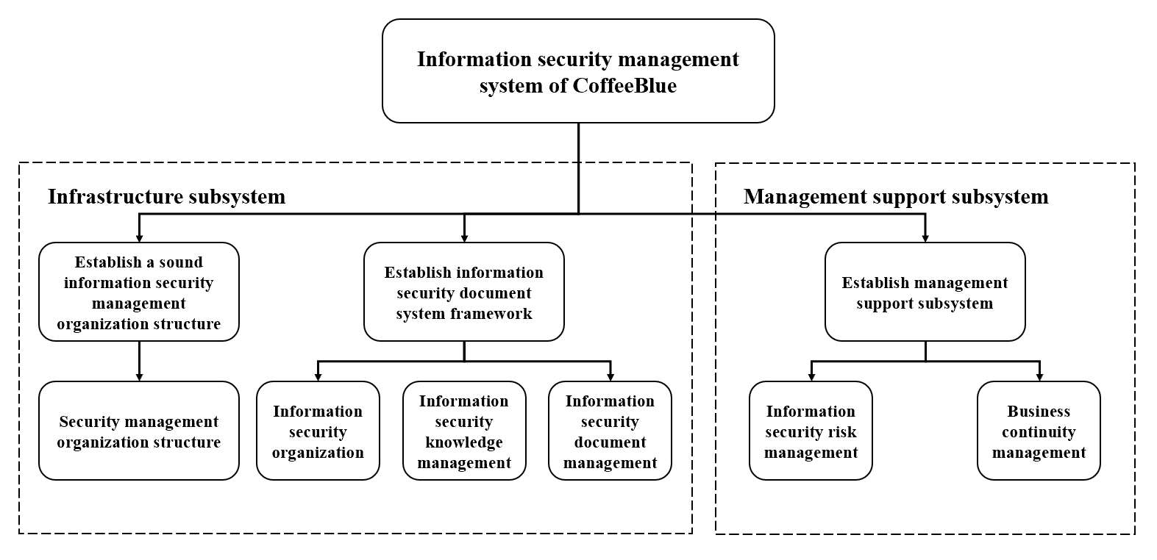
Fig.1 Information security management architecture diagram
  - Information security management policy

  - Objectives
Combining with the actual needs of CoffeeBlue and referring to the requirements of relevant parties of the company for information security management, the company's information security management objectives are as follows:
In the company's internal top-down construction of appropriate information security management system. Establish and cultivate professional and sustainable development of information security management team. Enhance the information security awareness of the company's employees, improve the company's ability to prevent and respond to information security incidents, and improve the company's ability to respond quickly to changes in the rapid environment of the core business.
  - Scope of application
According to the requirements of ISO 27001 information security management system and the actual situation of CoffeeBlue, the application scope is determined as follows: all employees of CoffeeBlue in headquarters and offices all around the world as well as customers with business requirements.
  - Information security risk management
Information security risk management is the process of risk identification and risk assessment of the existing information security risks in the daily business operation of the company. For the identified risks, risk disposal measures are implemented to reduce the risks to the risk level acceptable to the company and ensure that the risk level can be maintained. The basic flow of risk management process is shown in Fig 2.
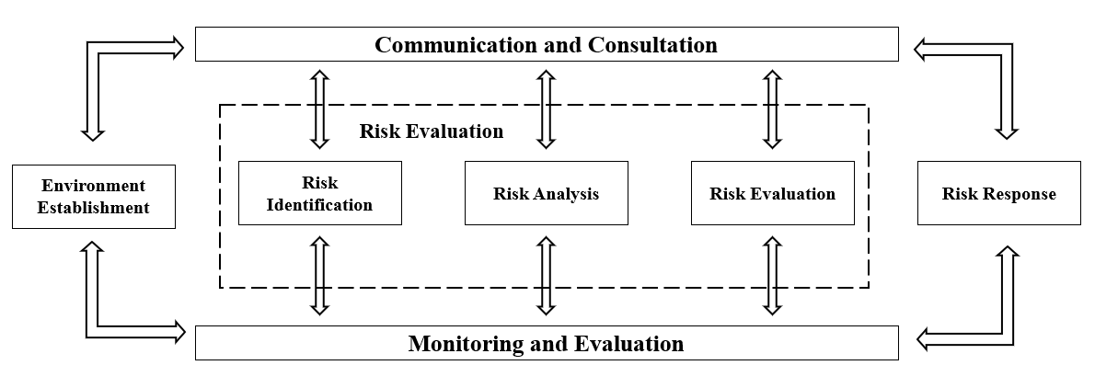
Fig 2 Risk management process
Among them, "environment establishment" describes the scope, environment and criteria of relevant information security risk management. Including: risk management methods, evaluation criteria, impact criteria and acceptance criteria. Internal information security risk assessment is mainly to identify the vulnerabilities and threats in the company's internal operations, evaluate the business value that may be reduced, and then decide what security protection measures to take to reduce the damage^{[4]}.

  - Risk identification
The purpose of risk identification is to generate a comprehensive risk list. The working process generally includes four processes: determining the assessment object, selecting the risk source, producing the risk assessment list and implementing the risk identification.The mapping of information security risk process is shown in table 2.
Table 2 Mapping of information security risk processes
Project | ISO/IEC27005 system process | Working Process
Risk Identification | Asset identification | Determine the evaluate project
Risk Identification | Threat identification | Choose the source of risk
Risk Identification | Exist control identification | Generate the risk assessment checklist
Risk Identification | Vulnerability identification | Choose the source of risk
Risk Identification | Consequence identification | Implement risk identification
  - Risk analysis
Risk analysis refers to the assessment of risks by considering various factors (risk sources, possibility of risk events, etc.). Including quantitative risk analysis and qualitative risk analysis. Risk analysis can assist enterprises to perfect the integration of information security management objectives into the overall business objectives of the enterprise, the more consistent the company's overall business objectives and information security objectives, the more benign interaction can be formed. At the same time, it can also provide a basis for the company's management to formulate information security management planning budget.
In the process of risk analysis, we will conduct quantitative risk analysis on the information assets whose value can be clearly identified, and calculate their expected value of single loss (SLE) and expected value of annual loss (ALE). Single loss expected value is the monetary value assigned to a certain information security incident, indicating the amount of loss a company may suffer when a specific threat occurs.
For the information assets whose value cannot be identified, a qualitative risk analysis matrix is used to determine the asset priority. For example: in view of the external commercial espionage against the company through the network database server, this event risk analysis team to the scene to the pre-selected good information department employees and business administration, the director of the center, ask them about the event from the harm degree, possible losses, such as the effectiveness of the preventive measures for 1-5 stars evaluation: Five stars represent the most serious, effective or likely to occur.
  - Risk evaluation
The purpose of risk evaluation is to compare the estimated value obtained after risk analysis with the relevant criteria determined by the company, so as to determine the level of risk and determine the priority of implementing risk management. After the risk assessment is completed, we will finally decide whether to accept the risk or take appropriate action.
In the process of risk evaluation, first of all, CoffeeBlue assigns values of 3, 2 and 1 to the asset value according to the secret level (highly secret, secret and internal) and CIA three elements (confidentiality, integrity and availability) respectively. Meanwhile, it also assigns values of 3, 2 and 1 to vulnerability and threat possibility according to high, medium and low.
Then, the information security management team members according to the calculation formula, the calculated risk value.
Finally, according to the calculated risk value, the risk grade is divided, and the corresponding risk acceptance criteria are determined.
  - Risk treatment
The goal of the risk management process is to take corresponding risk management measures to control the consequences caused by the existing information security risks within the acceptable range of a company.
The measures to deal with information security risks generally include the following four types: risk transfer, risk avoidance, risk mitigation and risk acceptance.
Through a series of processes such as prioritizing risks, evaluating risk treatment measures, and implementing cost-benefit analysis, appropriate risk treatment measures are selected for medium and high grade risks identified in the risk list to reduce them to acceptable levels of the company.
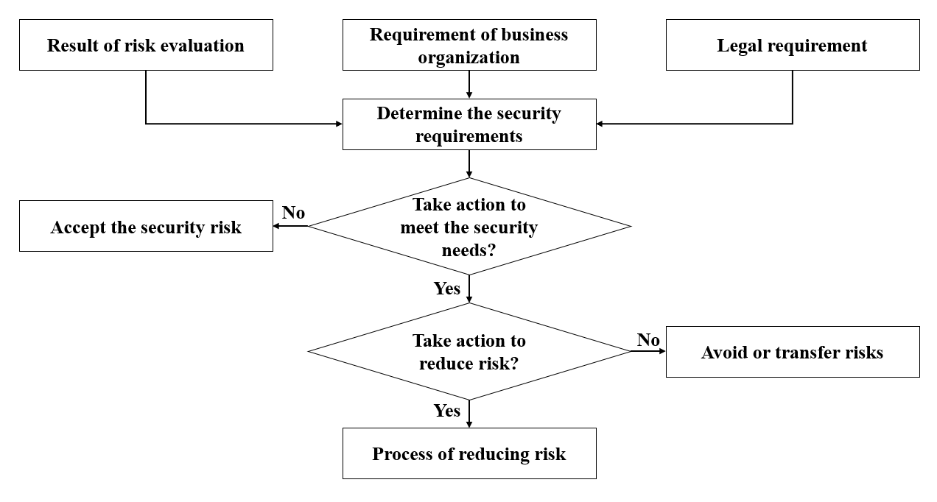
Fig 3 Flow chart of information security risk treatment
  - Business continuity management
Business continuity is an organizational capability within a company. It refers to the ability of the company to continue to deliver services to relevant parties at a predetermined acceptable level in the event of an unexpected interruption. Business continuity management integrates a company's business resilience and ability to respond effectively to unexpected events to protect the core business interests of key stakeholders in an organization^{[5]}.
Business continuity planning guidelines are described in ISO/IEC27031:2011 information and communication technology preparation guide for business continuity, which includes the following aspects^{[6]}.
(1) Formulate the Business continuity policy.
(2) Perform service impact analysis.
(3) Determine preventive and control measures.
(4) Develop a Recovery strategy.
(5) Develop a business continuity plan.
(6) Test and drill.
(7) Maintain the business continuity plan.
Combined with the original business continuity management system documents, further information security management related content into the business continuity management of enterprises, standardized business continuity management of enterprises. At the same time, the multi-dimensional construction integration between the two systems is realized in the management dimension.
(1) Set up a business continuity management team
The company needs to set up a business continuity management team whose members come from the marketing center, production center, business administration, information, security center, legal branch. The team is the responsibility of the related business of the enterprise information system problems and threats are discussed, and determine the ultimate goal of business continuity management and related business priorities.
(2) Adopt project management work way to promote the work
According to the working method of project management, the leader of the business continuity management team is responsible for project promotion and implementation, and is required to complete work tasks strictly in accordance with the project schedule. A project planning schedule has been prepared that includes a mapping of objectives to tasks, a mapping of resources to tasks, workflow, milestones, deliverables, budgets, deadlines, etc.
  - System document management
In the process of information security system document preparation and management, the system document group members start from risk assessment information security requirements, combined with the ISO/IE27001 information security management system, completed a complete set of information security management system documentation and management work by system documented requirement in file through the planning system framework, making writing outline and training writing requirements and specification.
In the process of document preparation, members of the system document group through continuous communication and discussion with relevant responsible departments, the actual work content and document requirements are combined, so that the document can fit the operation of the actual business process of the company, to ensure that the system document can finally be executed. After the completion of the document, according to the release management provisions of the system documents, the information security management team meeting review, the general manager of the company after the unified release and implementation. The complete set of information security management system documents includes four levels.
Level 1 document: Information security management manual, which covers information security management policy and applicability statement.
Level 2 document: Company information security rules and regulations. The content covers related management regulations in the daily information security management process of the company.
Level 3 document: operating procedures and guidance files. The content covers the company's information security management work related operation instructions, process specification documents and business system operation guide and other documents.
Level 4 documents: all kinds of records and forms in information security management.

Reference
- Syreyshchikova, N. V., Pimenov, D. Y., Mikolajczyk, T., & Moldovan, L. (2019). Information Safety Process Development According to ISO 27001 for an Industrial Enterprise. Procedia Manufacturing, 32, 278–285. https://doi.org/10.1016/J.PROMFG.2019.02.215
- Liu, Q., Du, Q., Shi, W., & Zhu, J. (2012). Modeling of risk treatment measurement model under four clusters standards (ISO 9001, 14001, 27001, OHSAS 18001). Procedia Engineering, 37, 354–358. https://doi.org/10.1016/J.PROENG.2012.04.252
- Fazlida, M. R., & Said, J. (2015). Information Security: Risk, Governance and Implementation Setback. Procedia Economics and Finance, 28, 243–248. https://doi.org/10.1016/S2212-5671(15)01106-5
- ISO/IEC 27001:2013 (ISO27001) Information technology – Security techniques – Information security management systems – requirements. International Standards Organization, 2013.
- Chapple Mike, Stewart James Michael, Gibson Darril. (ISC)²CISSP® Certified Information System Security Professional: Official Study Guide[M]. John Wiley & Sons, Inc.:2018-08-09.

