Events Operations Management

Assignment 1: Event Operations Planning Report

November 2019

Module Title: Event Operations Management
Project Name: Haunted Castle of Oystermouth
Name: Isobel Davies
Student Number: 1800673

Table of Contents

1.0 Event Description 2
2.0 Planning of the Event 2
3.0 Staffing the Event 3
4.0 Event Stakeholders and Resources Required 4
5.0 Contingency Planning 4
6.0 Evaluation 5
7.0 References 6
8.0 Appendices 7
8.1 Appendix 1: 8
8.2 Appendix 2 8
8.3 Appendix 3 9
8.4 Appendix 4 10
8.5 Appendix 5 11
8.6 Appendix 6 12
8.7 Appendix 7 13
8.8 Appendix 8 13
8.9 Appendix 9 14
8.10 Appendix 10 15
8.11 Appendix 11 16
8.12 Appendix 12 16
8.13 Appendix 13 17
8.14 Appendix 14 18
8.15 Appendix 15 19
8.16 Appendix 16 20

1.0 Event Description

The Haunted Castle of Oystermouth is a new Halloween event run, for the second year, by the Swansea City Council and the Friends of Oystermouth Castle. The castle, which is based in Mumbles, Swansea is steeped in history which dates back to the 12th Century. Friends of the castle were formed in 1989, they look after the day to day running of the Castle alongside Swansea Council. As the castle is ancient and fragile, conservation work is required to keep it in good repair. During 2010 organisational charities give the castle £3.1 million to restore some areas. As this is an ongoing issue new ideas for funding are constantly being discovered (Swansea Council, 2019) and with Shonk and Chelladurai proposing the quality of the event includes the environment it is held in, it is no wonder the venue was well chosen for an event of this kind with creepy corridors, winding stairs and ghosts of past occupants. (Michelini, 2017).
The event is run over the Halloween period, between Wednesday 30th and Thursday 31st of October, with three different hourly time slots (Appendix 1), allowing customers the availability of choosing a preferred date and opportunity to attend in case of high demand (Grover, 2019). The idea behind the event is to theme different areas of the castle in famous horror movies such as Texas Chainsaw Massacre, The Nun and It, giving the public an idea of whom to relate the ‘frightening’ character too.
Audience demographic is aiming for teenagers and adults, as the event is trying to give a real-life experience of an American haunted house attraction, with very graphic and frightening content to be seen. Children aged 9 or over are also allowed to attend but warned of the scary content. In 2018 the event totalled to 404 people (Appendix 15) and due to the event becoming more established and a wide range of age groups attending the event is planned to be a considerable size this year.

2.0 Planning of the Event

According to Masterman (2014) key factors that are required in a planning process for an event are the inclusion of cost-benefit forecast, which will allow organisers to budget accordingly; implementation strategies for new faculties or regeneration projects; the impact the event will have economically and culturally; allow objectives to be met and allow the use of mechanisms so that short, medium and long term goals can be aligned. This is shown in the planning process model which discovers the process an event needs to go through to become successful (Appendix 2).
An appraisal on the current situation of the event must be completed as it may likely there will be minor changes or improvements to vision and mission statements, aims and objectives, new plans for marketing the event, volunteering and financing (Bodwin et al. 2006) (Appendix 3). Implementation planning involves moving the planned operational notion into event staff and volunteers’ hands to be completed, it is a goal-driven task that can be hard to keep up as tasks need to be completed by certain deadlines(Adams, 2008). As there are many things in an event to handle, it is suitable to have items broken down into lists. Julia Rutherford Silvers (2016) has created the EMBOK guide matrix, which is a framework that breaks down areas of events into small manageable areas that the user feels apply to them. For example; under Human Resource Management there could be behaviour policies, employment regulation, payroll, and recognition programs.
The matrix areas can be processed by mind maps, Gantt Charts, Work Breakdown Structures, running schedules, critical path analysis and software such as Prince 2. A Gantt Chart is measured via bars that represent various tasks that need to be completed and by when. It is useful for planning and scheduling work ahead. (Gantt Chart, n.d). Van der Wagon and White (2010) say the benefit of using this chart is the tasks can be seen and allow you to change the timings of processes (Appendix 4). From the Gantt Chart and main event components we are then able to identify a critical path analysis, a scheduling item that allows the processes for a specific area such as marketing to become streamline and easily managed (Getz, 2010) (Appendix 5).

3.0 Staffing the Event

Van der Wagen (2007), explains Human Resources management as helping an organisation achieve its objectives. In planned events it can include normal considerations of staffing, however, it does come with other challenges. There are various issues with volunteers, as there is a constant change in staffing and providing a good experience for customers through professionalism and performance, which can be an issue with non-experienced volunteers (Getz, 2007). As well as external suppliers and the way they are governed; the importance that people do sign up to events; project planning and management of where they are stationed and consider the stakeholders and risks with event planning.
Shone and Parry (2004) describe a volunteer as a person who chooses to contribute their own time, skills and effort without pay to help or benefit a cause. It is important therefore that volunteers are treated fairly and like the rest of the team; use their time efficiently, don’t let them wait around on pointless tasks, let them complete tasks they have the appropriate skills in , listen to their ideas and acknowledge their achievements (Van der Wagen,2015). This is vital as it will keep up the motivation to do well and get volunteers to believe that they are in a worthwhile cause. Tum et al. (2006) disclose that all motivation theorists believe that humans have basic needs to motivate their behaviour. This is done through tangible and intangible rewards, including financial gain or being appreciated by the team.
Van der Wagen and White (2010) expresses that recruitment needs must be identified before hiring staff for the event to help maintain efficiency. There are various recruitment needs for the Halloween event (Appendix 6). They include the main event manager, Erika Kluge and deputy Obaidah Sbeitan who will oversee the event. Friends of Oystermouth Castle, Ostreme Centre actors and volunteers from Trinity Saint David will also be involved and will help with the set-up of the event and the running of it during the evening.
When dealing with staff and volunteers the legal aspect must be considered. This includes employment law; the maximum working hours that can be completed, equal pay, age discrimination and data protection (CIPD, 2019). Health and Safety must also be considered and consider the duty of care employees are given during the event (Legalisation, 2019). During the Halloween event, this area of expertise will be covered by Erika the main event manager who will have completed a detailed plan of the various health and safety risks and how they can be prevented for staff and guests.

4.0 Event Stakeholders and Resources Required

Tum et al. (2006) describe event stakeholders as a group or person who can affect or be affected by the performance of the organisation. As events are becoming increasingly professionalised, they are attracting support from bodies such as the government and the corporate sector. Therefore a wide range of agendas, objectives, and regulations must be achieved and no longer is it sufficient that an event reaches just the requirements of its audience (Bodwin et al. 2006). Successful event managers must, therefore, identify and manage all needs of the stakeholders which can sometimes overlap as the same needs can be identified by various stakeholders (Appendix 7).
Event Management, production and catering companies who are all involved in the setup and production of the event may also be stakeholders, these can vary on the budget experience and standards wanted to achieve during the event. Production Companies design staging, lighting, and special effects, they are stakeholders because they are producing a product that will be seen by members of the public. If the event does not go well and there are various issues this will reflect badly on the production company and put them in a negative light.
The Halloween event has a various range of stakeholders (Appendix 8) one being Swansea City Council who have a financial part to take in the event, from purchasing resources (Appendix 16) such as costumes and decorations, paying the main event manager Erika Kluge and also take a hand in marketing the event to the public via the council website and social media. Therefore, they will need to know the allocation of the budget (Appendix 9 ). The Friends of Oystermouth Castle will also be included as they are very strict in the events that are held at the castle to help preserve it.

5.0 Contingency Planning

As with any event, contingency allowances must be made for issues that could arise. Therefore ‘What if’ session must be given to staff at the event to ensure they know what to do if an issue arises, such as an electricity blackout, flood or security issue. Micro-contingency plans must be made and in place as well as fit within the overall event risk and emergency plans (Bodwin et al. 2006).
The Halloween event, being an outdoor event in Autumn can have a wide range of risks. These can vary from weather to mechanical issues such as a fire alarm going off. By producing a contingency plan, it is allowing the event manager to prepare for any of these issues that may arise and how to deal with them effectively. A contingency plan will not only show the likelihood of the event occurring but also the impact it will have, the solution, how to deal with it effectively, who will complete the task, as it may need to be specialised, and the date these will need to be completed. This is shown clearly in (Appendix 10) which identifies three different scenarios that could happen during the Halloween event and how they could be dealt with effectively if they were to come to fruition.

6.0 Evaluation

Bodwin et al. (2006) state that event evaluation is a crucial part of the event management process. By measuring, observing and monitoring events they will be assessed accurately. Evaluation outlines the features of the event but also provides stakeholders with important statistics and feedback, tools for analysis and improvement. Other valuable commodities include adding credibility to the event, establish outcomes, accept limitations and learn various lessons on what to do next time.
Three forms of event evaluation according to Getz (2005) include before the event, feasibility studies; during, monitoring and control; after, event impact studies and evaluation. Evaluations can be produced by primary and secondary research. Primary research is original research that is taken concerning the event or project, techniques like surveys, observations and adequacy of catering/toilet facilities. Secondary research is taken by external organisations and is not always conducted specifically for the event in question, they can range from research reports and journals (Bodwin et al. 2006). Data sources for evaluation include visitor questionnaires, sponsors, staff and volunteers’ views (Appendix 11). They can be collected via quantitative; visitor perceptions, questionnaire, and participation data or qualitative information; conducting feedback meetings, where all stakeholders are present and express their professional opinion which can then use for future improvement of the event. (Bodwin et al. 2006) (Appendix 12). There are limitations to event evaluation, including the inability to use the information effectively as valid improvement points may be forgotten. It should also be a frequent process throughout the event for superior event planning in the future.
The evaluation strategy in place for the Halloween event is to address randomly selected customers with a survey after their experience, this will allow direct feedback from the customers on how to improve the event (Appendix 13). An observation checklist (Appendix 14) will also be consulted by a member of staff before, during and after the event to analyse what needs improvement and what has gone well. Finally, we will conduct a feedback meeting with all stakeholders in the event (Appendix 7) so they can give the event manager clear views on the event and how it could be improved in the future.

7.0 References

Adams, L. (2008) 'The event planning model: The event implementation, monitoring, and management phase - Chapter 6'. In Adams, L. & Mallen, C. (ed.) Sport, Recreation and Tourism Event Management. London: Routledge, pp. 97–110.

Bowdin & Bowdin, G. A. J. (2005) Events management 2nd ed. Oxford: Butterworth-Heinemann.

CIPD (2019) Employment Law. Available at: https://www.cipd.co.uk/knowledge/fundamentals/emp-law (Accessed: 10 November 2019).

Gantt Chart (n.d) About Gantt Charts. Available at: http://www.ganttchart.com (Accessed: 6 November 2019).

Getz, D. (2005) Event Management and Event Tourism 2nd ed. New York: Cognizant Communication Corporation.

Getz, D. (2007) Event studies : theory, research and policy for planned events 2nd ed. Amsterdam ; London: Elsevier Butterworth-Heinemann.

Getz, D. (2010) Event studies : theory, research and policy for planned events 3rd ed. Amsterdam ; London: Elsevier Butterworth-Heinemann.

Groover, H. (2019) Haunted Castle of Oystermouth. Available at: http://www.enjoyswanseabay.com/events/haunted-castle-of-oystermouth/ (Accessed: 6 November 2019).

Legalisation Gov (2019) Health and Safety at Work etc. Act 1974. (Accessed 10 November 2019).

Masterman, G. (2014) Strategic Sports Event Management 3rd ed. New York: Routledge.

Michelini, L. (2017) 'EVENT VENUE SATISFACTION AND ITS IMPACT ON SPONSORSHIP OUTCOMES', Event Management, Vol 21(3), pp.319–332.

Rutherford Silvers, J. (2016) Event Management Body of Knowledge Project. Available at: http://www.juliasilvers.com/embok.htm (Accessed: 6 November 2019).

Shone, A. & Parry, B. (2004) Successful Event Management a Practical Handbook 2nd ed. London: Thomson.

Swansea Council (2019) History and Conservation. Available at: https://www.swansea.gov.uk/oystermouthcastleconservation (Accessed: 6 November 2019).

Tum, J., Norton, P. & Nevan Wright, J. (2006) Management of Event Operations. Oxford: Elsevier Ltd.

Van der Wagen, L. (2007) Human Resource Management for Events managing the events workforce. Oxon: Routledge.

Van der Wagen, L. & White, L. (2010) Events management : for tourism, cultural, business and sporting events 4th ed. Frenchs Forest, N.S.W: Pearson.

Van der Wagen, L. & White, L. (2015) Human Resource Management for the Event Industry 2nd ed. Oxon: Routledge.

8.0 Appendices

8.1 Appendix 1:

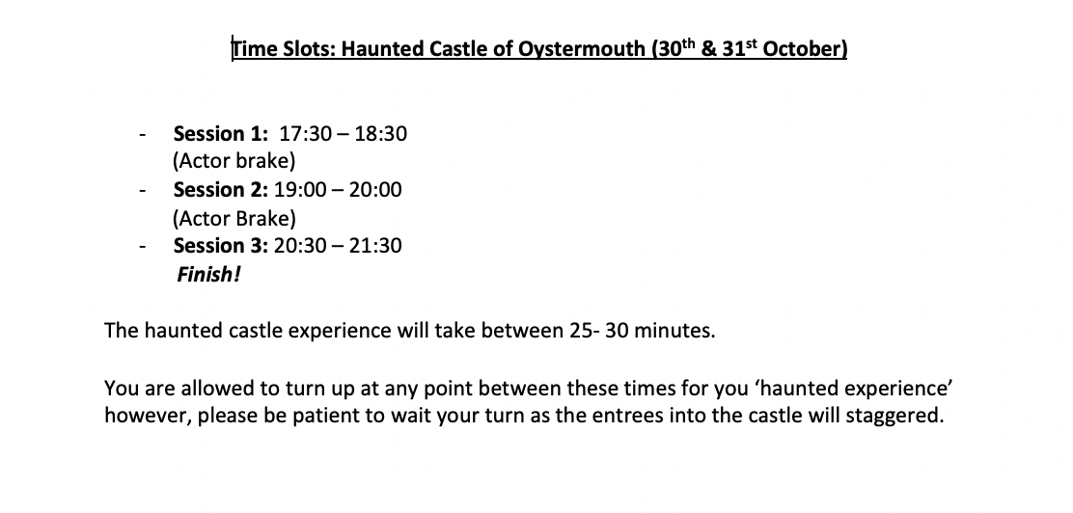
8.2 Appendix 2 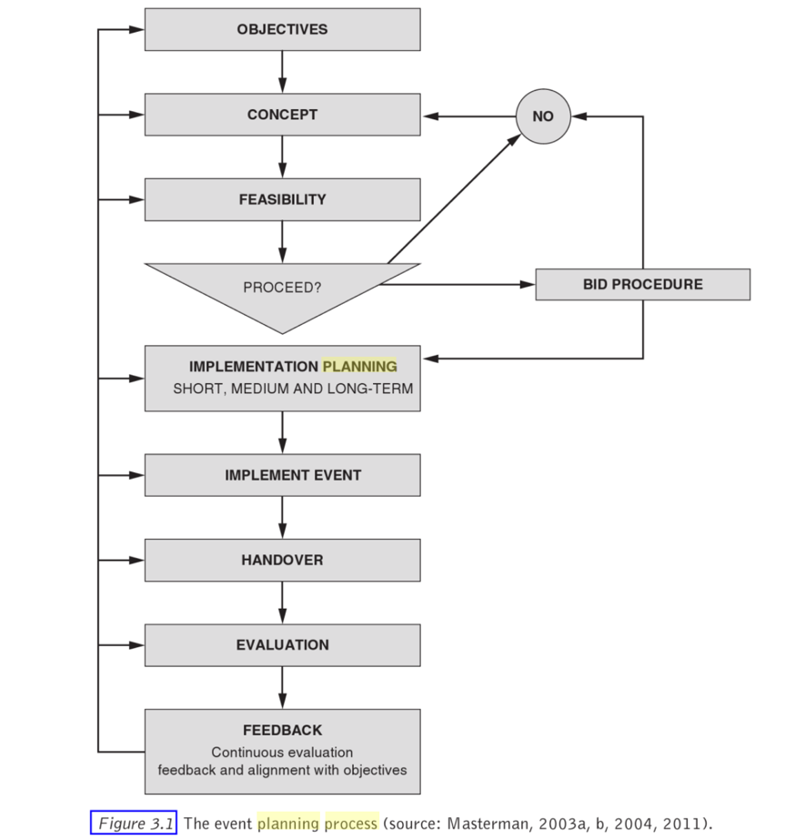

8.3 Appendix 3
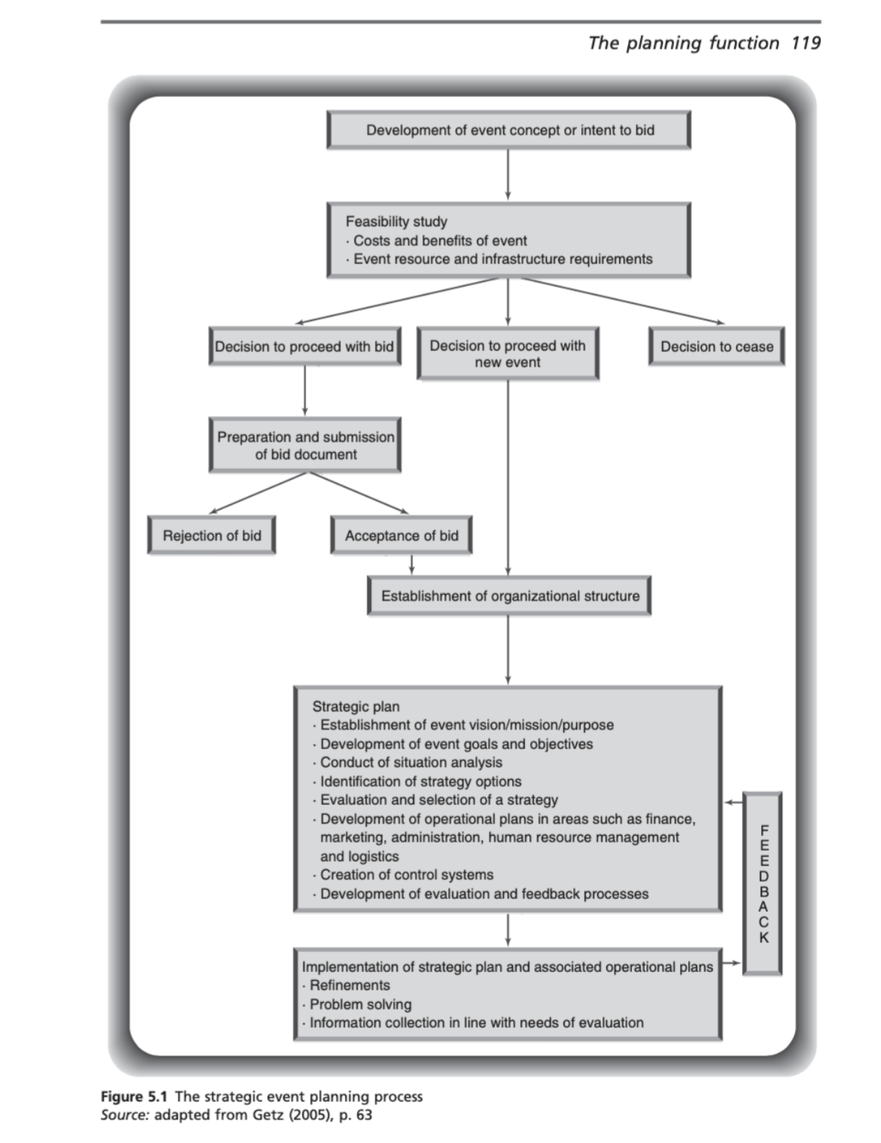

8.4 Appendix 4

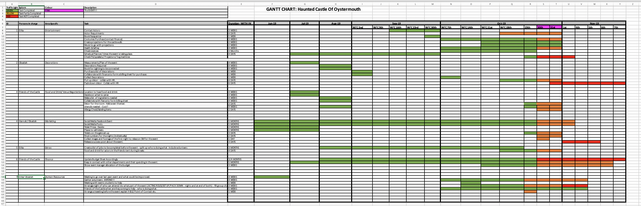

8.5 Appendix 5

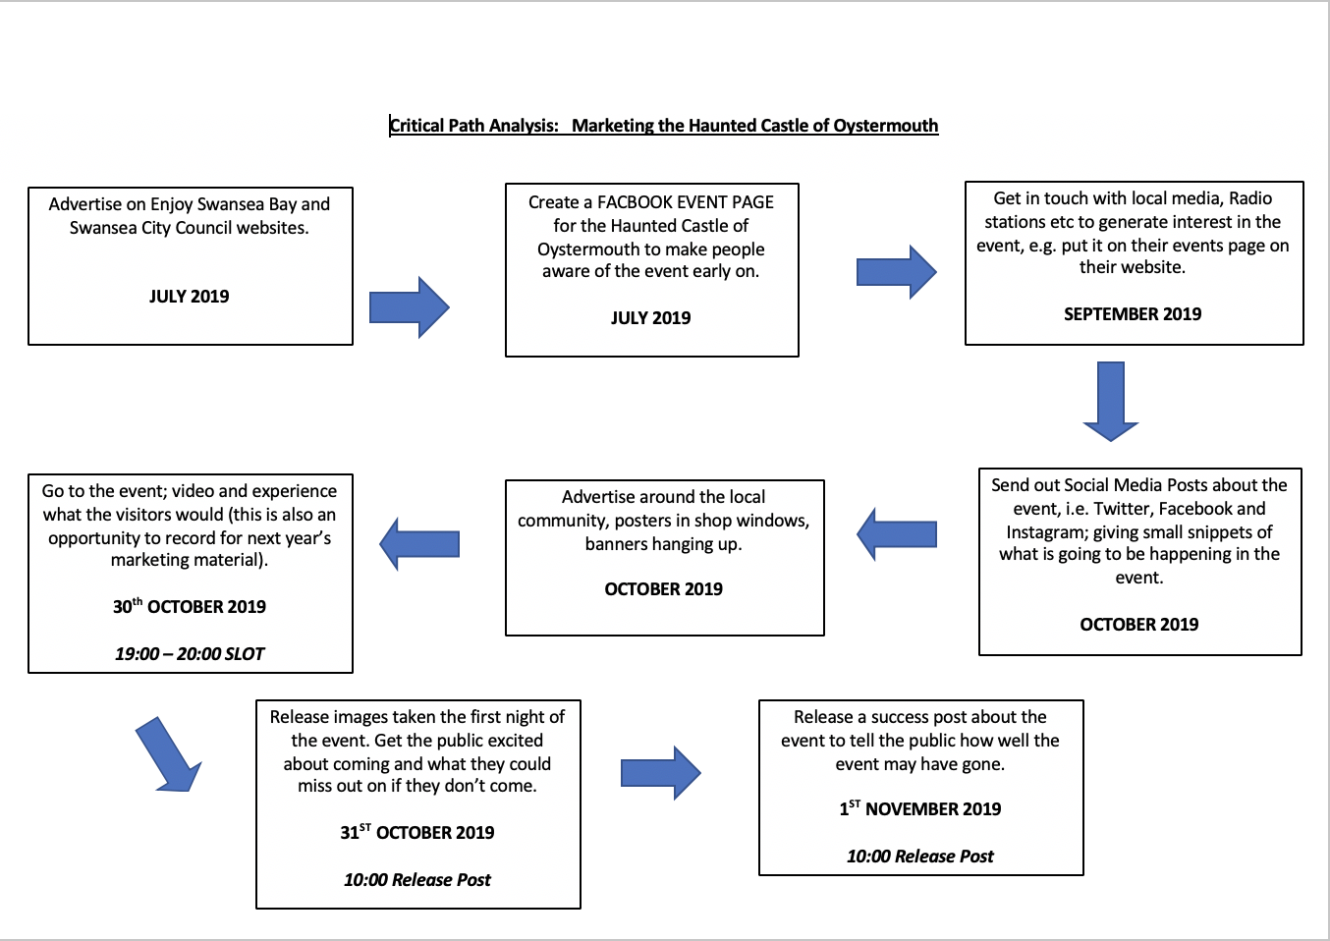

8.6 Appendix 6
Staffing List for Halloween Event at Oystermouth Castle:

Main Event Staff:
Erika Kluge
- Task
Main Event Manager/ Development Co-ordinator at Oystermouth Castle, the go to person if there are quires and issue with or about the event.
Obaidah Sbeitan
- Task
Deputy Event Manager, Collaborates with Erika to produce the event. If there are issues with the event get in contact with her also
Electrician:
From Swansea Council
- Task
Set up lighting and electricity sockets for the event for projectors and sound systems to work off.

Event Committee:
Ostreme Centre Actors & Friends of Oystermouth Castle
- Task
To help set up of the event and make sure the event is running to success in the evening.
Evening:
Actors: Being the main entertainment of the event.
Friends of the Castle: Assist with Hot Chocolate in the Ostreme Centre as well as complete ticket sales.

Volunteers:
Event Students from UWTSD
- Task
Volunteers will help fill in areas that are currently yet to be filled and used as overflow staff so they could be put anywhere during the event. The Event Management students from the University will be able to gain experience of producing and working in an event.

8.7 Appendix 7
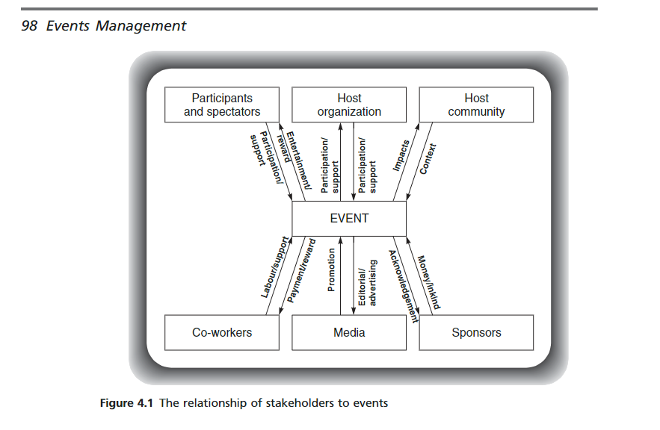

(Bodwin et al. 2006)

8.8 Appendix 8

Stakeholders the Haunted Castle of Oystermouth:
- City and County of Swansea Council
- Volunteers
- Friends of the Castle
- Audience
- Participants
- Cadwr (Welsh version of National Trust)
- Visit Wales
- Lighting/ Tech people.

8.9 Appendix 9

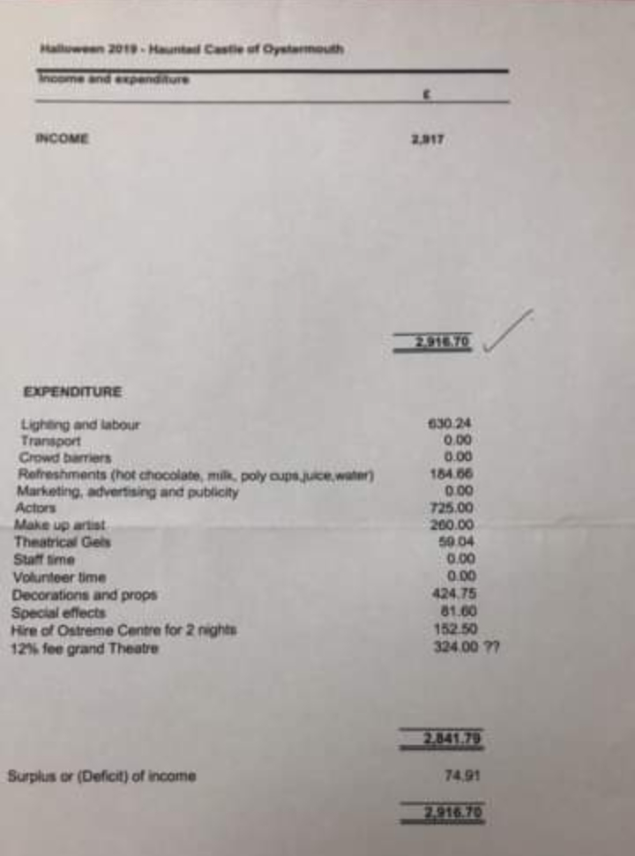

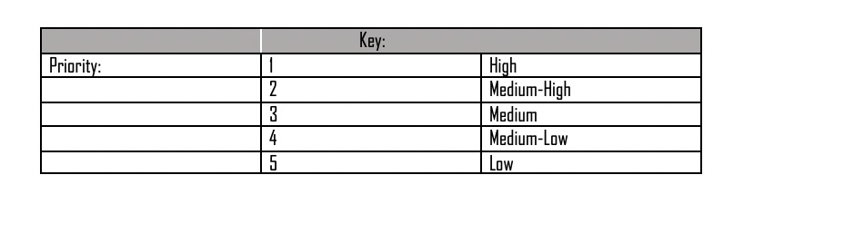
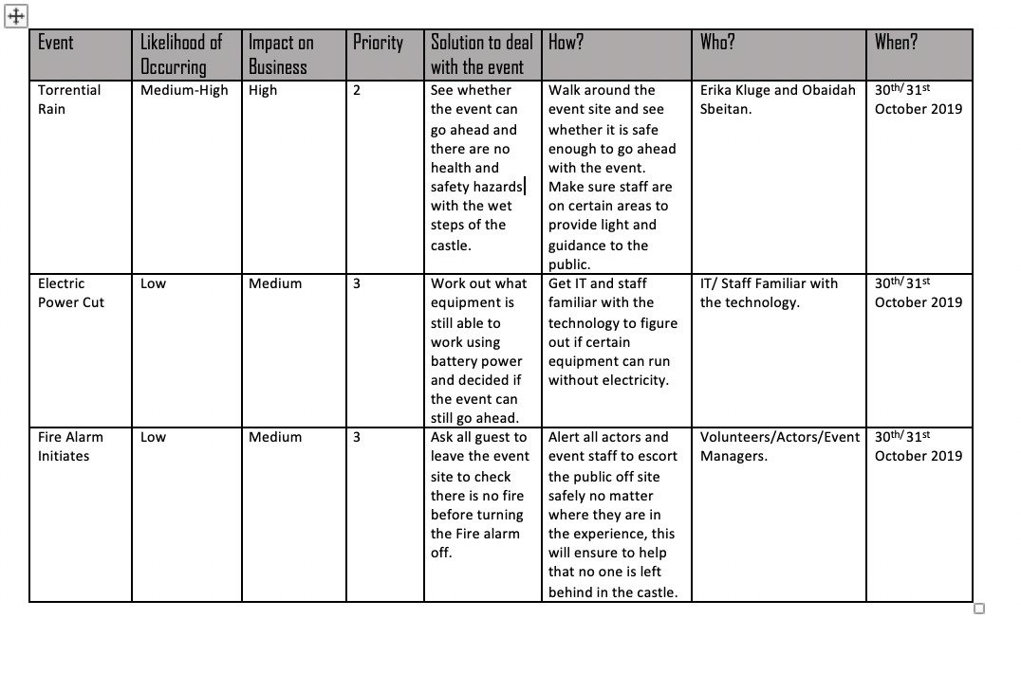
8.10 Appendix 10

8.11 Appendix 11

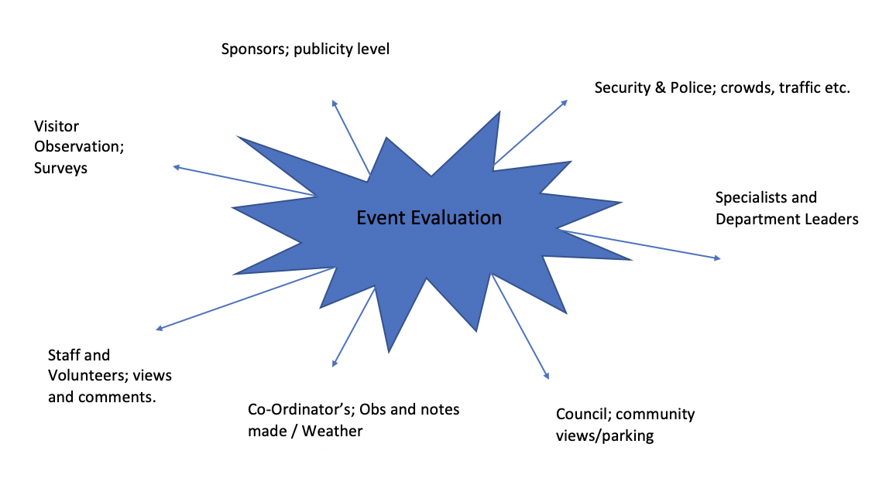

8.12 Appendix 12

Tum et al. (2006)

8.13 Appendix 13
Questionnaire: Haunted Castle of Oystermouth
(Circle the appropriate answer)

- What was the distance (in miles) you travelled to the event?

0-5 6-10 11-15 16- 20 21 +

- What is the first section of your postcode? E.g SA11
__________________

- Did you enjoy the event? 1 being poor 5 being fantastic.

1 2 3 4 5

- How could the event be improved?
____________________________________________________________
____________________________________________________________
____________________________________________________________

- Were there enough toilet facilities?

YES NO

- Can parking and traffic improvements be made?

YES NO

- How can they be improved?

_______________________________________________________________
_______________________________________________________________
_______________________________________________________________

- How did you hear about the event?

TV Newspaper Online Radio Social Media Posters

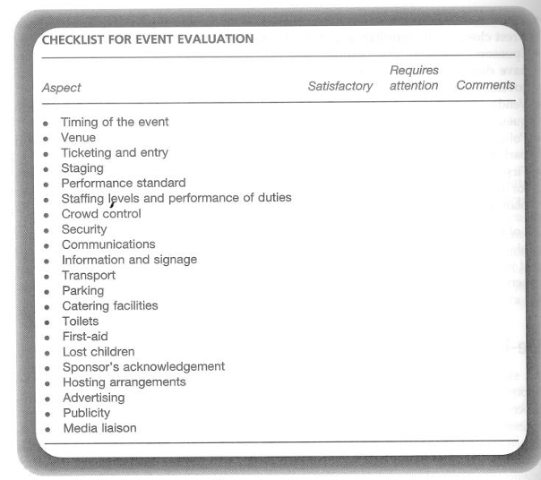
8.14 Appendix 14

(Bodwin et al. 2006)

8.15 Appendix 15

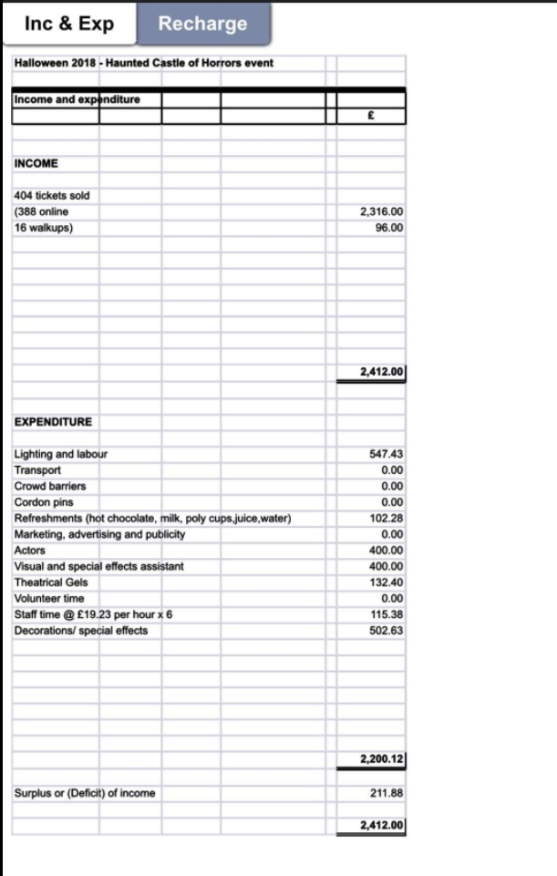

8.16 Appendix 16


