Component 2 – Practical: Essay

Student Name: Radu Acris
Student Number: 2239621

Lecturer Name: Ejike Robert Udeogu
LCBB5000
Data Handling and Business Intelligence

Contents
1.Introduction: 3
2. Summarising the dataset by providing descriptive statistics. 4
2.1. Descriptive statistics for the following variables: 4
2.1.1. Price & sqft_living: 5
2.1.3. Bathrooms: 7
3.Graphs: 8
4. Correlation analysis and suggestions for possible homebuyers. 11
4.1.Correlation analysis: 11
4.2. Suggestions for possible homebuyers. 12
4.3. Factors that Drive Price Increases. 12
5. Advantages and disadvantages of using MS Excel. 13
5.1.Advantages: 13
5.2.Disadvantages: 13
6. Data Mining Cycle. 14
7.Conclusion: 16
8.Bibliography 17

1.Introduction:

This current assessment requires analysing a comprehensive ,,U.S. housing dataset’’, to develop valuable insights for potential homebuyers. The analysis is structured in two main sections: section 1- covers statistical and visual data analysis, while section 2 -explores the tools and methodology. Key factors affecting house prices will be identified, with actionable recommendations provided for affordability and investment.
In this context, a data analyst expert at a major research centre specializing in U.S. housing markets will utilize the "USA Housing Dataset" and apply both Microsoft Excel and SPSS for an in-depth analysis. Excel has traditionally supported basic data processing, but with the recent acquisition of SPSS, more advanced statistical analysis will uncover significant price-driving factors. This project focuses on applying data mining techniques to generate practical, data-driven insights for guiding potential homebuyers.

2. Summarising the dataset by providing descriptive statistics.

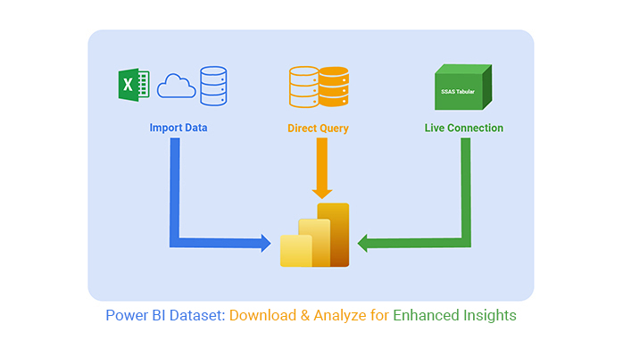
A dataset is a collection of data organized in a structured format, often in tables or spreadsheets, where each row represents an individual record or observation, and each column represents a different variable or attribute (Adriane Chapman, 2019). The data in a dataset can include both numerical and categorical information and is used for
Fig.1.
purposes like analysis, machine learning model training, or making informed decisions. Key components of a dataset include:
- Records (rows): Each row typically represents a single data point or observation.
- Attributes (columns): Each column represents a specific type of data or characteristic.
- Data types: The values in the dataset may vary, including numbers, text, or dates.
Datasets are commonly used in fields like data science, statistics, and research for analysis or modelling.

2.1. Descriptive statistics for the following variables:
- Price;
- sqft_living;
- sqft_lot;
- Bedrooms;
- Bathrooms using SPSS Statistic.

2.1.1. Price & sqft_living:

Fig.2.
For sqft_living, the small difference between the mean and median, along with a moderate standard deviation, indicates relatively consistent data (Murray J. Fisher, 2009).
Price - has significant variability and is heavily skewed by a few extremely high-value properties, leading to a large gap between the mean and median.
Sqft_living - also has some variability but is more balanced compared to price, with a more modest skew and fewer extreme outliers.
Central Tendency: | Dispersion (spread of the data):
- Mean: £553,062.88  The average price of the homes in the dataset.  - Median: £460,000  The middle value when prices are sorted. Since the mean is much higher than the median, this indicates that the data is distorted by a few very high-priced properties. | - Standard Deviation: £583,686.45  There is significant variation in home prices, indicating that the prices in the dataset vary widely.  - Range: £26,590,000  The difference between the minimum (£0, possibly losing data or a placeholder) and the maximum (£26,590,000). This wide range also supports the high variability (Ali & Bhaskar, 2019).

2.1.2. Sqft_lot & Bedrooms :

Fig.3.
Sqft_lot:
Central Tendency: | Dispersion:
- Mean: 14,697.64 sq ft  The average lot size is about 14,700 sq ft, which is significantly influenced by a few very large lots.  - Median: 7,676 sq ft  The middle value is much smaller than the mean, indicating a skewed distribution with some very large lots pulling the average up. (Ali & Bhaskar, 2019). | - Standard Deviation: 35,876.84 sq ft  Extremely high variability in lot size, reflecting a wide range from small lots to expansive ones.  - Range: 1,073,580 sq ft  The smallest lot is 638 sq ft, and the largest is over 1 million sq ft, showing an enormous spread.  Sqft_lot is highly variable and heavily skewed, with a small number of extremely large lots driving the statistics. The median and mode provide a more realistic picture of typical lot sizes than the mean.
Bedrooms:
Central Tendency: | Dispersion:
- Mean: 3.4  On average, homes have about 3 to 4 bedrooms.  - Median: 3  The middle value is 3 bedrooms, indicating that most homes cluster around this number. | - Standard Deviation: 0.9  There is relatively low variability in the number of bedrooms. Most homes are within ±1 bedroom of the mean.  - Range: 8  The smallest homes have 0 bedrooms (possibly data errors or unconventional homes), and the largest have 8 bedrooms.  Bedrooms are fairly consistent, with most homes having 3 to 4 bedrooms, and there are no extreme outliers.

2.1.3. Bathrooms:
Fig.4.

The summary statistics for bathrooms : mean = 2.16; median = 2.25; range = 6.75; and standard deviation = 0.78.
Central Tendency: | Dispersion:
- Mean: 2.16  On average, homes have about 2 bathrooms.  - Median: 2.25  The middle value (2.25) is slightly higher than the mean, indicating that most homes have around 2 to 2.5 bathrooms. | - Standard Deviation: 0.78  Moderate variability, with most homes falling within ±0.78 bathrooms of the mean (roughly between 1.4 and 2.9 bathrooms).  - Range: 6.75  The smallest homes have 0 bathrooms (likely indicating missing data or unconventional properties), and the largest have 6.75 bathrooms (likely representing luxury homes or properties with many full and half baths).

Bathrooms are fairly consistent across homes, with most having around 2 to 2.5 bathrooms. The slight positive skew and higher range indicate a small number of properties with significantly more bathrooms, possibly representing higher-end homes.
The statistics align well with typical home layouts, with the mode of 2.5 bathrooms being quite common in USA market.

3.Graphs:
Relationship between house price &:
- Number of bedrooms;
- Number of bathrooms;
- Square footage of living space (sqft_living);
- Year the house was built using MS EXCEL;

1.Price and Sqft_living :

Fig.5.
Square Footage: This clustered column displays a stacked bar comparison between "Price" and "sqft_living" across eight categories for USA Housing Dataset (Su, 2008). Each bar represents a total value, with "sqft_living" shown in blue, along with the specific values labelled on each section. The data indicates a trend where higher "Price" values are generally associated with larger "sqft_living" values, both of which is variable.

2.Price and Number of Bedrooms:

Fig.6.

Number of Bedrooms: The Pie chart shows how house prices in USA tend to vary with the number of bedrooms. Typically, houses with more bedrooms are priced higher, not the same result we have in our USA Housing Dataset, we can observe the highest prices on 3 and 4 bedroom properties (Su, 2008).

3.Price and Number of Bathrooms:
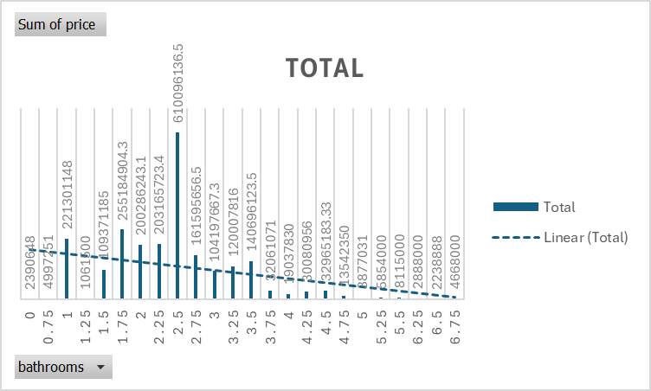
Fig.7.
Number of Bathrooms: The highest value occurs at 2.5 bathrooms (610,096,136.5). This associates with earlier descriptive statistics, which showed that 2.5 bathrooms are the most frequent, and homes with this count likely have higher aggregate metrics (e.g., total prices or frequencies). After the peak at 2.5 bathrooms, the values slowly decline. This advises that as the number of bathrooms increases beyond this point, there are fewer properties or lower aggregate metrics associated with them (Su, 2008).
4.Price and year the House was built:

Fig.8.
Year Built: The values generally increase over time, same in our chart analysis , particularly from the mid-20th century onward. This could reflect growth in prices, demand, or another metric influenced by economic and social factors. The overall trend suggests growth, though the rate of increase accelerates considerably in the mid-20th century (Su, 2008).

4. Correlation analysis and suggestions for possible homebuyers.

4.1.Correlation analysis:

Fig.9.
This table represents a correlation matrix, which measures the strength and direction of the linear relationship between pairs of variables.
Correlation coefficients range from -1 to 1:
- (1) indicates a perfect positive correlation.
- (-1) indicates a perfect negative correlation.
- (0) indicates no correlation.

Price is most strongly correlated with sqft_living (0.42), indicating that the size of the living area is a key driver of home prices.
The number of bathrooms also has a noticeable impact on price (0.32), while the number of bedrooms (0.19) and lot size (0.046) have much vulnerable effects.

4.2. Suggestions for possible homebuyers.

- Prioritize Newer Homes: Homes built in more recent years tend to be less expensive, possibly due to the lack of historic appeal or premium location that older homes might offer. Focusing on properties from more recent construction years can provide good value.
- Fewer Bathrooms Can Mean Savings: Homes with fewer bathrooms tend to be cheaper. If having an extra bathroom is not essential, prioritizing homes with fewer bathrooms may help reduce costs (Eldred, 2002).
- Opt for Fewer Bedrooms: Properties with fewer bedrooms are consistently more affordable. If a lower price is the primary goal, consider limiting your search to homes with one or two bedrooms.
- Consider Smaller Living Spaces: Although counterintuitive, in this dataset, homes with larger living areas are slightly less expensive. This may indicate that larger properties are located in areas with lower demand or are less centrally located. Buyers might save money by considering slightly larger homes in suburban or emerging neighbourhoods (Eldred, 2002).

4.3. Factors that Drive Price Increases.

- Older Properties in High-Value Areas: Older homes may hold historic or locational value, especially if situated in established neighbourhoods. Buyers interested in older homes should be prepared for potential maintenance costs but may benefit from the property’s long-term value appreciation (Lee, 2023).
- Bedroom Count as a Price Driver: Homes with a higher number of bedrooms command higher prices. Buyers who are price-sensitive may consider purchasing a smaller property or even planning for a future expansion instead of buying a home with many pre-existing bedrooms.
By focusing on these two factors and carefully selecting homes that align with these insights, potential buyers can balance affordability with quality while directing key price drivers in the housing market (Lee, 2023).

5. Advantages and disadvantages of using MS Excel.

5.1.Advantages:

Using MS Excel offers various key advantages that make it a valuable tool for data managing and analysis (Rahardja, 2024).
- Quick Data Retrieval: Unlike physical documents, data in Excel is easily searchable, enabling quick retrieval of specific information. This
digital access saves time and simplifies
Fig.10.
finding exact data points, even within large datasets.
- Powerful Mathematical Functions and Formulas: Excel’s built-in formula capabilities streamline complex calculations, making it easy to perform arithmetic, statistical, or financial calculations directly in the spreadsheet. This not only saves time but also reduces calculation errors.
- Enhanced Security and Reliability: Excel files can be password-protected and stored securely on computers, which makes them more secure than paper-based records. This feature helps prevent unauthorized access and reduces the likelihood of data loss (Rahardja, 2024).
- Centralized Data Management: With Excel, multiple worksheets can be created within a single file, allowing for comprehensive data organization in one place. This feature replaces the need for separate files or physical documents, making data management more streamlined and organized.

5.2.Disadvantages:
- Learning Curve: Excel has a steep learning curve, especially for beginners. With its vast array of functions, formulas, and shortcuts, users can find it overwhelming to navigate the tool fully. While tutorials and practice help, Excel's complexity may still be challenging for new users or those unfamiliar with advanced features.
- Calculation Errors: Excel calculations can sometimes lead to errors, especially when handling precise values like fractions, percentages, or large numbers. Rounding errors or misplaced decimal points can impact accuracy, particularly for financial or scientific data. Understanding formatting options for dates, currency, and percentages is essential but not always intuitive.
- Complexity of Formulas: Excel’s functions range from basic to highly complex, which can be daunting. Users often struggle with complex formulas or syntax, especially for tasks involving nested functions or advanced calculations. This can increase the chance of errors, requiring a solid understanding of formula structure and debugging.
- Data Handling and Performance Limitations: Excel struggles to handle large datasets efficiently. When managing thousands of rows or working with large files, performance can significantly slow down, leading to delays and sometimes crashes. Though workarounds exist (such as breaking data into smaller files or using data connections), these may not be ideal for users who need robust data processing.
Regardless of these weaknesses, MS Excel remains a powerful tool, especially when users take time to explore tutorials, practice regularly, and develop a strong grasp of its functions and formulas. For large-scale data needs database software or specialized data management tools may be better suited than Excel (Rahardja, 2024).

6. Data Mining Cycle.
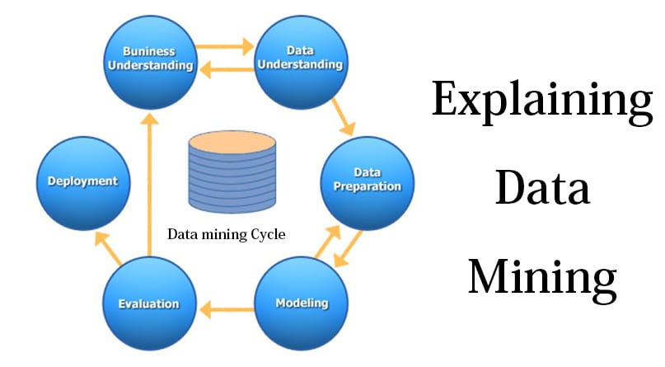
The Data Mining Cycle is a shaped process used to extract valuable insights from large datasets by applying analytical and statistical techniques. This cycle, often
Fig.11.
known as the CRISP-DM (Cross Industry Standard Process for Data Mining) model, involves six key phases: business understanding, data understanding, data preparation, modelling, evaluation, and deployment (Jackson, 2002). Each phase has a specific purpose, guiding data scientists from problem definition to actionable outcomes.
- Business Understanding:
- Meaning: This phase focuses on describing project objectives and requirements from a business perspective. It implicates identifying the business problems and determining how data mining can provide solutions.
- Importance: Confirms orientation between data mining tasks and business goals, making sure the project is relevant and valuable.
- Example: An X company wants to increase sales. The business objective might be to identify customer segments with high purchase potential, guiding the data mining efforts to improve targeted marketing.
- Data Understanding:
- Meaning: This stage involves collecting and exploring data to understand its properties and suitability for analysis.
- Importance: Ensures experience with the data and identifies any issues, such as missing or inconsistent values, that may impact the analysis.
- Example: The Internet Provider company gathers data from various sources, including customer demographics, browsing history, and past purchases, to identify customer behaviour patterns.
- Data Preparation:
- Meaning: Data is cleaned, transformed, and formatted for analysis. This step includes handling missing data, removing duplicates, and normalizing variables.
- Importance: Set up data in a way that maximizes the efficiency and accuracy of data mining models.
- Example: The company may create a consolidated dataset with features like "purchase frequency," "average spending," and "last visit date" for each customer, ensuring consistency in the data.
- Modelling:
- Meaning: This phase requires selecting and applying modelling techniques to identify patterns or relationships in the data. Techniques might include classification, regression or association analysis.
- Importance: Modelling converts data into actionable insights by revealing patterns that can support decision-making.
- Example: The Y company uses clustering techniques to group customers with similar purchase behaviours, allowing the identification of high-potential segments.
- Evaluation:
- Meaning: Models are evaluated for accuracy, reliability, and alignment with business objectives. The goal is to ensure that the model’s insights are effective and actionable.
- Importance: Confirms that the model completes desired objectives and meets the quality standards for deployment.
- Example: The company evaluates the customer segmentation model using metrics like profile score to measure the structure of groups, ensuring segments are important
- Deployment:
- Meaning: The final phase involves applying the model’s results in a practical setting where they can change decision-making. Operation may include generating reports or integrating insights into business processes.
- Importance: Sets the insights into case, allowing the business to benefit from the analysis and achieve objectives.
- Example: The company uses the customer segments identified to create targeted marketing campaigns, directing at high-potential groups to increase sales and improve customer retention.
The Data Mining Cycle is essential because it delivers a systematic approach to adapting raw data into actionable visions. By following these segments, every organization can ensure that their data mining efforts are methodical, efficient, and directly tied to business goals (Jackson, 2002).

7.Conclusion:
This report provides a comprehensive look at key metrics and patterns within the USA Housing Dataset, offering actionable insights for potential homebuyers and a discussion on using MS Excel for data analysis. Using MS Excel for this analysis offered an accessible way to perform descriptive statistics, correlation, and visualization. However, Excel has limitations in handling large datasets and performing complex analyses without specialized add-ins or software like SPSS.
The analysis of the house sales dataset revealed key insights into the factors influencing prices and offered practical guidance for homebuyers (Donghui Shi, 2002). Graphs representing the relationships between house prices and variables such as bedrooms, bathrooms, living space, and year built showed that larger living areas and newer construction years are associated with higher prices. The data mining cycle, following steps from business understanding to deployment, provided a structured framework to extract and apply insights effectively.
Overall, this report’s findings assist homebuyers to make informed choices, balancing property features with cost, and demonstrate Excel’s utility in data-driven analysis within its limits.

8.Bibliography
Adriane Chapman, E. S. L. K. G. K. L.-D. I. E. K. &. P. G., 2019. Dataset search: a survey. The VLDB Journal , 29(Special Issue Paper), p. 251–272.
Ali, Z. & Bhaskar, S. B., 2019. Descriptive Statistics, Measures of Central Tendency, Dispersion, Correlation and Regression. Airway, 2(3), pp. 120-125.
Donghui Shi, J. G. J. Z., 2002. Predicting home sale prices: A review of existing methods and illustration of data stream methods for improved performance. WIRES, 12(2).
Eldred, G. W., 2002. The 106 Common Mistakes Homebuyers Make (and How to Avoid Them). 2 ed. s.l.:John Wiley & Sons.
Ho, K. M., 2012. Scatter plot and correlation coefficient. ProQuest, 40(4).
Jackson, J., 2002. Data Mining; A Conceptual Overview, s.l.: CAIS.
Lee, J., 2023. What factors drive house prices in the USA?. Empirical Economics, Volume 66, p. 2533–2556.
Murray J. Fisher, A. P. M., 2009. Understanding descriptive statistics. Australian Critical Care, 22(2), pp. 93-97.
Rahardja, D., 2024. Advantages and disadvantages comparison of time-series forecast. Journal of Statistics & Management Systems, 27(4), p. 769–784.
Su, Y.-S., 2008. It’s easy to produce chartjunk using Microsoft®Excel 2007 but hard to make good graphs. Elsevier:Computational Statistics & Data Analysis, 52(10), pp. 4594-4601.

