Gareth Jones, Richard Morgan, James Williams 18/07/23

Changemakers: Creativity and Value Creation
ACCA5033

Mark Williams – 2022279

Assignment 2: Project Management

Content page

Front page 1
Title page 2
Content page 3
Introduction 4
E-portfolio website link 5
Task 1: What’s the Verdict? 6-7
Task 2: Project Management 8
Task 3: Project Reflection 9-10
References 11-12
Appendix 13-28

Introduction
This assignment covers the topics of quantitative and qualitative data research methods diving into topics such as types of charts such as line charts that simplify and create for ease of understanding of number correlations. The assignment also presents an A3 academic poster showcasing multiple aspects of the project such as Risk Matrix, Gantt Chart, objects, and technology with a brief description of the purpose for the project. Finally the assignment finishes up with a project reflection that covers the overall planning, management and design of the project and the steps that follow such as planning ahead to avoid potential issues and how the time used creating and following through with the project will develop skills that are able to be used in real world scenarios.

Link to e-portfolio website:
https://teal-oboe-993s.squarespace.com/home
Password is ChangeMakers

Task 1: What’s the Verdict?
Q1. Outline different sorts of Quantitative analysis and undertaking a basic analysis by using Excel to create a chart.
Quantitative data is the measurement of numbers in a statistical analysis, displaying the information in the form of graphs, charts and visual ways that display and explain the numerical data in a simple way[1]. This type of data measurement will be used within the project multiple times. The project provides training for NHS staff on Cyber Security threats and then calculates the knowledge gained through exams and then allows for modification of the articles and presentations and user will sit an additional exam. Through research the best way to display these results is through the use of line charts[2], this allows for the large amounts of numbers and the knowledge improvements to be visualized as shown in the example image below.
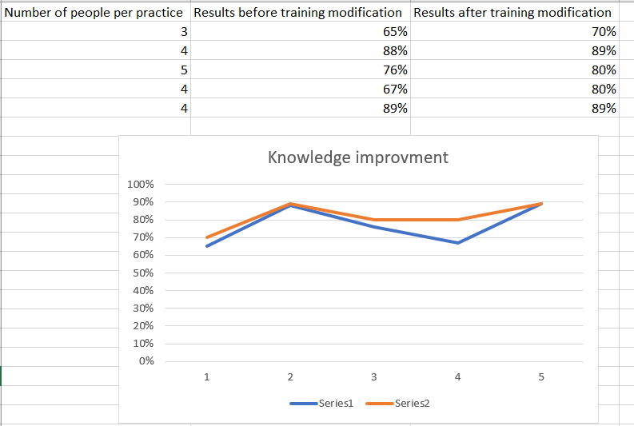
This image shows a theoretical scenario of multiple practices exam results on Cyber Security threats and awareness before and after modifying articles and presentations to compensate lack of lower marked area in the first exam attempt, which will provide either a positive, negative or zero correlation.

Other Quantitative research methods are the following[3]:
- Correlation research – The difference between two sets of results from the same test, displaying the relationship between the results weather there is a positive correlation, negative or zero correlation this type of research can be used to answer questions such as “is there a correlation between the increase of Cyber Security attacks and technology?” in the case of the project it will help answer the question “Is there an increase in knowledge of Cyber Security threats when staff are presented with information that has been modified for their weaknesses?”.

- Experimental research – Is used to find a cause effect relationship, where an experiment has taken place and is used to answer questions such as “The effect of NHS Cyber Security if staff have regularly tested on the subject.” In the case of the project the answer the question this research method will help answer is “Comparison between exam results after general Cyber Security Knowledge after study and personalised Cyber Security training.”

Q2. Document evidence to demonstrate some organisation of qualitative data.

Qualitative data research method is the analysis of communication in the form of words, such as feedback, and surveys[4]. For this project the use of qualitative data is vital because it involves the creation of presentations, interviews, and exams which involves researching ways to translate complex information into understandable data that even people with little to no knowledge will be able to fully understand. Qualitative data will also be used for the feedback from exams and interviews from focus groups to modify the presentations and articles to better fit staff at all levels of Cyber Security knowledge.

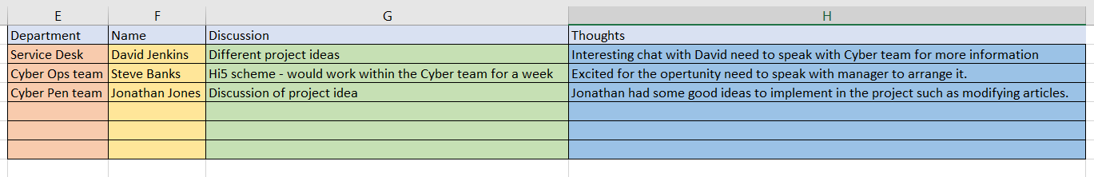
Below is an example of a Theme table and how it will be used throughout the project to keep track of important discussions, ideas, and thoughts to keep vital information flowing with people who will be assisting the project so the best ideas will be detailed and implemented within all aspects of the planning, action, and review stages of the project.
The three stages of qualitative data that will be followed during this project are as followed[5]:
- Data collection – Collecting data from colleagues, peer reviewed articles to create presentations and articles.

- Interpreting findings – Implementing feedback from interviews and exam results into the modified articles and presentations.

- Writing a report – Comparing both exam results and completing the report of the project with the findings.

Task 2: Project management

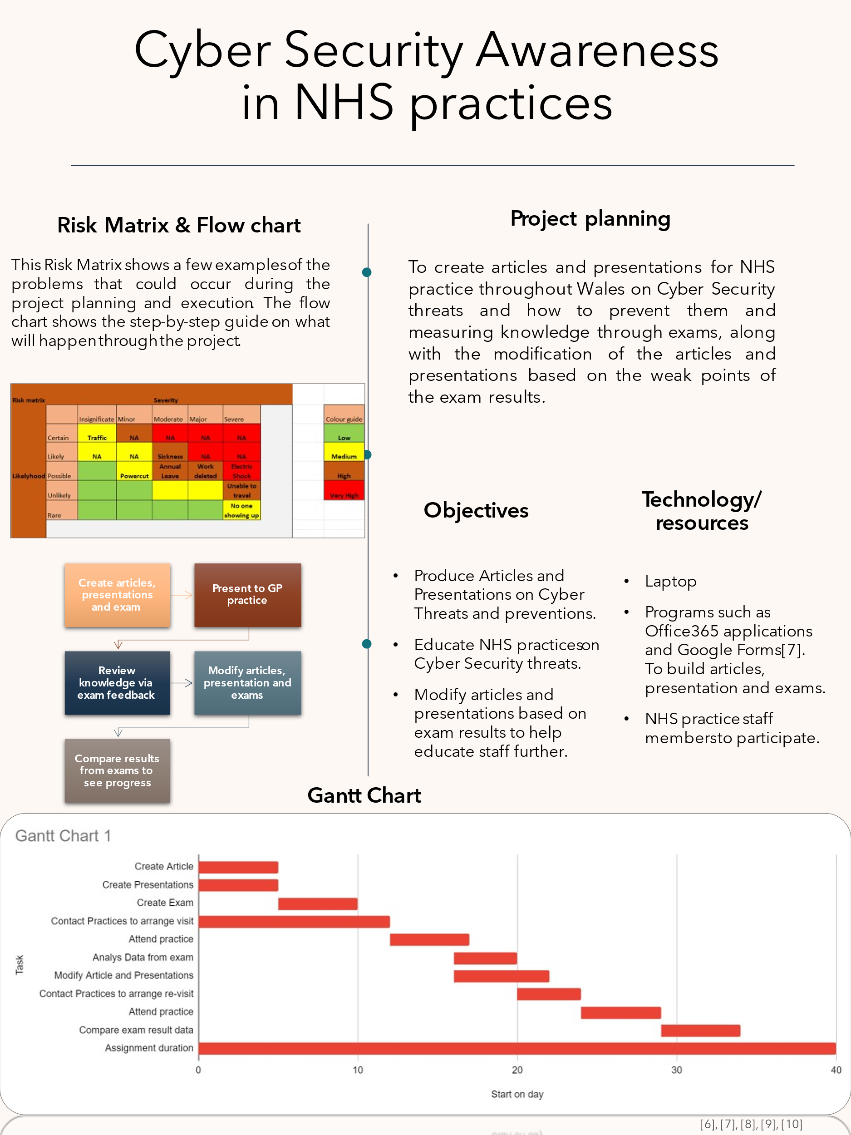

Task 3: Project reflection

How you intend to use this opportunity to develop new skills.
Throughout this project the skills I would like to develop further are stronger communication skills, to achieve this I will use the presentations I deliver to staff at multiple practices to train this ability and will hopefully achieve the goal of being able to talk in front of large crowds without issue. Another skill I’d like to develop is researching Cyber Security threats and prevention tactics and how to implement translate that information into simple to understand articles and presentation for staff who have knowledge at multiples levels. To achieve this goal I will study multiple Cyber Security peer reviewed articles, reports, and websites such as TryHackMe.com where I am able to study multiple Cyber Security classrooms[11] and implement these lessons into the presentations and articles.

How your project/new skills could have a positive impact on and contribute to society.
The projects’ main goal is to improve the knowledge of Cyber Security threats in NHS staff throughout general practices in Wales, this not only allows to mitigate Cyber risks within the NHS by having staff trained on the latest threats and how to prevent them but also teaches staff on how to protect themselves and others outside of the working environment and will be hopefully something they’re able to expand their knowledge on and share what they’ve learned with other which would then overall leave a positive contribution to society and the NHS.

Main risks/challenges you could face over the course of the project and what you can do to reduce/remove them.
The main risks I am concerned with during this project are people not having a willingness to attend the lessons and participate in certain aspects of the project such as the exams or if they do attend the first exam they might be on annual leave or sickness to prevent them attempting the second exam, to counter this issue and similar issues I will ask for staff members that haven’t got annual leave booked for the times I will be attending the practices, I will also be able to attend multiple days which will hopefully eliminate the issue with sickness.
Another potential challenge that may appear during this project will be the staff’s willingness to participate in the project and staff may cheat during exams and give false results to counter this type of issue I will be putting in place a strict exam where users will take the exam a distant apart from colleagues with no access to research questions.
Blow is a rick matrix created with different types of risks I am expecting to see during the project and will allow for me to edit this and also be able to predict and come up with way to predict and counter potential risks that appear.

Risk matrix |  |  |  | Severity
 |  | Insignificant | Minor | Moderate | Major | Severe |  |  | Colour guide
 | Certain | Traffic | NA | NA | NA | NA |  |  | Low
 | Likely | NA | NA | Sickness | NA | NA |  |  | Medium
Likelyhood | Possible |  | Power cut | Annual Leave | Work deleted | Electric Shock |  |  | High
 | Unlikely |  |  | Disruptive staff | Cheating on Exam | Unable to travel |  |  | Very High
 | Rare |  |  |  | Patients viewing confidential information | No one showing up

[12]

References
Task 1 References
[1] Surendran, A. (2023), Article: “Quantitative data: What it is, types & examples”, QuestionPro. Accessed: 11 July 2023, Available at: https://www.questionpro.com/blog/quantitative-data/#Types_of_Quantitative_Data_with_Examples, © 2023 QuestionPro Survey Software, Used for: information on Quantitative data.
[2] J. Walkenbach, Excel 2007 bible, 1st edition. Indianapolis, IN: Wiley, 2007. Available at: https://r2.vlereader.com/Reader?ean=9780470117088#, page: 368, used for: information on line charts.
[3] ramadmin, “Key elements of a research proposal – Quantitative Design”, Winston-Salem State University, Created: 10/10/14, Available at: https://www.wssu.edu/about/offices-and-departments/office-of-sponsored-programs/pre-award/_Files/documents/develop-quantitative.pdf, used for: information on Correlation research and Experimental research.
[4] Pritha Bhandari, “What Is Qualitative Research? | Methods & Examples”, Scribbr, 4th April 2022, Revised 30th January 2023, Available at: https://www.scribbr.co.uk/research-methods/introduction-to-qualitative-research/, used for information on qualitative data methods.
[5] Hsiu-Fang Hsieh, Sarah E Shannon, “Three Approaches to Qualitative Content Analysis”, ResearchGate, December 2005, Available at: https://www.researchgate.net/publication/7561647_Three_Approaches_to_Qualitative_Content_Analysis, used for: information on different types of stages for qualitative data research.
Task 2 References
[6] Website, Canva, Available at: https://www.canva.com/t/EADaoQT7FlA-dark-blue-and-orange-simple-poster/, used for information on different academic poster ideas.
[7] Website, Google Forms, Available at: https://www.google.co.uk/forms/about/, used for information on different ways to build exams and record results.
[8] Website, Google Docs, Available at: https://docs.google.com/spreadsheets/d/1_S0Z-Zsi3Bf78-qGAy-uvqqBjgObIYlE66-R4bwhCXo/edit?usp=sharing, used for creation of Gantt Chart.
[9] Website, smartdraw, Available at: https://www.smartdraw.com/flowchart/flowchart-maker.htm, used for information on flow charts.
[10] Website, ProjectManager, Available at: https://www.projectmanager.com/templates/risk-matrix-template-for-excel, used for information how to build a Risk Matrix.
Task 3 References
[11] Website, TryHackMe, Available at: https://tryhackme.com/, used for studying multiple Cyber Security threats, prevention, and other types of classrooms to improve Cyber Security Knowledge.
[12] Kat Boogaard, Wrike, “What is a Risk Matrix?”, May 13th 2022, Available at: https://www.wrike.com/blog/what-is-risk-matrix/#What-is-a-risk-assessment-matrix-in-project-management, used for information on how to build a Risk Matrix.

Appendix

Task 1: Unit 4 – What's the Verdict?:
Unit 4 Section 1: It's All In The Numbers

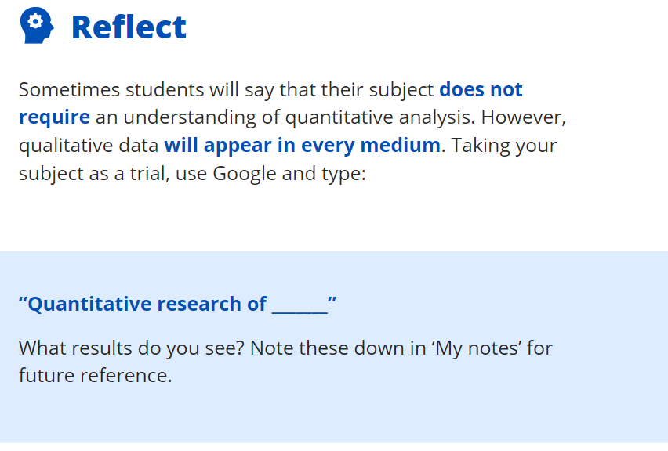
Values within questionnaire numbered format
Statistics of Cyber attacks
Statistics on different types of attacks.

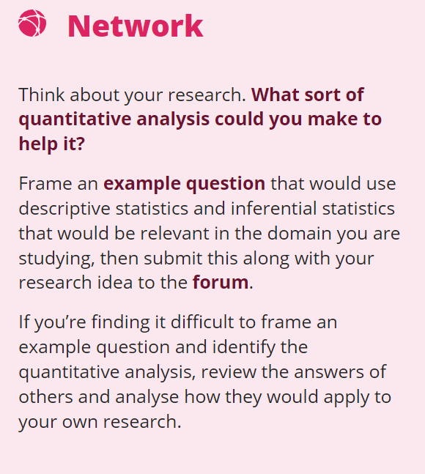
The question I will be using is: “Will the modification of articles and presentations provide a better understanding of Cyber Security threats and how staff are able to protect themselves and the NHS?”
And this will provide quantitative data that I will be able to analyse via statistics and be able to create graphs to display the data visually.

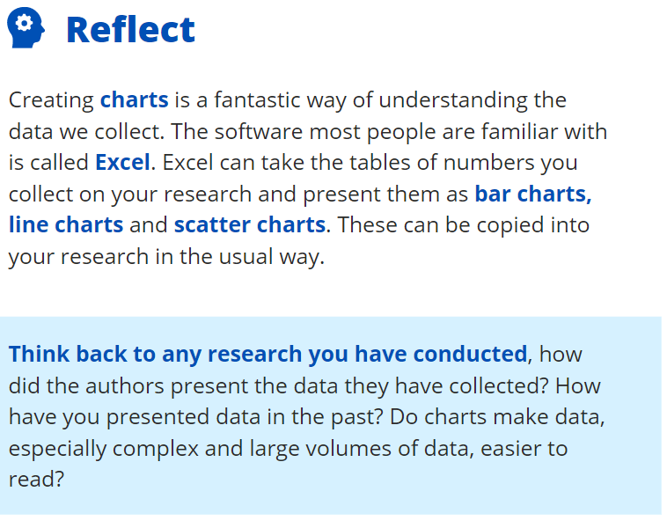
I’ve always found charts make complex and large volumes of data a lot easier to understand, as its visually easier to see the information that is being presented.
During my one of my last assignments regarding Cyber Security Compliances I remember seeing an article regarding cyber security statistics and how it has risen over the decades and the graphs was able to visually show the severity of the increase a lot better than words.
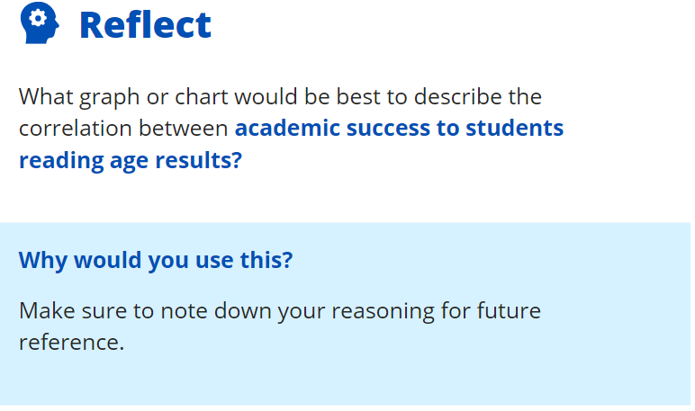
Scatter plot graph – It shows both results and allows a correlation between both of them to measure if there’s a positive, negative or zero correlation between the results.

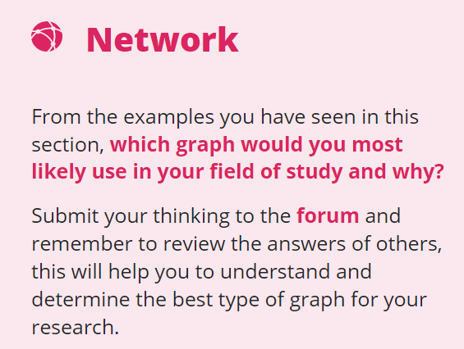
I believe the scatter graph along with bar graphs and possibly pie charts all of these will be used to display information clearly to show the effects both positive and negative the project has had and will provide data such as improvements in knowledge after changing aspects of training to fit specific users preferences.

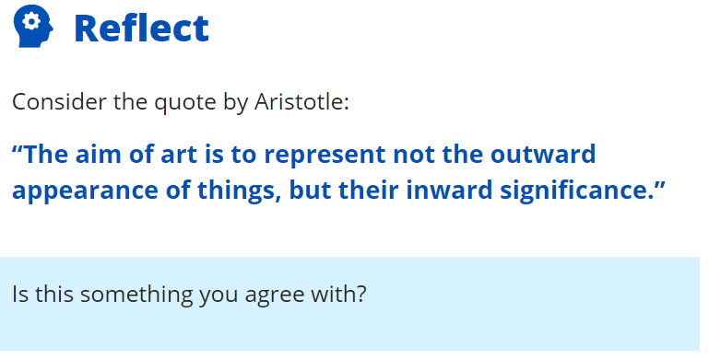
Yeah I somewhat agree with that quote art can be anything and sometimes art isn’t just the appearance but also the meaning behind it.

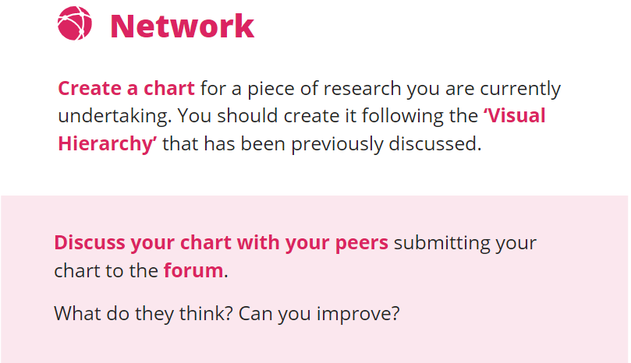
Above is the type of graph and information that I will be collecting and assessing during my project it shows the amount of people per practice that attempt the exam and again after the modification showing improvements.





Task 1: Unit 4 – What's the Verdict?:
Unit 4 Section 2: There's a Theme Here

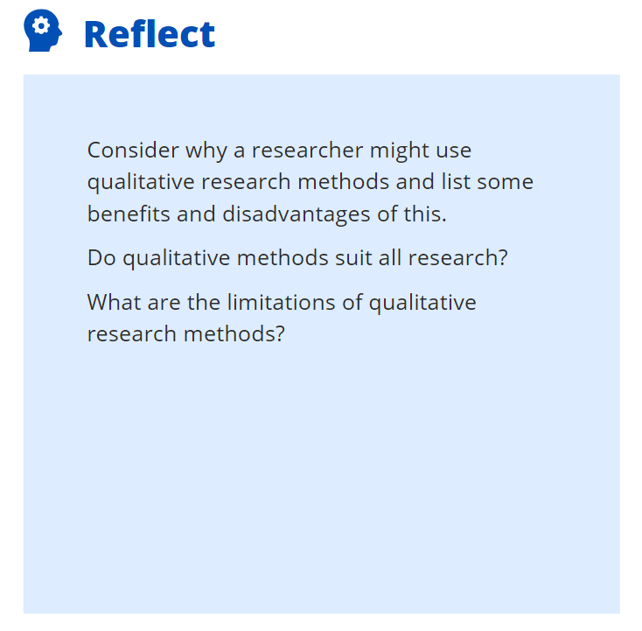
The benefits of qualitative research is being able to use variations of words to find exactly what you’re searching for. A negative for the type of research is there is so much content in the world at the moment it’s hard to find exactly what you’re looking for and even harder to find information that is correct.

Qualitative methods don’t suit all types of research as some require quantitative research especially if its statistical.

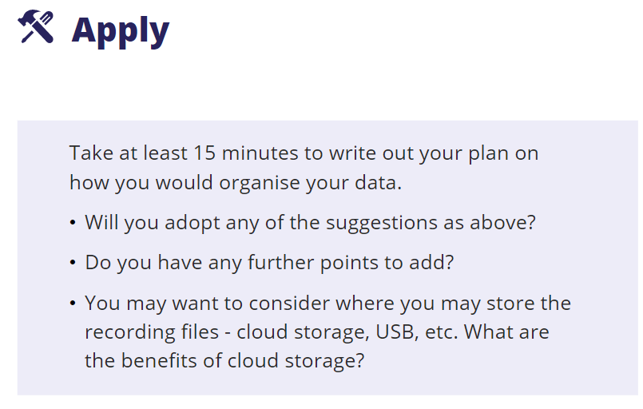
I will be creating a designated document for files relating to the assignment so they’re easy to locate and use when required, as for organising data I will be using charts such as pie chart, scatter graph and others to display information that will be visually pleasing and easy to comprehend.

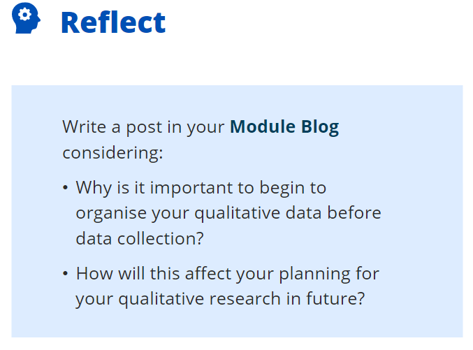
The organisation of qualitative data before data collections allow for making sure all the information you need to collect is in order and allows for optimising collecting the correct data and will benefit future research by having all data organised and understandable when trying to locate information this will then in turn help the flow of the project.

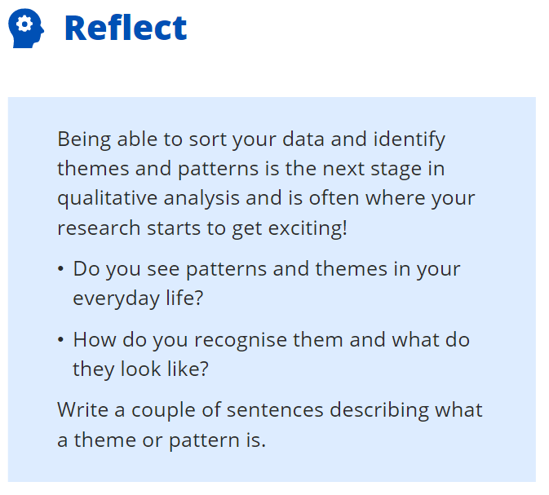
Every morning Ill brush my teeth and log into work then around 10am I will have breakfast and at 12:30 I will have chicken and pasta for lunch and then at some point either before or after work (depending on my shifts) I will go to the gym these are the noticeable patterns in my life.
A pattern is something that is the same so having breakfast at 10am each day is the same.
A theme would be going to the gym each day but not at a particular time and doing a different workout from the day before.

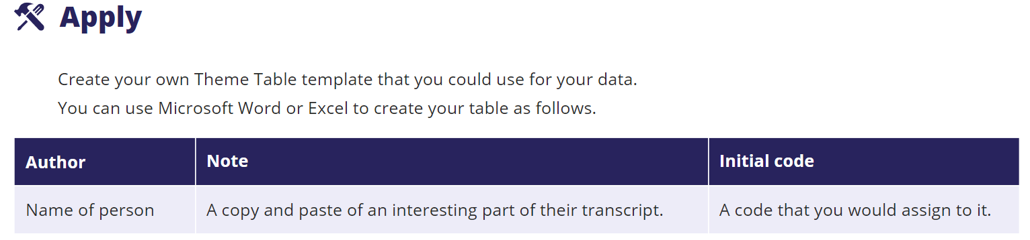

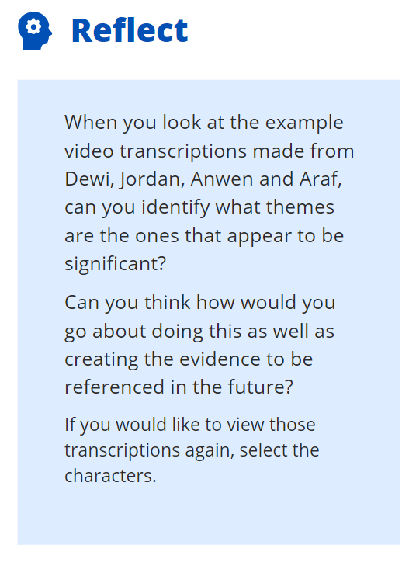
Themes for these people appear to be they all went to Trinity university, no one is from Swansea, a few of them appeared to have been injured/caught an illness during there time at Trinity university.
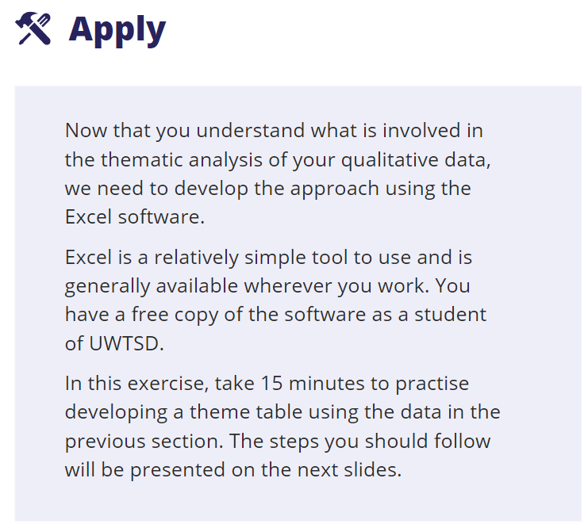
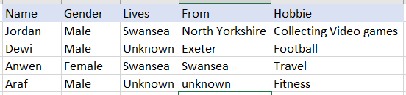

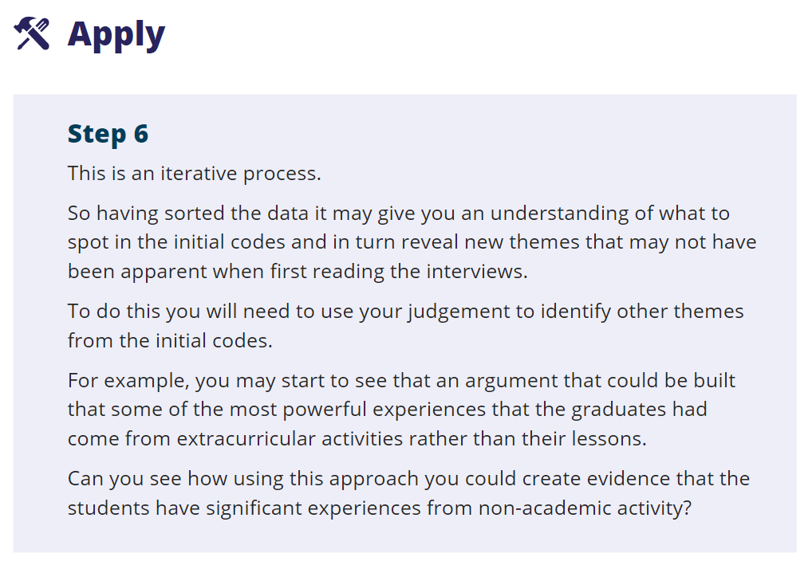
Yes the evidence shows that the students have all experienced something non-academic that was in a way life changing and is a theme for a few how they were ill during their studies and abroad.



