Student name:
Agnieszka Janina Wilkosz
Student ID number: 2115098
Programme: BA Leadership and Management
Module: Developing workplace critical thinking
Module code: BMSW5101
Lecturer:
Rebecca Stewart
Assignment Title:
Report – Analysis of a UK company.

Table of Contents
Introduction 2
An overview of the theory of management. 4
A critical evaluation of management theory. 6
Overview of how conflict might be resolved within the company. 11
Conclusion 12
Reference list 13

Introduction

Grocery retailing is the UK's largest retail sector, worth around $160 billion in 2005. Four retailers - Tesco, Sainsbury's, Asda, and Morrison - dominated the domestic market, accounting for 75% of grocery sales and around 30% of all UK retail sales (Dobson, 2008). There are now over 87,000 supermarkets across the country in the UK (Glover, 2022) and the UK Food & Grocery Retail Market with Total Revenue of $216.1 Billion in 2020 (Marketline,2022)
This report will focus on Wm Morrison Supermarkets PLC, the fourth largest company in the UK by market share (Rashid, 2020).



(Source Website, 2022)
In 1899 William Morrison opened an egg and butter stall in Bradford, followed by his son Ken Morrison in 1952, taking over his father's small group of stalls. In 1958, Ken opened the first store in Bradford with cash registers and prices. In 1961, Ken opened his first supermarket and built an empire (Morrison, 2022). Morrison is a food retail company with 492 stores located in supermarkets and 50 Morrisons Daily convenience stores, and 335 petrol stations in the UK. Approximately 12 million customers visit Morrison stores weekly. The company's retail stores primarily offer food and groceries to their customers.
They offer, among others, a selection of fish and seafood, fruit, salads and herbs, milk, eggs, butter, cooked meats, soups, and sauces, as well as beer, wine, spirits, frozen food, health products and cosmetics, flowers, clothes, home products.. Morrison serves petrol stations, cafes, and pharmacies and offers dry cleaning. Morrison owns and operates 18 production facilities and purchases fresh food directly from farmers. It gives the company direct control over the production and delivery of food to its supermarkets. It operates eight regional distribution centres and one nationwide supermarket service centre.

In addition to brick-and-mortar stores, the company sells its products online to around 90% of the UK population. In FY20, total sales excluding fuel recorded revenues of £13,865 million and fuel £3,671 million. Morrison has approximately 35,291 employees (MarketLine, 2022). The company emphasises training its employees. Morrisons developed a comprehensive training program that would help ensure a high standard of service. The program gave the company a chance to introduce and instil a Morrison "can do" culture in the workplace (Warehousing programs deliver for Morrisons, 2011).

(Source: Morrison, 2022)

An overview of the theory of management.

Since people started forming community organizations to achieve goals they could not achieve as individuals, management was essential to ensure the coordination of individual efforts (Modern management theories and practices, 2013). Management is critical part of any organization. Knowledge of management theory is essential for effective management and leadership (Mahmood, 2012). Fayol is the fathers of modern management (Conkright, 2015). He believed the proper management of personnel and other resources was the key to the success of an organization (Rahman, 2012). Administrative management theory is a classic theory that Fayol developed in 1916 based on his experience as senior manager. He introduced six functions and fourteen principles. Theory is prevalent and is still practised today, especially in large organizations (Mahmood, 2012).
Fayol believed that management had five primary roles. (Dahlgaard-Park, 2018).
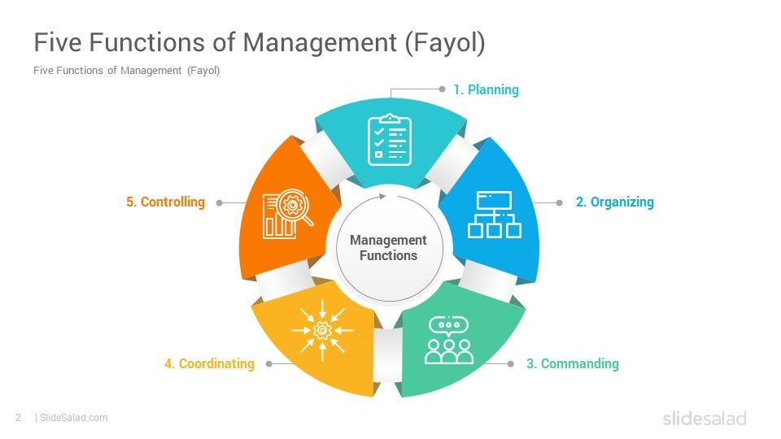
(Source: Website,2022)

"We may view many of [Fayol's] ideas as outdated, but there is no doubt that the principles of planning, organizing, leading, and controlling provide a framework for organizational operations that is still relevant and useful today" (Conkright, 2015, p17).

Planning: Building a road map for the future (Horst, 2015). Fayol emphasized the practice of anticipation and planning and prepared operating plans for the Comment mine (Jean-Louis, 2013). Morrison has long-term and short-term plans. One of them is the opening of the 500th supermarket by 2023. It currently has 486 stores. Morrisons wholesale director Paul Dobson said: "Ultimately, our ambition is to have thousands of stores in the future, not hundreds." Morrison has planned to buy McColl's convenience store chain (MarketLine, 2022).

Organizing: Once an action plan is developed, managers must provide everything necessary to carry it out (Horst, 2015). With the growing number of stores, Morrison had to open an additional warehouse, thus recruiting and training new employees. The training was provided to all staff.
Morrison decided to buy McColl's close 132 stores. Joseph Sutton said: "We deeply regret the proposed closure of 132 loss-making stores, but this is sadly an important step towards revitalizing the business. There is much work ahead of us, but there is no doubt that McColl's is a company with great potential." (MarketLine, 2022)

Command: managers must implement the plan; they need to understand the strengths and weaknesses of their employees (Horst, 2015). When the new warehouse opened, managers knew that 40% of future employees had no experience, so they provided training six months before opening ("Morrisons, 2011 provide storage programs)

Coordination: harmonizing the company's various activities to get things or activities in the right proportions and to match the means to the goals (Horst, 2015). It is believed that "in a well-coordinated company, departments work together. Day-to-day operations management should be adapted to the situation (Jean-Louis, 2013). Morrisons has 11% of the grocery market. The UK's second-largest fresh food producer has 16 production sites - including three slaughterhouses, seven packaging plants and one bakery. The animals must be delivered to the slaughterhouse, produced meat, delivered to the shops, and sold. (MarketLine, 2022).

Control: to verify means to "check that everything is going according to plans, according to established rules" (Jean-Louis, 2013). At Morrison, each department has a manager/director who checks that the work has been done to the highest standard. It is evidenced by the company's sales results and revenues. Thanks to the inspection, Morrison noticed that 132 stores were making losses, so decided to close them.
Fayol developed fourteen principles of administration that aligned with the five core management roles (Dahlgaard-Park, 2018). "Without principles, we are working in the dark and in chaos. Without experience and judgment, we are still working under great difficulties, even with the best of principles (Jones-Washington, 2018, p12)

A critical evaluation of management theory.

Fayol developed 14 general principles of management, which he said are universal management characteristics and should apply to managers (Crainer, 2003). Every organization uses at least one aspect of the Fayol Principles, and its principles will continue to apply for generations to come (Jones-Washington, 2018). Fayol placed more emphasis on the concept of proportion and flexibility than on the rigid structure associated with the term principle. He also realized that his list of 14 principles does not apply to all cases and that more modern, complementary principles are indeed needed in the 21st century (Yoo, 2006).
The pictures below describe the 14 principles.

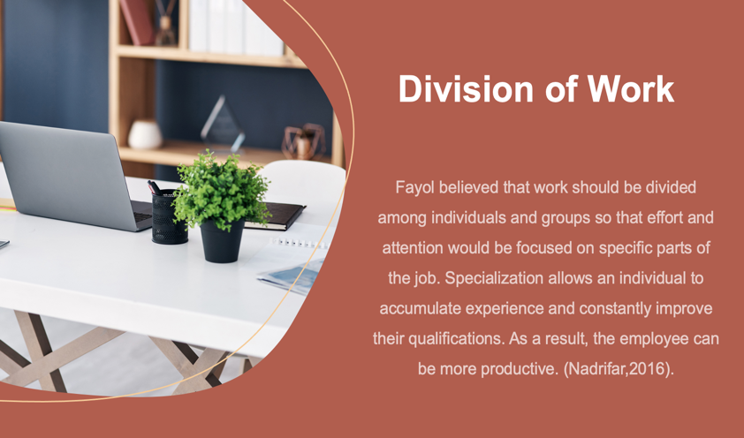
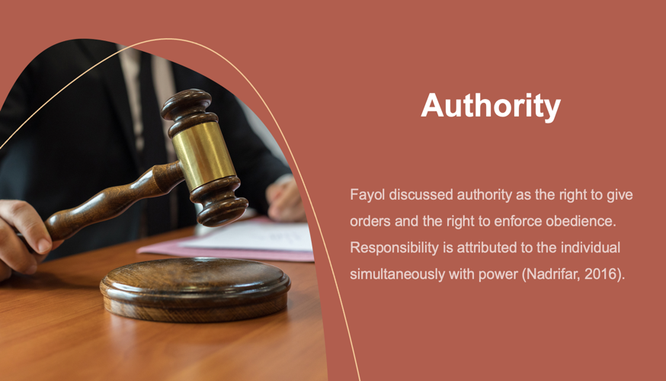

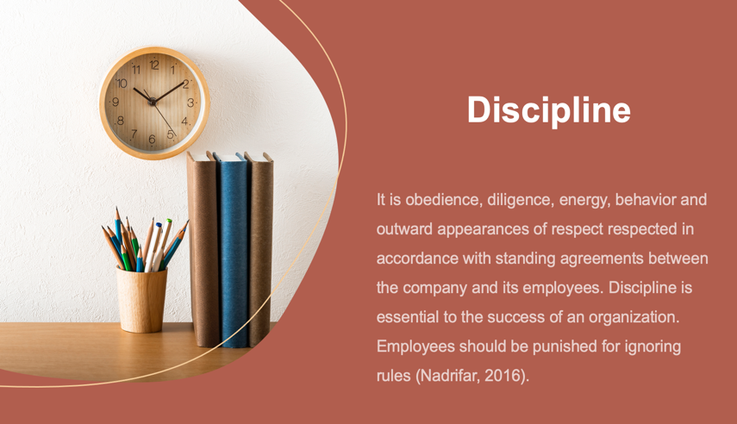
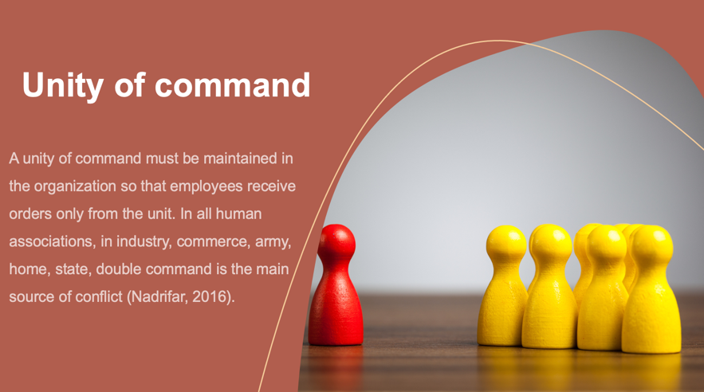

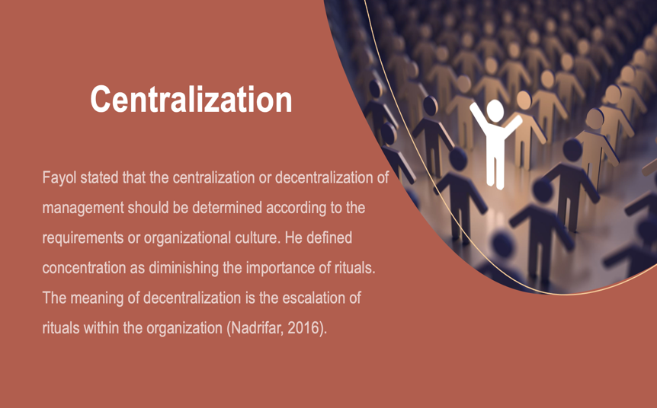
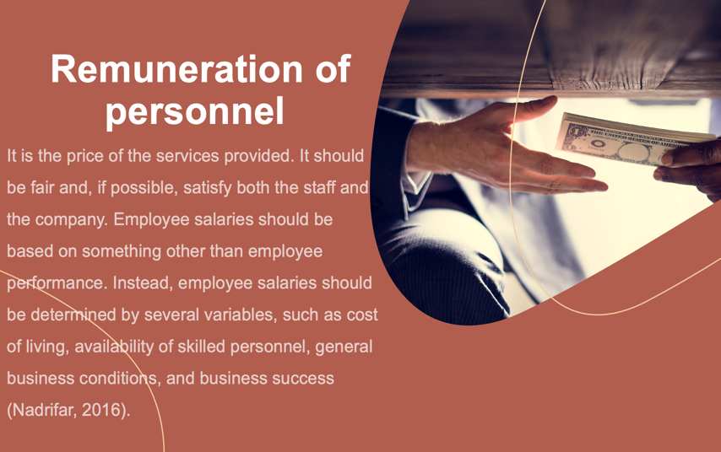


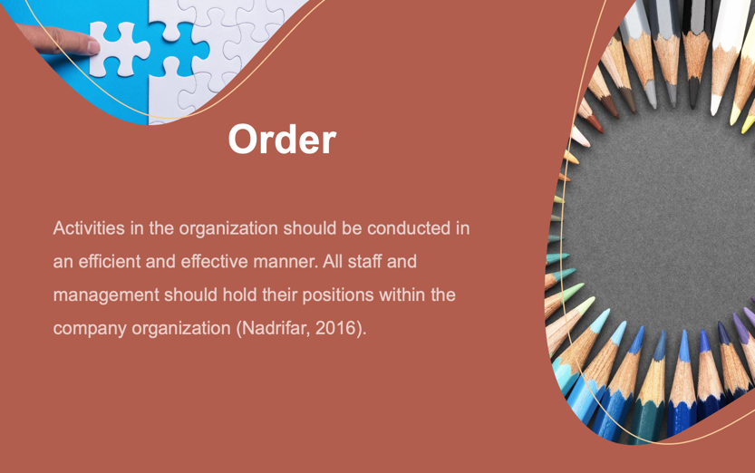

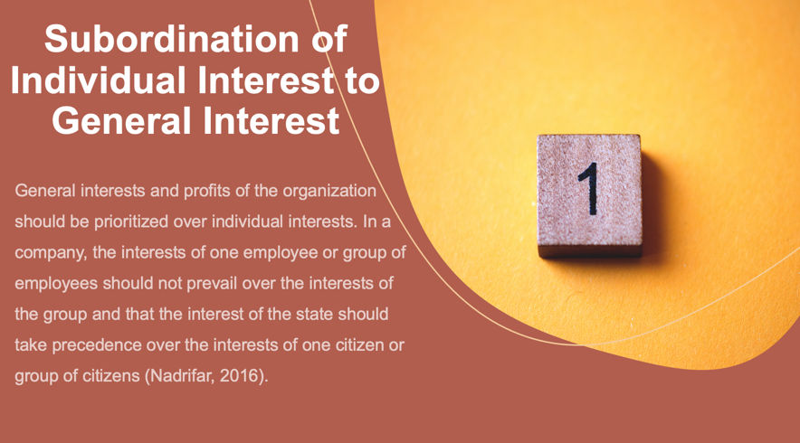
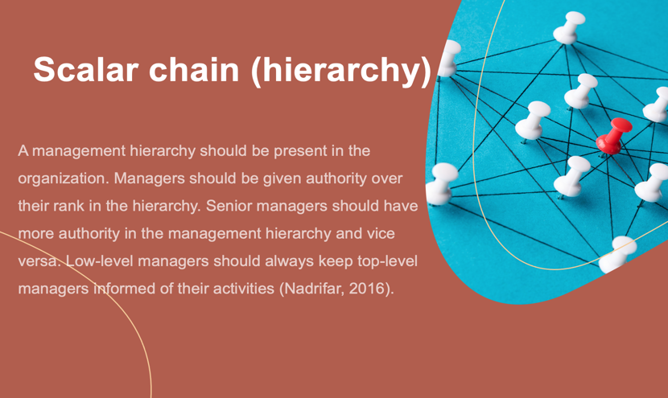

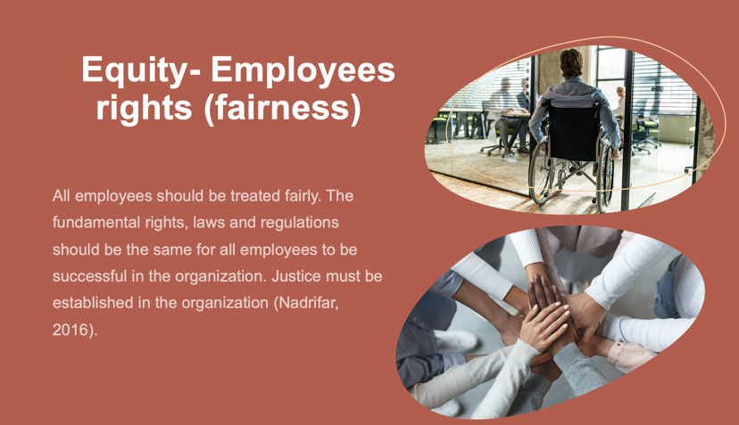
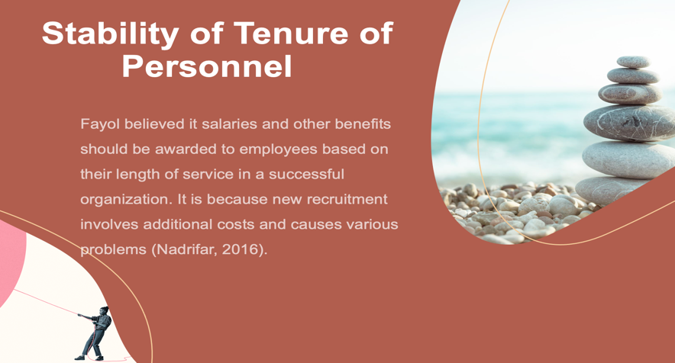

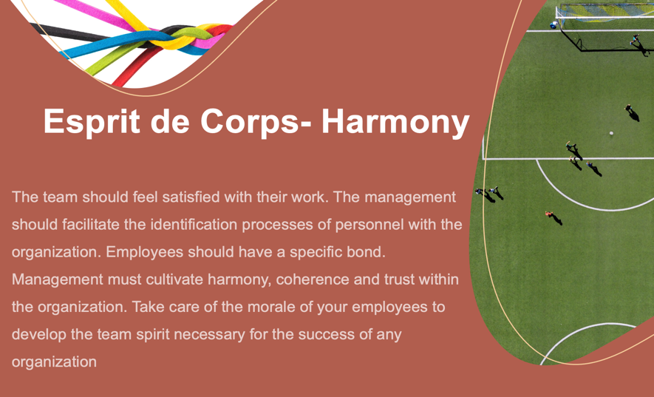


(Source: Wilkosz, 2022)

Division of work
Morrison plays a vital role in the company because all employees have specific roles, such as production, warehouse, sales, drivers, and management. Everyone knows their job and tasks. Morrison has a hierarchical structure. This principle is advantageous for big companies such as Morison (MarketLine, 2022), but it is useless for small businesses because of the small number of employees. It is impossible to give a specific role or task.
Unity of Direction
This principle is self-evident because every employee knows that working is to meet the company's purpose. At a company like Morrisons, people come to work daily with a greater purpose than simply making money for themselves or shareholders. Their primary role is to provide safe, tasty, good quality food at attractive prices and improve customers' lives (MarketLine, 2022). The entire company is focused on one goal: customer satisfaction and the sale of high-quality products. Morrison believes that all employees should be focused on this and not on their interests (Morrison, 2022)
Remuneration of personnel
"A Fair Pay for a Fair Day's Work" During the pandemic, they guaranteed triple the average annual bonus for 2020/21 for all frontline associates. We also recently announced a new wage bonus for 2021/22 of at least £10 per hour for all Morrisons supermarket staff (MarketLine, 2022).
Even though this principle was invented over 100 years ago, it fits perfectly into today's times, where money plays a vital role in human life.
Equity
Under the United Nations Guiding Principles on Business and Human Rights (UNGP), Morrison is committed to respecting the human rights of workers within the company and supply chains. A great workplace where every effort pays off and everyone can develop and contribute. Morrison wants to make sure everyone feels welcome and respected and remains committed to building a greater representation of minority groups of colleagues. Morrison has zero tolerance for harassment and bullying and believes it is the responsibility of all leaders and managers to support equality in the workplace. Also, take steps to support the career development of ethnic minorities (Morrison, 2022).
Equity is an excellent principle in today's world, where is a lot of racism and intolerance. Thanks to this principle, employees can feel safe.
Stability of Tenure
Morrison believes that success should be rewarded. So, from a simple thank you to well-deserved awards of recognition. It is how they retain the best talents. Morrison is proud that many employees choose to stay with them for so long. Anyone who has been with them for five years will receive a pay-out every five years. Employees who have worked for 25 years also organise a special event and a generous gift (Morrison,2022).
Harmony This rule is essential because Morrison builds a culture based on teamwork (Morrison, 2022). However, this principle does not say how to organise the work in the workplace or solve problems.

Fayol created the theory over 100 years ago, so in the 21st century, it is hard to use all the rules, and they must be interpreted differently than in the last century. For example, the Initiatives principle only mentions employee initiative, but employee development should also be added (Rodrigues, 2001). The theory has many pros and cons. The advantage is that the rules are flexible and can be adapted to any organisation. They help managers to coordinate work in the organisation. It does have many disadvantages. First, his theory is considered too formal. Secondly, he should have paid more attention to the employee. Thirdly, some of its terms are vague, superficial, and open to various interpretations (Rahman, 2012). Fourth, he suggested but should have explained that management can and should be learned. Despite these limitations, Fayol made unique and outstanding contributions to management (Crainer, 2003).

Overview of how conflict might be resolved within the company.
If organizations continue to use work teams, conflict is unavoidable as it is an unavoidable aspect of work teams. Conflict is the result of behaviour. It is an integral part of human life. Wherever there is interaction, there is conflict. It is associated with situations where there are conflicting interests between two opposing groups (Thakore, 2013).
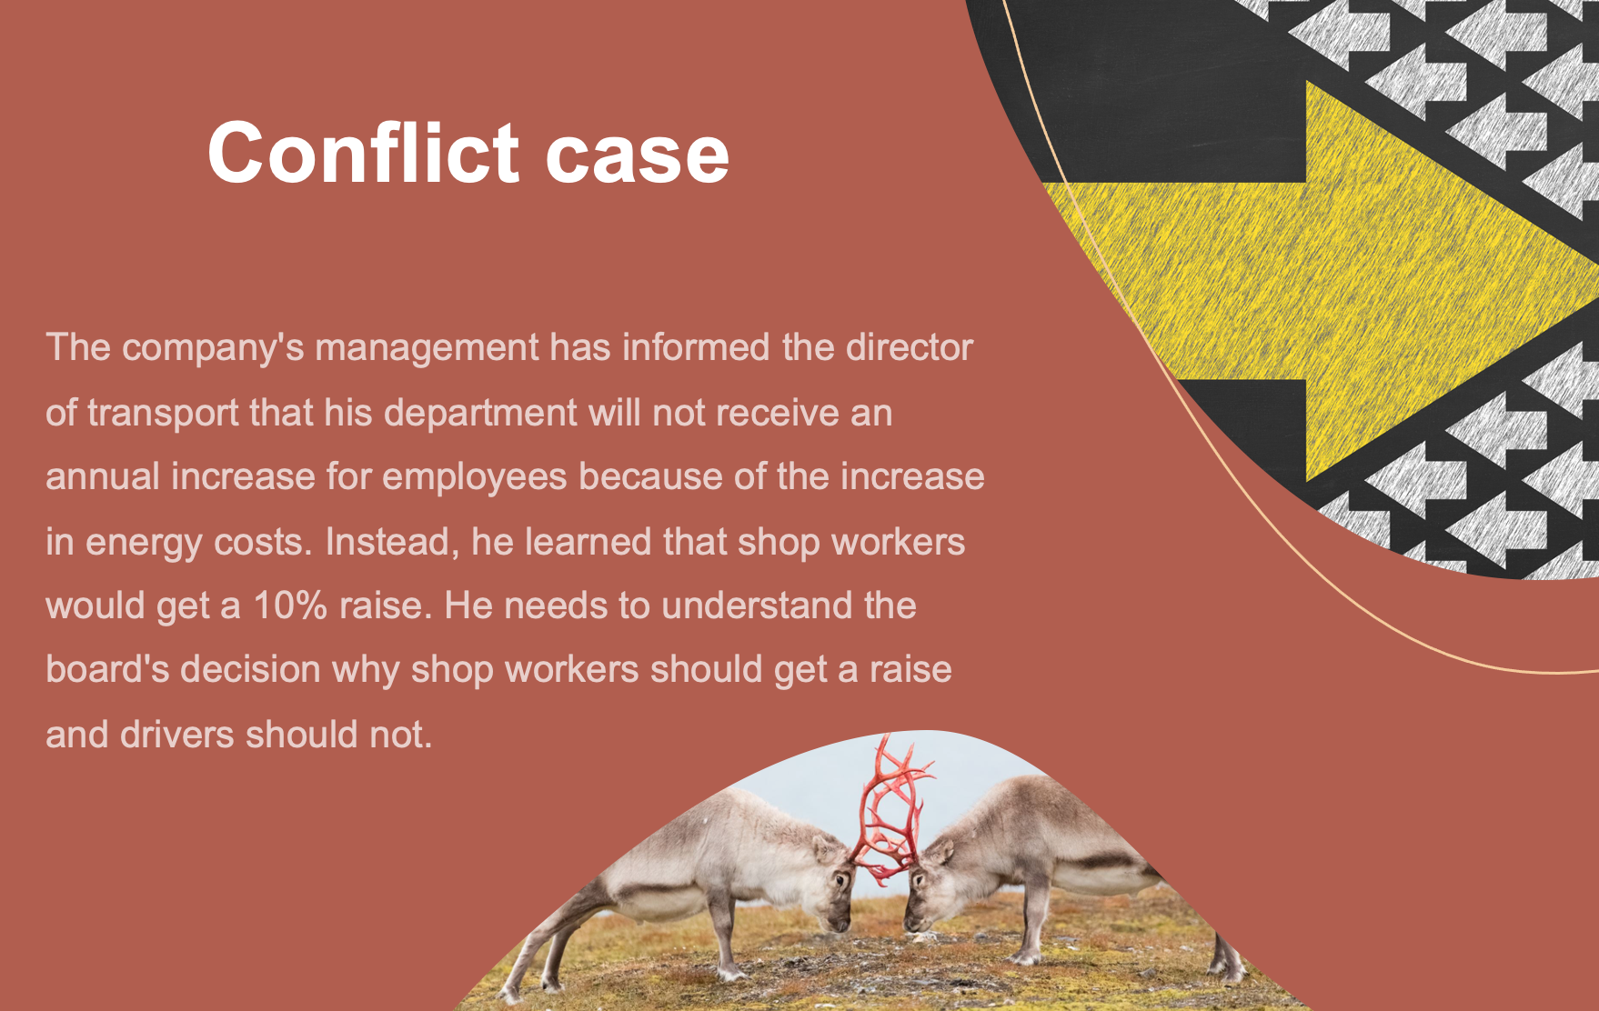
(Source: Wilkosz,2022)
Limited Resources Most organizational resources cause limited conflict, and units and departments must fight for their share. In this case, for an increase in wages for employees.
As a member of Morrison's board of directors, he is responsible for conflict resolution. He proposed a meeting with the director of transport and director of stores.
A board member presented that with the increase in energy costs, he could not raise the drivers' salaries because the cost of maintaining this apartment also increased significantly due to the increase in fuel prices because there was a Ukrainian-Russian war (Merritt, 2021). He argued that store employees should receive a raise because they earn much less than drivers, and during the pandemic, they were exposed to contact with customers and worked under challenging conditions.
The director of transport, thanks to a more detailed explanation, understood the management's decisions better, but he still disagreed. He proposed that the 10% increase be divided between the two departments, and each employee would receive a 5% increase. He argued that it is challenging to hire workers after Brexit, especially drivers who need to be qualified. It is easier to find a store employee who can be taught everything than to hire a driver without a license and wait for them to pass the test (Merritt, 2021). The store manager also suggested that the management reconsider the installation of solar panels, which reduces energy costs, and proposed the installation of motion sensors in warehouses or less used parts where the light will be turned on only when needed. A board member also ordered group work to the transport and shop director to prevent future conflict. They must create a joint report and present the results at the board meeting in 3 months. Also, the board sent two directors to a joint two-day training cost increase on how to keep the company profitable.

Conclusion

Although Fayol's theory was created over 100 years ago, it is still used by the organization. The Five Management Functions are widely used in organisations. All organizations plan, organise, commands, coordinates, and controls. These functions are helpful in the work of a manager because they set the way for him to manage. The 14 principles are focused mainly on the company's development and not on the development of the employee. For a company to achieve its goals, it must have trained, motivated, and committed employees. The above rules do not show how to manage an employee at all effectively but are only a set of ordinary, obvious rules on which managers can focus less.
There are always conflicts in the workplace that are important to solve and draw conclusions in further management.

Reference list

- Asda, Morrisons and Tesco offer employees an alternative route to a degree (2014) Human resource management international digest, 22(3), pp. 21–23. Available at: https://doi.org/10.1108/HRMID-05-2014-0060 [Accessed 16/11/2022].
- Conkright, T.A., 2015. Using the four functions of management for sustainable employee engagement. Performance Improvement, 54(8), pp.15-21.
- Crainer, S. (2003) ‘One Hundred Years of Management’, Business strategy review, 14(2), pp. 41–49. Available at: https://doi.org/10.1111/1467-8616.00258 [Accessed 20/11/2022].
- Dahlgaard-Park, S.M., Reyes, L. and Chen, C.K., 2018. The evolution and convergence of total quality management and management theories. Total Quality Management & Business Excellence, 29(9-10), pp.1108-1128.
- Dobson, P.W. and Waterson, M., 2008. Chain-store competition: customized vs. uniform pricing (No. 2068-2018-1613).
- Glover, A., Hayes, H.E., Ni, H. and Raikos, V., 2022. A comparison of the nutritional content and price between dairy and non-dairy milks and cheeses in UK supermarkets: A cross sectional analysis. Nutrition and Health, p.02601060221105744.
- Horne, S. (2014) ‘Morrisons’ vision of the future’, Farmers Weekly, 162(5), p. 22–.
- Horst, D.J., Broday, E.E., Bondarik, R. and de Paula Xavier, A.A., 2015. Open or closed? Macroergonomics approaching socio-technical systems productivity: An overview of the conceptual framework. Social and Basic Sciences Research Re view, 3 (2), pp. 98–115.
- Jean-Louis ,(2013) ‘Henri Fayol’, in The Oxford Handbook of Management Theorists. Oxford University Press. Available at: https://doi.org/10.1093/oxfordhb/9780199585762.013.0004 [Accessed 26/11/2022].
- Jones-Washington, M., 2018. The Effectiveness of Fayol’s Principles of Management.
- Jones-Washington, M., 2018. The Effectiveness of Fayol’s Principles of Management.).
- MarketLine Advantage, 2022 Wm Morrison Supermarkets Ltd. Available at: https://advantage-marketline-com.ezproxy.uwtsd.ac.uk/Company/Summary/wm_morrison_supermarkets_plc [Accessed: 16/11/2022].
- Merritt, K. and Zhao, S., 2021. An innovative reflection based on critically applying ux design principles. Journal of Open Innovation: Technology, Market, and Complexity, 7(2), p.129.
- Morrison (2022) About Us. Available at: https://www.morrisons-corporate.com/about-us [Accessed: 16/11/2022].
- Morrisons trains the butchers and bakers of tomorrow (2011) Human resource management international digest, 19(7), pp. 30–32. Available at: https://doi.org/10.1108/09670731111175579 [Accessed 16/11/2022].
- Nadrifar, A., Bandani, E. and Shahryari, H., An Overview of Classical Management Theories: A.
- Peaucelle, J.-L. and Guthrie, C. (2013) ‘Henri Fayol’, in The Oxford Handbook of Management Theorists. Oxford University Press. Available at: https://doi.org/10.1093/oxfordhb/9780199585762.013.0004 [Accessed 20/11/2022].
- Rahman, M.H., 2012. Henry Fayol and Frederick Winslow Taylor’s contribution to management thought: An overview. ABC Journal of Advanced Research, 1(2), pp.94-103.
- Rahman, M.H., 2012. Henry Fayol and Frederick Winslow Taylor’s contribution to management thought: An overview. ABC Journal of Advanced Research, 1(2), pp.32-41.
- Rashid, C.A., 2020. Balanced Score Card and Benchmarking as an Accounting Tool to Evaluate Morrison’s Performance. Journal of Global Economics and Business, 1(3), pp.59-72
- Rodrigues, C.A. (2001) ‘Fayol’s 14 principles of management then and now:a framework for managing today’s organizations effectively’, Management decision, 39(10), pp. 880–889. Available at: https://doi.org/10.1108/EUM0000000006527 [Accessed 19/11/2022].
- Thakore, D., 2013. Conflict and conflict management. IOSR Journal of Business and Management (IOSR-JBM), 8(6), pp.07-16.
- Warehousing programs deliver for Morrisons (2011) Human resource management international digest, 19(5), pp. 27–29. Available at: https://doi.org/10.110809670731111153320 [Accessed 19/11/2022].
- Warehousing programs deliver for Morrisons (2011) Human resource management international digest, 19(5), pp. 27–29. Available at: https://doi.org/10.1108/09670731111153320 [Accessed 16/11/2022].
- Yasin, O., 2013 MODERN MANAGMENT THEORIES AND PRACTICES. Main Issues Of Pedagogy And Psychology, 2(2), 15-27. https://doi.org/10.24234/miopap.v2i2.265 [Accessed 16/11/2022].
- Yoo, J.W., Lemak, D.J. and Choi, Y., 2006. Principles of management and competitive strategies: using Fayol to implement Porter. Journal of Management History.

