

Student name…………………………………………………Ionut Broasca
Student number …………………………………………………….1908327
Lecturer’s name ………………………………………….Benedict Maher
Module name ……Effective Team Working & Communication
Module code ………..…………………………………..BMSW4002_LON

Table of Contents

Introduction …………………………………………………….... page 3
Effective Communication………………………………….… page 3-4
Types of Communication.…………………………………... page 5-6
Verbal Communication …………………………….………… page7-8
Non-Verbal Communication ………………………..…….. page 8
Formal and Informal Communication…………………. page 9-11
Methods of successful Communication…………….… page 12-13
Conclusion …………………………………………………………. page 14
Refereces …………………………………………………………… page 14-15

Introduction
Communication is the process of passing information and understanding from one person to another. In simple words it is a process of transmiting and sharing ideas, opinions, facts, values etc. from one person to another or one organization to another. In a seminal research by Mehrabian (1981) we can see a percentage of types of communication used :
- 7% from verbal cues (words)
- 38% from vocal cues (volume, pitch, rhythm)
- 55% from facial expressions (smiling, frowning, etc.) and other body movements (arms crossed, eye contact etc.)

Effective Communication

Effective Communication and Teamwork is fundamental for the conveyance of excellent, safe patient consideration. Correspondence disappointments are an amazingly basic reason for unintentional patient mischief. The intricacy of therapeutic consideration, combined with the characteristic impediments of human execution, make it basically significant that clinicians have institutionalized specialized devices, make a domain where people can shout out and express concerns, and offer "basic language" to caution colleagues to perilous circumstances. Very habitually, compelling correspondence is circumstance or character subordinate. Other high dependability areas, for example, business avionics, have demonstrated that the selection of institutionalized instruments and practices is a successful procedure in improving cooperation and lessening hazard.
We depict our progressing persistent security execution utilizing this methodology inside Kaiser Permanente, a non-benefit American social insurance framework giving consideration to 8.3 million patients. We portray explicit clinical involvement with the utilization of careful briefings, properties of high unwavering quality perinatal consideration, the estimation of basic occasion preparing and reproduction, and advantages of an institutionalized correspondence process being taken care of by patients moved from medical clinics to gifted nursing offices. Also, exercises learned as to compelling procedures in accomplishing social change, proof of improving the nature of the workplace, practice move methodologies, basic achievement factors, and the advancing techniques for exhibiting the advantage of such work are portrayed.

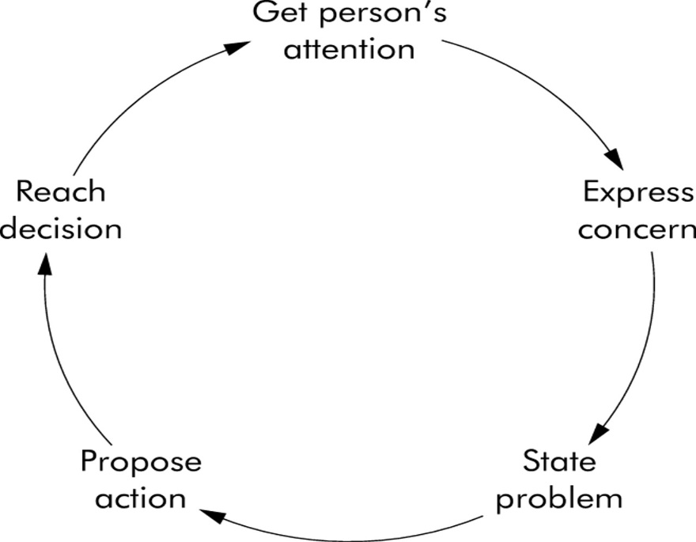

Types of Communication

Communication have four main types which I will describe you below. To mastering all types of communication you must to understand the importance of every type I will present you

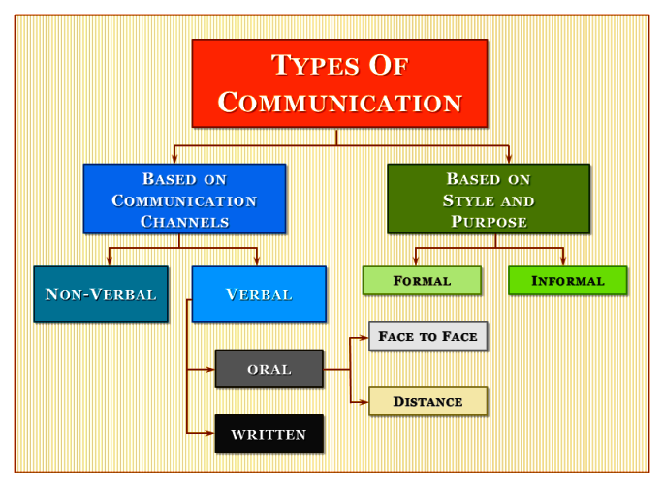

Here I will show you some types of communication channels:

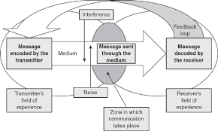


Verbal and Nonverbal communication
Verbal communication
is one of the most used way to share ideas, projects, problems etc. in the world. In that area of communication team members must to learn very quickly the process of understanding and transmitting a message, if that it is not present can create a misunderstanding between team members and ruin the main purpose of the team. Normally every newbie team member must to learn how to interact with the team for good of the team. Wheelan, Davidson & Tilin (2003) develop a system to classify the analyse of verbal interactions named Group Development Observation System (GDOS) and they separate that system in eight types of verbal interactions between a team member and the rest of the group:
Dependency statements are those who need help and support from the leader of the group to be qualify for in the group.
Counterdependency statements is a team member who refuse to take advice from the team leader or the group and to be on his own decision.
Fight statements they think opposite and counteracts with other arguments even those are worst then of the rest of the group.
Flight statements is the team member who it is in a group but never work and support the rest of the team.
Pairing statements always will be helpful and positive like a real team worker agreeing and supporting the group.
Work statements are like a bee working hard without questions and arguments reaching the group goal.
Unscorable statements include lack of activity, stupidity and unfinished work for the goal settled by the group and the leader.

Nonverbal communication

Nonverbal Communication it is different by the verbal communication but very important for the message you want to delivery. The way when you want to delivery a message must to contain: face expression, eye contact or hands gesture who works subconsciously and make the receiver to understand more accurate the message delivered. Like in the book of Malcolm Gladwell (2005) the message is not every time understood properly by the receiver and for a perfect meaning the sender use nonverbal communication and set the priorities of that message being understood very well. The importance of nonverbal communication is settled by how humans use to inform each other about what they concern and what they taught so basically we use more nonverbal communication then verbal. In a seminal research by Mehrabian (1981) we can see a percentage of types of communication:
- 7% from verbal cues (words)
- 38% from vocal cues (volume, pitch, rhythm)
- 55% from facial expressions (smiling, frowning, etc.) and other body movements (arms crossed, eye contact etc.).
Nonverbal communication help for a better understanding but also helps the sender to continue fluently his conversation increasing his self-confidence for a better speech (Goleman, 2006).

Formal and Informal communication
Formal Communication
Formal communication channels are perceived authoritatively by the association. Guidance and data are passed descending and upward along these channels (Anderson and Narus, 1984). Data in an association given by the proper correspondence makes directors' exercises simpler (Litterst and Eyo, 1982). Formal correspondence pursues the proper structure or pecking order of the association (Guffy, Rhoddes, and Rogin, 2005).
It very well may be upward, descending, or side-to-side headings of correspondences. Cost (1997) characterized formal communication as how much data about employment is transmitted by an association to its part and among the individuals from an association. By knowing the conventional outline of an association, a lot of the nature of the correspondence streams inside the association is unsurprising (Evertt and Rekha, 1976).
Formal correspondence has for some time been considered as the subject of research. Writing recommended that formal correspondence is identified with efficiency (Litterst and Eyo, 1982), work fulfillment (Holtzhausen, 2002), diminishes coordination costs (Sine, Mitsuhashi, and Kirsch, 2006), diminish struggle, strengthen trust and generally speaking fulfilment (Chio, Hsieh, and Yang, 2004), lastly diminish the negative impacts of bits of gossip which lead to acquiring fulfillment (Difonzo and Bordia, 2000).

Informal Communication
Just as the fromal communication, informal communication likewise assumes an inescapable job in an authoritative life (Crampton, Hodge, and Mishra, 1998). As per Homans (1951), presence of casual framework in an association is unavoidable in light of the fact that workers oppose being treated as unfortunate chore, and they cooperate as entire, carrying with them their own issues and purposes that offer ascent to unconstrained conduct that look to control their state of work (Ogaard, Marnburg, and Larsen, 2008, p. 2). Associates during their communications find their comparative mentalities, sentiments, and values and subsequently they become familiar and mates to one another, which bring about turning out to be companions (Hargie, Dickson, and Nelson, 2003). Casual correspondence depends on social relationship among individuals (Anderson and Narus, 1984; Litterst and Eyo, 1982; Guffy, Rhoddes, and Rogin, 2005). In particular, the inception of casual correspondence is "workers' private purposes" while the establishment of formal correspondence should serve the "reasons for the partnership" (Ogaard, Marnburg, and Larsen, 2008). By having casual correspondence, representatives can talk about their issues, frames of mind, work, and whatever they like, which at that point lead to fulfillment. Also, is exceptional that casual correspondence would be a superb wellspring of data about workers' good what's more, issues that help directors to lead workers effectively (Guffy, Rhoddes, and Rogin, 2005). Gilsdorf (1998) and Daniels, Speaker, and Papa (1997) noticed that casual channels of correspondence, for example, grapevine and tattle regularly fill the holes that conventional correspondence neglects to address. They articulated that, data that is transmitted through a conventional framework is either deficient or equivocal and casual framework generally remunerates these shortcomings.
Be that as it may, when representatives are not acquiring adequate data through the conventional channels, at that point they depend on casual channels (Gray and Laidlaw, 2002). Crampton, Hodge, what's more, Mishra (1998) condensed that when representatives feel undermined, uncertain, under pressure, and at whatever point a pending change exists, and eventually, when correspondence from the administration is restricted, workers are seen as depending more on grapevine. Thusly, casual correspondence should legitimately influence on correspondence fulfillment since the most significant job of casual correspondence is to satisfy the workers' instructive needs.
Methods of successful communication
On bellow I will present you two examples of successful methods in communication:
In aviation:
Assessments recommend that every year a large number of feathered creatures, prevalently Neotropical moving larks, slam into correspondence towers. To decide the relative impact chances that distinctive evening time Federal Aviation Administration (FAA) correspondence tower deterrent lighting frameworks posture to night‐migrating feathered creatures, we contrasted fatalities at towers and various frameworks: white strobe lights just; red strobe‐like lights just; red, blazing, brilliant lights just; and red, strobe‐like lights joined with non‐flashing, steady‐burning, red lights. Avian casualty information used to look at these pinnacle light frameworks were gathered all the while in Michigan on 20 successive days during early morning hours during top warbler movement at 24 towers in May and September 2005 (absolute = 40 days). Twenty‐one towers were 116–146 m over the ground level (AGL), and three were ≥305 m AGL. During the two 20‐day example time frames, we found a mean of 3.7 fowls under 116–146 m AGL towers furnished with just red or white glimmering obstacle lights, while towers with non‐flashing/steady‐burning lights notwithstanding the blazing lights were answerable for 13.0 fatalities per season.
Kruskal‐Wallis test, ANOVA, Student's t test, and various correlations techniques verified that towers lit around evening time with just glimmering lights were associated with altogether less avian fatalities than towers lit with frameworks that incorporated the FAA "the norm" lighting framework (i.e., a blend of red, blazing lights and red, non‐flashing lights). There were no huge contrasts in casualty rates among towers lit with red strobes, white strobes, and red, glowing, blazing lights. Results from related investigations at similar towers in May and September 2004 and September 2003 give auxiliary help to these discoveries. Our outcomes propose that avian fatalities can be diminished, maybe by 50–71%, at guyed correspondence towers by expelling non‐flashing/steady‐burning red lights. Our lighting change proposition can be cultivated at insignificant expense on existing towers, and such changes on new or existing towers extraordinarily decrease the expense of tower activity. Expelling non‐flashing lights from towers is one of the best and monetarily possible methods for accomplishing a huge decrease in avian fatalities at existing correspondence towers.
In hospital:
Compelling medical attendant patient correspondence is a basic part of human services. Time to impart, be that as it may, is restricted and dependent upon remaining task at hand requests. Little is thought about how attendants deal with this 'absence of time' when thinking about patients with formative inability and complex correspondence needs, who commonly convey at a moderate rate.In 2009, 15 emergency clinic medical nurses from a scope of wards in two metropolitan clinics took part in interviews about hindrances to and techniques for effective correspondence with patients with formative incapacity and complex correspondence needs in medical clinic. The information were broke down utilizing account request approach and the tales checked with the members. Attendants distinguished 'time' as a boundary and a facilitator to fruitful correspondence. Time as a hindrance was connected specifically to maintaining a strategic distance from direct correspondence and leaning toward that family or paid carers imparted for the benefit of the patient. Time as a facilitator was identified with esteeming correspondence, contributing additional time, and to applying a scope of versatile correspondence techniques to build up effective correspondence.
Conclusion
The purpose of communication is very important for everyone in this world and connect us like a web without it everything in this world will not function and chaos will take over, so is very important for us to learn and master those skills to lead, communicate and accomplish every task with no other obstacles.

References

(Anderson and Narus, 1984). Organizational Citizenship Behavior in Concern of Communication Satisfaction: The Role of the Formal and Informal Communication [Online] Available at: https://resources.saylor.org/wwwresources/archived/site/wp-content/uploads/2013/01/BUS209-2.2.2-OrganizationalCitizenshipBehavior.pdf (Accessed: 17 December 2019)
(Crampton, Hodge, and Mishra, 1998). Organizational Citizenship Behavior in Concern of Communication Satisfaction: The Role of the Formal and Informal Communication [Online] Available at: https://resources.saylor.org/wwwresources/archived/site/wp-content/uploads/2013/01/BUS209-2.2.2-OrganizationalCitizenshipBehavior.pdf (Accessed: 14 December 2019)

(Goleman, 2006) [1]Maund, Shriek, Tinkler, A. 2017. Certificate in Higher Education: Skills for the Workplace Student Yearbook.

(Ogaard, Marnburg, and Larsen, 2008, p. 2). Organizational Citizenship Behavior in Concern of Communication Satisfaction: The Role of the Formal and Informal Communication [Online] Available at: https://resources.saylor.org/wwwresources/archived/site/wp-content/uploads/2013/01/BUS209-2.2.2-OrganizationalCitizenshipBehavior.pdf (Accessed: 13 December 2019)

Gehring,kerlinger, manville ii, J.,.P.,.A.M. 2009. Ecological Society of America. [Online] Available at: https://esajournals.onlinelibrary.wiley.com/doi/abs/10.1890/07-1708.1 (Accessed: 24 December 2019)

Hemsley, B., Balandin, S. and Worrall, L. (2019). Nursing the patient with complex communication needs: time as a barrier and a facilitator to successful communication in hospital. [Online] Available at: https://onlinelibrary.wiley.com/doi/abs/10.1111/j.1365-2648.2011.05722.x (Accessed: 19 December 2019)

Malcolm Gladwell (2005) [1]Maund, Shriek, Tinkler, A. 2017. Certificate in Higher Education: Skills for the Workplace Student Yearbook.
Mehrabian (1981) [1]Maund, Shriek, Tinkler, A. 2017. Certificate in Higher Education: Skills for the Workplace Student Yearbook.

Wheelan, Davidson & Tilin (2003) [1]Maund, Shriek, Tinkler, A. 2017. Certificate in Higher Education: Skills for the Workplace Student Yearbook.

