
Module: Professional and Career development
Module code: BMSW 4005
Module Lecturer: Munodzinesa Zuwirai
Assignment Title: Reflective portfolio 2000 words
Student
Ion Adrian Barbu
2113245@student.uwtsd.ac.uk



Contents
Introduction 3
Know myself: 4
My SWOT analysis 5
Identify the career options available to me. 5
Research your options 6
Where can you find these options-opportunities? 8
The 10 Best Job Search Websites of 2022 8
World of work is changing 9
Objectives and goals setting S.M.A.R.T 10
Career development and employment law in the UK 11
Learning theories 12
Self-awareness methods 13
Mock Interview and Open Book assessment. 14
Conclusion 14
Reference 15

Introduction

Choosing a career path can be very difficult when you are not sure what you want to do with your life in the future. A good way in finding out more about yourself and what you want to do in the future is using models and theories such as Johari Window model or there are Kolb, Honey & Mumford or Neil Fleming which are some very good theories which will help you develop your knowledge about yourself. Personality test is also a great tool which can help you understand more about what you like and your way of being.

Know myself:

“Treat people as if they were what they ought to be and you help them to become what they are capable of being.”

JOHANN WOLFGANG VON GOETHE

For a start we used a very good personality test that was recommended to us by our lecturer. According to that test, my personality is an Advocate assertive.
I will write below the results of that test.
There may be no doubt that Advocates (INFJs) are the rarest personality type out there, but their impact on the world is undeniable. Dedicated to standing up and making a difference, they are idealistic and principled.
It is not about money or status that drives Advocate personalities, but rather, it is about making a difference, helping others, and connecting with others.

Strengths
Creative: There's something wonderful about advocates - they're not like everyone else. The creative personality type values the opportunity to express oneself and think outside the box, always looking for new opportunities to do so.
Insightful: Despite appearances, these personalities are aware of the dangers of misreading appearances. Life's deeper truths are sought by advocates who strive to move beyond superficiality.
Altruistic: These personality types don't like to gain success at another's expense. It is in their hearts that they desire to make the world a better place, beginning with themselves.
Weaknesses
Sensitive to Criticism: As long as it doesn't challenge their most cherished principles or values, advocates aren't adverse to feedback. People with this personality type can become defensive and dismissive when it comes to issues that matter to them.
Perfectionistic: Idealism defines the Advocate personality type. This is an admirable quality in many ways, but it often doesn't allow for real life's messiness. When advocates continually focus on imperfections and wonder if they should be looking for something better, it is difficult for them to appreciate their jobs, living situations, or relationships.

Prone to Burnout: As a result of their perfectionistic tendencies and reserve, advocates have few options when it comes to venting.

My SWOT analysis

Strengths | Weaknesses
Creative  Insightful  Altruistic | Sensitive to Criticism  Perfectionistic  Prone to Burnout
Opportunities | Threats
Independence  Freedom  Community events as a volunteer | Toxic people  Gossip  Impatience

Identify the career options available to me.

I want to be a Supervisor because: I am good to speak with people, i have good time management skills, i am multitasking. I am a good collaborator who communicates well and is comfortable taking the role of a leader.

I want to be computer engineering: because i like to work with computers. A computer hardware engineer researches, designs, develops and tests computer systems and components such as processors, circuit boards, memory devices, networks and routers. And i love to work with all of this. I have Data Entry qualification, strong computer knowledge.

I want to be a pilot because: I like to fly.

What makes me a good pilot?

1) Determination.

2) Great planning skills.

3) Confidence.

4) Self-reflection.

5) Clear communication.

Research your options

Making a job application
- Consult the documentation
Be sure to read everything that you sent. Don't miss a detail.
Information about the company
The information includes information about the company, work conditions, pensions, holidays, and bonuses.
You can find out more about the company by visiting the company's website or contacting the HR or Personnel department.
Description of the position.
There is an overview of the duties and responsibilities of the post-holder in this document.
Are you still interested in this? Make sure it matches the advertisement.

- Conduct a company research

In general, employers are proud of their businesses and expect applicants to know what they do, their values, policies, and achievements. Take note of what you see on their website. Search online (such as companieshouse.gov.uk) for plans and financial statements. Make sure you are comfortable with the working conditions and ethos of the company before you apply.

- Pay attention to directions

If you are required to submit a CV, personal statement, or any other information, follow all instructions carefully. Employers are likely to process applications that are correctly filled out. A lack of attention to details is reflected in an applicant's inability to follow instructions.

Complete the forms

Answer questions with tailored answers- Provide clear, specific, well-structured, proofread, and detailed answers to all employer-specific questions.
Honesty and accuracy are essential-It is the employer's responsibility to check the information provided, either immediately or later.
Avoid gaps- Make sure all questions have been answered. If you write 'see response above' you may lose a point. Employers may assume you have something to hide if you leave gaps in your work or educational histories. Explain why you are taking a break from work.

- Make yourself attractive
Make sure you mention all relevant skills, qualities, qualifications, training, and experiences.
- Be sure to use your records and evidence base
Maintaining accurate, updated personal records will enable you to identify information quickly and remind you of your most recent experiences when preparing applications.
- Include a covering letter
Please include a brief covering letter with your application.
A good example would be:
- Show passion and interest in the job.
- You should tailor your application to the job you're applying for, including any references you have.
- Describe where you saw the job advertised.
- In your personal statement, explain how you meet the requirements of the job.

Where can you find these options-opportunities?

Employers can use job websites to find employee and local job openings similar to classified ads. Searching for and applying to dozens of jobs on a job website is one of the best and most efficient ways to find and apply for jobs. Job websites have millions of listings and additional resources such as career coaching, resume tailoring, and blog posts filled with helpful tips.

The 10 Best Job Search Websites of 2022
- Best Overall: Indeed
- Runner-Up, Best Overall: Monster
- Best for Employer Research: Glassdoor
- Best for Remote Jobs: FlexJobs
- Best for Experienced Managers: Ladders
- Best for Startup Jobs: AngelList
- Best for Connecting Directly With Recruiters: LinkedIn
- Best for Up-to-Date Listings: Getwork
- Best for Recent College Graduates: Scouted
- Best for Hourly Workers: Snagajob
Source: https://www.thebalancecareers.com/top-best-job-websites-2064080

World of work is changing

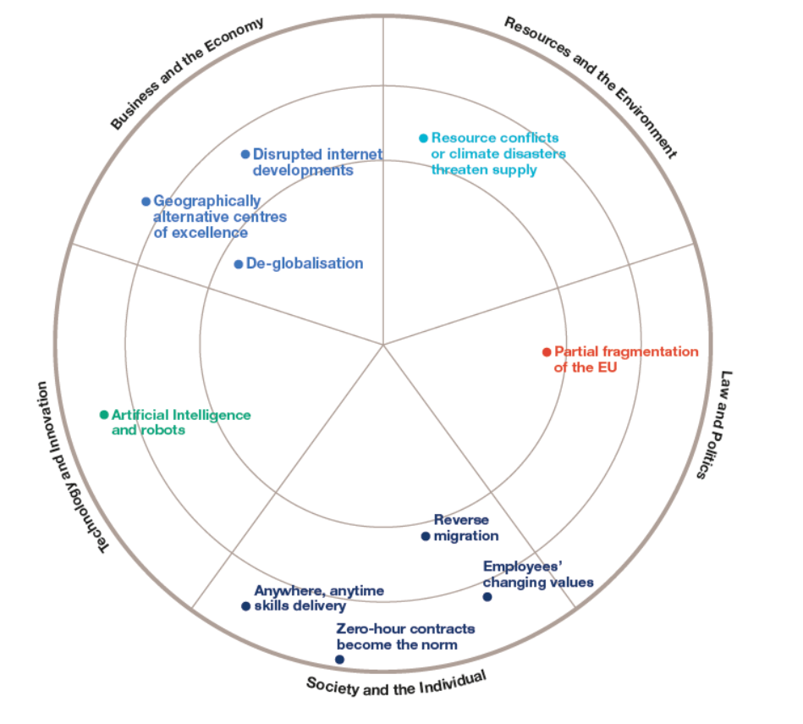

According to Wilson, R et al (2014) it is impossible to predict the future of long-term changes, including the 13 trends identified. Future developments and sharp deviations from 'business as usual' must be considered in our future plans. A list of ten key disruptions was selected based on their conceptual plausibility and their likely impact on jobs and skills if they were to occur in 2030.
- Reverse migration
- Changes in employee values
- Zero-hour contracts become the norm
- Delivery of skills anywhere and at any time
- A.I. and robots
- Globalization decline
- Centers of excellence located in alternative regions
- A disruption in the internet's development
- Supply disruptions are caused by conflicts over resources or climate disasters
- The EU's partial fragmentation

Objectives and goals setting S.M.A.R.T
You can visualize and achieve your success by setting a goal when you are attempting to accomplish something. You can quantify your progress towards your goal by using the SMART goal method.

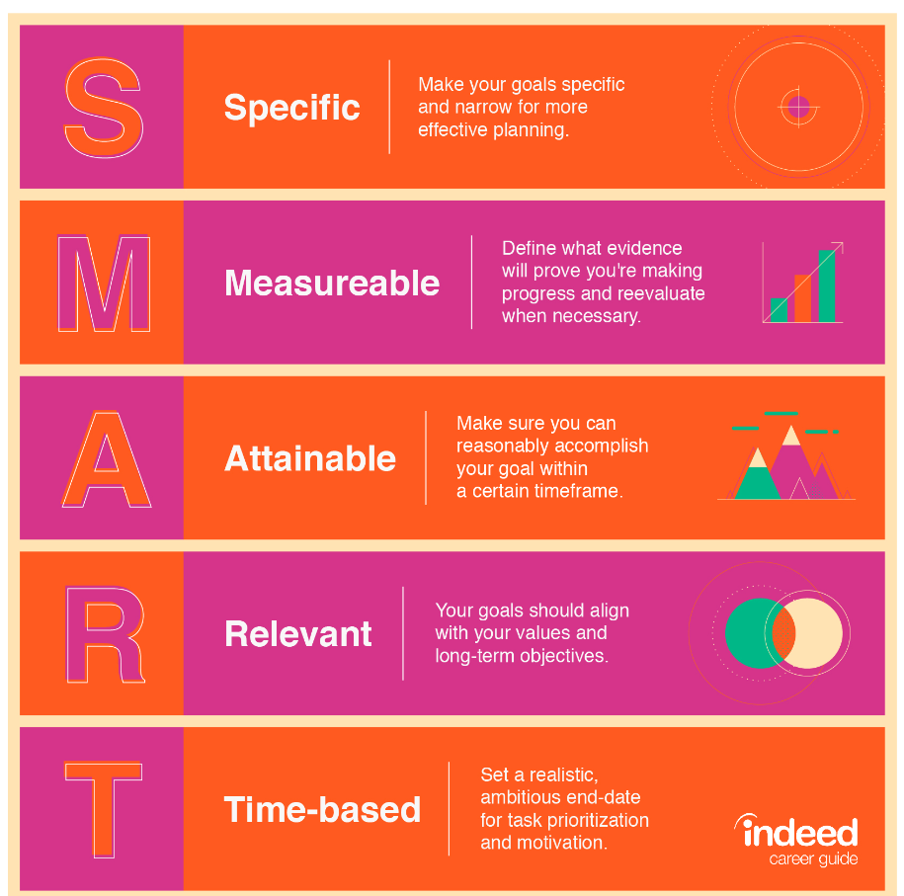

Set your goals according to the SMART acronym. A SMART method measures your progress and holds you accountable for your results. With SMART goals, you can assess what actions you need to take to reach your goals in a realistic manner.

A good example would be setting a goal to improve your typing skills. You see, however, that your goal is quite vague when you evaluate it using the SMART method. You can achieve a SMART goal by restating your objective in quantifiable terms, such as "typing more words per minute."

Career development and employment law in the UK

Since employers are often at the forefront of social change, employment law is extremely dynamic and jurisdiction specific. Many of these rights derive from European Community law, which comprises both contract law and statutory rights. As a matter of fact, many employment law changes are being driven by developments at the European Union level.

What are the different types of employment law?

A wide variety of work environment and process issues fall under this area of law. Examples include:
- An age discrimination law
- Harassment and bullying
- The same pay for equal work
- Sexual discrimination, racial discrimination, and religious discrimination
- Paternity, maternity, and parental leave are all included in parental leave
- Health and Safety

Learning theories

Learning styles can be divided into three categories:

1 Visual

Learning information visually (also called "spatial learning") is best done through whiteboard images, charts, graphs, diagrams, and maps. Writing something down or drawing it out helps visual learners remember it better. As they learn, they also tend to organize or visually compartmentalize information to help them connect concepts.
2 Auditory
In a lecture setting or as part of a spoken presentation, auditory learners are better able to process information when it is spoken out loud. The learners in this category remember what others say easily and prefer to discuss difficult or complex topics with others.When memorizing things, auditory learners prefer verbal instructions and repeat them aloud.

3 Kinaesthetic
Unlike visual or auditory learners, kinaesthetic learners process information through experience rather than by being told or shown. Learning styles like these tend to be more hands-on. They are more likely to interact with objects and can easily recall things they have done versus what they have heard or read.
Touch and feel are more appealing to them than hearing or reading, and they remember things they have done more readily than what they have heard or read.

Self-awareness methods

A person who is self-aware recognizes and acknowledges certain aspects of themselves, including their traits, behaviours, and feelings. In essence, it's a psychological state where one focuses on yourself.
According to Kendra Cherry (2020) The first component of a person's self-concept is the sense of self-awareness. Being self-aware is an important part of who you are, but it may not be something that is acutely focused on all the time. As a result, self-awareness develops at different points, depending on the situation and your personality.
As a result of the Lewis and Brooks-Gunn experiment, it is believed that children become self-aware around 18 months, when spindle cells growing rapidly in the anterior cingulate cortex peak.
Some of the best Self Awareness methods are Johari Window and Swot analysis. Let's not forget about our personal environment and our self-brand and aswell our personal power.
It is possible to develop genuine self-awareness through the insight of critical friends and colleagues: those who are willing to tell you what you need to hear instead of what you want to hear.

Mock Interview and Open Book assessment.
Mock Interview was a pleasant and refreshing experience at the same time. On this way I want to thank the teacher of this module for the way he teach us. I would like to highlight the way in which they teach us. He always had a professional attitude with us.
We, our class believe, we get a lot of knowledge about how to develop personally and how to develop our professional career.
Formal coursework, academic degrees, informal learning, attending conferences, and other forms of professional development are all examples of professional development (Rubens et al., 2018).

Conclusion

Developing a willing workforce is the most fundamental achievement of development. When businesses fail to motivate their employees, their work is usually dictated by their salary earnings. It is important to note, however, that motivation-oriented employees do not simply target salaries. Salary and other benefits are among the things that motivate the workforce. In fact, businesses with authoritative systems fail to produce effective employees because of a lack of peacefulness and freedom of mind. Personal and organizational development capabilities are necessary to address these issues.

Reference

- Adair, J 2010, Decision making and problem solving strategies, Kogan Page, London.
- Anastasia Belyh (2020) What is Career Development?
Available at: https://www.cleverism.com/what-is-career-development/
(Accessed: 19 June 2022).
- Cottrell, S 2021, Skills for Success: Personal Development and Employability, Bloomsbury Publishing Plc, London. Available from: ProQuest Ebook Central. [13 July 2022].
- EMILY POLNER (2022) Best Job Search Websites.
Available at: https://www.thebalancecareers.com/top-best-job-websites-2064080
(Accessed: 20 June 2022).
- Indeed Editorial Team (2019) How To Choose the Right Career Path for You in 9 Steps.
Available at: https://www.indeed.com/career-advice/finding-a-job/choosing-a-career-path
(Accessed: 17 July 2022).
- Indeed Editorial Team (2019) Guide on How To Write SMART Goals (With Examples)
Available at https://www.indeed.com/career-advice/career-development/how-to-write-smart-goals
(Accessed: 20 July 2022).
- The University of Law( 2021) Employment Law
Available at: https://www.law.ac.uk/employability/legal-practice-areas/employment-law/
(Accessed: 21 July 2022).
- Wilson, R et al (2014) Working Futures 2012-2022. Wath upon Dearne: UK Commission for Employment and Skills.

